Appendix D

Animal Bedding

Table of Contents

Page
Green Products Company D3
Harlan Laboratories – Bedding Packaging for Research Applications D7
Shepherd Specialty Paper (SSP) D10
Northeastern Product Corporation D11
Lab Supply D12
Animal Specialties and Provisions, LLC (June 30, 2010) D14
Animal Specialties and Provisions, LLC (August 9, 2010) D16
Roe Bio Medical Products D17
American Wood Fibers D18
The Andersons, Cob Products Division D26
The Andersons, Cob Products Division Presentation D29
Newco Distributors Inc. – Specialty Division D36
Absorption Corporation D37

This page intentionally left blank

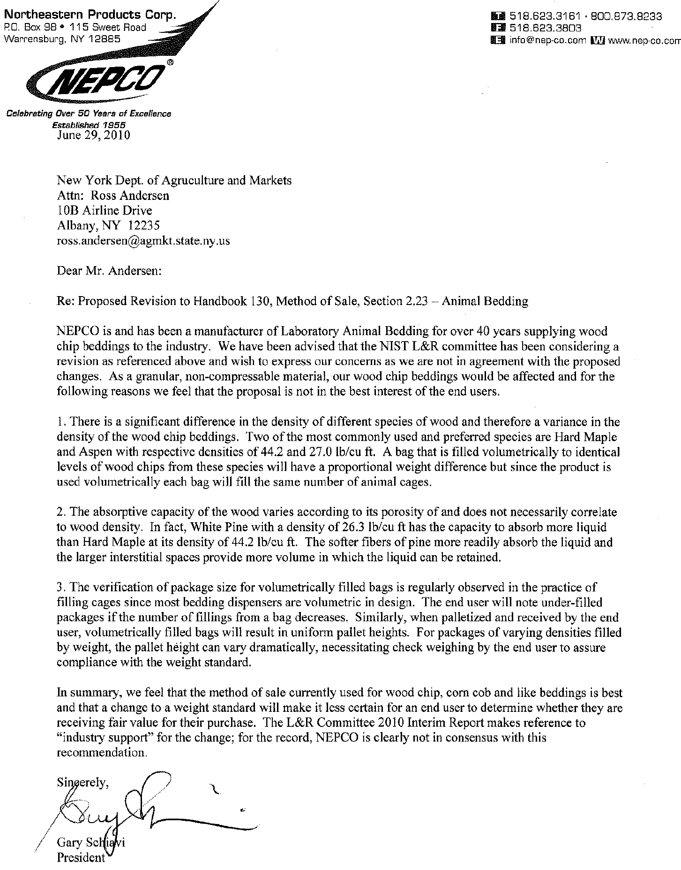
Jason Raynor
Lab Supply
General Manager
Phone: 1-800-262-5258 Fax: 817-492-9300
Lab Supply
Jason Raynor
Lab Supply
General Manager
Phone: 1-800-262-5258 Fax: 817-492-9300
Lab Supply
From: Norm_Peiffer@AndersonsInc.Com [mailto:Norm_Feiffer©AndersonsInc.Com] Sent: Wednesday, June 30, 2010 7:56 AM
To: undisclosed-recipients:
Cc: Ted_Weaver@AndersonsInc.com; Jerry_Reynolds©AndersonsInc.COM; Dale Theis©Andersonsinc.Com; Andrea_Gay@andersonsinc.com; Colleen_Kander©andersonsinc.com; Barb_Sample@AndersonsInc.com
Subject: Letter template for Weight & Measures HB 130
Here is a letter we drafted for your consideration to use when writing to your state W & M representative. Fell free to use as is (after adding your letterhead) or parts and pieces.
We'll get you the outcome as soon as we have it.

Thanks again

Ted Weaver (almost retired)
Andrea Gay
Colleen Kander Jerry Reynolds Norman Peiffer

Dear Mr. Benavides,
Re: Proposed Revision to Handbook 130, Method of Sale, Section 2.23 — Animal Bedding
As a member of the laboratory animal provisions and supplies industry, we do not support the proposed change that would allow selling of bedding used for laboratory animals to be sold by weight. Below are the specific reasons this proposed change is inappropriate for the laboratory bedding consumer or any end user. These reasons are counter to what is reported on Page L&R 18.
- There is no incentive for manufactures to produce a lighter product. The product varies seasonally and cannot be consistently produced to the same density per cubic foot while maintaining the quality of product. Furthermore, the product absorbency is not decreased by making it lighter, it is INCREASED. This was verified in an independent study by C.C. Burns & G.J. Mason, Department of Zoology, University of Oxford, UK, Animal Sciences Department & University of Guelph, Ontario, Canada. Accepted May 12, 2004 the study entitled: "Absorbencies for six different rodent beddings: commercially advertised absorbencies are potentially misleading". The study conclusion is: "By volume, corncob was the most absorbent bedding...". Corncob had the highest absorbency per cm³..."and "In contrast, reported absorbency values calculated per unit mass would give the misleading impression... Attached is a copy of the study for your reference.
- Historically, NIH has purchased primarily wood bedding for their labs, a product that has always been sold by volume. All customers including pharmaceutical, university research sites and large commercial breeders including Harlan who have purchased wood bedding have bought it by volume. Currently, The Andersons is the largest supplier of corncob to the laboratory animal market, and has been supplying customers since 2006 in government, pharmaceutical, university research sites and contract labs with corncob sold by volume.
- Moisture range is only part of the equation that determines the density of processed corncobs. All manufactures comply with the restrictions. Corncob genetic variation of the hybrid seed, seasonal changes in humidity, hammer mill processing, drying and final screening all contribute to the varying cubic density and thus mass of the finished product.
- Verification of package contents is easy with volume. The packages are sized to hold the stated volume of the package. The pallets stack heights when filled by volume are all the same heights. A 1.25 cubic foot bag fill can be checked by poured into it into a 1.25 cubic foot box that can be purchased on-line. A simple box with inside dimensions of 12" x 12" x 15" filled to capacity will verify the fill. In the case of bulk sack the dimensions are printed on a tag providing the bag dimensions. Dividing the multiple of all the dimensions by 1728 will yield the volume in cubic feet. Scales vary in accuracy must be calibrated to ensure consistency.
Conclusions:
The sale of dry, granular or non-compressible pelleted bedding is best sold by volume. The cages used to hold the animals are filled by volume in the lab, not by weight. In labs where automatic bedding dispensers are used, they are calibrated to dispense by volume, not weight. The seasonal variance in bulk density inherent in these natural products varies the bag fill and thus cage fill of the bags when the bedding is sold by weight. The bag fill and thus the number of cages fill per bag do not vary when the product is sold by volume.
The industry does not support this change as noted in the final paragraph of page 18 of L & R letter. The Andersons, the largest corncob manufacturer and supplier, nor any of the other largest manufacturers of laboratory bedding industry members commented upon the proposed resolution.
Thanks,
Jason

From: Gaccione, John [jpg4@westchestergov.com]
Sent: Wednesday, June 30, 2010 3:28 PM
To: Warfield, Lisa
Subject: FW: Proposed Revision to Handbook 130, Method of Sale, Section 2.23 -
Animal Bedding

More for you.

John P. Gaccione
Acting Director of Consumer Protection
Director of Weights and Measures
Westchester County Consumer Protection
(914)995-2164

From: Bill Clarke [mailto:Bill@animalspecialties.biz]
Sent: Wednesday, June 30, 2010 1:52 PM
To: Gaccione, John
Subject: Proposed Revision to Handbook 130, Method of Sale, Section 2.23 - Animal Bedding

Dear Committee Members,

As a member of the feed industry in Pennsylvania specializing in laboratory animal diets and
beddings, we do not support the proposed change that would allow the selling of bedding used for laboratory animals to be sold by weight. Below are the specific reasons this proposed change is inappropriate for the laboratory bedding consumer or any end user. These reasons are counter to what is reported on Page L&R 18.

1. There is no incentive for manufactures to produce a lighter product. The product varies seasonally and cannot be consistently produced to the same density per cubic foot while maintaining the quality of product. Furthermore, the product absorbency is not decreased by making it lighter, it is INCREASED. This was verified in an independent study by C.C. Burns & G.J. Mason, Department of Zoology, University of Oxford, UK, Animal Sciences Department & University of Guelph, Ontario, Canada. Accepted May 12, 2004 the study entitled: “Absorbencies for six different rodent beddings: commercially advertised absorbencies are potentially misleading”. The study conclusion is: “By volume, corncob was the most absorbent bedding…”. Corncob had the highest absorbency per cm³…”and “In contrast, reported absorbency values calculated per unit mass would give the misleading impression…”

2. Historically, NIH has purchased primarily wood bedding for their labs, a product that has always been sold by volume. All customers including pharmaceutical, university research sites and large commercial breeders including Harlan, who have purchased wood bedding have bought it by volume. Currently, The Andersons is the largest supplier of corncob to the laboratory animal market, and has been supplying customers since 2006 in government, pharmaceutical, university research sites and contract labs with corncob sold by volume.

3. Moisture range is only part of the equation that determines the density of processed corncobs. All manufactures comply with the restrictions. Corncob genetic variation of the hybrid seed, seasonal changes in humidity, hammer mill processing, drying and final screening all contribute to the varying cubic density and thus mass of the finished product.

4. Verification of package contents is easy with volume. The packages are sized to hold the stated volume of the package. The pallets stack heights when filled by volume are all the same heights. A 1.25 cubic foot bag fill can be checked by poured into it into a 1.25 cubic foot box that can be purchased on-line. A simple box with inside dimensions of 12” x 12” x 15” filled to capacity will verify the fill. In the case of bulk sack the dimensions are printed on a tag providing the bag dimensions. Dividing the multiple of all the dimensions by 1728 will yield the volume in cubic feet. Scales vary in accuracy must be calibrated to ensure consistency.

Conclusions:
The sale of dry, granular or non-compressible pelleted bedding is best sold by volume. The cages used to hold the animals in the lab are filled by volume, not by weight. In labs where automatic bedding dispensers are used, they are calibrated to dispense by volume, not weight. The seasonal variance in bulk density inherent in these natural products varies the bag fill and thus cage fill of the bags when the bedding is sold by weight. The bag fill and thus the number of cages fill per bag do not vary when the product is sold by volume.

The industry does not support this change as noted in the final paragraph of page 18 of L & R letter. The Andersons, the largest corncob manufacturer and supplier, nor any of the other largest manufacturers of laboratory bedding have commented upon the proposed resolution.

Thank you for your consideration,

William Clarke
Animal Specialties and Provisions, LLC
www.animalspecialties.biz
215-804-0144 Ext. 13

From: Bill Clarke [Bill@animalspecialties.biz]
Sent: Monday, August 09, 2010 2:22 PM
To: Warfield, Lisa
Subject: Lab Animal Bedding

Dear Ms. Warfield,
I had sent a previous letter against the provision or change regarding lab animal bedding being sold by weight instead of volume. We have sold corn cob bedding, wood beddings and paper bedding materials with some items packaged by volume AND some packaged by weight. I misunderstood the change was to cause all bedding to be sold by weight instead of volume. I could support the change (Handbook #130, Section 2.23 Paragraph 1) as worded specifically for ALPHA-dri or similar products (chipped paper products) manufactured by Shepherd Specialty Papers.

Thank you,

William Clarke
W. Edwards Deming Animal Specialties and Provisions, LLC
www.animalspecialties.biz
215-804-0144 Ext 13

"It is not necessary to change. Survival is not mandatory."
W. Edward Deming

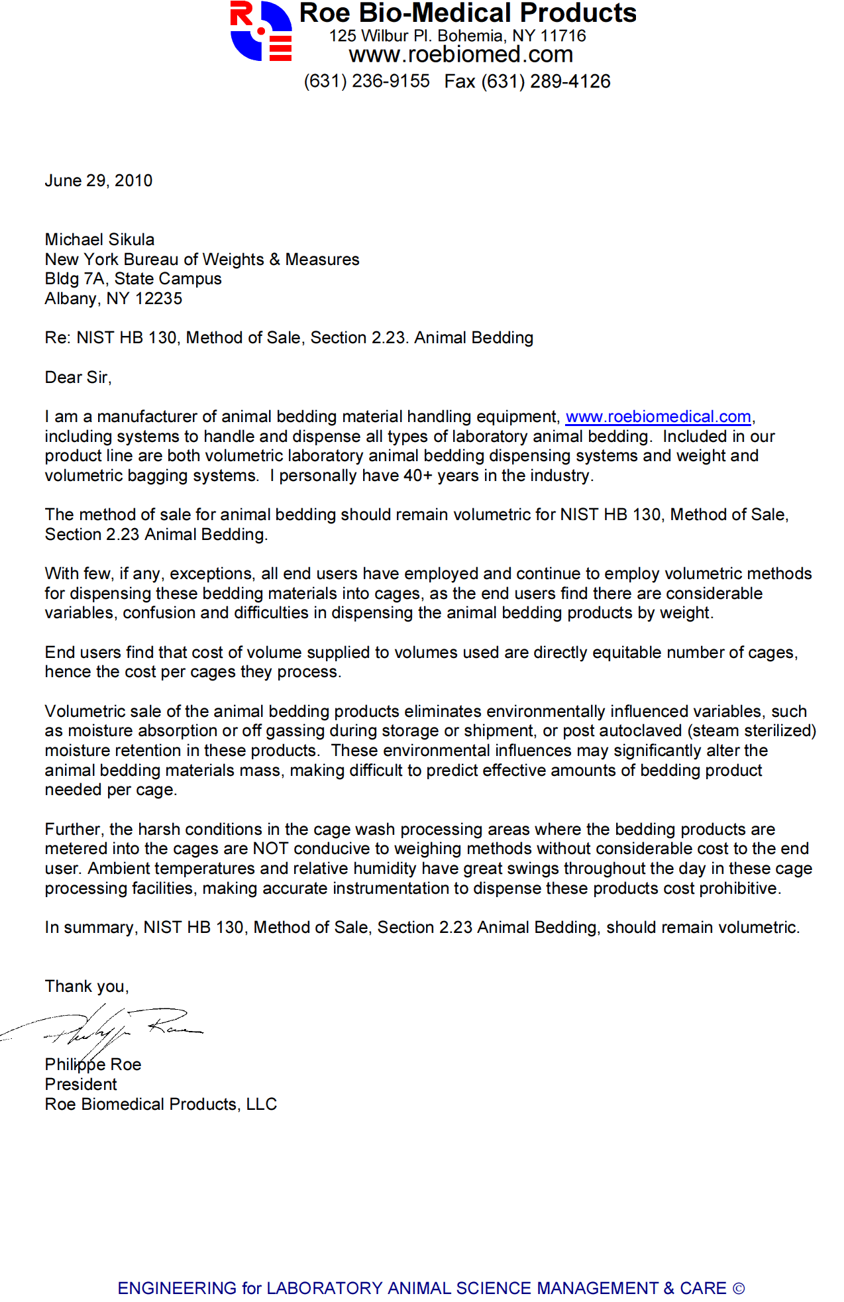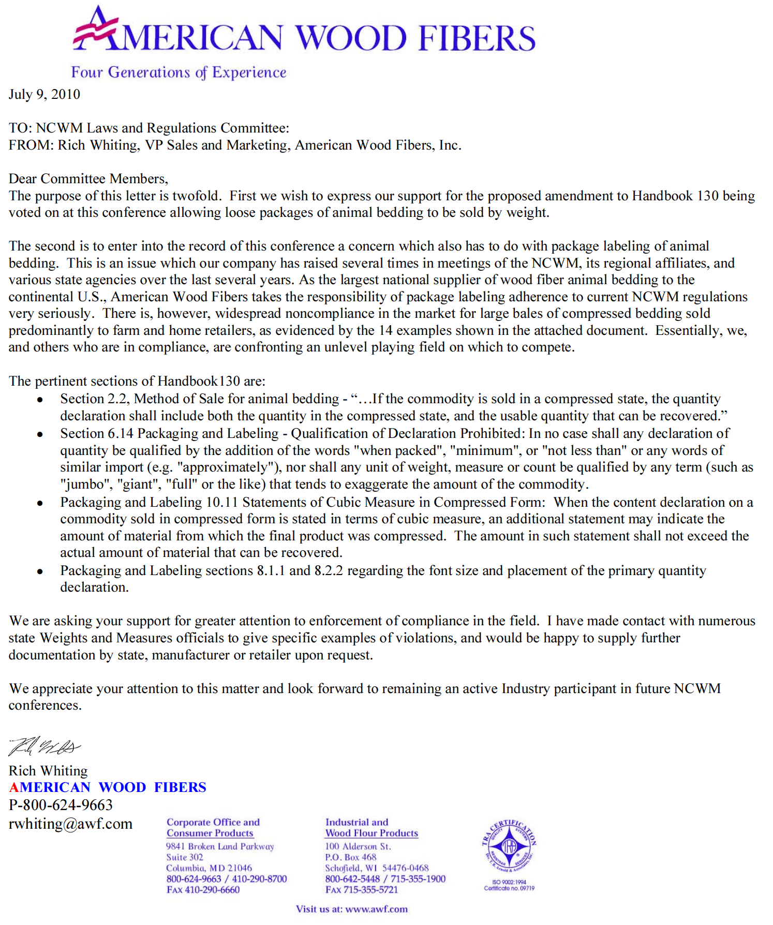
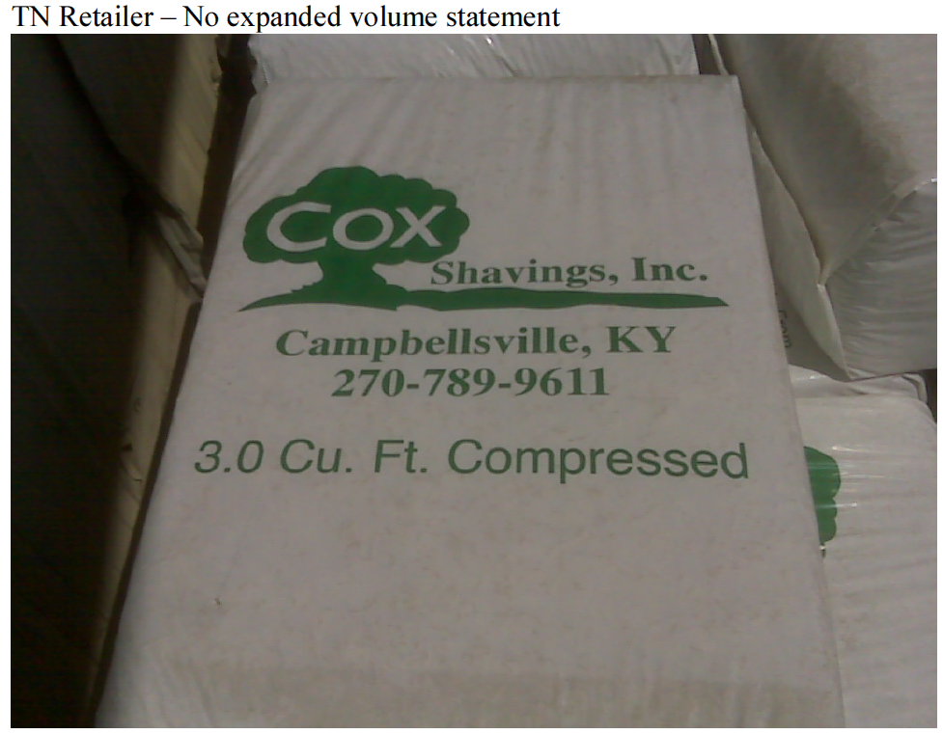
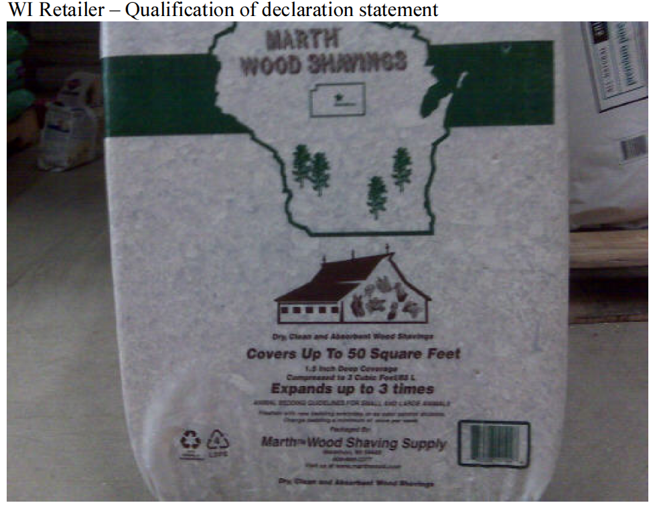
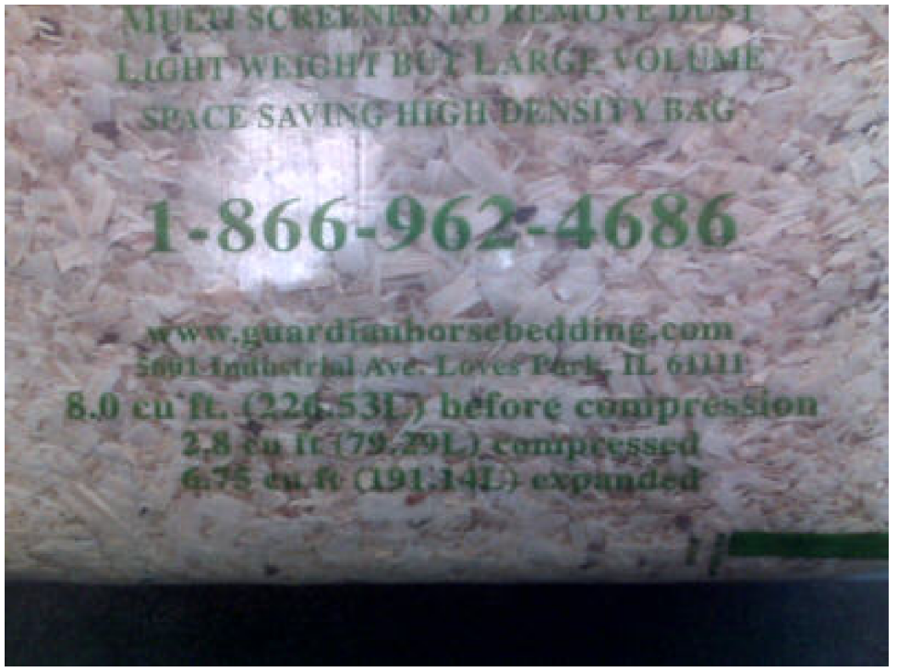
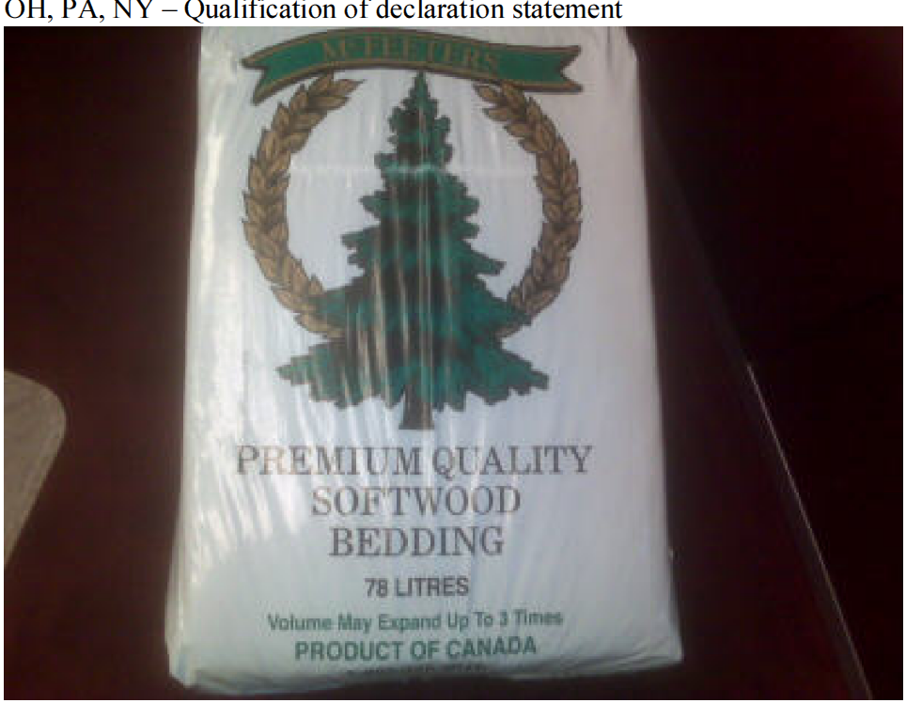
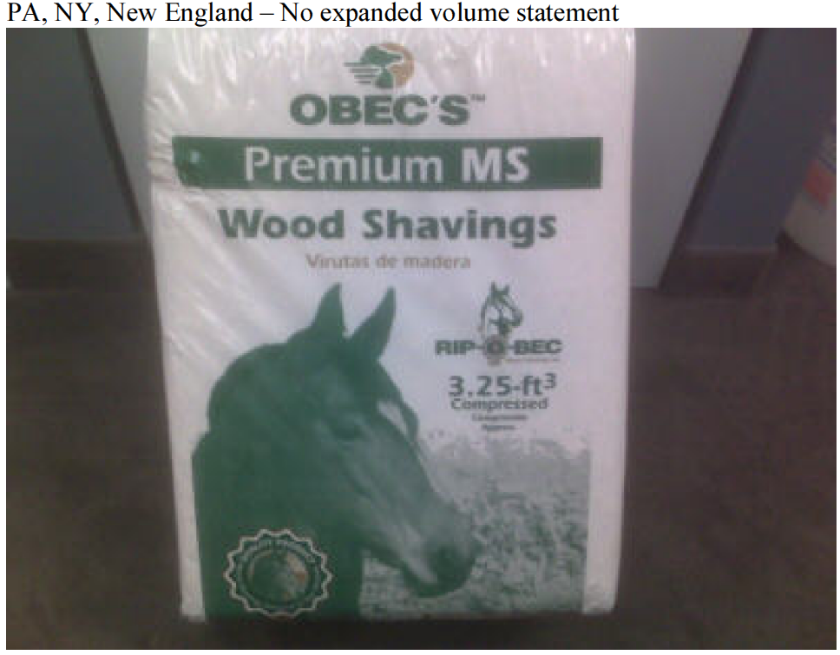
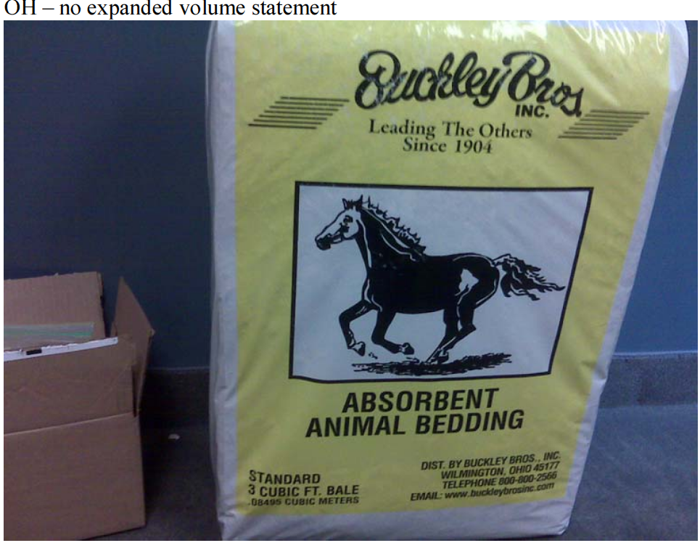
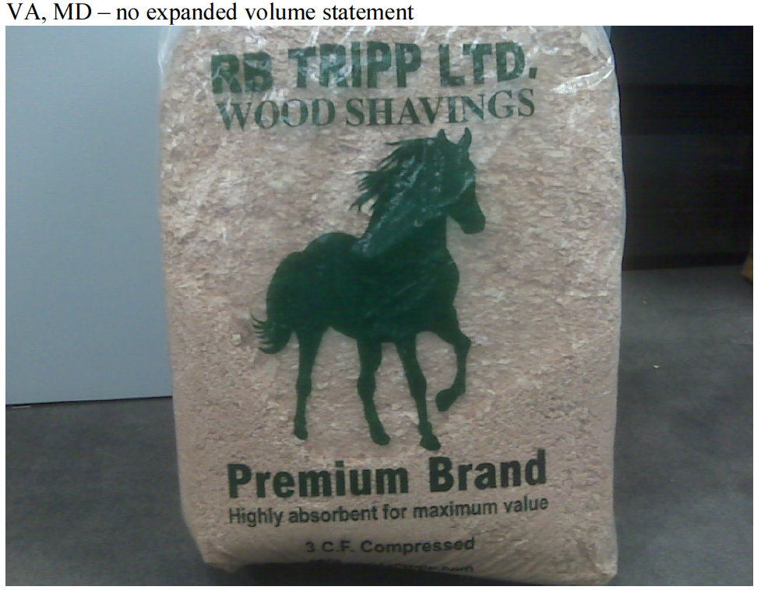
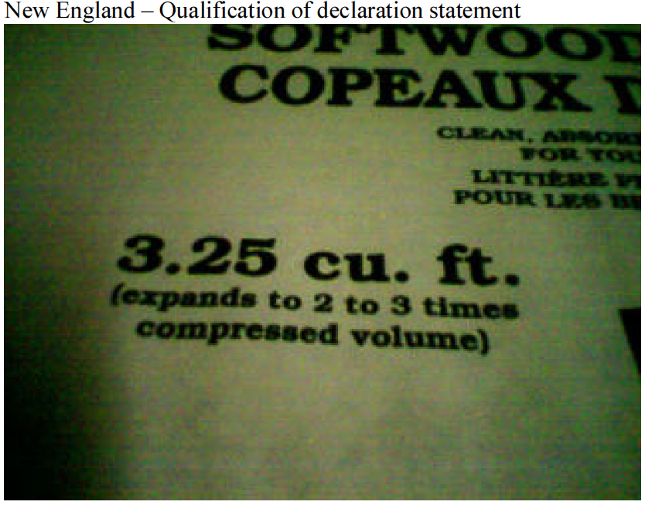
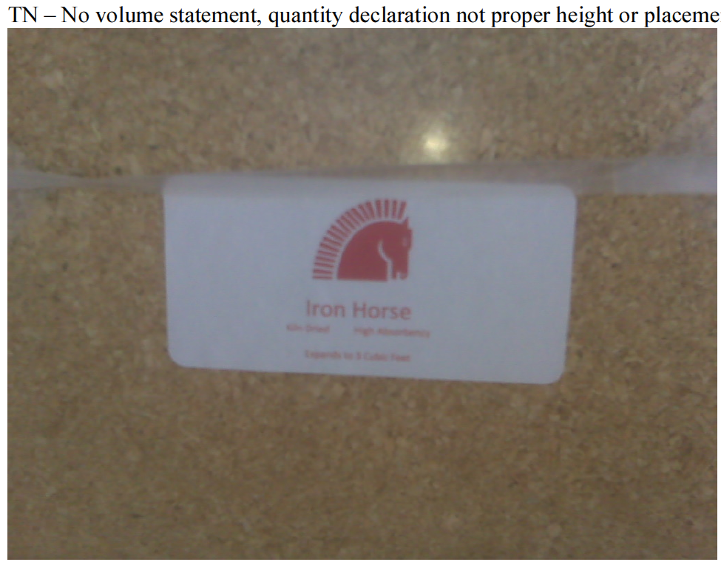
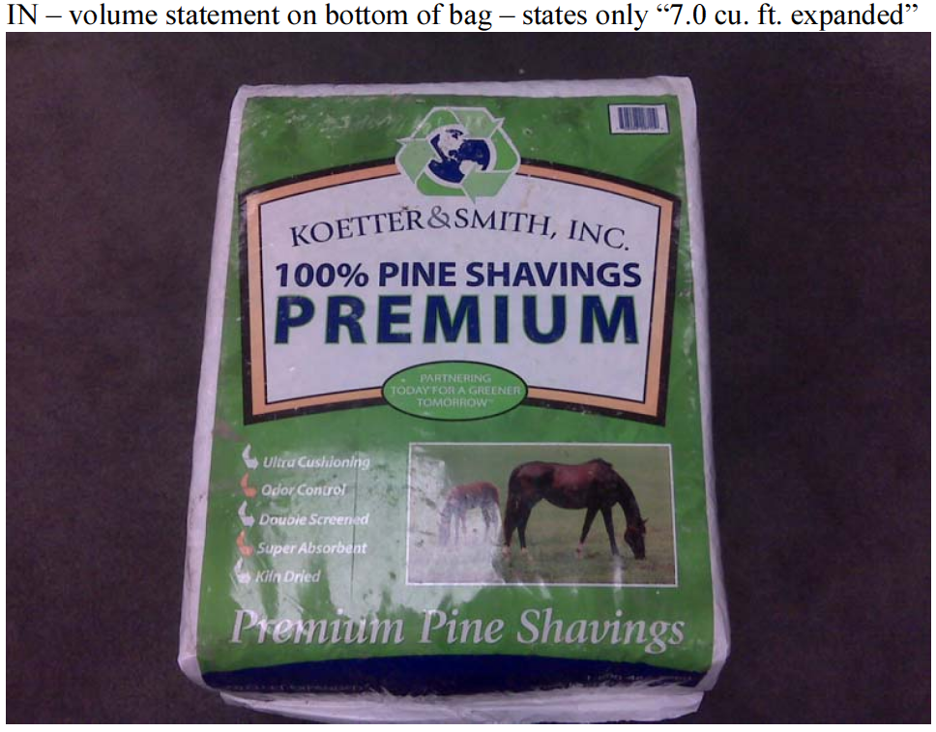
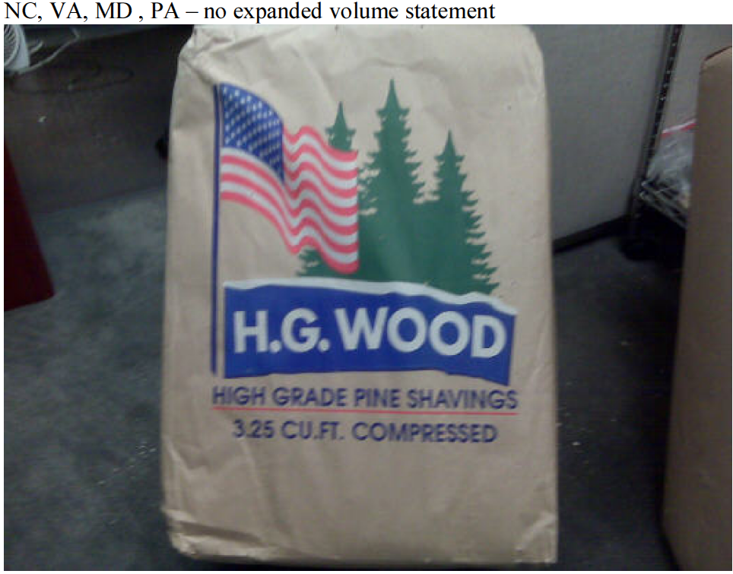
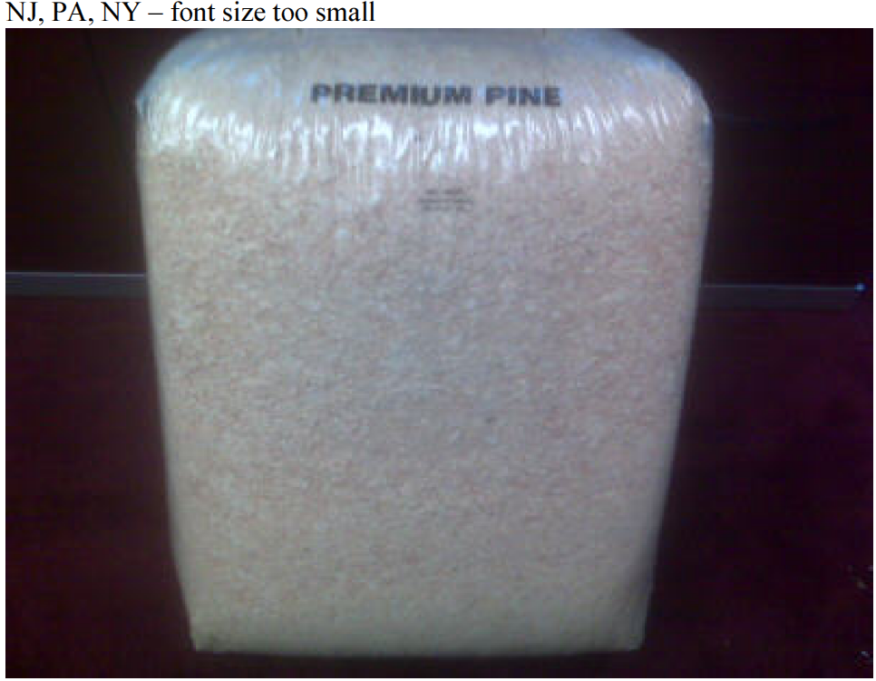
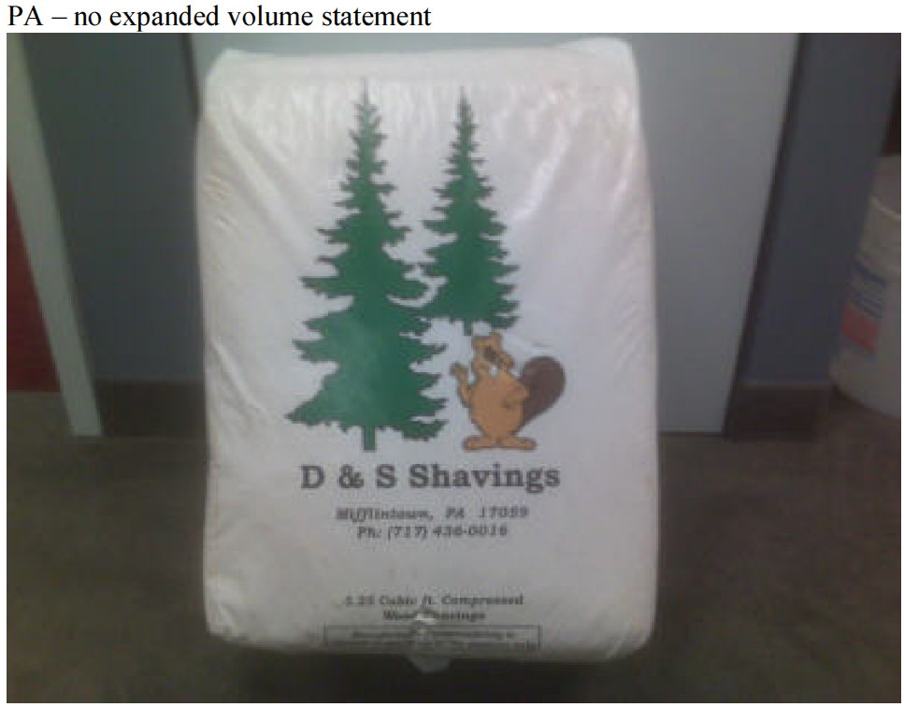
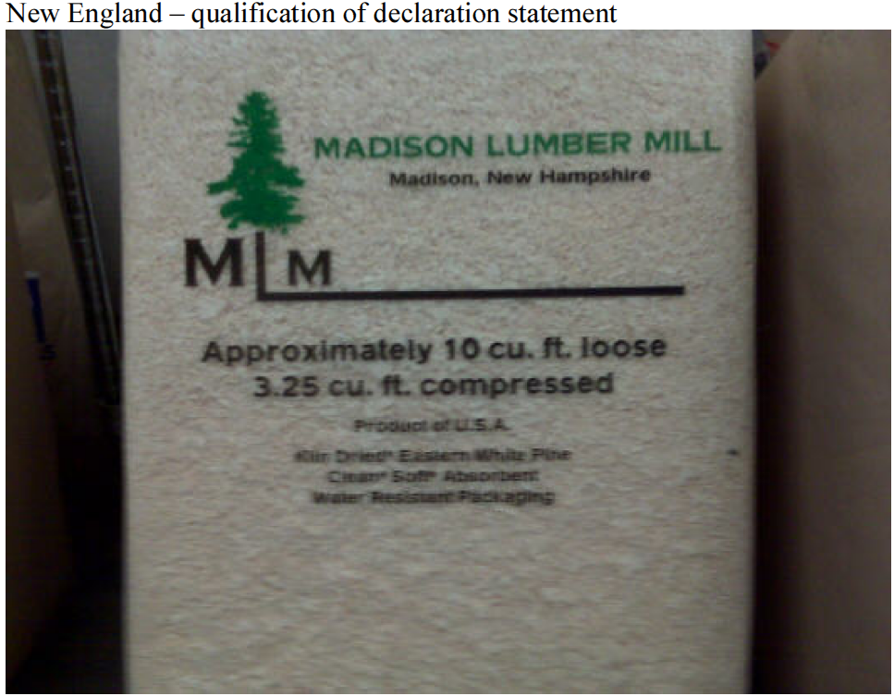

Page 1 of 3

480 W. Dussel Drive, Maumee, OH 43537
Thursday, July 08, 2010

To: Laws and Regulations Committee
Re: Proposed Amendment to NIST HB 130, Method of Sale Section 2.23 Animal Bedding

Dear Committee Members,

I would like to categorically address the major claims made within the four numbered paragraphs of Page L & R 18. These four paragraphs appear to form the basis for the amendment request.

1. Selling by weight vs. volume:
Why did we start selling by volume? It was a California W & M “stop sale” citation to one of the companies referenced as an “industry supporters” (ref: last paragraph on Page L & R 18), for selling animal bedding by weight vs. volume to pet stores. We were directly informed by this company that we should change to volume to comply with the law. Today that same company wants the HB130 exception implemented. We complied seeing no difference between commercial end users and non commercial end users. Both user types use the bedding products to fill their animal cages in the same way --- volumetrically.

I do not know when the current regulation was first established, but the NIST had it right to regulate the sale by volume as opposed to weight. Volume packaging means the bag will always contain the same volume of product bag after bag after bag. Biomass products have a wide range of densities or weight per cubic foot and it is this density range which causes the bag fill content to vary. The higher the density the less the bag fill – the lower the density the fuller the bag.
Volume is the significant and consistent method of sale. Consumers use the product by volume whether in a pets cage or in a research laboratory cage.

Consumers, a.k.a., end users can always budget or know their bedding cost per cage fill is always the same bag after bag regardless of its weight since the bag always contains the same volume. Cost per fill becomes very important when research is paid on a per diem basis. The R & D expenses of the private pharmaceutical industry and the government based facilities become more closely monitored, correct budgeting has become more important.

Page 2 of 3

2. Historically…..research sites have purchased bedding material on the basis of weight.
Weight was established in the late 1960’s as the method of sale for corn cob bedding to the pet and lab research community because we knew no better. The Andersons were one of the first, if not first, to sell corn cob bedding into the research community and we sold by weight which became the benchmark. Many of our customers complained about the differing volume amounts in a bag, but 40 lb is 40 lbs whether it is a bag of feathers or a baggie of iron. And we continued to sell by weight and as new competitors entered the corn cob bedding market they followed suit.
It was not the purchasing departments who established the standard it was the early vendors.

3. Moisture as an industry standard
We could not agree more with the moisture level standard. Our published specifications are less than 10% but are typically within the 6 to 8% range.

4. Verification of package contents
Verification of volume only requires a simple box with an inside dimension of 12 x 12 x 15 to determine if the package fill is correct for our 1.25 cubic foot. Or in the case of a large bulk bag, the bag dimensions are on an attached printed tag which has been affixed by the bag manufacturer. Again using these dimensions to calculate the bag volume is a matter of simple math.
The Andersons provided many educational materials during the transition period from weight to volume including calculators which compare the number of bag fills at differing densities of a bag sold by weight. The calculator also generates a cost per fill by volume and shows that regardless of the density, the bag’s volumetric content always yields the same number of fills regardless of the bag weight.
Unless a customer has access to a certified scale capable of handling the weight of a bulk bag (or for that matter weighing any size bag) there is no way to verify the weight as shown if in fact is correct. Volume is a mathematical equation and easily verified with the use of a calculator.

Bedding is used by volume not by weight. If the L& R committee would consult those “industry supporter” company web sites you will find Harlan sells some bedding products by volume and some by weight; while Shepherd Specialty Papers, sells by volume or by weight. Green Products supplies the corn cob bedding to Harlan by weight and to the pet industry the same product by volume. There is an interesting quote on the Shepherd web site; it is the comment that the Shepherd bedding dispensing system “…controls the exact amount of bedding per cage and replicating the volume across all cages in the facility. A small amount of variation in the amount of bedding used per can add up to thousands of dollars over the course of a year.” OUR POINT EXACTLY!!

When bedding is sold by weight a higher density has a higher cost per fill, the lower the density the reverse is true. When the bedding product is sold by volume and the cages are always filled by volume, the price per fill is always the same regardless of the density!!

Page 3 of 3

The end user customer receives consistent and fair value bag after bag after bag. And that’s the point of W & M regulations -- protecting the end user customer regardless of the industry the user belongs to.

Selling by weight to one industry and to another by volume is inconsistent. Next will be a request by a commodity producer to sell a bag of nuts by piece count instead of total bag weight or how about selling a loaf of bread by the number of slices instead of package weight?

Sincerely yours,

Norman Peiffer
Market Development Manager
Cob Products Division


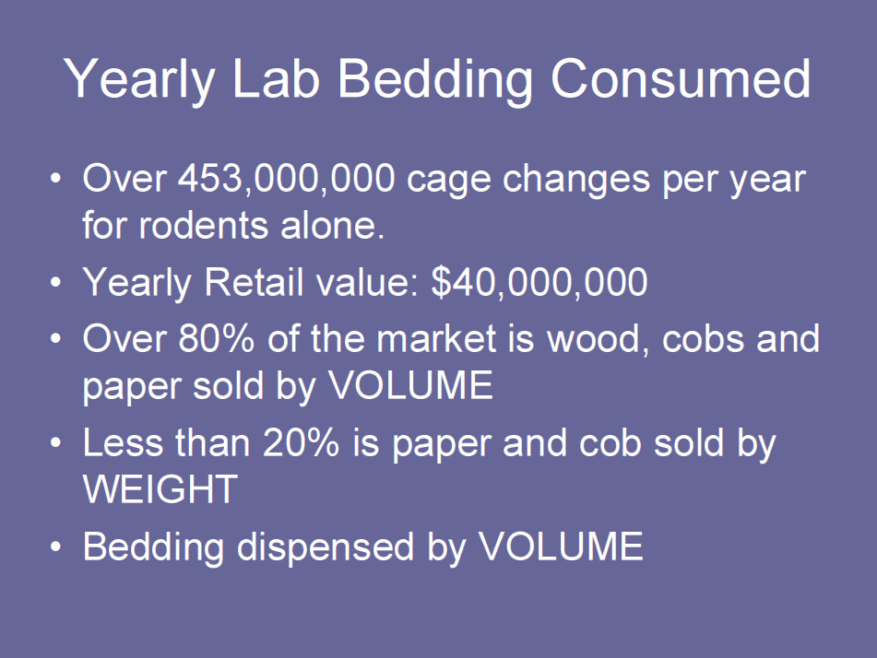
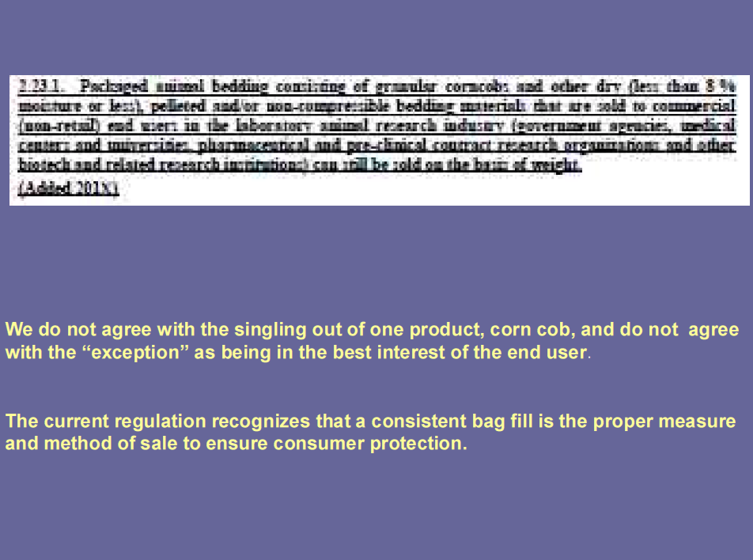
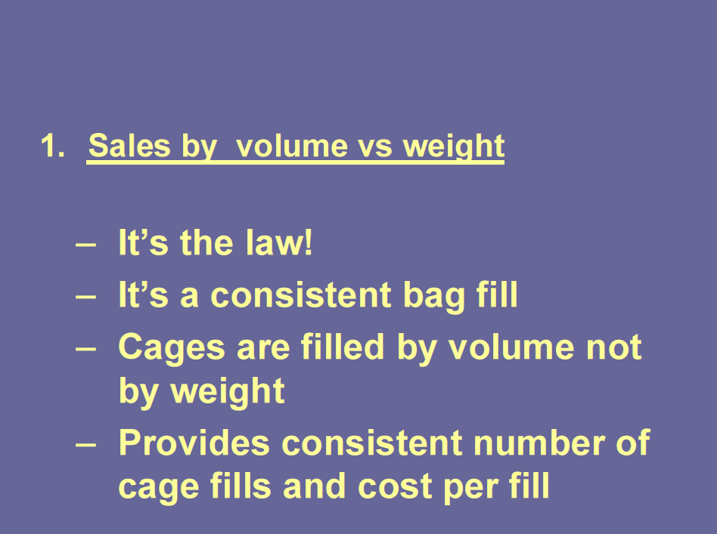
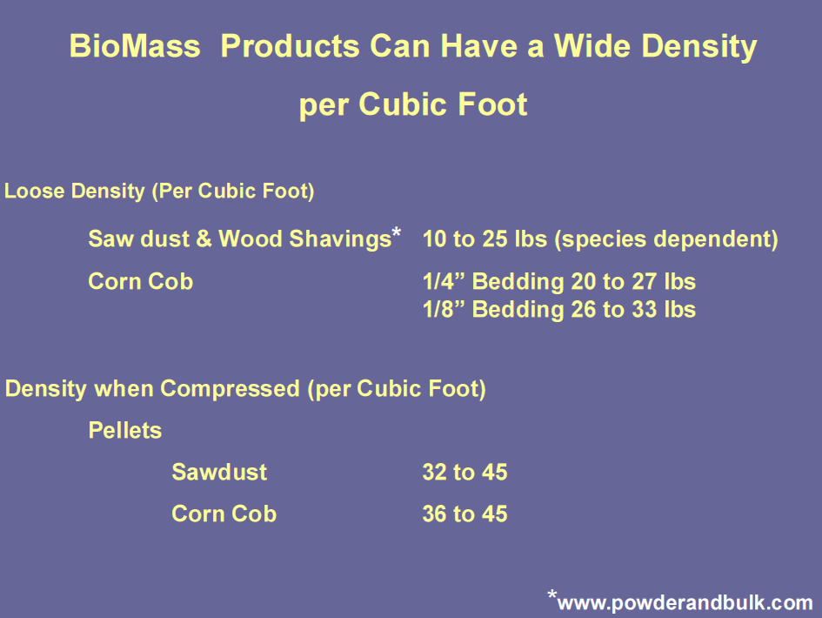
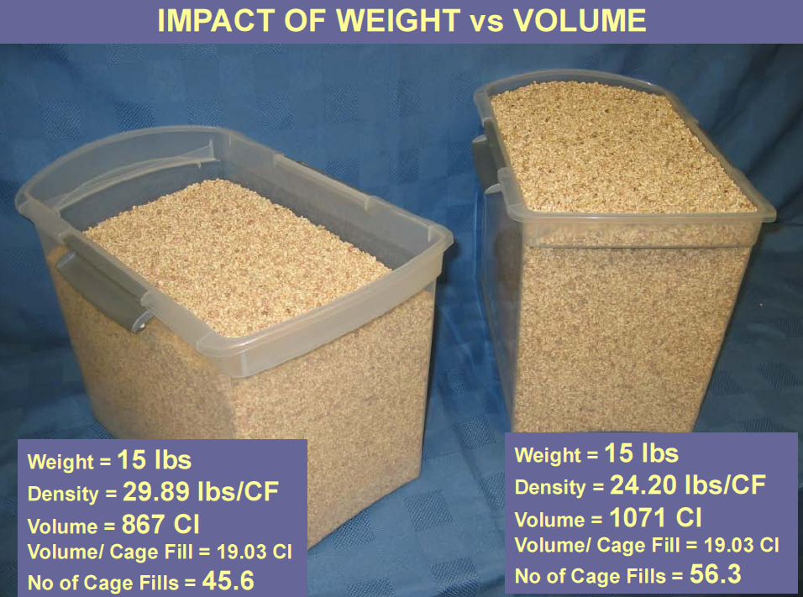
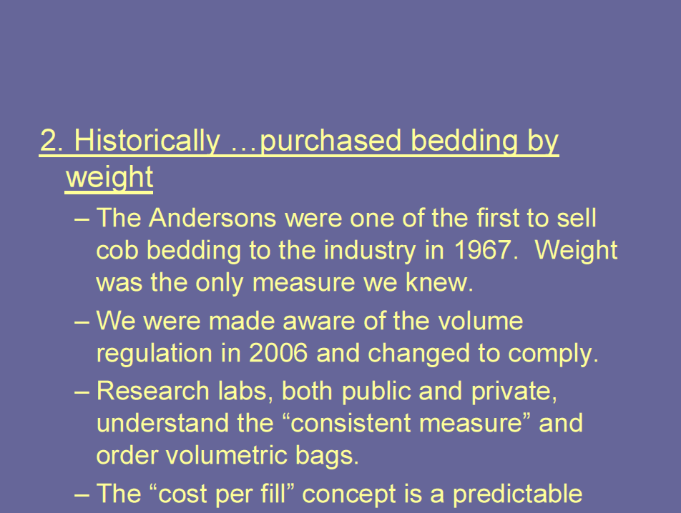
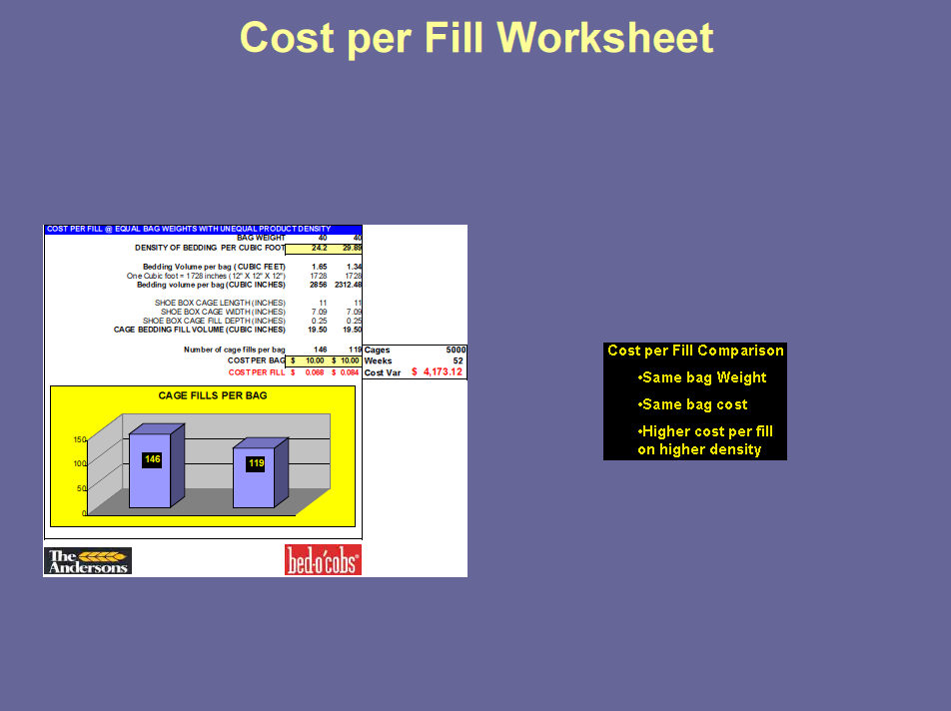
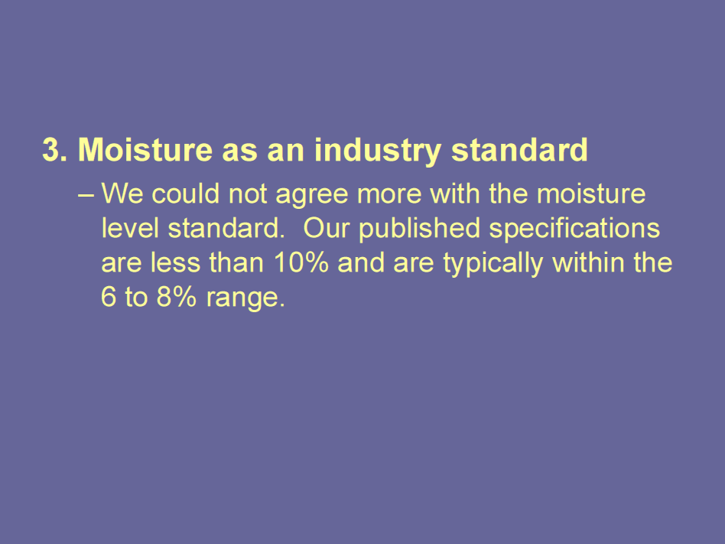
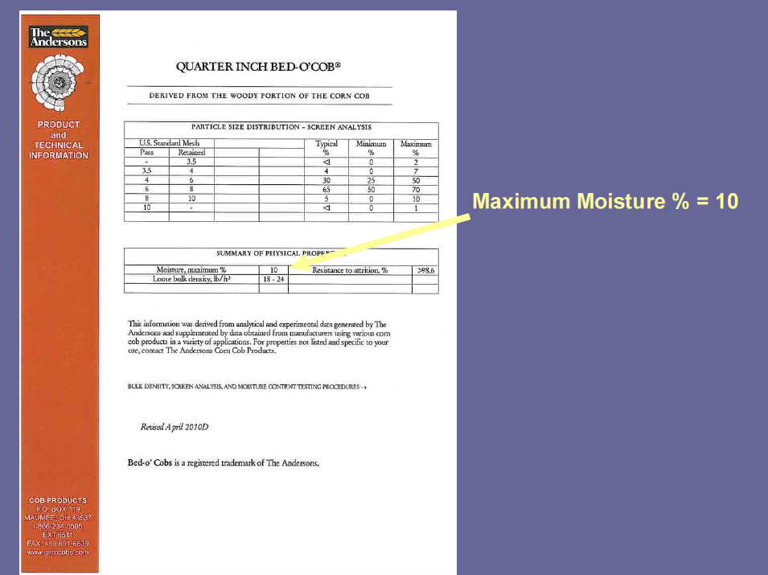

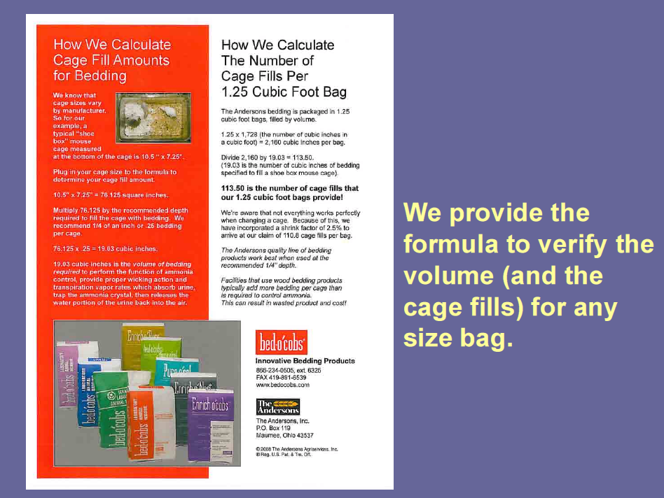


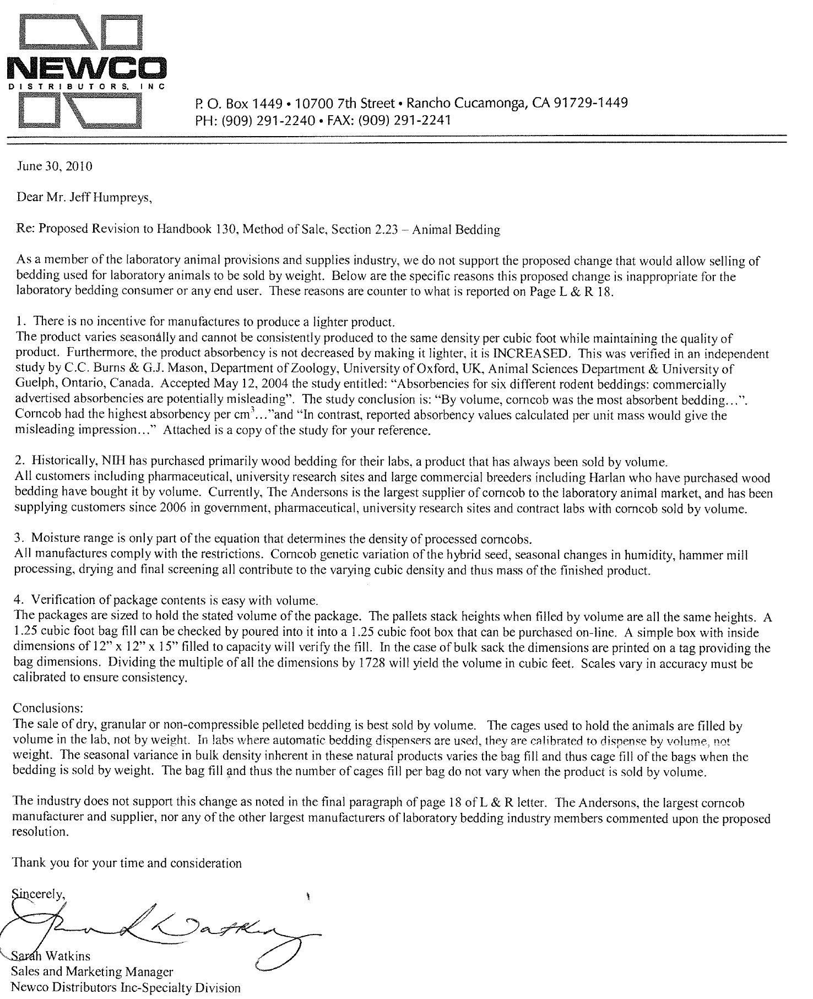
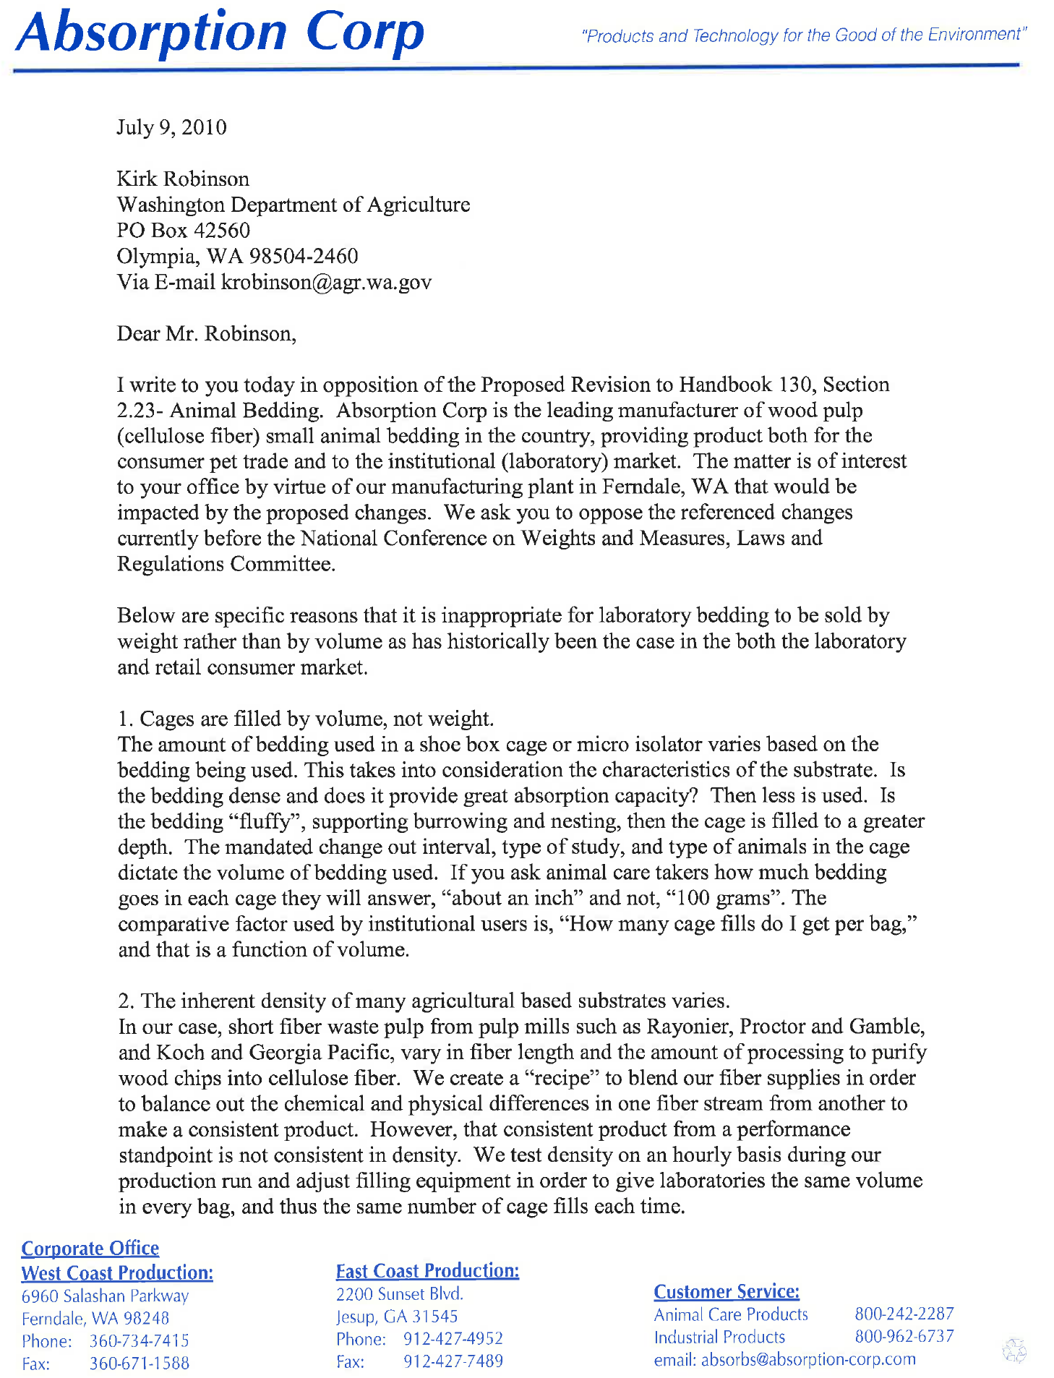
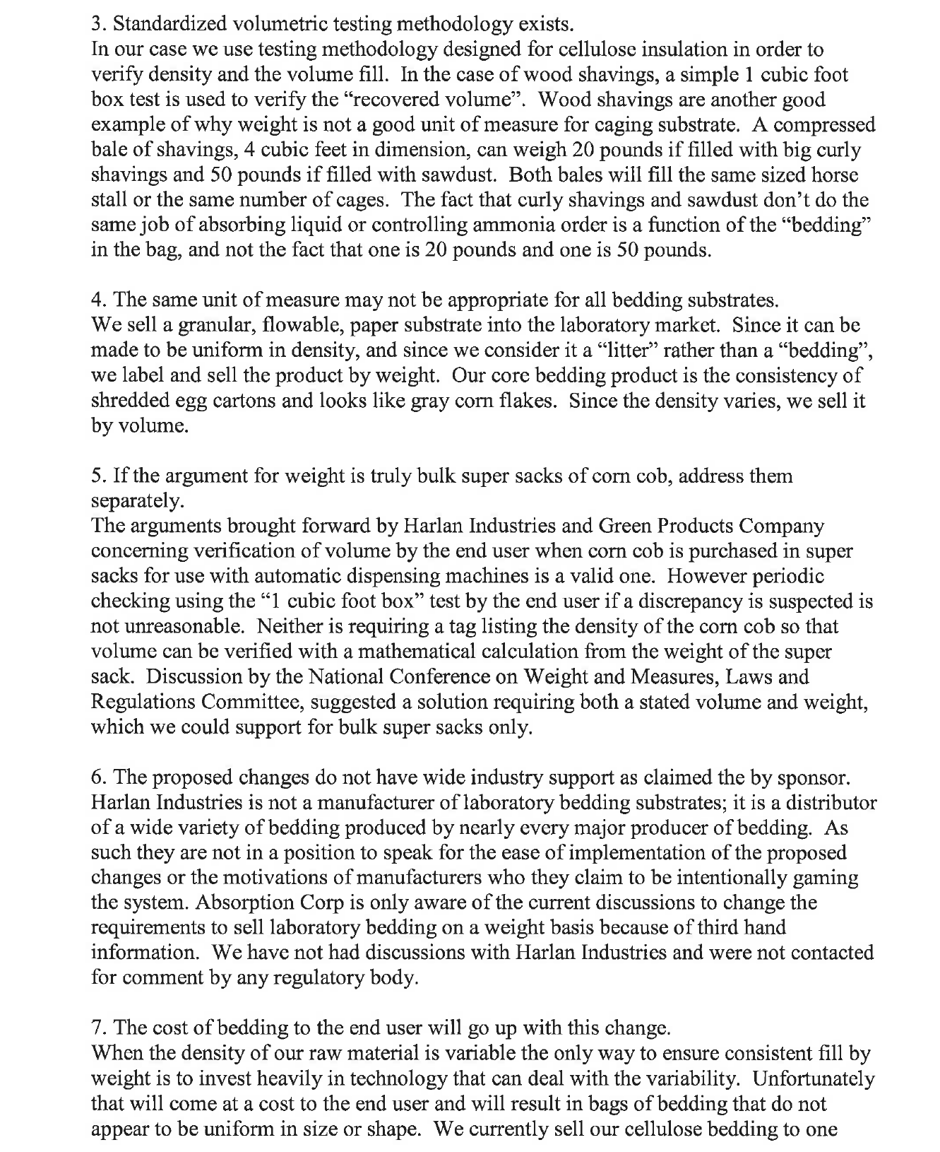
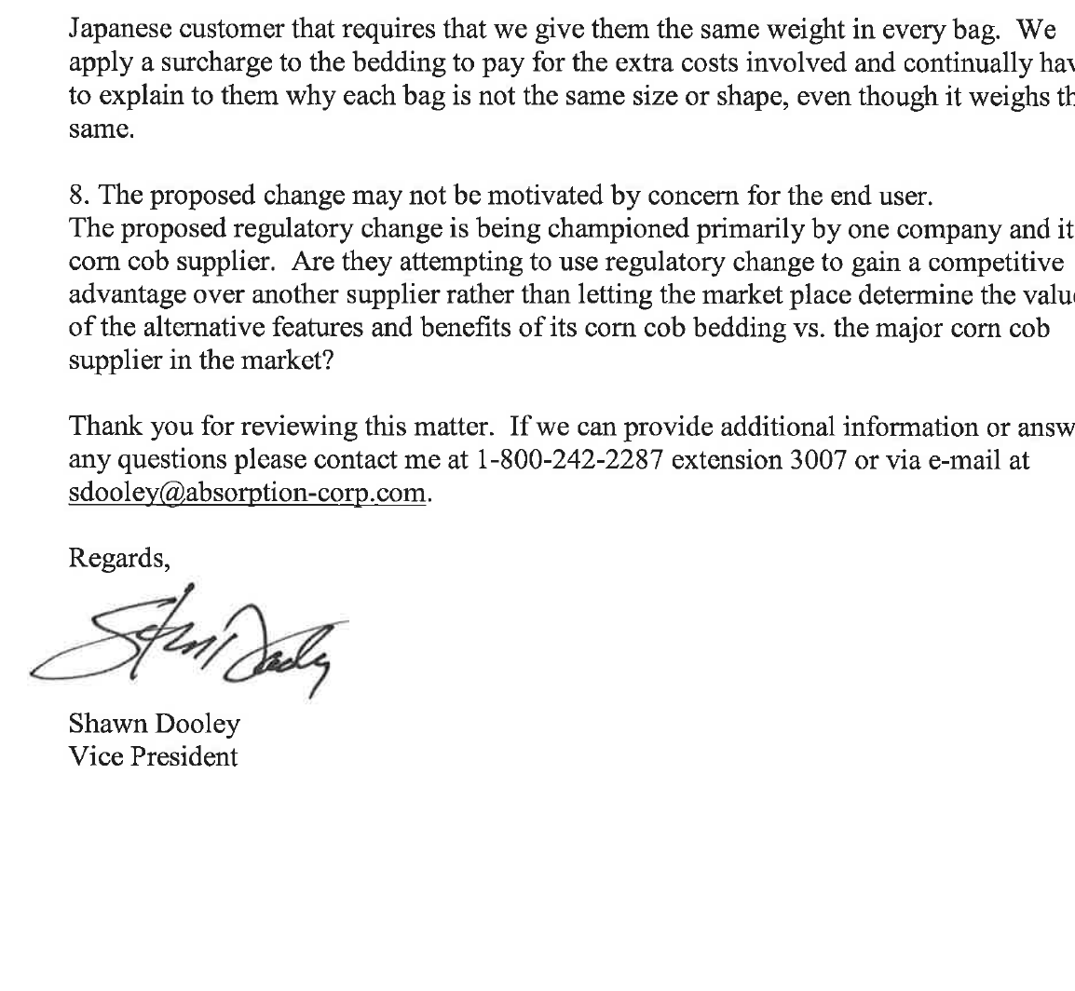

THIS PAGE INTENTIONALLY LEFT BLANK

