Appendix C

Packaged Printer Ink and Toner Cartridges

Table of Contents

Page
Lexmark Letter on Inkjet/Printer Cartridges C3
NIST Weights and Measures Division Position Paper on Inkjet and Printer Cartridges Considerations C8
G. J. Neville Design and Development Letter C10
Information Technology Industry Council (ITI) – Printer Toner and Ink Cartridges: Best Practices for Conveying Yield Performance to the Consumer C14
Information Technology Industry Council (ITI) – NCWM Proposal for Uniform Regulation for Method of Sales of Commodities – Packaged Printer Ink and Copier Toner (e-mail) C18

THIS PAGE INTENTIONALLY LEFT BLANK

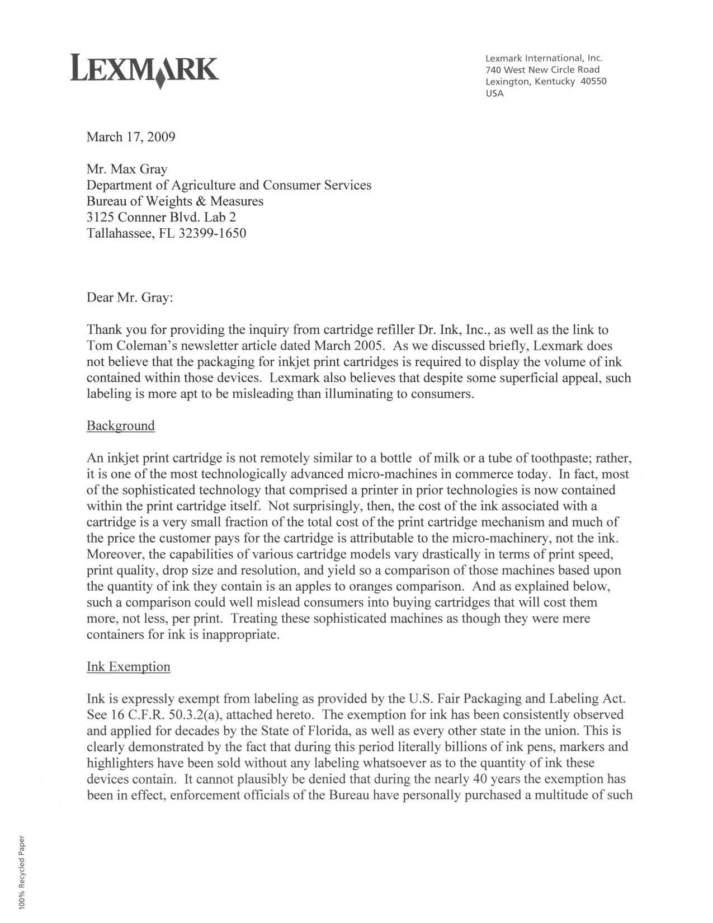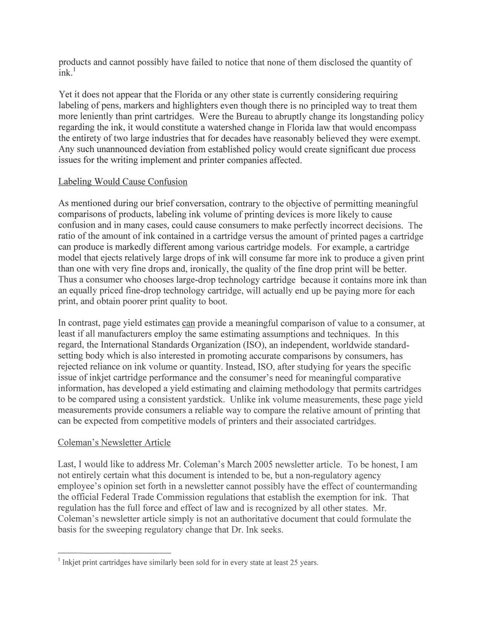
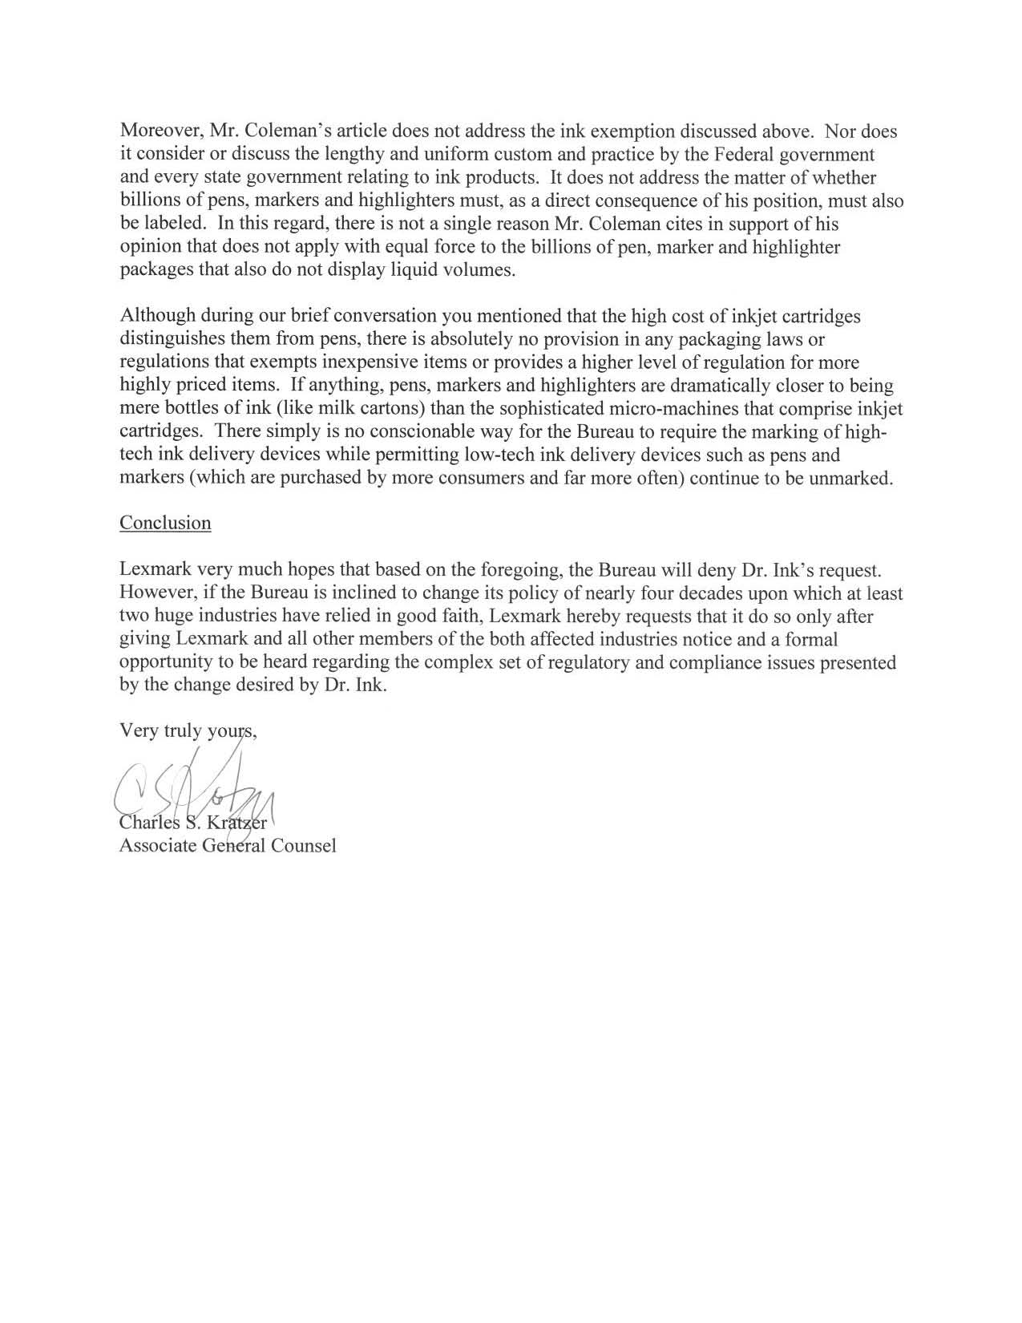
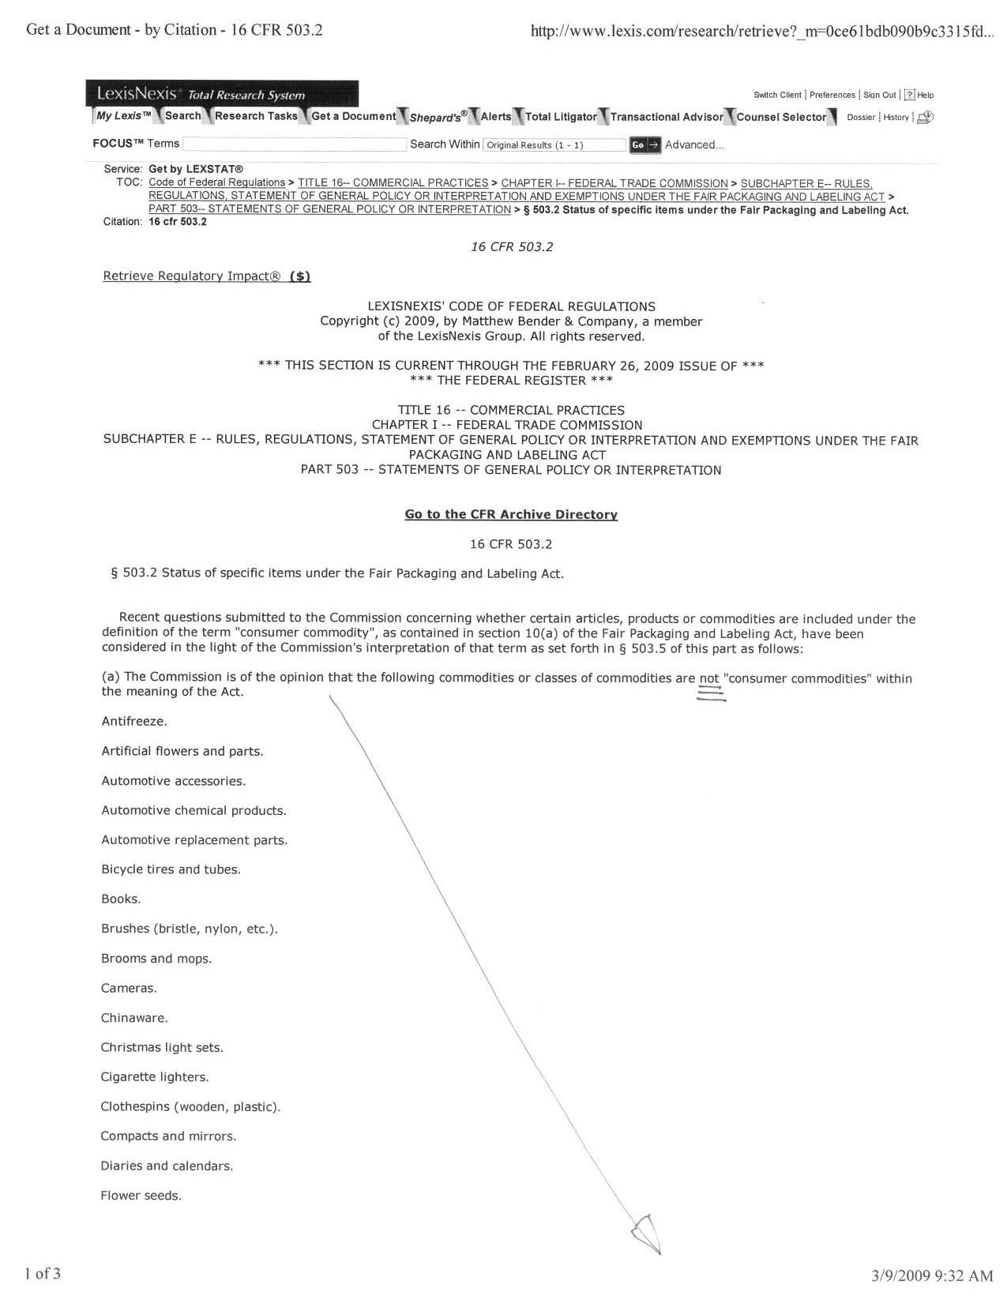
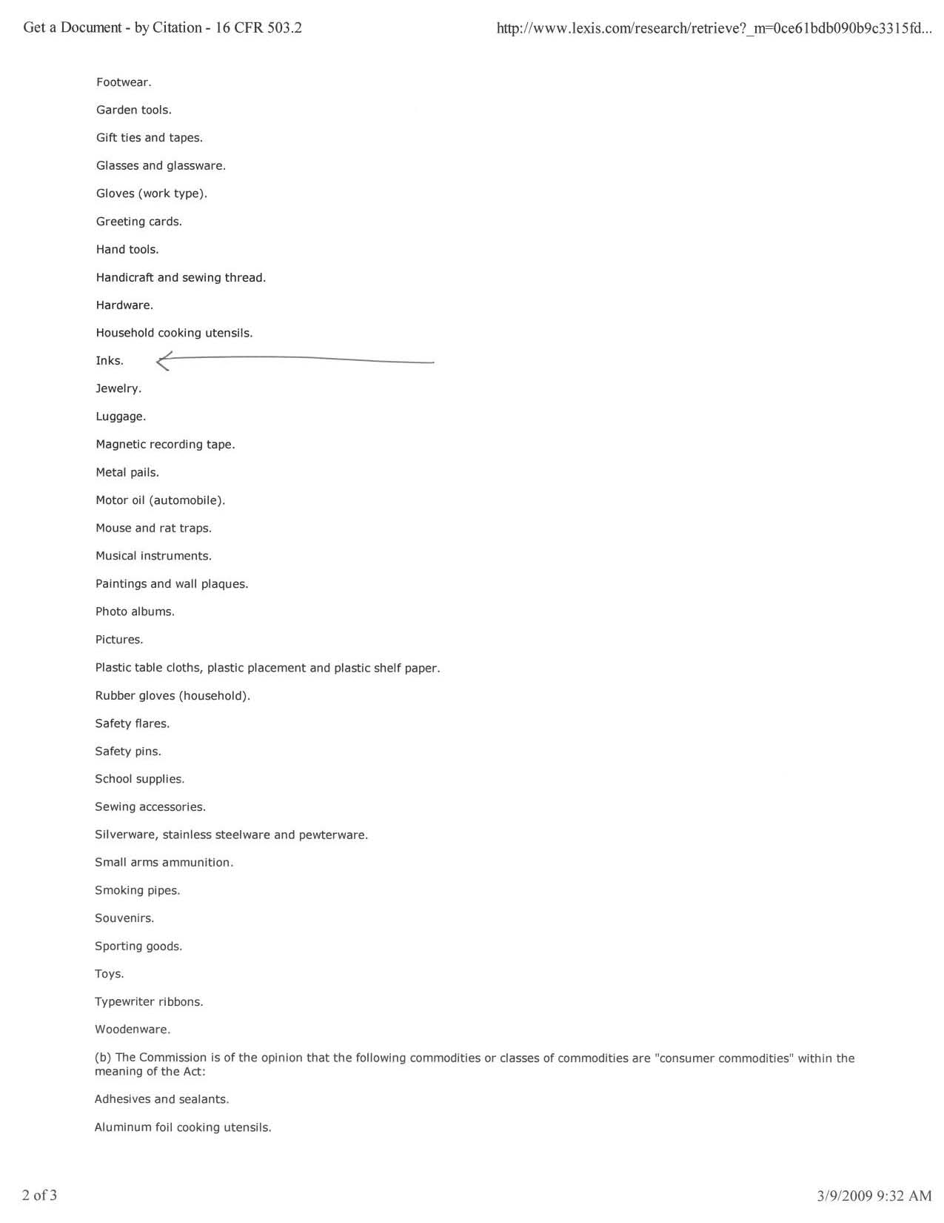

(Position Provided by NIST WMD February 2005)

Due to the discussion of inkjet cartridges, over the NIST W&M list server, WMD has investigated this situation. WMD concludes that inkjet cartridges need a net quantity statement in liquid measure to comply with Handbook 130 requirements. Our analysis is below and further discussion is welcomed.

Inkjet and Printer Cartridge Considerations
The model weights and measures law contains several relevant sections that apply to ink cartridges.

Weights and Measures Law, Section 19. “Information Required on Packages:”
Except as otherwise provided in this Act or by regulations promulgated pursuant thereto, any package, whether a random package or a standard package, kept for the purpose of sale, or offered or exposed for sale, shall bear on the outside of the package a definite, plain, and conspicuous declaration of:
- the identity of the commodity in the package;
- the quantity of contents in terms of weight, measure, or count;
- the name and place of business of the manufacturer, packer, or distributor, in the case of any package kept, offered, or exposed for sale, or sold in any other place other than on the premises where packed.
Weights and Measures Law, Section 17. “Method of Sale:”
The method of sale shall provide accurate and adequate quantity information that permits the buyer to make price and quantity comparisons, except as provided by established trade custom and practice. While trade custom and practice is a consideration in some instances… the burden to provide “accurate quantity information” by means of a designated “method of sale” is the responsibility of the manufacturer.
Count alone does not fulfill this requirement.
A declaration of quantity in terms of count shall be combined with appropriate declarations of the weight, measure, and size of the individual units unless a declaration of count is fully informative.
Packaging and Labeling Regulation, Section 6.4. – “Terms:” If there exists a firmly established general consumer usage and trade custom with respect to the terms used in expressing a declaration of quantity of a particular commodity, such declaration of quantity may be expressed in its traditional terms, provided such traditional declaration gives accurate and adequate information as to the quantity of the commodity. Any net content statement that does not permit price and quantity comparisons is forbidden.
Weights and Measures Law, Section 15. – “Misrepresentation of Quantity:” No person shall represent the quantity in any manner calculated or tending to mislead or in any way deceive another person. If “accurate quantity information” is not provided, consumers are certainly being mislead or deceived and cannot possibly make price and quantity comparisons.
The Federal Trade Commission (FTC) has informed us that the following commodities (partial list only - similar products) are excluded from FTC jurisdiction.
Ink
Fountain Pens
Kindred Products (ball point pens, lead pencils, lead refills, etc.)
School Supplies
Stationery and Writing Supplies
Typewriter Ribbon
Printer Cartridges*
*While printer cartridges are not listed specifically in Handbook 130, FTC has indicated to NIST that commodities of this nature do not fall under their jurisdiction.
Metric “Only” Labeling:
Since the labeling of printer ink cartridges fall under state labeling regulations, dual unit labeling is not required. Hence, these packages may be labeled in only metric units.
Packaging and Labeling Regulation, Section 11.33. “Inch-Pound Units, Exceptions – Consumer Commodities:”
The requirements for statements of quantity in inch-pound units shall not apply to packages that bear appropriate International System of Units (SI). This exception does not apply to foods, drugs, or cosmetics or to packages subject to regulation by the FTC, meat and poultry products subject to the Federal Meat or Poultry Products Inspection Acts, and tobacco or tobacco products.
NIST Handbook 133, “Checking the Net Content of Packaged Goods,” Fourth Edition, January 2005 – Product Testing:
NIST Handbook 133 has been prepared as a procedural guide for compliance testing of net content statements on packaged goods. The gravimetric test method (outlined in Chapter 2) uses weight measurement to determine the net quantity of contents of packaged goods. The handbook provides general test methods to determine the net quantity of contents of packages labeled in terms of weight and special test methods for packages labeled in terms of fluid measure or count. Gravimetric testing is the preferred method of test for products, such as inkjet and other types of printer cartridges. Therefore, the test method to verify the net contents of ink in printer cartridges exists. However, NIST recognizes the difficulties associated with determining the net content of these cartridges, such as, density determination, product cost, tare verification (cartridge), the cleaning of tare and standards, and finally, inspection lot size. Unless the products are checked at the plant or warehouse, it may be difficult to find a sufficient “retail” lot, adequate in size to obtain an appropriate sample.

G.J. Neville
Design & Development Company
812-B Lincoln Boulevard, Dillon Court Alley Entrance
Venice, California 90291
Tel: 310-795-4301
E-mail: gjneville@verizon.net

January 21, 2010

Attn: Mr. Don Onwiler, Executive Director
National Committee on Weights and Measures
1135- “M” Street, Ste. 110
Lincoln, NE 68508
Sent by E-mail: info@ncwm.net

Re: Citizen comment on
270-9 HB 130- Uniform Regulation for Method of Sale of Commodities—Packaged Ink and Toner Cartridges

Dear Mr. Onwiler:

On 01-19-10 I spoke with Ms. Lisa Warfield this morning and she directed me to certain print sources pertaining to the upcoming NCWM meetings, including the subject of Packaged Printer Ink and Toner Cartridges. Furthermore, she recommended I might speak with Mr. Ed Williams in Sacramento regarding these anecdotal experiences and observations.

I then spoke with Mr. Williams and he felt I should direct the following commentary to you for possible inclusion as citizen input in your upcoming committee meeting report.

I don’t do this much and I have a propensity for HOT AIR…hope this isn’t too bad.
_______________________

After having done my homework by reading Publication #15, Item 270-9, I shall first respond to certain comments made in Lexmark’s Fox in the Henhouse letter to Mr. Max Gray, dated, March 17, 2009 supporting the current ISO-developed standard for Toner-Ink measurement methodology; then offer a personal experience to illustrate the current standard’s shortcomings; then a few observations and unsolicited recommendations; and lastly, a closing comment on the need for furthering a new design paradigm and how your NCWM Conference can do something about it!

Item 1 -- It is irrelevant that the Ink/Toner component is a small part of the overall cost of a new or replacement cartridge—what matters is that the ink/Toner requires a costly and complex cartridge container for delivery. THEY ACT AS A UNIT! Lexmark’s implication that the relatively low cost of the Ink/Toner alone renders proper regulatory scrutiny unnecessary is totally spurious.

In fact, the opposite is true—the Ink/Toner and Cartridge combination is an EXTREMELY EXPENSIVE Ink/Toner Delivery System because Content and Container act as a unit which, furthermore, is uniquely designed (with certain patent protection) to fit the corresponding printer model(s). Whether an OEM or lower-priced Name Brand cartridge, the Unit is surprisingly expensive!

Items 2, 3 --Re standards for Page Yield and current ISO solutions—“yield estimating and claiming methodology that permits cartridges to be compared using a consistent yardstick”:
G.J. Neville
Design & Development Company
812-B Lincoln Boulevard, Dillon Court Alley Entrance
Venice, California 90291
Tel: 310-795-4301
E-mail: gjneville@verizon.net

My layman’s opinion is that the “consistent yardstick” approach alone is inadequate. It prevents quantification of the contents—the essential ingredient inside the cartridge. Why not require the OEM Ink/Toner Cartridge/Printer industry to comply with freshly conceived DESIGN CRITERIA with at least one goal being to provide the consumer with a simple, yet accurate “back-up indicator” of a cartridge’s actual toner content?

Personal observations:
The purpose of the foregoing recommendation would be to empower the consumer with a GUARANTEE for DELIVERY of the ENTIRETY of the purchased Ink/Toner.

This approach is meant only to supplement, not replace, the simpler, more convenient ISO-approved Page Count approach. The secondary consumer benefit would be to eliminate the “wiggle room”-based dealer responses to Ink/Toner shortage customer complaints as not many consumers are inclined to pry toner cartridges apart or properly argue issues of equity in the event of suspected shortages.

Whether by software revisions or hardware re-design, mandated new performance-based criteria can provide the consumer with a long-overdue checks-and-balances Tool to level the manufacturers’ playing fields.

Solutions can take many forms—whether alpha-numerics via existing LCD windows or by color bar chart display graphics or even by adoption of primitive “clear plastic” toner cartridges. At the very least, the consumer would then have some kind of needed VERIFICATION TOOL.

Naturally, Lexmark’s letter to Mr. Gray fails to address any constructive new solutions as none were previously required by any regulatory agency. To illustrate the need for the foregoing, consider my particular frustration which occurred because of the absence of a Verification Tool:

My personal experience (Haven’t we all had them?):
The following sequence occurred in my design office. We purchase Brother or Staples TN-350 Toner Cartridges for my Brother MFC 7420 desktop laser printer (purchased several years ago), which has generally been lightly used (average 3-15 copies daily) since purchase:

EVENTS IN MY OFFICE:

- Periodically, the printer shuts down and will not print any longer…until a replacement Toner Cartridge is purchased and inserted into the printer!
NOTE:
  - No easily noticeable, if any, Print Counter capability on the cartridge or the printer. The Toner Cartridge is a proverbial “Black Box”.
  - Printer shutdown appears to occur SIGNIFICANTLY BEFORE the estimated 2500 pages of usage.
  - No warning whatsoever of the pending total shutdown , i.e. printing quality drop-off or fade-out.
  - All printed copies 100% perfect prior to shutdown.

- Printer LCD Display Message then appears, saying something like “Out of Toner” or “Replace Toner Cartridge”

G.J. Neville
Design & Development Company
812-B Lincoln Boulevard, Dillon Court Alley Entrance
Venice, California 90291
Tel: 310-795-4301
E-mail: gjneville@verizon.net

- Printer cannot be cajoled into operating again without a new replacement cartridge, i.e. pushing the rocker switch to OFF, waiting 30 seconds, then back to ON; rocking toner cartridge; sliding the corona wire; etc.

EVENTS FOLLOWING AT THE STORE:
- I take “suspect” cartridge to office supply dealer (where I purchased the printer, cartridges and all office supplies). A question and complaint is planned prior to purchasing a new replacement cartridge.
- The Store Manager recites the manufacturer’s mantra about the difficulty of estimating toner consumption, varying printed text/page densities, etc.
- I then suggest we investigate the circumstances together—we remove End Cap from cartridge and….guess what….a SIGNIFICANT amount of toner spills out!
- The Store Manager then claims “Equipment Malfunction” may be responsible–did I purchase a Warranty? Ultimately, he reluctantly offered me a new replacement cartridge at half-price—but it was like pulling teeth from a donkey!.

EPILOGUE:
Was I satisfied? Yes and No

- Yes, because of the Manager’s offer--I didn’t feel like a total idiot.
- No, because of the repair disruption and the waste of my time.
- No, because of my uncertainty of a future repeat experience.
- No, because of the lack of final problem resolution—was the printer the real culprit or was it a batch of poorly designed Ink/Toner cartridges? Without the benefit of a built-in Diagnostic or Verification Tool(s)--either answer might be wrong. Will I, in the future, prematurely purchase again one or both of this manufacturer’s products?

To avoid that risk of becoming a true idiot (the second time burn), will I switch manufacturers to avoid that possibility?

- Probably yes. What a shame, because otherwise, the printer offers excellent value!

Final Thoughts/Conclusions:
The cartridge Page Yield Estimate, purportedly reflecting quantity of content, provides inadequate consumer protection without at least one additional design feature (in mechanism or software) to deliver to, and assure, consumer of full usage of the cartridge’s Ink/Toner contents.

Should not better Consumers Protection apply to the design of COMPLEX or PERMANENTLY SEALED CONTAINERS (i.e. Ink/Toner Cartridges)? These devices, during design, should trigger design compliance with additional new standards and regulations, generated by the appropriate agency, to assure the customer of:
- Quantity of container’s Contents
- Delivery of Entirety of Contents, as is practical.
- Provide consumer with a Print Count or Ink/Toner quantity verification tool, (on Cartridge or Printer Display Screen) as offered in larger printers.

G.J. Neville
Design & Development Company
812-B Lincoln Boulevard, Dillon Court Alley Entrance
Venice, California 90291
Tel: 310-795-4301
E-mail: gjneville@verizon.net

WHICH COMPARISON IS MORE APT?
Consider the comparison of a sophisticated, complex, injection-molded Ink/Toner Cartridge vs. an old-fashioned Burlap Bag for Grain or Paper Bag for Cement, where measurement can be easily confirmed because of the container’s scale, flexibility and negligible weight --after all, it’s just a BAG!

Now consider the same Toner Cartridge vs. a craftily-designed rigid Magician’s Box with a false bottom (designed by the Magician or Manufacturer), which by accident or design, conceals a portion (i.e.30%) of the grain--which remains unused and ultimately is then unknowingly discarded by the Consumer. Is that right?

Throughout history, did not the science of measurements ultimately evolve in most every society so as to identify and prevent the proliferation of deceptive and/or irregular measurement practices (whether for government tax gain or for the public’s protection)?

So Why Not Now?

EXAMPLE OFTHE NEW PARADIGM--REFILL THE REFILL:
The job of providing “replacement toner” could be done just as well with a Refill-the-Refill design. An affordable, small, lightweight, saltshaker-sized, two-ounce $3.00 Ink/Toner refill snap-on module or squeeze-dispenser bottle enabling a customer to conveniently refill an empty toner cartridge (purchased in $18.00 six-packs instead of buying one $50.00 traditional cartridge on six separate trip occasions). When do we “outlaw” UNAFFORDABLE, LARGE, HEAVY, PACKAGED, PALLETED and TRANSPORTED cartridges produced and sold in the usual way?

A side-by-side Energy Audit of the two approaches would indicate at least NINE BILLION DOLLARS OF WASTE and FAR MORE IN UNNECESSARY ENERGY COSTS in the ten billion dollars per year Ink/Toner Cartridge !ndustry. Did I read ten billion somewhere?

In closing, the Ink/Toner cartridge is only one of countless ethically-challenged manufactured products cluttering and consuming our environment. My experience, though very minor in the big scheme of things, again illustrates the range of social and environmental losses resulting from the current license manufacturers often have to legally harvest unearned profits and waste substantial energy in the process of producing these small-scale consumer products. The public suffers.

Respectfully,

Gary J. Neville

cc: Lisa Warfield,
Ed Williams

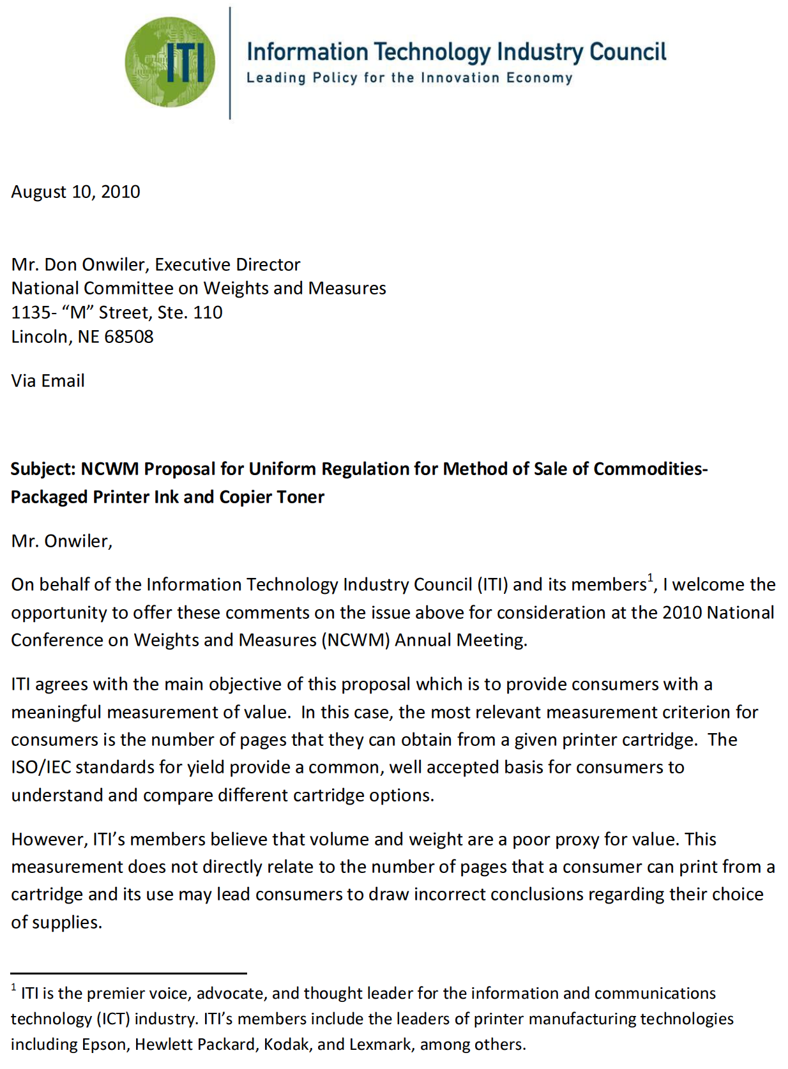
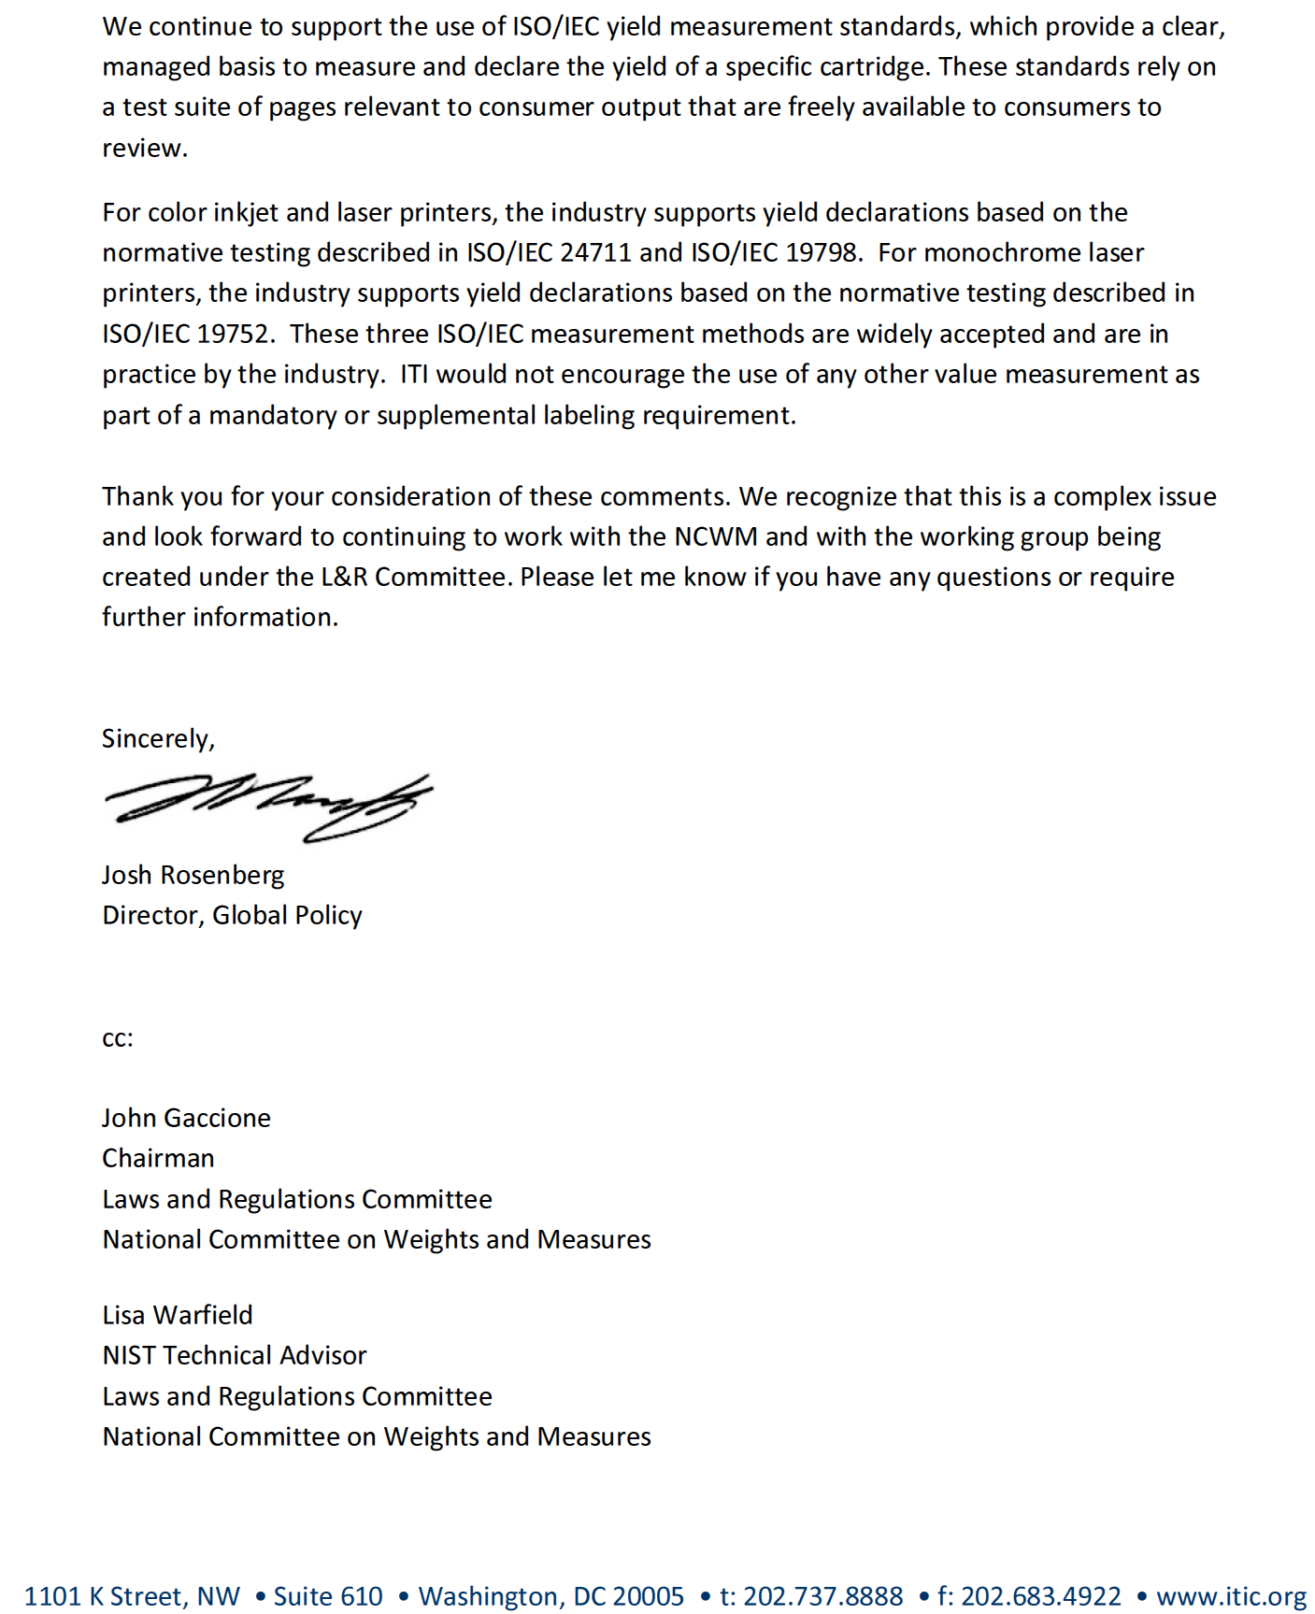

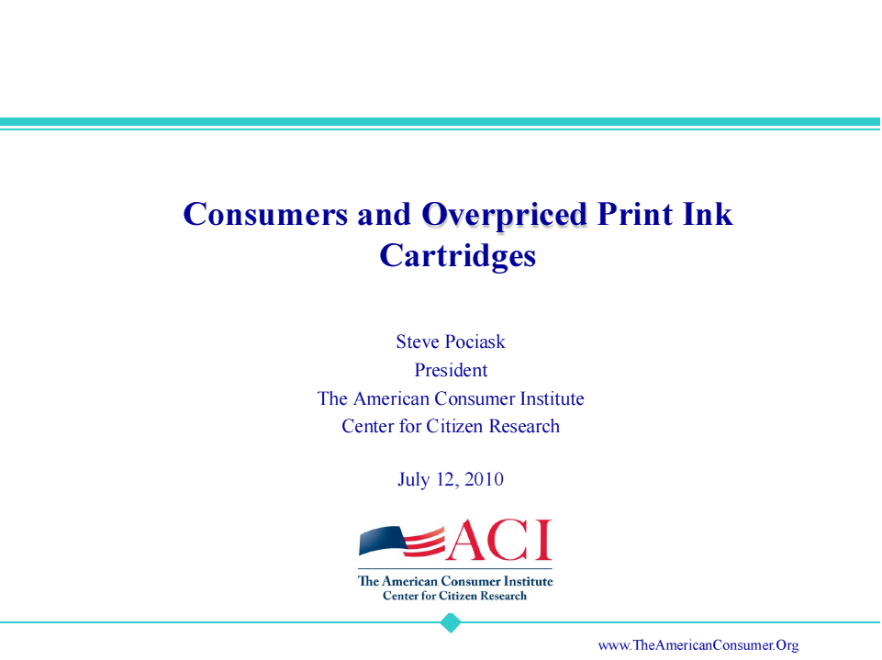
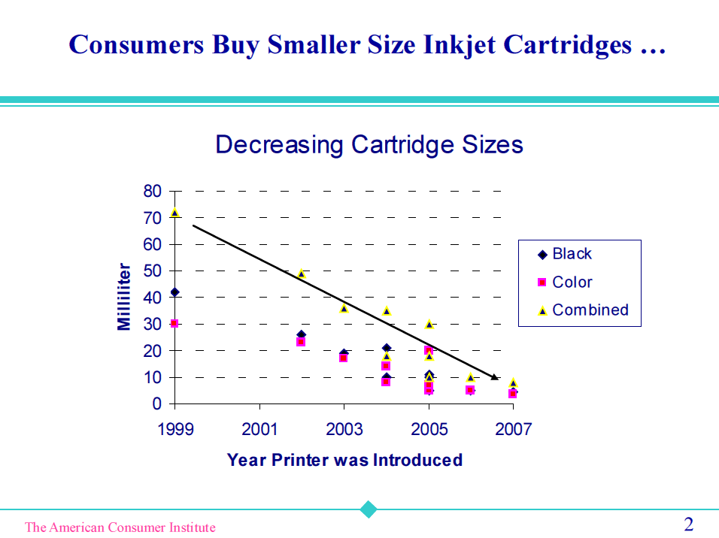
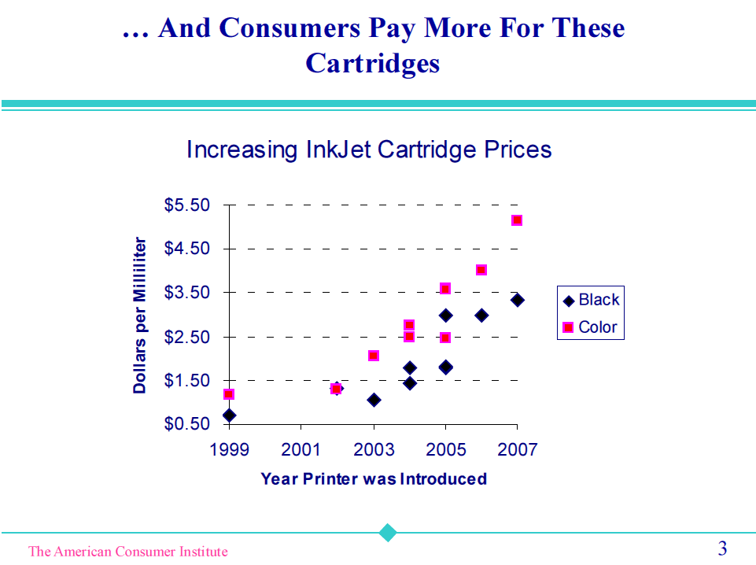
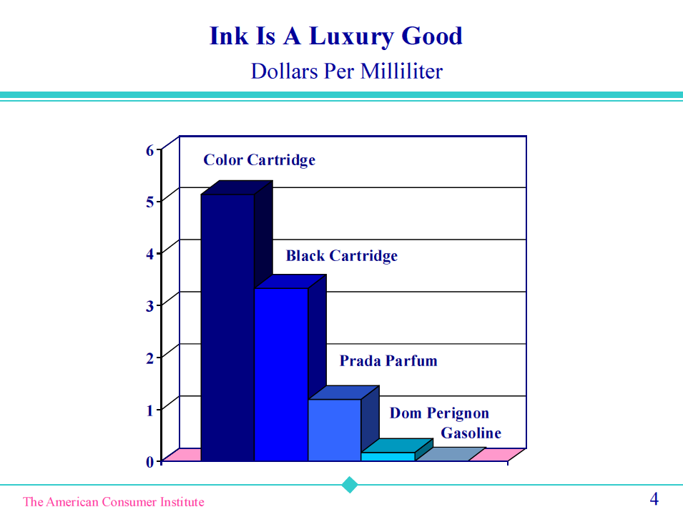
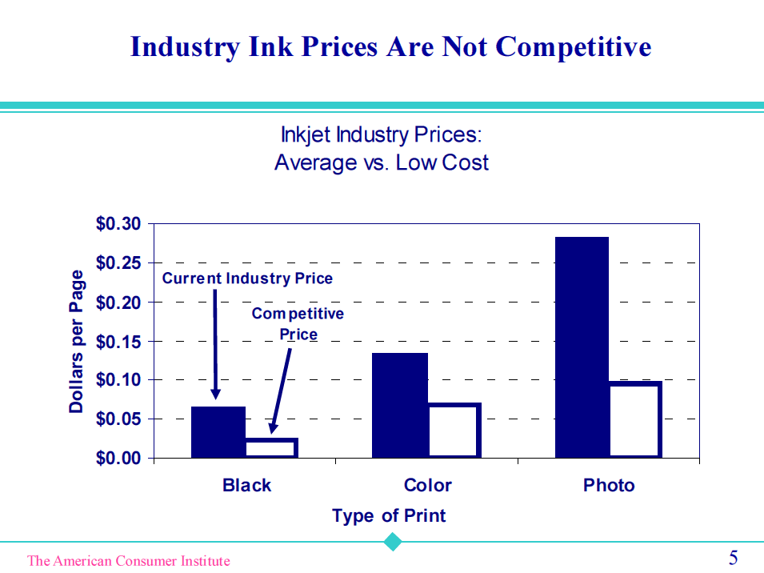
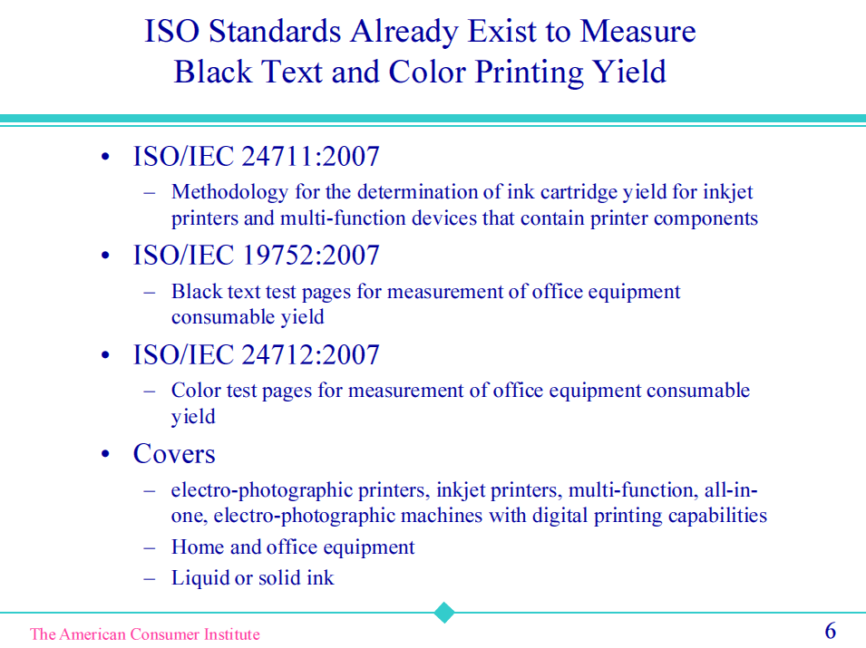
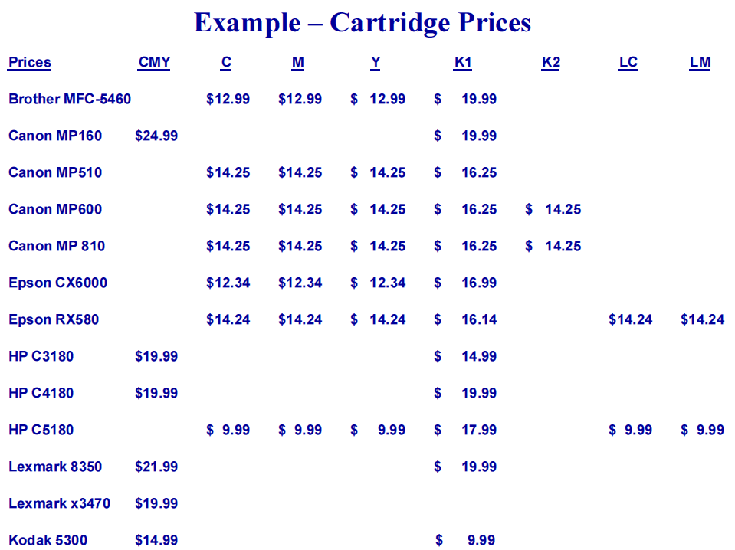
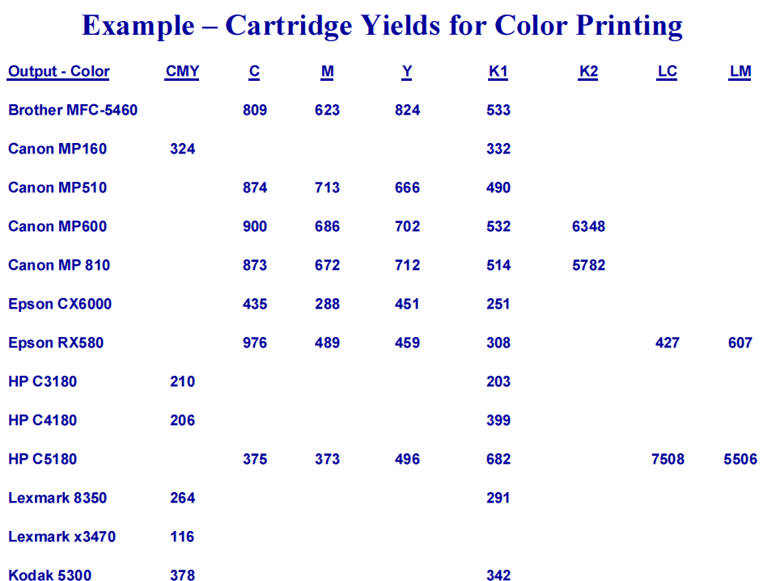
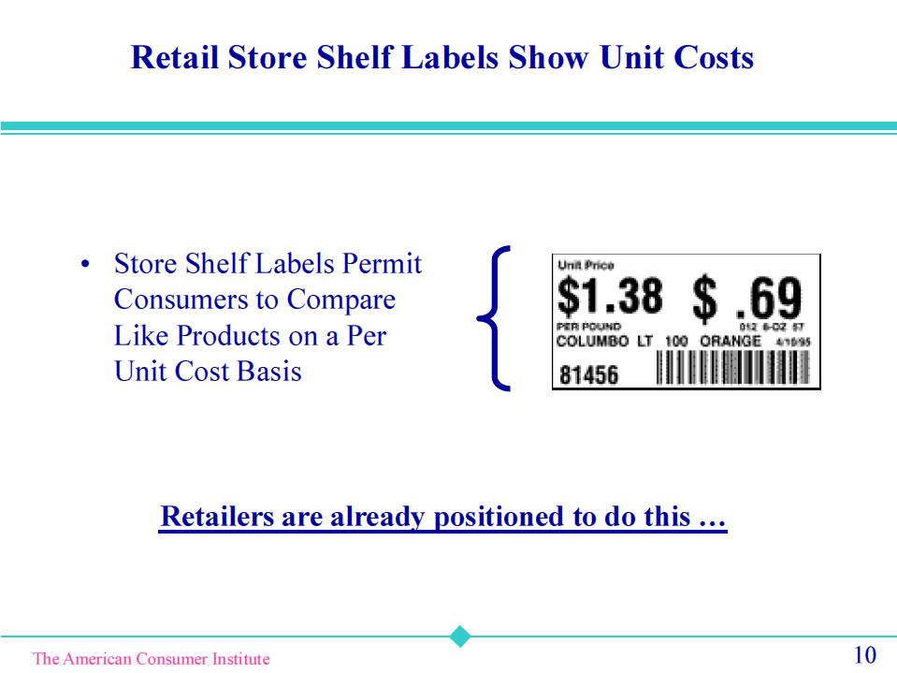
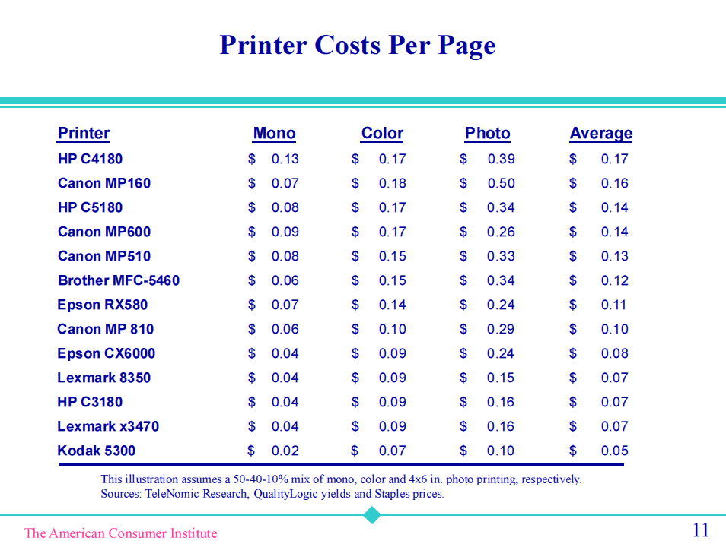
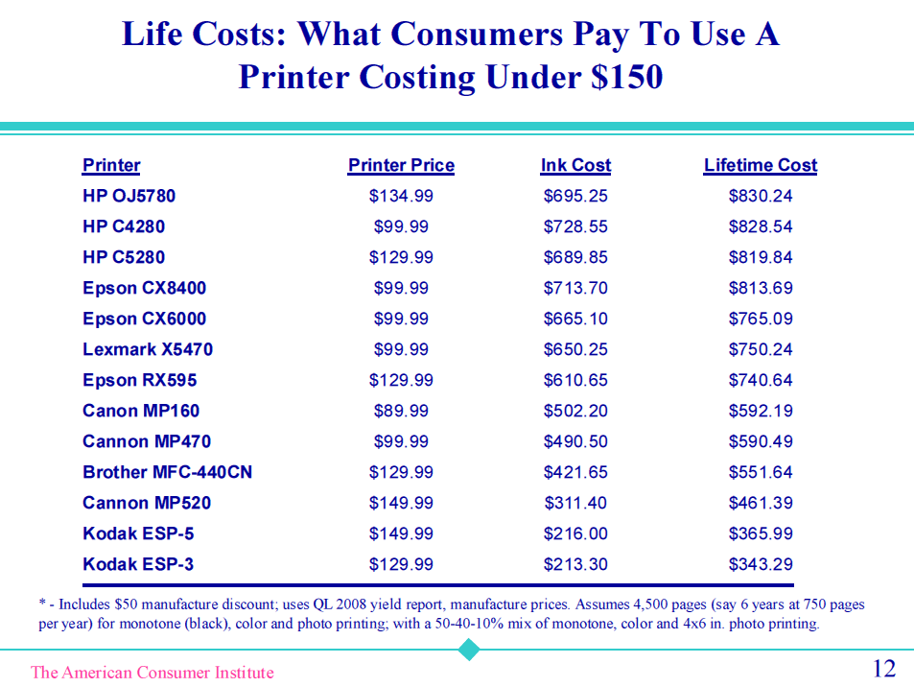
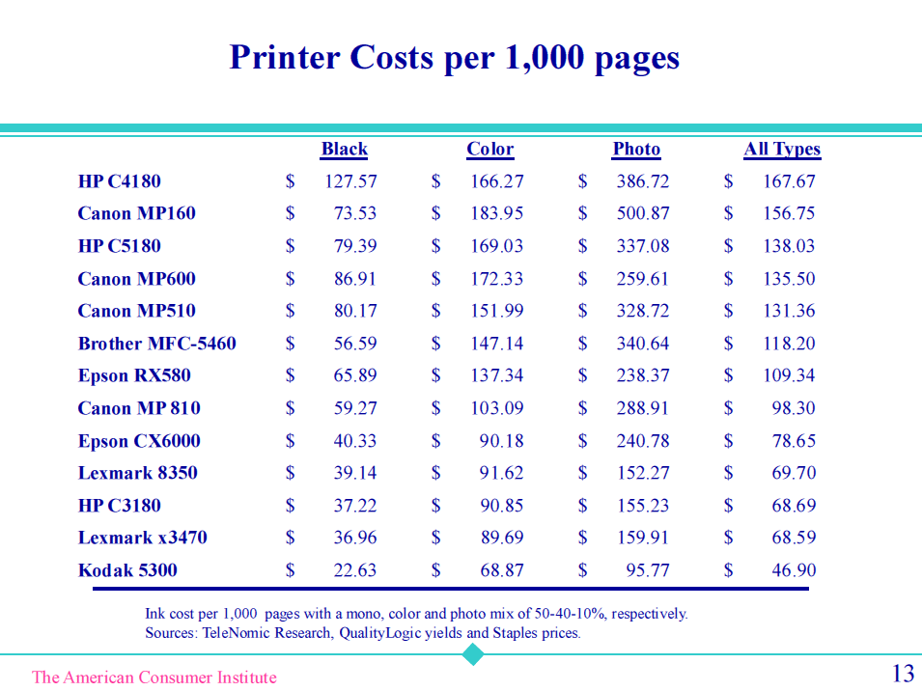
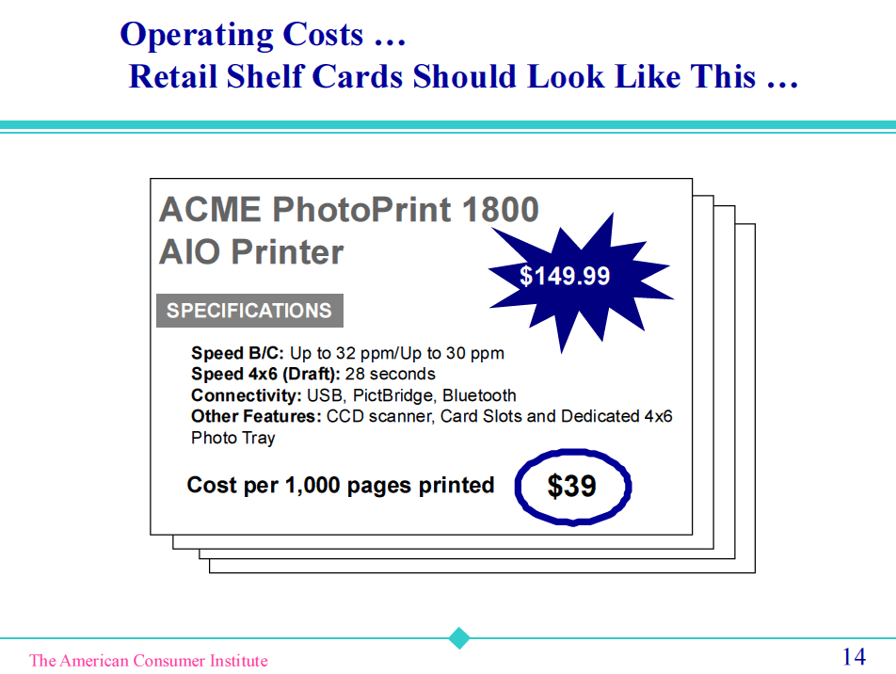
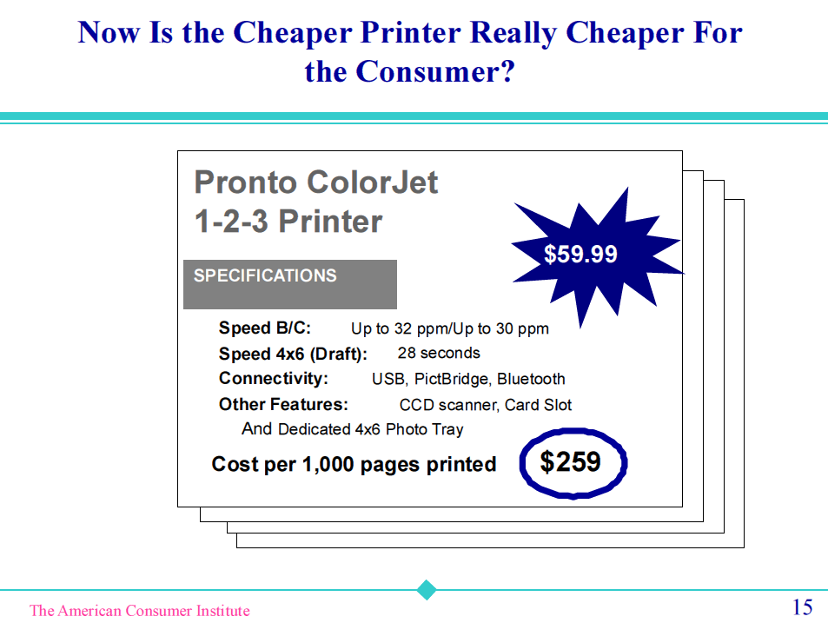
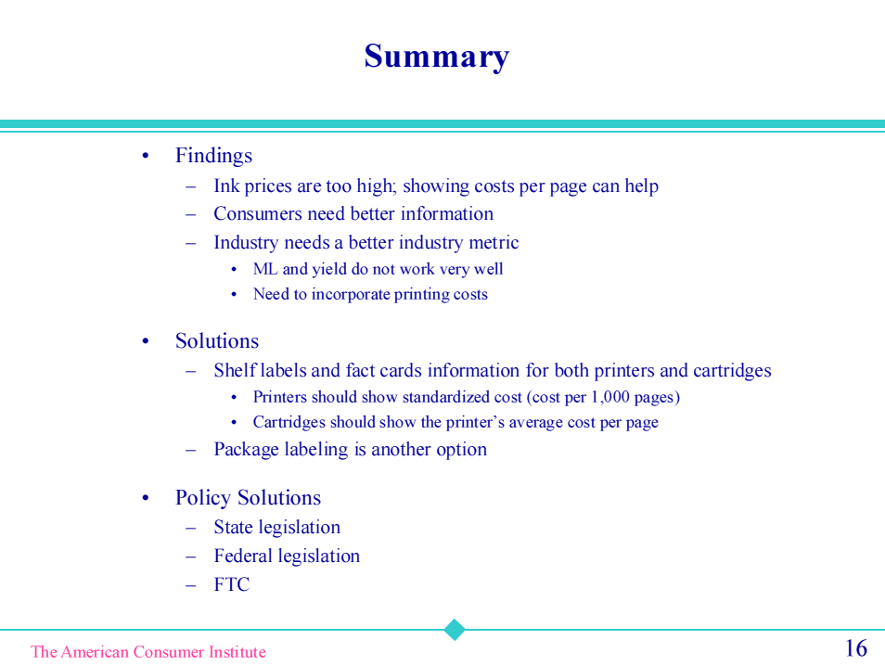

THIS PAGE INTENTIONALLY LEFT BLANK

