Report of the
Laws and Regulations (L&R) Committee
Mr. Ethan Bogren, Committee Chair
Westchester County, New York

2000 Introduction
This is the report of the Laws and Regulations (L&R) Committee (hereinafter referred to as the “Committee”) for the 102nd Annual Meeting of the National Conference on Weights and Measures (NCWM). This report is based on the Interim Report offered in the NCWM Publication 16, “Committee Reports,” testimony at public hearings, comments received from the regional weights and measures associations and other parties, the addendum sheets issued at the Annual Meeting, and actions taken by membership at the voting session of the Annual Meeting. The voting items shown below were adopted as presented when this report was approved. This report contains those recommendations to amend National Institute of Standards and Technology (NIST) Handbook 130 (2017), “Uniform Laws and Regulations in the Areas of Legal Metrology and Engine Fuel Quality,” or NIST Handbook 133 (2017), “Checking the Net Contents of Packaged Goods.”
Table A identifies the agenda and appendix items by reference key, title of item, page number and the appendices by appendix designations. The acronyms for organizations and technical terms used throughout the agenda are identified in Table B. The first four digits of the Reference Key Numbers of the items are assigned from the Subject Series List. The status of each item contained in the report is designated as one of the following: (D) Developing Item: the Committee determined the item has merit; however, the item was returned to the submitter or other designated party for further development before any action can be taken at the national level; (I) Informational Item: the item is under consideration by the Committee but not proposed for Voting; (V) Voting Item: the Committee is making recommendations requiring a vote by the active members of NCWM; (W) Withdrawn Item: the item has been removed from consideration by the Committee.
Table C provides a summary of the results of the voting on the Committee’s items and the report in its entirety. Some Voting Items are considered individually; others may be grouped in a consent calendar. Consent calendar items are Voting Items that the Committee has assembled as a single Voting Item during their deliberation after the Open Hearings on the assumption that the items are without opposition and will not require discussion. The Voting Items that have been grouped into consent calendar items will be listed on the addendum sheets. Prior to adoption of the consent calendar, the Committee entertains any requests from the floor to remove specific items from the consent calendar to be discussed and voted upon individually.
Proposed revisions to the handbook(s) are shown as follows. 1) deleted language is indicated with a bold face font using strikeouts (e.g., this report), and 2) proposed new language is indicated with an underscore bold faced font (e.g., new items). When used in this report the term “weight” means “mass.”
Note: The policy of NIST is to use metric units of measurement in all its publications; however, recommendations received by NCWM technical committees and regional weights and measures associations have been printed in this publication as submitted. Therefore, the report may contain references to U.S. customary units.
Subject Series List
Introduction 2000 Series
NIST Handbook 130 – General 2100 Series
Uniform Laws 2200 Series
Uniform Weights and Measures Law 2201 Series
Uniform Weighmaster Law 2202 Series
Uniform Engine Fuels and Automotive Lubricants Inspection Law 2203 Series
Uniform Regulations 2300 Series
Uniform Packaging and Labeling Regulation 2301 Series
Uniform Regulation for the Method of Sale of Commodities 2302 Series
Uniform Unit Pricing Regulation 2303 Series
Uniform Regulation for the Voluntary Registration of Servicepersons and Service Agencies for Commercial Weighing and Measuring Devices 2304 Series
Uniform Open Dating Regulation 2305 Series
Uniform Regulation for National Type Evaluation 2306 Series
Uniform Engine Fuels and Automotive Lubricants Regulation 2307 Series
Examination Procedure for Price Verification 2400 Series
NCWM Policy, Interpretations, and Guidelines 2500 Series
NIST Handbook 133 2600 Series
Other Items 2700 Series

Table A
Table of Contents
Reference Key | Title of Item | L&R Page
2000 Introduction 1
2301 nist HANDBOOK 130 – UNIFORM packaging and Labeling REgulation 6

2301-1 W Section 11. Exemptions, 11.XX. Multi-unit Fresh Fruit and Vegetable Packages. 6
2302 nist HANDBOOK 130 – UNIFORM REGULATION FOR THE METHOD OF SALE COMMODITIES 9

2302-1 V Section 1. Food Products and Section 2. Non-Food Products 9

2302-2 V Section 1.12. Ready-to-Eat Food 13

2302-3 W Section 1.12. Ready-to-Eat Food 18

2302-4 W Section 1.7.X. Bulk Ice Cream and Similar Frozen Products 21

2302-5 Section 2.13. Polyethylene Products 22

2302-6 V Section 2.17. Precious Metals 26

2302-7 I Section 2.20. Gasoline – Oxygenate Blends and Section 2.30. Ethanol Flex-Fuel (See related Item 2307-2) 31

2302-8 V Section 2.23. Animal Bedding 35

2302-9 V Section 2.36. Transmission Fluid (See Related Item 2307-1) 37

2302-10 W Section 2.XX. Agricultural Vending 42

2302-11 D Electric Watthour 45
2307 nist HANDBOOK 130 – UNIFORM ENGINE FUELS AND AUTOMOTIVE LUBRICANTS REGULATION 47

2307-1 V Section 2.14. Products for Use in Lubricating Automatic Transmission Fluids and
Section 3.14. Automatic Transmission Fluid (See Related Item 2302-9) 47

2307-2 I Section 3.28. Ethanol Flex Fuel and Section 3.8. Ethanol Flex Fuel (See related
Item 2302-7) 53

2307-3 I Section 4.1. Water in Retail Engine Fuel Storage Tanks, Gasoline Alcohol Blends,
Biodiesel Blends, Ethanol Flex Fuel, Aviation Gasoline, and Aviation Turbine Fuel, and Section 4.2. Water in Gasoline, Diesel, Gasoline-Ether, and Other Fuels. 57

2307-4 W Section 4.3. Dispenser Filters 59
2500 NCWM Policy, Interpretations, and Guidelines 62

2500-1 V Sections 2.1.1. Weight(s) and/or Measure(s)., 2.1.2. Weight(s) and/or Measure(s), 2.1.3. Definition of Net Weight., 2.2.1. Gift Packages., 2.2.2. Sand., 2.2.3. Sold by ⁴/₅ Bushel., 2.2.5. Lot, Shipment, or Delivery., 2.2.6. Aerosols and Similar Pressurized Containers., 2.2.7. Aerosol Packaged Products., 2.2.8. Variety and Combination Packages., 2.2.9. Textile Products., 2.2.10. Yarn., 2.2.11. Tint Base Paint., 2.2.12. Reference Temperature for Refrigerated Products: When a Product is Required to be Maintained under Refrigeration, 2.3.9. Fireplace Logs., 2.3.11. Packaged Foods or Cosmetics Sold from Vending Machines., 2.3.12. Movie Films, Tapes, Cassettes 62
2600 Handbook 133 75

2600-1 V Section 1.2.1. Inspection Lots and Section 3.10. Mulch and Soils Labeled by Volume 75

2600-2 W Section 1.2.3. Individual Package Requirement 83

2600-3 D Recognize the Use of Digital Density Meters 85

2600-4 V Section 4.5 Polyethylene Sheeting, BAGS, and Liners 87

2600-5 W Table 2-12. Upper and Lower MAV Limits for Fish and Fishery Products Labeled with a Count 94
2700 OTHER ITEMS 98

2700-1 D Fuels and Lubricants Subcommittee 98

2700-2 D Packaging and Labeling Subcommittee 100

2700-3 W NIST Handbook 158, “Field Sampling Procedures for Fuel and Motor Oil Quality Testing” 101
Appendix A Item: 2700-3, NIST Handbook 158 “Field Sampling Procedures for Fuel and Motor Oil Quality Testing” A1
Appendix B Item 2301-1: NIST Handbook 130 – Uniform Packaging and Labeling Regulation B1

Table B
Glossary of Acronyms and Terms

Acronym | Term | Acronym | Term
AKI | Minimum Antiknock Index | MAV | Maximum Allowable Variation
API | American Petroleum Institute | MPFS | Meat, Poultry, Fish, and Seafood
ASTM | ASTM International | OEM | Original Equipment Manufacturer
CFR | Code of Federal Regulations | NCWM | National Conference on Weights and Measures
CNG | Compressed Natural Gas | NEWMA | Northeastern Weights and Measures Association
CWMA | Central Weights and Measures Association | NIST | National Institute of Standards and Technology
FALS | Fuels and Lubricants Subcommittee | OWM | Office of Weights and Measures
FDA | Food and Drug Administration | PALS | Packaging and Labeling Subcommittee
FPLA | Fair Packaging and Labeling Act | PITI | Product Traceability Initiative
FTC | Federal Trade Commission | S&T | Specifications and Tolerances
HB | Handbook | SAE | Society of Automotive Engineers
IRQ | Identity, responsibility, and quantity | SWMA | Southern Weights and Measures
FG | Focus Group | TG | Task Group
JASO | Japanese Automotive Standards Organization | UPLR | Uniform Packaging and Labeling Regulation
L&R | Laws and Regulations | USNWG | U.S. National Work Group
LNG | Liquefied Natural Gas | WWMA | Western Weights and Measures Association

Table C
Voting Results

Reference Key Number | House of State Representatives |  |  | House of Delegates |  | Results
Reference Key Number | Yeas | Nays |  | Yeas | Nays | Results
Consent Calendar
2302-8 | 37 |  | 0 | 61 | 0 | Adopted
2302-9 |  |  |  |  |  | Adopted
2307-1 |  |  |  |  |  | Adopted
2500-1 |  |  |  |  |  | Adopted
2302-2 | 30 |  | 6 | 52 | 9 | Adopted
2302-6 | 33 |  | 5 | 51 | 8 | Adopted
2600-1 | 29 |  | 7 | 44 | 14 | Adopted
2600-4 | 37 |  | 0 | 57 | 1 | Adopted
2302-1 | 15 |  | 21 | 31 | 30 | Returned to Committee
2302-7 & 2307-2  To amend | No Vote |  |  |  |  | Committee moved to Informational Status
To Accept the Report | Voice Vote |  |  |  |  | Adopted
*Items 2302-7 and 2307-2 were voted upon as a block.

Details of All Items
(In order by Reference Key)

2301 nist HANDBOOK 130 – UNIFORM packaging and Labeling REgulation

2301-1 W Section 11. Exemptions, 11.XX. Multi-unit Fresh Fruit and Vegetable Packages.
(This item was Withdrawn.)
Source:
Counties of Monterey and Ventura, California (2017)
Purpose:
To eliminate the total quantity of the multi-unit package and “bags or counts” for non-consumer packages.
Item under Consideration:
Amend NIST Handbook 130, Uniform Packaging and Labeling Regulation as follows:
11.XX. Multi-unit Fresh Fruit and Vegetable Packages. – A multi-unit, non-consumer package of fresh fruits and vegetables bearing (a) the number of the individual units and (b) the quantity of each individual unit are exempt from 10.4.(c) declaration of the total quantity of the contents of the multi-unit package.
Background/Discussion:
This will allow for the UPLR to be identical to FDA’s preemptive regulation on multi-unit retail packages in 21 CFR 101.105(s).
Growers and producers are using a Product Traceability Initiative (PTI) sticker (2016 Food Safety Modernization Act requirement – www.fda.gov/Food/GuidanceRegulation/FSMA/default.htm) that also doubles for identity, responsibility, and quantity (IRQ) requirements. Producers are no longer putting all multi-unit requirements from HB 130, Section 10.4. Multi-unit Packages (omitting term “bag or counts” and total count) on their agricultural packages. This issue is prevalent in California, Arizona, Texas, and Florida.
21 CFR 101.105(s) that is presented here:
[Code of Federal Regulations]
[Title 21, Volume 2]
[Revised as of April 1, 2015]
TITLE 21--FOOD AND DRUGS, CHAPTER I--FOOD AND DRUG ADMINISTRATION DEPARTMENT OF HEALTH AND HUMAN SERVICES
SUBCHAPTER B--FOOD FOR HUMAN CONSUMPTION
PART 101 -- FOOD LABELING
Subpart G--Exemptions From Food Labeling Requirements - 21 CFR Sec. 101.105 Declaration of net quantity of contents when exempt.
(s) On a multiunit retail package a statement of the quantity of contents shall appear on the outside of the package and shall include the number of individual units, the quantity of each individual unit, and, in parentheses, the total quantity of contents of the multiunit package in terms of avoirdupois or fluid ounces, except that such declaration of total quantity need not be followed by an additional parenthetical declaration in terms of the largest whole units and subdivisions thereof, as required by paragraph (j)(1) of this section. A multiunit retail package may thus be properly labeled: "6-16 oz bottles--(96 fl oz)" or "3-16 oz cans--(net wt. 48 oz)". For the purposes of this section, "multiunit retail package" means a package containing two or more individually packaged units of the identical commodity and in the same quantity, intended to be sold as part of the multiunit retail package but capable of being individually sold in full compliance with all requirements of the regulations in this part. Open multiunit retail packages that do not obscure the number of units or prevent examination of the labeling on each of the individual units are not subject to this paragraph if the labeling of each individual unit complies with the requirements of paragraphs (f) and (i) of this section. The provisions of this section do not apply to that butter or margarine covered by the exemptions in 1.24(a) (10) and (11) of this chapter.
Item was initially as:
10.4. Multi-unit Retail Packages. ^{[NOTE 7, page 74]} – Any package containing more than one individual “commodity in package form” (see Section 2.1. Package) of the same commodity shall bear on the outside of the package a declaration of:
- the number of individual units;
- the quantity of each individual unit; and
- the total quantity of the contents of the multi-unit package.
Example:
soap bars, 6 Bars, Net Wt 100 g (3.53 oz) each
total Net Wt 600 g (1.32 lb).
The term “total” or the phrase “total contents” may precede the quantity declaration.
A multi-unit package containing unlabeled individual packages which are not intended for retail sale separate from the multi-unit package may contain, in lieu of the requirements of section (a), a declaration of quantity of contents expressing the total quantity of the multi-unit package without regard for inner packaging. For such multi-unit packages, it shall be optional to include a statement of the number of individual packages when such a statement is not otherwise required by the regulations.
Examples:
Deodorant Cakes –
5 cakes, Net Wt 113 g (4 oz) each, Total Net Wt 566 g (1.25 lb); or
5 cakes, Total Net Wt 566 g (1 lb 4 oz)
Soap Packets –
10 packets, Net Wt 56.6 g (2 oz) each, Total Net Wt 566 g (1.25 lb); or Net Wt 566 g (1 lb 4 oz); or 10 packets, Total Net Wt 566 g (1 lb 4 oz)
(Amended 1993)
NOTE 7: For foods, a “multi-unit” package means a package containing two or more individually packaged units of the identical commodity in the same quantity, intended to be sold as part of the multi-unit package but labeled to be individually sold in full compliance with this regulation. Open multi-unit retail food packages under the authority of the FDA or the USDA that do not obscure the number of units or prevent examination of the labeling on each of the individual units are not required to declare the number of individual units or the total quantity of contents of the multi-unit package if the labeling of each individual unit complies with requirements so that it is capable of being sold individually. (See also Section 11.11. Soft Drink Bottles and Section 11.12. Multi-Unit Soft-Drink Bottles.)
(Added 1984)
At the 2017 NCWM Interim Meeting, the Committee received modified language from the submitter requesting that the current item under consideration be stricken and replaced with language to create an exemption under Section 11. Exemption for multi-unit fresh fruit and vegetable packages. Two presentations were provided; Mr. Eric Lauritzen (Monterey County, California) and a joint presentation from Mr. Matthew McInerney (Western Growers Association) and Mr. Ed Treacy (Produce Marketing Association). Mr. David Sefcik, NIST Technical Advisor remarked that NIST Handbook 130, UPLR Section 10. Requirements: Specific Consumer Commodities, Non-consumer Commodities, Packages, Containers applied to consumer and non-consumer packages. He also remarked that the three exemptions for non-consumer packages are the net content statement can appear anywhere (no PDP), no font size, or free area requirements. Non-consumer packages may fall under the Food, Drug, and Cosmetic Act of 1938, as well as the UPLR. Other non-consumer products in the marketplace all comply. Mr. Sefcik reached out to Ms. Elizabeth Tansing (Food Marketing Institute) and commented, “Why would you not want to provide this information?” It gives the retailer a guarantee of what is in the box. It also provides the retailer the ability to protect themselves because they can do an audit by weighing at the warehouse or store and compare the results to the total net.” Other industry and commodities are required to be labeled with a total net if it is multi-unit package. There were concerns that if an exemption is granted other manufacturers would request similar exemptions. Ms. Anne Boeckman (Kraft Heinz Foods) believed it only applies to retail packages. Several states remarked they perform warehouse inspections on the basis of total net weight.
During the Committee work session, they reviewed several non-consumer labels for fresh fruits and vegetables. The Committee discussed whether there were spacing limitations that did not allow for proper labeling and were there any other restrictions not to have the labeling comply with the UPLR. It was also noted that NIST Handbook 130 regulations for symbols and abbreviations were not being followed. There was concern if this exemption was granted it would lead to other manufacturers to start requesting exemptions. It was unanimous that producers can comply and label in accordance with the regulations. This item was Withdrawn.
Regional Association Comments:
The WWMA did not forward this item to NCWM.
The CWMA heard several comments that they were unsure about the intent of this item, and the language does not add anything currently not included in NIST Handbook 130. CWMA did not forward this item to NCWM.
The SWMA reviewed a presentation provided by the submitter, which explained the concept of their proposal. NIST has contacted the Produce Marketing Association (PMA) seeking their requirements for net content labeling. The SWMA forwarded the item to NCWM and recommended the status of this item be Developing. It is recommended that the submitter work with NIST, OWM to further develop.
NEWMA received a comment from NIST, OWM that industry is concerned there would be a cost associated, if this change is not adopted. NIST will be meeting with the Produce Marketing Association and other stakeholders to discuss further. NIST commented the recommendation of inserting the term “retail” impacts a significant amount of the marketplace. NIST encouraged this be a Developing item until an update from meeting with stakeholders can be provided by the 2017 Interim Meeting. NEWMA forwarded the item to NCWM and recommended the status the status of the item be Developing.

2302 nist HANDBOOK 130 – UNIFORM REGULATION FOR THE METHOD OF SALE COMMODITIES

2302-1 V Section 1. Food Products and Section 2. Non-Food Products
(This item was returned to Committee.)
Source:
Los Angeles County, California (2016)
Purpose:
Clarify and formalize the long-standing, fundamental, core tenet of legal metrology and weights and measures regulation that the sale of any commodity, in any form or by any method, be according to legally-recognized, traceable units of measure.
Item under Consideration:
Amend NIST Handbook 130, Uniform Regulation for the Method of Sale of Commodities as follows:
Section 1. Food Products
(a) Any food product, whether sold from bulk or in packaged form, shall be sold only in a unit of measure or weight that meets all of the following criteria:
- is recognized and defined by NIST as legal for use in commerce;
- has been published in the “Federal Register”; and
- has metrological traceability ^{(NOTE #, page #)} to a national standard
Note: Sale of a product or commodity according to count, where appropriate to be fully informative to facilitate value comparison, is permissible as a method of sale.
(b) At the discretion of the respective State Director, the following commodities may be exempted from the method of sale limitations set forth in Section 1.(a) and permitted to be sold according to “head” or “bunch,” as appropriate:
- asparagus;
- Brussels sprouts (on stalk);
- rhubarb;
- edible bulbs (onions [spring or green], garlic, leeks, etc.);
- flower Vegetables (broccoli, cauliflower, Brussel sprouts, etc.);
- leaf vegetables (lettuce, cabbage, celery, parsley, herbs, loose greens, etc.); and
- root vegetables (turnips, carrots, radishes, etc.);
(Added 1989) (Amended 20XX)
And
Section 2. Non-food Products ^{[NOTE 1, page 109]}
(a) Any non-food product, whether sold from bulk or in packaged form, shall be sold only in a unit of measure or weight that meets all of the following criteria:
- is recognized and defined by NIST as legal for use in commerce;
- has been published in the “Federal Register”; and
- has metrological traceability ^{(NOTE #, page #)} to a national standard.
Note: Sale of a product or commodity according to count, where appropriate to be fully informative to facilitate value comparison, is permissible as a method of sale.
(b) The only exemptions from the method of sale limitations set forth in Section 2(a) shall be:
- Retail sales of compressed natural gas (CNG) sold as a vehicle fuel, which are permitted to be sold in terms of gasoline gallon equivalent (GGE) or diesel gallon equivalent (DGE) as defined, respectively, in Section 2.27.1. Definitions.
- Retail sales of liquefied natural gas (LNG) sold as a vehicle fuel, which are permitted to be sold in terms of diesel gallon equivalent (DGE) as defined in Section 2.27.1. Definitions.
Note: As defined in NIST Handbook 130, Uniform Weights and Measures Law, Section 1.15. Metrological Traceability means the property of a measurement result whereby the result can be related to a reference through a documented unbroken chain of calibrations, each contributing to the measurement uncertainty.
(Added 20XX)
Background/Discussion:
Much discussion and debate has been undertaken within the NCWM over the past two years regarding proposals for methods of sale of commodities (specifically, liquefied natural gas (LNG) and compressed natural gas (CNG) as vehicle fuels) based upon “equivalencies” to other methods of sale for different commodities (in these recent cases, based upon calculated average energy content comparisons to gasoline or diesel fuel). With the exception of a singular commodity, CNG, for which gasoline-liter-equivalent (GLE) and gasoline-gallon-equivalent (GGE) methods of sale were permitted some 20 years ago, the methods of sale for all other commodities have historically and consistently been established based upon legally-recognized units of weight or measure that are traceable to national standards maintained by NIST, the sole exceptions (found in interpretations and guidelines) being specific fresh vegetable commodities permitted to be sold by “head” or “bunch.” Discussions surrounding considerations of “equivalency” units have raised the potential for untold similar proposals to establish methods of sale for countless competing products in the marketplace claiming comparisons of performance, quality, energy or nutritional content, or other factors, which can be subjective, widely varying due to inconsistent chemical or biological makeup, or a host of other influences that are, or may be, based on little to no scientific or metrologically sound and traceable determinations or calculations.
While a core tenet of weights and measures regulation and legal metrology, whether regarding design and function of weighing and measuring devices or sales of commodities has always been widely recognized to require employment of units of measure that are recognized and published as legal for use and having metrological traceability, clear language in model laws and regulations developed by NCWM and published in NIST Handbooks is absent, likely never heretofore being deemed necessary due to the well-established, long-held tenet. This proposal serves to codify, memorialize, and specifically clarify that tenet as a formal adoption in the Uniform Regulation for the Method of Sale of Commodities to ensure against potentially misleading, confusing, or unclear business practices in commerce, whether in sales from bulk or in labeling of packaged commodities, that may be based upon observations, calculations, assumptions, or other considerations that may be subjective and not metrologically traceable.
At the 2016 NCWM Interim Meeting, Mr. Kurt Floren (Los Angeles County, California) remarked that this proposal would codify a long-standing practice. This item not intended to interfere with the current debate on liquefied natural gas (LNG). Mr. Floren encouraged the item on LNG to have a vote prior to considering this item. If the LNG proposal is adopted, this item could be amended from the floor of the Conference. A former regulator remarked that Uniform Weights and Measures Law, Section 12(n), Powers and Duties of the Director allows the term or unit of weight or measure be used if it is determined that an existing or firmly established practice. This proposal conflicts with Weights and Measures Law Section 12(n) that states this is a state function, not NIST controlled. The term “traceability” is in NIST Handbook 130, Uniform Weights and Measures Law. NIST remarked that when changes are made to NIST SP 811, “The NIST Guide for use of International System of Units” or NIST SP 330, “The International System of Units (SI)” it is required that a Federal Register notice be done. The Committee is unclear as to what issue this proposal resolves. The Committee would also like to know what impact this would have for all items covered under the current Method of Sale of Commodities Regulation. The Committee agreed to move this forward as a Developing Item to allow the submitter to develop additional data and to have the Regions submit feedback. At the 2016 NCWM Annual Meeting, there were no updates for the Committee but stated this is a commonsense practice in determining the method of sale of commodities.
At the 2017 NCWM Interim Meeting, Mr. Floren commented this item was delayed pending the outcome of a former L&R agenda item pertaining to compressed natural gas. The Committee agreed unanimously that this is ready as a Voting item.
At the 2017 NCWM Annual Meeting, Mr. Floren submitted modified language to the Committee for consideration. This modified language included the adopted Section 2.27.1. Definitions and a minor modification to Section 1. Food Products (b) to add language that it was at the discretion of the State Director. There were several voices that supported this item or concept. A retired New York regulator expressed his objection to this item in its entirety. He believes the Uniform Method of Sale Regulation is specific for the items having a uniform method of sale. He also stated NCWM’s authority does not extend to impact all products and commodities. This item was returned to Committee for future consideration.
Regional Association Comments:
At the 2016 WWMA Annual Meeting, it was noted that the adoption of L&R Item 232-8, at the 2016 NCWM Annual Meeting, (refer to the Report of the 101st National Conference on Weights and Measures [SP 1212, 2016]) resulted in the amendment of the method of sale for CNG (deleting allowance of sales according to gasoline liter equivalent [GLE]) and adding a new method of sale for LNG, allowing sales according to diesel gallon equivalent (DGE).
Recognizing the NCWM adoption of the Item 232-8 (refer to the Report of the 101st National Conference on Weights and Measures [SP 1212, 2016]) and its incorporation into NIST Handbook 130, the proposed amendments have been made to reflect changes to adopted methods of sale regarding CNG and LNG and includes them as exceptions to the original proposed requirement that all other methods of sale be according only to legally recognized metrologically traceable units of measure. The submitter encourages moving this item forward as a Voting item, with the proposed amendment below to Section 2. Non-food Products. Multiple local jurisdictions also supported this item with the proposed amendment below.
The Committee agrees the use of measurement units defined by the Secretary of Commerce are the most appropriate for use in commerce and would be the most effective in facilitating fair value comparisons in the marketplace. The measurement units defined by the Secretary of Commerce are published in NIST Handbook 44 in Appendices B and C.
Section 2. Non-food Products ^{[NOTE 1, page 109]}
(a) Any non-food product, whether sold from bulk or in packaged form, shall be sold only in a unit of measure or weight that meets all of the following criteria:
- is recognized and defined by NIST as legal for use in commerce;
- has been published in the “Federal Register”; and
- has metrological traceability ^{(NOTE #, page #)} to a national standard.
Note: Sale of a product or commodity according to count, where appropriate to be fully informative to facilitate value comparison, is permissible as a method of sale.
(a) The only exemption from the method of sale limitations set forth in Section 2(a) shall be retail sales of compressed natural gas sold as a vehicle fuel, which are permitted to be sold in terms of gasoline liter equivalent (GLE) or gasoline gallon equivalent (GGE) as defined in Section 2.27.1. Definitions
(b) The only exemptions from the method of sale limitations set forth in Section 2(a) shall be:
- Retail sales of compressed natural gas (CNG) sold as a vehicle fuel, which are permitted to be sold in terms of gasoline gallon equivalent (GGE) or diesel gallon equivalent (DGE) as defined, respectively, in Section 2.27.1. Definitions.
- Retail sales of liquefied natural gas (LNG) sold as a vehicle fuel, which are permitted to be sold in terms of diesel gallon equivalent (DGE) as defined in Section 2.27.1. Definitions.
Note: As defined in NIST Handbook 130, Uniform Weights and Measures Law, Metrological traceability means the property of a measurement result whereby the result can be related to a reference through a documented unbroken chain of calibrations, each contributing to the measurement uncertainty.
(Added 20XX)
At the 2016 CWMA Interim Meeting, an industry representative had concern this provision could inadvertently put the weights and measures community into a difficult position in the future, even though he philosophically agrees with the concept. A state regulator commented this is a reasonable approach to undergird the scientific principles of weighing and measuring. Another regulator wondered if this item would serve the purpose for which it is intended. She had concerns it would put weights and measures into a position where we would be locked into a scenario where we cannot respond in a nimble fashion. Another regulator commented, while it is unfortunate this item is necessary, he believed it should be moved forward as a voting item. At the 2017 CWMA Annual Meeting, two industry representatives spoke against the proposal as written. The Committee felt the 2016 concerns were still applicable. The CWMA recommends this as a Voting item.
At the 2016 SWMA Annual Meeting they heard from a regulator asking where could you find all the sections in Section 1. Food Products (a) and whether all three criteria’s need to be met? The SWMA recommends this item be Withdrawn.
At the 2016 NEWMA Interim Meeting, a recommendation was made by the NIST Technical Advisor to review the WWMA report for additional clarification. She summarized the changes that were related to units of measure for fuel gallon equivalencies. A regulator from New York commented there are other units of measure that are not necessarily recognized as a technical unit of measure (such as “hog’s head”), which would not meet these criteria. He believed this would be problematic for the State of New York and is unsure what problem this is trying to solve. The NIST Advisor reviewed the original purpose of this proposal was to provide a clear statement to avoid developing alternative units of measure when one already exists. NEWMA recommends this item be Withdrawn. At the 2017 NEWMA Annual Meeting this item was considered fully developed and ready for a Vote. This followed a discussion from a New York state regulator who has concerns with this item, commenting there are units of measure, which are customary but not included in NIST Handbook 130. He gave an example of face-cord that New York adopts by state law, but is prohibited in NIST Handbook 130.
Additional letters, presentations, and data may have been part of the Committee’s consideration. To review the supporting documentation, please refer to the “Report of the 101st National Conference on Weights and Measures” (SP1212, 2016) at: nvlpubs.nist.gov/nistpubs/SpecialPublications/NIST.SP.1212.pdf.

2302-2 V Section 1.12. Ready-to-Eat Food
(This item was Adopted.)
Source:
Meat, Poultry, Fish, and Seafood Task Group (MPFS) (2016)
Purpose:
Provide clarification in the definition and method of sale for these products.
Item under Consideration:
Amend the NIST Handbook 130, Method of Sale Regulation as follows:
1.12. Ready-to-Eat Food.
1.12.1. Definition - Ready-to-Eat Food. – Restaurant style type food offered or exposed for sale, whether in restaurants, supermarkets, or similar food service establishments, that is ready for immediate human consumption, though not necessarily on the premises where sold, and which does not require any cooking or heating preparation by the customer. Ready-to-Eat Food does not include sliced luncheon products, such as meat, poultry, or cheese when sold separately.
Some examples of Ready-to-Eat food items: (The list is not intended to be all inclusive):
- servings of pastas, potato or coleslaw;
- servings of salads, vegetables, or grains such as rice;
- pizzas, whole or sliced;
- meat/vegetable pockets/pies;
- tacos, fajitas, enchiladas, tostadas;
- cooked, whole chickens or turkeys;
- buckets, tubs, or individual pieces of cooked chicken or fish;
- cooked ribs by the slab or piece;
- stuffed clams, oysters, shrimp, and fish;
- cooked shrimp or crab cakes;
- slices of cake, pie, and quiche;
- donuts, bagels, and rolls for individual sale;
- cookies and brownies for individual sale;
- sandwiches, egg, and spring roll;
- servings of prepared chili or soup;
- stuffed peppers, tomatoes, and cabbage;
- knishes; and
- pickles
NOTE: The sale of an individual piece of fresh fruit (like an apple, banana, or orange) is allowed by count.
(Added 2004) (Amended 2017)
1.12.2. Methods of Sale. – Ready-to-Eat Food sold from retail cases displaying product in bulk or in single servings packed or prepared on the premises may be sold by weight, measure, or count (i.e., by piece, portion, or serving) (count includes servings). If pre-packaged, the product shall have the appropriate statement of quantity set forth in the current edition of NIST Handbook 130, Uniform Packaging and Labeling Regulation (UPLR).
(Amended 1993 and 2017)
Background/Discussion:
The current definition and method of sale is broad and subject to individual (both inspector and establishments) interpretation as to what is considered ready-to-eat. The State of Michigan submitted the following proposal at their 2015 CWMA Interim Meeting.
1.12. Ready-to-Eat Food.
1.12.1. Definition - Ready-to-Eat Food. – Restaurant style food offered or exposed for sale, whether in restaurants, supermarkets, or similar food service establishments, that is ready for consumption, and will not require additional cooking preparation by the customer. Consumption may not necessarily be on the premises where sold. though not necessarily on the premises where sold. Ready-to-Eat Food does not include bulk deli food or sliced luncheon products, such as meat, poultry, or cheese when sold separately.
NOTE: The sale of an individual piece of fresh fruit (like an apple, banana, or orange) is allowed by count.
(Added 2004) (Amended 20XX)
1.12.2. Methods of Sale. – Ready-to-Eat Food sold from bulk or in single servings packed on the premises may be sold by weight, measure, or count (count includes servings). shall be sold from bulk or in single serving packages. Bulk ready-to-eat foods may be sold by random weight or count which includes serving size. Pre-packaged single serving or multi-serving packages shall display a net weight statement representative of the contents, a unit price and a total cost.
(Amended 1993 and 201X)
At the 2016 NCWM Interim Meeting, the NIST Technical Advisor remarked the Meat, Poultry, Fish, and Seafood (MPFS) TG is tasked with reviewing the Method of Sale, Ready-to-Eat Food requirements. This task group is comprised of state directors, inspectors, and grocery store chains. The State of Michigan agreed this proposal should be developed by the MPFS TG. A MPFS TG member requested the history of this item be documented in the current report. The following excerpts are from the 1991 and 1992 NCWM Conference reports.
The Committee is aware that consumer buying habits and food marketing practices are constantly changing. Retail food stores compete with restaurants and fast food outlets in the prepared, ready-to-eat market. The traditional methods of sale required in retail grocery stores for ready-to-eat food items put grocers at a substantial competitive disadvantage compared to restaurants and fast food outlets that sell the same or similar items. An industry representative testified that consumers want to purchase these foods in supermarkets, but find it difficult to relate the cost per pound of a ready-to-eat item in the supermarket to the common method of sale used in a restaurant or fast food establishment (for example, “by each”.) The industry indicated that allowing supermarkets to offer ready-to-eat food for sale by the piece would enhance value comparison by consumers. When purchasing ready-to-eat items in the supermarket, most consumers do not compare the price per pound, for instance, to the unprepared product, but rather take the total cost of the meal into consideration. Consumers then compare that price not only to other products in the grocery store, but to the same prepared items they might buy were they dining at a restaurant or purchasing a meal at a fast food establishment. The following list is presented to illustrate a few of the menu item foods that would be included under the definition of ready-to-eat foods. The list is not intended to be all inclusive. Some examples of Ready-to-Eat food items:
- Servings of pastas
- Cooked, whole chickens or turkeys
- Bar-b-qued ribs by the slab or piece
- Stuffed clams, oysters, shrimp, and fish
- Slices of cake, pie, and quiche
- Sandwiches, egg, and spring roll
- Buckets or tubs of chicken or fish
- Servings of chili or soup
- Servings of salads, vegetables, or grains such as rice
- Meat/vegetable pockets/pies
- Tacos, fajitas, enchiladas, tostadas
- Stuffed peppers, tomatoes, and cabbage
- Knishes
- Pickles
- Pizzas, whole or sliced
- Cookies and brownies
The Committee heard comments during the Interim Meeting that restaurants sell such items by the piece or in small, medium, or large size portions, whereas supermarkets are required to sell them by weight or measure. Representatives from the food industry indicated that supermarkets are not inclined to sell by the piece any ready-to-eat food items that have traditionally been carried in their delis and sold by weight (such as sliced cold cuts or cheese, and prepared salads). Consumers are familiar and comfortable with the pricing and method of sale of these items, and grocers are reluctant to change the system. According to the Food Marketing Institute (FMI), which represents grocery retailers nationally, the supermarket business is highly competitive. Grocers depend on return business, and therefore most grocers would not risk “shorting” consumers by selling them inconsistent portions when offering ready-to-eat items by the piece. Rather, they would work to employ strict practices and controls to ensure uniform servings. FMI contacted their members from throughout the United States, grocery retailers large and small, regarding the sale of ready-to-eat food. Each agreed that the concerns raised initially by supermarkets in the northeastern part of the country are valid across the country. Retailers told FMI that their consumers would prefer to see ready-to-eat food items priced by the piece so they can easily determine the product's value.
In its deliberations to develop a definition for ready-to-eat foods, the Committee agreed that attempting to limit the definition to only items “prepared on the premises” was unreasonable because it would be impossible to enforce, especially if the term “prepared” is not defined. The Committee took the position that how the products are advertised and sold is the issue to be addressed, not where products are “prepared” or what constitutes “preparation.” The Committee recognized that many items sold in restaurants, fast food outlets, and supermarkets are prepared in central kitchens and then distributed to the various retail outlets, and that this is the trend for the future. The Committee also decided that attempting to develop an all-inclusive list of products that could be sold as ready-to-eat food would be difficult because of the wide scope of products; in addition, it would be difficult to keep such a list current.
The NCWM first addressed the issue of ready-to-eat food at the 43rd NCWM in 1958. At that time, the terms “carry out meal” and “menu items” were used to provide illustrations of what the Committee intended to exempt from any specific method of sale. These broad terms allowed the individual jurisdiction to establish, according to its marketplace needs, policies or individual regulations to address which products had to be sold by weight, measure, or count. The key to applying the proposed requirement is to focus on how a product is advertised. For example, if a product is advertised in the same way as a food item is on a restaurant or fast food outlet menu, it could be sold by weight, measure, or count.
The Committee considered the importance of this issue, which is of national significance, and believes that action by the NCWM is needed to provide the States and industry with uniform guidance. The Committee proposed to amend Section 1.12. Ready-to-Eat Food to permit the sale of any ready-to-food by weight, measure, or count (count includes serving sizes such as small, medium, or large) if the food is sold from bulk and is ready for consumption. The proposed definition for "Ready-To-Eat Food" is comparable to the definition for restaurant foods used by the Federal Food and Drug Administration regulations that implement the Nutrition Labeling and Education Act of 1990. At the Annual Meeting, the Committee heard comments that the proposal was not supported by the Central and Northeastern Weights and Measures Associations and several members of industry. Therefore, the item was carried forward as an informational item to allow for additional review and development of alternative proposals.
During 2016 NCWM Interim, Mr. Kurt Floren (Los Angeles County, California) recommended that consideration be given to the language in Section 1.12. Ready-to-Eat Food in removing the term serving size and have items sold by weight or count. The Committee would like to have the MPFS TG continue to develop this item and recommends this be an Informational item.
At the 2016 NCWM Annual Meeting, the Committee stated that the MPFS TG submitted language for consideration to the Committee on March 23, 2016. The L&R Committee accepted this language and looks forward to receiving feedback from the fall Regional Meetings.
At the 2017 NCWM Interim Meeting, there were several comments in support of this item to be a Voting item. A representative from New Hampshire remarked that this proposal did not provide clarity, and the examples are not defined in definition. She also remarked the method of sale does not consider small business where food is produced and packaged off-site. The Committee moved this forward as a Voting item.
At the 2017 NCWM Annual Meeting, Ms. Cheryl Ayer (New Hampshire) remarked that she did not concur with the language the Task Group submitted but does believe current handbook language needs to be modified. Ms. Julie Quinn (Minnesota) asked for clarification as to what the language covers and what it does not. She opposes this language because convenience stores treat cookies differently, some are bulk and some are packaged in a count. Ms. Lisa Warfield (TG Chair) commented these issues date back to 1958 and expressed that this is a fast-growing marketplace. If a product is prepackaged, it will need to meet NIST Handbook 130, Packaging and Labeling requirements for labeling. Several states expressed their support for this item.
Regional Association Comments:
At the 2016 WWMA Annual Meeting, there was concern expressed during the Committee work session that the list of items included in the proposal could be confused as an all-inclusive list. To try and clarify the Committee strengthened the language introducing the list of examples by removing the words “some” and “intended” and adding the phrase “includes but is not limited to….” The Committee believes this item as amended is fully Developed.
At the 2016 CWMA Interim Meeting an industry representative stated this issue was generated, at least in part, to address the sale of rotisserie chickens. A state regulator asked about items such as pizza, which is sold both cooked and ready-to-cook, and whether there would be an issue with selling the same item with two different methods of sale. One state regulator said her state is already doing this. Another state regulator wondered if ready-to-eat party platters and items that are cold but would likely be taken home would fall under this provision. A regulator stated the purpose of this item is to provide the consumer with information on the sale of a specific item at a particular time. A state regulator responded, consumers need to know what they are buying. For example, when a store offers a “pick five items” sale, there is no consideration of weight, so a price comparison does not exist. The regulator believes all items should have a weight for purposes of comparison. A regulator commented that a ready-to-eat product that provides a weight may not provide any useful informational to a consumer. Another regulator’s comment was grocery chains developed delis to allow grocers to sell products that otherwise would have been thrown away. Grocers need to remember ready-to-eat items are a separate entity from typical grocery store items. She also stated ready-to-eat food is regulated by the FDA and/or USDA from a food safety standpoint, and weights and measures may not need to regulate these items. A state regulator remarked consumers care about more than price per pound; consumers also care about portion size. She stated all ready-to-eat packaged foods should be sold by weight; another regulator agreed. A regulator commented he had concerns about having all ready-to-eat foods being sold by weight. This issue has many gray areas, and there was uncertainty among Committee members as to how it would be implemented. They felt this would be subjective and would lead to inconsistencies.
At the 2017 CWMA Annual Meeting, Ms. Warfield, NIST, OWM, L&R Technical Advisor, and Chair of the Ready-to-Eat TG stated 14 states, 7 industries representing grocery stores, and the Food Marketing Institute (FMI) participated in the workgroup. The Item under Consideration strengthens the language in the handbook. Ms. Warfield provided additional information about the growth of ready to eat foods being offered in grocery stores.
The CWMA believes this language is an improvement to the existing language. However, there are concerns that it may still not be clear. This is a fast-growing marketing area, and it is believed it is in the best interest to provide clear language to the states. The Committee does feel this is a tough issue, and they are moving it forward to allow the voting body to decide.
Ms. Quinn (Minnesota) submitted the following alternative language for consideration:
1.12.2. Methods of Sale. – Ready-to-Eat Food sold from retail cases displaying product in bulk or in single servings packed or prepared on the premises and packed at the time of sale may be sold by weight, measure, or count (i.e., by piece, portion, or serving) (count includes servings). If pre-packaged at any location either on-site or off-site, the product shall have the appropriate statement of quantity set forth in the current edition of NIST Handbook 130, Uniform Packaging and Labeling Regulation [UPLR].)
(Amended 1993 and 20XX)
The Committee reviewed the alternative language submitted by Ms. Quinn and believes the item under consideration should move forward without changes.
At the 2016 SWMA Annual Meeting, the Committee heard from a NIST Technical Advisor and Co-Chair of the MPFS TG that this proposal has been fully developed and submitted in March 2016 to the NCWM L&R Committee. The NIST Advisor remarked there were six members from SWMA on the TG. The Committee also reviewed a minor change from the WWMA final report and concurs with this change. Mr. Gene. Roberson (Mississippi) also provided the Committee with additional information on “ready-to eat” from his state. The SWMA recommends this as a Voting status.
During the 2016 NEWMA Interim Meeting, NEWMA heard from the NIST Technical Advisor and Co-chair of the TG who reviewed the WWMA proposed change. A regulator who served on the TG commented that the language was approved by the TG. A New York state regulator stated the title is ambiguous and does not help clarify what items this language covers. Food is consumed in contrasting manners considering the different cultures in our country. She believes the list should be eliminated. An all-inclusive list of “ready-to-eat” products is virtually impossible considering how quickly the market changes. The distinction between a number of sales terms should not determine if an item is “ready-to-eat.” The location where food items are prepared should not be a weights and measures issue. She recommends this item be an Informational item. The NIST Technical Advisor commented that years ago, a group worked to develop language for “ready-to-eat” items to address the sale of whole chickens at retail, and restaurants could not compete with the low price. She commented that leaving this project as an Informational item means that the Committee “owns” the project. She stated the item should remain as a Voting item with no other revisions needed. A regulator asked if a “ready-to-eat” item prepared in one state and sold in another would fall under federal oversight. A regulator from New York state asked if self-serve frozen custard and yogurt could be included in the list. The NIST Technical Advisor remarked that the list is not all-inclusive. A state regulator from New Hampshire requested the regional group review another proposal on their agenda regarding this same item. NEWMA recommends this be a Voting item.
At the 2017 NEWMA Annual Meeting, a state regulator from New York asked what items are included or excluded? The NIST Technical Advisor commented that items packed and prepared on the premise, whether or not intended to be warmed up, are considered “ready-to-eat.” She commented that ready-to-eat items are the fastest growing category of foods, and the Conference needs to be prepared for this rapidly growing sector of the marketplace. A state regulator from Maine commented that with regards to the intrastate regulation, packaged products require a label if it is a self-served product only. No label is required for products made onsite where a consumer must interact with a clerk for service. NEWMA considered this item fully developed and ready for a Vote.
Additional letters, presentations, and data may have been part of the Committee’s consideration. To review the supporting documentation, please refer to the “Report of the 101st National Conference on Weights and Measures” (SP1212, 2016) at: nvlpubs.nist.gov/nistpubs/SpecialPublications/NIST.SP.1212.pdf.

2302-3 W Section 1.12. Ready-to-Eat Food
(This item was Withdrawn.)
Source:
New Hampshire (2017)
Purpose:
Allow businesses the ability to offer restaurant type food to the consumer in a manner similar to restaurant counterparts.
Item under Consideration:
Amend NIST Handbook 130, Uniform Method of Sale Regulation as follows:
1.12. Ready-to-Eat Food.
1.12.1. Definitions – Ready-to-Eat Food. – Restaurant style food offered or exposed for sale, whether in restaurants, supermarkets, or similar food service establishments, that is ready for consumption, though not necessarily on the premises where sold. Ready-to-Eat Food does not include sliced luncheon products, such as meat, poultry or cheese when sold separately.
(a) Restaurant Style Food and Service. – Restaurant style food offered for sale in a manner similar to restaurants, including advertising, service, and sale where a customer places an order and receives prepared food. This type of food is ready for immediate human consumption and does not require any cooking or heating preparation by the customer.
(b) Self-Service from Bulk. – Bulk food offered for sale from a retail display case, such as donuts, muffins, etc. This type of food is ready for immediate human consumption and does not require any cooking or heating preparation by the customer.
(c) Single-Serve Packages. – Single serve portions that are pre-packaged by the seller and are ready for immediate human consumption and does not require any cooking or heating preparation by the customer.
NOTE: The sale of an individual piece of fresh fruit (like an apple, banana, or orange) is allowed by count.
(Added 2004) (Amended 20XX)
1.12.2. Methods of Sale. – Ready-to-Eat Food sold from bulk or in single servings packed on the premises may be sold by weight, measure, or count (count includes servings). may be sold by weight, measure, or count (i.e., by piece, portion, or serving). If pre-packaged, the product shall have the appropriate statement of quantity set forth in the current edition of NIST Handbook 130, Uniform Packaging and Labeling Regulation (UPLR).
(Amended 1993 and 20XX)
Background/Discussion:
The submitter, Ms. Cheryl Ayer, provided the following comments:
The act of providing food in a similar manner as restaurants should be the most important distinguishing factor to what is currently referred to as “Ready-To-Eat.” If grocery stores want to compete with restaurants, the method of advertising, service, and sale should be similar to restaurants.
Our intention is to create clarity to the proposed “Ready-To-Eat” regulation and not to eliminate current long-standing practices that have been adopted as reasonable, such as cooked wrapped chickens, donuts/muffins in a display case, etc. These types of items can be addressed at a jurisdictional level, or in the creation of specific methods-of-sale. New Hampshire does not support the L&R Item 232-3 proposal as it will likely lead to possible unintended consequences by changing the method-of-sale for numerous items, and is too confusing for regulators and businesses. The New Hampshire proposal is clear, concise, reasonable, and understandable.
Re: Title: “Ready-To-Eat” is an ambiguous and confusing title, as many things are ready-to-eat but are not intended to fall under this regulation. Why not call it what it is? If the intent is to compete with restaurants, then the title should align with that intent. “Restaurant Type Food and Service” embodies the intent of this regulation.
Re: List of examples: Why a “whole” turkey, but only a “slice” of quiche? Why a “serving” of vegetables, but a “bucket” of chicken. These qualifiers are unenforceable. Why can you buy eight single slices of pie, but not a whole pie? What if a vegetarian wants more than one serving to create a meal? What reasons do inspectors give to businesses when trying to explain this? All food items can theoretically be included in “ready-to-eat” when prepared and sold properly.
We do not feel it is appropriate to create an example list of allowed foods in the regulation. The list will be difficult to maintain because businesses will request the addition of food items. Enforcement may be hindered because of issues with interpretation. The list leads to more confusion rather than clarity. For these reasons, the list should be eliminated.
See language from the 1992 Annual Conference Ready-To-Eat Committee: “The Committee also decided that attempting to develop an all-inclusive list of products that could be sold as ready-to-eat food would be difficult because of the wide scope of products; in addition, it would be difficult to keep such a list current.”
Re: Packed and prepared on premise: This is not equitable for smaller businesses, food stands, farmers markets, etc. where the food is prepared offsite. The location where the food items are prepared should not be a weights and measures issue. This requirement will be time consuming and difficult to enforce, with no benefit to the consumer.
See language from the 1992 Annual Conference Ready-To-Eat Committee: “…the committee agreed that attempting to limit the definition to only items “prepared on the premises” was unreasonable because it would be impossible to enforce, especially if the term “prepared” is not defined…The Committee recognized that many items sold in restaurants, fast food outlets, and supermarkets are prepared in central kitchens and then distributed to the various retail outlets…”
Re: Portion Size: The distinction between portion sizes, slices, whole, etc. is not important to whether food should qualify as “restaurant type food.” Once an item is allowed to be sold by a single serving or slice, it is unenforceable to prevent people from buying multiple servings or slices. It is not reasonable for businesses or inspectors to research or enforce what a single serving is for each food item.
Re: Single Serve: If there is a strong need for single serve items, then there should be a separate regulation to cover this.
Re: Older version language: “…food for direct (i.e. seller and consumer are present when the quantity is determined) sale…”
This was taken out of the proposed language…why? This is the intent and should be included in the regulation. Businesses should compete in a similar manner as restaurants.
Re: Restaurants selling packaged food: If restaurants want to compete with grocery stores by selling pre-packed foods, then the packages need to follow NIST HB 130.
Clearly, regardless of what language is adopted, there is going to be some “gray area” and inspector/jurisdictional discretion will be necessary. However, the New Hampshire proposal is clear, concise, reasonable, and understandable.
At the 2017 NCWM Interim Meeting the submitter provided a brief presentation to provide a different perspective on ready-to-eat food regulation. Her language emphasizes the manner that food is sold, which includes advertising. It was remarked that the agenda Item 2302-2, Ready-to-Eat, addresses this submitters concerns. The Committee has Withdrawn this item.
Regional Association Comments:
At the 2016 CWMA Interim Meeting they believe there is merit in this proposal and the MPFS Task Group proposal and suggests the submitters work together to further develop it. The CWMA forwarded the item to NCWM and recommended it as a Developing item.
At the 2016 SWMA Annual Meeting, the Committee reviewed this proposal and did not believe it addressed the concerns for clarity. A fully developed ready-to-eat proposal has been submitted by the MPFS. The SWMA did not forward this item to NCWM.
At the 2016 NEWMA Interim Meeting, the submitter submitted this proposal after studying the current regulation, notes from the current task force, and other comments. Ms. Cheryl Ayer (New Hampshire) felt all issues that could be seen in the marketplace are not reflected as part of this regulation, and there was no clear direction for the business owner. She believes ready-to-eat should be food sold in similar “style” as a restaurant. If grocery stores want to sell food like a restaurant, they should sell it like a restaurant. Her intention is not to eliminate methods that are already well-established, but that this proposal covers how to sell restaurant-type food in a non-restaurant setting. The proposal takes a slightly different approach to this issue, and she recommends this proposal be accepted by the Committee and made an Informational item. A regulator from Massachusetts asked if the proposal is changing the term from “type” to “style.” Another state regulator from New Hampshire proposed that “restaurant-type” food be changed to “restaurant-style” food, as businesses will better understand this term. The NIST advisor commented that the language in the alternative proposal was fully vetted by many regulators and businesses. A regulator from New York suggested the language stay consistent. Another state regulator from New York commented there is no method of sale addressed in the proposal. The state regulator from New Hampshire stated the method of sale language in this proposal is the same as the alternate proposal. The regulator from New York remarked he is unclear in what the method of sale is? Ms. Ayers further commented this process is new for New Hampshire, and they welcome additional comments. The NIST Technical Advisor stated she reviewed all the regional reports from the fall and shared this proposal with the TG. The TG believes their submitted proposal (Item 2302-2) is fully developed and ready for Voting status. There is no plan for the TG to reconvene. A New Hampshire regulator commented that because an item is packed and prepared onsite, it should not be exempt from a unit of measure. A state regulator from New York remarked he supported some of the language of this item, and suggested the alternate proposal address the state’s concern. The submitter commented this proposal is different from the “ready-to-eat” TG item. The NIST Technical Advisor and the NEWMA L&R Chair stated if the submitter is not considering this as Ready-to-Eat language then it should not have the related section number (2.12. Ready-to-Eat) food assigned to it, but rather given an “XX” number. NEWMA forwarded the item to NCWM and recommended this as a Developing item.

2302-4 W Section 1.7.X. Bulk Ice Cream and Similar Frozen Products
(This item was Withdrawn.)
Source:
Florida (2017)
Purpose:
Update the advertising and price computing for bulk frozen milk products to include the current and commonly used practice of computing by weight in ounces.
Item under Consideration:
Amend the NIST Handbook 130, Method of Sale Regulation as follows:
1.7. Other Milk Products – Cottage cheese cottage cheese products, and other milk products that are solid, semi-solid, viscous, or a mixture of solid and liquid, as defined in the Pasteurized Milk Ordinance of the U.S. Public Health Service, as amended in 1965, shall be sold in terms of weight.
(Amended 1995)
1.7.1. Factory Packaged Ice Cream and Similar Frozen Products. – Ice cream, ice milk, frozen yogurt and similar products shall be kept, offered, or exposed for sale or sold in terms of fluid volume.
(Amended 1995)
1.7.2. Pelletized Ice Cream and Similar Pelletized Frozen Desserts. – A semi-solid food product manufactured at very low temperatures using a nitrogen process and consisting of small beads of varying sizes. Bits of inclusions (cookies, candy, etc.) that also vary in size and weight may be mixed with the pellets.
1.7.2.1. Method of Retail Sale. – Packaged pelletized ice cream or similar pelletized frozen desserts shall be kept, offered, or exposed for sale on the basis of net weight.
NOTE: This method of sale for pelletized ice cream shall be enforceable after April 17, 2010, and after August 2, 2011, for similar pelletized frozen desserts.
(Added 2010)
1.7.X. Bulk Ice Cream and Similar Frozen Products. – Ice cream, ice milk, frozen yogurt, and similar products when sold from bulk by weight shall be advertised, displayed, and sold in terms of whole weight units of ounces.
(Added 20XX)
Background/Discussion:
The bulk ice cream and frozen yogurt market has been operating with prices displayed in ounces (wt) without issue for many years. This unit has become commonly accepted throughout this industry and is more representative of actual purchase weights compared to pounds (i.e., not many people are purchasing multiple pounds of frozen yogurt in single serving applications). Handbook requirements to advertise the price by kilograms or pounds are not in line with consumer expectations that the advertised price will be in the same unit displayed during the sale. While this information is intended to allow the consumer to make a value comparison between locations, the currently displayed weight in ounces allows for the same. We believe this change will allow businesses to continue a practice that has had no adverse impact on the consumer.
If the rules, as they exist, are enforced and primary and supplemental pricing are posted, so that businesses can continue to advertise this product in the historically accepted weight unit, pricing may become more difficult for average consumers to interpret and thus lead to confusion in the marketplace. Enforcement of current regulations may also be costly for businesses and not benefit the consumer.
At the 2017 NCWM Interim Meeting, it was commented that NIST Handbook 130, Section 1.9.2. Advertising and Price Computing of Bulk Food Commodities covers how bulk items are sold. The issue at hand is retailers do not want to post the price per pound. In the past, there have been other companies with products they wanted to sell by ounces and were informed this was not allowed. In the past year, the Conference adopted an item that you could have a supplemental declaration in advertising meat by the ounce, but the price per pound had to be posted. For these reasons, the Committee Withdrew this item.
Regional Association Comments:
The 2016 WWMA Annual Meeting did not forward this item to NCWM.
At the 2016 CWMA Interim Meeting, it was noted that all similar frozen products are not sold in the same units. This proposal needs clarity to determine what is and what is not covered. The CWMA did not forward this item to NCWM.
At the 2016 SWMA Annual Meeting, a regulator remarked this proposal was being submitted to address a commonly used practice in the marketplace. The NIST Technical Advisor commented the same objective could be accomplished by enforcing NIST Handbook 130, Section 1.9.2. Advertising and Price. The SWMA forwarded the item to NCWM and recommended it as Voting status.
At the 2016 NEWMA Interim Meeting, the NIST Technical Advisor commented there is existing language under the Method of Sale, Section 1.9.2. Unit Pricing Advertising that already addresses this issue. A regulator from the State of New York commented he liked the idea of pricing yogurt by the ounce. The Chairman asked if the states were enforcing the existing regulation. The states remarked they were not doing enforcement on yogurt stores. NEWMA did not forward this item to NCWM.

2302-5 Section 2.13. Polyethylene Products
(The Committee moved this to Informational status.)
Source:
California (2017)
Purpose:
This proposal is to modify the current language to allow for a truncation method for larger non-consumer packages.
Item under Consideration:
2.13. Polyethylene Products.
2.13.1. Consumer and Non-Consumer Products. – Offered and exposed for sale shall be sold in the terms given in Section 2.13.1.1. Sheeting and film.

2.13.1.1. Sheeting and Film.
Consumer products shall include quantity statements in both SI and U.S. customary units.
Consumer products:
(a) length and width (in SI and U.S. customary units)
(b) area (in square meters and square feet)
(c) thickness (in micrometers and mils ^{[NOTE 4, page 117]})
(d) weight (in SI and U.S. customary units)
Non-Consumer Products:
(a) length and width (in SI or U.S. customary units)
(b) area (in square meters or square feet)
(c) thickness (in micrometers or mils ^{[NOTE 4, page 117]})
(d) weight (in SI or U.S. customary units)
(Added 1982) (Amended 1979, 1993, and 1998)
NOTE 4: 1 mil = 0.001 in = 25.4 micrometers (µm). 1 micrometer = 0.000 039 37 in.
(Amended 1993)
2.13.2. Consumer Products. – At retail shall be sold in the terms given in Section 2.13.2.1. Food wrap, Section 2.13.2.2. Lawn and trash bags, and Section 2.13.2.3. Food and sandwich bags.

2.13.2.1. Food Wrap.
(a) length and width
(b) area in square meters and square feet
(Amended 1979)

2.13.2.2. Lawn and Trash Bags.
(a) count
(b) dimensions
(c) thickness in micrometers and mils
(Amended 1993)
(d) capacity ^{[NOTE 5, page 118]}
2.13.2.3. Food and Sandwich Bags. – The capacity statement does not apply to fold-over sandwich bags.
(a) count
(b) dimensions
(c) capacity ^{[NOTE 5, page 118]}
NOTE 5: See Section 10.8.2. Capacity of the Uniform Packaging and Labeling Regulation.
2.13.3. Non-Consumer Products. – Shall be offered and exposed for sale in the terms given in Section 2.13.3.1. Bags. (Package shall be labeled in SI or U.S. customary units and may include both units.)
(Amended 1998)

2.13.3.1. Bags.
(a) count
(b) dimensions
(c) thickness in micrometers or mils
(d) weight
(e) capacity ^{[NOTE 5, page 118]}
2.13.4. Declaration of Weight. – The labeled statement of weight for polyethylene sheeting and film products under Sections 2.13.1.1. Sheeting and Film, and 2.13.3.1. Bags, shall be equal to or greater than the weight calculated by using the formula below. The final value shall be calculated to four no more than two digits after the decimal and truncate any additional digits and declared to three digits, dropping the final digit as calculated (for example, if the calculated value is 32.078 lb, then the declared net weight shall be 32.07 lb).
(Added 1977) (Amended 1980, 1982, 1987, 1989, 1990, 1993, and 2012, and 20XX)
For SI dimensions:
M = T × A × D/1000, where:
M = net mass in kilograms
T = nominal thickness in centimeters
A = nominal length in centimeters times nominal width ^{[NOTE 6, page 119]} in centimeters
D = minimum density in grams per cubic centimeter as defined by the latest version of ASTM Standard D1505, “Standard Test Method for Density of Plastics by the Density-Gradient Technique” and the latest version of ASTM Standard D883, “Standards Terminology Relating to Plastics.”
For the purpose of this regulation, the minimum density (D) for linear low-density polyethylene plastics (LLDPE) shall be 0.92 g/cm³ (when D is not known).
For the purpose of this regulation, the minimum density (D) for linear medium density polyethylene plastics (LMDPE) shall be 0.93 g/cm³ (when D is not known).
For the purpose of this regulation, the minimum density (D) for high density polyethylene plastics (HDPE) shall be 0.94 g/cm³ (when D is not known).
For U.S. customary dimensions:
W = T × A × 0.03613 × D, where:
W = net weight in pounds
T = nominal thickness in inches;
A = nominal length in inches times nominal width ^{[NOTE 6, page 118]} in inches
D = minimum density in grams per cubic centimeter as defined by the latest version of ASTM Standard D1505, “Standard Test Method for Density of Plastics by the Density-Gradient Technique” and the latest version of ASTM Standard D883, “Standards Terminology Relating to Plastics.”
0.03613 is a factor for converting g/cm³ to lb/in³
For the purpose of this regulation, the minimum density (D) for linear low-density polyethylene plastics (LLDPE) shall be 0.92 g/cm³ (when D is not known).
For the purpose of this regulation, the minimum density (D) for linear medium density polyethylene plastics (LMDPE) shall be 0.93 g/cm³ (when D is not known).
For the purpose of this regulation, the minimum density (D) for high density polyethylene plastics (HDPE) shall be 0.94 g/cm³ (when D is not known).
(Added 1977) (Amended 1980, 1982, 1987, 1989, 1990, 1993, and 2012)
NOTE 6: The nominal width for bags in this calculation is twice the labeled width.
Background/Discussion:
The most efficient means for testing polyethylene products is by weight. The method of truncating the weight value to three digits is suitable for smaller consumer packages, but not for non-consumer products where packages often range in weights from 10 lb to more than 1000 lb. As currently written, this section limits the calculated weight to three digits for all sizes of packages and will not accommodate heavier packages typically tested at wholesale or production sites. For example, a product with a calculated weight of 1759 lb would be truncated to 1750 lb, thus, providing a 9 lb allowance. If adopted, the proposed language would correct this error.
At the 2017 NCWM Interim Meeting, Ms. Kristin Macey (California) stated that this is important for the mil thickness of bags. The polyethylene test procedure was being reviewed and this change aligns with the test procedure. The Committee moved this forward as a Voting item.
At the 2017 NCWM Annual Meeting, Ms. Macey (California) commented that the language could be clarified. Ross Andersen (retired regulator) stated that when weight is required as part of the method of sale, the weight must be correct. The current formula is a minimum weight factor and is only good to a 1 % variance. Mr. Andersen (retired NY state regulator) recommends that the current language providing for three digits remain as is. He is recommending moving this and the test procedure forwarded, but provide examples in both the method of sale and test procedure. The NIST Technical Advisor remarked that he is seeking additional information from industry and recommends this be removed from voting status. The Committee concurred that additional work and vetting is needed for this item. For these reasons the Committee removed it from the Voting agenda and de-escalated the status to Informational.
Regional Association Comments:
At the 2016 SWMA Annual Meeting believes this item is fully developed. They forwarded the item to NCWM and recommended it as a Voting item.
At the 2016 NEWMA Interim Meeting they received no comments except that the SWMA believed it was fully developed and recommends this as a Voting item. During the NEWMA 2017 Annual Meeting, L&R voting session, discussion ensued regarding the need to retain the language that the Committee proposed to be stricken. The concern is that the language provides a practical way to test the product label to ensure it correctly represents the contents, and removal of the language would eliminate that option. The submitter of the item commented that the intent of the original language was to clarify an imperfect method, and the amendment by the Committee to strike the language was intended to further accomplish that end. The Committee deleted the sentence “The final value shall be calculated to four no more than two digits after the decimal and truncate any additional digits and declared to three digits, dropping the final digit as calculated (for example, if the calculated value is 32.078 lb, then the declared net weight shall be 32.07 lb.)” During Voting session NEWMA opted to recommend the item be changed to Informational, and recommends that the submitted and NIST further develop and vet the language.
At the 2017 CWMA Annual Meeting, Mr. Ron Hayes (Missouri) suggested a note to address other types of plastic sheeting products, gave an example of plastic bale wrap and plastic tubes for silage. He also commented that there are other types of plastic sheeting on the market which may need to be reviewed. The CWMA is recommending this as a Voting item.

2302-6 V Section 2.17. Precious Metals
(This item was Adopted.)
Source:
Florida (2016)
Purpose:
Provide critical information consumers should have when deciding to sell items containing precious metals.
Item under Consideration:
Amend the NIST Handbook 130, Method of Sale Regulation as follows:
2.17. Precious Metals.
2.17.1. Definition.
2.17.1.1. Precious Metals. – Gold, silver, palladium, platinum, or any item composed partly or completely of these metals or their alloys and in which the market value of the metal in the item is principally the gold, silver, palladium, or platinum component.
2.17.2. Quantity. – The unit of measure and the method of sale of precious metals, if the price is based in part or wholly on a weight determination, shall be either troy weight or SI units. When the measurement or method is expressed in SI units of mass, a conversion chart to troy units shall be prominently displays so as to facilitate price comparison. The conversion chart shall also display a table of troy weights indicating grains, pennyweights, and troy ounces. To facilitate price comparison and provide information allowing consumers to make an informed decision a chart must be prominently displayed and present in proximity to the purchasing scale being used for the transaction. This chart requirement is not intended to apply to pure precious metal bullion traded on commodity markets such as stock exchanges and the like rather it is only intended to apply to precious metals purchased by weight by businesses from the general public through non-retail transactions. The chart must be clearly visible to the seller and contain at a minimum the following information.
(a) A table of weights indicating grams and troy ounces.
(b) The percentages as noted in Table 3 of Precious Metal Contained in Common Mixtures found in the marketplace.
(c) If buying precious metals based on weight the chart shall also state the price per unit weight on which the buying price is based.
(d) If buying precious metals based on weight the following formula:
(Item Weight × Percentage in Decimal Form of Precious Metal Contained in the Item) ×
(Price per Weight Being Paid) = Potential Monetary Offer.
NOTE: The item weight and price per unit weight must be in the same units.
(e) When the measurement or method of sale is expressed in SI units of mass, a conversion chart to troy units must also be present on the chart.
Table 3. Percentage of Precious Metal Contained in Common Mixtures
Gold | 10 karat | 41.7 %
Gold | 14 karat | 58.3 %
Gold | 18 karat | 75.0 %
Gold | 24 karat | 100 %
Silver | Sterling | 92.5 %
Platinum | 900 Platinum | 90 %
Platinum | 950 Platinum | 95 %
Palladium | 950 Palladium | 95%

(Added 1982) (Amended 2017)
Background/Discussion:
The accurate and fair purchase of precious metals by retailers from the general public is dependent on two primary factors. The first factor being the accuracy of the scale, which is well covered in Section 2.20. of NIST Handbook 44. The second factor has not been addressed, but it involves the calculation or method used by buyers to make an offer to the seller (the general public). It is probably fair to say that the average consumer is unaware of how to calculate market value for their precious metal containing items (e.g., gold and silver jewelry, etc.) and, thus, creates the potential for an inequitable or uniformed transaction; despite an accurate scale. The weights and measures community routinely refers to the quintessential (and justified) need for “equitable transactions” and if the general public elects to sell precious metals in a time of need or for whatever reason they should have sufficient information to ensure value comparison and be able to engage in an equitable transaction. We believe this additional information will further ensure equitable transactions occur in the precious metal buying market (from the general public).
Florida officials are aware of scenarios where consumers were paid as low as 10 % of the melt value. Their suspicion is consumers were unaware they were being paid such a low percentage of the melt value for their property. The officials believe it is difficult for consumers to discern whether they are being offered a fair price for their items. The proposed information will help make it less difficult. Secondhand dealers and pawn shops may not be in favor of the additional declarations, but there is no additional cost or requirement to these businesses. Pursuant to existing language (since 1982) charts are already required.
At the 2016 NCWM Interim Meeting, Dr. Matt Curran (Florida) provided background information as to why this proposal was submitted. He believes providing consumers with this information will help them when making a precious metals transaction. The Committee encourages the submitter to reach out to notify stakeholders of this change. The Committee believes this item has importance for marketplace transactions and recommends this move forward as a Voting Item.
At the 2016 NCWM Annual Meeting, Dr. Curran remarked that the intent of this proposal was to address secondhand and pawn shops. This requirement is not intended for precious metals traded on the commodity market. There was discussion from the regions regarding the marketplace and how precious metals are sold in their region. It was remarked that terminology needs to be defined for the terms “meltdown, salvage, and secondhand market.” Ms. Julie Quinn (Minnesota) commented the language needs to include the salvage price offering and the chart should include grams. The Item under Consideration, which appeared in NCWM Publication 16 was modified by Dr. Curran from the floor. This modified proposal was not adopted and returned to Committee.
At the 2017 NCWM Interim Meeting, Dr. Curran remarked he had reached out to the regions with concerns on the original proposal. Dr. Curran submitted modified language and would like this language to proceed forward as a Voting item. The Committee agreed the previous concerns with this item have been addressed with additional clarity being provided as to the items intent. The Committee recommends this item move forward as a Voting item.
At the 2017 NCWM Annual Meeting, NEWMA commented this item needed further development. Dr. Curran remarked he met with the states that had expressed some concerns with the language. He had also vetted this proposal to industry. The Committee reviewed all the comments and continued to move the item forward as a Voting item.
Regional Association Comments:
WWMA received comment from NIST, OWM for support of the concept but suggested the reference to a purchasing scale should be removed in connection with the placement of the chart. The language should require instead, “The following information shall be prominently displayed and readable from a ‘reasonable customer position’ when describing placement of the chart.” An alternative to the proposed chart was offered since it is believed the chart as proposed puts too much of a burden on the inspector when trying to decide whether or not it conforms to the proposal. The chart suggested by the NIST Technical Advisor would require the buyer to post the karat and unit price. If troy units are used, then no conversion factors are required. If metric units are used, then conversion factors to troy units must be posted. NIST, OWM offered an amendment to the proposal. The Committee accepted the NIST, OWM’s amendment with minor revisions. The Committee recommended the following revisions and an Informational status be given to the item, as there were no industry members present at the WWMA meeting to provide additional input.
2.17. Precious Metals.
2.17.1. Definition.
2.17.1.1. Precious Metals. – Gold, silver, palladium, platinum, or any item composed partly or completely of these metals or their alloys and in which the market value of the metal in the item is principally the gold, silver, palladium, or platinum component.
2.17.2. Quantity. – If the price is based in part or wholly on a weight determination then the unit of measure and the method of sale or purchase of precious metals shall be in either troy ounces or pennyweights or fractions thereof; or grams or milligrams or fractions thereof.
2.17.3. Information Posting. – In order to facilitate price comparisons, the following information shall be prominently displayed and must be readable from a reasonable customer position (e.g., on a web page where the consumer accepts an offer to purchase their precious metals or, in direct sales, where the customer stands to see the scale indications and to observe the weighing).
(a) If the measurement is made in grams or milligrams a conversion chart to troy ounces or pennyweights as shown in Table 1 must be provided.
Table 1. Conversion Factors
Troy Units |  |  |  | Metric (SI) Units*
 |  | troy ounce (oz) T | pennyweight (dwt) | gram (g) |  | milligrams (mg)
1 troy ounce |  | 1 | 20 | 31.103 476 8 |  | 31 03.476 8
1 gram |  | 0.032 150 75 | 0.643 014 9 | 1 |  | 1000
1 pennyweight |  | 0.05 | 1 | 1.555 173 84 |  | 1555.173 84
Table 2. Percentage of precious metal contained in mixtures |  |  |  |  | Unit Price Paid  Per Troy Ounce
Gold | 10 karat |  | 41.7 % |  | $
 | 14 karat |  | 58.3 % |  | $
 | 18 karat |  | 75.0 % |  | $
 | 24 karat |  | 100 % |  | $
Silver | Sterling |  | 92.5 % |  | $
Platinum | 900 Platinum |  | 90 % |  | $
 | 950 Platinum |  | 95 % |  | $
Palladium | 950 Palladium |  | 95 % |  | $
(b) A statement of prices for the precious metals being purchased as a result of the weight determination. The statement of prices shall include, but not be limited to, the following in terms of the price per troy ounce:
(1) The prices for 24 karat, 18 karat, 14 karat, and 10 karat gold.
(2) The price for pure silver and sterling silver.
(3) The prices for platinum (900 and 950).
(4) The prices for palladium (950).
(c) The percentages as noted in Table 2 of precious metals contained in common mixtures found in the marketplace.
(d) If buying precious metals based on weight the following formula must be utilized in all transactions:
(Item Weight × Percentage in Decimal Form of Precious Metal Contained in the Item) × (Price per Weight Being Paid Melt Value Being Used × Percentage in Decimal Form Being Paid of Melt Value Being Used) = Monetary Value.
Note: The item weight and price per unit weight must be in the same units.
2.17.4. Exceptions. – The requirements in 2.17.3. Information Posting does not apply to precious metals sold over commodity exchanges.
(Amended 1982) (Amended 20XX)
At both the 2016 CWMA Interim Meeting and the 2017 CWMA Annual meeting, they believe the original proposal is too complicated and will not improve equity in the marketplace and offers substitute language for this proposal. The alternative proposal below is more concise, easy to understand and it clearly states the seller’s requirements. The CWMA recommends this alternative proposal as an Informational item.
2.17.1. Definition.
2.17.1.1. Precious Metals. – Gold, silver, platinum, palladium, or any item composed partly or completely of these metals or their alloys and in which the market value of the metal in the item is principally the gold, silver, platinum, or palladium component.
2.17.2. Quantity. – The unit of measure and the method of sale of precious metals, if the price is based When the price offered for items containing precious metals is based in part or wholly on the weight determination, shall be either troy weight or SI units. of precious metals they contain, the price per unit for the precious metal content must be in troy ounces. The receipt or recorded documentation of the transaction should contain the gross weight and the percent of precious metal multiplied by the price offered which will equal the price given by the buyer. When the measurement or method of sale is expressed in SI units of mass, a conversion chart to troy units shall be prominently displayed so as to facilitate price comparison. The conversion chart shall also display a table of troy weights indicating grains, pennyweights and troy ounces.
At the 2016 SWMA Annual Meeting they proposed the following modified proposal from the original submitter and recommended Voting status:
2.17. Precious Metals.
2.17.1. Definition.
2.17.1.1. Precious Metals. – Gold, silver, palladium, platinum, or any item composed partly or completely of these metals or their alloys and in which the market value of the metal in the item is principally the gold, silver, palladium, or platinum component.
2.17.2. Quantity. – The unit of measure and the method of sale of precious metals, if the price is based in part or wholly on a weight determination, shall be either troy weight or SI units. When the measurement or method is expressed in SI units of mass, a conversion chart to troy units shall be prominently displays so as to facilitate price comparison. To facilitate price comparison and provide Informational allowing consumers to make an informed decision a chart must be prominently displayed and present in proximity to the purchasing scale being used for the transaction. This chart requirement is not intended to apply to pure precious metal bullion metals traded on commodity markets such as stock exchanges and the like rather it is only intended to apply to precious metals purchased by weight by businesses from the general public through non-retail transactions by second hand markets. The chart must be clearly visible to the seller and contain at a minimum the following Informational.
(a) A table of troy weights indicating grains, pennyweights, grams and troy ounces.
(b) The percentages as noted in Table 3. Percentage of Precious Metals Contained in Common Mixtures found in the marketplace.
Table 3. Percentage of Precious Metal Contained in Common Mixtures
Gold | 10 karat | 41.7 %
 | 14 karat | 58.3 %
 | 18 karat | 75.0 %
 | 24 karat | 100 %
Silver | Sterling | 92.5 %
Platinum | 900 Platinum | 90 %
 | 950 Platinum | 95 %
Palladium | 950 Palladium | 95 %
(c) If buying precious metals based on weight the chart shall also state the price per unit weight minimum percentage of the current melt value being used to calculate the buying price and the minimum melt value on which the buying price is based.
(d) If buying precious metals based on weight the following formula:
(Item Weight × Percentage in Decimal Form of Precious Metal Contained in the Item) × (Price per Weight Being Paid Melt Value Being Used × Percentage in Decimal
(e) When the measurement or method of sale is expressed in SI units of mass, a conversion chart to troy units must also be present on the chart.
(Added 1982) (Amended 20XX)
At the 2016 NEWMA Interim Meeting, they reviewed several alternatives from other regions during its meeting. A question was asked if the revised language makes it clear this proposal does not address precious metals on the commodities exchange. After considerable discussion, the region collectively believed this issue needed further development and recommends it as a Developing item.
At the 2017 NEWMA Annual Meeting, the L&R Committee and members raise renewed concerns, which surfaced during open hearings, regarding the ability to maintain the price/value charts in the proposal given that the commodity is often exchanged in real time and remain a legitimate concern. The Table 3 percentages would also imply that purity of the items for sale falls under the purview of weights and measures inspectors. Historically, it has not. The participants also were not clear if the submitter reached out for industry input, and clarification is needed on this. NEWMA recommended this item be returned to the submitter for additional work and clarification.
Additional letters, presentations, and data may have been part of the Committee’s consideration. To review the supporting documentation, please refer to the “Report of the 101st National Conference on Weights and Measures” (SP1212, 2016) at: nvlpubs.nist.gov/nistpubs/SpecialPublications/NIST.SP.1212.pdf.

2302-7 I Section 2.20. Gasoline – Oxygenate Blends and
Section 2.30. Ethanol Flex-Fuel (See related Item 2307-2)
(This item was removed from the Voting agenda and returned to Informational status.)
Source:
KMoore Consulting, LLC (2017)
Purpose:
Align the duplicative labeling wording for Gasoline-Oxygenate Blends and Ethanol Flex Fuel blends that appears in Section B. Uniform Regulation for the Method of Sale of Commodities with the proposed Section G. Ethanol labeling being proposed by the NIST Handbook 130 Focus Group.
Item under Consideration:
Amend NIST Handbook 130, Uniform Method of Sale of Commodities Regulation as follows:
2.20. Gasoline-Oxygenate Blends.
2.20.1. Method of Retail Sale. – Type of Oxygenate must be Disclosed. – All automotive gasoline or automotive gasoline-oxygenate blends kept, offered, or exposed for sale, or sold at retail containing at least 1.5 mass percent oxygen shall be identified as “with” or “containing” (or similar wording) the predominant oxygenate in the engine fuel. For example, the label may read “contains ethanol” or “with MTBE.” The oxygenate contributing the largest mass percent oxygen to the blend shall be considered the predominant oxygenate. Where mixtures of only ethers are present, the retailer may post the predominant oxygenate followed by the phrase “or other ethers” or alternatively post the phrase “contains MTBE or other ethers.” In addition, gasoline-methanol blend fuels containing more than 0.15 mass percent oxygen from methanol shall be identified as “with” or “containing” methanol. This information shall be posted on the upper 50 % of the dispenser front panel in a position clear and conspicuous from the driver’s position in a type at least 12.7 mm (½ in) in height, 1.5 mm (¹/₁₆ in) stroke (width of type).
(Amended 1996)
2.20.2. Documentation for Dispenser Labeling Purposes. – The retailer shall be provided, at the time of delivery of the fuel, on product transfer documents such as an invoice, bill of lading, shipping paper, or other documentation:
(a) Information that complies with 40 CFR § 80.1503 when the fuel contains ethanol.
(b) For fuels that do not contain ethanol, information that complies with 40 CFR § 80.1503 and a declaration of the predominant oxygenate or combination of oxygenates present in concentrations sufficient to yield an oxygen content of at least 1.5 mass percent in the fuel. Where mixtures of only ethers are present, the fuel supplier may identify either the predominant oxygenate in the fuel (i.e., the oxygenate contributing the largest mass percent oxygen) or alternatively, use the phrase “contains MTBE or other ethers.”
(c) Gasoline containing more than 0.15 mass percent oxygen from methanol shall be identified as “with” or “containing” methanol.
(Added 1984) (Amended 1985, 1986, 1991, 1996, and 2014)
2.20.3. EPA Labeling Requirements Also Apply. – Retailers and wholesale purchaser-consumers of gasoline shall comply with the EPA pump labeling requirements for gasoline containing greater than 10 volume percent (v %) up to 15 volume percent (v %) ethanol (E15) under 40 CFR § 80.1501. (for additional information refer to Section 2.30.2. Labeling Requirements).
(Added 20XX)
2.30. Ethanol Flex Fuel.
2.30.1. How to Identify Ethanol Flex Fuel. – Ethanol flex fuel shall be identified as “Ethanol Flex Fuel or EXX Flex Fuel.”

2.30.2. Labeling Requirements.
  - Ethanol flex fuel shall be identified and labeled in accordance with Federal Trade Commission Automotive Fuel Ratings, Certification and Posting Rule, 16 CFR, as amended with an ethanol concentration no less than 51 and no greater than 83 volume percent shall be labeled “Ethanol Flex Fuel, minimum 51 % ethanol.” (For additional information refer to Section 2.20.3. EPA Labeling Requirements Also Apply.)
(Amended 2014 and 20XX)
- Ethanol flex fuel with an ethanol concentration less than or equal to 50 volume percent shall be labeled “EXX Flex Fuel, minimum YY % ethanol,” where the XX is the target ethanol concentration in volume percent and YY is XX minus five (− 5). The actual ethanol concentration of the fuel shall be XX volume percent plus or minus five (± 5) volume percent.
(Added 2014)
- A label shall be posted which states “For Use in Flexible Fuel Vehicles (FFV) Only.” This information shall be clearly and conspicuously posted on the upper 50 % of the dispenser front panel in a type at least 12.7 mm (½ in) in height, 1.5 mm (¹/₁₆ in) stroke (width of type). A label shall be posted which states, “CHECK OWNERS MANUAL,” and shall not be less than 6 mm (¼ in) in height by 0.8 mm (¹/₃₂ in) stroke; block style letters and the color shall be in definite contrast to the background color to which it is applied.
(Amended 2014)
(Added 2007) (Amended 2014 and 20XX)
Background/Discussion:
The proposal to eliminate the duplicative wording that appears in Section B. Method of Sale for Commodities will streamline the handbook contents, send users of the handbook to only one section that provides appropriate guidance on labeling for both oxygenated fuels and ethanol flex fuels. Having duplicative wording is both confusing and redundant. There is no other fuel related guidance for gasoline or diesel for that matter, which appears in Section B. All fuel related information appears in Section G. Uniform Engine Fuels and Automotive Lubricants section.
At the 2017 NCWM Interim Meeting, Dr. Curran (FALS Chair) remarked they are submitting modified language to the Committee. Several states and stakeholders support this amendment. There was a remark that the FTC rule references EPA but does not require it to be followed. The Committee moved this forward as a Voting item.
At the 2017 NCWM Annual Meeting, Dr. Curran informed the Committee that the FALS met Sunday, July 16, 2017. There was extensive discussion and comment on this item. The FALS was unable to achieve consensus on the language under consideration in NCWM Publication 16. The primary issue is EPA and FTC have conflicting regulations. The FTC labeling requirements has fewer elements to their language. The Committee noted that Section 2.30.1. was reflected as being stricken, this is not accurate and corrected editorially. The Committee reviewed the following alternatives.
- Making the item Informational and sending it back to the FALS for consideration and review.
- Move the item forward as it published in Publication 16 (2017).
- Move the item forward with proposed amendments submitted by API.
- Move the item forward with alternative language proposed by Committee member, Michelle Wilson and Washington State regulator, Tim Elliot.
The Committee agreed to add a cross reference to Section 2.20.3. EPA Labeling Requirements Also Apply and Section 2.30.2. Labeling Requirements to add clarity. This modified change was moved forward on the addendum sheet for a Vote. In response to a motion made on the floor during the voting session, the Committee reconsidered this item and agreed to Withdraw its recommendation for adoption and removed it from the voting agenda. It was believed the amended proposal was substantially different than the version published in the Committee’s agenda. The amended proposal will be returned to the Committee’s agenda.
The item as it appeared in NCWM Publication 16 (2017):
2.20. Gasoline-Oxygenate Blends.
2.20.1. Method of Retail Sale. – Type of Oxygenate must be Disclosed. – All automotive gasoline or automotive gasoline-oxygenate blends kept, offered, or exposed for sale, or sold at retail containing at least 1.5 mass percent oxygen shall be identified as “with” or “containing” (or similar wording) the predominant oxygenate in the engine fuel. For example, the label may read “contains ethanol” or “with MTBE.” The oxygenate contributing the largest mass percent oxygen to the blend shall be considered the predominant oxygenate. Where mixtures of only ethers are present, the retailer may post the predominant oxygenate followed by the phrase “or other ethers” or alternatively post the phrase “contains MTBE or other ethers.” In addition, gasoline-methanol blend fuels containing more than 0.15 mass percent oxygen from methanol shall be identified as “with” or “containing” methanol. This information shall be posted on the upper 50 % of the dispenser front panel in a position clear and conspicuous from the driver’s position in a type at least 12.7 mm (½ in) in height, 1.5 mm (¹/₁₆ in) stroke (width of type).
(Amended 1996)
2.20.2. Documentation for Dispenser Labeling Purposes. – The retailer shall be provided, at the time of delivery of the fuel, on product transfer documents such as an invoice, bill of lading, shipping paper, or other documentation:
(a) Information that complies with 40 CFR § 80.1503 when the fuel contains ethanol.
(b) For fuels that do not contain ethanol, information that complies with 40 CFR § 80.1503 and a declaration of the predominant oxygenate or combination of oxygenates present in concentrations sufficient to yield an oxygen content of at least 1.5 mass percent in the fuel. Where mixtures of only ethers are present, the fuel supplier may identify either the predominant oxygenate in the fuel (i.e., the oxygenate contributing the largest mass percent oxygen) or alternatively, use the phrase “contains MTBE or other ethers.”
(c) Gasoline containing more than 0.15 mass percent oxygen from methanol shall be identified as “with” or “containing” methanol.
(Added 1984) (Amended 1985, 1986, 1991, 1996, and 2014)
2.20.3. EPA Labeling Requirements Also Apply. – Retailers and wholesale purchaser-consumers of gasoline shall comply with the EPA pump labeling requirements for gasoline containing greater than 10 volume percent (v %) up to 15 volume percent (v %) ethanol (E15) under 40 CFR § 80.1501.
(Added 20XX)
2.30. Ethanol Flex Fuel.
2.30.1. How to Identify Ethanol Flex Fuel. – Ethanol flex fuel shall be identified as “Ethanol Flex Fuel or EXX Flex Fuel.”

2.30.21. Labeling Requirements.
- Ethanol flex fuel shall be identified and labeled in accordance with Federal Trade Commission Automotive Fuel Ratings, Certification and Posting Rule, 16 CFR, as amended with an ethanol concentration no less than 51 and no greater than 83 volume percent shall be labeled “Ethanol Flex Fuel, minimum 51 % ethanol.”
(Amended 2014 and 20XX)
- Ethanol flex fuel with an ethanol concentration less than or equal to 50 volume percent shall be labeled “EXX Flex Fuel, minimum YY % ethanol,” where the XX is the target ethanol concentration in volume percent and YY is XX minus five (− 5). The actual ethanol concentration of the fuel shall be XX volume percent plus or minus five (± 5) volume percent.
(Added 2014)
- A label shall be posted which states “For Use in Flexible Fuel Vehicles (FFV) Only.” This information shall be clearly and conspicuously posted on the upper 50 % of the dispenser front panel in a type at least 12.7 mm (½ in) in height, 1.5 mm (¹/₁₆ in) stroke (width of type). A label shall be posted which states, “CHECK OWNERS MANUAL,” and shall not be less than 6 mm (¼ in) in height by 0.8 mm (¹/₃₂ in) stroke; block style letters and the color shall be in definite contrast to the background color to which it is applied.
(Amended 2014)
(Added 2007) (Amended 2014 and 20XX)
Regional Association Comments:
The WWMA did not forward this item to NCWM.
At the 2016 CWMA Annual Meeting, they reviewed written comments from the submitter that indicate this provision should be referred to the FALS for further development. A regulator stated there is an informal focus group that has been updating the Uniform Engine Fuels section of NIST Handbook 130, and this new language will be a part of the process. A regulator asked how this provision would impact E15. She expressed concern if this provision would require changing the face of the dispenser from season to season. An industry representative from API commented on October 3, 2016, that EPA released the Renewable Enhancement and Growth Support (REGS) proposed rule and E15 is considered gasoline, and is not allowed to be re-labeled as flex fuel during the summer months. He believes this item needs to continue to be developed through FALS as the federal rule moves through the process. The CWMA did not forward this item to NCWM and recommended that it be Withdrawn.
At the 2016 SWMA Annual meeting they heard a comment that FTC was being consulted with regarding this issue. The submitter, a representative of API and the State of Florida would like to see the issue forwarded to FALS. The submitter took issue with the Method of Sale language differing from the Fuels and Lubricants Regulation. SWMA forwarded the item to NCWM and recommends it be giving an Informational status.
At the 2016 NEWMA Item Meeting, the L&R Chair commented that items 2302-7 and 2307-2 are both proposals that be reviewed by the FALS. NIST OWM commented that if you want it to go to FALS it will need to be given an information status from this region. A state regulator commented that the new FTC Part 306 allows E15 to be considered as part of D4814. Also, E15 would require the EPA label that 2001 and newer vehicles can use the product, but there is no octane label required. NEWMA forwarded the item to NCWM and recommended it for an Informational status to be reviewed by the FALS.
At the 2017 NEWMA Annual Meeting During the 2017 NEWMA Annual Meeting L&R voting session, there was repeated concern by a New York state regulator that section 2.30.2(c) of the item that originally appears in Publication 16 reflect strike-through language and should be reinstated if it does not contradict or countermand federal labeling requirements. The L&R suggested language was supported by the region. If possible, NEWMA wants to maintain section 2.30.2(c), and voting status contingent on review and report by FALS.

2302-8 V Section 2.23. Animal Bedding
(This item was Adopted.)
Source:
American Wood Fibers (2017)
Purpose:
Delay the enforceable date for the 2016 change to the Method of Sale of animal bedding from January 1, 2018, to January 1, 2020, to avoid undue hardship and costs for manufacturers and retailers
Item under Consideration:
Amend NIST Handbook 130, Uniform Regulation for the Method of Sale of Commodities as follows:
2.23. Animal Bedding.
(Amended 2016)
2.23.1. Definition.
2.23.1.1. Compressed Animal Bedding – Means that the volume of the bedding was reduced under pressure during the packaging process.
(Added 2016)
2.23.1.2. Useable Volume – The volume of the product that can be recovered from a package by the consumer after it is unwrapped and, if necessary, uncompressed.
2.23.2. Method of Sale.
- Packaged animal bedding of all kinds, except for baled straw, shall be advertised, labeled, offered for sale, and sold by volume in either a compressed or an uncompressed package. A package of compressed animal bedding shall be advertised, labeled, offered, and exposed for sale and sold on the basis of the “Useable Volume.” If unit pricing is provided for use by retail customers to make a value comparison it shall be in terms of the price per liter.
- A quantity declaration shall be in terms of the largest whole unit of the milliliter, liter, or cubic meter. A declaration may also include the quantity in terms of largest whole unit of the cubic inch, cubic foot, or cubic yard only. The terms “Useable Volume” must appear in the quantity declaration on a package of compressed animal bedding.
Examples for Uncompressed Animal Bedding:
Volume 41 Liters (1.4 Cubic Feet)
Volume 125 Liters
Examples for Compressed Animal Bedding:
Useable Volume 1.4 Cubic Feet (41 Liters)
Useable Volume 27.9 Liters (1700 Cubic Inches)
Useable Volume 113 L (4 Cubic Feet)
Useable Volume 226 L
- The display of a net or gross weight, pre-compression volume, compressed volume, or supplementary dry measure quantities (e.g., dry pint, dry quart, or bushel) anywhere on the package is prohibited.
(Added 2016)
2.23.3. Exemption - Non-Consumer Packages Sold to Laboratory Animal Research Industry. – Packaged animal bedding consisting of granular corncobs and other dry (8 % or less moisture), pelleted, and/or non-compressible bedding materials that are sold to commercial (non-retail) end users in the laboratory animal research industry (government, medical, university, preclinical, pharmaceutical, research, biotech, and research institutions) may be sold on the basis of weight.
(Added 2010)
NOTE: This method of sale for animal bedding shall be enforceable after January 1, 2018 2020.
(Added 2016) (Amended 2017)
Background/Discussion:
After calculating transition timing and days of inventory remaining, many industry manufacturers and retailers will still have remaining unused bag inventory after January 1, 2018. American Woods Fibers has 181 different bedding bags. Many of these bags are turned around rapidly, but there are quite a few products that have a very small market and a very slow turnover. Most of these are pet bedding. The minimum order on many bags is 25,000 this results in a lot of inventory. Based on estimates, we have 40 bags valued over $400,000 on-hand today that will not be sold by the end of calendar year 2017. In addition, when these changes were initially contemplated, as transition period of three years was envisioned.
At the 2017 NCWM Interim and Annual Meeting, there were no objections to this item. The Committee is recommending this as a Voting item.
Regional Association Comments:
At the 2016 CWMA Interim Meeting, they supported the request to extend the enforcement date to January 1, 2020, to allow for smooth implementation with minimal waste of product packaging. The CWMA recommended this be a Voting item. At the 2017 CWMA Annual Meeting, they believe the request to extend the enforceable date is reasonable and doesn’t significantly change policy only the timeline for implementation of the policy. The Committee feels previous CWMA comments are still applicable.
At the 2016 SWMA Annual Meeting, they did not receive comments. The SWMA recommended this be a Voting item.
At the 2016 NEWMA Interim Meeting, a comment was made from a Massachusetts representative stating this proposal is solely to extend the current implementation date. He said at the time it was initially adopted, industry had agreed 2018 was sufficient for them to use up existing labels. He believes the item should be Withdrawn. A NIST Technical Advisor commented that after further consideration, the industry realized there would be additional costs involved in testing material, etc., and asked for additional implementation time. NEWMA considered the item fully developed and forwarded it to NCWM, recommending it be a Voting item. At the 2017 NEWMA Annual Meeting, no comments were received, and the item was considered fully developed and ready for a Vote.
Additional letters, presentations, and data may have been part of the Committee’s consideration. To review the supporting documentation, please refer to the “Report of the 101st National Conference on Weights and Measures” (SP1212, 2016) at: nvlpubs.nist.gov/nistpubs/SpecialPublications/NIST.SP.1212.pdf.

2302-9 V Section 2.36. Transmission Fluid (See Related Item 2307-1)
(This item was Adopted.)
Source:
American Petroleum Institute (API) (2016)
Purpose:
Define how transmission fluids shall be identified in the marketplace on delivery documents and invoices and receipts from service.
Item under Consideration:
Amend NIST Handbook 130, Uniform Regulation for the Method of Sale of Commodities as follows:
2.36. Transmission Fluid.
2.36.1. Products for Use in Lubricating Transmissions – Transmission fluids shall meet the original equipment manufacturer’s requirements for those transmissions or have demonstrated performance claims to be suitable for use in those transmissions. Where a fluid can be licensed against an original equipment manufacturer’s specification, evidence of current licensing by the marketer is acceptable documentation of performance against the specification. In the absence of a license from the original equipment manufacturer, adherence to the original equipment manufacturer’s recommended requirements shall be assessed after testing per relevant methods available to the lubricants industry and the state regulatory agency. Suitability for use claims shall be based upon appropriate field, bench and/or transmission rig testing. Any manufacturer of a transmission fluid making suitable-for-use claims shall provide, upon request by a duly authorized representative of the Director, credible documentation of such claims. If the product performance claims published by a blender and/or marketer are based on the claim(s) of one or more additive suppliers, documentation of the claims may be requested in confidence by a duly authorized representative of the Director. Supporting data may be supplied directly to the Director’s office by the additive supplier(s).
2.36.1.1. Conformance. – Conformance of a fluid per Section 2.36.1. Products for Use in Lubricating Transmissions does not absolve the obligations of a fluid licensee with respect to the licensing original equipment manufacturer or the original equipment manufacturer’s licensing agent(s), where relevant.
2.36.1.2. Transmission Fluid Additives. – Any material offered for sale or sold as an additive to transmission fluids shall be compatible with the transmission fluid to which it is added, and shall meet all performance claims as stated on the label or published on any website referenced by the label. Any manufacturer of any such product sold in this state shall provide, upon request by a duly authorized representative of the Director, documentation of any claims made on their product label or published on any website referenced by the label.
2.36.2. Labeling and Identification of Transmission Fluid. – Transmission fluid shall be labeled or identified as described below.
2.36.2.1. Container Labeling. – The label on a container of transmission fluid shall not contain any information that is false or misleading. Containers include bottles, cans, multi-quart or liter containers, pails, kegs, drums, and intermediate bulk containers (IBCs). In addition, each container of transmission fluid shall be labeled with the following:
- the brand name;
- the name and place of business of the manufacturer, packer, seller, or distributor;
- the words “Transmission Fluid,” which may be incorporated into a more specific description of transmission type such as “Automatic Transmission Fluid” or “Continuously Variable Transmission Fluid”;
- the primary performance claim or claims met by the fluid and reference to where any supplemental claims may be viewed (for example, website reference). Performance claims include but are not limited to those set by original equipment manufacturers and standards-setting organizations such as SAE and JASO and are acknowledged by reference; and
- an accurate statement of the quantity of the contents in terms of liquid measure.
2.36.2.2. Identification on Documentation. – Transmission fluid sold in bulk shall be identified on the manufacturer, packer, seller, or distributor invoice, bill of lading, shipping paper, or other documentation with the information listed below:
- the brand name;
- the name and place of business of the manufacturer, packer, seller, or distributor;
- the words “Transmission Fluid,” which may be incorporated into a more specific description of transmission type such as “Automatic Transmission Fluid” or “Continuously Variable Transmission Fluid”;
- the primary performance claim or claims met by the fluid or reference to where these claims may be viewed (for example, website reference). Performance claims include but are not limited to those set by original equipment manufacturers and standards-setting organizations such as SAE and JASO and are acknowledged by reference; and
- an accurate statement of the quantity of the contents in terms of liquid measure.
2.36.2.3. Identification on Service Provider Documentation. – Transmission fluid installed from a bulk tank at time of transmission service shall be identified on the customer invoice with the information listed below:
- the brand name;
- the name and place of business of the service provider;
- the words “Transmission Fluid,” which may be incorporated into a more specific description of transmission type such as “Automatic Transmission Fluid” or “Continuously Variable Transmission Fluid”;
- the primary performance claim or claims met by the fluid or reference to where these claims may be viewed (for example, website reference). Performance claims include but are not limited to those set by original equipment manufacturers and standards- setting organizations such as SAE and JASO and are acknowledged by reference;
- an accurate statement of the quantity of the contents in terms of liquid measure.
2.36.2.4. Bulk Delivery. – When the transmission fluid is sold in bulk, an invoice, bill of lading, shipping paper, or other documentation must accompany each delivery. This document must identify the fluid as defined in Section 2.36.2.2. Identification of Documentation.
2.36.2.5. Storage Tank Labeling. – Each storage tank of transmission fluid shall be labeled with the following:
- the brand name;
- the primary performance claim or claims met by the fluid or reference to where these claims may be viewed (for example, website reference). Performance claims include but are not limited to those set by original equipment manufacturers and standards-setting organizations such as SAE and JASO and are acknowledged by reference.
2.36.3. Documentation of Claims Made Upon Product Label. – Any manufacturer, packer, or distributor of any product subject to this article and sold in this state shall provide, upon request of duly authorized representatives of the Director, credible documentation of any claim made upon their product label, including claims made on any website referenced by said label. If the product performance claims published by a blender and/or marketer are based on the claim(s) of one or more additive suppliers, documentation of the claims may be requested in confidence by a duly authorized representative of the Director. Supporting data may be supplied directly to the Director’s office by the additive supplier(s).
(Added 2017)
Background/Discussion:
Many original equipment manufacturers (OEMs) set their own transmission fluid standards and recommend that consumers use these fluids in their designated applications. However, the current version of NIST Handbook 130 does not adequately define how transmission fluids shall be identified in the marketplace, on delivery documents, invoices, and receipts from service. Requiring more specific information on invoices and receipts will provide some assurance to consumers that recommended automatic transmission fluids are being installed in their cars and trucks.
The changes proposed are consistent with those approved for gasoline and diesel engine (motor) oils sold in packages or dispensed from bulk containers.
At the 2016 NCWM Interim Meeting, Dr. Curran (FALS Chairman) recommended this and related Item 237-4 be an Informational item, so the language can be worked on. Several members supported additional work on this proposal. The Committee recommends this as an Informational item.
At the 2016 NCWM Annual Meeting, Mr. Ferrick (API) submitted modified language to the Committee for consideration. The Committee moved forward the modified language and looks forward to receiving feedback from the fall Regional Meetings.
At the 2017 NCWM Interim Meeting, Mr. Ferrick submitted modified language to the Committee for consideration. Mr. Ferrick remarked that the language refers to industry standards and specification in relation to performance standards. There were several stakeholders who support the amendment. The Committee moved forward the modified language as a Voting item.
At the 2017 NCWM Annual Meeting, Mr. Ferrick stated there was an editorial change submitted to FALS for review, and the FALS supports this change. One regulator expressed concerns with the phrase “primary performance claims” and would prefer the term “claims of suitability.” Mr. Ferrick explained the industry is accustomed to certain labeling nomenclature and often have blanket terminology to cover several varying transmissions. Several members voiced their support for this item.
Regional Association Comments:
The WWMA heard from one regulator stating this is a good item, it is very complete, and does a good job of modernizing the language. One regulator testified that “performance claims” should be replaced with “suitable for use claims” throughout the proposal. A performance claim is very general and would be difficult to enforce. “Are we not trying to say that the transmission fluid is acceptable for use in specific transmissions as opposed to making claims of reduced transmission wear, improved cleaning agents, extended fluid life, or the like?” One regulator stated the proposal had been updated to remove “performance claims” and replaced it with “suitable for use claims.” The WWMA believed this is a well-developed and worthy item and agreed with the suggested amendments it addresses, the concerns presented regarding the term “performance claims.” The WWMA believed replacing “performance claims” with “suitability for use claims” makes the labeling requirement clear and not subject to misinterpretation. The WWMA recommended the following modified proposal with Voting status.
2.XX. Transmission Fluid.
2.XX.1. Labeling and Identification of Transmission Fluid. – Transmission fluid shall be labeled or identified as described below.
2.XX.1.1. Container Labeling. – The label on a container of transmission fluid shall not contain any information that is false or misleading. Containers include bottles, cans, multi-quart or liter containers, pails, kegs, drums, and IBCs. In addition, each container of transmission fluid shall be labeled with the following:
- the brand name;
- the name and place of business of the manufacturer, packer, seller, or distributor;
- the words “Transmission Fluid,” which may be incorporated into a more specific ‘‘description of transmission type such as “Automatic Transmission Fluid” or “Continuously Variable Transmission Fluid”;
- claims of suitability for use in specific transmissions met by the fluid. Suitability-for-use claims include those set by original equipment manufacturers and standards-setting organizations such as SAE and are acknowledged by reference;
- references to locations where any supplemental claims may be viewed (for example, website references) and;
- an accurate statement of the quantity of the contents in terms of liquid measure.
2.XX.1.2. Identification on Documentation. – Transmission fluid sold in bulk shall be identified on the invoice, bill of lading, shipping paper, or other documentation with the information below:
- the brand name;
- the name and place of business of the manufacturer, packer, seller, or distributor;
- the words “Transmission Fluid,” which may be incorporated into a more specific description of transmission type such as “Automatic Transmission Fluid” or “Continuously Variable Transmission Fluid”;
- claims of suitability for use in specific transmissions met by the fluid. Suitability-for-use claims include those set by original equipment manufacturers and standards-setting organizations such as SAE and are acknowledged by reference;
- references to locations where any supplemental claims may be viewed (for example, website references) and;
- an accurate statement of the quantity of the contents in terms of liquid measure.
2.XX.1.3. Identification on Service Provider Documentation. – Transmission fluid installed from a bulk tank at time of transmission service shall be identified on the customer invoice with the information listed below:
- the brand name;
- the name and place of business of the service provider;
- the words “Transmission Fluid,” which may be incorporated into a more specific description of transmission type such as “Automatic Transmission Fluid” or “Continuously Variable Transmission Fluid”;
- claims of suitability for use in specific transmissions met by the fluid. Suitability-for-use claims include those set by original equipment manufacturers and standards-setting organizations such as SAE and are acknowledged by reference;
- references to locations where any supplemental claims may be viewed (for example, website references) and;
- an accurate statement of the quantity of the contents in terms of liquid measure.
2.XX.1.4. Bulk Delivery. – When the transmission fluid is sold in bulk, an invoice, bill of lading, shipping paper, or other documentation must accompany each delivery. This document must identify the fluid as defined in Section 2.XX.1.2.
2.XX.1.5. Storage Tank Labeling. – Each storage tank of transmission fluid shall be labeled with the following:
- the brand name;
- claims of suitability for use in specific transmissions met by the fluid. Suitability-for-use claims include those set by original equipment manufacturers and standards-setting organizations such as SAE and are acknowledged by reference;
2.XX.2. Documentation of Claims Made Upon Product Label. – Any manufacturer, packer, or distributor of any product subject to this article and sold in this state shall provide, upon request of duly authorized representatives of the Director, documentation of any claim made upon their product label.
(Added 20XX)
At the 2017 CWMA Annual Meeting they received comments from the submitter that the proposal is fully developed. Any further edits would be to provide greater clarity to the proper identification of transmission fluid in the marketplace. The CWMA recommends it as a Voting item.
At the 2016 SWMA Annual Meeting they reported that all comments indicated that this item should move to FALS for further development and vetting. SWMA recommended it as an Informational item
At the 2016 NEWMA Interim Meeting they received comment from the API (submitter) they had received a request for additional language changes from industry. He suggested these changes be made and then presented to FALS at the NCWM Interim Meeting in January. NEWMA agreed with this recommendation. A state regulator commented that he thought the language regarding a requirement that the label include “no false or misleading statements” was unnecessary. The submitter agreed to review this language. NEWMA recommended this be an Informational item. At the 2017 NEWMA Annual Meeting Items 2302-9 and 2307-1 were considered in tandem. An industry representative with API expressed support for this proposal and requests that NEWMA also support. Mr. Chuck Corr (Archer Daniels Midland) commented that the wording with both items should be identical. NEWMA does consider both items to be fully developed.

2302-10 W Section 2.XX. Agricultural Vending
(This item was Withdrawn.)
Source:
Mississippi (2017)
Purpose:
Provide a method of sale by weight for agricultural feed, grain (corn, wheat, etc.), rock salt, or protein pellets when dispensed by agricultural vending machines.
Item under Consideration:
Amend NIST Handbook 130, Uniform Method of Sale of Commodities Regulation as follows:
2.XX. Agricultural Vending. – Agricultural feed, grain (corn, wheat…), rock salt, or protein pellets shall be offered or exposed for sale on the basis of net weight.
Background/Discussion:
Agricultural vending machines are new to the marketplace, and this method of sale will allow the consumer to make value comparisons with various machines and locations when the method of sale allows for the same. Currently, there are two companies manufacturing agricultural vending machines and a possible third company coming into the marketplace. One of the existing companies is marketing the products by the gallon and the other by weight. Both manufacturers’ websites provide a listing of states where the machines are currently in operation. They also provide other information as to where you can expect to find these devices in the future. Information gathered from the websites includes locations in nine states and 43 devices current and pending. Recently, we received information that an ice vending machine owner was interested in converting their machines to handle agricultural type products during the winter months and then return to ice for the remainder of the year. Again, the issue here is price comparison; these commodities are marketed by weight at the retail market place today (big box, farm supply, sport/outdoor, and other similar stores). This proposal is necessary to prevent the next company coming up with another method of sale such as by the bag/sack, bushel, or truck load. It is essential to provide equity in the market place and the most accurate way to test products delivered by agricultural vending machines is by net weight
At the 2017 NCWM Interim Meeting, the submitter remarked that the handbook already covers this method of sale and for that reason it was Withdrawn.
Example 1.
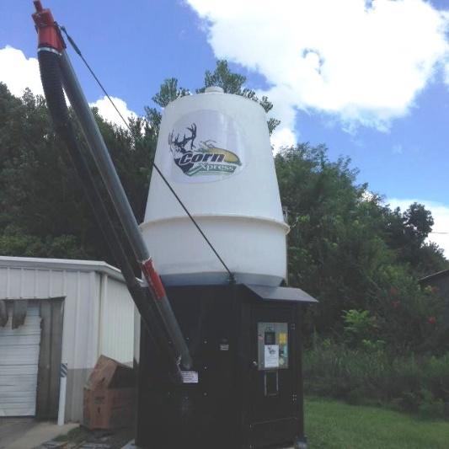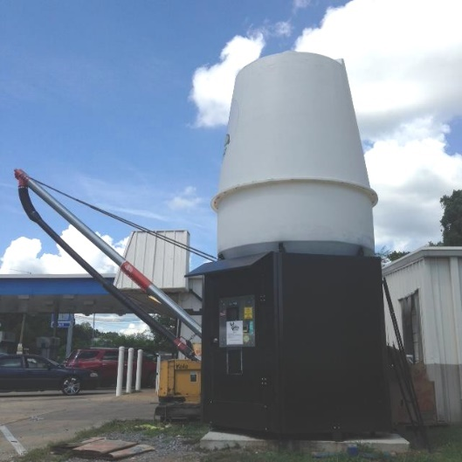
Figure 1. Vending Machine or Dispenser. Figure 2. Vending Machine or Dispenser.
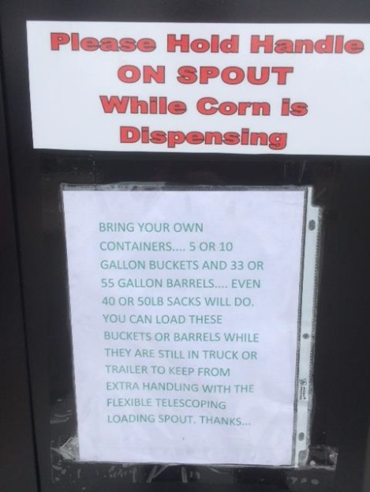
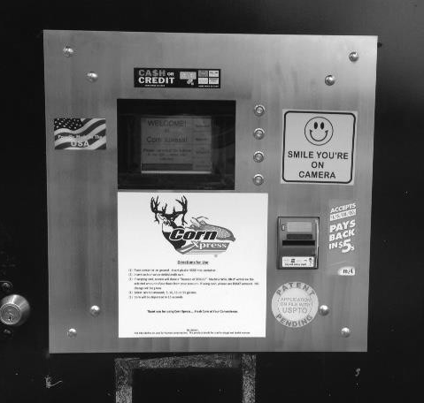
Figure 4. Instructions on Dispensing Product.

Figure 3. Vending Machine Selection Panel
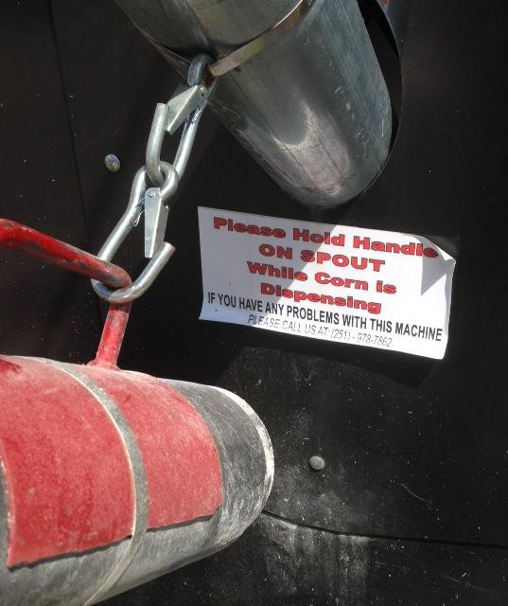
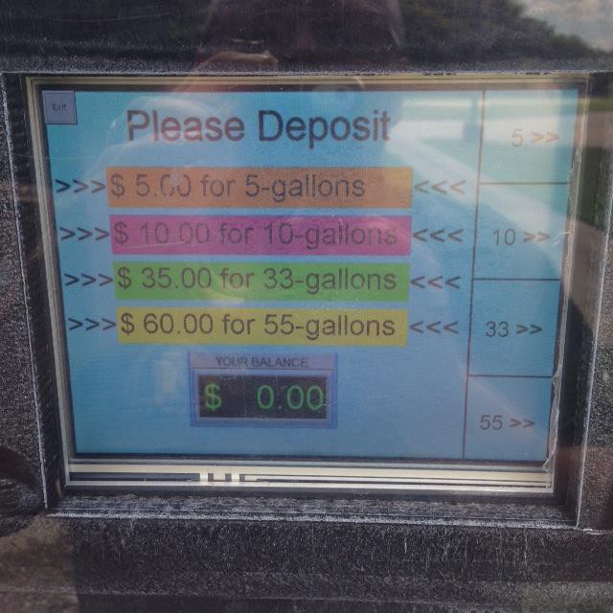
Figure 5. Instructions on Dispensing
Figure 6. Payment Screen.

Example 2:
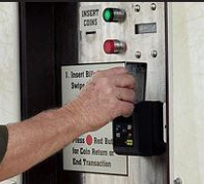
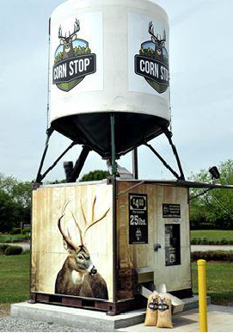
Figure 8. Payment/Selection Screen on Vending Machine.

Figure 7. Vending Machine or Dispenser.
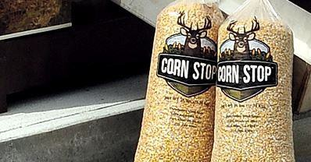
Figure 9. Dispensed Product.
All photos are the courtesy of the State of Mississippi.
Regional Association Comments:
At the 2016 CWMA Interim Meeting, it was commented that this proposal duplicates the existing method of sale for feed and is unnecessary. There was a question as to whether the dispensing devices are NTEP certified. The CWMA did not forward this item to NCWM.
At the 2016 SWMA Annual Meeting, the Committee received a presentation from CornXpress detailing the development and business processes for their machine. They expressed a desire to sell their product via their machine by volume. The SWMA heard from several states that the preferred method of sale be by weight. One state remarked they have vending machines that must be state type evaluated. Some states commented that competitors sell by weight. The SWMA L&R Committee believed that most regulators preferred the sales be by weight. The Committee also believed this proposal should be expanded to other commodities. The SWMA forwarded this to NCWM and recommended it as an Informational item.
At the 2016 NEWMA Interim Meeting, they did not forward this item to NCWM.

2302-11 D Electric Watthour
Source:
NIST OWM (2016)
This item has been assigned to the submitter for further development. For more information or to provide comment, please contact:
Tina Butcher
Chairman, NIST USNWG on Electric Vehicle Refueling and Submetering
(301) 975-2196, tbutcher@nist.gov
or
Juana Williams
Technical Advisor, NIST USNWG on Electric Vehicle Refueling and Submetering
(301) 975-3989, Juana.williams@nist.gov
Purpose:
- Make the weights and measures community aware of work being done within the U.S. National Work Group on Electric Vehicle Fueling and Submetering to develop proposed requirements for electric watthour meters used in submeter applications in residences and businesses;
- Encourage participation in this work by interested regulatory officials, manufacturers, and users of electric submeters.
- Allow an opportunity for the USNWG to provide regular updates to the S&T Committee and the weights and measures community on the progress of this work;
- Allow the USWNG to vet specific proposals as input is needed.
Background/Discussion:
The creation of Developing items on both the L&R and S&T Committee agendas will provide for a venue to allow the USNWG to update the weights and measures community on continued work to develop test procedures and test equipment standards. This item will also provide a forum for reporting on work to develop proposed method of sale requirements for electric watthour meters and a tentative device code for electric watthour meters in residential and business locations and serve as a placeholder for eventual submission of these proposals for consideration by NCWM.
In 2012, NIST OWM formed the U.S. National Working Group on Electric Vehicle Fueling and Submetering to develop proposed requirements for commercial electricity-measuring devices (including those used in sub-metering electricity at residential and business locations and those used to measure and sell electricity dispensed as a vehicle fuel) and to ensure that the prescribed methodologies and standards facilitate measurements that are traceable to the International System of Units (SI).
In 2013, the NCWM adopted changes recommended by the USNWG to the NIST Handbook 130 requirements for the Method of Sale of Commodities to specify the method of sale for electric vehicle refueling. At the 2015 NCWM Annual Meeting, the NCWM adopted NIST Handbook 44, Section 3.40. Electric Vehicle Refueling Systems developed by the USNWG.
This Developing item is included on the Committee’s agenda (and a corresponding item is proposed for inclusion on the L&R Committee Agenda) to keep the weights and measures community apprised of USNWG current projects, including the following:
- The USNWG continues to develop recommended test procedures for inclusion in a new EPO 30 for Electric Vehicle Refueling Equipment along with proposed requirements for field test standards.
- The USWNG is continuing work to develop a proposed code for electricity-measuring devices used in sub-metering electricity at residential and business locations. This does not include metering systems under the jurisdiction of public utilities. The USNWG hopes to have a draft code for consideration by the community in the 2016 - 2107 NCWM cycle.
The USNWG will provide regular updates on the progress of this work and welcomes input from the community.
The USNWG on Measuring Systems for Electric Vehicle Fueling and Submetering’s Subgroup on Watthour Type Electric (WHE) Meters will meet (and by Tele/web conference) on September 12 - 14, 2017, in Sacramento, California, to discuss the full development of a November 2014 version of a watthour meter draft code, intended to address legal metrology requirements for the device its minimum inspection and test procedures and test equipment, the appropriate method of sale of electricity through the device and an efficient process for achieving these goals. Additional discussion may include topics such as wireless technology, test procedures, traceability of test standards, and the subgroup’s next steps; as well as the U.S. standards development process and timelines for other related projects.
The USNWG will provide regular updates on the progress of this work and welcomes input from the community.
Regional Association Comments:
The Regions support the continued development of this item and acknowledges the importance of this work.

2307 nist HANDBOOK 130 – UNIFORM ENGINE FUELS AND AUTOMOTIVE LUBRICANTS REGULATION

2307-1 V Section 2.14. Products for Use in Lubricating Automatic Transmission Fluids and Section 3.14. Automatic Transmission Fluid (See Related Item 2302-9)
(This item was Adopted.)
Source:
American Petroleum Institute (API) (2016)
Purpose:
Define how transmission fluids shall be identified in the marketplace on delivery documents and invoices and receipts from service.
Item under Consideration:
Amend the NIST Handbook 130, Engine Fuels and Automotive Lubricants Regulation as follows:
2.14. Products for Use in Lubricating Automatic Transmissions. – Any automatic transmission fluid sold without limitation as to type of transmission for which it is intended shall meet all automotive manufacturers’ recommended requirements for transmissions in general use in the state. Automatic Transmission fluids that are intended for use only in certain transmissions, as disclosed on the label of its container, shall meet the latest automotive original equipment manufacturer’s recommended requirements for those transmissions or have been demonstrated performance claims to be suitable for use in those transmissions. Where a fluid can be licensed against an original equipment manufacturer’s specification, evidence of current licensing by the marketer is acceptable documentation of performance against the specification. In the absence of a license from the original equipment manufacturer, adherence to automotive the original equipment manufacturer’s recommended requirements shall be assessed after testing per relevant methods based on tests currently available to the lubricants industry and the state regulatory agency. Any material offered for sale or sold as an additive to automatic transmission fluids shall be compatible with the automatic transmission fluid to which it is added, and shall meet all performance claims as stated on the label. Any manufacturer of any such product sold in this state shall provide, upon request by duly authorized representative of the Director, documentation of any claims made on their product label. Suitability for use claims shall be based upon appropriate field, bench and/or transmission rig testing. Any manufacturer of a transmission fluid making suitable-for-use claims shall provide, upon request by a duly authorized representative of the Director, credible documentation of such claims. If the product performance claims published by a blender and/or marketer are based on the claim(s) of one or more additive suppliers, documentation of the claims may be requested in confidence by a duly authorized representative of the Director. Supporting data may be supplied directly to the Director’s office by the additive supplier(s).
(Added 2004, Amended 2017)
2.14.1. Conformance. – Conformance of a fluid per Section 2.14. Products for Use in Lubricating Transmissions does not absolve the obligations of a fluid licensee with respect to the licensing original equipment manufacturer or the original equipment manufacturer’s licensing agent(s), where relevant.
2.14.2. Transmission Fluid Additives. – Any material offered for sale or sold as an additive to transmission fluids shall be compatible with the transmission fluid to which it is added, and shall meet all performance claims as stated on the label or published on any website referenced by the label. Any manufacturer of any such product sold in this state shall provide, upon request by a duly authorized representative of the Director, documentation of any claims made on their product label or published on any website referenced by the label.
(Added 2017)
Section 3. Classification and Method of Sale of Petroleum Products
3.14. Automatic Transmission Fluid.
3.14.1. Labeling and Identification of Transmission Fluid. – Transmission fluid shall be labeled or identified as described below.
(Added 2017)
3.14.12. Container Labeling. – The label on a container of automatic transmission fluid shall not contain any information that is false or misleading. Containers include bottles, cans, multi-quart or liter containers, pails, kegs, drums, and intermediate bulk containers (IBCs). In addition, each container of automatic transmission fluid shall be labeled with the following:
(a) the brand name;
(b) the name and place of business of the manufacturer, packer, seller, or distributor;
(c) the words “Automatic Transmission Fluid” which may be incorporated into a more specific description of transmission type such as “Automatic Transmission Fluid” or “Continuously Variable Transmission Fluid”;
(d) the duty type of classification; the primary performance claim or claims met by the fluid and reference to where any supplemental claims may be viewed (for example, website reference). Performance claims include but are not limited to those set by original equipment manufacturers and standards-setting organizations such as SAE and JASO and are acknowledged by reference; and
(e) an accurate statement of the quantity of the contents in terms of liquid measure.
(Added 2004) (Amended 2017)
3.14.3. Identification on Documentation. – Transmission fluid sold in bulk shall be identified on the manufacturer, packer, seller or distributor invoice, bill of lading, shipping paper, or other documentation with the information listed below:
- the brand name;
- the name and place of business of the manufacturer, packer, seller, or distributor;
- the words “Transmission Fluid” which may be incorporated into a more specific description of transmission type such as “Automatic Transmission Fluid” or “Continuously Variable Transmission Fluid”;
- the primary performance claim or claims met by the fluid or reference to where these claims may be viewed (for example, website reference). Performance claims include but are not limited to those set by original equipment manufacturers and standards-setting organizations such as SAE and JASO and are acknowledged by reference; and
- an accurate statement of the quantity of the contents in terms of liquid measure.
(Added 2017)
3.14.4. Identification on Service Provider Documentation. – Transmission fluid installed from a bulk tank at time of transmission service shall be identified on the customer invoice with the information listed below:
- the brand name;
- the name and place of business of the service provider;
- the words “Transmission Fluid” which may be incorporated into a more specific description of transmission type such as “Automatic Transmission Fluid” or “Continuously Variable Transmission Fluid”;
- the primary performance claim or claims met by the fluid or reference to where these claims may be viewed (for example, website reference). Performance claims include but are not limited to those set by original equipment manufacturers and standards-setting organizations such as SAE and JASO and are acknowledged by reference; and
- an accurate statement of the quantity of the contents in terms of liquid measure.
(Added 2017)
3.14.5. Bulk Delivery – When the transmission fluid is sold in bulk, an invoice, bill of lading, shipping paper, or other documentation must accompany each delivery. This document must identify the fluid as defined in Section 3.14.2. Container Labeling.
(Added 2017)
3.14.6. Storage Tank Labeling. – Each storage tank of transmission fluid shall be labeled with the following:
- the brand name;
- the primary performance claim or claims met by the fluid or reference to where these claims may be viewed (for example, website reference). Performance claims include but are not limited to those set by original equipment manufacturers and standards-setting organizations such as SAE and JASO and are acknowledged by reference.
(Added 2017)
3.14.2.7. Documentation of Claims Made Upon Product Label. – Any manufacturer, or packer, or distributor of any product subject to this article and sold in this state shall provide, upon request of duly authorized representatives of the Director, credible documentation of any claim made upon their product label, including claims made on any website referenced by said label. If the product performance claims published by a blender and/or marketer are based on the claim(s) of one or more additive suppliers, documentation of the claims may be requested in confidence by a duly authorized representative of the Director. Supporting data may be supplied directly to the Director’s office by the additive supplier(s).
(Added 2004) (Amended 2017)
Background/Discussion:
Many original equipment manufacturers (OEMs) set their own transmission fluid standards and recommend that consumers use these fluids in their designated applications. However, the current version of NIST Handbook 130 does not adequately define how transmission fluids shall be identified in the marketplace on delivery documents, invoices, and receipts from service. Requiring more specific information on invoices and receipts will provide some assurance to consumers that recommended automatic transmission fluids are being installed in their cars and trucks.
The changes proposed are consistent with those approved for gasoline and diesel engine (motor) oils sold in packages or dispensed from bulk containers.
At the 2016 NCWM Interim Meeting, Dr. Curran (FALS Chairman) recommended this and related Item 232-9 be an Informational item, so the language can be developed. Several members supported additional work on this proposal. Mr. Ferrick (API) will be circulating language to all interested parties for review. The Committee recommends this as an Informational Item. At the 2016 NCWM Annual Meeting, Mr. Ferrick remarked that he is submitting updated language to the Committee for consideration. The Committee recommends the updated language for consideration.
At the 2017 NCWM Interim Meeting, Mr. Ferrick submitted modified language to the Committee for consideration. Mr. Ferrick remarked the language refers to industry standards and specification in relation to performance standards. There were several stakeholders who support the amendment. The Committee moved forward the modified language as a Voting item.
At the 2017 NCWM Annual Meeting, Mr. Ferrick commented that there was an editorial change submitted to FALS for review and the FALS supports this change. One regulator expressed concerns with the phrase “primary performance claims” and would prefer the term “claims of suitability.” Mr. Ferrick explained that industry is accustomed to certain labeling nomenclature, and often have blanket terminology to cover several varying transmissions. Several members voiced their support for this item.
Regional Association Comments:
The WWMA received comment from a regulator that the requirement, “Any transmission fluid sold without limitation as to type of transmission for which it is intended shall meet all manufactures recommended requirements for transmissions in general use in the state.” is unattainable and suggested alternative language to be provided to the Committee. Another regulator echoed this concern. A regulator testified that “performance claims” should be replaced with “suitable for use claims” through the proposal. A performance claim is very general and would be difficult to enforce, and they suggested the intent is to say that the transmission fluid is acceptable for use in specific transmissions as opposed to making claims of reduced transmission wear, improved cleaning agents, extended fluid life, or the like. The WWMA believed this is a well-developed and worthy item. The WWMA supports the suggested amendments and believe they address the concerns presented in the open hearings regarding the term “performance claims.” The WWMA believed replacing “performance claims” with “suitability for use claims” makes the labeling requirement clearer and less subject to misinterpretation. The WWMA recommended the following modified proposal and recommended Voting status for the item:
Section 2. Standard Fuel Specifications
2.14. Products for Use in Lubricating Automatic Transmissions. – Any automatic transmission fluid sold without limitation as to type of transmission for which it is intended shall meet all automotive manufacturers’ recommended requirements for transmissions in general use in the state. Automatic Transmission fluids that are intended for use only in certain transmissions, as disclosed on the label of its container, shall meet the latest automotive the original equipment manufacturer’s recommended requirements for those transmissions or have been demonstrated to be suitable for use in those transmissions. Adherence to automotive the original equipment manufacturer’s recommended requirements shall be based on tests currently available published by the transmission or vehicle manufacturer and available to the lubricants’ industry and the state regulatory agency. Suitability for use shall be based upon appropriate field, bench and/or transmission rig testing. Any manufacturer of a transmission fluid making suitable-for-use claims shall provide, upon request by a duly authorized representative of the Director, documentation of such claims.
(Added 2004, Amended 20XX)
2.14.1. Transmission Fluid Additives. – Any material offered for sale or sold as an additive to automatic transmission fluids shall be compatible with the automatic transmission fluid to which it is added, and shall meet all performance claims as stated on the label. Any manufacturer of any such product sold in this state shall provide, upon request by a duly authorized representative of the Director, documentation of any claims made on their product label.
(Added 20XX)
Section 3. Classification and Method of Sale of Petroleum Products
3.14. Automatic Transmission Fluid.
3.14.1. Container Labeling. – The label on a container of automatic transmission fluid shall not contain any information that is false or misleading. Containers include bottles, cans, multi-quart or liter containers, pails, kegs, drums, and intermediate bulk containers (IBCs). In addition, each container of automatic transmission fluid shall be labeled with the following:
(a) the brand name;
(b) the name and place of business of the manufacturer, packer, seller, or distributor;
(c) the words “Automatic Transmission Fluid;”
(d) the duty type of classification; claims of suitability for use in specific transmissions met by the fluid. Suitability-for-use claims include those set by original equipment manufacturers and standards-setting organizations such as SAE and are acknowledged by reference;
(e) references to locations where any supplemental claims may be viewed (for example, website references); and
(f) an accurate statement of the quantity of the contents in terms of liquid measure.
(Added 2004) (Amended 20XX)
3.14.2. Identification on Documentation of Claims Made Upon Product Label. – Transmission fluid sold in bulk shall be identified on the manufacturer, packer, seller or distributor invoice, bill of lading, shipping paper, or other documentation with the information listed below:
- the brand name;
- the name and place of business of the manufacturer, packer, seller, or distributor;
- the words “Transmission Fluid”;
- claims of suitability for use in specific transmissions met by the fluid. Suitability-for-use claims include those set by original equipment manufacturers and standards-setting organizations such as SAE and are acknowledged by reference;
- references to locations where any supplemental claims may be viewed (for example, website references); and
- an accurate statement of the quantity of the contents in terms of liquid measure.
(Added 2004) (Amended 20XX)
3.14.3. Identification on Service Provider Documentation – Transmission fluid installed from a bulk tank at time of transmission service shall be identified on the customer invoice with the information listed below:
- the brand name;
- the name and place of business of the service provider;
- the words “Transmission Fluid”;
- claims of suitability for use in specific transmissions met by the fluid. Suitability-for-use claims include those set by original equipment manufacturers and standards-setting organizations such as SAE and are acknowledged by reference;
- references to locations where any supplemental claims may be viewed (for example, website references) and;
- an accurate statement of the quantity of the contents in terms of liquid measure.
(Added 20XX)
3.14.4. Bulk Delivery. – When the transmission fluid is sold in bulk, an invoice, bill of lading, shipping paper, or other documentation must accompany each delivery. This document must identify the fluid as defined in Section 3.14.2.
(Added 20XX)
3.14.5. Storage Tank Labeling. – Each storage tank of transmission fluid shall be labeled with the following:
- the brand name;
- claims of suitability for use in specific transmissions met by the fluid. Suitability-for-use claims include those set by original equipment manufacturers and standards-setting organizations such as SAE and are acknowledged by reference;
(Added 20XX)
3.14.6. Documentation of Claims Made Upon Product Label. – Any manufacturer, packer, or distributor of any product subject to this article and sold in this state shall provide, upon request of duly authorized representatives of the Director, documentation of any claim made upon their product label.
(Added 2004) (Added 20XX)
At the 2016 CWMA Interim Meeting, they agreed with a comment from the submitter that this proposal is fully developed and ready for Voting status. Any further edits would be to provide greater clarity to the proper identification of transmission fluid in the marketplace. The CWMA is recommending this be a Voting item. At the 2017 CWMA Annual, meeting no negative comments were received for this item. The Committee confirmed this item is ready for a Vote.
The SWMA reported that all comments and letters indicated this item should move to FALS. The Committee requested FALS take into consideration the letter dated October 13, 2016, from ILMA in their continued development of this item. The SWMA recommended Informational status.
NEWMA received a comment from API, that they had received a request for additional language changes from industry. API suggested these changes be made and then presented to FALS in January. The region agreed to move this item forward as Informational item for further consideration by FALS. A state regulator stated he felt the language about a requirement in which the label include “no false or misleading statements” was unnecessary. The submitter agreed to review this language. NEWMA recommended Informational status for this item.
At the 2017 NEWMA Annual Meeting, Items 2302-9 and 2307-1 were considered in tandem. An industry representative with API expressed support for this proposal and requests that NEWMA also support it. Mr. Chuck Corr (Archer Daniels Midland) commented that the wording with both items should be identical. NEWMA does consider both items to be fully developed.
Additional letters, presentations, and data may have been part of the Committee’s consideration. To review the supporting documentation, please refer to the “Report of the 101st National Conference on Weights and Measures” (SP1212, 2016) at: nvlpubs.nist.gov/nistpubs/SpecialPublications/NIST.SP.1212.pdf.

2307-2 I Section 3.28. Ethanol Flex Fuel and Section 3.8. Ethanol Flex Fuel (See related item 2302-7)
(This item was removed from the Voting agenda and returned to Informational status.)
Source:
KMoore Consulting LLC (2017)
Purpose:
Align the ethanol labeling language with the recently released Federal Trade Commission updates to 16 CFR 306 on the Automotive Fuel Rating Rule as it pertains to ethanol fuel blend rating, labeling on retail dispensers, certification, and recordkeeping requirements.
Item under Consideration:
Amend NIST Handbook 130, Uniform Engine Fuels and Automotive Lubricants Regulation as follows:
3.2.8. EPA Labeling Requirements Also Apply. – Retailers and wholesale purchaser-consumer of gasoline shall comply with the EPA pump labeling requirements for gasoline containing greater than 10 volume percent (V%) up to 15 volume percent (V%) ethanol (E15) under 40 CFR § 80.1501. (For additional information refer to Section 3.8.2. Labeling Requirements)
3.8. Ethanol Flex Fuel.
3.8.1. How to Identify Ethanol Flex Fuel. – Ethanol flex fuel shall be identified as Ethanol Flex Fuel or EXX Flex Fuel.
3.8.2. Labeling Requirements.
(a) Ethanol flex fuel with an ethanol concentration no less than 51 and no greater than 83 volume percent shall be labeled “Ethanol Flex Fuel, minimum 51 % ethanol.” shall be identified and labeled in accordance with the Federal Trade Commission Automotive Fuel Ratings, Certification and Posting Rule, 16 CFR 306, as amended. (For additional information, refer to Section 3.2.8. EPA Labeling Requirements Also Apply.)
(Amended 20XX)
(b) Ethanol flex fuel with an ethanol concentration less than or equal to 50 volume percent shall be labeled “EXX Flex Fuel, minimum YY % ethanol,” where the XX is the ethanol concentration in volume percent and YY is XX minus five (− 5). The actual ethanol concentration of the fuel shall be XX volume percent plus or minus five (± 5) volume percent.
(Added 2014)
(c) A label shall be posted which states “For Use in Flexible Fuel Vehicles (FFV) Only.” This information shall be clearly and conspicuously posted on the upper 50 % of the dispenser front panel in a type at least 12.7 mm (½ in) in height, 1.5 mm (¹/₁₆ in) stroke (width of type). A label shall be posted which states, “CHECK OWNER’S MANUAL,” and shall not be less than 6 mm (¼ in) in height by 0.8 mm (¹/₃₂ in) stroke; block style letters and the color shall be in definite contrast to the background color to which it is applied.
(Amended 2007, 2008, and 2014, and 20XX)
Background/Discussion:
It is important that NIST Handbook 130 language stay in alignment with government regulations. The FTC regulation update was effective on July 14, 2016.
At the 2017 NCWM Interim Meeting, Dr. Curran (FALS Chair) remarked they are submitting modified language to the Committee. Several states and stakeholders support this amendment. There was a remark about the FTC rule references, the EPA but does not require it to be followed. The Committee is recommending this as a Voting item.
At the 2017 NCWM Annual Meeting, Dr. Curran informed the Committee that FALS met Sunday, July 16, 2017. There was extensive discussion and comment on this item. FALS was unable to achieve consensus on the language under consideration in the NCWM Publication 16. The primary issue is EPA and FTC have conflicting regulations. The FTC labeling requirements has fewer elements to their language. The Committee noted Section 2.30.1. was reflected as being stricken; this is not accurate and corrected editorially. The Committee reviewed the following alternatives.
    - Making the item Informational and send it back to FALS for consideration and review.
    - Move the item forward as published in NCWM Publication 16 (2017).
    - Move the item forward with proposed amendments submitted by the API.
    - Move the item forward with alternative language proposed by Committee member, Ms. Michelle Wilson and Washington State regulator, Mr. Tim Elliot.
The Committee agreed to add changed Section 3.2.8. EPA Labeling Requirements Also Apply to provide a statement to the user that there are also labeling Requirements under Section 3.8.2. Labeling Requirements. With these changes the Committee recommended the modified language for a Vote. In response to a motion made on the floor during the voting session, the Committee reconsidered this item and agreed to Withdraw its recommendation for adoption and removed it from the voting agenda. It was believed that the amended proposal was substantially different than the version that was published in the Committee’s agenda. The amended proposal will be returned to the Committee’s agenda.
The item as it was published in NCWM Publication 16 (2017):
3.8. Ethanol Flex Fuel.
3.8.1. How to Identify Ethanol Flex Fuel. – Ethanol flex fuel shall be identified as Ethanol Flex Fuel or EXX Flex Fuel.
3.8.2. Labeling Requirements.
(a) Ethanol flex fuel with an ethanol concentration no less than 51 and no greater than 83 volume percent shall be labeled “Ethanol Flex Fuel, minimum 51 % ethanol.” shall be identified and labeled in accordance with the Federal Trade Commission Automotive Fuel Ratings, Certification and Posting Rule, 16 CFR 306, as amended.
(Amended 20XX)
(b) Ethanol flex fuel with an ethanol concentration less than or equal to 50 volume percent shall be labeled “EXX Flex Fuel, minimum YY % ethanol,” where the XX is the ethanol concentration in volume percent and YY is XX minus five (− 5). The actual ethanol concentration of the fuel shall be XX volume percent plus or minus five (± 5) volume percent.
(Added 2014)
(c) A label shall be posted which states “For Use in Flexible Fuel Vehicles (FFV) Only.” This information shall be clearly and conspicuously posted on the upper 50 % of the dispenser front panel in a type at least 12.7 mm (½ in) in height, 1.5 mm (¹/₁₆ in) stroke (width of type). A label shall be posted which states, “CHECK OWNER’S MANUAL,” and shall not be less than 6 mm (¼ in) in height by 0.8 mm (¹/₃₂ in) stroke; block style letters and the color shall be in definite contrast to the background color to which it is applied.
(Amended 2007, 2008, and 2014, and 20XX)
Regional Association Comments:
At the WWMA, a regulator testified the proposal does not completely capture the new regulations contained in 16 CFR Part 306. He testified that the FALS Committee is working on a major revision of the Uniform Engine Fuels and Automotive Lubricants Regulation which would, among other things, align NIST Handbook 130 with 16 CFR Part 306. The lettering size as proposed conflicts with the Federal Trade Commission’s (FTC) requirement. The work of the FALS Committee is expected to take two or more years to complete. The WWMA recommended the amended version of the proposal below, which includes the exact text found in 16 CFR 306.12, mirrors the federal requirement language. The WWMA recommends Voting status for this amended version.
3.8.2. Labeling Requirements.
(a) Ethanol flex fuel with an ethanol concentration no less than 51 and no greater than 83 volume percent shall be labeled “Ethanol Flex Fuel, minimum 51 % ethanol.”
(b) Ethanol flex fuel with an ethanol concentration less than or equal to 50 volume percent shall be labeled “EXX Flex Fuel, minimum YY % ethanol,” where the XX is the ethanol concentration in volume percent and YY is XX minus five (− 5). The actual ethanol concentration of the fuel shall be XX volume percent plus or minus five (± 5) volume percent.
(Added 2014)
(c) A label shall be posted which states “For Use in Flexible Fuel Vehicles (FFV) Only.” This information shall be clearly and conspicuously posted on the upper 50 % of the dispenser front panel in a type at least 12.7 mm (¹/₂ in) in height, 1.5 mm (¹/₁₆ in) stroke (width of type). A label shall be posted which states, “CHECK OWNER’S MANUAL,” and shall not be less than 6 mm (¹/₄ in) in height by 0.8 mm (¹/₃₂ in) stroke; block style letters and the color shall be in definite contrast to the background color to which it is applied.
(Amended 2007, 2008, and 2014)
3.8. Ethanol Flex Fuels.
3.8.1. The label is 7.62 cm (3 in) wide × 6.35 cm (2¹⁄₂ in) long. “Helvetica Black” or equivalent type is used throughout. The band at the top of the label contains one of the following:
- For all ethanol flex fuels. The numerical value representing the volume percentage of ethanol in the fuel followed by the percentage sign and then by the term “ETHANOL”; or
- For ethanol flex fuels containing more than 10 percent and no greater than 50 percent ethanol by volume. The numerical value representing the volume percentage of ethanol in the fuel, rounded to the nearest multiple of 10, followed by the percentage sign and then the term “ETHANOL”; or
- For ethanol flex fuels containing more than 50 percent and no greater than 83 percent ethanol by volume. The numerical value representing the volume percentage of ethanol in the fuel, rounded to the nearest multiple of 10, followed by the percentage sign and then the term “ETHANOL” or the phrase, “51 % to 83 % ETHANOL.”
3.8.2. The band should measure 2.54 cm (1 in) deep. The type in the band is centered both horizontally and vertically. The percentage disclosure and the word “ETHANOL” are in 24-point font. In the case of labels including the phrase, “51 % - 83 % ETHANOL,” the percentage disclosure is in 18-point font, and the word “ETHANOL” is in 24-point font and at least 0.32 cm ⁽¹⁄₈ in) below the percentage disclosure. The type below the black band is centered vertically and horizontally. The first line is the text: “USE ONLY IN.” It is in 16-point font, except for the word “ONLY,” which is in 26-point font. The word “ONLY” is underlined with a 2-point (or thicker) underline. The second line is in 16-point font, at least 0.32 cm (¹⁄₈ in) below the first line, and is the text: “FLEX-FUEL VEHICLES.” The third line is in 10-point font, at least 0.32 cm (¹⁄₈ in) below the first line, and is the text “MAY HARM OTHER ENGINES.”
3.8.3. Colors. – The label background color is Orange: PMS 1495 or its equivalent. The knock-out type within the black band is Orange: PMS 1495 or its equivalent. All other type is process black. All borders are process black. All colors must be non-fade.
At the 2016 CWMA Annual Meeting they received a comment from a regulatory member of the FALS that this item is being addressed in the FALS Handbook 130, Uniform Engine Fuels update, which should be ready in draft form for review by the 2017 NCWM Interim Meeting. The CWMA recommended that this be a Developing item.
At the 2016 CWMA Interim Meeting, comments on this item and Item 2302-7 were taken together during open hearings. The American Petroleum Institute (API) testified during the CWMA L&R open hearing. API proposed an amendment to modify Items 2302-7 and 2307-2. Their suggested amendment is the double underlined language below. The other bold underlined text is part of the current proposal in NCWM Publication 16.
3.8. Ethanol Flex Fuel.
3.8.1. How to Identify Ethanol Flex Fuel. – Ethanol flex fuel shall be identified as Ethanol Flex Fuel or EXX Flex Fuel as defined in 16 CFR 306.0(o).
3.8.2. Labeling Requirements.
(a) Ethanol flex fuel with an ethanol concentration no less than 51 and no greater than 83 volume percent shall be labeled “Ethanol Flex Fuel, minimum 51 % ethanol.” shall be identified and labeled in accordance with the Federal Trade Commission Automotive Fuel Ratings, Certification and Posting Rule, 16 CFR 306, as amended with the exception that retailers and wholesale purchaser-consumers of gasoline shall comply with the EPA pump labeling requirements for gasoline containing greater than 10 volume percent (v %) up to 15 volume percent (v %) ethanol (E15) under 40 CFR § 80.1501.
(Amended 20XX)
(b) Ethanol flex fuel with an ethanol concentration less than or equal to 50 volume percent shall be labeled “EXX Flex Fuel, minimum YY % ethanol,” where the XX is the ethanol concentration in volume percent and YY is XX minus five (− 5). The actual ethanol concentration of the fuel shall be XX volume percent plus or minus five (± 5) volume percent.
(Added 2014)
(c) A label shall be posted which states “For Use in Flexible Fuel Vehicles (FFV) Only.” This informational shall be clearly and conspicuously posted on the upper 50 % of the dispenser front panel in a type at least 12.7 mm (¹/₂ in) in height, 1.5 mm (¹/₁₆ in) stroke (width of type). A label shall be posted which states, “CHECK OWNER’S MANUAL,” and shall not be less than 6 mm (¹/₄ in) in height by 0.8 mm (¹/₃₂ in) stroke; block style letters and the color shall be in definite contrast to the background color to which it is applied.
(Amended 2007, 2008, and 2014, and 20XX)
At the 2017 CWMA Annual Meeting, Mr. Prentiss Searles (API), testified during the CWMA L&R open hearing restating his remarks from the 2016 Interim Meeting (noted above). Eight individuals supported the item as written in NCWM Publication 16. There were four individuals in support of the API proposal.
The SWMA heard comment that FTC was being consulted on this item. Currently, the lettering size as proposed does conflict with the FTC requirement. The submitter from API and the State of Florida would like to see the issue forwarded to FALS. The submitter takes issue with the Method of Sale and Fuels and Lubricants section not having identical specifications. The SWMA recommended this be an Informational item.
At the 2016 NEWMA Interim Meeting, they received comments from the FALS Chair that this item and Item 2302-7 are both proposals that should go through FALS. NIST, OWM and an ethanol industry representative stated this proposal should remain Informational and referred to FALS for further development. A state regulator commented the new FTC Part 306 allows E15 to be considered as part of D4814. Also, E15 would require on the EPA label that 2001 and newer vehicles can use the product, but there is no octane label required. NEWMA forwarded the item to NCWM and recommended it as an Informational item.
During the 2017 NEWMA Annual Meeting voting session, there was discussion on this item and Item 2302-7. There was repeated concern by a New York State regulator that Section 2.30.2.(c) of the item, which originally appears in NCWM Publication 16 as struck language, should be reinstated if it does not contradict or countermand federal labeling requirements. The L&R Committee suggested language was supported by the region. If possible, NEWMA wants to maintain Section 2.30.2.(c) and Voting status contingent on review and a report provided by the FALS.

2307-3 I Section 4.1. Water in Retail Engine Fuel Storage Tanks, Gasoline Alcohol Blends, Biodiesel Blends, Ethanol Flex Fuel, Aviation Gasoline, and Aviation Turbine Fuel, and Section 4.2. Water in Gasoline, Diesel, Gasoline-Ether, and Other Fuels.
Source:
State of Colorado (2016)
Purpose:
Provide a consistent best management practice regarding managing water in any engine fuel utilizing current detection technology.
Item under Consideration:
Amend NIST Handbook 130, Uniform Engine Fuels and Automotive Lubricants Regulation as follows:
4.1. Water in Retail Engine Fuel Storage Tanks Gasoline-Alcohol Blends, Biodiesel Blends, Ethanol Flex Fuel, Aviation Gasoline, and Aviation Turbine Fuel. – No water phase greater than 6 mm (¼ in) as determined by an appropriate detection paste or other acceptable means, is allowed to accumulate in any retail tank utilized in the storage of engine fuels including, gasoline, gasoline-alcohol blend, biodiesel, biodiesel blends, ultra-low sulfur diesel, ethanol flex fuel, aviation gasoline, and aviation turbine fuel, gasoline ether blends, kerosene, or any other engine fuels.
(Amended 2008, 2012, and 2014, and 20XX)
4.2. Water in Gasoline, Diesel, Gasoline-Ether, and Other Fuels. – Water shall not exceed 25 mm (1 in) in depth when measured with water indicating paste or other acceptable means in any tank utilized in the storage of diesel, gasoline, gasoline-ether blends, and kerosene sold at retail except as required in Section 4.1. Water in Gasoline-Alcohol Blends, Biodiesel Blends, Ethanol Flex Fuel, Aviation Gasoline, and Aviation Turbine Fuel.
(Amended 2008, 2012, and 2014)
Background/Discussion:
All engine fuels degrade more rapidly in the presence of water and can result in an off-spec product, microbial growth, and internal corrosion of tanks and tank equipment. Besides impacting the quality of fuel such as when ethanol dissolves in water causing phase separation, affecting RVP and reducing AKI or octane number, the occurrence of microbial growth and corrosion particulates clog dispenser filters and affect other fuel clarity parameters. The fuels landscape has changed significantly across the country and currently almost all gasoline is blended with ethanol and all diesel is now Ultra Low Sulfur Diesel with up to five percent biodiesel. This proposal provides a consistent best management practice regarding managing water in any engine fuel utilizing current detection technology (water finding paste or other acceptable means), and simplifies the handbook by eliminating the necessity for Section 4.2. Water in Gasoline, Diesel, Gasoline Ether, and Other Fuels.
At the 2016 NCWM Interim Meeting, Dr. Curran (FALS Chairman) remarked that FALS is forming an informal focus group (FG) lead by Mr. Albuquerque (Colorado) for developing this item. Mr. Bill Hornback (Chevron Products Co.) remarked, there is no way to detect one-quarter inch of water. The Committee agreed additional work needs to be done and recommends this as an Informational item.
At the 2016 NCWM Annual Meeting, Mr. Mahesh Albuquerque (Informal IFG Chair) gave a presentation regarding water in fuel storage tanks. Mr. Albuquerque will continue to develop this item through the Informational focus group and report back to FALS on their progress.
At the 2017 NCWM Interim Meeting, Mr. Mahesh Albuquerque provided an update to FALS. Mr. Albuquerque noted this proposal arose because there are two different requirements in the handbooks regarding permissible levels of water in fuel storage tanks, and he was looking to harmonize them to one-quarter inch. He gave a presentation highlighting some of the research, which has been conducted regarding the effects of water in fuel storage tanks. Much discussion ensued and one of the overarching lingering questions left before group was if this was worth the cost of implementation. The informal FG plans to continue to evaluate this and other related questions in hopes to have a resolution ready to move forward in the near future.
At the 2017 NCWM Annual Meeting, Dr. Curran (FALS Chair) stated this item was discussed in length at the FALS meeting. Mr. Albuquerque (informal FG Chair) continues to gather information and vet the proposal
Regional Association Comments:
The WWMA received testimony from the submitter that this item will serve 1) to simplify the requirements in NIST Handbook130 by eliminating Section 4.2. Water in Gasoline, Diesel, Gasoline-Ether, and Other Fuels and applying a single standard for water allowance in all fuel storage tanks, and 2) to protect the fuel from degradation associated with water contamination, and 3) to reduce storage tank integrity issues associated with water contamination. He stated diesel fuel today is more susceptible to microbial growth since the comparatively high sulfur levels in pre-2006 diesel fuel naturally inhibited microbial growth. He is working with FALS on this item and invites participation from all stakeholders. One industry representative asked that the standard, whatever it ends up being, be uniformly applied to the fuels identified in Section 4.2. Water in Gasoline, Diesel, Gasoline-Ether, and Other Fuels. There was considerable discussion as to whether one-quarter inch is something that is detectible using current tank monitoring equipment and conventional water detecting paste. One industry representative testified that current tank monitoring equipment is unable to detect water levels less than three-quarter inch depth. However, most agreed water finding paste used in conjunction with sticking the tank is quite capable of resolving one-quarter inch of water. The WWMA agreed that additional input from industry, regulators, and the FALS Committee is necessary and recommended this be an Informational item.
The CWMA received a comment from a regulator who sits on the board of the Steel Tank Institute (STI) is currently on a working group that is revising the recommended practices for water in storage tanks. He believes NCWM and NIST Handbook 130 should be harmonized with this group, because there is a broad-based industry stakeholder group working on these recommendations. He further commented the maximum allowable limit will likely be one-half inch, as well as a frequency requirement that varies depending on the type of tank. A regulator commented their state requirement is one-half inch maximum allowable, but essentially it is a de minimus level that identifies any water. An industry representative from API asked several questions for consideration including: 1) how are UST facilities measuring the ¼ in water; are they able to use electronic measuring equipment or are they relying on stick and paste; 2) has Colorado or any other state identified a correlation between tank conditions when one inch of water is present versus a one-quarter inch of water; 3) are USTs changing out their filters more often with one inch of water than with one-quarter inch of water; is there any correlation between water in the tanks and consumer complaints; 4) if the facilities are using filters, are they using water sensitive filters; 5) how often are facilities cleaning their tanks; 6) how often are facilities removing the water from the tanks; and 7) is there a correlation to the amount of water measured in the tank? The state regulator on the STI board commented any presence of water will cause the issues such as corrosion, which is trying to be prevented. An industry representative from the National Biodiesel Board (NBB) commented that NBB does not oppose this idea, but also does not know the most effective de minimus amount. She commented that NBB believes that regardless of the maximum allowable limit, all fuels should have the same requirement. The CWMA recommended this be a Developing item. At the 2017 CWMA Annual Meeting, they believed the intent of this was valid; however, they feel the scientific supporting data is lacking. CWMA encourages further development of this proposal by the informational FG.
The SWMA heard from the FALS Chair that an informal focus group is working on this item. An API representative remarked that limiting water was important but wondered how the proposal will help address the issue. The SWMA recommended this be an Informational item.
At the 2016 NEWMA Interim Meeting, they received a report that an informal focus group from FALS is working to further develop this proposal by determining what the appropriate maximum water volume should be for storage tanks. A biodiesel industry representative commented that regardless of what is determined to be the de minimus amount of water allowed, it should be the same for all fuels, unlike what is currently in NIST Handbook 130. NEWMA recommended this be an Informational item. At the 2017 NEWMA Annual Meeting they support the work of the informal focus group.

2307-4 W Section 4.3. Dispenser Filters
(This item was Withdrawn.)
Source:
Missouri Department of Agriculture (2012)
Purpose:
Recognize the need for 10 micron or smaller nominal pore-sized filters for today’s diesel engines.
Item under Consideration:
Amend the NIST Handbook 130, Engine Fuels and Automotive Lubricants Regulation as follows:
4.3. Dispenser Filters.
4.3.1. Engine Fuel Dispensers.
- All gasoline, gasoline-alcohol blends, gasoline-ether blends, ethanol flex fuel, and M85 methanol dispensers shall have a 10 micron or smaller nominal pore-sized filter.
- All biodiesel, biodiesel blends, diesel, and kerosene dispensers shall have a 30 10 micron or smaller nominal pore-sized filter with the following exceptions:
  - Dispensers with flow rates greater than 15 gal per minute shall use a 30 micron or smaller nominal pore size filter.
  - Dispensers with flow rates less than or equal to 15 gal per minute in the following states may use a 30-micron or smaller nominal pore size filter during the months of December through March. These states include: Nevada, Idaho, Montana, Wyoming Colorado, South Dakota, Nebraska, Minnesota, Iowa, Wisconsin, Michigan, Illinois, Pennsylvania, New York, Vermont, New Hampshire, and Maine. This exception has a sunset date of April 2020.
  - Dispensers with flow rates less than or equal to 15 gal per minute in North Dakota may use a 30 micron or smaller nominal size filter during the months of November through March. This exception has a sunset date of April 2020.
(Amended 2014 and 20XX)
Background/Discussion:
Abnormal dispenser filter plugging at retail will alert the retailer of potential storage tank problems. Requiring 10-micron filters for all products will reduce the inventory and the potential of installing the wrong filter for all products at the same site.
NCWM 2012 Interim Meeting, Mr. Ronald Hayes, FALS Chair, informed the Committee that FALS recommended that this item be Informational because of industry concerns that 10-micron filters would be too restrictive of flow in high-flow systems. One industry representative expressed opposition for the use of 10-micron filters and recommends this item to be Withdrawn. A representative of an automobile manufacturer claimed diesel passenger vehicles do not have the sophisticated filtration systems commonly found on commercial duty vehicles and 10-micron filters on dispensers are needed for protection from particulate contamination. As proposed, this item could cause clogging of diesel dispenser filters in colder climates. The Committee believes this item has merit but lacks a consensus and believes FALS needs to address these concerns. The 2012 L&R Committee designated this item as an Informational Item and assigned it to FALS for further development.
At the 2012 NCWM Interim Meeting, it was apparent to the Committee there are many unresolved issues related to passenger vehicles. The Committee encourages the FALS to continue developing this item.
At the 2012 NCWM Annual Meeting, several stakeholders spoke in opposition on this item. Mr. Ronald Hayes, FALS Chair remarked that the FALS worked on this item in 2007 and believes FALS needs to continue to work on this item. The NCWM L&R Committee agreed that this item is not ready and supports the continued development by FALS.
At the 2013 NCWM Interim Meeting, Mr. Hayes, FALS Chairperson, remarked that a similar item was bought before the Committee in 2007. FALS did not have enough time in their work session to work on this item. There are several stakeholders and states that are having issues with the terminology and would like it removed from the agenda. Mr. Ronald Hayes (Missouri) remarked that they supported this item because contamination is an issue with cars that do not have filtering systems. The Committee reviewed comments from the Regional Associations however; FALS did not have sufficient time review and consider recommendation to the Committee. The Committee would like for FALS to continue to work on this item and is proposing this as an Informational item.
At the 2013 NCWM Annual Meeting, Mr. Hayes, FALS Chair requested that the Committee allow them to continue to work on a recommendation for this item. There was opposition on moving this item forward. In less than two years since this proposal came forward, there has been no data developed. The Committee reviewed Regional Association reports, open hearing comments, and letters received changed the status of this to a Developing item.
At the 2014 NCWM Interim Meeting, Mr. Hayes (Missouri), who submitted the proposal, offered modified language and supporting data to support the flow rate on 10-micron diesel filters. There was considerable discussion regarding the fill time reduction, burdensome cost for station owners, and equipment and filter maintenance. It was noted there is work being done within ASTM, but at this time the information cannot be shared. The Committee reviewed the Item Under Consideration within NCWM Interim Publication 15 (2014). The Committee moved forward the modified language provided by Mr. Hayes for consideration as a Voting Item.
At the 2014 NCWM Annual Meeting, the Committee reviewed several letters and additional data submitted by the Petroleum Marketers Association of America (PMAA). The FALS recommended this item move forward for a Vote. During open hearings, concerns were mixed regarding this this Item. Numerous were concerns were expressed concerning the data from PMAA. Several comments were heard that ASTM should be allowed to develop a standard.
At the 2015 NCWM Interim Meeting the FALS Chair notified the Committee that this proposal was discussed in their work session and the FALS group is divided on a recommendation. Mr. Russ Lewis (Marathon Petroleum Co.) submitted the Coordinating Research Council (CRC) report “Diesel Fuel Storage and Handling guide. In addition, Prentiss Searles (API) provided the Committee with a listing of the various studies and the findings that support moving this Item forward. The Committee reviewed additional letters and Regional Association recommendations. During open hearing testimony, there was discussion as to whether this is a weights and measures issue or a housekeeping issue for the stations. There was lengthy discussion was at length as to the type of particulates and contaminates that a 10 micron could filter. Cost effectiveness was a concern as to who would bear the burden of the cost. With the extensive discussion on this subject matter and new information received, the Committee is designating this item as a Voting Item.
At the 2015 NCWM Annual Meeting, Mr. Lewis (on behalf of API) provided a presentation on dispenser filters. Mr. Curran (FALS Chair) informed the Committee that FALS is divided on this issue but would like it to proceed with a Vote. There were no new comments other than those that have already been provided in this report. The outcome of the voting session was a split vote; therefore, it was returned to the Committee.
At the 2016 NCWM Interim Meeting, Mr. Prentiss Searles (API) provided a presentation and remarked that North Dakota is being stricken from Section 4.3.1.(b)(2). Dr. Curran (FALS Chairman) remarked that FALS had some opposition from marketers on this proposal. However, FALS is recommending this move forward as a Voting item. There was discussion on the floor as to who is responsible for clean tanks, refiners, terminals, or retailers? It was also mentioned that the ASTM standard may not be sufficient. The Committee is recommending this as a Voting Item.
At the 2016 NCWM Annual Meeting, Dr. Curran (FALS Chair) recommended that this item move forward with a vote even though FALS could not reach a consensus on this item. There were several remarks that this item should be Withdrawn due to the financial burden this would have on small independent operators. Oregon, Maine, and Massachusetts requested they be added to the exemption listing. States were added to the exemption listing based on temperature studies and on ASTM D975 10 percentile ambient temperature tables (fig. X 5.2 and 5.3). Those in support of this proposal agree studies on fuel cleanliness have been done. This item protects the consumer, and this proposal adds the last line of defense. Stations must maintain their tanks; however; they claim contamination is in the product being delivered. There was also a comment as to how the sunset date of April 2020 was determined. Mr. Russ Lewis remarked the sunset date was proposed so that if adopted and this did not resolve the issue, then it will allow for a switch back to the 30-micron filter.
At the 2017 NCWM Interim Meeting, Dr. Curran remarked that the FALS is recommending this be Withdrawn. The Committee did not see any new information or data come forward on this item, so they have Withdrawn this item.
Regional Association Comments:
The WWMA received a comment from a regulator that voting on this item was split solidly down the middle the last two times it was brought before NCWM for adoption and doesn’t see any evidence of this changing and asks that item be Withdrawn. A regulator testified that the item is overreaching and should simply be a business decision left up to the fuel marketers. The Committee observed there is no evidence of consensus among either regulators or industry on this issue. The WWMA recommended the item be Withdrawn.
The CWMA received a comment from a regulator that Missouri is credited as the submitter of this item, when in fact, the item originated from the Fuels and Lubricants Subcommittee. This item is a separate item pulled off a larger revision similar to the update revision currently being made through FALS. He commented that the engine manufacturers originally brought this concern to FALS, and several years later we are still deliberating the move from 30- to 10-micron filter maximum pore size. A state regulator from Minnesota commented that if this proposal is to ever pass, the requirement should be enforced at the terminal as well as at the retail level. A regulator commented that the further downstream the product gets, the more likely it is to collect particulate. An industry representative commented there have been very few issues or complaints from the retailers indicating they were taking possession of dirty fuel. The practicality of a 10-micron filter at the terminal is problematic. An industry representative commented the data indicating a problem with tank corrosion is at retail, not upstream. A regulator commented that the problem is with dirty tanks, not fuel filters. He commented that NCWM should consider labeling diesel fuel as filtered or unfiltered. The CWMA recommended this item be Withdrawn.
The SWMA heard from the FALS Chair that they have been unable to reach consensus on this item. The SWMA also heard API had no additional data to provide. The SWMA recommended the item be Withdrawn.
NEWMA recommended that the item be Withdrawn.
Additional letters, presentations, and data may have been part of the Committee’s consideration. To review the supporting documentation, please refer to the “Report of the 101st National Conference on Weights and Measures” (SP1212, 2016) at: nvlpubs.nist.gov/nistpubs/SpecialPublications/NIST.SP.1212.pdf.

2500 NCWM Policy, Interpretations, and Guidelines

2500-1 V Sections 2.1.1. Weight(s) and/or Measure(s)., 2.1.2. Weight(s) and/or Measure(s), 2.1.3. Definition of Net Weight., 2.2.1. Gift Packages., 2.2.2. Sand., 2.2.3. Sold by ⁴/₅ Bushel., 2.2.5. Lot, Shipment, or Delivery., 2.2.6. Aerosols and Similar Pressurized Containers., 2.2.7. Aerosol Packaged Products., 2.2.8. Variety and Combination Packages., 2.2.9. Textile Products., 2.2.10. Yarn., 2.2.11. Tint Base Paint., 2.2.12. Reference Temperature for Refrigerated Products: When a Product is Required to be Maintained under Refrigeration, 2.3.9. Fireplace Logs., 2.3.11. Packaged Foods or Cosmetics Sold from Vending Machines., 2.3.12. Movie Films, Tapes, Cassettes
(This item was Adopted.)
Source:
NIST/OWM (2017)
Purpose:
Remove sections from the Interpretations and Guidelines that are either no longer necessary or outdated.
Item under Consideration:
Amend NIST Handbook 130, NCWM Policy, Interpretations and Guidelines as follows:

2.1.1. Weight(s) and/or Measure(s).
(L&R, 1985, p. 77)
The measuring elements of a point-of-sale system are “weights and/or measures.” Errors in pricing when found in point-of-sale systems come under “Misrepresentation of Pricing” in the weights and measures law and are under the jurisdiction of weights and measures.
Background
A recommendation was made to change the definition of “weights and measures” in the Uniform Weights and Measures Law to specifically define a scanner or point-of-sale system as under weights and measures jurisdiction.
Several state representatives said that they had enforcement problems when a scanner or point-of-sale system was being used and when the price marked on an item (or on the shelf) was not the same as the price printed on the receipt. These officials believe that unless the law specifically defines these devices as “weights and measures,” they have no jurisdiction over the devices’ function.
The Committee disagreed. The NCWM Uniform Weights and Measures Law has a section that forbids the practice of a different price on the retail shelf as compared with the price provided by a scanner. Section 15 of the Uniform Weights and Measures Law reads:
No person shall misrepresent the price of any commodity or service sold, offered, exposed, or advertised for sale by weight, measure, or count, nor represent the price in any manner calculated or tending to mislead or in any way deceive a person.
This section (plus Section 14 forbidding misrepresentation of quantity), if enacted by a state, already provides enforcement authority over scanners and point-of-sale systems.
In addition, the Committee does not want to set a precedent by listing by name the types of devices that might be considered weights and measures devices. This might provide a potential “loop-hole” for those devices not specifically listed. Finally, the Committee members pointed out that it is the human element (the person reading in data or receiving price updates) that introduces the discrepancies in shelf and receipt prices rather than any inherent incapability of the reading device or scanner. Therefore, it is much more effective to forbid the practice of mispricing rather than focus on a single device or apparatus as the means for obtaining compliance.

2.1.2. Section 19(a), Identity.
(L&R Committee, 1986, p. 143)
Packaged food not containing meat or poultry does not have to have an identity statement if the identity of the commodity can easily be identified through the wrapper or container.
Background
Virginia Weights and Measures recommended revision to Section 19(a) of the Uniform Weights and Measures Law (UWML) to eliminate the exemption of an identity statement from packages when the item “can easily be identified through the wrapper or container.” The Committee is of the opinion that there is merit in retaining the language in Section 19(a) of the Uniform Law. Packages of fresh product packaged in a retail establishment are considered to be packages as long as a price is attached. If the exemption were eliminated, such packages instead of being marked, for example, “¹²/₈₉ cents” would have to be marked “lemons, ¹²/₈₉ cents.” It was argued that there could be a problem in deciding whether or not a commodity could “easily be identified” (such as might occur in an ethnic specialty grocery or with an exotic produce item). In researching the issue, the Committee has determined that Title 21, Section 101.100(b)(3) of the Code of Federal Regulations specifically exempts the food identity statement from having to appear “..if the common or usual name of the food is clearly revealed by its appearance.” Since no specific problems of enforcement were brought to the attention of the Committee concerning this issue, the Committee recommends no change to Section 19(a) at this time. However, the Committee recommends that Section 3.1. and 4. of the Uniform Packaging and Labeling Regulation be noted as follows:
Section 19(a) of the Uniform Weights and Measures Law, and 21 CFR 101.100(b) (3) for non-meat and non-poultry foods, specifically exempt packages from identity statements if the identity of the commodity “can easily be identified through the wrapper or container.”

2.1.3. Definition of Net Weight.
(L&R, 1987, p. 123)
1. It is the intent of this definition to include truck-loads of commodities, not just packages (“containers”).
2. It is not the intent to define the net weight of packaged goods as requiring dry tare (“. . . excluding. . . substance(s) not considered to be part of the commodity” could just as well be interpreted as excluding liquids not considered part of the commodity at the time of sale).
3. It is also the intent to permit more specific definitions as the occasion warrants (“. . . material(s) . . . not considered. . . part of the commodity” might include dirt or “foreign material” in a commodity).

2.2.1. Gift Packages
(Resol. 1975, p. 237)
See also Interpretation 2.2.8.
Interpretation Seasonal gift packages are often put up in retail stores in baskets and other decorative containers using cellophane or other clear flexible wrap to enclose a number of similar or dissimilar prepackaged items (for example: cheese, jellies, sausages, wine, fruit, etc.). The resulting combination or variety package must have a legally conforming label including the net contents statement.

2.2.2. Sand.
(L&R, 1978, p. 151)
Interpretation
Sand put up in permanent wooden bins is a consumer package and must be labeled with all mandatory information as required by the Uniform Packaging and Labeling Regulation.
Background
The State of Hawaii raised the issue of the sale of sand in permanent wooden bins and sold by price per cubic measure. The Committee agrees with Hawaii that the sale of sand in this manner is subject to the Uniform Packaging and Labeling Regulation, under the definition of “Consumer Package” (Section 2.2. of the Uniform Packaging and Labeling Regulation) and that no further action is needed.

2.2.3. Sold by ⁴/5 Bushel.
(L&R, 1974, p. 220)
Interpretation
The trade practice of crating citrus fruit in ⁴/₅ bushel units is a long-standing one. It is not intended to be a consumer package. If offered as a consumer package, the general consumer usage and trade custom in the particular state would have to be explored:
Section 6.10.(b)(1) of the Uniform Packaging and Labeling Regulation would permit a declaration employing different fractions in the net quantity declaration other than those permitted under Section 6.10.(b) if there exists a firmly established practice of using ⁴/₅ bushel in consumer sales and trade custom.
Background
It has been called to the attention of the Committee that certain commodities are being sold to consumers in “unacceptable” fractional units of dry measure in violation of Section 6.10. of the Uniform Packaging and Labeling Regulation. Specifically, the Committee has been asked for an interpretation as to whether the packaging of oranges in a ⁴/₅ bushel, which is later sold unweighed to a consumer, is a violation of the binary submultiple principle as implied in Section 6.10.(b). Some Committee members asserted that a clear exception exists under Section 6.10.(b)(1) which applies to this long established tradition of crating citrus fruit in ⁴/₅ of a bushel. Approximately 85 % of this fruit is sold by this trade practice. Additionally, it was asserted that the packager never intended the ⁴/₅ bushel to be a consumer package, but if the ⁴/₅ bushel of citrus fruit is sold to consumers, this would be a matter between the appropriate state or local official and the retailer.
The consensus of the Committee is that this action of the packagers is not in violation of the indicated section.

2.2.5. Lot, Shipment, or Delivery.
(L&R, 1981, p. 95)
Policy
The requirements for the average package net contents to meet or exceed the labeled declaration may be applied to production lots, shipments, or deliveries. Shipments or deliveries are smaller collections of packages than production lots that may or may not consist of mixed lot codes.
Emphasis in inspection activities should be placed on warehouse and in plant testing without neglecting retail consumer protection.
Background
The Committee heard a petition from the California Brewers Association to define a lot as:
…a selection of containers under one roof produced by a single company of the same size, type and style, manufactured or packed under similar conditions with a minimum number to be equivalent to one production line shift.
The intention of the petition is to focus Weights and Measures enforcement on production lots as opposed to small collections of packages on retail shelves, because the production lot is under the control of the packager.
An alternative proposal was made that would require mingling of lot and date codes in package inspection at warehouse locations.
The Committee has reviewed the proposals in light of Section 7.6. and Section 12.1. of the Uniform Packaging and Labeling Regulation which refers to “shipment, delivery, or lot.” If the petition is approved, the terms “shipment” and “delivery” would have to be dropped from this Uniform Regulation.
The Committee recognizes the inherent value of in-plant and warehouse inspection and is of the opinion that, wherever possible, such inspections should be carried out. At the same time, the Committee recognizes the need for the state and local weights and measures officials to protect the consumer at the level where the ultimate sale is made. Therefore, the Committee recommends no change to the Uniform Regulation.
The Committee looks forward to the work of the Special Study Group on Enforcement Uniformity of the NCWM which will be exploring the mechanisms that might be instituted to make in-plant inspection workable.

2.2.6. Aerosols and Similar Pressurized Containers.
(L&R, 1976, p. 248)
See also Guideline 2.2.7.
Interpretation
It is the opinion of the NCWM that an FDA opinion as expressed in the Fair Packaging and Labeling Act Manual Guide FDA 7563.7, not objecting to volume declarations on aerosol products, does not supersede or preempt state requirements that aerosols be labeled by net weight.
Background
The Department of Commerce through the Office of Weights and Measures of the National Institute of Standards and Technology, under its statutory responsibility for “cooperation with the states in securing uniformity in weights and measures laws and methods of inspection,” developed Section 10.3.
10.3. Aerosols and Similar Pressurized Containers – The declaration of quantity on an aerosol package and on a similar pressurized package shall disclose the net quantity of the commodity (including propellant), in terms of weight, that will be expelled when the instructions for use as shown on the container are followed.
Several states, which are among the 32 that have adopted the Uniform Packaging and Labeling Regulation, indicated that pressurized cans were currently being marked by volume rather than by weight as required above. Industry representatives indicated that according to the FDA, they are permitted to mark this type of container by volume and that for competitive purposes they will continue to do so. The NCWM was asked to contact FDA and inform them that a declaration of volume on pressurized containers is not acceptable to the states since it cannot be verified.
A meeting was requested to express NIST/NCWM’s concern over the FDA position on quantity of contents declarations on aerosols, which is found in the Fair Packaging and Labeling Act (FPLA) Manual Guide FDA 7563.7. This Guide states that in the past, the FDA has not objected to the use of units of volume to declare the net contents of aerosol preparations that would be liquid if not combined with the propellant and a net weight statement in avoirdupois units for products that would be solids if not combined with a propellant. The FDA was asked to modify its position to provide that existing state regulations (concerning aerosol quantity of contents declarations) are not superseded by FDA Guidelines. FDA officials stated that the FDA would consider the request, but it did not appear at the time of the Interim Meetings that the FDA would make any statement to modify its position without following its administrative procedures and permitting interested parties to exhaust every element of due process.
One industry representative stated that there has been a good deal of concern that fluorocarbon propellants may in the long run cause the partial destruction of the ozone layer in the upper atmosphere surrounding the earth, and that the diminution of the ozone layer would have adverse effects on human health. Therefore, they have converted to new formulations which eliminate fluorocarbon propellants. As a result of this conversion to a non-fluorocarbon propellant system, which uses a propellant with a much lower density than that of the usual fluorocarbon propellants, continued use of a weight measure would be highly misleading to the consumer. Therefore, some spray labels have been changed so as to denote the contents in terms of fluid measure, rather than in terms of weight measure.
The industry representative stated that if manufacturers were to be required to use weight measure, consumers would be deceived into buying products, such as hair spray, with large amounts of fluorocarbon that vaporizes before it reaches the hair. Consumers prefer products with a large amount of base. Industry further indicated that they wanted to avoid a confrontation with the states over this issue and believe that the matter can readily be resolved without the need for litigation. Although the use of fluid measure on the principal panel will give consumers the most helpful information at the point of purchase, the industry would have no objection to putting the net weight on the back of the label.
The Committee wants to commend FDA for their interest in this matter and the manufacturers who seek to improve their product and its labeling information. The Committee is also encouraged to work with all interested parties to resolve this issue. However, the Committee does not believe that mere guidelines can preempt a Uniform Regulation developed under the technical authority of the federal agency delegated by Congress and adopted by the states through its representatives, no matter how broad the preemptive clause of an act might be. Additionally, the Committee cannot support open and notorious violations of state regulations where those violations occurred prior to bringing the issue before the Conference. Therefore, the Committee believes that NCWM should support a firm stand by the states that their regulations must be respected.

2.2.7. Aerosol Packaged Products.
(Liaison, 1979, p. 239)
See also Guideline 2.2.6.
Policy
The NCWM recommends all aerosol packages be labeled by net weight. FDA permits volume declarations. The NCWM has requested the FDA to change its regulations and revise its interpretation of these regulations.
Substance of Petition
The NCWM petitions the FDA to make the necessary changes to their regulations and interpretation of 21 CFR 101.105(g) as appearing in the FDA Fair Packaging and Labeling Manual Guide, 7563.7 pertaining to the quantity of contents declaration on aerosol packaged products. It is requested that the net quantity statement on aerosol packaged products or similar pressurized packages be made in terms of net weight only. The reasons for recommending such changes are as follows:
1. Net quantity labeling of aerosol packaged products in terms of net weight is a firmly established trade practice for such products.
2. Net quantity labeling of aerosol packaged products in terms of volume is difficult (if not impossible) to verify with consumer verification methods or by conventional package inspection methods. State or local enforcement action is discouraged by such labeling.
3. Since the labeling of aerosol packaged products by volume cannot be compared with the labeling of such products in terms of net weight, labeling in terms of volume and weight inhibits value comparisons and causes consumer confusion with respect to the quantity of product the consumer is buying and can be a form of deceptive labeling.
4. Uniformity between all state and federal regulations is highly desirable for both enforcement and fair competition in the marketplace. The Uniform Packaging and Labeling Regulation and the FTC and EPA Regulations require net quantity labeling of aerosol packaged products in terms of net weight.

2.2.8. Variety and Combination Packages.
(L&R, 1982, p. 149)
See also Guideline 2.2.1.
Interpretation
(a) Seasonal gift packages are “variety packages” within the meaning of the Uniform Packaging and Labeling Regulation if they contain “reasonably similar commodities” (such as various fruits). They are “combination packages” if they contain “dissimilar commodities” (such as wine, fresh fruit, and jellies). Variety package labels must declare the total quantity in the package. Combination package labels must declare a quantity declaration for each portion of dissimilar commodities.
(b) The example provided with Section 10.6., Variety Packages, of the Uniform Packaging and Labeling Regulation, shows a total quantity declaration and individual declaration for each type of commodity. The individual declaration is not required but is encouraged.
Background
The Committee reviewed Section 10.5 and Section 10.6 of the Model Packaging and Labeling Regulation in order to determine the need for further clarification. Several questions have arisen over the years with respect to:
(1) What are the net contents labeling requirements for seasonal gift packages composed of varying types of commodities or goods all combined into one package?
(2) Is the example provided in Section 10.6. entirely in keeping with the declaration requirements? (This section requires that total net contents be declared, but the example shows both total and individual net contents.)
The Committee believes that there is no need to modify these sections, but the discussions below may serve as guidance to enforcement officials and packagers on these sections.
Concerning labeling requirements for seasonal gift packages, it must first be determined what the individual units comprising each package are. The following examples are possibilities:
(a) individual packages of sausage, individual packages of cheese;
(b) several kinds of fruit of different weights; and
(c) several kinds of fruit, bottle of wine, several packages of cheese.
Examples (a) and (c) above are combination packages and should be labeled with net quantities of each unit or type of unit. It is possible to combine fruit net weight (or count if appropriate) as one declaration, cheese net weight as a second declaration, etc.
Example (b) above is a variety package and must be labeled with the total net weight or count (as appropriate) of fruit in the package. It is also reasonable for packagers to include, for full consumer information, a declaration of the individual net contents of each type of package or item in the gift package although this latter declaration is not required (e.g., 1 lb bananas, 3 pears). This is also the key to the second question asked above concerning the example provided in Section 10.6.; that is, although a declaration of individual item net contents is not required, packagers are encouraged to provide additional information wherever useful to the consumer.

2.2.9. Textile Products.
(L&R, 1977, p. 215)
Interpretation
(a) When a range of widths (e.g., 58/60) appears on the label of bolts or rolls for yard goods, enforcement action should be taken whenever the action width falls below the lesser of the two widths given as the range (in the example above, when the fabric width is less than 58 in).
(b) Section 10.9.3. Textiles: Variations from Declared Dimensions of the Uniform Packaging and Labeling Regulation is not to be interpreted as providing tolerances. The average requirement must be met. The average quantity of contents of a lot, shipment, or delivery must equal or exceed the declared dimensions. Dimensions of individual packages of textiles may vary as much as Section 10.9.3. permits, but the average requirement must still be met.
Background
The State of California and the American Textile Manufacturers Institute asked the NCWM Laws and Regulations Committee and the National Institute of Standards and Technology to assist in the resolution of two textile-product issues. In the first issue California asks for help in correcting a short measure condition, apparently a nationwide problem, which has been found in the packaging and labeling of textile yard goods put up on bolts or rolls.
The problem is outlined as follows:
1. Approximate width measurements are being used by some manufacturers in their label declarations.
Example: 58/60 in (inch) width
2. Label declarations are false and misleading in that actual amounts are less than the quantity represented on the label.
3. Section 10.9.3. of the Uniform Packaging and Labeling Regulation is extremely vague as to its intent and true meaning. Are the substantial variations (3 % and 6 %); (6 % and 12 %) permitted as product tolerances, or are they maximum unreasonable minus and plus errors to be allowed when sampling the product for quantity when using Handbook 67?
California favors the repeal or clarification of Section 10.9.3. and suggests amending Section 10.9.2.(k) to read:
The quantity statement for packages of textile yard goods packaged on the bolt or roll for either wholesale or retail shall state its net measure in terms of yards for the length and width of the item, or its net weight in terms of avoirdupois pounds or ounces, or in terms of their metric equivalent.
During the Interim Meetings, a representative of the American Textile Manufacturers Institute (ATMI) informed committee members that the proposal to identify the width of yard goods with a single measurement (as opposed to a range) would be given serious consideration by their members, after which a recommendation will be finalized and submitted to the Laws and Regulations Committee.
After the Interim Meetings, the National Home Sewing Association said that if a single width declaration is required, the following could result:
(a) No change in manufacturing process would be effectuated; only the size declaration on bolts would be changed.
(b) Short measure problems could be created because consumers would look for the fabric to be exactly the stated width. Because the manufacturing processes were not changed, the width is actually the same as it was with the range declaration.
(c) Increased cost to manufacturers would result. One loom is used for many different fibers now; a single width declaration could create a need for many looms for each of the different fibers, thereby imposing “pass-along” costs to consumers.
(d) Consumer deception would be fostered in that a single declaration implies actual measurement.
California officials state that roll or bolt fabric should be labeled accurately with a single declaration. Additionally, they believe that industry does have enough shrinkage data on fibers used in the manufacturing processes, and thus could provide accurate measurement declaration on finished fabrics or materials.
The Committee believes that accurate quantity information should be provided on consumer products; however, no labeling changes should be required until patterns and yard goods are marketed in metric units. At that time, all measures shall be singularly stated (eliminating dual numbers) and, until that time, any products where size declaration is a range and found to be less than the smaller of the range declaration shall be subject to enforcement action. For example, a product marked “58 to 60 in” and found to be less than 58 inches should be considered to be in violation of weights and measures laws and/or regulations.
Additionally, the Committee affirms that the intent of the Variations from Declared Dimensions permitted in Section 10.9.3. in no way eliminates the requirement that quantity declarations for textiles must, on the average, not be less than declared declarations.

2.2.10. Yarn.
(L&R, 1983, p. 153)
Interpretation
The appropriate net contents declaration for yarn is weight.
Background
A consumer has requested that the net quantity statement for yarn be changed from weight to length. The proposal is based on the consumers’ use of the product, darker colors often weigh more per unit of length. Therefore, they found that a lighter color yarn will “go farther” in craft applications than a darker yarn; consumers indicate that it is difficult to predict how much yarn of varying colors to purchase based on a weight declaration. The Committee is sympathetic to the request but must support existing labeling requirements for several reasons.
Yarn, by nature, is extremely stretchy; in order to label yarn by length, a specified tension would have to be applied in order to make any repeatable length measurement. Such a tension would have to be agreed upon by all the yarn manufacturers, and they would have to apply to compliance testing of product by weights and measures officials. Even if this tension “standard” were negotiated and decided upon, it would have little real meaning in use by needle crafters, knitters, and others. The tension applied to yarn in use varies from user to user and from application to application; therefore, the length also varies. Not only does dyeing yarn change the weight, dyeing also changes the length of yarn. For these reasons, industry representatives also support the requirements as they presently are written in the Uniform Packaging and Labeling Regulation.
The Committee recognizes the difficulty of working with this product and suggests that users of yarn consider buying an excess of the yarn over what is expected to be used in any application. The consumers should find out before purchase if, after finishing the product, they can return the unopened skeins to the retailers from whom the skeins were purchased.

2.2.11. Tint Base Paint.
(L&R, 1986, p. 146)
Section 11.23. of the Uniform Packaging and Labeling Regulation currently permits tint base paints (paints to which colorant must be added prior to sale) to be labeled in terms of the volume (a quart or gallon) that will be delivered to the purchaser after addition of the colorant only if three conditions are met:
1. “the system employed ensures that the purchaser always obtains a quart or a gallon”;
2. “a statement indicating that the tint base paint is not to be sold without the addition of colorant is presented on the principal display panel;” and
3. “the contents of the container, before the addition of colorant, is stated in fluid ounces elsewhere on the label.”

2.2.12. Reference Temperature for Refrigerated Products: When a Product is Required to be Maintained under Refrigeration.
(L&R, 1990, p. 86)
Background
Section 6.5.(b) was revised to clarify that the reference temperature of 4.4 ºC (40 ºF) applies only to products that must be refrigerated to maintain product quality, rather than to items, such as carbonated soft drinks, that are refrigerated for the purchaser’s convenience.
Guideline
The Committee also discussed how an inspector could decide whether a product under refrigeration is required to be maintained under refrigeration. The following guidelines are provided:
1. The traditional food items that normally require refrigeration and are found in refrigerated cases will not ordinarily have any statement about requiring refrigeration. These items include milk, orange juice, and similar products. They may be tested at any temperature at, above or below their reference temperature of 40 ºF (4 ºC) because such products are at their maximum density at their reference temperature, and the volume of such products will always increase at higher or lower temperatures. Thus any errors made by not measuring at the exact reference temperature will be in the favor of the packer.
2. Food items that normally require refrigeration, but which are processed so as not to require refrigeration prior to opening, will have “refrigerate after opening” or similar wording on the label. Such items as milk and orange juice can be found in this category as well as in the “refrigeration required” category. The two categories can be distinguished by the “refrigerate after opening” statement, which calls for testing at or above their reference temperature of 68 ºF (20 ºC).
3. Food items that are not expected to require refrigeration, but which may be refrigerated for the convenience of the consumer (such as carbonated beverages), are to be tested at temperatures of 68 ºF (20 ºC) or above even when found refrigerated for the convenience of the consumer.

2.3.9. Fireplace Logs.
(L&R, 1975, p. 174)
Interpretation
Time of burning is not an appropriate quantity declaration for fireplace logs. (Section 2.4.3. of the Uniform Method of Sale of Commodities requires single logs to be sold by weight, or if packaged and less than 4 ft³, weight plus count.)
Background
The enforceability of quantity declarations using time as the basis of measurement for commodities, including packaged commodities, must be considered carefully if equity in the marketplace is to be achieved. The Committee wants to stress to those who have submitted time declaration questions that the enforceability factor should not override consumer protection and uniformity considerations. Based on the above criteria, the Committee recommends that the Conference take the position that time is not an appropriate quantity declaration for fireplace logs.

2.3.11. Packaged Foods or Cosmetics Sold from Vending Machines.
(L&R, 1982, p. 152)
Interpretation
Packaged foods and cosmetics sold from vending machines must be labeled the same as similar items not sold in vending machines, including identity, responsibility, net contents, and ingredient declaration, except that Section 3.3. of the Uniform Regulation for the Method of Sale of Commodities permits identity and net contents to be posted on the machine in lieu of appearing on the package.
Background
As part of its review of the Uniform Regulation for the Method of Sale. of Commodities, the FDA recommended adding a statement to Section 3.3. that packaged foods and cosmetics sold in vending machines must in general be labeled in accordance with requirements for similar articles not sold in vending machines (e.g., ingredient declaration requirements). The Committee recommends that this information be made a guideline rather than incorporated as part of the uniform regulation.

2.3.12. Movie Films, Tapes, Cassettes.
(L&R, 1975, p. 174)
Guideline
Movie film may be sold by linear measure. Magnetic tapes and cassettes may be sold by either linear measure or playing time.
Background
The enforceability of quantity declarations using time as the basis of measurement for commodities, including packaged commodities, must be carefully considered to achieve equity in the marketplace. The Committee wants to stress to those who have submitted time declaration questions that the enforceability factor should not override consumer protection and uniformity considerations. The committee further recommends that the states follow FTC guidelines in requiring lineal measure for the sale of movie films and permit either linear measure or playing time for magnetic tapes and cassettes.

NOTE: To find the history on the following items, please refer to past Reports of the National Conference Weights and Measures; Sections 2.1.1. Weight(s) and/or Measure(s)., 2.1.2. Weight(s) and/or Measure(s), 2.1.3. Definition of Net Weight., 2.2.1. Gift Packages., 2.2.2. Sand., 2.2.3. Sold by ⁴/₅ Bushel., 2.2.5. Lot, Shipment, or Delivery., 2.2.6. Aerosols and Similar Pressurized Containers., 2.2.7. Aerosol Packaged Products., 2.2.8. Variety and Combination Packages., 2.2.9. Textile Products., 2.2.10. Yarn., 2.2.11. Tint Base Paint., 2.2.12. Reference Temperature for Refrigerated Products: When a Product is Required to be Maintained under Refrigeration. 2.3.9. Fireplace Logs., 2.3.11. Packaged Foods or Cosmetics Sold from Vending Machines., 2.3.12. Movie Films, Tapes, Cassettes.
Background/Discussion:
There was no yearly review to revise or update the Interpretations and Guidelines (I&G) located in the back of NIST Handbook 130. The NIST Office of Weights and Measures reviewed the current language in the Interpretations and Guidelines Section and believes the following information can be removed. Below NIST has included their justification for removal for each Section.
2.1.1. Weight(s) and/or Measure(s). – This is a good interpretation and useful information in relationship to Price Verification. However, the NCWM amended the Uniform Weights and Measures Law (UWML) in 1990, this appears in Section 16. Misrepresentation of Pricing. This is addressed in the UWML, Section 12(q) Powers and Duties of the Director which provides specific authority to conduct Price Verification Inspections.
2.1.2. Section 19(a), Identity. – The UWML Section 19(a) and the Uniform Packaging and Labeling Regulation (UPLR) Section 3. Declaration of Identity: Consumer Package (NIST Handbook 130 (2016- page 59) addresses this area and this interpretation is no longer valid.
2.1.3. Definition of Net Weight. – The 1997 L&R Reports provides information regarding this subject matter. The UWML Section 1. Definitions, 1.8. Net: “Mass” or Net “Weight” was added in 1988. If individuals are seeking background information regarding this matter it could be retrieved from the conference reports.
2.2.1. Gift Packages. – The NCWM adopted UPLR Section 2.9. Combination Package, 2.10. Variety Package, and 10.5. Combination Packages, 10.6. Variety Packages.
2.2.2. Sand. – In 2000 the NCWM adopted a Method of Sale of Commodities for this item (2.29. Sand, Rock, Gravel, Stone, Paving Stone, and Similar Materials, when Sold in Bulk.)

2.2.3. Sold by ⁴/₅ Bushel. – This reference 6.10.(b)(1), which is no longer accurate. The UPLR Section 6.11. Fractions addresses this issue.
2.2.5. Lot, Shipment, or Delivery. – This 1981 interpretation is no longer needed and is outdated. NIST Handbook 133 - Chapter 1 adequately supersedes this section.
2.2.6. Aerosols and Similar Pressurized Containers and 2.2.7. Aerosol Packaged Products. – This 1976 interpretation is no longer required. Both FDA and FTC, as well as the UPLR define labeling requirements. In addition, the Conference adopted a method of sale for Bag-on-Valve (BOV) containers.
2.2.8. Variety and Combination Packages. – The NCWM adopted UPLR 10.5 Combination Packages and 10.6. Variety Packages.
2.2.9. Textiles Products. – This issue was raised by California in 1977. Over the past years this issue has been address in the marketplace. The terms range and approximate dimensions on yard – goods and fabrics and most, if not all, clothing patterns now include SI Units. This this information is no longer needed.
2.2.10. Yarn. – NIST does not see this as either an interpretation or guideline. It was an explanation for not accepting a proposal. This information can be found on the past conference reports.
2.2.11. Tint Based Paint. – This information is in the UPLR Section 11.23. Tint Base Paint.
2.2.12. Reference Temperature for Refrigerated Products. - When a Product is Required to be Maintained under Refrigeration. – This information is adopted in NIST Handbook 133, Chapter 3 Table 3-1.
2.3.9. Fireplace Logs. – This was adopted as a method of sale in 1991. Refer to MOS Section 2.4. Fireplace and Wood Stove.
2.3.11. Packaged Food or Cosmetics Sold from Vending Machines. – The Method of Sale Regulation, Section 3.3. includes these requirements.
2.3.12. Movie Films, Tapes, Cassettes. – A UPLR Section 11.22. Camera Film, Video, Recording Tape, Audio Recording Tape, and Other Image and Audio Recording Media Intended for Retail Sale and Consumer Use was adopted in 1990.
At the 2017 NCWM Interim Meeting it was noted the by the NIST Technical Advisor that this removes sections that are no longer necessary or deemed to be outdated. Ms. Kristin Macey (California) supports this item but believes these items may have some value and recommends that a note be in the handbook as to where to find the history. The Committee agrees by keeping these items in the Index of the handbook interested parties would be directed to a note indicating when these items were removed from the Handbook. With noting that historical perspective is available in previous versions of the handbook the Committee recommends this item as Voting.
Regional Association Comments:
At the 2016 SWMA Annual Meeting they received a comment from the NIST Technical Advisor that these items have either been adopted or are obsolete. Removing these sections will not hinder the work of the PALS guidance document. The PALS Chair commented they are working on additional topics and any item could be incorporated into their reference document. The NIST Technical Advisor remarked that the history of any item in the handbook or Conference can be found in the Reports of the National Conference on Weights and Measures. The SWMA recommended that this be a Voting item.
NEWMA received comment from NIST Technical Advisor that these items either have already been adopted or are obsolete. This information can be found in the Reports of the National Conference on Weights and Measures, so they are no longer needed. NCWMA considered the item fully developed and recommended them as a Voting item.
At the 2017 CWMA Annual Meeting they believe this item has merit and recommends this as a Voting item.

2600 Handbook 133

2600-1 V Section 1.2.1. Inspection Lots and Section 3.10. Mulch and Soils Labeled by Volume
(This item was Adopted.)
Source:
Mulch & Soil Foundation (2016)
Purpose:
Clarify test procedures and promote uniform practices.
Item under Consideration:
Amend NIST Handbook 133 as follows:
Chapter 1. General Information
1.2. Package Requirements
1.2.1. Inspection Lot
An “inspection lot” (called a “lot” in this handbook) is defined as a collection of identically labeled (except for quantity or identity in the case of random packages) packages available for inspection at one time. The collection of packages will pass or fail as a whole based on the results of tests on a sample drawn from the lot in accordance with Section 1.3. Sampling Plans and Section 2.3.4. Random Sample Selection. This handbook describes procedures to determine if the packages in an “inspection lot” contain the declared net quantity of contents and if the individual packages’ variations are within acceptable limits.
(Amended 2017)
Chapter 3. Test Procedures – For Packages Labeled by Volume
3.10. Mulch and Soils Labeled by Volume
Mulch is defined as “any product or material except peat or peat moss that is advertised, offered for sale, or sold for primary use as a horticultural, above-ground dressing, for decoration, moisture control, weed control, erosion control, temperature control, or other similar purposes.”
Soil is defined as “any product or material, except peat or peat moss that is advertised or offered for sale, or sold for primary use as a horticultural growing media, soil amendment, and/or soil replacement.”
3.10.1. Test Equipment:
- A test measure appropriate for the package size that meets the specifications for test measures in Table 3-4. “Specifications for Test Measures for Mulch and Soils”
- Drop cloth/polyethylene sheeting for catching overflow of material
- Level (at least 15 cm [6 in] in length)
Table 3-4.
Specifications for Test Measures for Mulch and Soils
Nominal Capacity of Test Measure⁴ | Actual Volume of the Measure | Interior Length¹ | Interior Width¹ | Interior Height² | Marked Intervals on Interior Wall³ | Volume Equivalent of Marked Intervals
30.2 L  (1.07 cu ft)  for testing packages that contain less than 28.3 L  (1 cu ft or 25.7 dry qt) | 31.9 L  (1.13 cu ft) | 213.4 mm  (8.4 in) | 203.2 mm (8.0 in) | 736.6 mm (29 in) | 12.7 mm  (¹/₂ in) | 550.6 mL  (33.6 cu in)
28.3 L  (1 cu ft) | 28.3 L  (1 cu ft)  33.04 L (1.16 cu ft) | 304.8 mm  (12 in) | 304.8 mm (12 in) | 304.8 mm  (12 in)  355.6 mm (14 in) | 12.7 mm  (¹/₂ in) | 1179.8 mL  (72 cu in)
28.3 L  (1 cu ft) | 28.3 L  (1 cu ft)  33.04 L (1.16 cu ft) | 406.4 mm  (16 in) | 228.6 mm  (9 in) | 304.8 mm  (12 in)  355.6 mm (14 in) | 12.7 mm  (¹/₂ in) | 1179.8 mL  (72 cu in)
56.6 L  (2 cu ft) | 63.7 L  (2.25 cu ft) | 304.8 mm  (12 in) | 304.8 mm (12 in) | 685.8 mm  (27 in) | 12.7 mm  (¹/₂ in) | 1179.8 mL  (72 cu in)
56.6 L  (2 cu ft) | 63.7 L  (2.25 cu ft) | 406.4 mm  (16 in) | 228.6 mm  (9 in) | 685.8 mm  (27 in) | 12.7 mm  (¹/₂ in) | 1179.8 mL  (72 cu in)
84.9 L  (3 cu ft) | 92 L  (3.25 cu ft) | 304.8 mm  (12 in) | 304.8 mm (12 in) | 990.6 mm  (39 in) | 12.7 mm  (¹/₂ in) | 1179.8 mL  (72 cu in)
84.9 L  (3 cu ft) | 92 L  (3.25 cu ft) | 406.4 mm  (16 in) | 228.6 mm  (9 in) | 990.6 mm  (39 in) | 12.7 mm  (¹/₂ in) | 1179.8 mL  (72 cu in)
Measures are typically constructed of 1.27 cm (¹/₂ in) marine plywood. The measure must accommodate the entire contents of the package being tested, and a transparent sidewall is useful for determining the level of fill, but must be reinforced if it is not thick enough to resist distortion. If the measure has a clear front, place the level gage at the back (inside) of the measure so that the markings are read over the top of the mulch.
Notes
¹ Other interior dimensions are acceptable if the test measure approximates the configuration of the package under test, can accommodate the entire contents of the package at one time and does not exceed a base configuration of the package cross-section.
² The height of the test measure shall be 355.6 mm (14 in) for a 1 cu ft package, 685.8 mm (27 in) for a 1.5 - 2 cu ft package or 990.6 mm (39 in) for a 3 cu ft package. may be reduced, but this will limit the volume of the package that can be tested.
³ When lines are marked in boxes, they should extend to all four sides of the measure if possible to improve readability. It is recommended that a line indicating the MAV level also be marked to reduce the possibility of reading errors when the level of the mulch is at or near the MAV.
⁴ The Nominal Capacity is given to identify the size of packages that can be tested in a single measurement using the dry measure with the listed dimensions. It is based on the most common package sizes of mulch in the marketplace. If the measures are built to the dimensions shown above the actual volume will be larger than the nominal volume so that plus errors (overfill) can be measured accurately.
(Amended 2010 and 2017)
3.10.2. Test Procedure
1. Follow the Section 2.3.1. “Define the Inspection Lot.” Use a “Category A” sampling plan in the inspection, and select a random sample.
2. Open each package in turn. Empty the contents of the package into a test measure and level the contents by hand. Do not rock, shake, drop, rotate, or tamp the test measure. Read the horizontal marks to determine package net volume.
2. Note Some types of mulch are susceptible to clumping and compacting. Take steps To ensure that the material is loose and free flowing when placed into the test measure, gently massage the package while rolling the bag on the ground (or flat surface) at least four full rotations (but not more than eight full rotations), without lifting or dropping the package, before opening to reduce the clumping and compaction of the material.
Note: Mulch products stored exposed to the elements may become saturated with moisture. Excessive moisture adds weight to mulch particles and distorts the volume test results. Test samples with flowing or excessive collected moisture in the package shall be excluded from the test procedure.
3. Exercise care in leveling the surface of the mulch/soil and determine the volume reading from a position that minimizes errors caused by parallax.
3. Placing contents into the test measure.
- Open the bag, gather the bag opening to ensure that no product is lost. Place the gathered bag opening as far into the top of the measure as possible without disturbing or leaning against the measure.
- Release the bag opening and quickly dump the contents of the package into a test measure in a continuous flow
Note: Do not touch the product or disturb the test measure by rocking, shaking, dropping, or tamping it during the test procedure.
- Massage the outside of the bag to maintain a continuous flow of the product but not for the purpose of de-clumping the product.
- Using your hand, gently level the contents, being careful not to affect the compaction of the product.
4. Read the horizontal marks at a position level with the product and round the readings between two marked intervals up to the nearest 38.1 mm (½ in) increment to determine the package net volume.
5.4. Determine package errors by subtracting the labeled volume from the package net volume in the measure. Record each package error.
Package Error = Package Net Volume − Labeled Volume
(Amended 2017)

3.10.3. Evaluation of Results
Follow the procedures in Section 2.3.7. “Evaluate for Compliance” to determine lot conformance.
Note: In accordance with Appendix A, Table 2-10. Exceptions to the Maximum Allowable Variations for Textiles, Polyethylene Sheeting and Film, Mulch and Soil Labeled by Volume, Packaged Firewood, and Packages Labeled by Count with 50 Items or Fewer, and Specific Agricultural Seeds Labeled by Count, apply an MAV of 5 % of the declared quantity to mulch and soil sold by volume. When testing mulch and soil with a net quantity in terms of volume, one package out of every 12 in the sample may exceed the 5 % MAV (e.g., one in a sample of 12 packages; two in a sample of 24 packages; four in a sample of 48 packages). However, the sample must meet the average requirement of the “Category A” Sampling Plan.
(Amended 2017)
Background/Discussion:
Recent observations of test activities being conducted by industry and states indicate there are areas in the current test procedures that are not sufficiently defined to assure uniform testing practices by all parties. Council testing conducted by Dr. William Fonteno (Horticultural Substrates Lab at North Carolina State University) indicates some reported and observed variations in testing procedures that are not completely defined in NIST Handbook 133 can have an adverse impact on testing results due to the highly variable particle size distribution that is the very nature of the products.
There should be no major costs resulting from this proposal. Some manufacturers and inspectors may need updated test measures suitable for the package size being tested. All stakeholders will benefit from coordinated training by NIST and industry and test procedures uniformly applied in interstate commerce.
At the 2016 NCWM Interim Meeting, it was noted this proposal clarifies the language of the testing procedures currently within NIST Handbook 130. It was noted the language in Section 1.3.1. Audit Test stating “Do not take enforcement action using audit test results,” should be underlined and bold in NIST Handbook 130. Since the change is not a technical correction or clarification the language was removed from the Item Under Consideration.
The Committee made the following changes:
- Remove the term “statistically valid” from Section 1.2.1.
1.2.1. Inspection Lot
An “inspection lot” (called a “lot” in this handbook) is defined as a collection of identically labeled (except for quantity or identity in the case of random packages) packages available for inspection at one time. The collection of packages will pass or fail as a whole based on the results of tests on a statistically valid, randomly drawn sample drawn from of the lot. This handbook describes procedures to determine if the packages in an “inspection lot” contain the declared net quantity of contents and if the individual packages’ variations are within acceptable limits.
- Under 3.10.2. Test Procedure modified the second sentence in the note to read: Test samples with flowing or excessive collected moisture in the package shall be excluded from the test procedure.
With the modifications stated above the Committee is recommending this be a Voting item.
At the 2016 NCWM Annual Meeting, Mr. LaGasse (Mulch and Soil Council) remarked that this clarifies the current test procedures in NIST Handbook 133. Mr. Floren (Los Angeles County, California) remarked that he has no issue with the inspection procedure but has major concerns with Section 1.2.1. This section applies to all products in the marketplace for those reasons this portion of the proposal should be stricken. The handbook already states how a random selection is to be done. Mr. Mike Sikula (New York) opposed this item because it is difficult to pour the product into the test measure without touching. Mr. Craig VanBuren (Michigan) asked for the supporting data regarding the change in the test measure size. It is also suggested that the term “excessive moisture” is too subjective.
The Committee made the following changes:
1.2. Package Requirements
1.2.1. Inspection Lot
An “inspection lot” (called a “lot” in this handbook) is defined as a collection of identically labeled (except for quantity or identity in the case of random packages) packages available for inspection at one time. The collection of packages will pass or fail as a whole based on the results of tests on a randomly drawn sample drawn from the lot in accordance with Section 1.3. Sampling Plans and Section 2.3.4. Random Sample Selection. This handbook describes procedures to determine if the packages in an “inspection lot” contain the declared net quantity of contents and if the individual packages’ variations are within acceptable limits.
The Committee made a minor editorial change to the note in Section 3.10.2.3. in removing the word “touching” and replacing it with the word “disturbing”
At the Voting session, a motion to amend was heard from the State of Michigan. This motion was to Withdraw the Table 3-4. Test Measure size until further data can be submitted on why this change is valid. The Committee removed this item from Voting status.
- Additional testing needs to be done on the use and variability of the various test vessels sizes. This data should be shared with membership in advance of any meetings.
- Modify the language to state that the measurement must be made in a single pour. In stating this requirement, the specifications for the current test measurement not be changed?
- Concern was voiced regarding the cost of building new test vessels. Possible solution: Permit the use of the current test vessels but have a note that test vessels constructed after a specific date use the new recommended chart.
- The current practice and use of test measures has been used for an extended period of time, why is this change before the Conference? The product has not changed, so why is there a proposal before the conference?
- When there is “excessive moisture the package is not to be tested. However, because this product is stored outside it could be could be affected by the various weather climates (i.e., rain, sleet, ice, humidity, snow). In some regions once, the product gets wet and then has exposure to freezing temperatures it never dries out. The term “excessive moisture” is too subjective
- Replace the word “touch” with “disturb(ing)” in the test procedure has been sufficient resolution and this will appear in the Fall regional reports to get additional feedback.
3. Placing contents into the test measure.
- Open the bag, gather the bag opening to ensure that no product is lost. Place the gathered bag opening as far into the top of the measure as possible without disturbing or leaning against the measure.
- Release the bag opening and quickly dump the contents of the package into a test measure in a continuous flow.
Note: Do not touch the product or disturb the test measure by rocking, shaking, dropping, or tamping it during this procedure.
At the 2017 NCWM Interim Meeting, the Committee accepted the modifications submitted through the 2016 fall regional meetings and moves this forward as a Voting item.
At the 2017 NCWM Annual Meeting, Mr. LaGasse (MSC) reported the proposal was amended to address prior issues and concerns and were reviewed at the regional meetings. Ms. Elson-Houston (Ohio) expressed concern about the number of various test vessel and was it financially feasible for a state with many county jurisdictions to afford this procedure. She also was concerned there has not been an answer provided as to what is “excessive moisture.” The way this is defined is open to interpretation.
Regional Association Comments:
The WWMA reviewed a letter from the Mulch and Soil Council to NCWM requesting to amend the proposal to address concerns raised by the State of Michigan during the 2016 NCWM Annual Meeting. The amendment requested by the Mulch and Soil Council would delete the original proposed changes to Table 3-4 for 2 and 3 cubic foot test measures. The requirements for 2 cu ft and 3 cu ft test measures in the 2016 edition of NIST Handbook 133 would be retained “as is” in this amendment to the original proposal. The WWMA supported the proposed modification to the Table 3-4 as shown below and recommended this be a Voting item.

Table 3-4.
Specifications for Test Measures for Mulch and Soils
Nominal Capacity of Test Measure⁴ | Actual Volume of the Measure | Interior Length¹ | Interior Width¹ | Interior Height² | Marked Intervals on Interior Wall³ | Volume Equivalent of Marked Intervals
30.2 L  (1.07 cu ft)  for testing packages that contain less than 28.3 L  (1 cu ft or 25.7 dry qt) | 31.9 L  (1.13 cu ft) | 213.4 mm  (8.4 in) | 203.2 mm  (8.0 in) | 736.6 mm  (29 in) | 12.7 mm  (1/2 in) | 550.6 mL  (33.6 cu in)
28.3 L  (1 cu ft) | 28.3 L  (1 cu ft)  33.04 L  (1.16 cu ft) | 304.8 m  (12 in) | 304.8 mm  (12 in) | 304.8 mm  (12 in)  355.6 mm  (14 in) | 12.7 mm  (1/2 in) | 1179.8 mL  (72 cu in)
56.6 L  (2 cu ft) | 63.7 L  2.25 cu ft) | 304.8 mm  (12 in) | 304.8 mm  (12 in) | 685.8 mm  (27 in) | 12.7 mm  (1/2 in) | 1179.8 mL  (72 cu in)
56.6 L  (2 cu ft) | 63.7 L  2.25 cu ft) | 406.4 mm  (16 in) | 228.6 mm  (9 in) | 685.8 mm  (27 in) | 12.7 mm  (1/2 in) | 1179.8 mL  (72 cu in)
84.9 L  (3 cu ft) | 92 L  (3.25 cu ft) | 304.8 mm  (12 in) | 304.8 mm  (12 in) | 990.6 mm  (39 in) | 12.7 mm  (1/2 in) | 1179.8 mL  (72 cu in)
84.9 L  (3 cu ft) | 92 L  (3.25 cu ft) | 406.4 mm  (16 in) | 228.6 mm  (9 in) | 990.6 mm  (39 in) | 12.7 mm  (1/2 in) | 1179.8 mL  (72 cu in)
Measures are typically constructed of 1.27 cm (¹/₂ in) marine plywood. The measure must accommodate the entire contents of the package being tested, and a transparent sidewall is useful for determining the level of fill, but must be reinforced if it is not thick enough to resist distortion. If the measure has a clear front, place the level gage at the back (inside) of the measure so that the markings are read over the top of the mulch.
Notes
¹ Other interior dimensions are acceptable if the test measure approximates the configuration of the package under test, can accommodate the entire contents of the package at one time and does not exceed a base configuration of the package cross-section.
² The height of the test measure shall be 355.6 mm (14 in) for a 1 cu ft package, 685.8 mm (27 in) for a 1.5 - 2 cu ft package or 990.6 mm (39 in) for a 3 cu ft package. may be reduced, but this will limit the volume of the package that can be tested.
³ When lines are marked in boxes, they should extend to all four sides of the measure if possible to improve readability. It is recommended that a line indicating the MAV level also be marked to reduce the possibility of reading errors when the level of the mulch is at or near the MAV.
⁴ The Nominal Capacity is given to identify the size of packages that can be tested in a single measurement using the dry measure with the listed dimensions. It is based on the most common package sizes of mulch in the marketplace. If the measures are built to the dimensions shown above the actual volume will be larger than the nominal volume so that plus errors (overfill) can be measured accurately.

The 2016 CWMA Interim Meeting, it was unclear whether the item was fully developed based on comment during the meeting. The CWMA recommended this item be Developing. At the 2017 CWMA Annual Meeting, no comments were received. Previously the CWMA felt this item needed more development, but no such comments were received at these hearings to support further development.
At the 2016 SWMA Annual Meeting, they heard a comment from Mr. LaGassee (Mulch and Soil Council) that there is a modification to the Table 3-4. for the 2 cu ft and 3 cu ft test measures. This modification addresses the concerns the states had at the 2016 NCWM Annual Meeting. The submitter also left out the test measure for 9 × 16 test measures. The SWMA supported the proposed modification to Table 3-4 as shown below and recommended it as a Voting item.
Table 3-4.
Specifications for Test Measures for Mulch and Soils
Nominal Capacity of Test Measure⁴ | Actual Volume of the Measure | Interior Length¹ | Interior Width¹ | Interior Height² | Marked Intervals on Interior Wall³ | Volume Equivalent of Marked Intervals
30.2 L  (1.07 cu ft)  for testing packages that contain less than 28.3 L  (1 cu ft or  25.7 dry qt) | 31.9 L  (1.13 cu ft) | 213.4 mm  (8.4 in) | 203.2 mm  (8.0 in) | 736.6 mm  (29 in) | 12.7 mm  (¹/₂ in) | 550.6 mL  (33.6 cu in)
28.3 L  (1 cu ft) | 28.3 L  (1 cu ft)  33.04 L (1.16 cu ft) | 304.8 mm  (12 in) | 304.8 mm  (12 in) | 304.8 mm  (12 in)  355.6 mm  (14 in) | 12.7 mm  (¹/₂ in) | 1179.8 mL  (72 cu in)
28.3 L  (1 cu ft) | 28.3 L  (1 cu ft)  33.04 L (1.16 cu ft) | 406.4 mm  (16 in) | 228.6 mm  (9 in) | 304.8 mm  (12 in)  355.6 mm  (14 in) | 12.7 mm  (¹/₂ in) | 1179.8 mL  (72 cu in)
56.6 L  (2 cu ft) | 63.7 L  (2.25 cu ft) | 304.8 mm  (12 in) | 304.8 mm  (12 in) | 685.8 mm  (27 in) | 12.7 mm  (¹/₂ in) | 1179.8 mL  (72 cu in)
56.6 L  (2 cu ft) | 63.7 L  (2.25 cu ft) | 406.4 mm  (16 in) | 228.6 mm  (9 in) | 685.8 mm  (27 in) | 12.7 mm  (¹/₂ in) | 1179.8 mL  (72 cu in)
84.9 L  (3 cu ft) | 92 L  (3.25 cu ft) | 304.8 mm  (12 in) | 304.8 mm  (12 in) | 990.6 mm  (39 in) | 12.7 mm  (¹/₂ in) | 1179.8 mL  (72 cu in)
84.9 L  (3 cu ft) | 92 L  (3.25 cu ft) | 406.4 mm  (16 in) | 228.6 mm  (9 in) | 990.6 mm  (39 in) | 12.7 mm  (¹/₂ in) | 1179.8 mL  (72 cu in)
Measures are typically constructed of 1.27 cm (¹/₂ in) marine plywood. The measure must accommodate the entire contents of the package being tested, and a transparent sidewall is useful for determining the level of fill, but must be reinforced if it is not thick enough to resist distortion. If the measure has a clear front, place the level gage at the back (inside) of the measure so that the markings are read over the top of the mulch.
Notes
¹ Other interior dimensions are acceptable if the test measure approximates the configuration of the package under test, can accommodate the entire contents of the package at one time and does not exceed a base configuration of the package cross-section.
² The height of the test measure shall be 355.6 mm (14 in) for a 1 cu ft package, 685.8 mm (27 in) for a 1.5 - 2 cu ft package or 990.6 mm (39 in) for a 3 cu ft package. may be reduced, but this will limit the volume of the package that can be tested.
³ When lines are marked in boxes, they should extend to all four sides of the measure if possible to improve readability. It is recommended that a line indicating the MAV level also be marked to reduce the possibility of reading errors when the level of the mulch is at or near the MAV.
⁴ The Nominal Capacity is given to identify the size of packages that can be tested in a single measurement using the dry measure with the listed dimensions. It is based on the most common package sizes of mulch in the marketplace. If the measures are built to the dimensions shown above the actual volume will be larger than the nominal volume so that plus errors (overfill) can be measured accurately.
At the 2017 NEWMA Interim Meeting, an industry representative reviewed the changes already proposed and commented that an additional proposed change had been recommended. He stated new products are coming to the market, which are sold in 1 cu ft packages, so there needs to be testing materials to accommodate the smaller size. This new addition was presented at the SWMA Annual Meeting. NEWMA considered this item fully developed and recommends it be a Voting item. At the 2017 NEWMA Annual Meeting, a state regulator from New York remarked he recognizes a great amount of work has been undertaken to develop this item. His concerned is about practicality in the field while using this method. The NIST Technical Advisor commented this method is used in the NIST training class. The Technical Advisor also stated there was confusion as to which units could be included in the test lot (overly wet units for example), and this proposal clarifies those areas of confusion. A state regulator from Connecticut remarked this procedure is easier than procedures in the past. NEWMA considered this item fully developed and ready for a Vote.
Additional letters, presentations, and data may have been part of the Committee’s consideration. To review the supporting documentation, please refer to the “Report of the 101st National Conference on Weights and Measures” (SP1212, 2016) at: nvlpubs.nist.gov/nistpubs/SpecialPublications/NIST.SP.1212.pdf.

2600-2 W Section 1.2.3. Individual Package Requirement
(This item was Withdrawn.)
Source:
Ventura County, California (2016)
Purpose:
Improve efficiency in the time and resources to conduct inspections where it is determined early in the testing that the lot is going to fail.
Item under Consideration:
Amend NIST Handbook 133 as follows:
1.2.3. Individual Package Requirement
The variation of individual packages contents from the labeled quantity must not be “unreasonably large.” In this handbook, packages that are under filled by more than the Maximum Allowable Variation (MAV) specified for the package labeled net quantity statement are considered unreasonable minus errors (UME). Unreasonable shortages are not generally permitted, even when averages in other packages in the same lot, shipment, or delivery compensate for such shortages. If during an official package inspection using “Category A” or Category B” sampling plan, the number of packages whose net values exceed the number of negative MAV’s permitted for the sample size, then the lot fails and testing may be considered complete for the purpose of removing the lot from sell in its current condition. Completion of the official package inspection sampling plan for each lot is needed for further enforcement actions. This handbook does not specify limits of overfilling (with the exception of textiles), which is usually controlled by the packer for economic, compliance, and other reasons.
(Amended 2010 and 20XX)
Background/Discussion:
Current procedures in NIST Handbook 133 require inspectors to test all products in a sample before determining compliance of a lot (e.g., Peat Moss Section 3.9.). If one follows the test procedure in Section 3.9.2.2., Test Procedures, (“Open each package in turn, …”), every package must be opened and its error determined before the results can be evaluated. Section 3.9.3. Evaluation of Results, then refers the inspector to Section 2.3.7. where unreasonable minus errors (UMEs) are considered. Every test procedure in the handbook has the same requirement. If an inspector determines the number of package errors exceed the UMEs allowed before completing testing of all the packages in the sample, there is no provision to allow the inspector to reject the lot. All the packages must be tested. The submitter has tested peat moss where the first two packages had UMEs. This exceeded the number allowed in the sample and would, in the final analysis, have resulted in the rejection of the lot. Yet following the requirement of Section 3.9.2.2. Test Procedure, the rest of the sample had to be tested, for a product that should have been rejected after the test of the first two packages. Requiring testing of the whole sample before determining the number of packages errors exceeding the number of UME’s allowed is costly in time and resources. It would be far better to allow an inspector to reject a lot when early in the testing there are obvious multiple unreasonable minus errors that exceed the number allowed. This would shorten the overall testing time for products requiring extensive time to determine errors and still result in the same determination of compliance.
There are several products that require destructive testing and excessive testing times, sometimes 15 or 20 minutes for each sample (e.g., peat moss, mulch and soils, ice cream novelties, paint, compressed gas in cylinders). Requiring the testing of all packages in a sample for those products, which require extensive and time-consuming testing, when it is apparent the lot fails because of an excess of UMEs, is an unnecessary waste of time and resources. Permitting rejection of a lot before all samples have been tested would eliminate an unnecessary and arduous procedure and provide an efficient resolution to the sampling of difficult to test products.
At the 2015 NCWM Annual Meeting, during a discussion on the testing of peat moss, a NIST Technical Advisor stated the intent of the handbook was to allow the failure of a lot immediately on discovering excessive UMEs and this was taught in NIST Handbook 133 classes. Although this may be what the authors of NIST Handbook 133 intended, unless it is made clear through specific language, it is very possible such action by an inspector could face a legal challenge.
It is realized that proposal Option 1 affects many different sections of the NIST Handbook 133; therefore, it cannot address every specific section. If this proposal is supported by one or more of the regional weights and measures associations and forwarded to the L&R Committee, it will be up to the Committee and the NIST Technical Advisors to identify and correct the language in each test procedure within the handbook.
At the 2016 NCWM Interim Meeting, there was not a fully developed proposal for the Committee to consider. The Committee believed this item had merit and returned it to the submitter to develop a proposal. The Committee recommended this be a Developing Item.
Initial language submitted:
Amend NIST Handbook 133 as follows:
Option 1.
Amend each test procedure in NIST Handbook 133, indicated in 14 above, to make it permissive to allow the rejection of a lot if it is obvious that the number of UMEs exceeds the number allowed before all samples in the lot have been tested.
For each test procedure add the phrase “If an inspector at any time during testing packages determines the number of unreasonable minus errors exceeds the number allowed, the inspector may fail the lot without further testing and will not need to follow the requirements of Section 2.3.7. Evaluation for Compliance.”
Option 2.
Make one “general” statement up front in Chapter 1, in Sections 1.2.3. and/or 1.2.4. and/or or Chapter 2, Section 2.3.7.1. where it talks about the Individual Package Requirements and MAV.
The general statement or explanation should say something along the lines that “nothing in NIST Handbook 133 or the test procedures are to be interpreted that an inspector must continue testing all samples when the number of MAVs allowed are exceeded. Once the MAVs allowed are exceeded, the lot fails and can be immediately rejected. It is no long necessary (required) to continue testing the remainder of the samples. Reference to statements such as “every package must be opened and its error determined before the results can be evaluated” does not apply in cases where the number of allowed MAVs is exceeded.”
At the 2016 NCWM Annual Meeting, the submitter of the proposal provided the Committee with developed language. The Committee accepted the language and looks forward to receiving feedback from the fall regional meetings.
At the 2017 NCWM Interim Meeting, there were no comments heard on this item. After review of the fall regional reports, the Committee Withdrew this item.
Regional Association Comments:
At the WWMA, the submitter testified she believed it is necessary to perform a complete inspection in the event further legal action would be taken. The WWMA L&R Committee contemplated how best to include sampling and testing requirements that are taken as part of an investigation and will lead to legal action and generally believed this requirement is outside of the scope of Section 1.2.3. Individual Package Requirement. Further research and development is needed to amend this proposal to correctly set the requirements for sampling and testing in this case. The Committee understood the importance of separating the requirements for removing a lot from sale or taking different levels of enforcement action. The WWMA is recommend this as a Developing item.
The CWMA received a comment from a regulator that this item could inadvertently create inefficiency if the testing fails the entire lot before any destructive sampling is undertaken. In cases where litigation requires package inspection, a partial or full test may still be necessary. A second state regulator indicated he believed there is a provision in federal language that you cannot take action from an audit inspection or gross weights. The group agreed this issue needs further development and input. The CWMA recommended this be a Developing item.
The SWMA heard comments that the item was not necessary and inspectors could already do this. Enforcement action should not be in NIST Handbook 133. The SWMA recommended that the item be Withdrawn.
NEWMA recommended the item be Withdrawn.
Additional letters, presentations, and data may have been part of the Committee’s consideration. To review the supporting documentation, please refer to the “Report of the 101st National Conference on Weights and Measures” (SP1212, 2016) at: nvlpubs.nist.gov/nistpubs/SpecialPublications/NIST.SP.1212.pdf.

2600-3 D Recognize the Use of Digital Density Meters
Source:
Missouri (2016)
Purpose:
Allow the use of digital density meters for package checking testing of viscous fluids such as motor oils, diesel exhaust fluid (DEF), and antifreeze.
Item under Consideration:
Amend NIST Handbook 133 as follows:
Develop specific test procedures for NIST Handbook 133, “Chapter 3. Test Procedures – For Packages Labeled by Volume” that would recognize the use of digital density meters in lieu of volumetric flasks and thermometers when testing certain viscous fluids such as motor oil, DEF, antifreeze, syrups, etc.
Background/Discussion:
Current test procedures are slow and awkward due to the need of using borosilicate glassware for package checking. Digital density meters are fast, use small samples size (2 ml) and have built in thermometers.
Digital density meters are fast and accurate in comparison with recognized NIST Handbook 133 test procedures for viscous fluids. Using digital density meters equipped with built-in API density tables will not require the cooling samples to 60 °F. There is no need to “wet down” volumetric flasks before each measurement. Most non-food products may be recovered without contamination. Only a small sample size (2 ml) of the product is needed for testing. There is no need for a partial immersion thermometer or volumetric flasks. The current method in “Section 3.4. Volumetric Test Procedures for Viscous Fluids – Headspace” does not work for plastic oblong bottles often used for motor oil. This new test procedure would eliminate the entrapment of air in testing viscous fluids (i.e., motor oil, DEF, antifreeze, syrups, etc.) Well established ASTM and other international standard test methods are available with precision statements.
At the 2016 NCWM Interim Meeting, Mr. Ron Hayes (Missouri) spoke regarding his submittal of this proposal. The Committee believes this item has merit and requested the submitter form an informal task group to further develop. Mr. Hayes agreed this item needs additional data gathered to support the use and accuracy of the digital density meters. The American Petroleum Institute (API) remarked that they would like to assist the task group on this project. The Committee is making this a Developing item.
At the 2017 Interim Meeting, the submitter, Mr. Hayes, asked for the states participation in a round robin to compare the current handbook test procedures with the density meter. The Committee encouraged the submitter to develop a proposal by fall 2017.
At the 2017 Annual Meeting, Mr. Hayes provided an update to membership that he had completed a comparison in his lab and is seeing uncertainty in the glass method. He is aware some states have purchased the density meters, and he would like to do a round robin to gather additional required data. The Committee encourages those states to contact Mr. Hayes.
Regional Association Comments:
The WWMA supported the continued development of this item. The WWMA recommended the item be Withdrawn until a proposal has been developed for consideration.
The CWMA recommended this item remain in Developing status.
The SWMA heard no comments on the item and recommends the submitter follow up with the NCWM L&R Committee to provide further information. The SWMA recommended the item remain in Developing status.
NEWMA received comment from NIST, OWM that this item is a placeholder for future development. A state regulator from New York commented he doesn’t know if the digital density meters are accurate, and how they are tested/verified. NEWMA recommended this item remain in Developing status until fall 2017.
Additional letters, presentations, and data may have been part of the Committee’s consideration. To review the supporting documentation, please refer to the “Report of the 101st National Conference on Weights and Measures” (SP1212, 2016) at: nvlpubs.nist.gov/nistpubs/SpecialPublications/NIST.SP.1212.pdf.

2600-4 V Section 4.5 Polyethylene Sheeting, BAGS, and Liners
(This item was Adopted.)
Source:
California (2017)
Purpose:
Add procedures to NIST Handbook 133 for testing polyethylene bags and liners, including bags with a cut out (T-shirt bags).
Item under Consideration:
Amend NIST Handbook 133 as follows:
4.5. Polyethylene Sheeting, Bags, and Liners
Most polyethylene products are sold by length, width, thickness, area, and net weight. Accordingly, this procedure includes steps to test for each of these measurements.

4.5.1. Test Equipment
- A scale that meets the requirements in Section 2.2. “Measurement Standards and Test Equipment.”
- Steel tapes and rules. Determine measurements of length to the nearest division of the appropriate tape or rule.
- Metric units:
For labeled dimensions 400 mm or less, linear measure: 300 mm in length, 1 mm divisions; or a 1 m rule with 0.1 mm divisions, overall length tolerance of 0.4 mm.
For labeled dimensions greater than 400 mm, 30 m tape with 1 mm divisions.
- U.S. customary units:
For labeled dimensions 25 in or less, use a 36 in rule with ¹/₆₄ in or ¹/₁₀₀ in divisions and an overall length tolerance of ¹/₆₄ in.
For dimensions greater than 25 in, use a 100 ft tape with ¹/₁₆ in divisions and an overall length tolerance of 0.1 in.
- Deadweight dial micrometer (or equal) equipped with a flat anvil, 6.35 mm or (¼ in) diameter or larger, and a 4.75 mm (³/₁₆ in) diameter flat surface on the head of the spindle. The anvil and spindle head surfaces should be ground and lapped, parallel to within 0.002 mm (0.0001 in), and should move on an axis perpendicular to their surfaces. The dial spindle should be vertical, and the dial should be at least 50.8 mm (2 in) in diameter. The dial indicator should be continuously graduated to read directly to 0.002 mm (0.0001 in) and should be capable of making more than one revolution. It must be equipped with a separate indicator to indicate the number of complete revolutions. The dial indicator mechanism should be fully jeweled. The frame should be of sufficient rigidity that a load of 1.36 kg (3 lb) applied to the dial housing, exclusive of the weight or spindle presser foot, will not cause a change in indication on the dial of more than 0.02 mm (0.001 in). The indicator reading must be repeatable to 0.001 2 mm (0.000 05 in) at zero. The mass of the probe head (total of anvil, weight 102 g or [3.6 oz], spindle, etc.) must be 113.4 g (4 oz). The micrometer should be operated in an atmosphere free from drafts and fluctuating temperature and should be stabilized at ambient room temperature before use.
- Gage blocks covering the range of thicknesses to be tested should be used to check the accuracy of the micrometer
- T-square
4.5.2. Test Procedures
a. Test Procedure for Polyethylene Sheeting
- Follow Section 2.3.1. “Define the Inspection Lot.” Use a “Category A” sampling plan in the inspection; select a random sample.
- Be sure the product is not mislabeled. Check the label declaration to confirm that all of the declared dimensions are consistent with the required standards. The declaration on sheeting, film, and bags shall be equal to or greater than the weight calculated by using the formulas below. Calculate the final value to four digits and declare to three digits dropping the final digit (e.g., if the calculated value is 2.078 lb, then the declared net weight is truncated to 2.07 lb).
Example:
Label –
Polyethylene Sheeting
1.82 m (6 ft) × 30.48 m (100 ft)
101.6 µm (4 mil)
5.03 kg (11.1 lb)
- Use the following formulas to compute a target net weight. The labeled weight should equal or exceed the target net weight or the package is not in compliance.
- For SI (metric) Dimensions:
Target Mass in Kilograms = (T × A × D) ÷ 1 000
Where: T = nominal thickness in centimeters
A = nominal length in centimeters × nominal width (the nominal width for bags is twice the labeled width) in centimeters
D = minimum density in grams per cubic centimeter*
Note: Check label for density declaration and type of polyethylene. Refer to Box * for density (D) value if not declared.
*Determined by the latest versions of ASTM Standard D1505, “Standard Method of Test for Density of Plastics by the Density-Gradient Technique” and ASTM Standard D883, “Standard Terminology Relating to Plastics.”
For the purpose of this regulation, the minimum density (D) for linear low density polyethylene plastics (LLDPE) shall be 0.92 g/cm³ (when D is not known).
For the purpose of this regulation, the minimum density (D) for linear medium density polyethylene plastics (LMDPE) shall be 0.93 g/cm³ (when D is not known).
For the purpose of this regulation, the minimum density (D) for high density polyethylene plastics (HDPE) shall be 0.94 g/cm³ (when D is not known).
- For U.S. Customary Dimensions:
Target Weight in Pounds = T × A × D × 0.036 13
Where: T = nominal thickness in inches;
A = nominal area; that is the nominal length in inches × nominal width (the nominal width for bags is twice the labeled width) in inches;
D = minimum density in grams per cubic centimeter; 0.036 13 is a factor for converting g/cm³ to lb/in³.
- Perform the calculations as shown in the following example. If the product complies with the label declaration, go to Step 5.
Example:
- For metric units:
(0.010 16 cm × [(1.82 m × 100 cm/m) × (30.48 m × 100 cm/m)] × 0.92 g/cm³) ÷
1000 g/kg = a target weight of 5.18 kg
In this example, the labeled net mass of 5.03 kg does not meet the target net mass, so the product is not in compliance.
- For U.S. customary units:
(0.004 in) × [(6 ft × 12 in/ft) × (100 ft × 12 in/ft)] × 0.92 g/cm³ × 0.03613
= a target weight of 11.48 lb
In this example, the labeled net weight of 11.1 lb does not meet the target net weight, so the product is not in compliance.
- Select packages for tare samples according to Section 2.3.5.1. “Determination of Tare Sample and Average Tare Weight.”
- Determine and record the gross weights of the initial tare sample.
- Extend the product in the sample packages to their full dimensions and remove by hand all creases and folds.
- Measure the length and width of the product to the closest 3 mm (¹/₈ in). Make all measurements at intervals uniformly distributed along the length and width of the sample and record the results. Compute the average length and width, and record.
- With rolls of product, measure the length of the roll at three points along the width of each roll and measure the width at a minimum of 10 points along the length of each roll.
- For folded products, such as drop cloths or tarpaulins, make three length measurements along the width of the sample and three width measurements along the length of the sample.
- Determine and record the average tare weight according to Section 2.3.5.1. “Determination of Tare Sample and Average Tare Weight.”
- Follow the procedures in Section 2.3.7. “Evaluate for Compliance” to determine the lot conformance requirements for length, width, and weight.
- If the sample failed to meet the package requirements for any of these declarations, no further measurements are necessary. The lot fails to conform.
Note: If the sample meets the package requirements for the declarations of length, width, and weight proceed to Step 12 to verifying the thickness declaration.
- Measure the thickness of the plastic sheet with a micrometer using the following guide. Place the micrometer on a solid level surface. If the dial does not read zero with nothing between the anvil and the spindle head, set it at zero. Raise and lower the spindle head or probe several times; it should indicate zero each time. If it does not, find and correct the cause before proceeding.
- Take measurements at five uniformly distributed locations across the width at each end and five locations along each side of each roll in the sample. If this is not possible, take measurements at five uniformly distributed locations across the width of the product for each package in the sample.
- When measuring the thickness, place the sample between the micrometer surfaces and lower the spindle head or probe near, but outside, the area where the measurement will be made. Raise the spindle head or probe a distance of 0.008 mm to 0.01 mm (0.000 3 in to 0.000 4 in) and move the sheet to the measurement position. Drop the spindle head onto the test area of the sheet.
- Read the dial thickness two seconds or more after the drop, or when the dial hand or digital readout becomes stationary. This procedure minimizes small errors that may occur when the spindle head or probe is lowered slowly onto the test area.
- For succeeding measurements, raise the spindle head 0.008 mm to 0.01 mm (0.000 3 in to 0.000 4 in) above the rest position on the test surface, move to the next measurement location, and drop the spindle head onto the test area. Do not raise the spindle head more than 0.01 mm (0.000 4 in) above its rest position on the test area. Take measurements at least 6 mm (¼ in) or more from the edge of the sheet.
- Repeat Steps 12 through 16 above on the remaining packages in the sample and record all thickness measurements. Compute and record the average thickness for the individual package and apply the following MAV requirements.
(Amended 2012 and 2017)

b. Test Procedure for Polyethylene Bags and Liners
- Follow Section 2.3.1. “Define the Inspection Lot.” Use a “Category A” sampling plan in the inspection; select a random sample.
- Follow the steps in Section 4.5.2.a. “Test Procedure for Polyethylene Sheeting” for calculating the weight of polyethylene sheeting. Multiply the calculated weight times the count (the number of bags or liners), then multiply by two (to account for both sides of each bag or liner) to obtain your target net weight.
- To determine the target net weight for bags with a cut out, (i.e., t-shirt or specialty bags), subtract from the target net weight the weight of the cut out. Use the following method to calculate the weight of the cut out:
  - Trace the cut out on ruled graph paper with 0.5 cm (¼ in) squares as shown in the diagram that follows, (Figure 1.).
  - For t-shirt bags with a fold or gusset, you will need to draw an extra line up from the gusset to the edge of the graph paper. This will aid in accounting for the additional plastic layers within the bag (see shaded area in Figure 4-1).

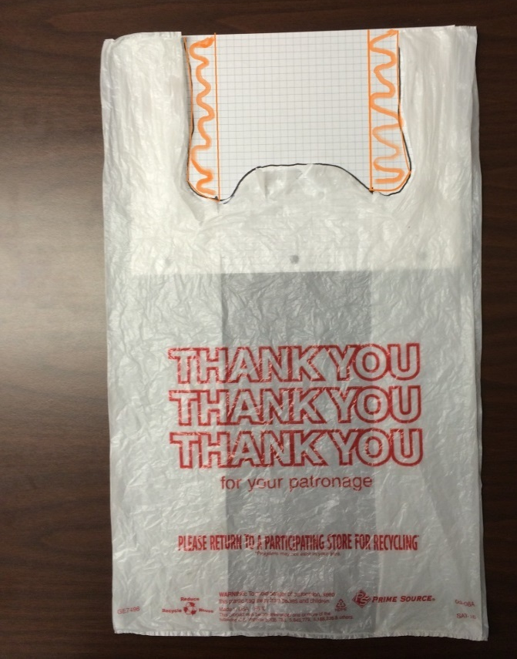
Figure 4-1. T-Shirt Bag.

- Count the squares and divide this number by the number of squares per square inch (sq in) (i.e., 16 – ¼ inch squares = 1 sq in) to determine the total area of the cutout. Adjust your total area by taking into account the number of layers for each region counted. (Figure 2)
- Once the total area of the bag has been determined, take the total area of the cutout and divide it by the total area of the bag to calculate the percentage of the cutout.
- Compute and record the weight of the bag without the cutout by subtracting the calculated net weight of the cutout from the total target net weight of the bags being tested. The calculated net weight of the cutout is determined by multiplying the total target net weight of the bag by the percentage of the area of the cutout.
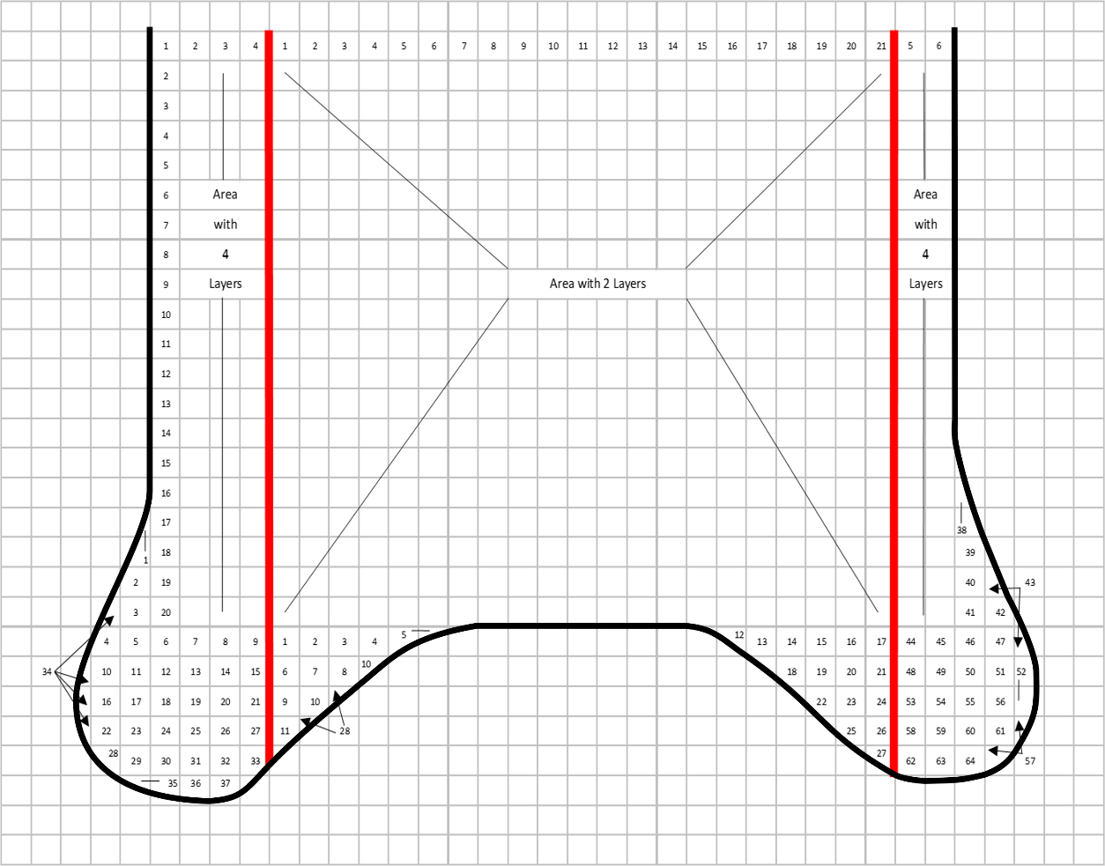
Figure 4-2. Polyethylene Bag Outline on Graph
Example:
    - To find the total area of the cut out, determine the area for the 4-layer region and the area for the 2-layer region and add them together. For example:
4-Layer Area: 4 [(6 × 20) + 64 additional boxes]/16 squares/sq in = 46 sq in
2-Layer Area: 2 [(21 × 20) +28 additional boxes]/16 squares/sq in = 56 sq in.
The area of the cut out = 46 sq in + 56 sq in = 102 sq in.
- If the total area for the bags prior to cut out is 836 sq in, then the percentage of the cut out is 12.2 %, (102 sq in ÷ 836 sq in = 0.1220 × 100)
- Multiply the theoretical weight by 12.2 % to determine the weight of the cut out for the bags, then subtract this from the target net weight to determine the weight of the bags.
- If the calculated target net weight for a box of bags is 11.57 lb, then 12.2 % would weigh 1.41 lb (11.57 lb × 12.2% = 1.41lb). Therefore, the target net weight of the product: 11.57 lb − 1.41 lb = 10.16 lb
(Amended 2017)

4.5.3. Evaluation of Results
- Individual Thickness
Note: Refer to Appendix A, Table 2-10. Exceptions to the MAVs for Textiles, Polyethylene Sheeting and Film, Mulch and Soil Labeled by Volume, Packaged Firewood, and Packages Labeled by Count with 50 Items or Fewer, and Specific Agricultural Seeds Labeled by Count.
(Amended 2010)
- On polyethylene with a declared thickness greater than 25 µm (1 mil or 0.001 in): an individual thickness measured may be up to 20 % less than the declared thickness.
- On polyethylene with labeled thickness less than or equal to 25 µm (1 mil or 0.001 in), individual thickness measurements may be up to 35 % below the labeled thickness.
Count the number of values that are smaller than specified MAVs (0.8 × labeled thickness if 25 µm [1 mil] or greater or 0.65 × labeled thickness, if less than 25 µm [1 mil]). If the number of values that fail to meet the thickness requirement exceeds the number of MAVs permitted for the sample size, the lot fails to conform to requirements. No further testing of the lot is necessary. If the number of MAVs for thickness measurements is less than or equal to the number permitted for the sample size, go on to Evaluation of Results – Average Thickness.
- Average Thickness
The average thickness for any single package should be at least 96 % of the labeled thickness. This is an MAV of 4 % (refer to Appendix A, Table 2-10. Exceptions to the MAVs for Textiles, Polyethylene Sheeting and Film, Mulch and Soil Labeled by Volume, Packaged Firewood, and Packages Labeled by Count with 50 Items or Fewer, and Specific Agricultural Seeds Labeled by Count.) Circle and count the number of package average thickness values that are smaller than 0.96 × labeled thickness. If the number of package average thicknesses circled exceeds the number of MAVs permitted for the sample size, the lot fails to conform to requirements. No further testing of the lot is necessary. If the number of MAVs for package average thickness is less than or equal to the number of MAVs permitted for the sample size, proceed to Section 2.3.7. “Evaluate for Compliance” to determine if the lot meets the package requirements for average thickness.
(Amended 2010)
Background/Discussion:
The most efficient means for testing polyethylene bags is by weight. Polyethylene bags that include a cut out (T-shirt bags) are especially problematic because there is not currently a method to determine the amount of cut out material.
At the 2017 NCWM Interim Meeting, Ms. Macey (California) stated this is important for mil thickness of bags. The polyethylene test procedure was being reviewed and this change aligns with the test procedure. The NIST Technical Advisor remarked this test procedure was used in a training class, and it is fully developed. The Committee is recommending this as a Voting item.
At the 2017 NCWM Annual Meeting, the Committee reviewed all submitted proposed changes. The Committee will not be moving forward the language in Section 4.5.2.a.2. Test Procedure. There is developing work being done to the companion Uniform Method of Sale for Polyethylene (Item 2302-5). When the method of sale issue has been resolved, the Committee grants editorial privileges for Section 4.5.2.a.2. to be updated. The current NIST handbook language for this specific session will remain unchanged.
Regional Association Comments:
WWMA did not forward this item to NCWM.
At the 2017 CWMA Annual Meeting, Mr. Hayes (Missouri) suggested a note to address other types of plastic sheeting products, gave an example of plastic bale wrap and plastic tubes for silage. He also commented there are other types of plastic sheeting on the market, which may need to be reviewed.
The SWMA received comment from the NIST Technical Advisor that they would be using this procedure next week in a training course being taught in California. The SWMA recommended that NIST and California provide data/feedback to the NCWM L&R Committee on how well this procedure works to the National Committee. The SWMA forwarded the item to NCWM and recommended Informational status.
At the 2016 NEWMA Interim Meeting, the NIST Technical Advisor remarked there is additional work being done in the field to gather additional test data. NEWMA forwarded the item to NCWM and recommended Informational status. At the 2017 NEWMA Annual Meeting, it was noted this item is a companion to Item 2302-5. A state regulator from California, who was present at the NEWMA meeting, stated this proposal came from a NIST Packaging and Labeling class. These items are noted changes that resulted from this training.
Additional letters, presentations, and data may have been part of the Committee’s consideration. To review the supporting documentation, please refer to the “Report of the 101st National Conference on Weights and Measures” (SP1212, 2016) at: nvlpubs.nist.gov/nistpubs/SpecialPublications/NIST.SP.1212.pdf.

2600-5 W Table 2-12. Upper and Lower MAV Limits for Fish and Fishery Products Labeled with a Count
(This item was Withdrawn.)
Source:
U.S. Department of Commerce, NOAA Seafood Inspection (2017)
Purpose:
The U.S. Department of Commerce, NOAA Seafood Inspection intends to apply NIST Handbook 133 “Maximum Allowable Variables (MAVs)” to Declared Counts to all applicable U.S. Grade Standards for Fish and Fishery Products. This proposal would add a new MAV table, which can be used by state and local officials, to verify the supplemental declared count statement on a package (i.e., shrimp and scallops), recognizing that the method of sale is net weight.
Item under Consideration:
Amend NIST Handbook 133, Appendix A as follows:
U.S. Department of Commerce, NOAA Seafood Inspection
Table 2-12. Upper and Lower MAV Limits for Fish and Fishery Products Labeled with a Count
Sample Size¹ | Number of Package Errors Allowed to Exceed the Maximum Allowable Variations
6 | 0
Labeled Quantity | Maximum Allowable Variations (MAVs)
17 or less | 0
18 to 50 | 1
51 to 83 | 2
84 to 116 | 3
117 to 150 | 4
151 to 200 | 5
201 to 240 | 6
241 to 290 | 7
291 to 345 | 8
346 to 400 | 9
401 to 465 | 10
466 to 540 | 11
541 to 625 | 12
626 to 725 | 13
726 to 815 | 14
816 to 900 | 15
901 to 990 | 16
991 to 1075 | 17
1076 to 1165 | 18
1166 to 1250 | 19
1251 to 1333 | 20
1334 or more | 1.5 % of labeled count rounded off to the nearest whole number.
¹The sample size for all lot sizes is six.
(A note should be included in the Scope of Chapter 4 indicating when an inspector uses Table 2-12 to verify declared counts [i.e., shrimp and scallops] the inspector should randomly select six packages from the sample and, if the sample size is under six, select all packages.)
Background/Discussion:
Per Federal Regulation 21 CFR Part 101, finished product packages with label declarations must meet labeling requirements. When a processor labels a finished product package, label declarations must be truthful and accurate per FDA labeling laws. Such statements that must meet labeling laws include statement of identity, ingredients (if applicable), name of manufacturer or distributor, and other information such as net weights, counts per package and counts per pound.
NOAA Seafood Inspection inspects fish and fishery products for net weight compliance since the method of sale for such products is net weight. In the interest of harmonization, NOAA recently adopted NIST Handbook 133 guidance for determining net weight compliance to align our inspection practices with NIST and state agencies.
NOAA Seafood Inspection also evaluates labeling claims, including declared counts per package and declared counts per pound. NOAA recently adopted NIST Handbook 133 guidance by applying the MAVs in Table 2-7 to the upper and lower limits for declared counts per package and declared counts per pound to fish and fishery products.
Declared Counts Per Package and Declared Counts Per Pound
When evaluating fish and fishery products such as shrimp or scallops, products that have a higher count per pound are smaller in size and less expensive. And, products that have a lower count per pound are larger in size and more expensive. Products sold with a higher count per pound than the declared count per pound negatively affects the consumer’s purchase price. Products sold with an either a higher or lower count per pound than the declared count per pound can also affect the product’s intended use (i.e., baked stuffed shrimp instead of cocktail shrimp or jambalaya).
Applying MAVs to higher counts per package and higher counts per pound as well as lower counts per package and lower counts per pound would establish an acceptable threshold for variability for the producer, as well as establishing a uniform procedure to ensure that declared counts per package and declared counts per pound meet labeled claims for consumers.
For clarification purposes, the following information provides guidelines to determine a sample unit’s compliance for shrimp count per package and shrimp count per pound.
Shrimp Count Per Package and Shrimp Count Per Pound
Size designation (count per pound) refers to the number of whole, unbroken, and undamaged shrimp on a per pound basis in a primary package (sample unit). Whole shrimp refers to unbroken and undamaged shrimp, that have a minimum of five (four) complete segments with or with tail fins attached for ≤ 70 (> 70) determined shrimp count per pound, respectively.
To determine the actual count per package or actual count per pound, the whole, unbroken, and undamaged shrimp are separated from any physical adulteration, extraneous material, broken shrimp, damaged shrimp, shrimp pieces and unusable material present in the sample unit and defined below.
- Physical adulteration refers to the presence of any visible foreign material that has not been derived from product and (1) poses a threat to human health, and includes, but is not limited to animal excreta, animal infestation, glass, metal, plastic, or wood or (2) renders the product unfit for human consumption. It does not include (1) extraneous material or (2) distinct and persistent odors or flavors, which have not been derived from product and pose a threat to human health and includes, but is not limited to contaminants such as solvents or fuel oil.
- Extraneous material refers to visible extraneous material that has not been derived from product and (1) does not pose a threat to human health, and includes, but is not limited to, seaweed, or (2) does not render the product unfit for human consumption.
- Broken shrimp refers to shrimp that have a break in the flesh more than or equal to one-half the shrimp’s thickness where the break occurs and the break results in fewer than five (four) whole consecutive segments, with or without tail fins attached for ≤ 70 (> 70) determined shrimp count per pound, respectively.
- Damaged shrimp refers to shrimp that are crushed or mutilated so as to materially affect its appearance and usability and the damage results in fewer than five (four) whole consecutive segments, with or without tail fins attached for ≤ 70 (> 70) determined shrimp count per pound, respectively.
- Shrimp pieces refers to shrimp that have fewer than five (four) segments, with or without tail fins attached for a sample unit with ≤ 70 (> 70) determined shrimp count per pound, respectively.
- Unusable shrimp material refers to any objectionable material that has been derived from the shrimp and does not pose a threat to human health, and includes, but is not limited to detached walking legs, detached shells, detached antennae, detached heads, or detached tail fins.
Then, the whole, unbroken, and undamaged shrimp are counted and weighed to determine the shrimp count per pound.
Example 1: During product inspection, it was determined that a 16.23-ounce sample unit has 75 whole, unbroken, and undamaged shrimp that weigh 15.58 ounces. The sample unit’s size designation – shrimp count per pound is calculated as 77.02 shrimp count per pound.
$$\frac{75 whole shrimp}{15.58 ounces}= \frac{x whole shrimp}{16.00 ounces}$$
$$X=77.02 shrimp count per pound$$
Example 2: During product inspection, it was determined that an 8.35-ounce sample unit has 30 whole, unbroken, and undamaged shrimp that weigh 7.35 ounces. The sample unit’s size designation – shrimp count per pound is calculated as 65.31 shrimp count per pound.
$$\frac{30 whole shrimp}{7.35 ounces}= \frac{x whole shrimp}{16.00 ounces}$$
$$X=65.31 shrimp count per pound$$
When a count per package or count per pound is declared on the label, the NIST Table is used to ascertain MAVS and to determine if a sample unit is in compliance.
Examples of Using NIST Table to Ascertain MAVS for Count per Pound (CPP)
- An 8-ounce sample unit with a declared 35 shrimp count per package should have 35 whole shrimp (and a retail price based on 70 shrimp count per pound). Using Table 2-12 would allow 34 to 36 whole shrimp to meet the labeling declaration for declared count per package.
- A 12-ounce sample unit with a declared 150 shrimp count per package should have 150 whole shrimp (and a retail price based on 200 shrimp count per pound). Using Table 2-12 would allow 146 to 154 whole shrimp to meet the labeling declaration for declared count per package.
- An 8-ounce sample unit with a declared 60 to 80 shrimp count per pound should have 30 to 40 whole shrimp. Using Table 2-12 would allow 29 to 41 whole shrimp to meet the labeling declaration for declared count per pound.
- A 2-pound (32-ounce) sample unit has a declared 100 to 125 shrimp count per pound should have 200 to 250 whole shrimp. Using Table 2-12 would allow 195 to 257 whole shrimp to meet the labeling declaration for declared count per pound.
NOAA Seafood Inspection acknowledges that the method of sales for fish and fishery products is net weight and during all product inspections determines net weight compliance. However, some products such as shrimp and scallops are initially priced and sold using the standard U.S. quantitative unit “count per pound,” then sold on a net weight basis. In order to demonstrate the relevance for applying MAVs to count per pound ranges, NOAA Seafood Inspection would be pleased to present retail shrimp or scallop packages with different declared counts per pound to the SWMA and NEWMA meeting attendees.
At the 2017 NCWM Interim Meeting, there was discussion regarding the reference of scallops and shrimp; however, the table list “fish and fishery” products. There is also a term of upper limits being used, but this is not a term used in NIST Handbook 133. If this term is adopted is needs further explanation.
At the Committee work session, it was determined that considerable work needs to be done to develop this proposal. The Committee encourages the submitter to take into consideration comments heard at the SWMA and NEWMA regional meetings. The submitter should work out internal (NOAA) considerations prior to coming to NCWM. The submitter should also be clearer on what their proposal is considering. The Committee discussed the regional presentation and discussion regarding the segmentation of shrimp to develop a count. This is a quality procedure for NOAA and not a procedure for weights and measures officials. There is nothing documented on segmenting shrimp within NIST Handbook 133 and is this a role of the weights and measures officials? Is this a quality or quantity issue? Table 2-12 MAV Limits for Shrimp and Scallops should be reviewed for clarity on the table title and headers. The Committee Withdrew this item.
Regional Association Comments:
The SWMA heard a presentation from Ms. Jane Fox-Dobson with NOAA seafood inspection. Ms. Fox-Dobson remarked that NOAA seafood inspection adopts NIST Handbook 133. It was clarified by the NIST Technical Advisor that states will continue to do inspections using the proper method of sale of net weight. During the Committee work session, there were questions concerning, “if count would just be applied toward seafood with the U.S. Grade Standard.” Ms. Fox-Dobson remarked they are a fee for service program, and they do not look at the international marketplace. There was discussion on renaming the table to read “Table 2-12. MAV Limits for Shrimp and Scallops labeled with a supplementary declaration” and the column that read “Labeled Quantity” would read “Labeled Count.” After further clarification from Ms. Fox-Dobson, she would need inspectors to also follow the NOAA procedure for count. The Committee believed too many changes were needed, and this was not heard during open hearings. The SWMA forwarded this item to NCWM and recommended Developing status.
NEWMA received a presentation from Ms. Fox-Dobson of NOAA, regarding maximum allowable volume requirements in seafood regulations. NIST, OWM asked why NOAA isn’t developing their own handbook? These new proposed regulations may result in language weights and measures will not adopt. Also, who would train inspectors on the testing methods? An industry representative commented this proposal is new for the industry as well, so they want to have some time to review it for consideration. The submitter will be further developing the proposal and include various updates for consideration at the 2017 NCWM Interim Meeting in January. A regulator from the New York commented, if we adopt this proposal, we would have to start verifying other supplemental information statements on packaging. NEWMA forwarded this item and recommended it be Developing.

2700 OTHER ITEMS

2700-1 D Fuels and Lubricants Subcommittee
Source:
The Fuels and Lubricants Subcommittee (2007)
Purpose:
Update the Uniform Engine Fuels, Petroleum Products, and Automotive Lubricants Regulation in NIST Handbook 130 including major revisions to fuel ethanol specifications. Another task will be to update the Basic Engine and Fuels, Petroleum Products, and Lubricants Laboratory Publication.
Item under Consideration:
This item is under development. All comments should be directed to Dr. Matthew Curran, FALS Chair at (850) 921-1570, Matthew.Curran@freshfromflorida.com, or Ms. Lisa Warfield, NIST Technical Advisor at (301) 975-3308, lisa.warfield@nist.gov.
Background/Discussion:
The Subcommittee met on Sunday, January 10, 2016, at the NCWM Interim Meeting in San Diego, California, to review several significant issues related to fuel and motor vehicle fluid standards appearing before the L&R Committee. The meeting began with an update from an agenda review teleconference, which was held on Tuesday, December 15, 2015. There were six items on the L&R agenda with one additional related item in the Method of Sale section, which were discussed by FALS. The meeting also consisted of updates from the three informal focus groups (FG) working within FALS. Summaries are detailed below. Finally, a fourth informal focus group was formed within FALS during the Sunday meeting to investigate L&R Item 237-5 relating to minimum requirements for water in fuel storage tanks.
The Subcommittee met on Sunday, January 8, 2017, at the NCWM Interim Meeting in San Antonio, Texas, to review several significant issues related to fuel and automotive fluid standards appearing before the L&R Committee. The meeting began with an update from an agenda review teleconference, which was held on Tuesday, January 3, 2017. There were four items on the L&R agenda with two additional related items in the Method of Sale section, which were discussed by FALS. The meeting also consisted of updates from four informal focus groups (IFG) working within FALS; further discussion on some of the agenda items; and several presentations from FALS members. Summaries of the IFGs are detailed below. Finally, the Subcommittee discussed membership and voting guidelines that would be applied to agenda items and issues addressed within FALS.
The Subcommittee met on Sunday, July 16, 2017, at the NCWM Annual Meeting in Pittsburgh, Pennsylvania, to review several significant issues related to fuel and motor vehicle fluid standards appearing before the L&R Committee. The meeting began with an update from an agenda review teleconference, which was held on Thursday, June 8, 2017. There were four items on the L&R agenda with two additional related items in the Method of Sale section, which were discussed by FALS. Item 2307-2 related to Ethanol Flex Fuels was discussed at the meeting as the submitter was not able to attend the agenda review teleconference. The meeting also consisted of updates from the four informal focus groups (FG) working within FALS. Summaries are detailed below.
Handbook 130 Harmonization IFG: Ms. Marilyn Herman delivered an update to the FALS membership. She noted the FG has held several teleconferences and met at the 2015 NCWM Annual Meeting as well as at the ASTM International Meeting in Austin, Texas, in December 2015 to gather input and suggestions. The FG has developed several drafts and has posted them on the NCWM collaboration site for all to review and comment. She encouraged members to continue to review the document and provide comment. While significant progress has been made, she noted the project is going to take time due to the magnitude of possible changes to the handbook as well as how to address the recently released Federal Trade Commission final rule pertaining to labeling requirements for ethanol blended fuels. At the 2017 NCWM Interim Meeting, Ms. Herman provided an update to the FALS membership. She noted the IFG has held several teleconferences and distributed e-mails to gather input and suggestions and review existing semi-final drafts. She provided an update of the path forward and indicated the IFG was targeting completing work to have it ready for consideration during the 2017 regional and 2018 national cycle. At the 2017 NCWM Annual Meeting, Mr. Randy Jennings commented that the informal FG reviewed the latest draft proposal to NIST Handbook 130, and the comments on the draft during a four-hour call the previous week. Mr. Jennings will provide a revised document with changes based on the call for consideration to recommend as Voting item at the 2018 NCWM Interim Meeting.
Renewable Diesel Labeling and Definitions FG: At the 2015 NCWM Annual Meeting, Ms. Rebecca Richardson (MARC IV Consulting) delivered an update to the FALS membership. She noted they had held several teleconferences and exchanged e-mails and were still trying to determine what course of action, if any, should be recommended through FALS about the FTC labeling requirements for renewable diesel fuels. At the 2017 NCWM Interim Meeting Ms. Richardson provided an update to the FALS membership on behalf of Mr. Allan Morrison (California). She noted that Allan had received renewed interest in the work of this IFG and has reviewed the history of the issues. At the 2017 NCWM Annual Meeting, Mr. Morrison requested the informal FG resume work, but at the meeting FALS was informed the informal FG had not had a chance to meet since the request was made to resume work.
Premium Diesel IFG: Mr. Ron Hayes provided an update to the FALS membership on behalf of Mr. Manuch Nikanjam (Chevron Global Downstream, LLC) and Mr. Randy Jennings (Tennessee). Mr. Ron Hayes (Missouri) noted the informal FG was reviewing all aspects of the premium diesel requirements including fuel cleanliness, energy content, corrosion, stability, filter blocking tendencies, lubricity, injector deposits, cetane number, aromatics, and metals. The informal FG held one face-to-face meeting in Nashville, Tennessee, and has had numerous other calls and e-mail exchanges. They have broken the topics up into categories to determine the utility in carrying them forward and will convene monthly until those evaluations have been completed. The hope of the informal FG is to have a proposal ready for the 2018 meeting cycle.
Water in Storage Tanks Informal FG: Mr. Mahesh Albuquerque provided an update and revisited the intent if his proposal since it is related to current L&R agenda Item 2307-3. The intent of the proposal is to harmonize the permissible amount of water allowed in both blended and unblended fuel storage tanks. However, there has been many questions raised as to the benefit of moving forward in this direction. The informal FG is working to address cost analysis issues as well as how effective such a change would be if implemented. (Refer to Item 2307-3 for additional information.)
Additional letters, presentations, and data may have been part of the Committee’s consideration. To review the supporting documentation, please refer to the “Report of the 101st National Conference on Weights and Measures” (SP1212, 2016) at: nvlpubs.nist.gov/nistpubs/SpecialPublications/NIST.SP.1212.pdf.

2700-2 D Packaging and Labeling Subcommittee
Source:
Packaging and Labeling Subcommittee (2011)
Purpose:
Provide an update of the activities of this Subcommittee which reports to the L&R Committee. The mission of PALS is to assist the L&R Committee in the development of agenda items related to packaging and labeling. The Subcommittee will also be called upon to provide important and much needed guidance to the regulatory and consumer packaging communities on difficult questions. PALS will report to NCWM L&R Committee. The Subcommittee is comprised of a Chairperson and eight voting members.
Item under Consideration:
This item is under development. All comments should be directed to Mr. Chris Guay, Packaging and Labeling Subcommittee Chair, at (513) 983-0530, guay.cb@pg.com or Mr. David Sefcik, NIST Technical Advisor, at (301) 975-4868, david.sefcik@nist.gov.
Background/Discussion:
The Package and Labeling Subcommittee (PALS) comprised of four voting regulatory officials (one from each region) and four voting from industry (retailers and manufacturers) in addition to its Chairman and NIST Technical Advisor. Mr. Guay, PALS Chair, reported that work is currently being held through monthly webinar meetings and at the NCWM meetings. Members of NCWM can participate in the PALS webinar meetings by contacting Mr. Guay. PALS members are responsible for providing updates at their Regional Meetings. Mr. Guay added, PALS will be developing proposals and providing guidance and recommendations on existing proposals as assigned by the NCWM L&R Committee. He also stressed the importance of having key federal agencies (FDA, FTC, and USDA) participating.
Mr. Guay reported, the Subcommittee is working on a Recommended Practice Document for quantity expressions appearing on the principal display panel (PDP) in addition to the statement of net quantity and is also considering further development of the following items:
- Additional Net Content Declarations on the Principal Display Panel to Meet U.S. and International Requirements – Package net contents are most commonly determined by the product form, for example – solid products are labeled by weight and liquid products are labeled by volume. Semi-solid products such as pastes, creams, and viscous liquids are required to be labeled by weight in the United States and by volume in Canada.
- Icons in Lieu of Words in Packaged labeled by Count – Can a clear and non-misleading icon take the place of the word “count” or “item name” in a net content statement? While existing Federal regulation requires regulatory label information to be in “English,” the increasing presence of multilingual labels and the growing diversity of the U.S. population suggest more consumers are served with a clear and non-misleading icon.
- Multipacks and Bundle Packages – The net content statements for multipacks and bundled packages of individually labeled products can be different based on the approach used to calculate them. The difference is the result of the degree of rounding for dual U.S. customary units and metric declarations. Using two apparently valid but different methods can yield one net content statement result, that provide better accuracy between the metric and U.S. customary unit declarations and a different net content result, which is consumer friendly.
At the 2015 NCWM Interim Meeting, Mr. Guay (PALS Chair) reported PALS was making progress on a Recommended Practice Document for quantity-related statements appearing on the package net content statement outside of the required statement of net quantity. He noted that no guidance or regulation exists for these types of statements and, as a result, every manufacturer creates their own approach. A Recommended Practice Document is expected to help bring uniformity and consistency by providing a reference for these types of label statements. This document will either be a stand-alone document on the NCWM website or included as part of another NCWM publication.
At the 2015 NCWM Annual Meeting, Mr. Guay (PALS Chair) reported the FTC has recommended adoption of the five-amendments recommended by PALS into their final FPLA regulations. FTC also responded to each recommendation made by PALS. FTC did not propose adoption of amendments from any other source.
Mr. Guay (PALS Chair) and Angela Godwin (Ventura County, California) gave an abbreviated presentation providing details of the developing Recommended Practice Document to build awareness and to get broader input on this item. The Subcommittee’s goal is to have the document drafted by early 2016, so that it can be refined and edited prior to the 2016 NCWM Annual Meeting. It is expected to be submitted for regional review in the fall of 2016.
At the 2016 NCWM Interim Meeting Mr. Guay (PALS Chair) and Mr. Hal Prince (PALS SWMA representative) gave a presentation on the developing Recommended Practice Document. PALS noted this document is envisioned to be a stand-alone document on the NCWM website and PALS is targeting to have the document drafted by April 2016 with the goal of getting a broader review by the NCWM membership prior to submission as a formal NCWM item.
At the 2016 NCWM Annual Meeting, Mr. Guay (PALS Chair) reported the Subcommittee continues to address question and issues surfacing as the PALS Subcommittee works on the Recommend Practice Document.
At the 2017 NCWM Interim Meeting, Ms. Ann Boeckman (PALS Member) provided a presentation to the PALS summarizing the history of the U.S. Fair Packaging and Labeling Act, FTC’s FPLA regulations, and positions taken by FTC when questions were referred to the agency. The PALS Committee is planning to contact FTC and FDA to discuss how PALS can provide guidance to manufacturers consistent with FTC and FDA requirements and interpretations.
At the 2017 Annual Meeting, PALS met with a representative of the FDA to provide a detailed overview of the background, development, and status of the developing Recommended Best Practice Document. While also invited, FTC was unable to attend this meeting. PALS is planning to continue development of this document and continue outreach to the federal agencies as it works to finalize the first draft of the document. PALS plans to share the Best Practice Document with NCWM members for input once the draft is complete.
Regional Association Comments:
Additional letters, presentations, and data may have been part of the Committee’s consideration. To review the supporting documentation, please refer to the “Report of the 101st National Conference on Weights and Measures” (SP1212, 2016) at: nvlpubs.nist.gov/nistpubs/SpecialPublications/NIST.SP.1212.pdf.

2700-3 W NIST Handbook 158, “FiELD sAMPLING pROCEDURES FOR FUEL AND MOTOR OIL qUALITY tESTING”
Source:
NIST Office of Weights and Measures (2017)
Purpose:
NIST Handbook 158, “Field Sampling Procedures for Fuel and Motor Oil Quality Testing: A Handbook for Use by Fuel and Oil Regulatory Officials” was published by NIST, OWM in 2016. NIST is requesting the NCWM L&R Committee delegate to the Fuels and Lubricants Subcommittee (FALS) the responsibility for maintenance of this handbook. FALS have the most subject matter experts to assist with any modifications that may arise. NIST OWM would serve as Technical Advisors and editor of this handbook.
Item under Consideration:
Adopt NIST Handbook 158, “Field Sampling Procedures for Fuel and Motor Oil Quality Testing: A Handbook for Use by Fuel and Oil Regulatory Officials.”
See Appendix A for NIST Handbook 158 in its entirety.
Background/Discussion:
Fuel and motor oil quality programs are implemented to provide an official presence in the marketplace and to verify that sellers of engine fuels and motor oils have control systems in place, which ensure the products they sell conform to the quality specifications in federal and state laws and regulations. Routine, unannounced verification of fuel and motor oil quality enables the programs to identify sellers and their suppliers who have quality control systems in place and to focus enforcement resources on those who do not. This handbook outlines how samples are to be taken, identified, protected, and transported to a laboratory for testing. It also provides information on safety and sampling equipment and includes illustrations of the equipment and forms described in the text. Adoption and use by regulatory programs may improve the accuracy and reliability of quality testing and contribute to national uniformity in sampling methods.
NIST heard from some states, which had additional changes, that they would like to have reviewed. For these reasons, NIST will continue to review any additional changes and continue to maintain this document. The Committee Withdrew this item
Regional Association Comments:
The WWMA received a comment from the submitter that this item was developed to provide a fuel sampling handbook. NIST OWM does not have the resources or expertise to continuously maintain this document and asks it to be turned over to the experts in the Fuels and Lubricants Subcommittee for ongoing maintenance so it can remain a current, relevant, useful resource to states. The submitter notes this book addresses the sampling procedure necessary to obtain E15 samples from blending dispensers, which may be used by EPA in their individual fuel sampling programs. The WWMA believed this document is valuable and assignment to the L&R Committee would ensure it remains a relevant tool for Weights and Measures jurisdictions for years to come. The WWMA recommended forwarding the document to the NCWM Professional Development Committee for a review of Section 3. Safety and Environment and to solicit nationwide comments on that section. The WWMA forwarded the item to NCWM and recommended it as an Informational item.
At the 2016 CWMA Interim Meeting received a comment from a regulator that a great deal of effort had gone into this draft. He is hoping for additional reviews from FALS, other regions, state regulators, and industry. The CWMA forwarded the item to NCWM and recommended it as an Informational item.
The SWMA forwarded the item to NCWM with the modifications that were submitted by the submitter of the proposal (shown below) and recommended it as an Informational status.
III. SAFETY AND ENVIRONMENT
C. Static Electricity
The movement or separation of materials, including liquids, generates static electricity. When these materials are different, such as when fuel moves through a nozzle or a piece of clothing is separated from a car seat as a driver leaves the seat of a car, there is often a transfer of free electrons. If either or both of the materials are poor conductors, the potential for a static discharge can build as one material becomes negative and the other positive, depending on which accumulates excess electrons. When there is no bond or ground in place to dissipate the charges, the voltage builds and the static electricity seeks an outlet. High humidity does not prevent static electricity, and lightning, the strongest example of static electricity, is common during rainstorms.
Learn about Lightning Safety and use safe work practices when working outdoors by studying the National Oceanic and Atmospheric Administration (NOAA) factsheet on Lightning Safety at www.lightningsafety.noaa.gov/resources/OSHA_FS-3863_Lightning_Safety_05-2016.pdf. Additional Informational on lightning safety is available at www.lightningsafety.noaa.gov/.
Never underestimate the danger posed by static electricity when taking samples. Even though a specific fuel and air combination must be present for a spark to cause ignition, those conditions cannot be measured with the senses. Think and act as if a very hazardous situation exists whenever carrying out the tasks described in this handbook. Study and use good grounding practices and bonding equipment, noting that nothing completely eliminates the hazard presented by the accumulation of static electricity, which can build up rapidly for a wide variety of reasons in different sources (e.g., on clothing or the flow of fuel from the nozzle into a sampling container). Before pouring fuel into another container or from a nozzle into a container, be sure they are bonded or grounded to each other. For example, place the nozzle against the opening of the container and insert it as deep as possible (use a fill tube if available) to reduce splash filling and to maintain a smooth flow so that droplets do not form. Remember to ground equipment in accordance with the instructions of the manufacturer.
Sampling procedures can introduce spark promoters into storage tanks or transport compartments so extra caution, good grounding procedures and special non-sparking equipment and tools, must be used (e.g., cords made from synthetic materials such as nylon could cause charges as it rubs against a glove or other objects). When working around rusted steel, a spark hazard can be created if equipment made of aluminum or magnesium is used.
Be aware of the notices placed on and around dispensers and ensure compliance with any warnings (e.g., such as not filling a container while it is sitting on a plastic bed liner or while it is in an enclosed space such as the trunk of a car). After getting out of a vehicle, touch a metal part of the dispenser housing to discharge any electrostatic charge before going to the dispenser island.
Do not take samples during hail and thunderstorms or when lightning is observed.
Do not take samples from a dispenser connected to a storage tank being filled by a tanker truck because the filling process generates an electrostatic charge. Wait for 30 minutes after the delivery is completed before sampling from the tank or opening its fill ports.
It is a good habit to ground the static charge on one’s body by touching a metal part of the dispenser or support structure of a tank before taking a sample. On tanks and drums, touch the structure at a point at least 1 m (39 in) away from an opening.
NOTE: To learn more about static electricity as it relates to fuels, visit the Petroleum Equipment Institute’s “Stop Static” URL at www.pei.org/static. Also, view the U.S. Chemical Safety and Hazard Investigation Board’s video on one static caused explosion of non-conductive liquids to understand why reviewing SDSs periodically is essential: www.youtube.com/watch?v=tVZzdtnZaJk (see also: www.speedway.com/About/FuelSafety).
D. Personal Protective Equipment
- Clothing: Outer garments should be made from anti-static materials such as cotton (avoid wool and synthetics which, when moving against each other, can rapidly build up static charges). The color of the clothing should be suitable for the working environment and brightly colored or covered with a vest with light reflecting elements that conform to the Class 2 or 3 requirements in the latest edition of ANSI/ISEA 107 “High-Visibility Safety Apparel and Headwear.”¹ This type of high-visibility safety apparel alerts motorists and other equipment operators to an official’s presence in high traffic areas around fuel dispensers and storage tanks.
- Shoes: Steel toed shoes or boots manufactured to be static dissipative and slip resistant with oil/gas resistant soles should be worn. Footwear capable of causing sparks should not be worn.
- Eye/Face Protection: Safety glasses or goggles should be worn whenever samples are handled and especially during collection where splashing or spraying could occur.
- Skin: Avoid skin contact with all fuels, oils, and other chemicals. Hand protection should be worn whenever handling samples. Gloves should be made of Nitrile2, or coated with Neoprene or Tychem2. Materials such as Nitrile2 offer chemical resistance, are considered to be strong disposable gloves, and are generally safe for people who are allergic to latex. PVC-coated gloves are recommended for use with biodiesel.
- Toxic Materials: Avoid breathing toxic vapors. When fuel, oil vapors or mists are present, wear a National Institute for Occupational Safety and Health (NIOSH) –approved organic vapor/mist respirator and maintain it in accordance with the manufacturer’s instructions.
5. Toxic Vapors: Avoid breathing toxic vapors by taking samples only when there is adequate ventilation. As most fuel and oil samples are taken outdoors or in services bays, which are well ventilated, the use of a respirator is typically not required.
NOTE 1: This section is for Informational purposes and should not be taken as the basis for requiring the use of a respirator. An Industrial Hygienist can determine compliance with state or federal safety requirements by sampling the environment to determine if concentrations of vapor or mists are within occupational exposure limits. Sometimes additional ventilation or engineering controls can be used to reduce concentrations or if not, a National Institute for Occupational Safety and Health (NIOSH) approved respirator should be worn.
At the 2016 NEWMA Interim Meeting NIST OWM stated that this new handbook was mailed to all state directors, and is a published document available on the NIST website. She said NIST is asking that FALS maintain this handbook, so changes to the document would be submitted on a Form 15 for consideration by NCWM. NEWMA forwarded the item to NCWM, but did not recommend a status for possible adoption by NCWM. Instead, NEWMA recommended the NCWM L&R Committee accept the publication and refer it to FALS for continued maintenance.
Mr. Ethan Bogren, Westchester County, New York | Committee Chair
Mr. Louis Sakin, Towns of Hopkinton/Northbridge
Mr. John Albert, Missouri
Ms. Michelle Wilson, Arizona
Mr. Hal Prince, Florida
Ms. Rebecca Richardson, Marc IV Consulting | AMC Representative
Mr. Lance Robertson, Measurement Canada | Canadian Technical Advisor
Ms. Lisa Warfield, NIST OWM | Technical Advisor
Mr. David Sefcik, NIST OWM | Technical Advisor
Laws and Regulations Committee

Appendix A
Item: 2700-3, NIST Handbook 158
“Field Sampling Procedures for Fuel and Motor Oil Quality Testing”
NOTE: The handbook text that follows retains its original page numbering.

THIS PAGE INTENTIONALY LEFT BLANK

FIELD SAMPLING PROCEDURES FOR FUEL AND MOTOR OIL QUALITY TESTING

A HANDBOOK FOR USE BY FUEL AND OIL QUALITY REGULATORY OFFICIALS

Editor:
Kenneth Butcher
Linda Crown
David Sefcik
Lisa Warfield

Carol Hockert, Chief
Office of Weights and Measures
Physical Measurements Laboratory

http://dx.doi.org/10.6028/NIST.HB.158
April 2016

U.S. Department of Commerce
Penny Pritzker, Secretary
National Institute of Standards and Technology
Willie May, Under Secretary of Commerce for Standards and Technology and Director
NIST Handbook |  | 158
 | 2016 Edition

Certain commercial entities, equipment, or materials may be identified in this document in order to describe an experimental procedure or concept adequately. Such identification is not intended to imply recommendation or endorsement by the National Institute of Standards and Technology, nor is it intended to imply that the entities, materials, or equipment are necessarily the best available for the purpose.

National Institute of Standards and Technology Handbook 158, 2016 Edition
Natl. Inst. Stand. Technol. Handb. 158, 2016 Ed., 68 pages (April 2016)
CODEN: NIHAE2

ACKNOWLEDGEMENTS
The staff of the Office of Weights and Measures of the National Institute of Standards and Technology expresses sincere appreciation to the remarkable program directors, field officials, laboratory staff and other personnel from the States of California, Colorado, Georgia, Missouri, North Carolina and Virginia who shared their expertise, enthusiasm, knowledge and technical resources to make this handbook possible.

THIS PAGE INTENTIONALLY LEFT BLANK

Table of Contents
ACKNOWLEDGEMENTS iii
I. Purpose and Scope 1
II. Terminology 1
A. Chain-of-Evidence (custody) 1
B. Sample 1
C. Sampled Lot 2
III. Safety and EnviroNmenT 2
A. Awareness 2
B. Safety Data Sheet (SDS) 3
C. Static Electricity 3
D. Personal Protective Equipment 4
E. Other Safety and Accessory Equipment 4
F. Vehicle and Sample Case Markings for Hazardous Materials Transportation – Alerting Emergency Responders 5
G. Safety and Health Checklist and Periodic Review 6
H. Training 7
IV. Sampling Procedure OVerView 7
A. Data 8
B. Instruments and Sampling Equipment 8
C. Sampling Procedures 8
V. FUEL Sampling 8
A. Types of Manual Sampling 9
B. Samplers 9
C. Fuel Sample Containers 15
D. Washing and Drying Sample Containers (one example) 18
E. Capacities 19
F. Identifying Samples for Traceability 19
G. Sample Transport Cases 20
I. Security Seals for Containers and Boxes 21
J. Recommended Sampling Equipment - Nozzle Extender 21
VI. Sampling Procedure for Taking Fuel Samples at Retail Fueling Locations 22
A. Preparation 22
B. Sample and Containers 24
C. Sampling 26
D. Protecting Fuel Samples 31
E. Visual Inspection – (Per ASTM D6751 and ASTM D4814-09b - 6. Workmanship) 32
F. Transporting Samples to Laboratory 34
G. Chain of Evidence (Custody) and Transfer 34
H. Timeliness of Samples 34
I. Respond to Test Results – Time is of the Essence. 34
VII. Testing for Water in a Fuel Storage Tank 36
A. Storage Tanks 36
VIII. Labeling Enforcement Checklist and Sampling Procedure Outline for Taking Samples of Motor Oil at Service Locations 38
A. Preparation 38
B. Labeling and Documentation 39
C. Payment for Samples 44
D. Taking Oil Samples 45
Appendix A. – Monthly Safety and Health Equipment Checklist a-1
Appendix B. – Examples of Fuel Sampling and Chain-of-Custody Reports b-1
Appendix C. – Examples of Notice of Violation and Stop Sale Reports c-1
Appendix D. – References and Acknowledgments d-1

I. Purpose and Scope
Fuel and motor oil quality programs are implemented to provide an official presence in the marketplace and to verify that sellers of engine fuels and motor oils have control systems in place which ensure the products they sell conform to the quality specifications in federal and state laws and regulations. Routine, unannounced verification of fuel and motor oil quality enables the programs to identify sellers and their suppliers who have quality control systems in place and to focus enforcement resources on those who do not. This handbook outlines how samples are to be taken, identified, protected and transported to a laboratory for testing. It also provides information on safety and sampling equipment and includes illustrations of the equipment and forms described in the text.
NOTE: This handbook only covers the sampling of products stored at or near atmospheric pressure. For instance, the procedures for sampling fuels stored under pressure (e.g., LPG & CNG) are not included.

II. Terminology

A. Chain-of-Evidence (custody)
A record keeping system documenting the history of the collection, movement, storage location(s), custody (who possessed or controlled it), and other conditions (e.g., environmental and storage conditions, if critical to protecting the product) of a sample from the time it was obtained to the time it is accepted and logged into the laboratory management system for testing. See ASTM D4840 “Standard Guide for Sample Chain-of-Custody Procedures” for more information.

B. Sample
An amount of fuel or motor oil taken from a storage tank or dispenser that is representative of a larger amount of product. A majority of the samples collected are classified as either “open,” “routine,” or “regular” samples which means they are periodically collected through “announced” inspection visits (that is the official identifies his or her self and notifies the seller that an inspection will be made and samples collected). A sample collected specifically in response to a complaint can be taken after announcing the purpose of the visit or as an unannounced or “undercover” investigation. References to other names for samples are mentioned in the section on sampling but those terms (i.e., nozzle sample versus bottom sample) only refer to the point of collection of the sample and should not be confused with this definition.
Complaint/Undercover Investigation Sample: The collection of a sample(s) of the product(s) in question without announcing its collection to the station operator/owner. This can be done by means of a "trap tank" in an undercover vehicle or by purchasing the product and putting it in an Underwriters Laboratory or Factory Mutual listed, approved container.
User Collected Sample: A sample that was not collected by a regulatory official following the prescribed sampling procedures. This sample can be tested but no immediate enforcement action can be taken on negative results because the sample may have been contaminated or mishandled by the user. However, the test results may indicate the need to take an official sample.
NOTE: Evidence is something that tends to prove or disprove the existence of an alleged fact. A sample is “evidence” (and must be treated as such) but, it is typically called a “sample.” A sample that is not collected in accordance with prescribed procedures, or which has an undocumented chain of custody, will have little chance of being admitted as evidence in legal proceedings.
NOTE: For evidentiary purposes the collection of samples and related activities should be noted and documented either on paper or in digital data systems (these systems are acceptable for use only if there is a real-time continuous data back-up in operation and the data is maintained on a remote server) and all documents should bear the seal of the state or local authority as well as the identity of the agency collecting the sample. On each official document there should be a space for the placement of an official’s signature of attestation or execution along with the individual’s title and date of signing. Notes about an inspection should answer the questions who, what, when, where, why and how. This documentation allows for an independent evaluation of the work conducted and will allow an official to refresh his or her memory should he or she be asked to testify about an inspection at a later time.

C. Sampled Lot
The amount of fuel or motor oil represented by a particular sample (i.e., the volume of product in the storage tank).

III. Safety and EnviroNmenT

The procedures in this handbook require the handling of harmful and flammable materials in hazardous work locations. This handbook cannot encompass all of the dangers that may be present while taking fuel and motor oil samples. Officials must identify and comply with the health and safety practices for each work location, following all notices and local requirements. Both short term and long term effects can impact health so being proactive is essential.

The safety and physical well-being of officials and other individuals at the site is the first priority. This handbook does not address all of the safety issues that need to be considered before collecting samples. It is the official’s duty to obey the safety rules in effect in the work environment in which samples are collected and to seek out advice and training on good working practices. Officials must work safely so that their actions do not harm others. Collecting samples requires working in hazardous environments with dangerous materials, which means that even a minor incident could result in serious injury or death. Samples should never be transported in the passenger compartment of a vehicle. Samples must be transported in closed metal boxes designed to contain a spill when secured in the trunk of a car, pickup or van should an accident occur. Never smoke or allow open flames around a vehicle used to transport samples.

A. Awareness
The best safety tools are the senses of sight, smell, and hearing, and they should be used throughout the collection process to alert the official of potential dangers. The traits of vanity, apathy, and laziness have resulted in many injuries while common sense, patience, and safe work habits help to avoid them. Obtain and use available Personal Protective Equipment (PPE) regardless of appearance, such as safety glasses, fuel and oil resistant gloves, bright orange or yellow safety vests or respirators. The job of sampling these products increases the frequency of exposure to the inhalation of harmful fumes; and fuel splashes or spills may contaminate clothing, result in flash fires, or cause other hazards such as slippery walking and climbing surfaces. (Note: It is a good idea to carry a change of clothing in case clothes do get soaked with fuel or motor oil). In retail locations for example, there is the added danger of vehicular traffic and exposure to accidents caused by careless or distracted motorists or customers who may disregard safety rules and endanger others. No sample is worth an injury. Follow safety protocols and stop sampling immediately if safety cannot be controlled in the work environment. When working alone, extra precaution should be taken, such as advising the business personnel about the work that is being done and reminding them of their responsibility to ensure a safe working environment for those present on their property.

B. Safety Data Sheet (SDS)
Read the SDS for each type of fuel (e.g., gasoline, gasohol, kerosene, E-85, diesel, marine fuel, aviation fuel) or motor oil that is sampled and periodically review (e.g., every six months) updated SDSs to learn new information on the product.
NOTE: To learn more see the American Petroleum Institute’s “Safety Data Sheets: Petroleum Industry Practices” at this URL: http://www.api.org/~/media/Files/EHS/Health_Safety/SDS_Petroleum_Industry_Practices_Feb2009.pdf).
Additional information is available from OSHA at: https://www.osha.gov/Publications/HazComm_QuickCard_SafetyData.html and information on Safety Data Sheets is available at: https://www.osha.gov/Publications/OSHA3514.html
A detailed explanation of hazardous pictograms and symbols is available from OSHA at: https://www.osha.gov/Publications/OSHA3636.pdf

C. Static Electricity
The movement or separation of materials, including liquids, generates static electricity. When these materials are different, such as when fuel moves through a nozzle or a piece of clothing is separated from a car seat as a driver leaves the seat of a car, there is often a transfer of free electrons. If either or both of the materials are poor conductors, the potential for a static discharge can build as one material becomes negative and the other positive, depending on which accumulates excess electrons. When there is no bond or ground in place to dissipate the charges, the voltage builds and the static electricity seeks an outlet. High humidity does not prevent static electricity, and lightning, the strongest example of static electricity, is common during rainstorms.
Never underestimate the danger posed by static electricity when taking samples. Even though a specific fuel and air combination must be present for a spark to cause ignition, those conditions cannot be measured with the senses. Think and act as if a very hazardous situation exists whenever carrying out the tasks described in this handbook. Study and use good grounding practices and bonding equipment, noting that nothing completely eliminates the hazard presented by the accumulation of static electricity, which can build up rapidly for a wide variety of reasons in different sources (e.g., on clothing or the flow of fuel from the nozzle into a sampling container). Before pouring fuel into another container or from a nozzle into a container, be sure they are bonded or grounded to each other. For example, place the nozzle against the opening of the container and insert it as deep as possible (use a fill tube if available) to reduce splash filling and to maintain a smooth flow so that droplets do not form. Remember to ground equipment in accordance with the instructions of the manufacturer.
Sampling procedures can introduce spark promoters into storage tanks or transport compartments so extra caution, good grounding procedures and special non-sparking equipment and tools, must be used (e.g., cords made from synthetic materials such as nylon could cause charges as it rubs against a glove or other objects). When working around rusted steel, a spark hazard can be created if equipment made of aluminum or magnesium is used.
Be aware of the notices placed on and around dispensers and ensure compliance with any warnings (e.g., such as not filling a container while it is sitting on a plastic bed liner or while it is in an enclosed space such as the trunk of a car). After getting out of a vehicle, touch a metal part of the dispenser housing to discharge any electrostatic charge before going to the dispenser island.
Do not take samples during hail and thunderstorms or when lightning is observed.
Do not take samples from a dispenser connected to a storage tank being filled by a tanker truck because the filling process generates an electrostatic charge. Wait for 30 minutes after the delivery is completed before sampling from the tank or opening its fill ports.
It is a good habit to ground the static charge on one’s body by touching a metal part of the dispenser or support structure of a tank before taking a sample. On tanks and drums, touch the structure at a point at least 1 m (39 in) away from an opening.
NOTE: To learn more about static electricity as it relates to fuels, visit the Petroleum Equipment Institute’s “Stop Static” URL at http://www.pei.org/static Also view the U.S. Chemical Safety and Hazard Investigation Board’s video on one static caused explosion of non-conductive liquids to understand why reviewing SDSs periodically is essential: https://www.youtube.com/watch?v=tVZzdtnZaJk (see also: https://www.speedway.com/About/FuelSafety).

D. Personal Protective Equipment
- Clothing: Outer garments should be made from anti-static materials such as cotton (avoid wool and synthetics which, when moving against each other, can rapidly build up static charges). The color of the clothing should be suitable for the working environment and brightly colored or covered with a vest with light reflecting elements that conform to the Class 2 or 3 requirements in the latest edition of ANSI/ISEA 107 “High-Visibility Safety Apparel and Headwear.” This type of high-visibility safety apparel alerts motorists and other equipment operators to an official’s presence in high traffic areas around fuel dispensers and storage tanks.
- Shoes: Steel toed shoes or boots manufactured to be static dissipative and slip resistant with oil/gas resistant soles should be worn. Footwear capable of causing sparks should not be worn.
- Eye/Face Protection: Safety glasses or goggles should be worn whenever samples are handled and especially during collection where splashing or spraying could occur.
- Skin: Avoid skin contact with all fuels, oils and other chemicals. Hand protection should be worn whenever handling samples. Gloves should be made of Nitrile, or coated with Neoprene or Tychem2. Materials such as Nitrile2 offer chemical resistance, are considered to be strong disposable gloves, and are generally safe for people who are allergic to latex. PVC-coated gloves are recommended for use with biodiesel.
- Toxic Materials: Avoid breathing toxic vapors. When fuel, oil vapors or mists are present, wear a National Institute for Occupational Safety and Health (NIOSH) – approved organic vapor/mist respirator and maintain it in accordance with the manufacturer’s instructions.

E. Other Safety and Accessory Equipment
- Eye Wash: Portable eye wash station or emergency eye flush solution kit (e.g., Eyesaline² or equivalent).
2. Flashlight: Use an explosion proof flashlight, Class I Division 1 C&D, Class I Division 2 A, B, C, D, Class II Division 2 G, T3C Operating Temperature.
3. Tools: Set of non-sparking tools (including screwdrivers, adjustable wrenches, hammer and pry tools).
4. Traffic Cones: Four or more – 90 cm (36 in) fluorescent traffic cones (for blocking sampling area and tank openings).
- Fire Extinguishers:
  - Fire Extinguisher 5 kg (10 lb) or larger: B type extinguishers are best suited for petroleum fires but a multi-purpose fire extinguisher labeled A, B, C or any combination of those letters is recommended since any type of fire may be encountered. Assure that portable fire extinguishers with current, valid inspection dates are maintained in a fully charged and operable condition and kept in their designated places at all times except during use.
- Foam extinguishers for samples with more than 10 % ethanol by volume: AR Foam Fire Extinguisher – 6 L (2.5 gal): When the ethanol content of fuels is E10 or higher, an Alcohol Resistant (AR) foam must be used on gasoline fires as traditional AFFF foams have minimal effect.
- First Aid: A first aid kit that meets or exceeds American National Standard (ANSI) Z308.1-1998 "Minimum Requirements for Workplace First-aid Kits."
- Fuel Containers: 9.4 L to 19 L (2.5 gal to 5 gal) capacity metal fuel containers. These are used to hold fuel from nozzle flushes and to obtain undercover samples, and these must conform to “7-29 - Ignitable Liquid Storage in Portable Containers” from Factory Mutual - Global Property Loss Prevention Data Sheets and Underwriters Laboratory # 30 “Standard for Metal Safety Cans.” These requirements cover metal safety cans that have nominal capacities of 19 L (5 gal) or less and that are primarily intended to store and handle flammable and combustible liquids, such as gasoline, naphtha, kerosene, acetone, MEK, and similar liquids in accordance with the Flammable and Combustible Liquids Code, NFPA 30.
- Digital Evidence Data: Digital camera that is waterproof and shock resistant with GPS and wireless functions. This is for use in collecting photographic evidence such as signs, device markings, totalizer indications and other information.
- Spill Clean-Up Materials
a. “Fuel/Oil Spill Kit”: Kit is used to contain, clean up, and dispose of spilled liquids such as water, oil, and chemicals. Spill kits typically include absorbent products (such as socks, pillows, and pads), a disposal bag, a steel self-closeable container for storage, and absorbent wipes for cleaning up spills.
b. Wiping Cloths: Lint free wiping cloths or disposable wipes for wiping down sample containers and tools. Vehicles should be equipped with a self-closing steel trash can, stored outside the driver compartment, and used to hold disposable rags and wipes.

F. Vehicle and Sample Case Markings for Hazardous Materials Transportation – Alerting Emergency Responders
1. Vehicles: A vehicle used to transport limited quantities of hazardous material (less than 454 kg [1001 lb] aggregate gross weight) is not required to display hazardous material placards under U.S. Department of Transportation Hazardous Material Regulations. However, under that regulation, voluntary placarding is permitted to alert emergency responders that the vehicle’s cargo compartment may contain containers of flammable or combustible liquids. This information may be valuable in case the vehicle is involved in an accident or other emergency.
For the exemption see: 49 CFR §172.504 “General Placarding Requirements.”
(c) Exception for less than 454 kg (1,001 pounds). Except for bulk packagings and hazardous materials subject to §172.505, when hazardous materials covered by table 2 of this section are transported by highway, placards are not required on (1) A transport vehicle which contains less than 454 kg (1001 pounds) aggregate gross weight of hazardous materials covered by table 2 of paragraph (e) of this section; The exceptions provided in paragraph (c) of this section do not prohibit the display of placards in the manner prescribed in this subpart, if not otherwise prohibited (see §172.502), on transport vehicles which are not required to be placarded.
- Sample Cases: When “limited quantities” of flammable liquids are contained in carrying cases or shipping cartons, other exceptions and labeling requirements apply. Under this exemption, officials are permitted to transport Class 3 Flammable and Combustible Liquids without a special driver’s license and shipping papers are not required. However, individual container capacity must not exceed certain limits (for Packing Group II it is 1 L (0.3 gal) and carrying cases and shipping cartons must be labeled with a “limited quantities” placard which conforms to 49 CFR 172.315 such as shown below:
For the exemption see: 49 CFR §173.150 Exceptions for (Limited Quantities) of Class 3 (Flammable and Combustible Liquids).
§173.150 Exceptions for Class 3 (flammable and combustible liquids).
(a) General. Exceptions for hazardous materials shipments in the following paragraphs are permitted only if this section is referenced for the specific hazardous material in the §172.101 Table of this subchapter.
(b) Limited quantities. Limited quantities of flammable liquids (Class 3) and combustible liquids are excepted from labeling requirements, unless the material is offered for transportation or transported by aircraft, and are excepted from the specification packaging requirements of this subchapter when packaged in combination packagings according to this paragraph. A limited quantity package that conforms to the provisions of this section is not subject to the shipping paper requirements of subpart C of part 172 of this subchapter, unless the material meets the definition of a hazardous substance, hazardous waste, marine pollutant, or is offered for transportation and transported by aircraft or vessel, and is eligible for the exceptions provided in §173.156 of this part. In addition, shipments of limited quantities are not subject to subpart F (Placarding) of part 172 of this subchapter. Each package must conform to the packaging requirements of subpart B of this part and may not exceed 30 kg (66 pounds) gross weight. Except for transportation by aircraft, the following combination packagings are authorized: (1) For flammable liquids in Packing Group I, inner packagings not over 0.5 L (0.1 gallon) net capacity each, packed in a strong outer packaging; (2) For flammable liquids in Packing Group II, inner packagings not over 1.0 L (0.3 gallons) net capacity each, packed in a strong outer packaging. (3) For flammable liquids in Packing Group III and combustible liquids, inner packagings not over 5.0 L (1.3 gallons) net capacity each, packed in a strong outer packaging.
Reference: Find the latest version of these regulations at Code of Federal Regulations at: http://www.ecfr.gov.

G. Safety and Health Checklist and Periodic Review
Reorder replacement supplies immediately after use so adequate supplies are available to do the job. Also, during the first week of each month, safety and health related supplies should be inventoried and inspected to ensure that they are undamaged, any expiration of use dates are current and that equipment is ready for use. By setting a specific time to do the inspection, it will become a habit. Anticipate the need for replacement supplies so that they can be ordered to allow ample time to obtain them and have them delivered. A sample checklist for inspecting safety and health equipment is presented in Appendix A. “Safety and Health Equipment Checklist.”

H. Training
Prior to performing any sampling activities, officials should attend training courses or webinars in these subjects:
    - Fire Extinguishers: Use of fire extinguishers in fighting fires (a live fire demonstration is recommended).
For example see: Fire Extinguisher Training at http://emergency.yale.edu/sites/default/files/files/TMS-Fire-Extinguisher-Training.pdf
2. U.S. Department of Labor: Occupational Safety and Health Administration (OSHA) Training on Flammable and Combustible Materials and Emergency spill response including how to clean up small spills.
For example see: OSHA Flammable Liquids at https://www.osha.gov/dte/library/flammable_liquids/flammable_liquids.html
For example see: How Fire Departments Respond to Small Fuel Spills - Self Study at https://www.pca.state.mn.us/sites/default/files/c-er4-05.pdf
3. Ladder Safety: Sometimes climbing may be required to obtain samples, so courses on ladder safety and cargo tanker safety are recommended.
For example see: Ladder Safety - Self Study at http://www.laddersafetytraining.org/ and Climbing on Tankers at http://www.cargotanksafety.org/wp-content/uploads/2014/03/ctrmctrailerclimbingtrainingoutline3-28-2011-110330091455-phpapp02.pdf
4. First Aid Training: This is required under OSHA First Aid Standard 29 CFR 1910.151 which requires that in the absence of an infirmary, clinic or hospital in close proximity to the workplace, a person or persons shall be adequately trained to render first aid. The First Aid, CPR, and AED Training must conform to OSHA First Aid Standard 29 CFR 1910.151 and should be provided by an instructor certified by the National Safety Council.
For example, see First Aid OSHA Compliance Training at http://www.nsc.org/learn/Safety-Training/Pages/first-aid-train-your-employees.aspx
5. Driver Training: It is recommended that officials take an on-line or self-study Professional Truck Driver training course by the National Safety Council. The training covers defensive driving techniques to help avoid collisions, injuries and violations, and teaches personal responsibility for driving decisions.
For example see: Professional Truck Driver Defensive Driving Course at http://www.nsc.org/learn/Safety-Training/Pages/professional-truck-driver-training.aspx
6. Other Training Resources: https://www.osha.gov/dte/library/index.html
7. OSHA Laboratory Safety Guidance: https://www.osha.gov/Publications/laboratory/OSHA3404laboratory-safety-guidance.pdf

IV. Sampling Procedure OVerView
Specific quality assurance guidelines must be established within every fuel or motor oil inspection program to facilitate the implementation of a sampling program. However, the following general quality assurance procedures apply:

A. Data
All data must be documented on standardized primary inspection reports and sample collection worksheets or entered into a digital equivalent.

B. Instruments and Sampling Equipment
All instruments and sampling equipment must be operated in accordance with the operating instructions supplied by the manufacturer, unless otherwise specified in the work plan. Equipment checkout and calibration activities must occur prior to sampling/operation and they must be documented.

C. Sampling Procedures
Sampling procedures should be identical to those used by the Environmental Protection Agency (see 40 CFR 80.8) to collect samples of gasoline, diesel fuel, blendstocks, fuel additives, and renewable fuels for purposes of determining compliance with applicable laws and regulations.
1. Manual Sampling: Manual sampling of retail/wholesale fuel dispensers and storage tanks shall be performed according to the applicable procedures specified in the latest edition of ASTM International (ASTM) D4057 “Standard Practice for Manual Sampling of Petroleum and Petroleum Products.”
2. Automatic Sampling (not addressed in this handbook): Automatic sampling of petroleum products in pipelines shall be performed according to the applicable procedures specified in the latest edition of ASTM D4177 “Standard Practice for Automatic Sampling of Petroleum and Petroleum Products.”
3. Sampling and Sample Handling for Volatility Measurement: Samples to be analyzed for Reid Vapor Pressure (RVP) shall be collected and handled according to the applicable procedures specified in the latest edition of ASTM D5842 “Standard Practice for Sampling and Handling of Fuels for Volatility Measurement.”
4. Sample Compositing: Composite samples shall be prepared using the applicable procedures specified in ASTM D5854 “Standard Practice for Mixing and Handling of Liquid Samples of Petroleum and Petroleum Products.”
5. Sampling Plans: The collection of fuel and motor oil samples should be carried out under a directed work plan that ensures that these products are subject to periodic verification throughout the jurisdiction. Sampling is typically carried out without advance notice so there is no opportunity for the seller to alter either the product or labeling on the dispensing device. Variances from a plan are permitted (e.g., when new installations or new sellers or suppliers enter a marketplace). Increased frequency of inspections can be initiated on sellers whose products fail, but this decision should be based on the circumstances of each failure and should not be an automatic response. For example, if the cause of the failure was due to the mis-drop of a product by a new or part-time truck driver, then the likelihood of a repeat of this type of error is much less and may not merit a diversion of inspection resources. That is especially true if corrective actions and preventative measures are taken by the delivery company and seller.

V. FUEL Sampling
A sample is a small amount of fuel taken from a storage tank or dispenser that is representative of a larger amount of fuel. The sample will be tested to determine if the fuel quality is in compliance with fuel quality standards. Sampling can be done manually or automatically with automatic systems. This handbook only addresses manual sampling. There are many “types” of samples defined by the location in a tank from where they are collected.

A. Types of Manual Sampling
1. Nozzle/Outlet Sampling: Taking a sample from the outlet nozzle of a fuel dispenser or pump. This is the most common type of sample taken by officials. It is presumed to be representative of the fuel sold to consumers through all of the dispensers piped to the same storage tank.
Tank Sampling Positions
When there is a need to collect a sample from a storage tank, a weighted bottle is used to collect the following samples from various levels of fuel in the tank:
Top Sample: A sample taken 152 mm (6 in) below the top level of fuel.
Upper Sample: A sample taken from the middle of the top third level of fuel.
Middle Sample: A sample taken from the middle level of fuel (or a level halfway between the upper and lower sampling points).
Lower Sample: A sample taken from the middle of the bottom third level of fuel.
Bottom Sample: A sample taken on the bottom of a tank.
2. All-Level Sample (sometimes called a “composition sample”): A sample taken by submerging a closed-weighted bottle sampler to a point as near as possible to a tank’s outlet point. The sampler is then opened and raised at a constant rate so that it is between 70 % and 80 % full when it emerges from the top level of fuel.
3. Average Sample: A sample consisting of proportionate parts from all levels of the fuel (e.g., an average sample from a horizontal, cylindrical, or a spherical tank should contain more material from the middle of the tank where the diameter is greatest.)

B. Samplers
The most frequently used containers for collecting fuel samples from retail engine fuel dispensers are clear or amber glass bottles (PVC coated safety bottles that reduce spills if broken are available) or metal cans such as shown below. Typically, samples used for quality testing at the wholesale level are taken from storage tanks and tank trucks. There are also times when samples must be taken from bulk storage as part of an investigation or follow-up to a consumer complaint. The safe collection of a representative sample should be the criteria for selecting sample locations. A representative sample can be collected using techniques or equipment designed for obtaining fuels from various fuel depths. The structure and characteristics of some storage tanks present access problems with collection of samples from more than one location; therefore, the selection of sampling devices is an important consideration. Depending on the type of storage vessel, the official can choose a bacon bomb sampler, subsurface grab sampler, or a glass thief to collect the sample. Other custom-made samplers may be used depending on the specific application. Sometimes samples are taken from fuel storage tanks, tanker trucks and even barges. To collect samples from these sources, specialized fuel sampling equipment must be used. These include a weighted bottle (see Figure 1), a submerged sampler or bacon-bomb thief (see Figures 2, 3, and 5), and tank and drum thieves (see Figures 4 and 6). There are many other types of sampling equipment of many different designs so the following are only examples of a few of the different tools available to the official for use in fuel sampling. The drop line and other lines used on samplers is 100 % cotton rope with a brass end hook for attaching the rope to the sampler.
NOTE: If a sampler is used to take the fuel sample for microbiological testing, it must be cleaned and sterilized prior to use.
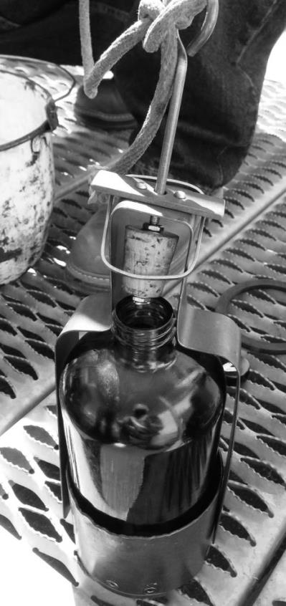 | 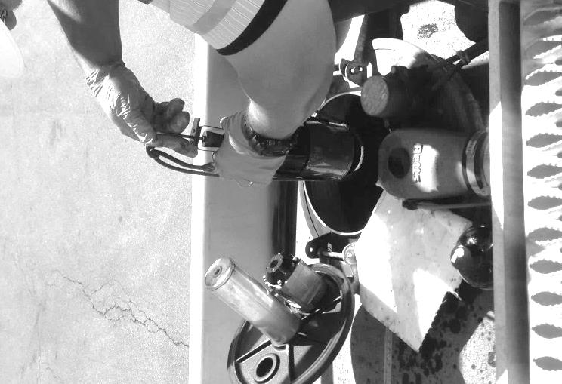
Figure 1. A Weighted Bottle for use in sampling Stationary Tanks and Tanker Trucks.
Photo courtesy of Chevron Products Company and the California Division of Measurement Standards.

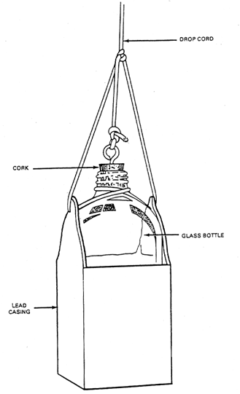
Figure 2. Weighted Sampling Bottle.
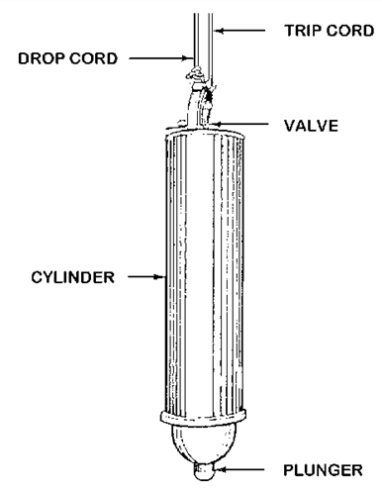  Figure 3. Bacon Bomb Thief. |  | 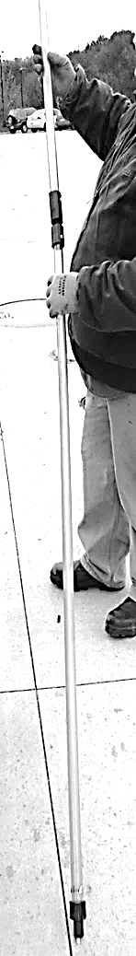  Figure 4. Tank Thief Sampler.  Photo courtesy of the Missouri Department of Agriculture.
 | 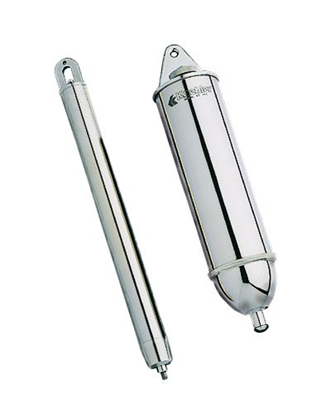  Figure 5. Submerged Samplers (Bacon Bomb Thieves) of Different Capacities. |   Figure 6. Drum Thief.
 | Photo courtsey of Koehler Instruments (2015)
1. Weighted Bottle Sampler: The weighted bottle sampler (see Figures 1 and 2) consists of a bottle permanently attached to a base. (Some of these types of samplers use a copper cylinder or beaker.) A drop cord is attached to the handle through a ring in the stopper so that a short, quick pull on the cord opens the bottle at any desired point beneath the surface of the liquid. This sampler is used to take an upper, middle, lower, or all-level sample of liquid product. It is used for sampling tanker or barge compartments, shore-tanks, tank cars, and tank trucks.
Typical Procedures for Taking an All-Level Sample Using a Weighted Bottle Sampler:
NOTE: To ground a static buildup the person taking the sample should touch the tank at a point not less than 1 m (39 in) away from the sampling opening before starting the sampling process.
Recommended Steps: Place an appropriate disposable fuel/oil spill pad (sometimes called a “soaker pad”) next to the tank sampling point.
NOTE: Fill the sampler with fuel and drain it completely before taking a sample.
a. Assemble the weighted bottle sampler and open the tank access port.
b. If the weighted bottle sampler is to be used to obtain samples at specific depths, then estimate the depth to be sampled and mark the sampling line at the desired depth. In some cases, a storage tank gauge stick may be lowered to the bottom of the tank, removed, and then used to measure the actual depth of the fuel as indicated on the stick. Using the sample line, slowly lower the sampler until the desired level is reached.
c. When the sampler is at the required depth, pull out the bottle stopper with a sharp jerk of the sampler line and allow the bottle to fill completely (usually evidenced by the cessation of air bubbles).
d. Retrieve the sampler by the sample line. Position it over the fuel/oil spill pad and wipe off the exterior of the sampler body with a disposable rag.
e. Position the sampler over the sample container and release its contents by pulling up on the plunger line. Fill the sample container to 80 % of capacity.
f. Cap the sample container tightly, and (if used in your jurisdiction, attach a security seal) place it in transport carrier.
g. Properly dispose of any excess fuel in the sampling device; then clean, dry, and store it.
h. Reseal the tank access port and properly dispose of any contaminated soaker pads or rags.
2. Submerged Samplers (Bacon-Bomb-Thief) (Figures 3 and 5): These samplers are typically used to take bottom samples but can be modified to take samples at different levels. They consist of a nickel-plated brass cylinder tapered at both ends and fitted with an internal, plunger-type valve. The valve opens automatically when the sampler strikes the bottom of a storage tank and allows the fuel to enter the container and closes when lifted. A drop cord is attached to a ring at the top of the sampler.
Typical Procedures for Use of a Submerged Sampler:
NOTE: To ground a static buildup, the person taking the sample should touch the tank at a point at least 1 m (39 in) away from the sampling opening before starting the sampling process.
Recommended steps: place an appropriate disposable fuel/oil spill pad (sometimes called a “soaker pad”) next to the tank sampling point.
NOTE: Fill the sampler with fuel and then rinse and drain it before taking a sample.
- Attach the sample line and the plunger line to the sampler.
b. Estimate the depth to be sampled and then mark the sampling line with the desired depth. In most cases, a storage tank gauge stick may be lowered to the bottom of the tank, removed, and then used to measure the actual depth of the fuel as indicated on the stick.
c. Open the tank access port. Using the sample line, slowly lower the sampler until the desired level is reached.
d. Pull up on the plunger line and allow the sampler to fill before releasing the plunger line to close the seal.
e. Retrieve the sampler by the sample line being careful not to pull up on the plunger line and thereby prevent accidental opening of the bottom valve.
f. Position it over the fuel/oil spill pad and wipe off the exterior of the sampler body with a disposable rag.
g. Position the sampler over the sample container and release its contents by pulling up on the plunger line. Fill the sample container to 80 % of capacity.
h. Cap the sample container tightly and, (if used in your jurisdiction, attach a security seal) place in transport carrier.
i. Properly dispose of any excess fuel in the sampling device and then clean, dry, and store it.
j. Reseal the tank access port and properly dispose of any contaminated soaker pads or rags.
3. Tank or Drum Thief Sampler (Plastic Cylinder): Typically these are plastic cylinder (tube type) samplers which consist of a multi-piece, plastic tube, 1 m (39 in) to 5 m (195 in) long and 38.1 mm (1½ in) at maximum diameter. The tubes are typically fitted with two finger rings at the upper end and three supporting legs at the bottom. Both ends are tapered with openings. The top opening of the sampler is closed with a stopper (or gloved thumb) or valve until the sampler is submerged in the liquid. Then the stopper is removed from the opening or the valve is opened, allowing the fuel to fill the sampler. It is used in tanks drums, barrels, or cans.
Typical Procedures for Use:
NOTE: To ground a static buildup, the person taking the sample should touch the tank at a point at least 1 m (39 in) away from the sampling opening before starting the sampling process.
NOTE: Fill the sampler with fuel and then rinse and drain it before taking a sample.
a. Remove cover from sample container and place it on a solid level surface at a conveniently located height so that it is easily accessible when holding a filled thief tube (typically a clean, dry jar with a large opening is use to collect this fuel sample so that the tube thief can be easily inserted.)
b. Open the tank access port. Slowly insert thief tube into storage tank. Hold it firmly with a wiping cloth while sampling and use the cloth to dry the tube as you remove it from the tank. Keep the cloth in contact with the tube throughout the process to reduce the buildup of static electricity.
c. Open the tube or valve and allow the fuel in the storage tank to reach an equal level in the tube. Once the tube is filled close the tube or valve firmly.
d. Remove the thief tube from the storage tank slowly to confirm that there is no fuel leaking and then insert the tube into the receiving jar. Wipe the tube dry.
e. Release the fuel into the sampling container until it is filled to 80 % of capacity.
f. Close the tube or valve firmly and remove the sampler from the sample container. Close the sample container. Dispose of any excess fuel in the tube and then clean, dry, and secure the sampler.
g. Reseal the tank access port and properly dispose of any contaminated soaker pads or rags.

C. Fuel Sample Containers
Types of sample containers may include clear or amber colored borosilicate glass bottles (laboratory grade) or metal cans. (Note: Shatter resistant glass bottles are available from a variety of vendors.) Only cans with seams soldered on the exterior surface may be used for fuel samples. (If they are not properly soldered, minute traces of flux may contaminate the sample and interfere with tests for dielectric strength, resistance to oxidation, and sludge formation.) There are several reasons that clear bottles may be preferred. Glass prevents permeation and allows a visual inspection of the sample for cleanliness and to see if there is free water or solid impurities present. However, samples of gasoline, jet fuel, and kerosene must be protected from direct sunlight so amber bottles or cans are recommended for those fuels. Clear glass bottles covered with paper or foil may also be used, and immediately placing a clear bottle in a transport box (described elsewhere in this handbook) also provides protection. Screw caps made of either plastic or metal may be used; the caps should provide a vapor tight closure seal. The screw caps must be protected with liners made of metal foil, Teflon, polyethylene, or other material that will not be destroyed by or affect the sample product. Plain cork stoppers and lids with cardboard inner-liners are not acceptable. If samples are shipped, see the U.S. Department of Transportation requirements in §49 Code of Federal Regulations. Containers may be reused indefinitely but must be cleaned and resealed to reduce the possibility of contamination. See Table 1. Suggested Container Types and Minimum Sample Sizes and Figures 7 through 12 for examples of the containers typically in use and minimum sample sizes. For a more detailed statement on specifications for sampling containers see ASTM D5854 “Standard Practice for the Mixing and Handling of Liquid Samples of Petroleum and Petroleum Products.”
Table 1.
Suggested Container Types and Minimum Sample Sizes for Fuel
Product |  | Container Material |  |  |  | Minimum Sample Size
 |  | Glass | Aluminum | Metal | FHDPB “Plastic” | Minimum Sample Size
1. | Gasoline – General⁴ | X | X | X | NO | 2 L
 | Alcohol/Ether | X | X | X | NO | 2 L
 | Vapor Pressure | X | X | X | NO | 1 L
 | Trace Lead | X | X | X | NO | 1 L
2. | Diesel Fuel – General | X | X | X | NO | 2 L
3. | Kerosene – General | X | X | X | NO | 2 L
4 | Fuel Oil – General | X | X | X | NO | 2 L
5. | Aviation Gas – General^{2,3} | X | X | X | NO | 2 L
6. | Aviation Turbine Fuel – General^{2, 3} | X | X | X | NO | 2 L
7. | Biodiesel – General | X | X | X | NO | 1 L
8. | E85 – General | X | X | X | NO | 1 L
9. | Hydrogen – General | X | X | X | NO | 1 L
10. | Methanol – General | NO | NO | X¹ | NO | 1 L
NOTE 1: Methanol (also known as methyl or wood alcohol) is used as a fuel primarily in race cars. It is also available in gasoline-methanol blends that range from 10 % to 30%. If samples are taken of these fuels do not use aluminum containers because there is a potential for corrosion to occur. It is recommended that containers constructed of 316L series stainless steel be used to hold samples of this fuel or blends containing methanol. See the “Methanol Safe Handling Manual” at Methanol Institute (www.methanol.org) for specific guidance on handling this product.
NOTE 2: See ASTM D4306 “Standard Practice for Aviation Fuel Sample Containers for Tests Affected by Trace Contamination” for more guidance on containers and their preparation prior to placing fuel in them. Generally, borosilicate glass bottles are adequate if wrapped in aluminum foil or stored in a sealed sample box to protect the fuel from light.
NOTE 3: When collecting samples of aviation gasoline and aviation turbine fuel for thermal stability, water separation, trace metal and other tests refer to ASTM 4306 for special container requirements and guidance on cleaning, preparation and handling procedures. The sample must be tested within 24 hours of taking.
NOTE 4: According to Section 6. Interferences in ASTM D2699 “Standard Test Method for Research Octane Number of Spark-Ignition Engine Fuel” and ASTM D2700 “Standard Test Method for Motor Octane Number of Spark-Ignition Engine Fuel” exposing fuels to UV wavelengths shorter than 550 nm for a short period of time may significantly affect octane number ratings. For this reason, fuel samples must be protected from damaging light. Collect and store fuels to be tested for research or motor octane in an opaque container, such as a dark brown glass bottle or metal can to minimize exposure to UV emissions from sources such as sunlight or fluorescent lamps.

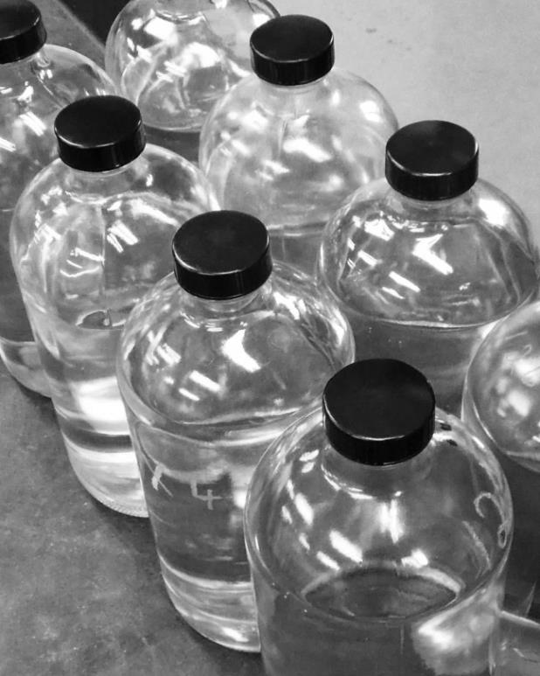  Figure 7. Clear Bottles. | 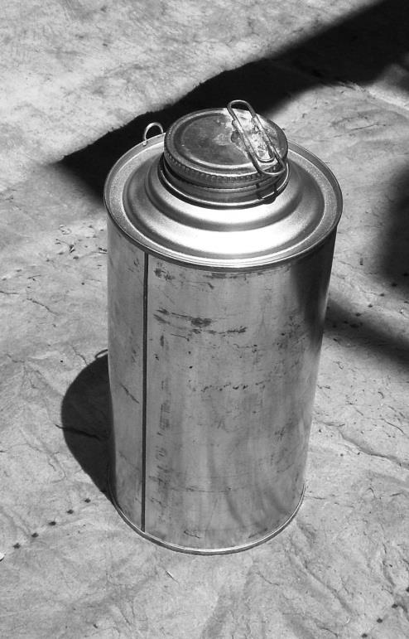  Figure 8. Can with Provision for Security Seal.
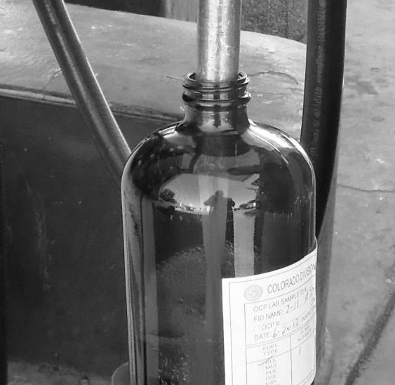  Figure 9. Amber Brown Bottle with Label. | 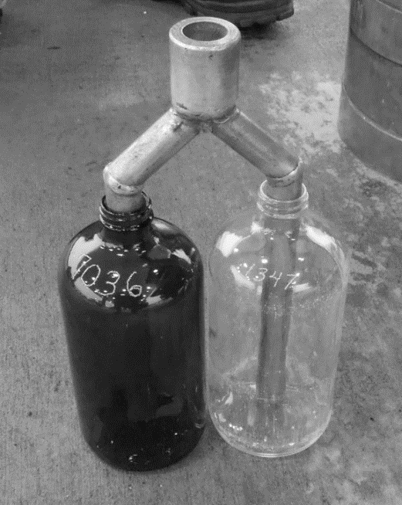  Figure 10. Bottles with Etched Identity Numbers.
Photo courtesy of the State of Colorado, Div. of Oil and Public Safety. Photo courtesy of the Missouri Department of Agriculture.

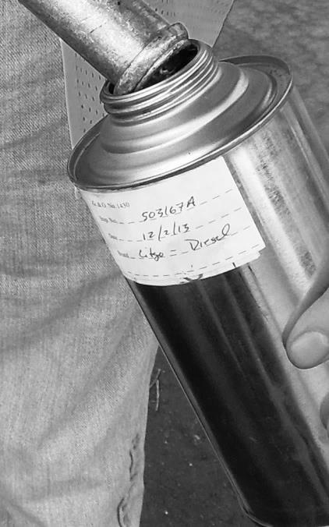  Figure 11. One Quart – Metal Container with Label. | Figure 12. One Liter - Stainless Round Container with Wire Security Seal Loops.

D. Washing and Drying Sample Containers (one example)
After each use, the sample container should be cleaned using the following procedure or one that provides equivalent or better results:
1. Rinse with a solvent. Discard solvent in accordance with good environmental practice.
2. Wash with a strong soap solution.
3. Rinse with distilled water.
4. Dry in a dust-free cabinet at a temperature of at least 40 °C (104 °F) or warmer.
5. Close container immediately after it is dry.
6. Store in a location specifically designated for clean-ready to use, sample containers.
NOTE: Samples Containers for Microbiological Testing: A sterilized glass or polypropylene bottle must be used to hold the sample. If a sampler is used to take the fuel sample, it too must be cleaned and sterilized before use. Sterilization can be accomplished by placing the bottle (and cap if heat resistant) in an oven at 160 °C (320 °F) for one hour. Alternatively, an autoclave may be used as long as the bottle and cap are dried prior to use. Microbiological sampling requires procedures not covered in this handbook. Refer to ASTM D7464 - 14 “Standard Practice for Manual Sampling of Liquid Fuels, Associated Materials and Fuel System Components for Microbiological Testing” for guidance on sampling methods and handling procedures.
NOTE: Sample Containers for Trace Analysis: Use procedures that ensure sampling equipment and containers are made with materials known not to interfere with the analysis. It is also important to ensure that every component of the sampling process is clean and dry so that the fuel sample is not contaminated or tainted.
NOTE: To avoid potential rust contamination, metal containers may be cleaned using Varsol or acetone.

E. Capacities
The capacity of the most common sample bottles and containers are typically 937 mL (1 QT) and they have sealing caps compatible with fuel. Bottles and sealing caps must be clean and dry prior to use.

F. Identifying Samples for Traceability
The information shown in Table 2 illustrates the type of information typically collected on a fuel sample. In many jurisdictions, the sample container is permanently marked with a unique identifying number and no label is applied. In other jurisdictions, a label is applied to the container which bears a unique identifier number. In most jurisdictions, a Fuel Sample Data Sheet (FSDA) is included with the sample in the shipping case. Some information may be stored in a database while other data is entered on a data sheet.
Table 2.
Examples of Entries on a Fuel Sample Data Sheet
 | Item | Entry
1. | Sample number/unique container identity | Enter the sample container’s unique identifier number. Each sample must have a unique identifier such as a number or alpha numeric code so its handling can be traceable, and so that all collection reports and laboratory tests are linked to the original sample.
2. | Product identification | Obtained from device product label, tank marking, or bill of lading.
3. | Ethanol content | Indicate if device label or signage reads (e.g., “up to 10 %” or “contains 10 %” or other claim).
4. | Sampling location identity | Enter business name, identifier number (this may be assigned by the fuel regulatory agency), address of sample location, business mail address, agent name, telephone, fax, and e-mail. This information may be used to immediately notify the seller to remove the product from sale should the sample fail.
5. | Special test to be conducted on sample | This item is entered if there is a reason to call for a specific test to be conducted on a sample. This may be used in cases where the testing laboratory does not routinely conduct the requested test on all samples (e.g., in case of a consumer complaint).
6. | Sampled lot | Amount of fuel that the sample represents. Total liters or gallons in the source fuel storage tank represented by the sample.
7. | Supplier(s) of fuel | Enter the name of the supplier or suppliers of the fuel in the source fuel storage tank.
8. | Date of last fuel delivery to storage tank. | Enter the day of the latest delivery of the fuel into the storage tank from which the sample was taken.
9. | Sample Taken by | Name (or identifier number) of the official who took the fuel sample.
10. | Source of sample | Identify the specific source of the sample (e.g., dispenser or storage tank identity, number or location, or license or vehicle number of tank truck and compartment number).
11. | Date/Time sample collected | Enter the time of day, day, month and year indicating when the sample was collected.
12. | Sampling Equipment Used | Enter weighted bottle or other sampling tool, if applicable.
13. | Type of Sample (when taken with a Sampler) | Enter outlet sample, or upper, middle, lower, bottom or all level sample depending on the collection method used.
14. | Notes/Safety Warning Label | Enter weather conditions and any remarks necessary to accomplish the analysis of the sample. Provide Required Safety Warnings.  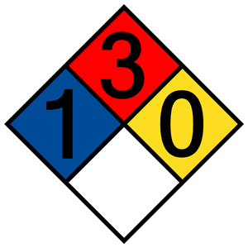
15. | Security Seal(s) | Enter the identification number of any security seal applied to a sample container or transport case.

G. Sample Transport Cases
Most jurisdictions place fuel samples in sealable insulated containers immediately after they are taken. These cases (see examples in Figure 13) hold the fuel sample safely for transport while protecting them from sunlight and heat. A sample case must bear a label indicating that it contains gasoline or oil samples to alert anyone who handles it that it contains flammable liquids. (See also Section I., F. Vehicle and Sample Case Markings for Hazardous Materials Transportation – Alerting Emergency Responders, Item 3. Sample Cases.)
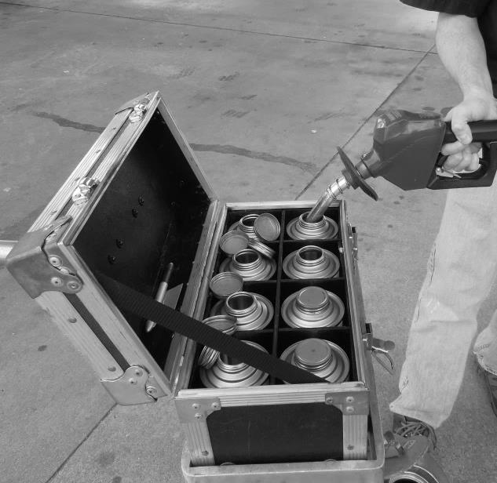  Figure 13a.- Sample Box. | 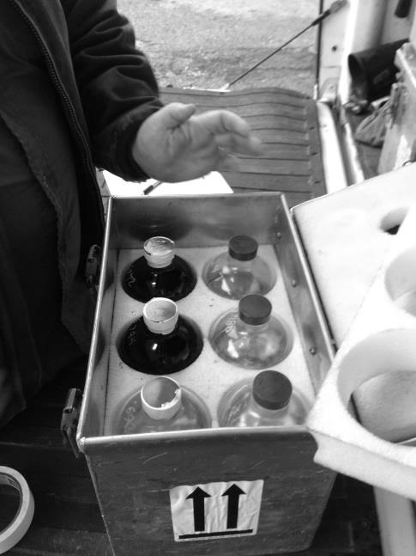  Figure 13b. Sample Box Showing Insulation.
Photo courtesy of the North Carolina Department of Agriculture and Consumer Services. | Photo courtesy of the Missouri Department of Agriculture.
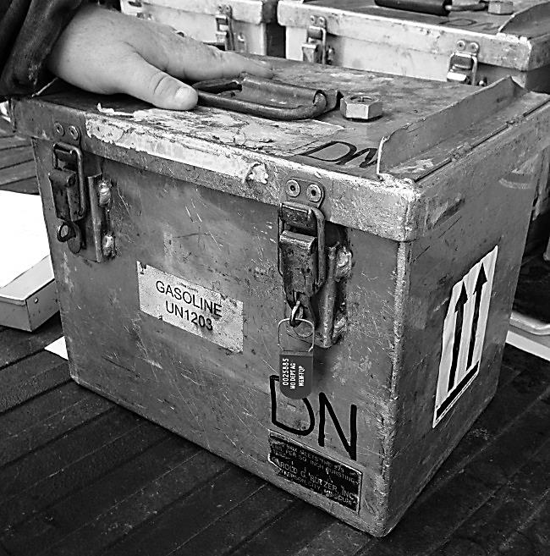  Figure 13c. Sample Box showing Security Seal in Place | 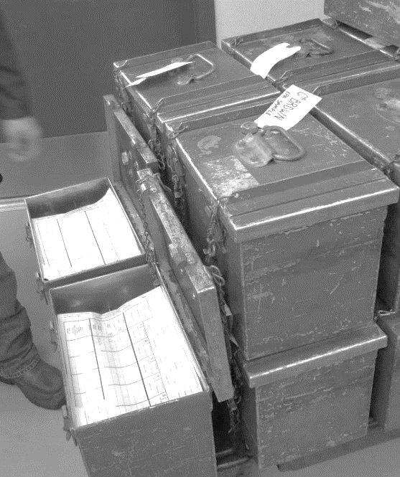  Figure 13d. Sample Box containing Collection Reports as received at the Fuel Laboratory.
Photo courtesy of the Missouri Department of Agriculture. | Photo courtesy of the Georgia Department of Agriculture.

1. Procedure for Use of Transport Boxes:
Once samples have been collected:
  - Recheck that the sample container is not overfilled and confirm tightness of the cap/seal on the container and check for leakage.
  - Ensure a unique sample identification number is on the can. Place sample container in the transport box.
  - Ensure that the custody record for each transport box is complete, placed in a plastic protective cover, and placed in the container or affixed to the inside lid.
  - Secure and custody seal the lid of the transport box and record the security seal number on the primary inspection report.

I. Security Seals for Containers and Boxes
A container holding a fuel sample should be sealed as part of the chain of custody system but this sealing is not mandatory if other safeguards are in place. For example, if the fuel is held under the secure control and possession of the fuel official who collected the sample from time it was collected until it is delivered to the fuel laboratory, sealing is unnecessary. Another exception to sealing is permitted if the container is placed in a sealed sample transport box for storage and transportation to the fuel laboratory.

J. Recommended Sampling Equipment - Nozzle Extender
It is recommended that all fuel samples taken from a dispenser nozzle be collected using a nozzle extender. These tubes are typically constructed of Schedule 80 non-ferrous metal. They can be constructed of a single tube (See Figure 14.) or made for bi-furcated filling (See Figure 15.). See ASTM D5842 for detailed instruction on fabricating these extenders.
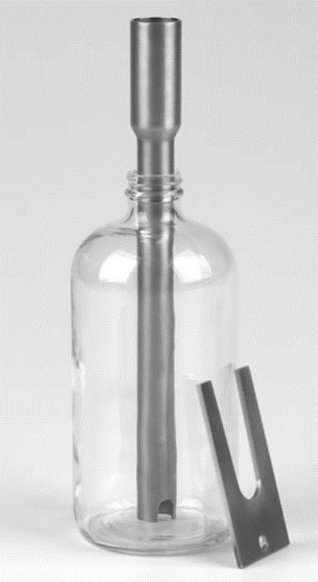  14. Single Nozzle Extender. | 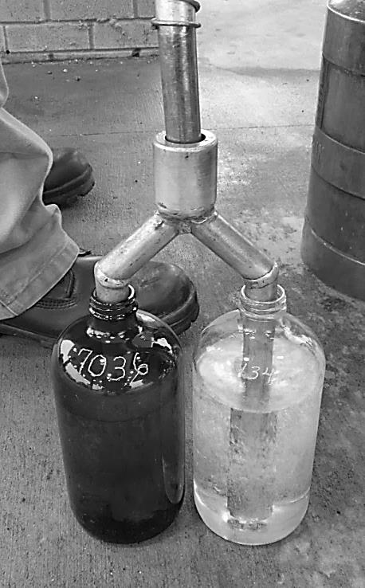  15. Dual Nozzle Extender.  Photo courtesy of the Missouri Department of Agriculture.

VI. Sampling Procedure for Taking Fuel Samples at Retail Fueling Locations

A. Preparation
1. Conduct: Officials must conduct themselves in a professional manner at all times when taking samples. This includes being aware of what is going on around them so that a safe working environment prevails. Officials should park vehicles in a suitable location until management of the sampling location have been notified of the identity, authority, and nature of the visit. When sampling at retail locations, it is often necessary to have the fuel dispensers authorized for operation so that samples can be taken. Officials must establish contact with the authorized management representative and explain how samples will be taken to ensure that the console operator(s) understands what is expected in assisting the official. It is management’s right to observe sampling procedures and be present during the sample collection process if they choose to do so. This will allow the person to confirm the source of the fuel and identity of the container and enable them to satisfy themselves that the sample container was properly sealed and purged fuel was returned to the proper storage.
2. Business Identity: Obtain the business ownership and other identity information.
3. Storage Tank: To ensure that purged fuel is returned to the correct storage tank, verify that the markings on the storage tank are understood, and that they match the fuel identity chart. If there is any doubt about the proper storage tank, the official should ask the location manager to indicate the appropriate tank access point.
NOTE: For reference see NIST Handbook 44, “Specifications, Tolerances, and Other Technical Requirements for Weighing and Measuring Devices,” Section 3.30. Liquid-Measuring Devices Code, U.R.2.5. Product Storage Identification. (See also NIST Handbook 130, Uniform Engine Fuels and Automotive Lubricants Regulation, Section 4.4. Product Storage Identification.):
Source: NIST Handbook 44 – Section 3.30.
UR.2.5. Product Storage Identification.
(a) The fill connection for any petroleum product storage tank or vessel supplying motor-fuel devices shall be permanently, plainly, and visibly marked as to product contained.
(b) When the fill connection device is marked by means of a color code, the color code key shall be conspicuously displayed at the place of business.
4. Avoid Disrupting Normal Business Operations: The official should select a dispenser lane for sampling and either block the lane around the dispenser with safety cones or park their vehicle in the lane. The vehicle should be positioned to allow ample access to the dispenser. The official should turn off lights, radios and the vehicle engine and set its parking brake. A walk-around inspection should be conducted to ensure there is easy access to sampling equipment and a fire extinguisher. At the end of the sampling and before the vehicle is moved another walk-around inspection should be made to ensure that all equipment has been collected and all samples and the dispenser are secured (e.g., that the dispenser housing is reclosed if it was opened for inspection.)
5. Payment for Samples: In most jurisdictions, the official is obligated to pay the retail value of the product if a fuel sample is taken from a place of business where it can be sold legally unless the sample is being collected pursuant to a search warrant, or the fuel’s owner surrenders the sample at no cost.
A sample of a payment receipt is shown below:
PAYMENT RECEIPT
Agency Responsible for Engine Fuel Quality
Address,
City, State, Zip
Telephone, E-mail, URL
Seller’s Name: | Address: |  | Date:
Received $___________________as payment for the fuel or oil samples described below taken for inspection purposes as provided for by Chapter xxxxx of the Code of the State of ___________________.
__________________________________________________
Signature of Business Representative
Sample Taken: |  | Official:
6. Documentation: Throughout an official visit, it is important that information about device labeling and signage related to the fuel be recorded to document the product identity and other claims made by the seller. The official should make a brief record of actions taken and his or her observations as well as details of any relevant information provided by the seller or the seller’s representative. Taking notes, photographs, and keeping logs provide permanent records of a fuel sampling activity and facilitate enforcement.

B. Sample and Containers
1. Sample Size: A fuel sample of at least 1 L (1 qt) should be taken. If a vapor pressure test is to be performed, an additional fuel sample of the same volume should be taken. As a general rule, a sufficient amount of product should be collected to allow for the initial test, a repeat test, and retention of some product for evidence in case of legal action. For reasons of due process, irreplaceable evidence, whether favorable or unfavorable to a regulated business, should not be discarded prior to the conclusion of legal proceedings, including the time allowed for the filing of appeals.
2. Sample Container Fill Levels: To allow for thermal expansion, sample containers should not be filled to more than 80 % of their capacity. Samples taken for vapor pressure testing MUST be filled between the 70 % to 80 % level. The official should always close sample containers tightly immediately after filling and check for leaks by tilting the container up and holding it in the inverted position for 10 seconds. The most widely used method for the collection of fuel samples is to fill a clean sample bottle with fuel from a dispenser nozzle/outlet. This eliminates the use of other sampling equipment and reduces the risk of contamination. The sample container should be of the type best suited to the product and to the purpose of the test. It must be visually inspected immediately prior to use to ensure it is clean, dry, and lint-free. Only use clean and dry sampling equipment and containers to prevent contamination of the fuel sample.
Table 3.
Sample Size – Container Fill Levels Based on Dispenser Readings
Sample Container  Capacity  1 Fl Qt* | 70 % Capacity | 80 % Capacity
Sample Container  Capacity  1 Fl Qt* | Dispenser Readings from Zero (0)
0.25 gal | 0.175 gal | 0.200 gal
0.946 L* | 0.662 L | 0.756 L
Sample Container Capacity 1 L | 0.700 L | 0.800 L
*These values are provided for situations where a one fluid quart container is used to take a sample from a retail dispenser which delivers in liters.
3. Recommended Sampling Practice: It is recommended that the sample container be placed on the island next to the dispenser (or on a grounded cart such as the one pictured below) to avoid the possibility that the container will be dropped or that a spill might result in the official’s clothes being soaked with fuel. Submerged filling of an open container is critical to ensuring safety and to reduce the loss of light ends The official should use a cotton rag to wipe and clean the parts of the nozzle and extension piece that come into contact with the sample container and fuel sample. Use of an extension tube constructed of conductive metal (e.g., copper) that reaches to the bottom of the sample container to ensure submerged filling of the container (see Figure 16) is recommended for taking all samples. The official should place the metal nozzle spout in contact with the extension piece or container to prevent build up and discharge of static electricity and then manually control the nozzle and fill the container slowly to decrease the build-up of static electricity. It is recommended that the sample container be kept at least 1 m (3 ft) away from any vehicle during filling to prevent ignition of fumes by hot engines or catalytic converters during filling.
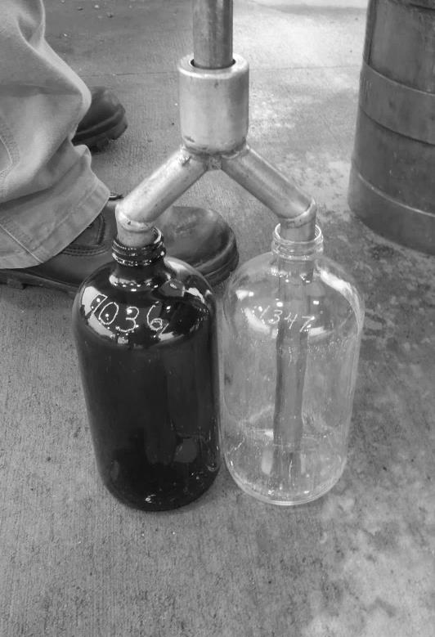 |  |  | 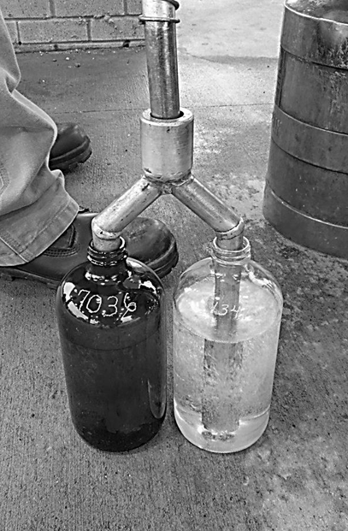
Figure 16. Sample Bottles Empty and Filled with Bifurcated Tube.
Photos Courtesy of Missouri Department of Agriculture
 | 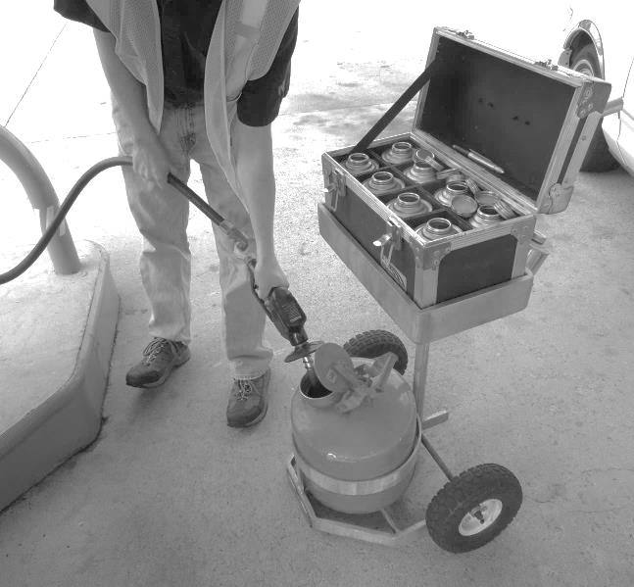  17. Fuel Sampling Cart with Transport Case and Safety Gasoline Can to hold fuel from nozzle-hose flushes.* | 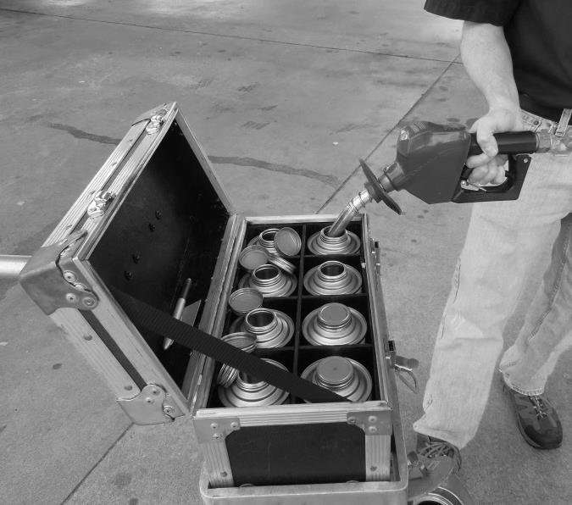  18. Fuel Sampling Cart with Sample Container bonded to cart and ground.*
 | *This cart is used by the State of North Carolina. Photos courtesy of the North Carolina Department of Agriculture and Consumer Services

C. Sampling
1. Sample Taken from a Measuring Device that Dispenses a Single Product: No flushing is required for this nozzle-hose combination. The official should:
  - Place the sample container on the concrete drive-way, a grounded cart, or on the island next to the dispenser so it is grounded or bonded.
- Use a cotton rag to wipe the parts of the nozzle and extension tube that come into contact with the sample container and fuel sample.
- Authorize the dispenser and place the nozzle/outlet and extension tube in the sample container and fill it slowly to reduce foaming and light end loss and so that air leaves the container without splashing fuel droplets. Continue until it is filled to the specified volume (or the dispenser indicates the quantity specified for the sample). See Table above for dispenser readings when the delivery begins at 0.000.
- Close the sample container and mark as required.
2. Sample Taken from a Multi-Product or Blended Product Dispenser (See Section 3. for recommended procedures for use in taking an E15 sample.):
Background: In 2000, the National Conference on Weights and Measures (NCWM) Laws and Regulations (L&R) Committee issued a guideline recommending that the minimum flush quantity to be at least 1.1 L (0.3 gal). Since that time, data from a number of states indicates that this amount (1.1 L) is not sufficient. NIST recommends that a minimum flush quantity of 1.8 L (0.5 gal) be used for most installations unless the installation indicates that a larger purge is justified. The fuel used for flushing the nozzle of the dispensers should be collected in an approved container and then be returned to the storage tank containing the lowest octane fuel but do not return flex-fuel blends of ethanol above 10 % to the source storage tank. Provision must be made by the seller for disposing of blended products which cannot be returned to storage tanks. The amount of fuel flushed from each dispenser must be recorded on the primary inspection report and a copy presented to the seller.
The official should:
- Select the lowest grade. Authorize the dispenser and run 1.8 L (0.5 gal) slowly into an approved container (e.g., a 19 L [5 gal] safety can or test measure).
NOTE: When a sample is taken from a measuring device that is capable of blending different grades of fuel for delivery through a single nozzle, the official must flush the hose and nozzle prior to taking a sample. NIST recommends that a minimum flush quantity of 1.8 L (0.5 gal) be taken from a typical dispenser installation equipped with a standard length hose.
b. Use a cotton rag to wipe the parts of the nozzle and extension tube that come into contact with the container and fuel sample. (See Table 3. Sample Size – Container Fill Levels Based on Dispenser Readings when the delivery begins at zero [0]).
c. Place the nozzle/outlet and extension tube in the sample container and fill it slowly to reduce foaming and light end loss and so that air leaves the container without splashing fuel droplets. Continue until it is filled to the specified volume (or the dispenser indicates the quantity specified for the sample).
d. Seal the sample container and mark as required. The exterior of the sample container must be wiped to ensure it is clean and dry prior to placement in a sample transport case.
e. Reset and reauthorize the dispenser, select the next grade, flush the nozzle and hose and fill the sample container as described above. Continue this process until samples of all grades have been taken.
f. Return purged fuel to proper storage and record quantities on inspection report. Do not return flex-fuel blends of ethanol above 10 % to the source storage tank. Provision must be made by the seller for disposing of blended products which cannot be returned to storage tanks.
NOTE: Where mid-grade flex fuels are blended using Multiple Product Dispensers (MPD), adjustments MUST be made to the blend ratio of each dispenser at different times throughout the year to ensure that the blend contains the required amount of ethanol. The time at which these changes are made is dependent on the geographic location of the dispenser. The blend ratio required to achieve the correct blend depends on the amount of ethanol contained in the unleaded gasoline and E85. The amount of ethanol contained in these components will vary with the provider. Each grade of mid-grade flex fuel dispensed through blending dispensers must be independently tested for ethanol content at the time the dispenser (or group of dispensers) is installed at a facility, and prior to use.
3. Recommended Sampling Procedures for Taking an E15 Sample from a Multiple Product Dispenser (MPD).
Background: Multiple Product Dispensers (MPDs) or blender pumps are designed to deliver a single grade of product or to combine two grades at the dispenser in predetermined ratios by drawing fuel from different storage tanks and using sensors and flow rate controllers that ensure the targeted blend is dispensed. These pumps have been used for many years to create mid-octane fuels by blending the low and high octane fuels at the dispenser. The typical MPD uses a feedback system to adjust the blend delivered at the nozzle. To do that, two grades of fuel from two different inlets are fed through individual meters with their quantities controlled by a variable flow valve located after each meter. The dispenser senses the amount of product going through each meter and adjusts the opening of each valve to conform to the ratio for the selected product. At the beginning of the transaction and during re-starts (i.e., the blend ratio mechanism is reset every time the user closes and reopens the nozzle and when the nozzle’s automatic shutoff kicks in and the nozzle is then restarted), the dispenser makes adjustments to attain the correct blend ratio as it relates to the entire transaction and to deliveries made at normal speed. It is important to recognize that the fuel blend is also affected by both the flow rate of the dispenser and system pressure, which vary depending on the number of dispensers on the system drawing from the different fuel storage tanks. The blend ratios will be different when using a MPD to produce E15 and mid-level ethanol blends (Exx). Because the normal fuel sampling process involves taking a small quantity of fuel at a slow flow rate (and that may involve re-starts), it is likely that the fuel blend in these samples are not representative of the fuel delivered in a typical customer transaction. The Environmental Protection Agency (EPA) has recognized that this operational characteristic of MPDs for blending E15 may result in the inadvertent mis-fueling of E15 in vehicles, engines, and equipment not covered under the EPA’s E15 waiver to the Clean Air Act. To help ensure that customers do not inadvertently mis-fuel vehicles, engines, and equipment not covered underE15 waiver, the EPA requires retailers to dispense E15 at a MPD only through EPA-approved MPD configurations. (See pages 43 and 45 in the “E-15 Retailer Handbook” by the Renewable Fuels Association at http://ethanolrfa.3cdn.net/643f311e9180a7b1a8_wwm6iuulj.pdf.)
For these reasons, it is recommended that a fuel quality sample (e.g., 1 L) be taken from a larger sample of between 7.5 L (2-Gal) and 9.4 L (2.5- Gal) or more. The sample should be collected in a clean container (e.g., a 9.4 L (2.5- Gal) or 19 L (5-Gal) safety can under a continuous flow delivered at or near the full-flow rate of the device because this allows the dispenser adequate time to account for system variations in making its adjustments to the blend ratio. If the flow is interrupted prior to collecting at least 7.5 L (2–gal) the product must not be used in a fuel sample. By following the recommended procedures to collect samples for fuel quality determinations, an official should obtain an accurate representation of the fuel that the dispenser has delivered.
Important: For samples to be tested for conformance to volatility standards during the VOC season (June 1- Sept 15) additional steps and procedures will need to be followed. See NOTICES section for appropriate ASTM International Standards.
E15 Sampling Procedure
There are several methods that can be used to obtain a sample of the product that is representative of the fuel going into the customer’s tank in a typical delivery. Here are three suggestions based on whether the official is simply taking a fuel sample or taking a fuel sample in conjunction with testing the dispenser for accuracy according to NIST Handbook 44.
There are three acceptable Methods for procuring samples for quality testing.
Method #1 (Taking a Fuel Sample)
- Flush the dispenser with a minimum of 1.8 L (0.5-Gal) using E15 (or with the blend being tested) into a separate container using a continuous flow at or near the full-flow rate of the device and dispose of the flushed fuel.
- Place the nozzle into the can against the opening at a level to avoid overfilling but positioned to reduce the possibility of prematurely activating the automatic shut-off mechanism. If practical, maintain a continuous flow by avoiding manual restarts of the nozzle. Start a new transaction with the E15 setting (or whatever blend is under test), dispense at least 7.5 L (2-Gal) into a clean 9.4 L (2.5-Gal) or larger safety can using a continuous flow at or near the full-flow rate of the dispenser. If the flow is stopped for any reason prior to the collection of 7.5 L (2-Gal) dispose of the fuel and repeat this step.
- Take the sample from the fuel in the container.
Method #2 – (Taking a Fuel Sample)
1. Flush the dispenser with a minimum of 7.5 L (2-Gal) with continuous flow at or near the full-flow rate of the device using E15 (or whatever blend is being tested). If there is a flow interruption prior to delivering 2-Gallons do not restart the flow, dispose of the fuel. Repeat this step until more than 7.5 L (2-Gal) is delivered without interruption. Proceed to next step.
2. Pull a sample from what is left in the hose (residual) into an appropriate clean sampling container. The sample should not exceed 0.49 L (0.13-Gal).
3. Dispose of the flushed fuel.
Method #3 (Taking a Fuel Sample in conjunction with a device accuracy test)
- Flush the dispenser with a minimum of 1.8 L (0.5-Gal) using E15 (or whatever blend is being tested) into a separate container using a continuous flow at or near the full-flow rate of the device. Dispose of the flushed fuel.
- Place the nozzle in the test measure and against the opening at a level to avoid overfilling the test measure and but positioned to reduce the possibility of prematurely activating the automatic shut-off mechanism. Conduct a device accuracy test in the E15 setting (or whatever blend is being tested), and dispense 19 L (5-Gal) into a test measure to check the accuracy of the dispenser. Operate the nozzle at or near the full-flow rate of the device and, if practical, maintain a continuous flow by avoiding manual restarts of the nozzle.
- After the accuracy test is completed, take the fuel sample directly from the test measure by filling the sample container using a clean dry funnel.
NOTICE: It is recommended that the following ASTM International Standards be utilized to procure fuel quality samples and to determine the ethanol content of E15 (or whatever blend is being tested) samples.
- ASTM D5599 - 15 “Standard Test Method for Determination of Oxygenates in Gasoline by Gas
Chromatography and Oxygen Selective Flame Ionization Detection”
- AsTM D5501-12^{Ɛ 1} “Standard Test Method for Determination of Ethanol and Methanol Content in Fuels
Containing Greater than 20% Ethanol by Gas Chromatography”
- ASTM – D4057 - 12 “Standard Practice for Manual Sampling of Petroleum and Petroleum Products”
- ASTM - D5842 - 14 “Standard Practice for Sampling and Handling of Fuels for Volatility Measurement”
^{Ɛ 1} Note – Editorial corrections were made to 7.4.3. and 7.5. in July 2013
- NIST Handbook 44, Section 3.30. Liquid Measuring Devices, User Requirements (UR).
NOTE: Alternative Flush Quantities: The recommended minimum flush amount is based on the internal volume of a 3 m (10 ft) hose. In NIST Handbook 44, “Specifications Tolerances and other Technical Requirements for Commercial Weighing and Measuring Devices,” Section 3.30. Liquid Measuring Device Code, U.R.1.1. User Requirement (shown below) permits discharge hose lengths up to 5.5 m (18 ft) on most retail fuel dispensers, but dispensers at marinas are permitted to extend to 15 m (50 ft).
UR.1.1. Discharge Hose.
UR.1.1.1. Length. – The length of the discharge hose on a retail motor-fuel device:
(a) shall be measured from its housing or outlet of the discharge line to the inlet of the discharge nozzle;
(b) shall be measured with the hose fully extended if it is coiled or otherwise retained or connected inside a housing; and
(c) shall not exceed 5.5 m (18 ft) unless it can be demonstrated that a longer hose is essential to permit deliveries to be made to receiving vehicles or vessels.
An unnecessarily remote location of a device shall not be accepted as justification for an abnormally long hose.
UR.1.1.2. Marinas and Airports.
UR.1.1.2.1. Length. – The length of the discharge hose shall be as short as practicable, and shall not exceed 15 m (50 ft) unless it can be demonstrated that a longer hose is essential.
The following Table 5. provides the approximate volume contained in various internal diameters of fuel hoses with the length of 3 m (10 ft). The recommended purge is adequate for the most commonly used hose with an internal diameter up to 22.2 mm (⁷/₈ in) hose diameter. If an official encounters hoses with larger internal diameters or lengths of greater than 3 m (10 ft) the flush amount can be adjusted to fully purge the hose and reduce the chance for contamination. If 3 m (10 ft) lengths of the larger interior diameters hoses are found, increase the flush to the quantities stated in Column 2. If longer lengths of any of the discharge hoses are found, the official should measure its length and multiply that value by the volume contained in 304 mm (1 ft) by the volume in Column 3. For example, if a blending dispenser with a 18 ft discharge hose with an interior diameter of ⁷/₈ in is found, multiply 18 × 0.030 gal = flush volume of 0.540 gal.
Table 5.
Approximate Volume Contained in Various Internal Diameters of Fuel Hoses
(based on the hose length of 3 m [10 ft])
Column 1.  Discharge Hose Interior Diameter | Column 2.  Approximate  Volume in 3 m (10 ft) | Column 3.  Approximate  Volume in 304 mm (1 ft)
12.7 mm (¹/₂ in) | 0.370 L (0.10 gal) | 0.037 L (0.010 gal)
15.9 mm (⁵/₈ in) | 0.600 L (0.16 gal) | 0.056 L (0.015 gal)
19.1 mm (³/₄ in) | 0.870 L (0.23 gal) | 0.075 L (0.020 gal)
22.2 mm (⁷/₈ in) | 1.170 L (0.31 gal) | 0.113 L (0.030 gal)
25.4 mm (1 in) | 1.552 L (0.41 gal) | 0.151 L (0.040 gal)
31.8 mm (1¹/₄ in) | 2.422 L (0.64 gal) | 0.227 L (0.060 gal)
NOTE: Except for the ethanol blends noted above, return the accumulated flush fuel for all of the sampled blends to the lowest grade storage tank.
NOTE: If a weights and measures official is testing dispensers for compliance with NIST Handbook 44 using a 19 L (5 gal) test measure, the flush procedure can be skipped and the fuel sample taken after the official has filled the measure and determined the device error.
NOTE: Officials should verify and document the dispenser’s programed blend ratio if they have the appropriate access equipment and training from the device manufacturer. This is a good practice to carry out on new installations and devices where there is a suspected problem with fuel grades. Instructions for accessing the blend ratio of a device are included in the Certificate of Conformance for a blending device from the NCWM. The NCWM Certificate of Conformance Search Engine is located at this URL: http://www.ncwm.net/ntep/cert_search.
5. Taking a Sample of Fuel for Volatility Measurement
The vapor pressure of a fuel is affected by evaporation and composition so special handling and filling equipment is required. This nozzle sampling procedure is based on ASTM D5842 “Standard Practice for Sampling and Handling of Fuels for Volatility Measurement.”
a. If the sample is taken from a blending dispenser, flush the nozzle with 1 L (0.3 gal) of the grade of product being sampled. This step is taken to ensure the hose and nozzle is not contaminated with a blend of fuel different from that intended to be tested.
The official should then:
b. Rinse the sample container (and sampling device if used) with fuel and allow it to drain before filling. This step is taken to ensure the container is not contaminated and it cools the container which may help to reduce evaporation.
c. Use a nozzle extender to fill the sample container slowly to 70 % to 80 % of its capacity. The slow filling time and nozzle extension are used to reduce evaporation.
d. Immediately seal the sample container and check it for leaks. If a leak is found discard the sample and container and take another sample using a new container. It is recommended that a sealing tape be wrapped around the container lid to further reduce the chance of evaporation (See Figure 4 below for an example of bottles sealed in this manner).
NOTE: When glass bottles are used in collecting samples for vapor pressure testing, it is recommended that container sealing tape be used to seal the lower edge of the cap to the neck of the bottle to prevent evaporation. (This is usually a stretchable tape that reduces the chance for gas exchange and prevents the entry of contaminants. These tapes remain flexible in most temperatures and they are waterproof and resistant to most chemicals.) If the containers are properly sealed and leak free, they can also be inverted during shipment to prevent evaporation.
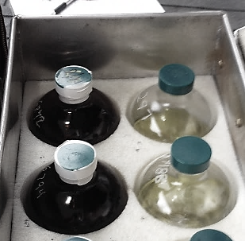  Figure 19. Sealing Tape Applied to Amber Sample Bottles  Intended for Vapor Pressure Testing. | 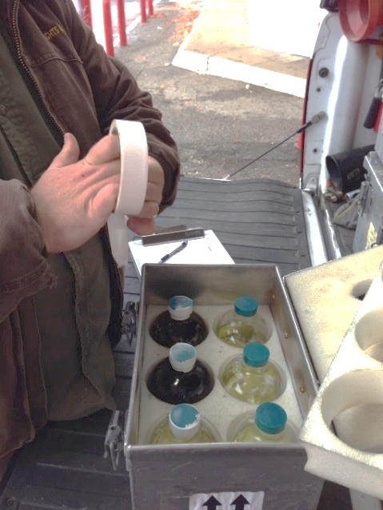

Photos courtesy of the Missouri Department of Agriculture.

D. Protecting Fuel Samples
Extreme care and good judgment are necessary to ensure the samples obtained are representative of the product being sold, assuring the test results are the same as if the sample had been tested immediately after it was taken. Samples should be kept cool or be cooled and protected from sunlight in order to minimize any potential reaction due to the light sensitivity of the sample. Samples of gasoline and JP-4 (which is not widely used) should be kept cool to prevent “light ends” from evaporating. Also, samples of fuels with lead additives must be protected from sunlight. It is necessary to protect all volatile samples of petroleum products from evaporation. In every situation the product sampled should be put directly into a sample container as soon as it is obtained. This must be done with vapor pressure samples. When it is necessary to obtain product with a sampling apparatus (or it is an undercover purchase in a consumer type gas can), or from an underground storage tank, transfer the product to a sample container immediately. If applicable, keep the containers and samplers closed except when material is being transferred. Never completely fill any container; allow adequate room for expansion by filling them to no more than 80 % capacity. To prevent the loss of liquid and vapors during transport, screw the caps of containers down tightly and check for leakage (check for leakage by tilting the container on its side and looking for fuel leaks around the cap or air bubbles entering the fuel).
NOTE: Control temperature conditions. According to ASTM D4814 fuels should not be cooled below their dispensed temperatures or 15 °C (59 °F) because cooling of gasoline-oxygenate fuels can produce changes in appearance (e.g., hazing) that are not reversed on rewarming.

E. Visual Inspection – (Per ASTM D6751 and ASTM D4814-16a - 6. Workmanship)
Immediately examine the fuel sample to determine if it is clear and bright at the ambient temperature, at the fuel temperature at the point of custody transfer, or at a lower temperature agreed upon by the purchaser and seller. The fuel must be visually free of undissolved water, sediment, or suspended matter. If the fuel does not pass this visual inspection, a stop-sale order should be issued immediately.
Label and seal the containers immediately after the sample is obtained and place in a secure sample transport box for transportation to the fuel laboratory for testing. The official should RECHECK that every sample is accurately identified and documents are completed. If the lab receives a sample with missing or incomplete labels or documents, it will be rejected and disposed of without testing.

Figure 20. Visual Inspection of Samples.
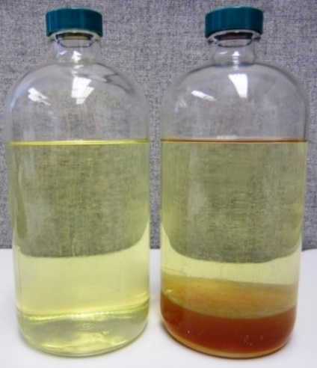
FAIL
PASS
Clean, Bright Sample Passes Sample with Water Fails
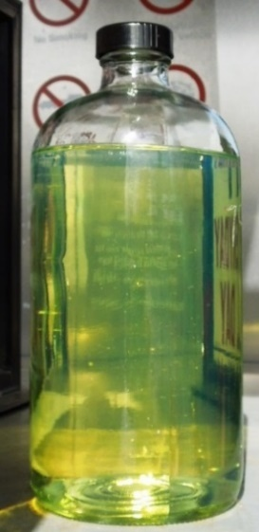  PASS | 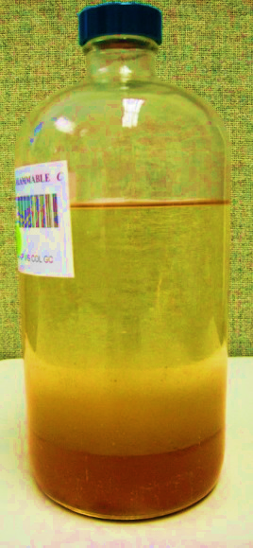  FAIL
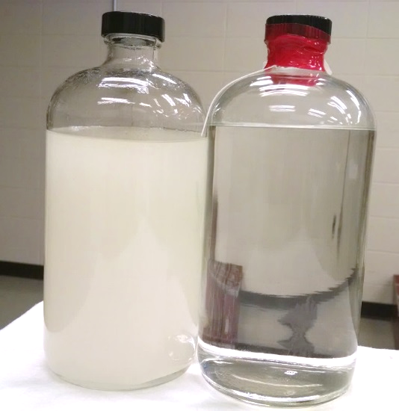
PASS
FAIL

F. Transporting Samples to Laboratory
There are several approaches used to transport fuel and oil samples to a fuel laboratory. All are acceptable as long as the integrity of the chain-of-custody is documented.
1. Direct Delivery: The official who collects the sample transports it directly to the laboratory and presents it for testing.
2. Public Carrier Delivery: The official who collects the sample packs it in appropriate shipping cartons, labels them and delivers them to a public carrier who then transports the sample to the fuel laboratory for testing (or to a delivery point where a representative from the laboratory picks up the samples).
3. Laboratory Courier: The officials who collect samples deliver them to a central consolidation point where a courier collects the samples and transports them to the fuel laboratory. These couriers are almost always employees of the fuel laboratory.
The collection of fuel samples requires that the fuel official receives a continuous supply of fresh sample containers, so it is important to set up a cost effective system that simplifies the transportation of fuel samples to the laboratory while at the same time ensures that it resupplies the field official.

G. Chain of Evidence (Custody) and Transfer
A chain of evidence (custody) is a record of each person who has come into possession of the fuel sample from the time it is taken until the time the test results on the sample are presented as evidence in an administrative or judicial proceeding. A sample is in custody if it is in the official’s possession or if it is under his or her control, or the control of another authorized person while stored in a secure location. A chain of evidence is the only means to prove that the sample presented in the proceeding is the one obtained at the location in question.
A record must be maintained which lists all those persons coming in possession of the evidence. This is particularly true when an analysis of fuel samples is to be made. It must be proven that there was no tampering with, alteration, or substitution of the sample between the time it was collected and the time of analysis by the fuel laboratory. The burden of proof is on the party offering the sample into evidence.
Fuel samples must be passed from the field person who obtained them to the laboratory personnel through a controlled process. When this takes place, the record must indicate to whom and when the sample was released. In other words, the chain of custody must be maintained. This means that the transfer of the sample must be documented each time, and that the record must remain with the sample. If this proof is not available, the sample and its analysis may be excluded from evidence.
Although an accurate and complete record is maintained of the chain of custody, it is still advisable that the samples go through as few people as possible. The fewer involved, the less chance there is the sample may be tampered with, altered, or lost. Also, should a case end up in court or administrative hearing, fewer witnesses will be needed to be called to establish the fact that the sample analyzed is the same fuel sample collected at the location. See ASTM D4840 “Standard Guide for Sample Chain-of-Custody Procedures” for more information. A sample of a Chain-of-Custody document is presented in Appendix C.

H. Timeliness of Samples
Due to the velocity at which fuel is sold from a seller’s tanks, a sample that is not analyzed and the results provided within 24 hours to 48 hours of its collection is of little value in stopping the sale of nonconforming fuel.

I. Respond to Test Results – Time is of the Essence.
If a sample fails any laboratory test, immediate action must be taken to ensure the product is removed from sale. Follow-up oversight must verify that the seller has taken the appropriate corrective actions including determining and documenting the cause of the failure so it can be included in a program assessment to identify possibilities for changes in quality standards or handling and storage procedures. Timely testing of all samples is a critical factor because, after subsequent deliveries occur, the sample is no longer representative of the product in the storage tank.
- If the Sample Passes: No enforcement action is taken. The test reports are stored according to the record keeping requirements of the enforcement agency and the results are added to the compliance history of the seller and cross-referenced to the supplier. All test results are also incorporated into a summary of test results which can be analyzed and presented in (annual) reports detailing the benefits of fuel quality testing.
2. If the Sample Fails:
  - Recommended Engine Fuel Off-Sale Guidance: Upon notification from the laboratory that a product sample did not meet specifications, the official should go to the location where the sample was obtained and contact the manager. It is also appropriate to issue an initial notification of an off-sale order by e-mail or by telephone to the location manager and, if appropriate, the corporate office if the retailer is a chain store outlet. E-mail notifications of test failures to the seller are the fastest way to prevent the sale of out of specification product and initiating corrective actions.
- Report the test results for the sample, what the specifications for that product are, and what action is going to be taken. Refer questions about the test results to the management of the fuel program. Do not recommend how to correct or bring the failed fuel into compliance because the agency may be held liable should advice be found to be improper.
The official should:
- If applicable, read and record the pump totalizers and determine the amount of product in the storage tank from which the sample was originally taken.
- If additional product has been added to the storage tank since the original sample was taken, resample the product, label and seal it and then send it to the laboratory for testing (or if applicable retest on-site).
- If additional product has not been added to the storage tank since the sample was collected, label and seal the storage tank fill pipe(s) and/or dispenser(s) in accordance with agency policy.
- Explain the agency’s policy on the disposition of off-sale product (e.g., off-sale fuel cannot be sold and must be corrected or disposed of within 10 days of off-sale action). Leave a written copy of any instructions with the manager.
- If the agency requires the official to be present when the off-sale product is to be removed from the tanks, the official should advise the seller to contact his or her office to make an appointment. When fuel storage tank(s) are to be pumped out, the official should check the tags and seals applied when the product was ordered off sale to see that they are intact. If they are not secure, the official should document his or her findings and take action according to agency policy or notify management. Also, the official should check the totalizer readings and measure the amount of product in the tank to determine if any has been removed. Break the seals and allow the product to be pumped out of the storage tank. Have the lines and filters flushed with sufficient compliant product to assure all off-specification product is removed before releasing the dispensers for use. It is sound procedure to obtain a sample of replacement product from the delivery truck and of the new product through the dispenser after it has been emptied into the storage tank so they can be tested to ensure the problem has been corrected.
- Verify Product Disposition: The official should require the seller to provide a written explanation of how the off-sale product was disposed of. Some questions that may be asked are: How was sale of volatile product prevented? Was the product disposed of or returned to supplier? What documents or processes confirm the disposition? Was the process completed within 30 days of notice?
NOTE: Examples of a Notice of Violation and a Stop Sale Order are provided in Appendix C.

VII. Testing for Water in a Fuel Storage Tank

A. Storage Tanks
According to the Steel Tank Institute, the installation of storage tanks and lax maintenance procedures used for water monitoring and removal can lead to a number of problems, from degradation of fuel quality and subsequent vehicle performance to damage of the storage system. This concern pertains to all storage systems, both underground and aboveground, regardless of the material used for their construction and irrespective of the fuel stored in the tank. According to Clean-Diesel Org (see http://www.clean-diesel.org/), not only is water a problem in itself, but it also creates the environment for biological growth within the fuel. Studies have revealed that less than 6.35 mm (0.25 in) of water is more than sufficient to promote microbial growth. Microorganisms live at the level of the fuel‐water interface and feed on the fuel. The presence of microorganisms can lead to filter plugging, pump and injector problems, deactivation of the water monitor, and buildup within the tank, which is costly to remove.
It is recommended that a manual inspection for water be made on each storage tank at a location, and that every jurisdiction enforce the maximum water limits specified in their jurisdiction’s laws or regulations such as those specified in NIST Handbook 130, Uniform Engine Fuels and Automotive Lubricants Regulation, Section 4. “Retail Storage Tanks and Dispenser Filters.” While most modern storage tank monitoring systems have water monitoring features, those may not be accurate, so a manual measurement using a gauge stick with water finding paste and calibration chart are recommended. Officials should inspect each automatic system for the level of water in each storage tank and document the results on the inspection reports, and compare the automatic indication with the manual readings to indicate any significant differences that exist. Officials should take action based on the level determined using the stick and water paste that exceed the specified limits (i.e., order the water removed by a specified deadline and require seller to report completion of the removal). Whatever measuring device the official uses must be capable of measuring the fuel level over the full range of the tank's height to the nearest 3 mm (¹/₈ in). If the storage system does not have an automatic monitoring system, it is recommended that the official conduct a manual inspection for water in each storage tank at each sample location and enforce the maximum water limits specified in their jurisdiction’s laws or regulations such as those specified in NIST Handbook 130, Uniform Engine Fuels and Automotive Lubricants Regulation, Section 4. “Retail Storage Tanks and Dispenser Filters.”
Section 4. Retail Storage Tanks
4.1. Water in Gasoline-Alcohol Blends, Biodiesel Blends, Ethanol Flex Fuel, Aviation Gasoline, and Aviation Turbine Fuel. –No water phase greater than 6 mm (¼ in) as determined by an appropriate detection paste or other acceptable means, is allowed to accumulate in any tank utilized in the storage of gasoline-alcohol blend, biodiesel, biodiesel blends, ethanol flex fuel, aviation gasoline, and aviation turbine fuel.
4.2. Water in Gasoline, Diesel, Gasoline-Ether, and Other Fuels. –Water shall not exceed 25 mm (1 in) in depth when measured with water indicating paste or other acceptable means in any tank utilized in the storage of diesel, gasoline, gasoline-ether blends, and kerosene sold at retail except as required in Section 4.1. Water in Gasoline-Alcohol Blends, Biodiesel Blends, Ethanol Flex Fuel, Aviation Gasoline, and Aviation Turbine Fuel.
1. Equipment: The Environmental Protection Agency specifies the following requirement for gauge sticks and other water measuring systems:
2. Gauge Stick or Other Gauges: The gauge stick used to measure the depth of liquid in an underground tank must be clearly labeled in 3 mm (¹/₈ in) graduations starting with zero at the bottom end. Inspect the stick to ensure the end has not been worn or cut off and that the stick is not warped. The stick should be made of non-sparking material, such as wood, and varnished to minimize the creeping of fuel above the actual fuel level in the tank. Whatever measuring device the official uses must be capable of measuring the fuel level over the full range of the tank's height to the nearest 3 mm (¹/₈ in).
3. Water Finding Paste: The best way to measure water is to use water-finding paste that is applied to the bottom of a gauge stick (when testing fuel that contains ethanol, use a water paste that is formulated for use with blend gasolines). Follow the paste manufacturer’s directions for using the water paste, especially the amount of time the stick needs to be immersed in the fuel and what color change indicates the presence of water.
NOTE: It is a good idea to take a photograph of the stick after applying the paste and another photo with the stick and a measuring tape laid next to it to indicate the water level if excessive water is found.
NOTE: Read the paste manufacturer’s Safety Data Sheet for warnings and storage requirements, and follow the exposure controls and personal protection equipment requirements.
4. Procedure: The manual way of measuring the amount of water in an underground tank is with a wooden gauge stick. To take a reading, apply a thin film of the water finding paste on one side of the stick and its bottom and spread it uniformly over the surface to a height of 100 mm (4 in). Lower the stick gently to the bottom of the tank and let it sit for 5 seconds to 10 seconds (or follow the paste manufacturer’s instructions if they differ from this recommendation) and then raise it quickly. Locate the paste and determine if there is any change in the color of the paste which would indicate that water is present. Record the number of millimeters (inches) of water indicated to the nearest 3 mm (¹/₈ in).
For manual gauging, if there is no separate gauge opening, the tank‐fill drop tubes must have no obstruction at the end of the tube which will interfere with gauging of water. Be aware of drop tubes with “floating striker plates” – these devices won’t show the lowest 19 mm (0.75 in) of the tank.
5. Action: If the permitted water limit is exceeded, issue an order that the seller have the water removed.
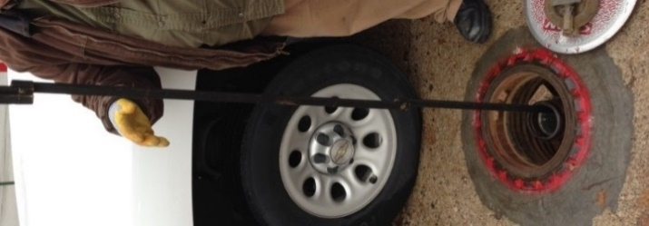  Figure 21. Testing for Water. | 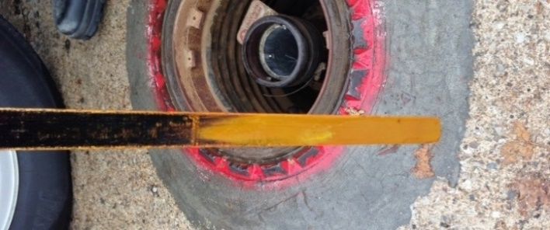  Figure 22. Stick with Paste – No Water Indicated.
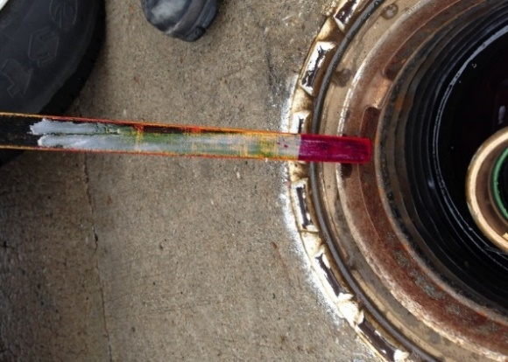
Figure 23. Sticks with Red Coloring that Shows Water Levels in Different Storage Tanks.

VIII. Labeling Enforcement Checklist and Sampling Procedure Outline for Taking Samples of Motor Oil at Service Locations

A. Preparation
1. Contact: Officials should park their vehicle in a suitable location until they have notified the management of the business where sampling will occur of their identity, authority, and nature of the visit. When sampling at retail locations, is it often necessary to have the oil dispensers unlocked or air compressors started so samples can be taken. Officials must establish contact with the authorized management representative and explain how samples will be taken and ensure that employees understand what is expected of them in assisting the official. It is management’s right to observe sampling procedures and to be present during the sample collection process if they choose to do so. This will allow the person to confirm the source of the oil and identity of the container and enable them to satisfy themselves that the sample container was properly sealed and purged product was returned to the proper storage.
2. Business Information: Obtain the business ownership and other identity information.
3. Labeling: Ensure that the label on any vehicle engine (motor) oil container, receptacle, dispenser, or storage tank is properly labeled. In addition, if remote tank filling ports are used, it is recommended that they be properly marked and secured. If there is any doubt, the official should ask the manager to indicate the location of the appropriate storage tank for each grade or brand of oil.

B. Labeling and Documentation
If the official’s state adopts the Uniform Method of Sale of Commodity Regulation in NIST Handbook 130, carry out an inspection according to Section 2.33 “Labeling of Vehicle Engine (Motor) Oil.”
2.33. Oil.
2.33.1. Labeling of Vehicle Engine (Motor) Oil. – Vehicle engine (motor) oil shall be labeled.
2.33.1.1. Viscosity. – The label on any vehicle engine (motor) oil container, receptacle, dispenser, or storage tank, and any invoice or receipt from service on an engine that includes the installation of vehicle engine (motor) oil dispensed from a receptacle, dispenser, or storage tank, shall contain the viscosity grade classification preceded by the letters “SAE” in accordance with SAE International’s latest version of SAE J300, “Engine Oil Viscosity Classification.”
NOTE: If an invoice or receipt from service on an engine has limited room for identifying the viscosity, brand, and service category, then abbreviated versions of each may be used on the invoice or receipt and the letters “SAE” may be omitted from the viscosity classification.
2.33.1.1. Viscosity – Are the following labeled with the viscosity grade classification preceded by the letters “SAE” in accordance with SAE International’s latest version of SAE J300, “Engine Oil Viscosity Classification?” |  | Yes | No | Comments
a. | Containers
b. | Receptacles
c. | Dispensers
d. | Storage Tanks
e. | Invoice or Receipts
2.33.1.2. Brand. – The label on any vehicle engine (motor) oil container and the invoice or receipt from service on an engine that includes the installation of bulk vehicle engine (motor) oil dispensed from a receptacle, dispenser, or storage tank shall contain the name, brand, trademark, or trade name of the vehicle engine (motor) oil.
2.33.1.2. Brand. – Are the following labeled with the name, brand, trademark, or trade name of the vehicle engine (motor) oil? |  | Yes | No | Comments
a. | Containers
b. | Receptacles
c. | Dispensers
d. | Storage Tanks
e. | Invoice or Receipts
2.33.1.3. Engine Service Category. – The label on any vehicle engine (motor) oil container, receptacle, dispenser, or storage tank and the invoice or receipt from service on an engine that includes the installation of bulk vehicle engine (motor) oil dispensed from a receptacle, dispenser, or storage tank shall contain the engine service category, or categories, displayed in letters not less than 3.18 mm (¹/₈ in) in height, as defined by the latest version of SAE J183, “Engine Oil Performance and Engine Service Classification (Other than “Energy Conserving”),” API Publication 1509, “Engine Oil Licensing and Certification System,” European Automobile Manufacturers Association (ACEA), “European Oil Sequences,” or other Vehicle or Engine Manufacturer standards as approved in Section 2.33.1.3.1. “Vehicle or Engine Manufacturer Standard.”
2.33.1.3. Engine Service Category. – Are the following labeled with the engine service category, or categories? |  | Yes | No | Comments
a. | Containers
a. | Height of the letters at least 3.18 mm (¹/₈ in)?
b. | Receptacles
b. | Height of the letters at least 3.18 mm (¹/₈ in)?
c. | Dispensers
c. | Height of the letters at least 3.18 mm (¹/₈ in)?
d. | Storage Tanks
d. | Height of the letters at least 3.18 mm (¹/₈ in)?
e. | Invoice or Receipts
e. | Height of the letters at least 3.18 mm (¹/₈ in)?
2.33.1.3.1. Vehicle or Engine Manufacturer Standard. – The label on any vehicle engine (motor) oil container, receptacle, dispenser, or storage tank and the invoice or receipt from service on an engine that includes the installation of vehicle engine (motor) oil dispensed from a receptacle, dispenser, or storage tank shall identify the specific vehicle or engine manufacturer standard, or standards, met in letters not less than 3.18 mm (¹/₈ in) in height. If the vehicle (motor) oil only meets a vehicle or engine manufacturer standard, the label must clearly identify that the oil is only intended for use where specifically recommended by the vehicle or engine manufacturer.
2.33.1.3.1. Vehicle or Engine Manufacturer Standard. – Are the following labeled with the specific vehicle or engine manufacturer standard, or standards the oil meets?  NOTE: If the oil only meets a vehicle or engine manufacturer standard, the label must clearly identify that the oil is only intended for use where specifically recommended by the vehicle or engine manufacturer. |  | Yes | No | Comments
a. | Containers
a. | Height of the letters at least 3.18 mm (¹/₈ in)?
b. | Receptacles
b. | Height of the letters at least 3.18 mm (¹/₈ in)?
c. | Dispensers
c. | Height of the letters at least 3.18 mm (¹/₈ in)?
d. | Storage Tanks
d. | Height of the letters at least 3.18 mm (¹/₈ in)?
e. | Invoice or Receipts
e. | Height of the letters at least 3.18 mm (¹/₈ in)?
2.33.1.3.2. Inactive or Obsolete Service Categories. – The label on any vehicle engine (motor) oil container, receptacle, dispenser, or storage tank and the invoice or receipt from service on an engine that includes the installation of bulk vehicle engine (motor) oil dispensed from a receptacle, dispenser, or storage tank shall bear a plainly visible cautionary statement in compliance with the latest version of SAE J183, Appendix A, whenever the vehicle engine (motor) oil in the container or in bulk does not meet an active API service category as defined by the latest version of SAE J183, “Engine Oil Performance and Engine Service Classification (Other than “Energy Conserving”).” If a vehicle engine (motor) oil is identified as only meeting a vehicle or engine manufacturer standard, the labeling requirements in Section 2.33.1.3.1. Vehicle or Engine Manufacturer Standard applies.
2.33.1.3.2. Inactive or Obsolete Service Categories. – Do the following bear a cautionary statement in compliance with the latest version of SAE J183, Appendix A, whenever the vehicle engine (motor) oil in the container or in bulk does not meet an active API service category as defined by the latest version of SAE J183, “Engine Oil Performance and Engine Service Classification (Other than “Energy Conserving”).” If a vehicle engine (motor) oil is identified as only meeting a vehicle or engine manufacturer standard, the labeling requirements in Section 2.33.1.3.1. Vehicle or Engine Manufacturer Standard applies. |  | Yes | No | Comments
a. | Containers
a. | Is the cautionary statement plainly visible?
b. | Receptacles
b. | Is the cautionary statement plainly visible?
c. | Dispensers
c. | Is the cautionary statement plainly visible?
d. | Storage Tanks
d. | Is the cautionary statement plainly visible?
e. | Invoice or Receipts
e. | Is the cautionary statement plainly visible?
2.33.1.4. Tank Trucks or Rail Cars. – Tank trucks, rail cars, and other types of delivery trucks that are used to deliver bulk vehicle engine (motor) oil are not required to display the SAE viscosity grade and service category or categories on such tank trucks, rail cars, and other types of delivery trucks.
2.33.1.5. Documentation. – When the engine (motor) oil is sold in bulk, an invoice, bill of lading, shipping paper, or other documentation must accompany each delivery. This document must identify the quantity of bulk engine (motor) oil delivered as defined in Sections 2.33.1.1. Viscosity; 2.33.1.2. Brand; 2.33.1.3. Engine Service Category; the name and address of the seller and buyer; and the date and time of the sale. For inactive or obsolete service categories, the documentation shall also bear a plainly visible cautionary statement as required in Section 2.33.1.3.2. Inactive or Obsolete Service Categories. Documentation must be retained at the retail establishment for a period of not less than one year.
2.33.1.5. Documentation Requirements |  | Yes | No | Comments
a. | Invoice
i. | Does the seller provide an invoice?
ii. | Is the date and time of sale included?
iv. | Is the seller name and address included?
v. | Is the buyer name and address included?
vi. | Does it identify the quantity of bulk oil delivered?
vii. | 2.33.1.1. Viscosity. – Does it include the viscosity grade classification preceded by the letters “SAE” in accordance with SAE International’s latest version of SAE J300, “Engine Oil Viscosity Classification”?
viii. | 2.33.1.2. Brand. – Does it include the name, brand, trademark, or trade name of the vehicle engine (motor) oil?
ix. | 2.33.1.3. Engine Service Category. – Does it include engine service category, or categories?
x. | 2.33.1.3.2. Inactive or Obsolete Service Categories. – If applicable, includes a cautionary statement in compliance with the latest version of SAE J183, Appendix A.
xi. | Is the document retained at retail business for at least one year?
b. | Bill of Lading
i. | Does the seller provide a Bill of Lading?
ii. | Is the date and time of sale included?
iv. | Is the seller name and address included?
v. | Is the buyer name and address included?
vi. | Does it identify the quantity of bulk oil delivered?
vii. | 2.33.1.1. Viscosity. – Does it include the viscosity grade classification preceded by the letters “SAE” in accordance with SAE International’s latest version of SAE J300, “Engine Oil Viscosity Classification”?
viii. | 2.33.1.2. Brand. – Does it include the name, brand, trademark, or trade name of the vehicle engine (motor) oil?
ix. | 2.33.1.3. Engine Service Category. – Does it include the engine service category, or categories?
x. | 2.33.1.3.2. Inactive or Obsolete Service Categories. – If applicable, includes a cautionary statement in compliance with the latest version of SAE J183, Appendix A.
xi. | Is the document retained at retail business for at least one year?
c. | Shipping paper or other documentation.
i. | Does the seller provide other shipping paper?
ii. | Is the date and time of sale included?
iv. | Is the seller name and address included?
v. | Is the buyer name and address included?
vi. | Does it identify the quantity of bulk oil delivered?
vii. | 2.33.1.1. Viscosity. – Does it include the viscosity grade classification preceded by the letters “SAE” in accordance with SAE International’s latest version of SAE J300, “Engine Oil Viscosity Classification”?
viii. | 2.33.1.2. Brand. – Does it include the name, brand, trademark, or trade name of the vehicle engine (motor) oil?
ix. | 2.33.1.3. Engine Service Category. – Does it include the engine service category, or categories?
x. | 2.33.1.3.2. Inactive or Obsolete Service Categories. – If applicable, includes a cautionary statement in compliance with the latest version of SAE J183, Appendix A.
xi. | Is the document retained at retail business for at least 1 year?
xii. | Does the seller provide an invoice?
3.13.2. Labeling of Recreational Motor Oil.
3.13.2.1. Viscosity. – The label on each container of recreational motor oil shall contain the viscosity grade classification preceded by the letters “SAE” in accordance with the SAE International’s latest version of SAE J300, “Engine Oil Viscosity Classification.”
3.13.2.2. Intended Use. – The label on each container of recreational motor oil shall contain a statement of its intended use in accordance with the latest version of SAE J300, “Engine Oil Viscosity Classification.”
3.13.2. Labeling of Recreational Motor Oil.  3.13.2.1. Viscosity. –The label on each container of recreational motor oil shall contain the viscosity grade classification preceded by the letters “SAE” in accordance with the SAE International’s latest version of SAE J300, “Engine Oil Viscosity Classification.” |  | Yes | No | Comments
a. | Containers:  Is the viscosity grade classification provided and is it preceded by the letters “SAE.”

3.13.2. Labeling of Recreational Motor Oil.  3.13.2.2. Intended Use. – The label on each container of recreational motor oil shall contain a statement of its intended use in accordance with the latest version of SAE J300, “Engine Oil Viscosity Classification.” |  | Yes | No | Comments
a. | Containers:  Does the label contain a statement of its intended use?

C. Payment for Samples
In most jurisdictions, the official is obligated to pay the retail value of the product if an oil sample is taken from a place of business where it can be sold legally unless the sample is being collected pursuant to a search warrant, or the product’s owner surrenders the sample at no cost.
PAYMENT RECEIPT
Agency Responsible for Engine Fuel Quality
Address,
City, State, Zip
Telephone, E-mail, URL
Seller’s Name: | Address: |  | Date:
Received $___________________as payment for the fuel or oil samples described below taken for inspection purposes as provided for by Chapter xx-xx of the Code of the State of ___________________.
__________________________________________________
Signature of Business Representative
Sample Taken: |  | Official:

D. Taking Oil Samples
- Packaged Engine (Motor) Oil: Motor oil is typically packaged in 946 mL (1 qt) and larger containers. Sample packages are usually taken at retail locations from a lot of containers offered for sale on the shelf. To obtain a sample of packaged motor oil, select one package from the lot and either purchase it or provide the seller with an evidence receipt. Apply a sample identity label (do not cover label information) to the package and document the business location, date, time of purchase, identity, and other information about the sample on an official report form, and document the chain-of-custody. Secure, protect, and ship or transfer to the quality laboratory.
- Nozzle Samples.
  - Sample Container and Sample Size: Use a clean sample container that has a secure cap. See the following table.
Suggested Container Types and Minimum Sample Sizes for Motor Oil
Product | Container Material |  |  |  | Minimum Sample Size
Product | Glass | Aluminum | Metal | FHDPB “Plastic”¹ | Minimum Sample Size
Engine (motor) Oil – General | YES | YES | YES | YES | 1 L
NOTE 1: Fluorinated High-Density Polyethylene Bottles (FHDPB) are available in wide mouth sizes and are fluorinated inside and outside for improved barrier properties and reduced solvent absorption and penetration. Fluorination enhances long-term container performance and prevents or reduces permeation loss. Useful with most aggressive organic solvents, they are durable and puncture-resistant.
b. Sample Collection
c. Identifying Samples for Traceability: The following information illustrates the type of information typically collected for an oil sample. It is acceptable to either permanently mark the sample container with a unique identifying number or to apply a label to the container with a unique number. An Oil Sample Data Sheet should be prepared and included with the sample in a shipping container or sample case. This information can also be collected directly in a database or entered on a data sheet. Regardless of the system used, the following is a compilation of the information usually collected for an oil sample.
Examples of Entries on an Oil Sample Data Sheet
 | Item | Entry
1. | Sample number/unique container identity | Enter the sample container’s unique identifier number. Each sample must have a unique identifier such as a number or alpha numeric code so that its handling can be traceable and so that all collection reports and laboratory tests are linked to the original sample.
2. | Product Identification – Viscosity grade, Service Category | }Obtained from device label, tank marking, or bill of lading.
3. | Brand
4. | Sampling location identity | Enter business name, identifier number (this may be assigned by the fuel regulatory agency), address of sample location, business mail address, agent name, telephone, fax, and email. This information may be used to immediately notify the seller to remove the oil from sale if the sample fails.
5. | Sampled lot | Amount of oil that the sample represents. Total liters or gallons in the source oil storage tank represented by the sample.
6. | Supplier(s) of oil | Enter the name of the supplier or suppliers of the oil in the source storage tank.
7. | Date of last oil delivery to storage tank. | Enter the day of the latest delivery of the oil into the storage tank from which the sample was taken.
8. | Sample Taken by | Name (or identifier number) of the official who took the sample.
9. | Source of sample | Identify the specific source of the sample (e.g., dispenser number, storage tank number or location, or license number of tank truck and compartment number).
10. | Date/Time sample collected | Enter the time of day, day, month and year indicating when the sample was collected.
11. | Sample Type | Nozzle or other collection method
12. | Notes/Safety Notice  | Enter weather conditions and any remarks necessary to accomplish the analysis of the sample. Safety warning label.
13. | Security Seal(s) | Enter the identification number of any security seal applied to a sample container or transport case.

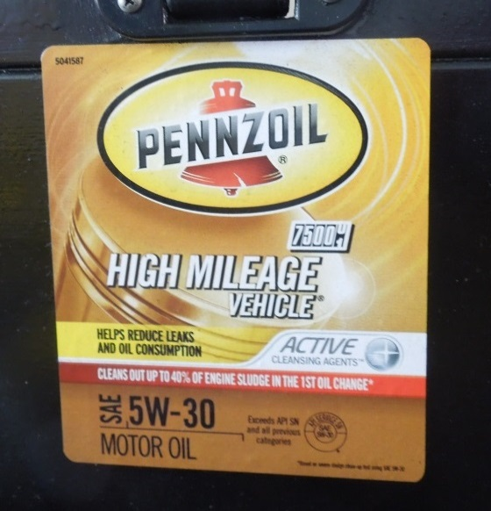  Figure 24. Brand and Viscosity on a Dispenser. | 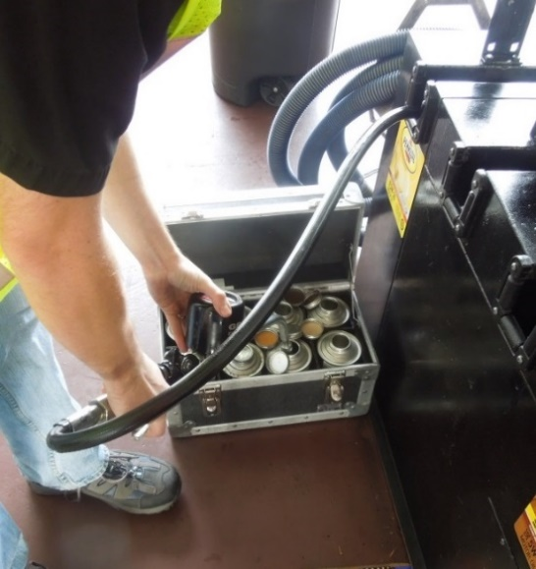  Figure 25. Taking Oil Samples – Metal Cans.
Photo courtesy of North Carolina Department of Agriculture and Consumer Services.
- Sampling
- Sample Taken from a Measuring Device that Dispenses a Single Product: Typically no flushing is required for these single product nozzle-hose combinations if they are protected from contamination. If the official is taking a sample from an oil dispenser covered with an accumulation of dirt and oil, take care to clean the nozzle to ensure that dirt and debris are not introduced to the container. It may be necessary to first run enough oil into another container to ensure the nozzle is dispensing uncontaminated oil.
When bulk storage is used, one aspect to look at is the accuracy and clarity of the markings of storage tanks and remote fill openings to avoid the possibility of cross-mixing or contamination. Storage conditions affect the shelf-life of most lubricants so officials should determine if the seller is aware of the manufacturer’s recommendations. If no shelf-life guidance is provided and the lubricant is greater than two-years old, the seller should contact the manufacturer for guidance about the suitability of the oil for use. Most oils are not affected by normal storage temperatures but sometimes storage tanks can be located too near heat sources, which may create situations that cause oil additives to oxidize prematurely.
- Operate oil meters/fillers manually and do not use automatic pre-set delivery features when collecting oil samples.
- If the oil meter/filler control is equipped with a totalizing device, the official should record the product identity and the before and after readings on the sample collection report.

SKIN INJECTION HAZARD: Some oil delivery systems operate under high-pressure. Fluids spraying from dispenser valves, hose leaks, or ruptured components may send out spray that may pierce skin and cause serious injuries and long-term health consequences (e.g., oil, chemicals and dirt can be injected under the skin). The official should wear personal protective equipment and, should an injury occur, he or she should seek immediate medical attention. The official should never point a dispenser valve at anyone or at any part of his or her body or put a hand over the end of a nozzle while opening or operating the flow valve regardless of its operating pressure.
    - The official may hold the sample container or place it on a solid level surface adjacent to the dispenser.
The official should then:
    - Use a cotton rag to wipe and clean the parts of the nozzle that comes into contact with the sample container and oil sample.
    - Ensure the dispenser is operational (e.g., air supply is turned on) and, if required, have the dispenser authorized.
    - Place the nozzle/outlet in the sample container and fill it slowly. Continue until it is filled to the specified volume (or the dispenser indicates the quantity specified for the sample).
    - Seal the sample container and mark as required.
    - Record the sample information on an official report and document the details needed to start the chain of custody process.
    - Issue a Notice of Violation for any labeling violations found during the inspection. An example of a Notice of Violation is provided in Appendix C.
- Protecting and Transporting the Sample
- Protecting Samples: The samples should be kept cool and be protected from ultraviolet light to prevent deterioration and mishandling. A shipping carton or hard-shell sample transport case similar to those used to protect fuel samples may be used.
- Transporting Samples: Transport the sample and related documentation to the quality laboratory in a timely manner in accordance with agency procedures. This is important because, after subsequent deliveries occur, the sample is no longer representative.
f. Documentation – Collecting Information: Throughout a visit, it is important that officials collect information about device labeling and other signage to document the identity and other claims made by a seller about the oil being sampled. It is good to record a brief description of actions and observations as well as recording any relevant information provided by the seller. Taking notes, photographs and keeping logs, provide permanent records of a sampling activity and facilitate enforcement.
g. Follow through actions: See IX. “Respond to Test” In the fuel sampling outline for guidance on how to respond to test results and initiating stop sale actions.

Appendix A. – Monthly Safety and Health Equipment Checklist
Safety and Health Equipment Checklist
Notice: Reorder replacements immediately after they are used or damaged.
Date: |  | Official:
 | Item: | Inspected | Replace | Comment:  - Condition?  - What type or brand is needed and how many?
1. | Safety Clothing/Vest
2. | Steel-Toed Shoes or Boots
3. | Eye/Face Protection
4. | Gloves
5. | Respirator/Filters, Dust Mask
6. | Eye-Wash Kit and Solution
7. | Safety Flashlight/Batteries
8. | Safety/Non-sparking Tools
9. | Traffic Cones
10. | Fire Extinguisher (recharge or replace immediately after use) |  |  | Expiration Date:
11. | First-Aid Kit
12. | Safety Fuel Storage Can
13. | Digital Camera (data card/battery)
14. | Oil Spill Kit – (absorbent, wipes)
15. | Lint Free Wiping Cloths
16. | Vehicle Emergency Triangles
17. | Rain Suit/Weather Clothing
18. | Hardhat
19.
20.
21.
22.
23.
24. | Other Equipment Needed:
25. | Other Supplies Needed:
Questions:
- Does the equipment fit properly and is it clean, sanitary and serviceable?
- Are there rips, tears, or cuts that reduce usability of the item?
- Does it require regular replacement or recharging? Is it stored properly and is it easily accessible?
- Have you been trained in proper use?
- Have you read the Safety Data Sheets (SDSs) for fuel products within the last 180 days?

Appendix B. – Examples of Fuel Sampling and Chain-of-Custody Reports

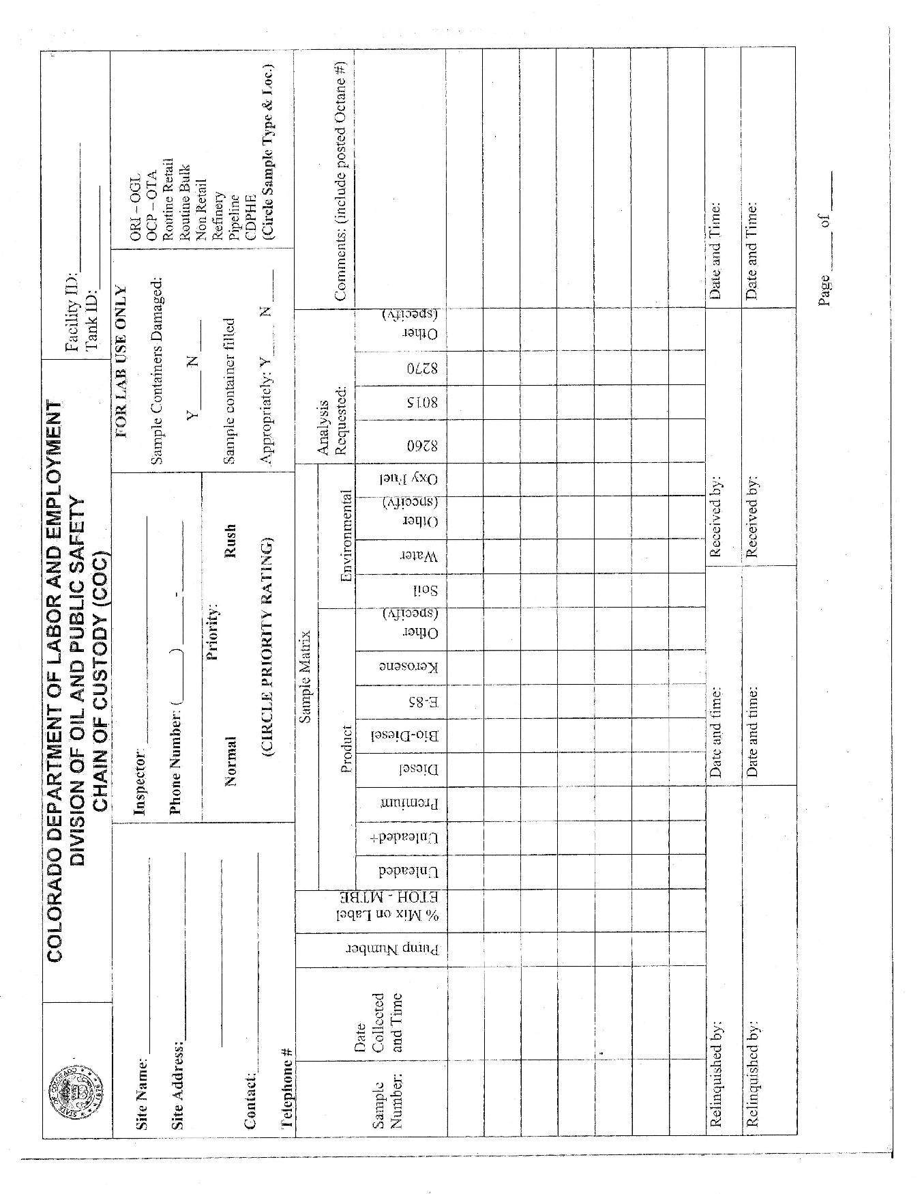

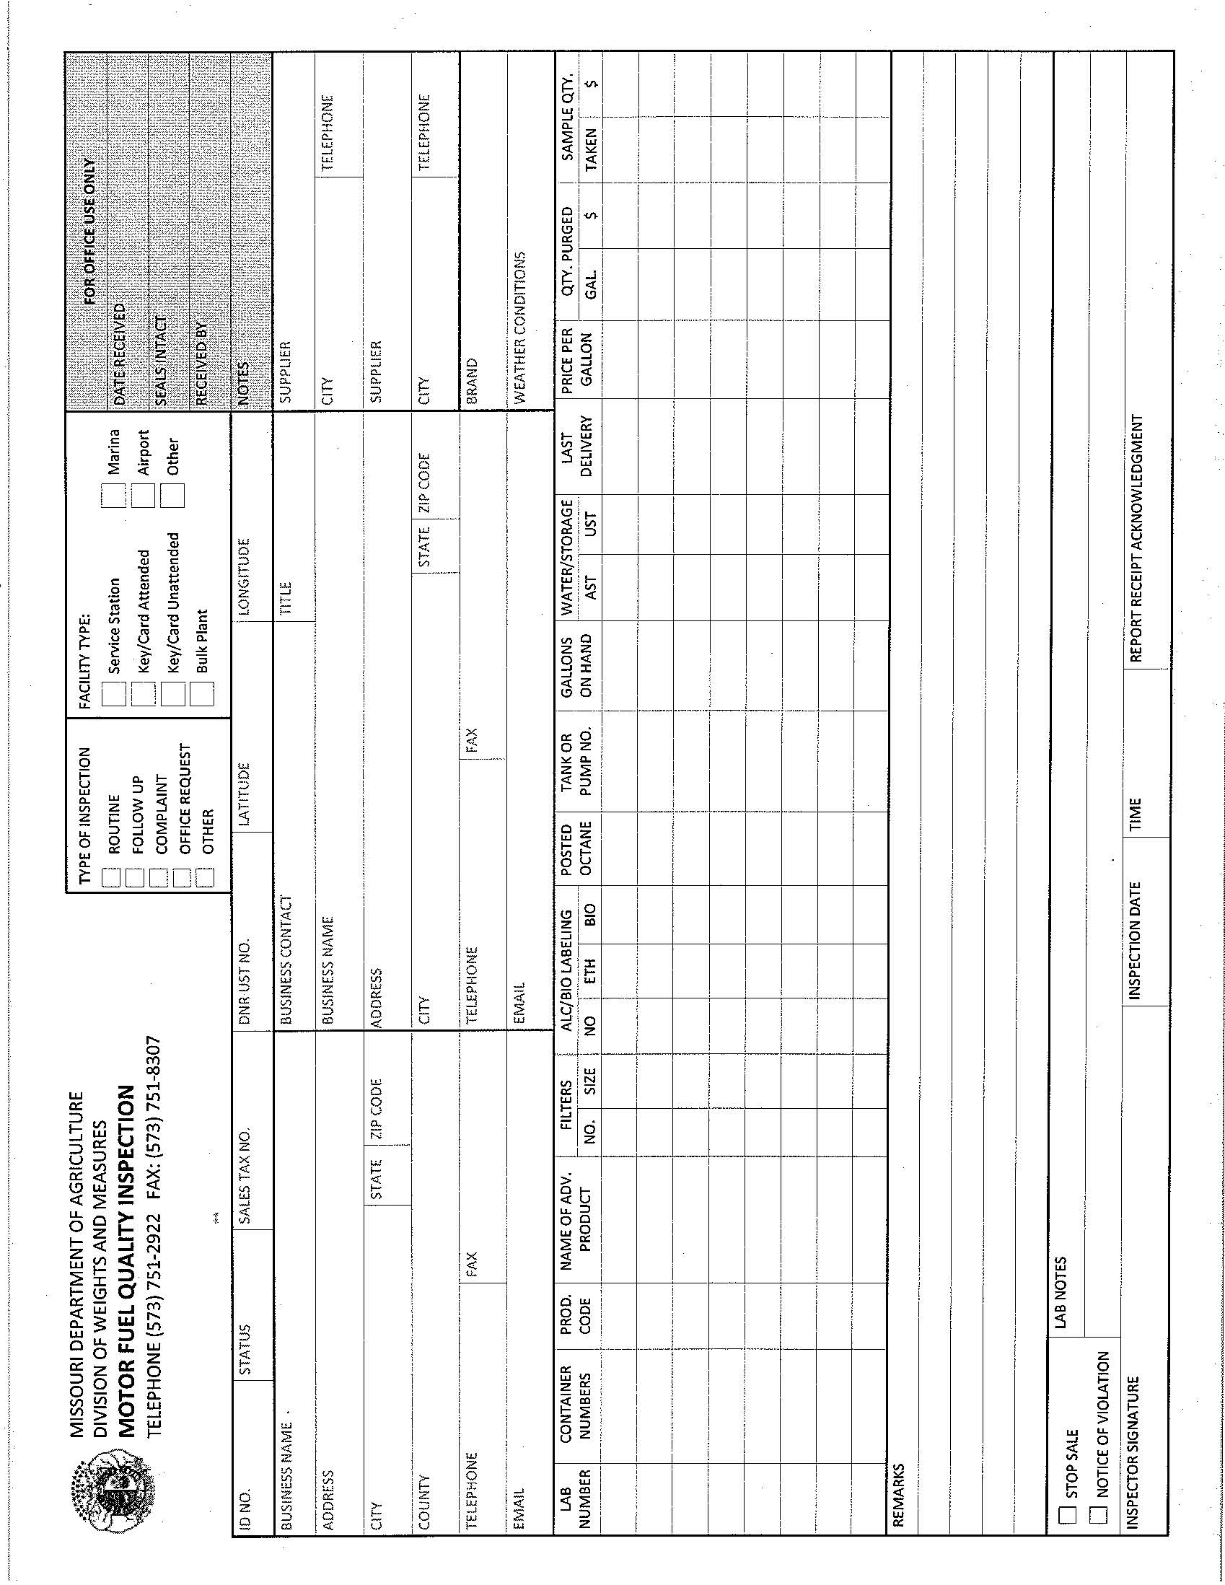

THIS PAGE LEFT INTENTIONALLY BLANK

Appendix C. – Examples of Notice of Violation
and Stop Sale Reports
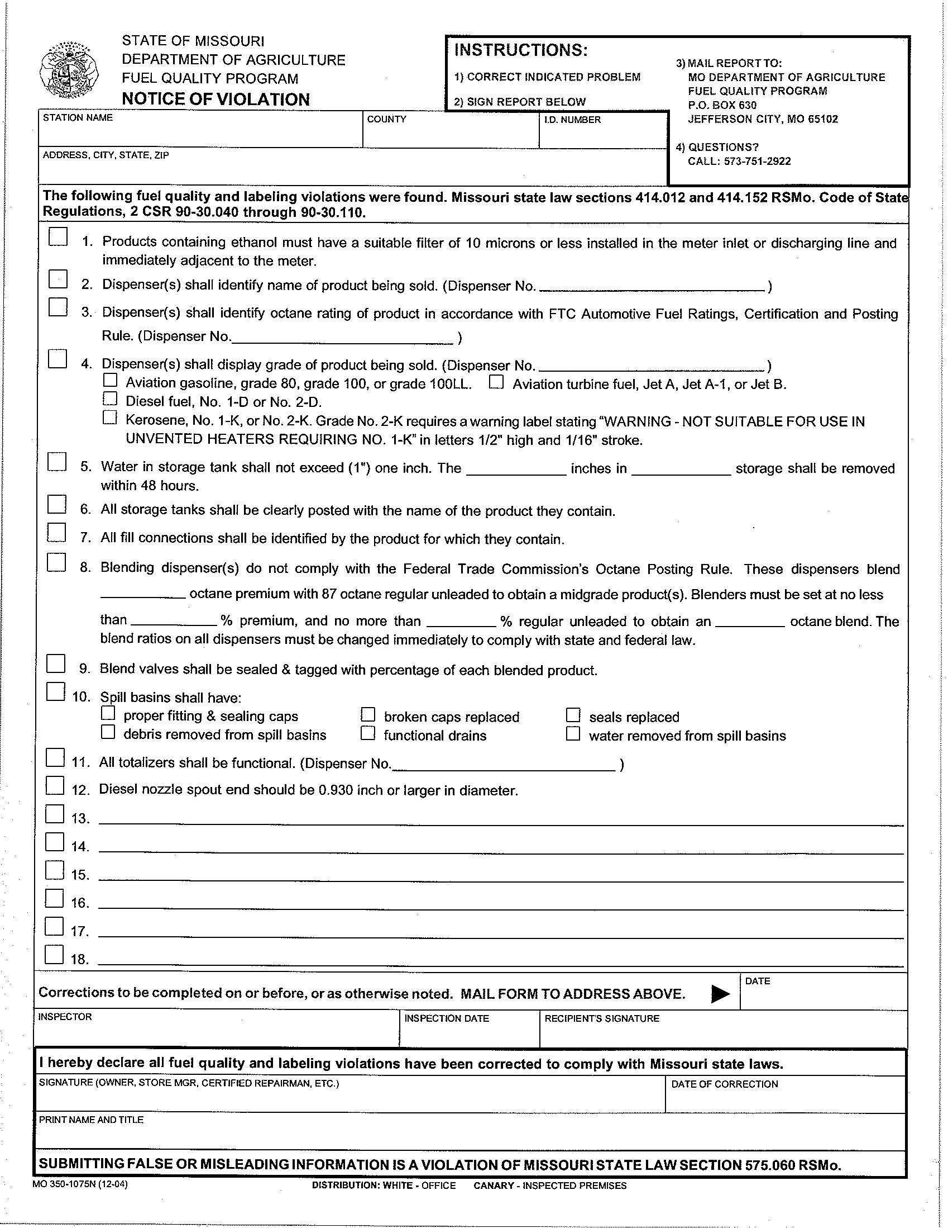

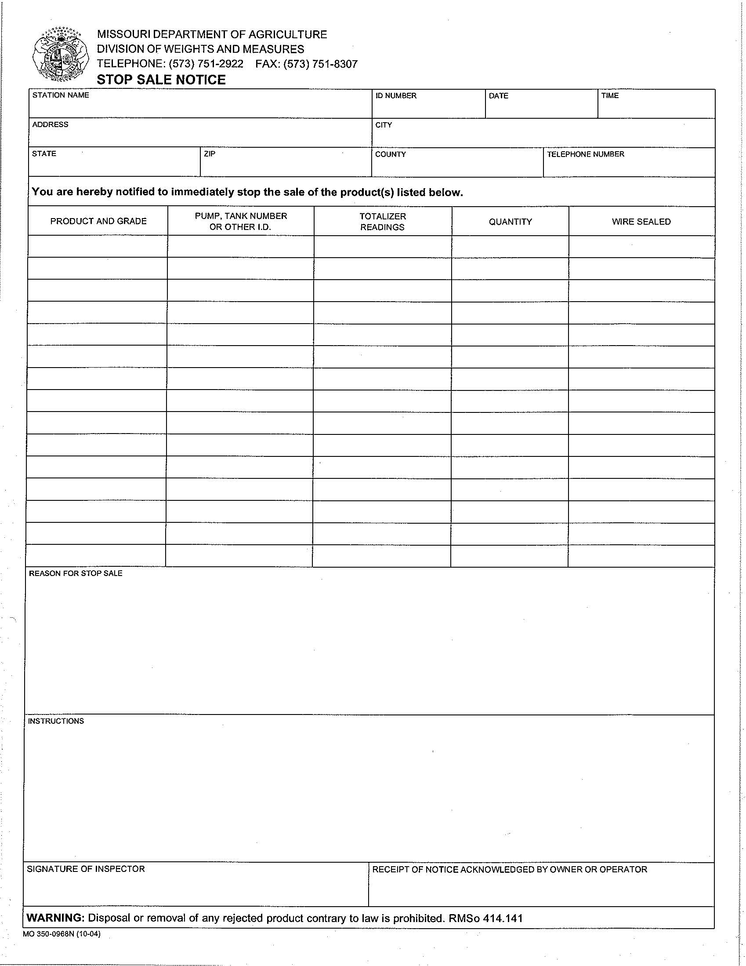

THIS PAGE LEFT INTENTIONALLY BLANK

Appendix D. – References and
Acknowledgments
1. “Fuel and Fuel System Microbiology: Fundamentals, Diagnosis, and Contamination Control” (2003) – (47 pages) Frederick J. Passman, Editor. ASTM International Manual Series: Manual 47.
2. “Petroleum Laboratory Testing and Operations” (1997) – Field Manual 10-67-2 Headquarters Department of the Army.
3. NCWM Publication 21 – “Petroleum Products – Sampling Procedures and Safety Manual” (1997) – National Conference on Weights and Measures.
4. NFPA 77 “Recommended Practice on Static Electricity” (2014) – National Fire Protection Association.
5. API Recommended Practice 2003 – 7th Edition “Protections Against Ignitions Arising Out of Static, Lightning and Stray Currents” (2008).
6. ASTM D6759 - 09 “Standard Practice for Sampling Liquids Using Grab and Discrete Depth Samplers”
7. “Biodiesel Handling and Use Guide” (4th Edition) (2009) – National Renewable Energy Laboratory - REL/TP-540-43672
8. “7-29 Ignitable Liquid Storage in Portable Containers” – Factory Mutual - Global Property Loss Prevention Data Sheets – Access free with registration and available at https://www.fmglobal.com/FMGlobalRegistration/Default.aspx . This site was accessed on 10/30/2014.
9. Underwriters Laboratory # 30 “Standard for Metal Safety Cans.” This standard is available at http://ul.com/ Accessed 10/30/2014.
10. “Methanol Safe Handling Manual” (2013). This manual was published by the Methanol Institute and it is available at http://www.methanol.org/Health-And-Safety/Safe-Handling/Methanol-Safe-Hanlding-Manual.aspx . This site was accessed on 10/30/2014.
11. ASTM D5842-14 - “Manual of Petroleum Measurement Standards (MPMS) Chapter 8.4” & ASTM D5842 - “Standard Practice for Sampling and Handling of Fuels for Volatility Measurement.”
12. Manual of Petroleum Measurement Standards – Chapter 8.1 “Standard Practice for Manual Sampling of Petroleum and Petroleum Products” Fourth Edition (2013). American Petroleum Institute.
13. “Aviation Fuels Technical Review (FTR-3)” – (2004) Chevron Global Aviation – Chevron Products Company, Houston Texas.
14. “Draft Fuel Sampling Procedures” (2013) – Written by the Colorado Division of Oil and Public Safety.
15. ASTM D4840-99 (2010) “Standard Guide for Sample Chain-of Custody Procedures.”
16. ASTM D5854-15“Standard Practice for the Mixing and Handling of Liquid Samples of Petroleum and Petroleum Products.” (2015)
17. NIST Handbook 44 “Specifications Tolerances and other Technical Requirements for Commercial Weighing and Measuring Devices” (2016).
18. European Standard – I.S. EN 14275:2013 “Automotive Fuels - Assessment of Petrol and Diesel Fuel Quality - Sampling from Retail Site Pumps and Commercial Site Fuel Dispensers” (2013).
19. European Standard – I.S. EN ISO 3170:2004 “Petroleum Liquids – Manual Sampling” (2004).
20. Training Module – Twelve: “Petroleum Products.” This training document was published by the California Division of Measurement Standards (2002).
21. Australia – Division 5.2 Under Subsection 58(A) procedures related to the collection of fuel samples (2013).
22. Standard Operating Procedure – Seven – “Sample Preservation, Storage, Handling and Documentation.” This is a publication of the U.S. Environmental Protection Agency (Revision 2.0, 2003).
23. Chain of Custody Form (COC) - Colorado Department of Labor and Employment – Division of Oil and Public Safety. This form is provided in this handbook as an example.
24. API Standard 1512 (1st Edition) “Petroleum Test Laboratory Accreditation Program” (October 1995). This standard is published by the American Petroleum Institute.
25. ASTM D4814 – 16a “Standard Specification for Automotive Spark-Ignition Engine Fuel.” (2016)
26. ASTM D4306 – 15 “Standard Practice for Aviation Fuel Sample Container for Tests Affected by Trace Contamination” (2015).
27. ASTM D4953 – 15 “Standard Test Method for Vapor Pressure of Gasoline and Gasoline-Oxygenate Blends (Dry Method) (2015).
28. NIST Handbook 130 “Uniform Laws and Regulations in the Areas of Legal Metrology and Engine Fuel Quality” (2016).
29. “Ethanol-Water Phase Separation White Paper” by Samir Jain. Published by Veeder-Root. Accessed at http://nationalpetroleum.net/Ethanol-Water-Phase-Separation-facts.pdf on December 11, 2014.
30. “Keeping Water Out of Your Storage System.” Steel Tank Institute (2005). Accessed on December 12, 2014, at http://www.steeltank.com/Portals/0/pubs/KeepingWaterOutofYourStorageSystem_updated%20_2_.pdf
31. “Guidance for Underground Storage Tank Management at ULSD Dispensing Facilities” by Clean-Diesel Org. Accessed on December 12, 2014 at http://www.clean-diesel.org/pdf/GuidanceforUndergroundStorageTankManagement_FINAL.pdf
32. “Operating and Maintaining Underground Storage Tank Systems: Practical Help and Checklists” by the Environmental Protection Agency. Accessed on December 12, 2014 at http://www.epa.gov/oust/pubs/ommanual.htm
33. “Manual Tank Gauging – For Small Underground Storage Tanks” by the Environment Protection Agency. Accessed on December 12, 2014 at http://www.epa.gov/swerust1/pubs/manltank.pdf
34. “Tank Smart – Daily Inventory and Statistical Inventory Analysis.” Module 11 – Maine Department of Environmental Protection. Accessed on December 12, 2014 at http://www.maine.gov/dep/waste/tanksmart/
documents/TankSmart_Mod.11_DI&SIA.pdf
35. Photos – several of the photographs of fuel and fuel and water mixtures and field sampling equipment were provided by the Missouri Department of Agriculture’s Fuel Quality Program.
36. Sample Collection and Summary Report – Courtesy of the Georgia Department of Agriculture – Fuel Oil Laboratory.
37. ASTM D6224-09 “Standard Practice for In-Service Monitoring of Lubricating Oil for Auxiliary Power Plant Equipment.”
38. API 1525A “Bulk Engine Oil Chain of Custody and Quality Documentation.” First Edition, (2012).
39. “Crime Scene Investigation – A Guide for Law Enforcement” (2013). National Forensic Science Technology Center in which NIST participants.
40. ASTM D7464-14 “Standard Practice for Manual Sampling of Liquid Fuels, Associated Materials and Fuel System Components for Microbiological Testing.”
41. Material Safety Data Sheet – “High Mileage Motor Oil 10W30” from the Valvoline Company.
42. ASTM D2699-15a “Standard Test Method for Research Octane Number of Spark-Ignition Engine Fuel.”
43. ASTM D2700-16 “Standard Test Method for Motor Octane Number of Spark-Ignition Engine Fuel.”

THIS PAGE LEFT INTENTIONALLY BLANK

Appendix B
Item 2301-1: NIST Handbook 130 – Uniform Packaging and Labeling Regulation
11.XX. Multi-Unit Fresh Fruit and Vegetable Packages.
Presentation by United Fresh Produce Association, Western Growers Association, Produce Marketing Association and Presentation by California Agriculture Commissioners and Sealers Association

This ANSI Standard “High-Visibility Safety Apparel and Headwear (ANSI/ISEA 107-2010) was established by American National Standards Institute (http://ansi.org/) and the International Safety Equipment Association (http://www.safetyequipment.org/). Officials and other workers are routinely exposed to the hazards of low visibility while on the job. This standard provides guidelines for the selection and use of high-visibility safety apparel such as shirts, rainwear, outerwear, safety vests and headwear to improve worker visibility during the day, in low-light conditions, and also at night.
NOTICE: The mention of trade or brand names does not imply endorsement or recommendation by the U.S. Department of Commerce over similar products which provide equivalent or better protection that may be available from other manufacturers.
The term “light ends” means hydrocarbons from crude distillation that are low density (lighter weight than gasoline) and have low boiling temperatures. Butanes are the most common light end hydrocarbons used in gasoline.
Based on data from several programs, when a 1.1 L flush is used, many samples failed because the amount of fuel retained in dispensers varies depending on the installation. In some instances, the use of a 1 gal flush may be required to eliminate the possibility that hose and nozzle contamination can cause a sample to fail or that a failure can be called into question. By increasing the flush quantity to a minimum of 1.8 L (0.5 gal) programs were successful in addressing issues where installations requiring additional piping would fail due to inadequate purge of 1.1 L (0.3 gal) value. Based on this information, NIST recommends a minimum flush quantity of 1.8 L (0.5 gal) be used for most installations unless the installation indicates that a larger purge is justified.
From Draft “Blending and Dispensing Flex Fuels” by the Colorado Department of Labor and Employment – Division of Oil and Public Safety at: https://www.colorado.gov/pacific/sites/default/files/Guidance%20-%20Blending%20And%20Dispensing%20Flex%20Fuels.pdf. Accessed 8/12/2015. See also “Missouri Guidelines for Blending Flex Fuels Pilot Program” at http://www.blenderpumps.org/factors-to-consider/state-guidelines-a-programs/103-guidelines-for-blending-flex-fuels-pilot-program.html. Accessed 8/12/15.

