General Session
Proceeding Speeches, Presentations, and Awards
Pittsburgh, Pennsylvania
July 16 – 20, 2017

Table A
Table of Contents
Reference Key Page GEN-
General Session Proceeding Speeches, Presentations, and Awards 1
Honorary President’s Address “Measurements: The Constant Frontier” 3
Honorary President’s Address Presentation 5
National Conference on Weights and Measures Chairman’s Address 11
National Conference on Weights and Measures Chairman-Elect’s Address 13
Roll Call of the States 17
102nd NCWM Annual Meeting/Award Recipients 17
Anniversary Awards 17
Special Recognition Awards 18
Lifetime Achievement Award 19
Distinguished Service Award 20
Contributions Award 21

THIS PAGE INTENTIONALLY LEFT BLAN

Honorary President’s Address
“Measurements: The Constant Frontier”

Pittsburgh, Pennsylvania
July 18, 2017

Kent Rochford

Acting Under Secretary of Commerce for Standards and Technology and
Acting Director, National Institute of Standards and Technology (NIST)
Mr. Kent Rochford, Acting Director of the National Institute of Standards and Technology (NIST) and Acting Under Secretary of Commerce, gave a presentation at the 102nd Annual Meeting. This presentation gives a thoughtful look at NIST’s impact on measurement and science. Currently, NIST is working to redefine the kilogram based on a property of nature, the Planck constant, rather than using a physical artifact that is affected by environmental factors.
Mr. Rochford’s presentation follows.

THIS PAGE INTENTIONALLY LEFT BLANK

Honorary President’s Address Presentation

National Conference on Weights and Measures
Chairman’s Address

Pittsburgh, Pennsylvania

July 18, 2017

Kristin Macey

California Department of Food and Agriculture

Division of Measurement Standards
Honored guests, fellow members, and friends, it is my honor to welcome you to Pittsburgh, Pennsylvania, and the 102nd Annual Meeting of the National Conference on Weights and Measures (NCWM).
This time last year in Denver, Colorado, we learned the name, and briefly met, the new chief of the National Institute of Standards and Technology (NIST), Office of Weights and Measures (OWM), Dr. Doug Olson. Any change at NIST OWM will potentially affect the NCWM, and anyone following Carol Hockert has big shoes to fill. However, today, I am pleased to report that Carol’s knowledge transfer efforts worked; Dr. Olson has grown very big feet and is filling in those shoes quite nicely. Doug’s actions so far speak volumes about the commitment NIST has to the NCWM and ensures our relationship will remain on solid ground.
My theme for this year is “Tradition and Technology: Finding the Right Balance.” Pittsburgh is such a great city to experience instances of each. It is one of the few U.S. cities now testing autonomous vehicles in real-world conditions. Indeed, the transportation sector is a very good example of how the speed of technological changes are necessitating the development of new and timely measurement standards. For those of you who are interested in tradition, it may surprise you that there is, right here in Pittsburgh, a museum of old weights and measures artifacts, provided and supported by the International Society of Antique Scale Collectors. This is an excellent example of how we give reverence to our past.
Regarding standards development, I am pleased to appoint former NCWM Chairman Jerry Buendel, to lead the Charter Team he created to review NCWM’s current method of developing and creating new standards. To briefly recap the issue: The process to adopt prompt measurement standards has become more problematic in recent years. Industry is constantly ahead of regulators in developing new measurement technologies or means to sell their products. The NCWM Committees’ agendas have grown. They report there is not enough time at their meetings to thoroughly consider each item, develop finished language, and deliver items ready for consideration at the voting sessions. When the voting and publishing changes to the NIST handbooks becomes delayed, this frustrates businesses trying to go through proper channels. Regulators are also becoming more impatient with the deferral of agenda items, as states are being forced to react with state-specific laws that may or may not agree with the adopted uniform codes. Patchwork enforcement is not good for businesses. It is problematic for regulators and NIST technical advisors. Under Jerry’s leadership, we have an opportunity to refresh NCWM’s review of how we conduct business to ensure process efficiency and effectiveness for all.
As you heard earlier today, NCWM is conducting a widespread review of regulatory programs across the United States this year that will establish a baseline for recurring future surveys. The NCWM Weights and Measures Survey, developed by Don Onwiler (NCWM), Steve Harrington (Oregon) and Craig VanBuren (Michigan) was sent to all state directors this July. This is the most comprehensive request for information in recent years. The survey asks questions about funding sources, operating expenses, staffing, salaries, scope of activities, inspection intervals, and compliance rates. The NCWM Board of Directors has approved a two-year cycle for this survey, which will alternate with the biannual NIST Metrology Workload Survey. Additionally, the Board has approved the development of a comprehensive Petroleum Laboratory Survey. Combined, these three surveys will give us valuable data accruing on a broad spectrum of subject areas that can be used by individual jurisdictions and the U.S. weights and measures community. This is in keeping with our Strategic Goal 2 to expand the role of the NCWM as a source of support for state and local weights and measures programs.
Another way NCWM is demonstrating value to regulatory and industry stakeholders is the continued advancement on professional certification exams. It has been five years now since the first exam was produced for retail motor-fuel dispensers. Six exams are in place, and two more have just been created. Unlike the others, these two are to test individuals on the basic weighing and measuring concepts of NIST Handbook 44, “Specifications, Tolerances, and Other Technical Requirements of Weighing and Measuring Devices.” After the Board of Directors approves proctoring procedures, all exams will need to be proctored. This will assure the integrity of the exam process and is a requirement of the accreditation we are seeking.
Our Conference, the 102nd, is being held in the historic Omni-William Penn Hotel, built in 1916. This is where celebrities and presidents stay when visiting Pittsburgh. Every sitting president since Theodore Roosevelt has stayed here while in office so we know that John F. Kennedy has been here. You’ve heard the good things that NCWM is doing this year, so in the spirit of JFK let me just say, “My fellow members, ask not what NCWM can do for you, ask what you can do for NCWM!” Ours is an organization that is driven from the bottom up; NCWM is only the conduit for change. It is most likely to be an inspector in the field who finds something amiss which generates a proposal to change a handbook. For each of the 237 registrants at this Conference, there are tenfold back home. How do we inspire, train, and retain these people? Some of them will become our future leaders, so how do we get them involved in our process? Let them participate! Do you remember your first NCWM Conference? I do, and I remember what an inspiration it was to me. Allow your employees to experience the same “light-bulb moment.” Expose them to a regional meeting, NIST training event, or NCWM Conference if nearby. This year a full 20 % of the registrants are first time attendees, and we have two students registered, Maxwell Kirby and Holly Butcher. Help them grow into our future leaders! Other things you can do to keep the Conference fresh in our minds is to talk about these meetings with your staff back home and continue to educate your administrators about the importance of weights and measures.
In closing, I want you to know how much your trust and confidence this last year has meant to me. I’ve been supported at each step of the way by many groups and individuals – by the Nominating Committee who selected me; by Jerry Buendel who, as immediate past chair, was my mentor; by Don Onwiler, the NCWM staff, and Board of Directors who had to put up with a newbie; and by the NIST staff with their coordination of events and technical support.
Thanks to each one of you for making this year’s Conference a huge success! And next year, you will be in good hands with Jimmy Cassidy as Chairman, and Brett Gurney who is on the horizon for 2018!

National Conference on Weights and Measures
Chairman-Elect’s Address
Pittsburgh, Pennsylvania
July 20, 2017

James Cassidy

City of Cambridge, Massachusetts
Good Morning,
I am honored to be the Chairman of the 103rd Meeting of the National Conference of Weights and Measures. For those of you who don’t know me and I think most do, because I have been told by many that I got character and a great personality; if not most, the colorful clothes that I do wear, and I do stand out. I am Jim Cassidy from the City of Cambridge in Cambridge, Massachusetts. I have been with the City of Cambridge, Weights and Measures Department for 18 years. My first Conference was in 1999 when I was able to come and represent the City of Cambridge.
Now, I would like to thank the City of Cambridge, City Manager, Louis DePasquale, and the Deputy City Manager, Lisa Petersen, and a couple of my former bosses, Bob Healy and Rich Rossi, which are great city managers and given me the opportunity to be here and participate with this great group. I do want to thank all of them for making this possible.
Over my 18 years, I have served as presiding officer multiple times and sat on the Credentials Committee. I have been on the Laws and Regulations Committee as Kristen (Macey) mentioned earlier. Going on in 2002 to 2007, I was very grateful in accepting this when Ross Anderson offered it to me. In 2007, I was the Chair as Kristin said earlier when the Conference was dealing with Automatic Temperature Compensation (ATC). Myself and my friend, Mr. Chesser, got to stand up here for quite a long time up at Snow Bird. It was a contentious long day, but we got through it. After serving as the L&R Committee Chair, I went on the Board of Directors from 2011 through 2016, when I was nominated to the Chair-elect position. I have served as the past chair of the Northeastern Weights and Measures Association (NEWMA) and numerous committees at NEWMA. I am presently the Secretary/Treasurer.
I’m also honored to be the fifth National Chairperson from the Commonwealth of Massachusetts. I am the third local official from Massachusetts, behind J.E. Bowen in 1967 and Tom Geiler in 1994. We also had J.P. McBride in 1958 and Ed Stadolnik in 1981, which were the State Directors at that time, and I’m grateful and honored. I would like to thank the Massachusetts folks that are here today Lou Sakin, Jack Walsh, Elaine Vieira, Angel Nazario, Mark Coyne. Past members, Bob McGrath, Bill Timmons, Tom Geiler and Steve Agostinelli. I can’t forget, one of my good friends, that couldn’t be here; he sent me a nice e-mail this morning, Charlie Carroll. As well as, many of my friends of NEWMA, Steve Giguere, John McGuire, Frank Greene Walt Remmert, Mike Sikula, Marc Paquette, Cheryl Ayer, and Ethan Bogren. All the great work that they have done here, and the other people here from NEWMA. I want to thank them for everything they have done.
In saying that, my theme for this upcoming year is “Back to the Basics, As We Arrive in the Cloud.” As we look into the future of weights and measures, as we have seen this week folks, we now have a tentative code for Transportation Network Measurement System (TMNS). My main goal with saying this is there will be other devices and other systems we are going to look at that will be cloud based in other different ways. But, we must still remember, I’m still an inspector, I get my hands dirty, and I want to make sure every other inspector in this room feels comfortable. And, you have to remember a couple of things, a mile is still going to be 5280 feet, a gallon is still 231 cubic inches and a pound is still 16 ounces. How we test devices and systems might be a little bit different, but the measurement will still be the same. And I want to make sure we all understand this and feel comfortable. Not to take two steps back and when we’re not sure what is going on here; what we do, the main concepts will not change. I don’t think they ever will change. And, I want to make sure we really feel comfortable with that there.
My other goals for this year: first, I must thank Matt Curran for doing a great job with Fuels and Lubricants Subcommittee (FALS) group. I will replace Matt with Bill Striejewske from Nevada. Bart, thank you very much for allowing Bill to step into this role. I could meet with Bill when we sat in Boston. He has a lot of great drive. He is a very intelligent man, and he will help that group immensely. But saying that, when we look at our organizational chart, we only have a few states who participate on the FALS Committee on the regulated side. I am reaching out now, and I will as I come around the country to the four regions this year. I’m going to be asking you folks that have fuel quality labs and programs, if you have some great people in those groups, we need them, and I want them. Whatever I can do to help, if travel is an issue in the beginning, they still have web meetings. We need to strengthen that group, and there are other subcommittees and tasks groups, but this one right here is one of my tasks for right now. As we go along, we are going to be looking at others. But this is one of my main ones. So, I am reaching out to the states with these programs, if you have good quality people, we need them. Because, honestly folks, our membership is our Conference, we are better in numbers.
That’s how I feel and I hope you feel the same way. Also, in talking about the regions, it was a great year, going from Hawaii with Jerri Kahana and Tim Lloyd, they did a fabulous job at the Western Weights and Measures Association (WWMA). Then going to Arlington, Texas, Phil Wright did a great job, and I thank those folks there. Kristin and I had a great time traveling together this year. We went to NEWMA, my home region, Ethan did a great job. Then we finished up in Lincoln, Nebraska. Ken Tichota also did a great job.
My goal is to strengthen our subcommittees and regions associations are as follows
    - Reach out to states with fuel labs to help strengthen the expertise of the membership to the FALS, which includes creating an on-line list server that allows members to communicate and access information.
    - Evaluate the structure of all regional meetings to ensure that they are running smoothly and efficiently.
    - For all regions, to designate one representative to assist me in mapping out a master calendar for our regional meetings.
Now, I would like to thank Jane Zulkiewicz and Matt Curran for their service on the S&T Committee, Lou Sakin for the L&R Committee, Stacey Carlson for the PDC, and Matt Curran for the FALS.
The appointments are as follows:
Standards and Tolerances (S&T) Committee
- Brad Bachelder, Maine: representing the Northeast region.
- Joe Eccleston, Maryland: completing Matt Curran’s term; representing the Southern region.
Laws and Regulations (L&R) Committee
- John McGuire, New Jersey: representing the Northeast region.
Professional Development Committee (PDC)
- Jean Kliethermes, Missouri
Fuels and Lubricants Subcommittee (FALS)
- Bill Striejewse, Nevada: Chairman
Credentials Committee
- David Aguay, San Luis Obispo, California
Nominating Committee
- Chair Kristin Macey, Chair
- Stephen Benjamin
- Mark Coyne
- Frank Greene
- Ivan Hankins
- Rich Lewis
- Hal Prince
Presiding Officers
- Tim Chesser, Arkansas
- Loren Minnich, Kansas
- Bart O’Toole, Nevada
- Jack Walsh, Town of Wellesley, Massachusetts
Parliamentarian
- Lou Straub, Fairbanks Scale
Chaplain
- Constantine Cotsoradis, Flint Hills Resources.
Lastly, I would like to thank my lovely wife for her support and sacrifice in allowing me to fulfill my commitment and passion in weights and measures. After all, we are one of three couples, which I know of, that met through this fabulous organization. And thanks to you, Mr. John Albert and Mr. Ron Hayes, for letting me steal her away.

THIS PAGE INTENTIONALLY LEFT BLANK

Roll Call of the States
The Roll Call of the States is taken at the commencement of the Voting Session of the Annual Meeting.

Alabama
Alaska
American Samoa
Arizona (X)
Arkansas (X)
California (X)
Colorado (X)
Connecticut (X)
Delaware
District of Columbia (X)
Florida (X)
Georgia (X)
Guam
Hawaii (X)
Idaho
Illinois (X)
Indiana (X)
Iowa (X)
Kansas (X)
Kentucky (X)
Louisiana
Maine (X)
Maryland (X)
Massachusetts (X)
Michigan (X)
Minnesota (X)
Mississippi (X)
Missouri (X)
Montana
Navajo Nation
Nebraska (X)
Nevada (X)
New Hampshire (X)
New Jersey (X)
New Mexico (X)
New York
North Carolina (X)
North Dakota
Northern Mariana Islands
Ohio (X)
Oklahoma
Oregon (X)
Pennsylvania (X)
Puerto Rico
Rhode Island
South Carolina
South Dakota (X)
Tennessee (X)
Texas (X)
Utah (X)
Vermont (X)
Virgin Islands
Virginia (X)
Washington (X)
West Virginia
Wisconsin (X)
Wyoming

Present (X): 38
Absent: 19

102nd NCWM Annual Meeting/Award Recipients

Anniversary Awards

For 5 Years Attendance
- Luciano Burtini
- Joanna Johnson
- Jeri Kahana
- Robert Legg
- Matt Maiten
- Marco Mares
- Rachelle Miller
- Joe Moreo
- Louis Sakin
- Richard Scali
- Richard Shipman
- Elisa Stritt
- Stan Toy
For 10 Years Attendance
- John Albert
- Chuck Corr
- Fran Elson-Houston
- Krister Hard af Segerstad
- Jim Hewston
- Dmitri Karimov
- Julie Quinn
- Craig VanBuren
- Lisa Warfield
For 15 Years Attendance
- Cary Ainsworth
- Jerry Buendel
For 20 Years Attendance
- Kurt Floren
- Bob Murnane
For 25 Years Attendance
- Michael Kelly
- Don Onwiler
For 30 Years Attendance
- Lou Straub
- Richard Suiter

Special Recognition Awards
Presiding Officers
- Tim Chesser, Arkansas
- Loren Minnich, Kansas
- Marc Paquette, Vermont
- Jack Walsh, Town of Wellesley, Massachusetts
Chaplain
- Constantine Cotsoradis, Flint Hills Resources
Parliamentarian
- Lou Straub, Fairbanks Scale, Inc.
Sergeants-at-Arms
- Chris Brenner, Pennsylvania
- Ron Pierce, Pennsylvania
Nominating Committee
- Chairman – Jerry Buendel, Washington
- Stephen Benjamin, North Carolina
- Charles Carroll, Massachusetts
- Kurt Floren, Los Angles California
- John Gaccione, Westchester County, New York
- Joe Gomez, New Mexico
Credentials Committee
- Chairman – Matt Maiten, Santa Barbara County, California
Associate Membership Committee
- Chairman – Richard Shipman, Rice Lake Weighing Systems Inc.
- Vice-Chair – Bill Callaway, Crompco
- Secretary/Treasurer – Mark Flint, ADM
COMPLETING TERMS
Board of Directors
- Brett Gurney, Utah, Active Membership (Western)
- Raymond Johnson, New Mexico (Treasurer)
Laws and Regulations Committee
- Louis Sakin, Towns of Hopkinton/Northbridge, Massachusetts
Professional Development Committee
- Stacy Carlsen, Marin County, California
Specifications and Tolerances Committee
- Jane Zulkiewicz, Town of Barnstable, Massachusetts
CONTRIBUTIONS AWARD
- Dr. Matthew Curran, Florida
- Rebecca Richardson, MARC-IV Consulting
DISTINGUISHED SERVICE AWARD
- Tim Chesser, Arkansas
- Kurt Floren, Los Angeles County, California
LIFETIME ACHIEVEMENT AWARD
- Ross Andersen, Retired, New York

Lifetime Achievement Award
Qualifications: This award recognizes members that are by and large well-known and highly regarded for their outstanding performance and contributions to NCWM. No more than one (1) award can be granted annually. The recipient will have been a member of NCWM for at least ten years. Nominees will be considered based on the following characteristics:
Integrity: Their contributions based on unbiased input in such a manner that members are confident that the only motivation is for the improvement the organization and our work products.
Leadership: Their contribution in leading NCWM Committees, Sub-Committees, Sectors, Task Forces, Ad Hoc Assignments, work as Appointive Officials, or other displays of leadership that have advanced the NCWM toward becoming an overall better organization. The individual selected for this award will have displayed sound decision making capabilities, communication skills, motivational skills, and a tolerance for the views of others.
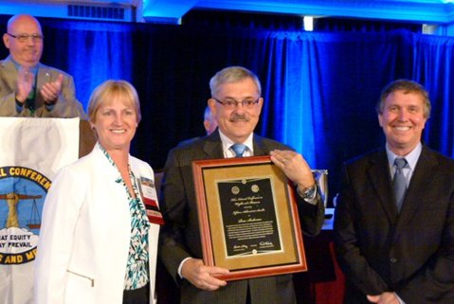
Figure 1. Lifetime Achievement Award recipient, Mr. Ross Anderson (center), receives his award from Ms. Kristin Macey, NCWM Chairperson (left), and President Dr. Kent Rochford, NIST Acting Director (right).

Distinguished Service Award
Qualifications: This award recognizes members that have made a long-term commitment of service and leadership to NCWM. The recipient will have been a member of NCWM for at least ten years and made significant contributions to the enhancement of the organization as a whole through committee service, important contributions to standards development, served as a resource for knowledge, promoted the vision for NCWM, or other long-term commitments that have advanced the mission of NCWM. Please note it is not necessary for the nominee to have provided contributions in each category.
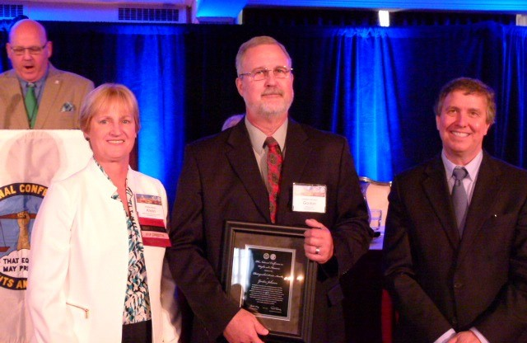  Figure 2. Distinguished Service Award to Mr. Gordon Johnson, Gilbarco, Inc.  Mr. Gordon Johnson (center), receives the Distinguished Service Award form Ms. Kristin Macey, NCWM Chairperson (left) and Conference President, Dr. Kent Rochford (NIST, Acting Director (right). |  | 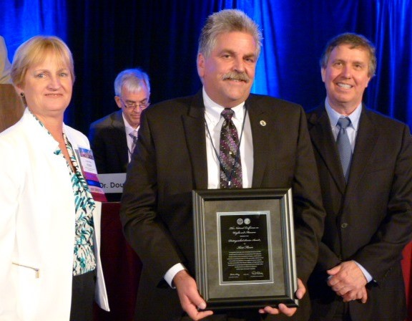  Figure 3. Distinguished Service Award to Mr. Kurt Floren, Los Angeles County, California.  Mr. Kurt Floren, Los Angeles County, California (center), receiving the Distinguished Service Award from Chairperson Kristin Macey (left), and Dr. Kent Rochford (right).

Contributions Award
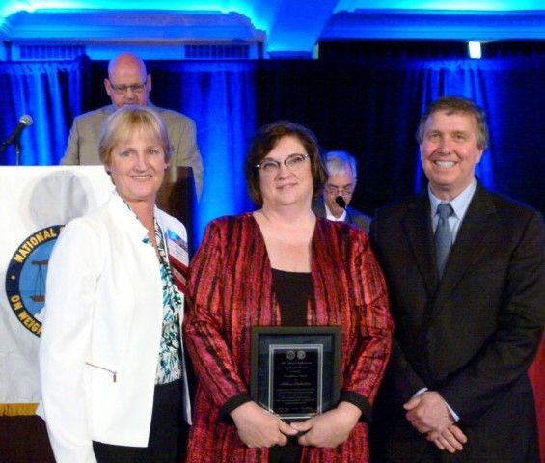
The NCWM Contributions Award recognizes members who have made notable contributions to NCWM standards, policy, administrative support or other services deemed worth of recognition. Recipients have been NCWM members for at least five years.
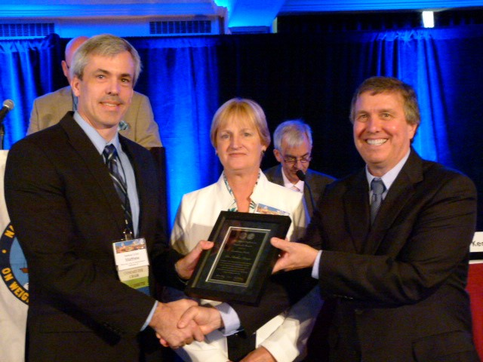
Figure 5. Contributions Award was presented to Dr. Matthew Curran, Florida.
Chairperson Kristin Macey (center) and President Dr. Kent Rochford (right) present the award to Dr. Matthew Curran (left).
Figure 4. Contributions Award was present to Ms. Rebecca Richardson, MARC IV Consulting.
Chairperson Kristin Macey (left) and President Dr. Kent Rochford (right) present the award to Ms. Rebecca Richardson (center).

THIS PAGE INTENTIONALLY LEFT BLANK

The criteria for special awards were obtained from the NCWM website at http://www.ncwm.net.

