Dear Friends,

I am honored to invite you all to the 95th Annual Meeting of the National Conference on Weights and Measures (NCWM). The 2010 meeting will be held in St. Paul, Minnesota, July 11 - 15, at Crowne Plaza St. Paul Riverfront.

This year’s theme is “Breaking Molds to Shape the Future,” and I feel that we are doing just that at the NCWM. Our technical committees and the Board of Directors are moving us forward at a rapid pace with a progressive agenda for the Annual Meeting. This year, we will have discussions on uniform method of sale for packaged printer ink and toner cartridges, declaration of biodiesel content on diesel fuel product transfer documents, price posting and computing capability and requirements for retail motor-fuel dispensers, and the many other technical items listed in this publication. You will also hear about the next steps in the implementation of the emerging National Certification Program, updates on the Conformity Assessment Program component of the National Type Evaluation Program, and other exciting opportunities on the horizon that will help to further our ability to meet the organizational mission and goals.

The work put forth by the many volunteers of the NCWM throughout the year continues to amaze me. This organization is driven by our members, and could not exist without your dedication to the pursuit of uniformity through the weights and measures standards development process.

The Annual Meeting is intended to be a model forum for members and interested parties to come together and take action on the work items presented by the committees. Stakeholder input on each and every item listed in this publication is a vital component to reaching an end product through a consensus building process. So with that, I urge you all to submit your opinions to the various committees with jurisdiction over the items of interest to you, and to attend the Annual Meeting and support your positions by making your voice heard.

I want to thank each of you for your continued support for the NCWM, and I look forward to seeing everyone in St. Paul.

Sincerely,
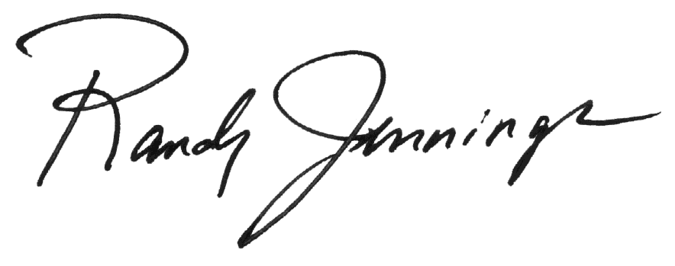
Randy Jennings
NCWM Chair

THIS PAGE INTENTIONALLY LEFT BLANK

