Certain commercial entities, equipment, or materials may be identified in this document in order to describe an experimental procedure or concept adequately. Such identification is not intended to imply recommendation or endorsement by the National Institute of Standards and Technology, nor is it intended to imply that the entities, materials, or equipment are necessarily the best available for the purpose.

Checking the Net Contents
of Packaged Goods
as adopted by the 101st National Conference on Weights and Measures 2016
Editors:
Linda Crown
David Sefcik
Lisa Warfield

Georgia Harris, Acting Chief
Office of Weights and Measures
Physical Measurement Laboratory

This publication is available free of charge from:
http://dx.doi.org/10.6028.NIST.HB.133-2017

November 2016
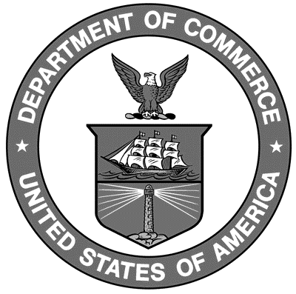
U.S. Department of Commerce
Penny Pritzker, Secretary

National Institute of Standards and Technology
Willie May, Under Secretary of Commerce for Standards and Technology and Director
NIST Handbook | 133

2017 Edition
Supersedes NIST Handbook 133, 2016 Edition

NIST Handbook | 133

National Institute of Standards and Technology Handbook 133, 2017 Edition Natl. Inst. Stand. Technol. Handb. 133, 2017 Ed. 248 Pages (Nov. 2016)
CODEN: NIHAE2

U.S. GOVERNMENT PUBLISHING OFFICE
WASHINGTON: 2016

Internet: bookstore.gpo.gov Phone: toll free (866) 512-1800; DC area (202) 512-1800 Fax: (202) 512-2250 Mail: Stop SSOP, Washington, DC 20402-0001 ISBN 0-16-051249-2

