Certain commercial entities, equipment, or materials may be identified in this document in order to describe an experimental procedure or concept adequately. Such identification is not intended to imply recommendation or endorsement by the National Institute of Standards and Technology, nor is it intended to imply that the entities, materials, or equipment are necessarily the best available for the purpose.

Checking the Net Contents
of Packaged Goods
as adopted by the 99th National Conference on Weights and Measures 2014
Editors:
Linda Crown
David Sefcik
Lisa Warfield
Carol Hockert, Chief
Office of Weights and Measures
Physical Measurement Laboratory
http://dx.doi.org/10.6028.NIST.HB.133
November 2014
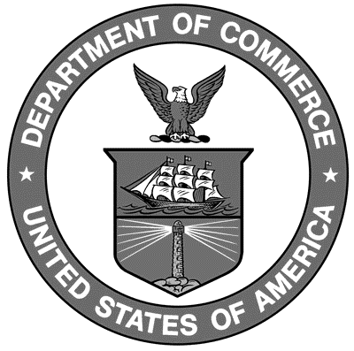
U.S. Department of Commerce
Penny Pritzker, Secretary
National Institute of Standards and Technology
Willie May, Acting Under Secretary of Commerce for Standards and Technology and Acting Director

NIST Handbook | 133

2015 Edition
Supersedes NIST Handbook 133, 2014 Edition

NIST Handbook | 133

National Institute of Standards and Technology Handbook 133, 2015 Edition Natl. Inst. Stand. Technol. Handb. 133, 2015 Ed. 190 Pages (Nov. 2014)
CODEN: NIHAE2

U.S. GOVERNMENT PRINTING OFFICE
WASHINGTON: 2014

Internet: bookstore.gpo.gov Phone: toll free (866) 512-1800; DC area (202) 512-1800 Fax: (202) 512-2250 Mail: Stop SSOP, Washington, DC 20402-0001 ISBN 0-16-051249-2

