Specifications, Tolerances, and Other Technical Requirements for
Weighing and Measuring Devices
as adopted by the 103rd National Conference on Weights and Measures 2018
Editors:
John Barton
Tina G. Butcher
Linda D. Crown
Richard A. Harshman
G. Diane Lee

Dr. Douglas A. Olson, Chief
Office of Weights and Measures
Physical Measurement Laboratory
This publication is available free of charge
from: https://doi.org/10.6028.NIST.HB.44-2019
November 2018
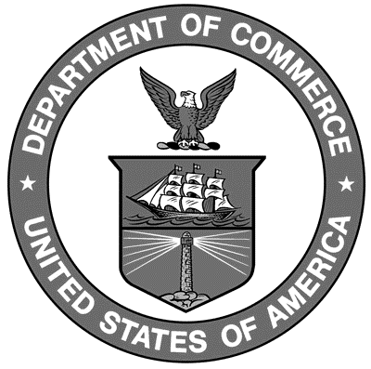

U. S. Department of Commerce
Wilbur L. Ross, Jr., Secretary

National Institute of Standards and Technology
Dr. Walter Copan, NIST Director and Under Secretary of Commerce for Standards and Technology
NIST Handbook | 44
2019 Edition
Supersedes NIST Handbook 44, 2018 Edition
Certain commercial entities, equipment, or materials may be identified in this document in order to describe an experimental procedure or concept adequately. Such identification is not intended to imply recommendation or endorsement by the National Institute of Standards and Technology, nor is it intended to imply that the entities, materials, or equipment are necessarily the best available for the purpose.

National Institute of Standards and Technology Handbook 44, 2019 Edition
Natl. Inst. Stand. Technol. Handb. 44, 2019 Ed., 546 pages (Nov. 2018)
CODEN: NIHAE2

