Checking the Net Contents
of Packaged Goods
as adopted by the 103rd National Conference on Weights and Measures 2018
Editors:
Linda Crown
David Sefcik
Lisa Warfield
Dr. Douglas Olson, Chief
Office of Weights and Measures
Physical Measurement Laboratory
This publication is available free of charge from:
https://doi.org/10.6028/NIST.HB.133-2019
November 2018
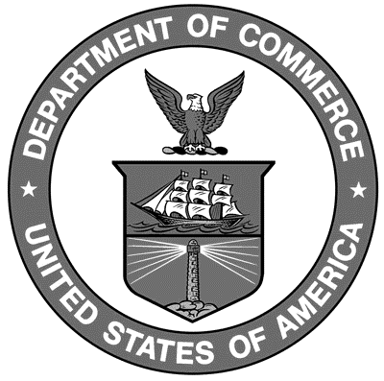
U.S. Department of Commerce
Wilbur Ross, Secretary
National Institute of Standards and Technology
Dr. Walter Copan, NIST Director and Under Secretary of Commerce for Standards and Technology

NIST Handbook | 133

2019 Edition
Supersedes NIST Handbook 133, 2018 Edition

Certain commercial entities, equipment, or materials may be identified in this document in order to describe an experimental procedure or concept adequately. Such identification is not intended to imply recommendation or endorsement by the National Institute of Standards and Technology, nor is it intended to imply that the entities, materials, or equipment are necessarily the best available for the purpose.

National Institute of Standards and Technology Handbook 133, 2019 Edition Natl. Inst. Stand. Technol. Handb. 133, 2019 Ed. 256 Pages (Nov. 2018)
CODEN: NIHAE2

