Specifications, Tolerances, and Other Technical Requirements for
Weighing and Measuring Devices
as adopted by the 101th National Conference on Weights and Measures 2016
Editors:
Tina Butcher
Linda Crown
Rick Harshman

Georgia Harris, Acting Chief
Office of Weights and Measures
Physical Measurement Laboratory
This publication is available free of charge
from: https://dx.doi.org/10.6028.NIST.HB.44-2017
November 2016
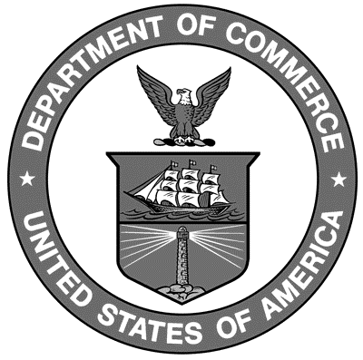

U. S. Department of Commerce
Penny Pritzker, Secretary

National Institute of Standards and Technology
Willie May, Under Secretary of Commerce for Standards and Technology and Director
NIST Handbook | 44
2017 Edition
Supersedes NIST Handbook 44, 2016 Edition

Certain commercial entities, equipment, or materials may be identified in this document in order to describe an experimental procedure or concept adequately. Such identification is not intended to imply recommendation or endorsement by the National Institute of Standards and Technology, nor is it intended to imply that the entities, materials, or equipment are necessarily the best available for the purpose.

National Institute of Standards and Technology Handbook 44, 2017 Edition
Natl. Inst. Stand. Technol. Handb. 44, 2017 Ed., 524 pages (Nov. 2016)
CODEN: NIHAE2

