Uniform Laws and Regulations
in the Areas of
Legal Metrology and
Engine Fuel Quality

as adopted by the 102nd National Conference on Weights and Measures 2017

Editors:
Linda Crown
David Sefcik
Lisa Warfield

Dr. Douglas Olson, Chief
Office of Weights and Measures
Physical Measurement Laboratory

This document is available free of charge
from: https://doi.org/10.6028/NIST.HB.130-2018

November 2017

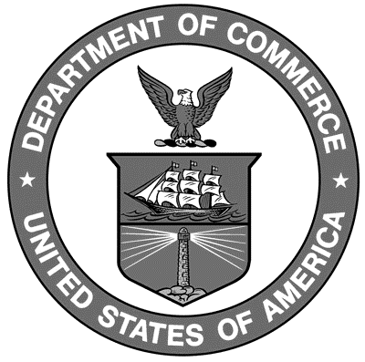

U.S. Department of Commerce
Wilbur L. Ross, Jr., Secretary

National Institute of Standards and Technology
Dr. Walter Copan, NIST Director and Under Secretary of Commerce for Standards and Technology
NIST Handbook₁₃₀
2018 Edition
Supersedes all previous editions

Certain commercial entities, equipment, or materials may be identified in this document in order to describe an experimental procedure or concept adequately. Such identification is not intended to imply recommendation or endorsement by the National Institute of Standards and Technology, nor is it intended to imply that the entities, materials, or equipment are necessarily the best available for the purpose.

National Institute of Standards and Technology Handbook 130, 2018 Edition
Natl. Inst. Stand. Technol. Handb. 130, 2018 Ed., 302 pages (November 2017)
CODEN: NIHAE2

