Uniform Laws and Regulations
in the Areas of
Legal Metrology and
Engine Fuel Quality

as adopted by the 101st National Conference on Weights and Measures 2016

Editors:
Linda Crown
David Sefcik
Lisa Warfield

Georgia Harris, Acting Chief
Office of Weights and Measures
Physical Measurement Laboratory

This document is available free of charge
from: https://dx.doi.org/10.6028/NIST.HB.130-2017

November 2016

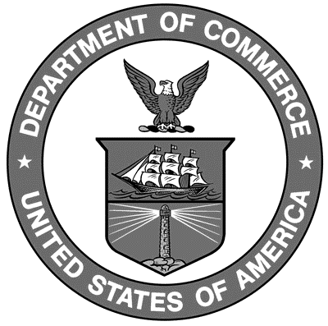

U.S. Department of Commerce
Penny Pritzker, Secretary

National Institute of Standards and Technology
Willie May, Under Secretary of Commerce for Standards and Technology and Director
NIST Handbook₁₃₀
2017 Edition
Supersedes all previous editions

Certain commercial entities, equipment, or materials may be identified in this document in order to describe an experimental procedure or concept adequately. Such identification is not intended to imply recommendation or endorsement by the National Institute of Standards and Technology, nor is it intended to imply that the entities, materials, or equipment are necessarily the best available for the purpose.

National Institute of Standards and Technology Handbook 130, 2017 Edition
Natl. Inst. Stand. Technol. Handb. 130, 2017 Ed., 304 pages (November 2016)
CODEN: NIHAE2

