President’s Address

National Institute of Standards and Technology
Portland, Maine
July 17, 2012

Dr. Willie E. May

Associate Director for Laboratory Programs/Principal Deputy

Thank you, Carol and good morning all.
I’d like to thank Commissioner Whitcomb, the State of Maine, and the people of Portland for hosting this wonderful Conference.
I’d also like to thank Chairman Floren and Don Onwiler of the National Conference on Weights and Measures (NCWM) for inviting me to speak this morning on behalf of the National Institute of Standards and Technology (NIST) Director, Pat Gallagher. I’m truly honored to be here.
I am the Associate Director of Laboratory Programs and also serve as Principal Deputy to the NIST Director. Prior to my current position, I served as Founding Director of the NIST Material Measurement Laboratory, Chemical Science and Technology Laboratory, and led the Analytical Chemistry Division. In addition to my duties at NIST, I am also Vice President of the International Committee on Weights and Measures (CIPM), and President-Elect of the CIPM’s Consultative Committee on Metrology in Chemistry and Biology. Through both my responsibilities with the CIPM and working at NIST for – well a very long time, I am somewhat familiar with the International Organization of Legal Metrology (OIML) and Legal Metrology, but this is really my first formal interaction with the National Conference on Weights and Measures (NCWM).
Slide presentation follows on next page.

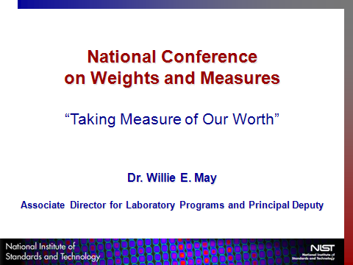

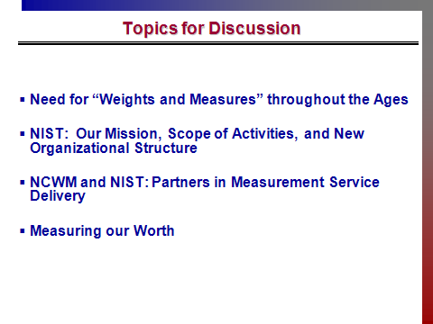

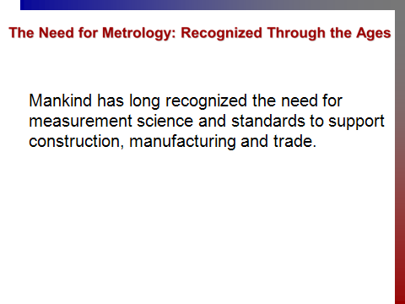

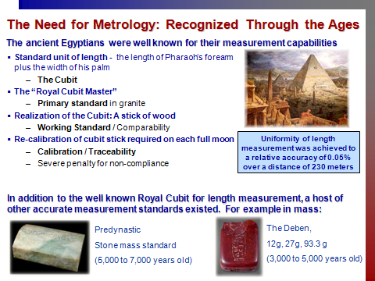

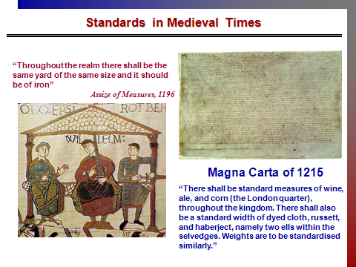

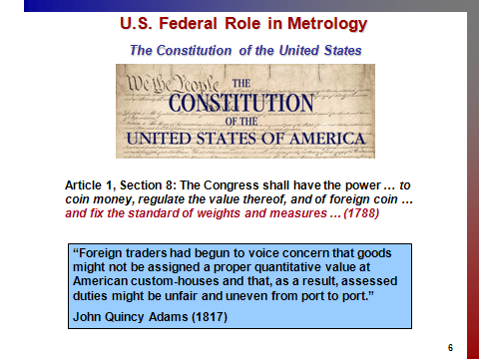

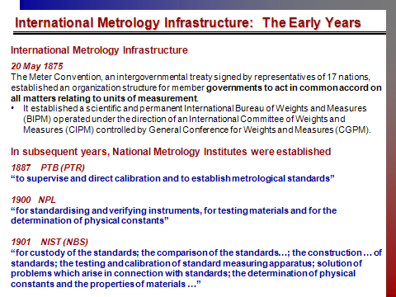

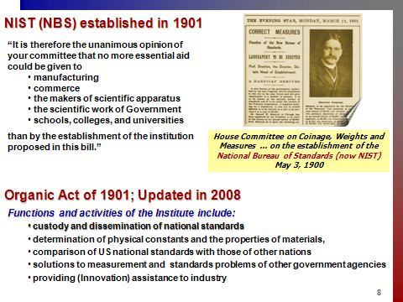

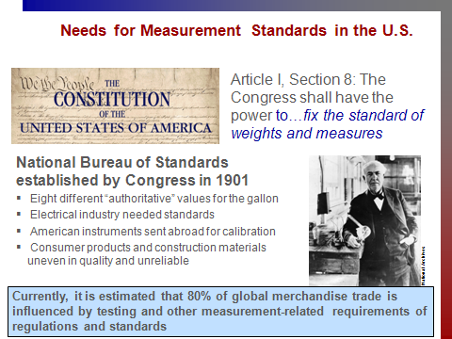

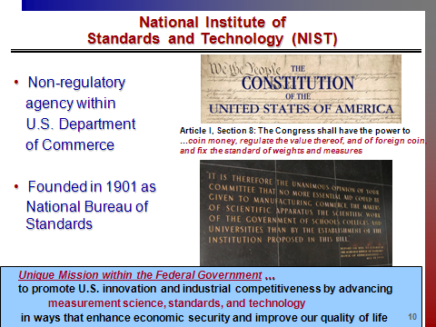

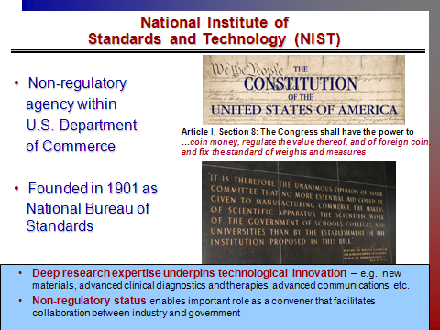

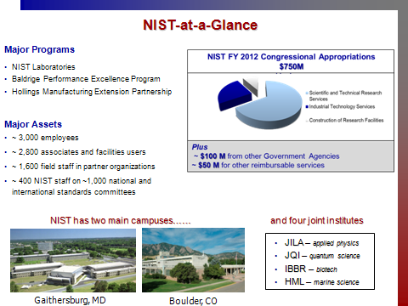

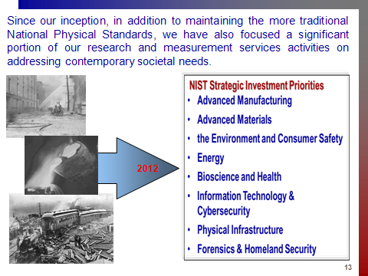

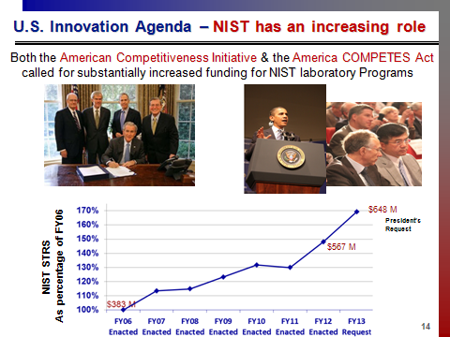

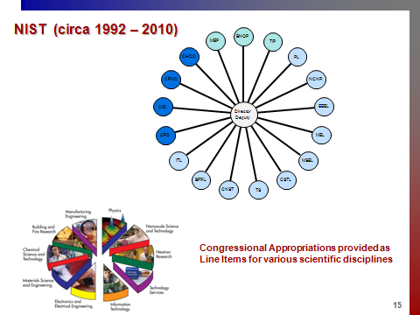

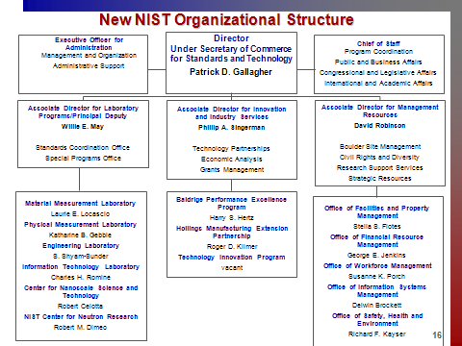

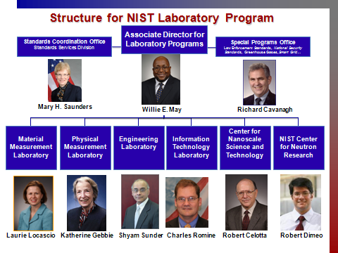

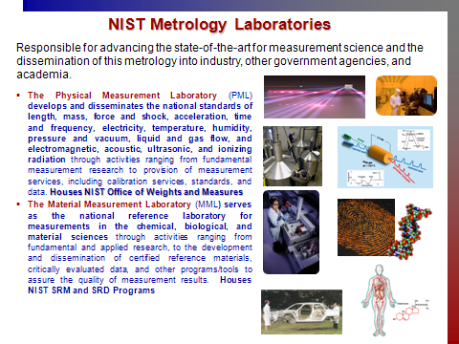

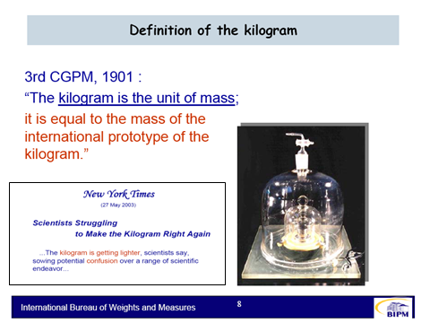

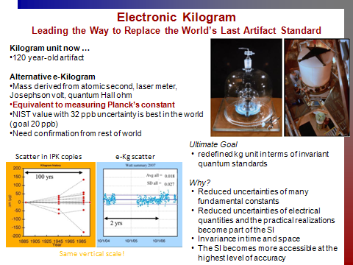

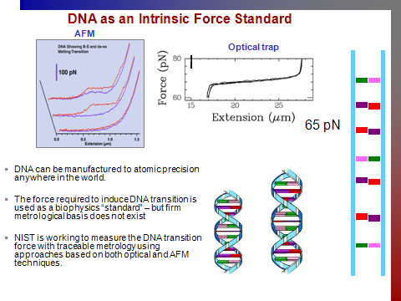

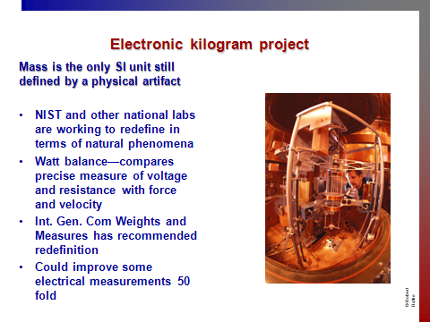

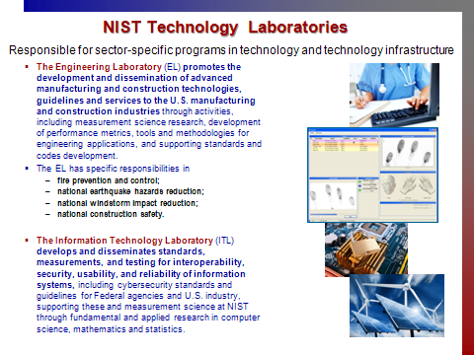

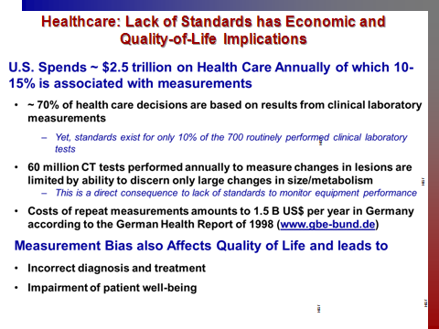

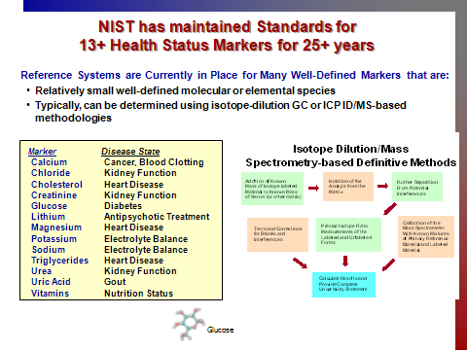

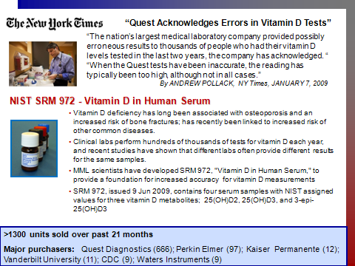

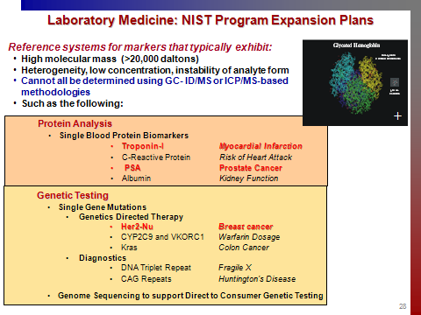

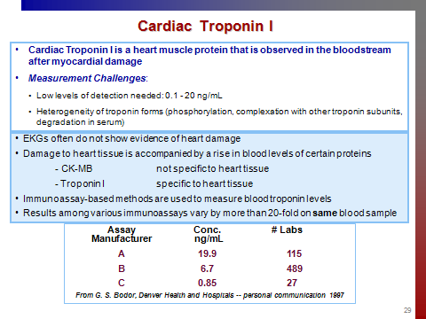

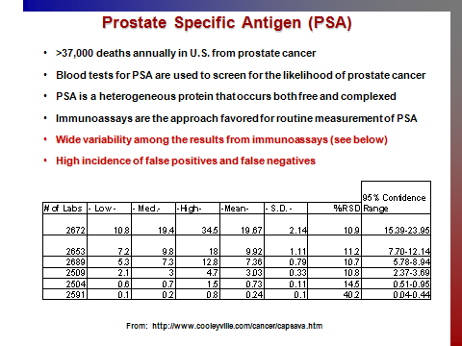

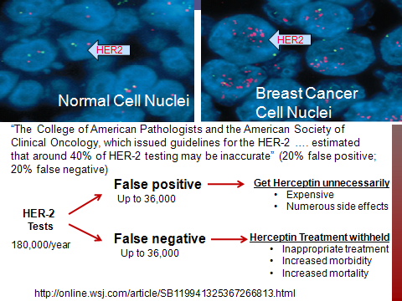

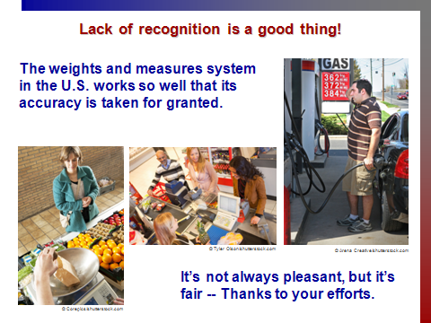

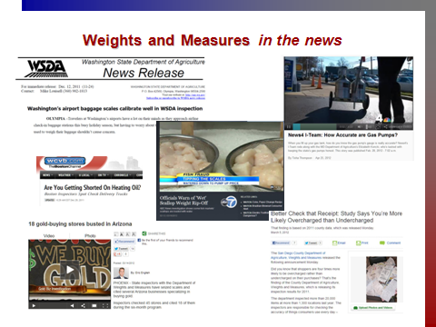

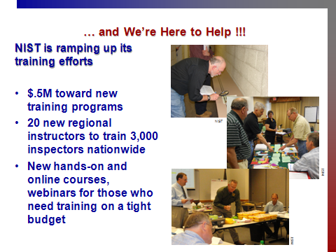

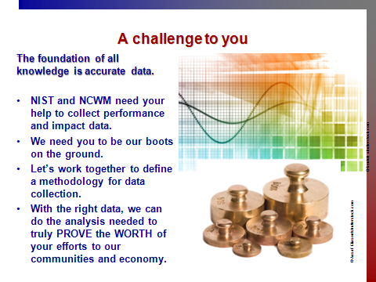

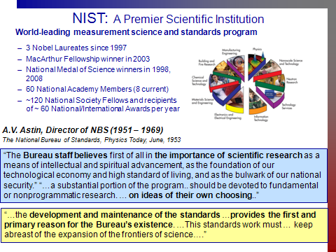

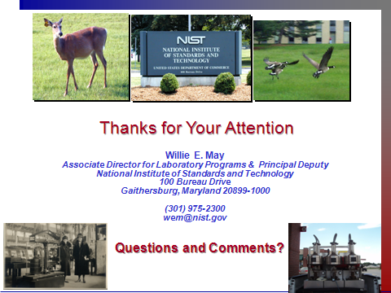

Chairman’s Address

National Conference on Weights and Measures
Portland, Maine
July 17, 2012

Kurt E. Floren

Commissioner, Los Angeles County Department of Agriculture

Los Angeles, California

Good morning. First, let me welcome you to the 97th Annual Meeting of the National Conference on Weights and Measures (NCWM). I thank you for the honor of serving as Chairman of NCWM over this past year.
Secondly, let me confess at the outset that I have failed to accomplish anything close to what I had hoped and intended to do in the course of my chairmanship. This year, I had the sincere pleasure of traveling around the country, attending regional meetings and observing the great work of so many dedicated Weights and Measures officials, Associate Members, and interested parties from around the states. At each, I found myself doing something of an apology tour, expressing frustration and regret at the lack of progress in producing final work products in keeping with my theme for the year, “Taking Measure of Our Worth.”
As I know I am not alone, this has been an indescribably challenging year, scrambling to retain support and funding for the very important work that we all do in a horrific economic environment. As I commented in my last newsletter article, I am so very proud of what we do. I highlighted the mottos that appear on the NCWM Website: “Creating Confidence – Ensuring Equity”; “Giving A Voice To All”; “The Standard for Fairness in the Marketplace.”
I have always been astounded at the array of topics and issues dealt with in the work of the Conference. The agendas with which we are dealing this week are no exception, from railway track scale and retail motor fuel dispenser issues to polyethylene products, hydrogen fuel, and, of all things, animal bedding. It really is astounding – and sobering. What weights and measures regulatory and standards issues touch upon also touch virtually every consumer in this country and beyond every single day. That makes what we strive to do of tremendous worth and importance, not just in our governmental, manufacturing, and marketing worlds, but to every citizen in every community.
NCWM has accomplished a great deal over recent years. There is a temptation, as Chairman, to focus on and highlight what has been occurring in the last 12 months. But, it is important to consider things from a long-term perspective, in reverse and in moving forward. Looking back, to the credit of so many of you and of the great leadership provided by our past Chairs and Board members, NCWM has undertaken many major operational reorganizations and service delivery improvements, making it a much stronger and more effective organization:
- Just four years ago, NCWM assumed full management of its operations, including membership, arrangement and conduct of our meetings, hiring of an outstanding Executive Director, and establishment of a permanent home office, achieving fiscal soundness, stability, and organizational effectiveness not before enjoyed.
- Enactment of the Verified Conformity Assessment Program (VCAP) has accomplished great steps toward ensuring that load cell and, soon, other device manufacturing processes of those holding certificates of conformance result in uniformity and consistency in production, lending assurance and verification to quality and production-meets-type requirements.
- We have implemented the On-Line Position Forum, providing a great means to expand and enhance opportunities for members to actively participate in the development of standards, whether or not able to physically attend our meetings. The Forum is receiving increased attention and utilization, and enhancements continue to be identified to make it more user-friendly and functional.
- The National Certification Program has been launched, with the work of the Professional Development Committee, our contractor and old friend Ross Andersen, and the many subject matter experts from among our members and their staffs teaming to continue development of exams to cover the broad spectrum of weights and measures disciplines. These certifications will serve to demonstrate and document the knowledge and competence of inspectors and ensure uniformity of skills and abilities in our system.
- Strategic Planning has been fully incorporated, not in the form of a dusty document turning yellow on a shelf, but a living document that is continually assessed, updated, and employed, with clear goals and strategies to enhance NCWM as a national and international resource, to provide ongoing and improved training opportunities for members, to improve the National Type Evaluation Program, and to secure the financial stability of the Conference.
The list goes on. And so does the work in continuing to build upon these achievements and derive ever-increasing returns from them. These represent the visions of many among us and, particularly, the endeavors of preceding NCWM Chairs and Boards of Directors who deserve great admiration for that forward vision. All of this and more has been done while fulfilling our core work in developing the standards and procedures that fill our handbooks and provide the assurance of equity in the marketplace, to which NCWM is dedicated.
All that I have mentioned are works in progress. None are complete, but, rather, are incredibly valuable undertakings that will and must continue to develop to produce their full potential in benefits for us all. This brings me back to my confession of not having fulfilled all that was my vision under our year’s theme, “Taking Measure of Our Worth.”
Back home in California, to say that things have been “challenging” would be a gross understatement. We, like so many states, have been dealing with continually declining resources and endless streams of threats to our programs. Our State Department of Food and Agriculture, within which resides our State Weights and Measures agency, Division of Measurement Standards, lost over $33 million in general fund support – 35 % of its budget – over the last year and a half. Program reductions have been widespread, not the least of which was utter decimation of all general fund support to Division of Measurement Standards, excepting only minimal funding of its metrology laboratory, upon which local jurisdictions rely for standards calibrations. In May, even that was significantly reduced due to continuing State revenue shortfalls.
To add to this, multiple legislative bills seeking to exempt certain industry sectors from all weights and measures regulatory oversight had to be addressed, as did the impending sunset of a statute authorizing County Sealers to charge device registration fees, the core support mechanism for local device inspection programs. As Agricultural Commissioner/Sealer of our state’s largest jurisdiction and Vice-President of our statewide organization of Commissioners/Sealers, the call to action for self-preservation did severely frustrate advancements in formulating National Weights and Measures support strategies that I had envisioned in my role as your Chairman.
However, crisis often stimulates ingenuity, and I want to share some positive outcomes of these intense struggles. In addressing these fiscal challenges, representatives of industries affected by many threatened programs were brought together, teaming with regulators to examine program activities and identify least destructive approaches to reductions. Mutual objectives and concerns were considered and discussions of program values were undertaken in developing strategies to deal with funding issues. In every case, reliable, detailed data proved critical in reaching agreement in ranking program priorities and making sound decisions.
In the case of our device registration fee legislation, we benefited from a decades-long practice of our State Division of Measurement Standards in collecting and compiling statewide device inspection testing, compliance, and expenditure data. Each County Sealer reports monthly inspection results for 29 specific categories of devices, recording pass/fail rates and hours expended for each. Year-end financial reports collected from all jurisdictions enable extrapolation of actual program costs. In negotiating with industry groups and legislators over recent months, this detailed information provided convincing evidence of the need for these regulatory activities and the actual costs of delivering the valuable consumer and competitor protection services. In negotiating with one industry sector originally seeking an outright exemption from all inspections and from registration fee requirements, the data we were able to produce served to demonstrate the value of regulatory inspections to them in securing fair competition and, in the end, solicited not only agreement on a fee structure, but a “support” position from them on the bill. As a final result, our device registration bill, even in these times of extreme economic pressure, is moving forward with revenue increases exceeding $2 million toward enhancements of local Weights and Measures activities.
As to the State Weights and Measures funding dilemma, this same data served to convince legislators of the importance of State oversight, coordination, and training in support of local jurisdictions and facilitated development of State administrative fees that County Sealers, under newly-established statutory and regulation authorities, are now collecting through our device registration billings and remitting to the State Division of Measurement Standards to sustain its device program work.
Finally, other innovative ideas have been implemented, including securing monies in the form of cy pres awards in settlements of civil prosecutions brought jointly by the County and State Weights and Measures agencies against chronic violators. Those funds have been utilized to sustain package inspection and price verification programs at the State level, effectively causing non-compliant entities to carry the costs.
What this exhausting year in my state has produced is a dress rehearsal for what, I believe, must be pursued on a national basis. True teamwork among jurisdictions – State and County – and engagement of industry members, sharing and cooperating in data gathering and presenting a unified picture of the worth of Weights and Measures programs, is proving invaluable in producing innovative funding mechanisms very different from those of the past. We cannot keep doing things as we have always done them.
So, my year as Chairman draws to a close. Has progress been disappointing in taking the measure of our worth nationally? Yes. Is there a declaration of defeat? No. Efforts must continue. I remain committed to continuing the effort and hope we can team together to accomplish far more than any of us can do individually. Like so many major NCWM endeavors, work is ongoing. Full results are not yet realized. But, there is great promise in what can be achieved. I thank you for the honor you have given me this year, and hope that, through teamwork, we can accomplish for years to come much more than what could be done in a single challenging year.
Again, I thank you, sincerely.

Chairman Elect’s Address

National Conference on Weights and Measures
Portland, Maine
July 17, 2012

Stephen Benjamin

North Carolina Department of Agriculture and Consumer Services

Thank you Kurt, good morning everyone and thank you for being here. It is a privilege and honor to have been selected to serve as your Chairman for the coming year. I will be brief as I am about all that stands between you and your trip home.
First of all, I would like to thank all of those that have served on our committees, subcommittees, sectors and task groups this past year, both at the Conference and regional levels. It is your time and dedication to the issues that come before us that make the National Conference on Weights and Measures (NCWM) successful. I would also like to thank my staff for the effort they must put in while I’m fulfilling my duties, first as Chairman-elect and now as Chairman of NCWM. Finally, I would like to thank my family for being supportive of this opportunity.
Speaking of family, we recently went on a family vacation to the Shenandoah Valley area of Virginia, about a five-hour drive from our home. As usual, after about 30 minutes on the road, my six-year old daughter asked the question, “Are we there yet daddy?” Being a patient and loving father, I took a deep breath and went with my second response, “Not yet sweetheart.”
This scene was repeated a number of times during the drive, but I also had time to think, well aware that I had to deliver this speech just a few weeks later. Certainly at lot has gone on over the years in the NCWM, but I asked myself, “Are we there yet?” In considering this, I don’t know if there is a final destination for our organization, but there have definitely been milestones on the journey forward. Some of these milestones have been significant to this organization, such as the transition of NTEP management from NIST, OWM to the Conference, and more recently the transition from Management Solutions to our own Executive Director and staff. Many other milestones are in the form of proposals that come before us, some of them involving a great deal of time and sometimes spirited discussion.
You’ve all heard the cliché, “it’s not about the destination, but the journey.” As an organization we have a goal, “That equity may prevail,” that is the journey we are on. We proceed along this path as new technologies are developed for devices, new fuels are introduced, and new products are marketed and even old products in new packaging. In short, the world of weights and measures is constantly changing, and we must move forward to address these needs through our proposal process.
We have worked these past few years on moving the NCWM forward as an organization as well. How can we do better in promoting what we do and improve at how we do it? At the risk of sounding like a broken record, I think the biggest step recently was the management change we made in 2007. This action provided us a dedicated staff focused on the business of the Conference. It also allowed for funds to pursue projects such as website improvements, online applications and registrations, web posting of training material, and the online position forum. We continued on this path forward as we implemented the Verified Conformity Assessment Program (VCAP), the Professional Certification Program, and the formation of the Packaging and Labeling Subcommittee, which held their first face-to-face meeting this past Sunday.
With this in mind, my theme this coming year is “On the Path to Tomorrow.” I encourage the continued development of projects such as the “tool kit” for weights and measures programs that will put facts, contacts, and materials to support their programs at their fingertips. The Professional Certification Program and VCAP continue to grow and reach more people. The Board of Directors continues to look at ways to increase services to the members in order to make membership meaningful. The key to moving forward is simply your involvement. Many of you may equate involvement with serving on an NCWM standing committee, but I say even participating at a regional level or on a task group or even replying to a question on a list server is a step on the path. We are working together and sharing our knowledge to move forward.
To this end I make the following appointments for the coming year:
- Laws and Regulations Committee:
Louis Sakin, Towns of Hopkinton/Northbridge, Massachusetts, five year term
- Specifications and Tolerances Committee:
Edward Seidler, Town of Framingham, Massachusetts, five year term
- Professional Development Committee:
Stacy Carlsen, Marin County , California five year term
- Nominating Committee:
Committee Chair, Kurt Floren, Los Angeles County, California
Judy Cardin, Wisconsin
Thomas Geiler, Barnstable Regulatory Services, Massachusetts
Joe Gomez, New Mexico
Maxwell Gray, Florida
Randy Jennings, Tennessee
Tim Tyson, Kansas
- Credentials Committee:
To be announced later.
- Presiding Officers:
Jack Walsh, Town of Wellesley, Massachusetts
John Albert, Missouri
SWMA, to be decided.
WWMA, to be decided.
- Parliamentarian:
Lou Straub, Fairbanks Scales, Inc.
- Chaplain:
Stephen Langford, Cardinal Scale Manufacturing Co.
- Sergeants-at-Arms:
I will be working with our members from Kentucky to designate Sergeants-at-Arms for our 2013 Annual Meeting.
I look forward to seeing you all in Charleston, South Carolina, for the Interim Meeting in January and have a safe trip home.
Thank you.

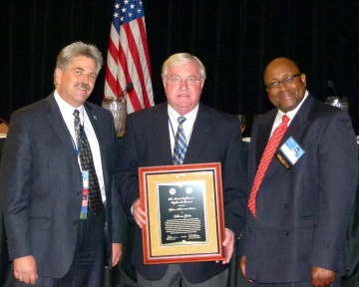
Special Recognitions

NCWM Lifetime Achievement Award Recipient

Tom Geiler
Only one NCWM Lifetime Achievement Award may be given each year. The 2012 recipient is Tom Geiler, Director of the Regulatory Services Department of Barnstable, Massachusetts.
Tom began his career as a meat cutter. He must have excelled, because he went on as a meat department manager for 15 years. During this same time, he was also a reserve police officer for his community; a position he would hold for 35 years. In 1974, he took the experience he gained in law enforcement and retail, and applied it to a new line of work as weights and measures sealer. Thirty-eight years later, he still holds that position as well as a few other duties.
Pictured: Kurt Floren, NCWM Chairman; Tom Geiler, Award Recipient; and Willie E. May, NIST.
In those 38 years, Tom has attended 35 consecutive NCWM Annual Meetings. He has served the Education, Administration, and Consumer Affairs Committee, the Subcommittee on Members Expenses, the Task Force on Planning for the 21st Century, the Laws and Regulations Committee, the Privatization Work Group, the Budget Review Committee, the United States/Canada Mutual Recognition Work Group, the Strategic Planning Subcommittee, the Legislative Liaison Committee, the Finance Committee, and many years on the Nominating Committee. He served twice as a NCWM Vice Chairman, two terms on the Executive Committee, and a term on the NTEP Board of Governors. He was the NCWM Chairman in 1994 and Chairman of the NTEP Board of Governors in 1995. In 2001, he returned to the Board of Directors where he served as Treasurer through 2006. Most recently, he has served as Credentials Committee Coordinator. He worked very hard to establish a National Train the Trainer Program when he served on the Education, Administration, and Consumer Affairs Committee and worked closely with the Office of Weights and Measures to obtain the funding necessary to accomplish this. His tenure on the Privatization Work Group opened the eyes of legislators to the pitfalls of privatizing Weights and Measures.
This man has been a leader at all levels of weights and measures enforcement, never seeking personal reward but always demonstrating concern for consensus and integrity in his arguments to advance the philosophy of Equity in the Marketplace. His service records to his state and regional associations are equally impressive. In addition to those associations, he is also affiliated with the International Society of Weighing and Measuring, International Society of Antique Scale Collectors, New England Parking Officials, Massachusetts Parking Officials Association, Massachusetts Licensing Officials Association, and if that isn’t enough, he has probably attended more Western Weights and Measures Association meetings than anyone who lives in the western region. NCWM proudly recognizes Tom Geiler with the 2012, NCWM Lifetime Achievement Award.

Distinguished Service Award Recipient

Charles Carroll
Charlie is a native of Chelsea, Massachusetts, and currently resides in Wakefield. He is a graduate of Boston College High and attended the University of Massachusetts Boston and Harvard School of Government. In his long history of weights and measures service, he was Deputy Sealer of Weights and Measures in Chelsea from 1959 to 1971. He was Inspector of Standards for the Massachusetts Division of Standards from 1971 to 1973. He was then appointed to Supervisor until 1983 when he was appointed Assistant Director. In 2008, he was again promoted with an appointment to his current position as Director of the Division of Measurement Standards. He is in his 53rd year of service in weights and measures. During this time, he has maintained membership and active participation in the Eastern and Western Massachusetts Weights and Measures Associations, the state Weights and Measures Association, the Northeastern Weights and Measures Association, and the National Conference on Weights and Measures. He rounds out his interests as an avid fan of Boston professional sports, and he enjoys bowling and golf.
Pictured: Kurt Floren, NCWM Chairman, congratulates Charles Carroll for his distinguished service.

Charlie attended his first NCWM Annual Meeting in 1982, and this year marks his 31st consecutive year of attendance. During those years, Charlie has served twice as NCWM Vice-Chairman. He served four years on the Resolutions Committee, chairing that committee two of those years. He served five years on the Specifications and Tolerances Committee, chairing that committee for two years. In 1992, Charlie participated in a Canada/United States meeting to explore opportunities in legal metrology to reduce trade barriers between our countries. From 1996 to 1998, Charlie served on the NCWM Executive Committee and the NTEP Board of Governors. After NCWM incorporation, Charlie served on the Board of Directors and NTEP Committee from 1999 to 2000 and again from 2005 to 2009. He served on the Nominating Committee in 2011 and 2012. Charlie also served on the state committee that developed the certification criteria and text questions for state certification.
What isn’t recognized in his list of services is Charlie’s consummate quiet gentleman’s approach to every situation: filled with the wisdom of his years of experience and his friendly smile. He has calmly served as a leader to NCWM through difficult and exciting times of transition and growth. All of the qualities recognized here have also been recognized by his colleagues at the regional and state levels where he was the recipient of the Northeastern association’s 1985 Man of the Year Award and the Massachusetts Weights and Measures Lifetime Achievement Award in 2005.
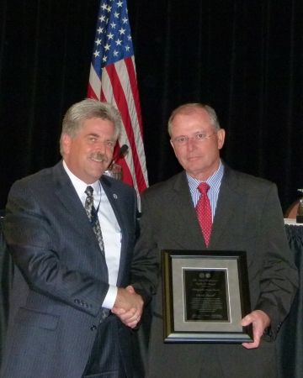

Distinguished Service Award Recipient

Tina Butcher
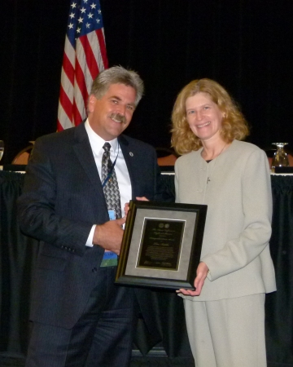
Tina Butcher, Group Leader for the Legal Metrology Devices at the National Institute of Standards and Technology (NIST), Office of Weights and Measures (OWM) began her public service in the Pest Management Program at the Maryland Department of Agriculture. The pest management experience must have prepared her well for her illustrious career in weights and measures. In 1983, she was transferred to Maryland’s Weights and Measures Program where she spent five years as a field inspector.
In 1987, she moved to NIST, OWM. With that move, Tina quickly became involved in many NCWM activities. Among her list of contributions, she was technical advisor to the Task Force on Energy Allocation in 1988 and 1989; the Multiple Dimensions Measuring Devices Work Group in the early 1990s; the Task Force on Safety from 1989 to 1991; the Executive Committee in 1991; the Liaison Committee in 1993 and 1994; the Handbook 44 Reorganization Work Group from 1999 to 2001; and the Automatic Temperature Compensation Steering Committee in 2008 and 2009. Her technical advisor service to NCWM standing committees include the Specifications and Tolerances Committee from 1993 to 1998 and again from 2008 forward, and the Professional Development Committee in 2007 and 2008. Tina is well-known for her contributions over many years to the National Type Evaluation Program. She has been technical advisor to many NTEP groups including the Measuring Sector from 1988 to 1995 and from 2008 to 2011; the Weighing Sector from 1992 to 1997, the Grain Moisture Meter Sector from 1992 to 1995, the Belt-Conveyor Scale Sector in 1997, the NTEP Committee from 1999 to 2001; the Laws and Regulations Committee regarding the model NTEP regulation from 1999 to 2002; the United States/Canada Mutual Recognition Work Group from 1994 to 2000; and the NTEP Long-Term Business Plan Work Group from 1998 to 2000. Tina was the NTEP Manager from 1994 to 2000 prior to transfer of its administration to NCWM. In addition to all of these contributions to NCWM, Tina has made significant contributions at NIST with developmental assignments in the Malcolm Baldridge National Quality Award Program and in the NIST Director’s Office in 2002 and 2003. She was the recipient of the U.S. Department of Commerce Bronze Medal in 2003.
Pictured: Kurt Floren, NCWM Chairman and NIST, Office of Weights and Measures’ Tina Butcher.
Through all of this continuing service, Tina has made significant and lasting contributions to codes throughout Handbook 44 and was integral in the creation of code sections such as the Mass Flow Meter Code. She is widely regarded for her superior technical writing skills and her calm manner that leads to input from others toward sound decision making. She has also earned the respect of NCWM members for her ability to inject important technical and historic information while avoiding personal dictation in the decisions. Tina’s long-term service to NCWM and the weights and measures community is truly remarkable. Tina’s personal time is devoted to her family and other activities including the Altar Guild and teaching children’s classes at her church. She is Co-Director of her church’s Junior Daughters of the King Chapter and enjoys volunteering in her daughter, Holly’s, various sports and school activities.

Distinguished Service Award Recipient

Ronald Hayes
Ron Hayes, Missouri Weights and Measures Director, received his education in computer science and mathematics from Missouri University of Science and Technology. In 1976, Ron went to work for the Missouri Department of Agriculture. In his early years, he was a grain moisture meter inspector and assisted the department in developing that new program. He taught laboratory techniques in his role as a laboratory assistant, and he performed petroleum tests as an assistant metrologist. In 1982, Ron was promoted to Fuel Quality Program Administrator and Laboratory Manager. In 2008, he was again promoted to his current position as Director of the Division of Weights, Measures and Consumer Protection.
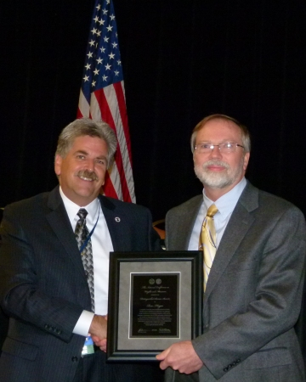
Ron attended his first NCWM Annual Meeting in 1984, and this is his 23rd year of attendance. Ron’s experience managing the Petroleum Laboratory formed the foundation of much of his service to NCWM in his early years. He has been a member of the Southern Weights and Measures Association and the Central Weights and Measures Association after it was formed in 1985. He has been a member of the NCWM Fuels and Lubricants Subcommittee since 1992. He has chaired that subcommittee since 2006. Ron chaired the Motor Fuel Regulation Working Group from 1993 to 1995. He has also served as a member of the Premium Diesel Work Group and the Automotive Lubricants Work Group. Ron served as a Presiding Officer of our Annual Meetings in 2003, 2004, and 2005. In addition to his current responsibilities as chair of the Fuels and Lubricants Subcommittee, Ron is an officer on the NCWM Board of Directors.
Much of Ron’s work over these many years has been in concert with standards development within ASTM International as a member of the ASTM D02 Committee on Petroleum Products and serving on many subcommittees under it. NCWM and ASTM have much in common and Ron has greatly assisted both organizations to maximize each other’s resources toward common goals. An employee of his once described Ron as “wicked smart.” We can all agree with the spirit of that compliment, and we are grateful that he has applied his talents to our benefit.
Pictured: Kurt Floren, NCWM Chairman, presents award to Ron Hayes.

Distinguished Service Award Recipient

Chris Guay
Chris Guay is a Regulatory Fellow at Procter and Gamble Company. He resides in Mason, Ohio, and has many hobbies including hiking, backpacking, photography, painting, and electric trains. He graduated Magna Cum Laude with a Chemical Engineering Bachelor of Science degree from the University of Illinois in 1982 and received his MBA in Management from the University of Cincinnati in 1990. Chris has been a regular attendee and supporter of the Ohio, Central, Northeastern, Southern, and Western Weights and Measures Associations as well as many other trade associations affiliated with Procter and Gamble product lines.
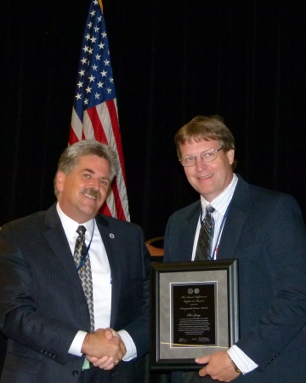
Chris attended his first NCWM Annual Meeting in 1990, and this year is his 21st year of attendance. His official service began in 1993 on the Associate Membership Committee. He served that committee from 1993 to 1995, 1997 to 2001, 2004 to 2005, and 2007 to present with his current term to expire in 2015. During those years, he was Vice-Chairman of the Associate Membership Committee in 1993, 2007, 2011, and 2012, and chaired the committee in 1994 and 2008. Chris chaired a special task group under the Associate Membership Committee from 1993 to 1995 that developed recommendations to increase the involvement of industry membership in the NCWM structure, including appointments to standing committees. Sometimes you get what you ask for, and Chris was appointed to the Administrative and Public Affairs Committee from 1996 to 1998. This was followed immediately with a five-year term on the Laws and Regulations Committee from 1999 to 2003. In 1998, Chris participated in an important planning meeting as NCWM was transitioning into a nonprofit corporation that needed administrative support. He served on the Nominating Committee in 2001 and 2002. He served a five-year term on the Board of Directors from 2004 to 2008. Today, in addition to his service to the Associate Membership Committee, Chris is Chairman of the new Packaging and Labeling Subcommittee. This subcommittee was his brainchild to assist the Laws and Regulations Committee and NCWM to effectively address critical issues in the consumer packaging industry.
We have come to cherish Chris’ ability to speak softly, intelligently, and directly; never one to sugar coat a situation. In Chris’ home state of Ohio, he recognized the value that county officials could bring to the regional and national scene, and he worked directly with them to show them the way at a time when NCWM had a need for the additional expertise and leadership. Chris was mentored in his early years by one of our most cherished industry members, Bill Braun, who pushed us all to be organization oriented, not issue oriented. Chris is just that person as represented by his words, his service, and his actions. For this reason, he was awarded the Bill Braun Award by the Central Weights and Measures Association in 2008.
Pictured: Kurt Floren congratulates Chris Guay, recipient of the Distinguished Service Award.

2012 Contributions Award Recipient

Tim Tyson
The Contributions Award was presented to Tim Tyson, Director of the Kansas Department of Agriculture, Weights and Measures Division.
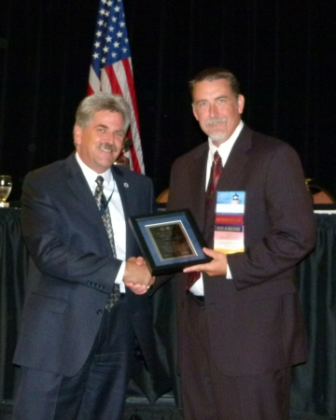
Tim obtained his Bachelor of Science degree in Animal Science from Kansas State University. He also holds a Bachelor of Science degree in Computer Science from Friends University in Wichita. Prior to his employment with the Kansas Department of Agriculture, Tim spent 14 years at the management level in food manufacturing facilities and three years in software development in the insurance industry. In 2006, Tim was named Director of Weights and Measures for the State of Kansas. He is also Director of the Department’s Feed and Seed Division and Grain Warehouse Licensing. In addition to their day jobs, Tim and his wife, Karyn, operate a ranch, and he enjoys hunting.
Pictured: Tim Tyson receives the 2012 Contributions Award from Kurt Floren.
In a very short time, Tim was recognized for his leadership abilities in the weights and measures community. He was Chairman of the Central Weights and Measures Association in 2008. He joined the NCWM Board of Directors in 2008 as an at-large director. He was elected as Chairman-Elect for 2010 and NCWM Chairman of the Board in 2011. This year, Tim chaired the Nominating Committee, and he is completing his service to the Board of Directors this week as the NTEP Committee Chair.
Tim is thought of as the “quiet man from Kansas.” He is a man of few words, but when he speaks it is direct, on point, and spoken with authority and confidence. He is highly regarded for his ability to listen, analyze, and provide leadership with wisdom. His regional association, the Central Weights and Measures Association (CWMA) has noted his significant efforts and leadership in the areas of commodity labeling and moisture allowance standards. In the past year, he has been innovative in his approach to demonstrate the impact and importance of weights and measures regulatory oversight for the citizens in Kansas.

Attendance Recognition
5th Year Attendees
John Albert | Missouri Department of Agriculture
Chris Bradley | Seraphin Test Measure
James Brown | Petroleum Equipment Institute
James Byers | San Diego County, California Weights and Measures
Chuck Corr | Archer Daniels Midland Company
John Eichberger | National Association of Convenience Stores
Ivan Hankins | Iowa Department of Agriculture
Krister Hard af Segerstad | IKEA
Fran Elson-Houston | Ohio Department of Agriculture
Zina Juroch | Pier 1 Imports
Dmitri Karimov | Liquid Controls
James McGetrick | BP Products
Kristin Moore | Renewable Fuels Association
Julie Quinn | Minnesota Department of Commerce
Rob Underwood | Petroleum Marketers Association of America
Craig VAnBuren | Michigan Department of Agriculture and Rural Development
Tim White | Michigan Department of Agriculture and Rural Development
10th Year Attendees
Cary Ainsworth | USDA, GIPSA
Jerry Buendel | Washington State Department of Agriculture
Judy Cardin | Wisconsin Department of Agriculture, Trade and Consumer Protection
Rafael Jimenez | Association of American Railroad Transportation Technology Center
Thomas McGee | PMP Corporation
15th Year Attendees
Charles Ehrlich | NIST Office of Weights and Measures
Kurt Floren | Los Angeles County California Weights and Measures
Alan Johnston | Measurement Canada
Robert Murnane | Seraphin Test Measure
Bill Ripka | Thermo Fisher Scientific
20th Year Attendees
Norman Brucker | Precision Measurement Standards, Inc.
Michael Keilty | Endress + Hauser Flowtec AG USA
Don Onwiler | NCWM
25th Year Attendees
Louis Straub | Fairbanks Scales
Richard Suiter | Richard Suiter Consulting
35th Year Attendees
Thomas Geiler | Town of Barnstable, Massachusetts Weights and Measures

THIS PAGE INTENTIONALLY LEFT BLANK

