Report of the
Professional Development Committee (PDC)

Mr. Stacy Carlsen, Committee Chair
Marin County, California

400 Introduction
The PDC (hereinafter referred to as the “Committee”) submits this Final Report for consideration of the 97th National Conference on Weights and Measures (NCWM). This report contains the items discussed and actions proposed by the Committee during its Interim Meeting in New Orleans, Louisiana, January 22 - 25, 2012. The Committee conducted Open Hearings for the items in Table A during the Annual Meeting held July 22 - 26, 2012, in Portland, Maine. Table A identifies the agenda items by reference key, title of item, page number, and the appendices by appendix designations. The acronyms for organizations and technical terms used throughout the agenda are identified in Table B. The first three digits of an item’s reference key are assigned from the Subject Series List. The status of each item contained in the report is designated as one of the following: (D) Developing Item: the committee determined the item has merit; however, the item was returned to the submitter or other designated party for further development before any action can be taken at the national level; (I) Informational Item: the item is under consideration by the Committee but not proposed for Voting; (V) Voting Item: the Committee is making recommendations requiring a vote by the active members of NCWM; (W) Withdrawn Item: the item has been removed from consideration by the Committee. Table C provides the Summary of Voting Results for each Voting Item.

During the Annual Meeting, some Voting Items are considered individually, others may be grouped in a consent calendar. Consent calendar items are Voting Items that the Committee has assembled as a single Voting Item during their deliberation after the Open Hearings on the assumption that the items are without opposition and will not require discussion. The Voting Items that have been grouped into consent calendar items will be listed on the addendum sheets. Prior to adoption of the consent calendar, the committee will entertain any requests from the floor to remove specific items from the consent calendar to be discussed and voted upon individually.

Committees may change the status designation of agenda items (Developing, Informational, Voting, and Withdrawn) up until the report is adopted, except that items which are marked Developing, Informational or Withdrawn cannot be changed to Voting Status. Any change from the Committee Interim Report (as contained in this publication) or from what appears on the addendum sheets will be explained to the attendees prior to a motion and will be acted upon by the active members of NCWM prior to calling for the vote.

An “Item Under Consideration” is a statement of proposal and not necessarily a recommendation of the Committee. Suggested revisions are shown in bold face print by striking out information to be deleted and underlining information to be added. Requirements that are proposed to be nonretroactive are printed in bold faced italics. Additional letters, presentations and data may have been part of the Committee’s consideration. All sessions are open to registered attendees of the conference. If the Committee must discuss any issue that involves proprietary information or other confidential material; that portion of the session dealing with the special issue may be closed provided that (1) the Chairman or, in his absence, the Chairman-Elect approves; (2) the Executive Director is notified; and (3) an announcement of the closed meeting is posted on or near the door to the meeting session and at the registration desk. If at all possible, the posting will be done at least a day prior to the planned closed session.

Note: The policy is to use metric units of measurement in all of its publications; however, recommendations received by NCWM technical committees and regional weights and measures associations have been printed in this publication as submitted. Therefore, the report may contain references to inch-pound units.

Subject Series List
Introduction 400 Series
Education 410 Series
Program Management 420 Series

Table A
Table of Contents
Reference Key | Title of Item | PDC Page
400 Introduction 1
410 EDUCATION 3

410-1 I Professional Certification Program 3

410-2 I Instructor Improvement 10

410-3 I Recommended Topics for Conference Training 12
420 PROGRAM MANAGEMENT 14

420-1 I Safety Awareness 14

420-2 I PDC Publication 15
APPENDICES
Appendix A ⎯ Professional Certification Program Curriculum Work Plan A1
Appendix B ⎯ Draft Module – Weights and Measures Core Mathematics B1
Appendix C ⎯ Safety Incident / Accident Report C1

Table B
Glossary of Acronyms and Terms

Acronym | Term | Acronym | Term
ADDIE | Analysis, Design, Development, Implementation, and Evaluation | NIST | National Institute of Standards and Technology
BOK | Body of Knowledge | OWM | Office of Weights and Measures
CWMA | Central Weights and Measures Association | PDC | Professional Development Committee
ISO | International Standardization Organization | RSA | Registered Service Agents
LPG | Liquefied Petroleum Gas | SME | Subject Matter Expert
NCWM | National Conference on Weights and Measures | SWMA | Southern Weights and Measures Association
NEWMA | Northeastern Weights and Measures Association | WWMA | Western Weights and Measures Association

Table C
Summary of Voting Results

Reference Key  Number | House of Senate Representatives |  | House of Delegates |  | Results
 | Yeas | Nays | Yeas | Nays
To Accept the Report | Voice Vote |  |  |  | Adopted

Details of All Items
(In order by Reference Key)

410 EDUCATION

410-1 I Professional Certification Program
Source:
Carryover Item 401-1 (This item originated from the Committee and first appeared on its Agenda in 2003 and has undergone continuing development.) The numbering change reflects harmonization in all NCWM reports. More information on the Committee’s work is available at www.ncwm.net/content/ntp. Copies of reports from recent years are also available on the website under interim and annual meeting archives pages.

Background/Discussion:
It is important that users of the Professional Certification Program understand how the pieces fit together and form a coherent system. To illustrate the relationships the Committee can describe the system as a triangle of interdependent parts (see diagram below). The standards come in the form of goals with measureable learning objectives. The education part involves training provided to help the candidate reach the desired level of proficiency for each of the learning objectives. The certification involves an assessment of proficiency that measures whether or not the objectives have been met.

Certification Triangle
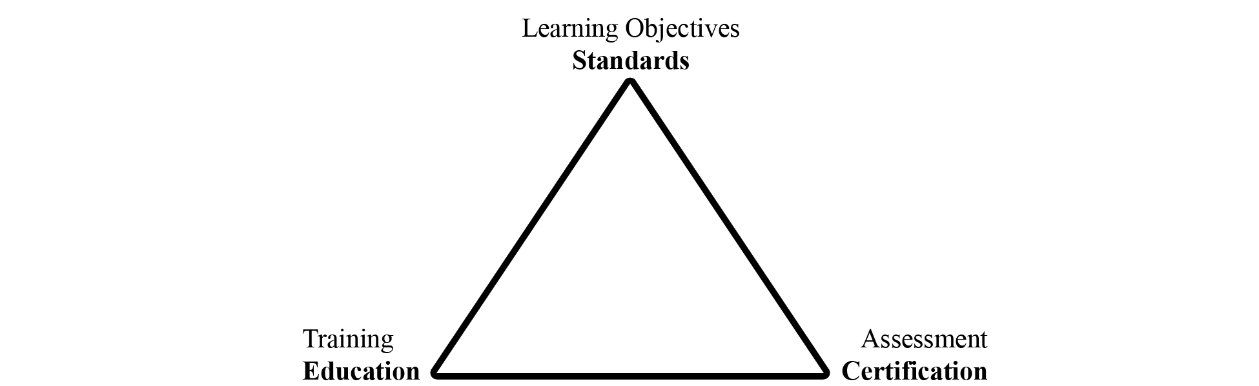

The Committee has until now focused attention on the standards and the certification pieces in the triangle as illustrated in the following flowcharts.

Standard Subsystem

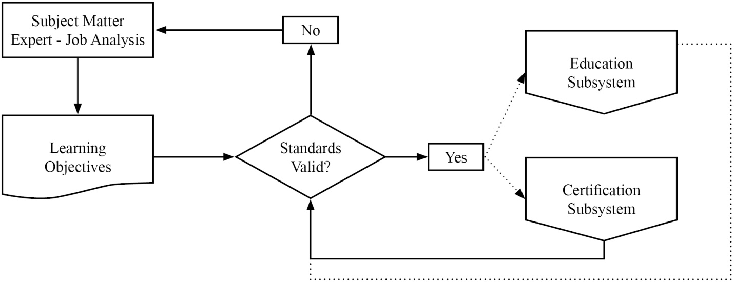

Certification Subsystem

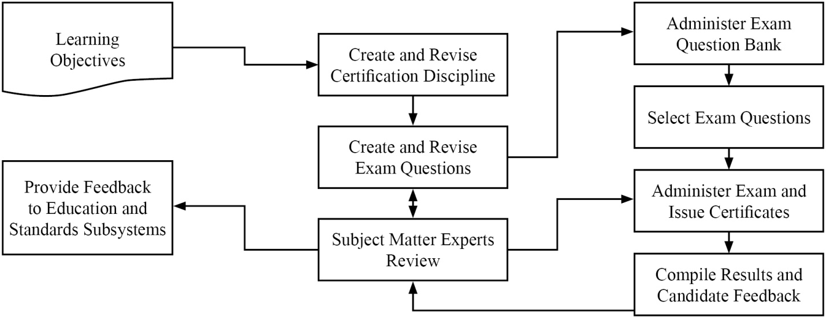

The Committee has described this work in a number of documents. In those documents, the committee is using terminology consistent with current usage in the education and certification field. The following important terms will be used throughout the Committee’s work on the subject.

Body of Knowledge (BOK) – refers broadly to the knowledge and skills required to function as a weights and measures professional. The term may refer broadly to the entire scope of knowledge and skills required within the profession or in a more directed manner to any selected subset for which the particular person is responsible. The BOK describes what you expect the weights and measures professional to achieve as opposed to how weights and measures professional will achieve it. To make the BOK more manageable in administration of the Professional Certification Program, it will be subdivided into modules in a tree-like structure moving from general knowledge and skills to more specific areas.

Module – refers to a group of related subject materials within the BOK. The module contains the articulated learning objectives for the subject area. Each module is considered a single, self-contained course of study. However, a broader course may span multiple modules and specific training may include only part of a module or parts of multiple modules. The PDC has created a standard format to create modules for the Professional Certification Program. The Committee has also created the Curriculum Outline and work plans to help manage the work activities within the program to create the many modules necessary to cover the entire profession.
Learning Objective – refers to the articulation of expectations of performance in measureable terms. Learning objectives are stated using active terms to be precise and measureable. There are two types of learning objectives, a terminal objective and an enabling objective. Terminal objectives state broadly the expectation of performance. The enabling objectives state the specific parts or steps required to demonstrate competence. The PDC has developed a guide to writing the learning objectives for both terminal and enabling which include the active verbs associated with the cognitive levels in Bloom’s Taxonomy. In training, the instructor will typically choose learning activities to explore each of the enabling objectives in an attempt to reach the terminal objective. In assessment, the questions will typically test for competence in each of the enabling objectives to demonstrate that the terminal objectives have been met.

Professional Certification – refers to verification of proficiency relative to all or part of the BOK for the profession as designated by the PDC for inclusion in a certification exam. The selected BOK includes all or part of specific modules and is documented in an exam description. Each of the modules, or combinations, is given a specific weighting in the design of the exam. After obtaining a passing score on the exam, the candidate is issued a certificate stating the competency standard has been met.

Curriculum – refers to the list of modules that are used to document the BOK (see Appendix A).

Bloom’s Taxonomy – refers to a classification of levels of cognitive leaning widely used in the field of education. The levels are knowledge, understanding, application, analysis, integration, and evaluation. The active verbs used in the articulation of learning objectives define the cognitive level. In training, the learning activities are matched to the cognitive level. In assessment, the form of the question is also matched to the cognitive level. The use of Bloom’s Taxonomy is described in detail in the Body of Knowledge Model document.

The PDC has prepared program documents that are available on NCWM website.

- The Curriculum Outline, which breaks the profession of weights and measures into component parts called modules.
- The Body of Knowledge Model, which explains how to create modules to document the learning objectives.
- The Modules developed thus far.
- The Certifications developed thus far.
Results of the Retail Motor Fuel Dispensing Systems exam indicate it will be very important as the program moves forward that trainers integrate the learning objectives into their materials and design courses in such a way that candidates will achieve the desired levels of learning. See Item 401-2 Instructor Improvement.

At the 2011 Interim Meeting, the committee addressed the need to build partnerships between the states, National Institute of Standards and Technology (NIST), Office of Weights and Measures (OWM), and NCWM. Each group has roles in relation to the Certification Triangle as shown in the diagram below.
Professional Certification Program
Applying Certification Triangle (Triumvirate Partnership)
States | NCWM PDC | NIST
- National Certified Workforce  - Assessment Tools and Certification Triangle Applied  - Student Meets Training Milestones  - Feedback to Trainer and Employee  - Value Exam Results = Recognition + Adult Learning  - Develop New Training Standards  - NCWM/NIST Regional Education and Training | - Website and Administer Professional Certification Program  - Enlist SMEs  - Learning Objectives and Standards  - Curriculum Work Plans, Discipline, Segments  - Write/Verify Exam Questions  - Exam Evaluation/Statistical Analysis | - Training and Education  - Instructor Improvement “ADDIE”  - State Instruction Support  - Technical Materials  - Train the Trainer Material  - Classroom and Field Training

At the 2012 Interim Meeting, the Committee received a comment from NIST, OWM that there is a need to provide an assessment tool to measure basic competence in fundamental subject areas such as NIST Handbook 44. They hope to partner with NCWM to administer those assessments using NCWM testing service. This would assure that participants at NIST, OWM sponsored training possess basic levels of proficiency in prerequisite materials so that instructors can deliver the primary material rather than spend time bringing all students up to the prerequisite level.
The Committee agrees and believes this fits with ongoing efforts to create a BOK and an exam to assess competence in mathematics for the entry level inspector. This could also be a useful tool to any jurisdiction offering training in these basic areas. The Committee will call these baseline competency examinations defined as:

Baseline Competency Examination – refers to verification of proficiency relative to one of the basic modules in the BOK for the profession. After obtaining a passing score on the exam, the candidate is issued a certificate stating the competency standard has been met.

The initial modules under consideration for the basic competency examinations are:

- Module XX. Weights and Measures Core Mathematics
- Module 4.2. NIST Handbook 44 – Introduction to Device Control
- Module 4.3. Weighing Systems – General
- Module 4.4. Dynamic Volume Measuring Systems – General
The BOK document for the Core Mathematics module has been drafted and will be posted on the website and appears in Appendix B.

The professional certifications currently developed (or in development) are:

- Retail Motor Fuels – Certification available through NCWM;
- Basic Package Labeling/Checking;
- Small Capacity Scales; and
- Vehicle Tank Meters.
The Committee reported that 18 Subject Matter Expert (SME) volunteers are working on the Basic Package Labeling/Checking Exam and 20 SME volunteers are working on the Small Capacity Scales Exam. Those exams are nearing completion. Invitations will be sent shortly to NCWM members to solicit SME volunteers to work on the Vehicle Tank Meter Exam. The Committee noted that SME’s are the backbone of the program but also that they have competing priorities. One consideration is the idea of doing this work using web meetings, one to brief and train SME’s at the start of a project and one at the end to resolve any remaining issues with complex questions on the exam. The idea is to minimize the time commitment of our SME volunteers while maintaining high quality in our exams.

The PDC conducted a survey in November 2011 to evaluate priorities for future exam development, appropriate range of device capacities to include in the medium or large capacity scale modules, request feedback from people who had taken the Retail Motor Fuel Dispensing Systems Exam, appropriateness of our examinations for Registered Service Agents (RSAs), and potential problems in standardizing exams on the current NCWM standards.

The committee received 134 responses covering 25 states, approximately 80 % weights and measures and 20 % industry. Based on the responses the committee has selected the following subjects for priority development and will be requesting that the Board of Directors extend the Certification Coordinator’s contract for these new projects:

- Medium Capacity Scales;
- Large Capacity Scales III and IIIL;
- Liquefied Petroleum Gas (LPG) and Anhydrous Ammonia Liquid; and
- Price Verification.
Survey questions on the Retail Motor Fuel Dispensing Systems Exam indicated that the majority were somewhat or very satisfied with the test taking experience, that the exam questions were appropriate to the basic level inspector, that the questions were straight forward and clearly written, and that they were able to finish in the allotted time. The only problems identified seemed to be related to computer connections and loading of graphics. NCWM staff worked with the testing service to mitigate these issues.

On the issue of using NCWM professional certifications for RSAs, the majority responded with interest in this area. The Committee worked with NCWM staff to solicit RSA volunteers to take the exam for free in order to obtain feedback. Volunteers who passed the exam would receive the formal certificate if they were members or if they pay the $75 testing fee as non-members. Four RSAs took the exam thus far and others are scheduled to take it. The Committee will gather additional data, evaluate the results and report at the Annual Meeting.

At the 2012 Interim Meeting, several state officials questioned the appropriateness of charging these volunteers for the certificate if they are non-members. They noted that the service agents invested considerable time in taking the exam so that those who passed could have been rewarded with a waiver of the fee. Mr. Onwiler, NCWM Executive Director, reported that the exam fee structure is controlled by the Board of Directors. The exam fee is waived for members as a way to improve membership value. The exam has always been available to service agents, but this was a means of acquiring volunteers for data collection without making them pay fees as non-members. The Committee verified that participants were advised of the conditions when the volunteers were contacted. The Western Weights and Measures Association (WWMA) made a proposal in 2011 that NCWM consider a tiered membership that would allow for a group rate category or reduced fees for non-members presently employed in a weights and measures related field wishing only to take the examinations. The Committee will ask the Board to consider these comments.

On the subject of the use of the current NCWM standard as the basis of all exams, the feedback from the survey clearly indicated that this should not be a problem for most jurisdictions. Therefore, the Committee will develop all exams based on the current editions of NCWM standards.

Officials had concerns about preparing their workforce for taking the Retail Motor Fuel Dispensing Systems Exam. As the PDC proceeds in offering other certifications, the Committee wants jurisdictions and industry to feel supported and confident that the training they provide for their workforce will be comprehensive and will prepare their people to take the certification exams without providing them with the exam questions. The Committee, therefore, recommends better communication so they understand what tools are available to help them create their own comprehensive training programs. The critical viewpoint is that a professional has to be prepared to perform the job and not just prepared to take the exam. This is the age old question of training to the learning objectives (the BOK) or training to the exam. The Committee strongly believes that training has to focus on the BOK and not on the exam questions.

At the 2012 Annual Meeting, the Committee met with the Board to provide an update on progress and agree on priorities. The Certification Coordinator reported that two additional question banks for small capacity scales and package checking had passed the technical review and were submitted to NCWM Headquarters. He also reported that SME volunteers are now working on the Vehicle Tank Meter Exam, and he is expecting to start the search for SME volunteers for the medium and large capacity scale exams shortly after the Annual Meeting. NCWM Executive Director, Don Onwiler, reported that there has been a slight glitch in the system that must be corrected before two new the exams can be opened for use. This involves making sure that Headquarters controls the individual’s access to exams. Each candidate gets access to initially take the exam and then can get a retest if they fail. The original process had given the candidate access to all exams using the same credentials. As soon as this is corrected, they will broadcast the availability of the two new exams.

The idea of accrediting the certification program was discussed. The Executive Director reported that he had been discussing the idea with the Institute for Credentialing Excellence (ICE) to see what parts of our program might be potential stumbling blocks. One area involves the SMEs who develop and vet the test questions. Our problem is that our SMEs are virtually all trainers within their jurisdictions and the vetting and training functions need to be separated. One possible avenue that we are pursuing is to restrict the access each SME has to the exam bank by only allowing them to review a part (~¼) of the test bank. The advice also suggested that SMEs be asked to sign over rights to the test questions and that NCWM seek to copyright its exams. The Committee and the Coordinator will continue to work with the Executive Director toward the goal of meeting the accreditation standards, and both the Coordinator and Headquarters will work on documenting procedures as a necessary step in that process. The Executive Director will continue to seek advice towards this long term project from ICE.

The Executive Director provided the Committee and the Board with the following statistics on the Retail Motor Fuel Exam.

 | FY 2011 | FY 2012
Number of Individuals taking the exam | 76 | 128
Number of Organizations taking the exam | 32 | 68
Number of Exams taken | 189 Note(1) | Note (2)
Number of Certificates issued | 45 | 79
Further Breakout State Gov’t  Local Gov’t  Industry |  | 86  37  5

Note 1. In the Beta testing phase several took the exam multiple times.
Note 2. Results unavailable yet for FY 12

The Committee and the Board agreed that priorities will remain on the Professional Certifications. The Committee will not be pursuing the competency exams. This will help focus efforts to get the exams out based on priorities established by the survey the Committee conducted.

The Committee understands that the SMEs are the critical part of our certification program. The Committee wants to recognize those that are contributing and also encourage others to volunteer on future projects (i.e., the medium and large capacity scale exams that will start soon). To this end, the Committee wants to express gratitude by giving recognition to the following who contributed to the package checking and small capacity scale exams.

Package Checking Basic | Small Capacity Scales Class III
Butcher, Ken, NIST OWM | Chesser, Tim, AR
Chesser, Tim, AR | D'Arcy, Carlos, FL
D'Arcy, Carlos, FL | Dillibaugh, John, PA
Dillibaugh, John, PA | Feagan, Bruce, WA
Feagan, Bruce, WA | Guerney, Brett, UT
Guerney, Brett, UT | Hicks, Tyler, OK
Hicks, Tyler, OK | Johnson, Ray, NM
Johnson, Ray, NM | McGee, Robert, SC
McGee, Robert, SC | Merritt, Kevin, ID
Merritt, Kevin, ID | Miller, Rachelle, WI
Miller, Rachelle, WI | Paquette, Marc, VT
Paquette, Marc, VT | Shultz, Steve, NV
Shultz, Steve, NV | Smith, Dan, AK
Tubacki, Jeff, IL | Stokes, John, SC
Wilson, Peter, VA | Tubacki, Jeff, IL
 | Wilson, Peter, VA

The Committee heard testimony from a number of individuals during the open hearings and appreciates the comments. In particular, the Committee is very pleased that states are starting to find ways to integrate our standards and the certifications in their programs. One state reported their efforts to mandate in regulation that Registered Service Agents get NCWM certification to demonstrate competence. Another is giving CEUs to county officials who obtain NCWM Certification. Others are using the exam results to evaluate their training efforts. One jurisdiction is using NCWM certifications in labor relations to demonstrate that retention and promotion decisions are being based on an unbiased third party assessment. The CWMA is considering whether it might be possible to use the NCWM exam in their reciprocal testing program for RSAs.

One state director reported that he had his entire staff take the RMFD exam. He provided some valuable feedback that the Committee and the Coordinator will consider. One involved making clear which versions of the handbooks are being used in the exams. He also reported that candidates taking the exam wanted to learn about which questions they got wrong. He also wanted the Committee to look at extending the Certification Program to accredit the overall weights and measures program.
The Committee understands the concern about the wrong answers, but maintaining the integrity of the test precludes us from giving that kind of specific feedback on the exam. At the end of the exam, the candidate is provided with the pass/fail on each segment of the exam and the final score. The candidate is also provided with the option of designating the e-mail address where the results will be sent. Thus, the results could go to a supervisor or the director. The Committee is considering avenues to provide feedback that will help states identify potential weaknesses in their training programs. Again, the Committee wants to divert the focus from the test back to ensuring mastery of the learning objectives in the BOK. To that end, the Committee is considering providing general statistics on each part of the exam so that a jurisdiction or company could compare their staff’s results with the composite of all those who took the exam. There is a further fear that providing detailed feedback on specific learning objectives, where exam results showed low scoring, would then divert the focus from the broad objectives of the BOK.

410-2 I Instructor Improvement
Source:
Carryover Item 401-3 (This item originated from the Committee and first appeared on its agenda in 2003.)

Background/Discussion:
Prior to the 2010 Annual Meeting, Ms. Georgia Harris, NIST, OWM, provided the Committee with reference material on teaching methods and assessment of training success. Distilling the essence of these materials, the Committee believes that instructors need training in more than just the technical material; they need training in setting the learning objectives, developing the training materials with those objectives in mind, selecting training methods that incorporate adult learning styles, and evaluating the effectiveness of their training.

Education Subsystem
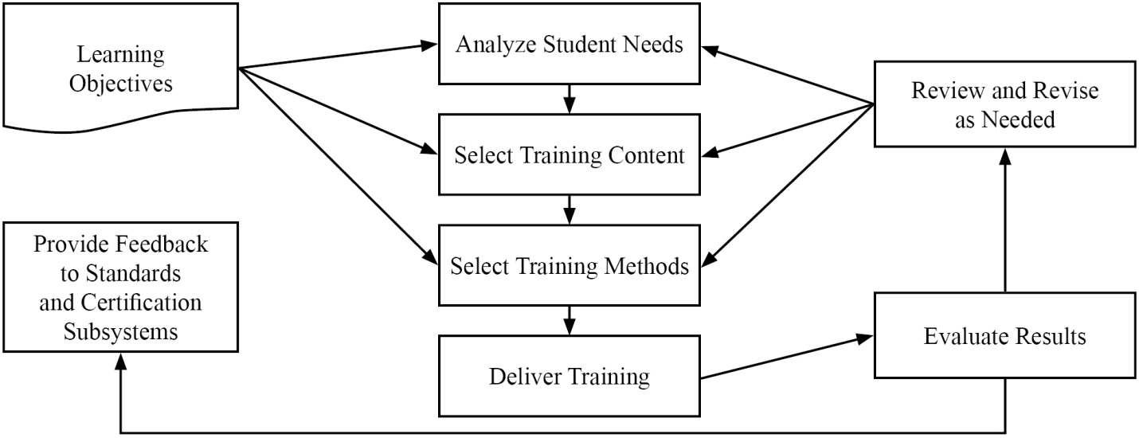

The chart below covers three levels of learning objectives and relates them to (1) the training activities most likely to be successful and (2) the best methods for assessing the success of the training. The curriculum segments state the learning objectives using verbs similar to those in the bottom row of the table. These drive both the training activities required to promote adult learning and the assessment tools appropriate to measure success at that level.

Assessments | Multiple Choice | Multiple Choice | Practical Examples Short Answer
Training Activities | Lecture  Videos  Examples | Discussion  Review  Learner  Presentation | Exercises  Simulations  Demonstrations
Cognitive Levels | Knowledge | Comprehensive | Application
 | Define  Relate  List | Restate  Discuss  Describe  Identify | Employ  Apply  Use  Illustrate

NIST, OWM has expressed a strong interest in collaborating with NCWM in efforts to educate instructors in adult learning techniques and relating them to the learning objectives in NCWM curriculum. The Committee will be posting NIST, OWM material on converting technical content to training material on the PDC training resources web pages. The importance of pre-training analysis and post-training evaluation cannot be overestimated. Failure to include these steps often leads to failure of training efforts.

Professional Certification Program
Systems Approach to Training Evaluation

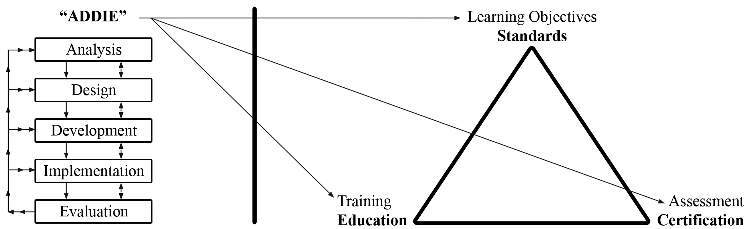

The Committee is calling on the states and other training developers to implement the Analysis, Design, Development, Implementation, and Evaluation (ADDIE) model in their training preparations and post training evaluation. Everyone needs to participate in the development of new BOK modules and then encourage their trainers to use existing BOK modules in their training plans.

The Committee encourages members to also look at the presentation on A Complete Training Program prepared by Ms. Carol Hockert, NIST, OWM. The presentation outlines ways to develop training programs and improve instruction of weights and measures material. It can be found at: ncwm.net/sites/default/files/meetings/annual/2012/PDC%20docs/2012_Pub16_PDC_A_Complete_Training_Program_Presentation.pdf.

At the 2012 Interim Meeting, advisors from NIST, OWM reported that they are using NCWM BOK in preparing new training initiatives. They are stressing adult learning techniques, particularly focusing on the use of hands-on training as the most popular and effective training tool. This ties in closely with the new baseline competency exams discussed in Item 410-1. NIST, OWM is using these exams to ensure students in NIST sponsored training courses are competent in prerequisite course materials prior to taking training. They reported that they are already drafting questions for the baseline competency exams. They see significant efficiencies in using NCWM testing services for this purpose since they are already in place.

Ms. Hockert, NIST, OWM, recommended a basic math prerequisite for persons taking Metrology or other related weights and measures courses sponsored by NIST. The math exam would allow trainees to demonstrate entry level math skills and make the training process more efficient and effective. One official discussed the California licensing requirement of a college degree which requires a certain number of math courses and asked if this would satisfy the need for the math prerequisite. Several California officials expressed concern about the Professional Certification Program replacing existing state licensing programs, and if adopted it might require amendment of existing state statutes. Because math competency is an essential skill for weights and measures work, the Committee recommends that the PDC include in its scope the development of an exam to demonstrate basic math competency before taking the Fundamentals of Metrology or other training courses at NIST.

At the 2011 Southern Weights and Measures Association (SWMA), it was stated that we should consider training state trainers on adult learning techniques as well as subject matter. No further recommendations were made.
At the 2012 Annual Meeting, the Committee stressed instructor improvement. The Committee reviewed the importance of using the NCWM learning objectives and the ADDIE model in training. This stresses the importance of training to the goals in the BOK and not training to pass the test. If the training is appropriate and has been delivered effectively, the employee should have no problem passing a fair exam. The end is not a certificate on the wall, but rather a competent inspector. In other words,

JOB SUCCESS = EXAM SUCCESS
Ms. Hockert, NIST, OWM, stressed that good training requires a partnership between the trainee, trainer, and the supervisor. The Committee agrees that buy-in from all levels is critical to training success.

410-3 I Recommended Topics for Conference Training
Source:
Carryover Item 401-5 (This item originated from the Committee and first appeared on its agenda in 2003.)

Background/Discussion:
The Board of Directors has charged the Committee with recommending appropriate topics for the technical sessions at future Annual Meetings. The Board of Directors asked the PDC to review and prioritize possible presentations and submit those to NCWM Chairman. The Chairman will coordinate with NCWM staff to secure presenters and schedule the sessions.

The PDC continues to carry the following list and recommends these topics for possible training seminars, roundtables, or symposia for presentation at NCWM meetings:

- Marketplace Surveys;
- Alternative Fuels Issues (Fuel Volatility, Ethanol Blending, and Biodiesel Blend);
- Ergonomics (including Proper Lifting Techniques, Back and Stress Techniques, and Office Ergonomics);
- Public Relations (specifically dealing with aggressive/angry people) (recommended by the SWMA);
- General Safety Issues (recommended by the WWMA);
- Defensive Driving (recommended by the WWMA);
- Administrative Civil Penalty Process (recommended by the WWMA);
- Price Verification (recommended by the WWMA);
- Customer Service (recommended by the WWMA);
- Ethics (recommended by the CWMA);
- Moisture Loss;
- Economic Justification of Weights and Measures Programs;
- Demonstrating the Value of Enforcement Programs;
- Documenting Investigations for Court Proceedings;
- Training the Trainer in Adult Learning Methods;
- Honing Presentation Skills; and
- Emerging Issues.
The PDC asked for suggestions for future training or recommendations on how to prioritize suggestions already on the list. Based on the needs identified in the first two items (401-1 and 401-2), the Committee would like to recommend that the regional associations and NCWM consider offering training for trainers on how to identify learning objectives, and design training materials that integrate interactive activities and adult learning styles. NIST has a 1.5-hour course on taking technical material and turning it into a course for adult learners, which may be appropriate to fill this need.

The following is a list of recent presentations, available at www.ncwm.net/content/annual-archive:

- An Overview of Unit Pricing in the United States (Mr. David Sefcik, 2011);
- Grocery Unit Pricing in Australia (Mr. Ian Jarratt, 2011);
- Grocery Unit Pricing in Canada (Mr. Ian Jarratt, 2011);
- The U.S. Hydrogen Measuring System: The Turning Point? (Ms. Kristin Macey, 2011);
- Corrosion in Ultra Low Sulfur Diesel Underground Storage Systems (Mr. Prentiss Searles and Ms. Lorri Grainawi, 2010);
- Risk-Based Inspection Schemes (Mr. Henry Oppermann, 2010);
- Diesel Exhaust Fluid (DEF) (Mr. Gordon Johnson and Mr. Randy Moses. 2009);
- Fuel Volatility and Ethanol Blending (Mr. Jim McGetrick, 2009);
- Investigative Techniques (Mr. Michael Cleary, 2009);
- Automatic Temperature Compensation (ATC) Field Test Procedures;
- Elements of an Effective Safety and Health Program (Mr. Dan Whipple, 2008);
- Analyzing Temperature Compensation Data (Mr. Henry Oppermann and Mr. Steven Malone, 2007);
- The Great Temperature Compensation Debate (Mr. Ross Andersen, 2007);
- NIST Handbook 44 Scale Code Tare Changes (Mr. Steve Cook).
The Committee discussed the benefits of, and avenues to, sharing training resources within the weights and measures community, including a training events calendar, a repository of presentations, lesson plans, videos, and other valuable training tools. The Committee believes the Associate Membership Committee funds may be well used in this area.

The Committee further recommends the following training topics be scheduled for the 2012 Annual Meeting:

- Economic Justification of Weights and Measures Programs;
- Training the Trainer in Adult Learning Techniques; and
- How to Conduct and Analyze a Marketplace Survey.
These topics are in keeping with the Chairman’s theme, “Taking Measure of our Worth”, and ongoing efforts in training at NIST, OWM.

420 PROGRAM MANAGEMENT

420-1 I Safety Awareness
Source:
Carryover Item 402-1 (This item originated from the Committee and first appeared on its agenda in 2003.)

Background/Discussion:
In the past, the Committee’s responsibility extended to the identification of safety issues in the weights and measures field and included efforts to increase safety awareness. Jurisdictions are encouraged to send their safety reports and issues to their regional safety liaison, who in turn will forward them to the PDC. Below is a list of the Regional Safety Liaisons.

Central Weights and Measures Association (CWMA):
Ms. Julie Quinn, Minnesota Weights and Measures Division

Northeastern Weights and Measures Association (NEWMA):
Mr. Michael Sikula, New York Bureau of Weights and Measures

Southern Weights and Measures Association (SWMA):
Mr. Steve Hadder, Florida Department of Agriculture and Consumer Services

Western Weights and Measures Association (WWMA):
Mr. Douglas Deiman, Alaska Division of Measurement Standards/CVE
The Committee will continue asking the regions to prepare articles for the NCWM Newsletter and has revised the schedule as follows for future issues. The Committee plans to notify the Regional Safety Liaisons as their assignment date approaches.

CWMA | 2013, Issue 1 | February | January 18, 2013
NEWMA | 2013 Issue 2 | May | April 16, 2013
SWMA | 2013, Issue 3 | September | July 16, 2013
WWMA | 2014, Issue 1 | February | January 18, 2014
CWMA | 2014, Issue 2 | May | April 16, 2014

Email all articles to NCWM headquarters at info@ncwm.net.

The Committee would like to thank those persons who submitted safety related articles to NCWM Newsletter. In particular, the Committee recognizes the contributors for the 2011 NCWM Newsletters.
- Consumer Tips for Proper Gasoline Handling, 2011 Issue 1 (Mr. Steve Hadder, FL)
- Vehicle Safety Issues for Weights and Measures Inspector, 2011 Issue 2 (Mr. Douglas Deiman, AK)
- Controlling the Risk of Solitary Workers, 2011 Issue 2 (Mr. Brett Gurney, UT)
- Incident Reports Improve Safety, 2011 Issue 3 (Ms. Julie Quinn, MN)
The Committee asks for suggestions for safety articles that people would like to see in future newsletters or safety issues that need to be addressed immediately. The PDC reminds regional associations to check the submission deadlines for their upcoming article assignments. Send completed articles to NCWM headquarters by the submission deadline.

The PDC received a request during the work session that the publication dates be kept current in this ongoing item.
At the 2011 CWMA Interim Meeting, it was noted that the CWMA PDC developed an Incident/Accident Report (Appendix C) to be used for people to send in reports in a systematic way. The purpose was to make it easier for people to report incidents and accidents, and also to count the types and causes of incidents and accidents so we can learn from them. The Committee recommends including this report as an appendix so other regions can consider its use as well. It should be added to the CWMA website so people can download and use it. It was recommended that the Committee should concentrate on safety issues rather than on counting incidents as many jurisdictions will not submit the reports.

At the 2012 Annual Meeting, the Committee heard a request that there could be a benefit in compiling the safety articles from the NCWM Newsletters on the website to make them more accessible. The NCWM currently provides access to the past editions of the NCWM Newsletter on the website but you would have to search each edition individually to find an individual article. The Committee will consider that suggestion and consult with Headquarters on a solution.

420-2 I PDC Publication
Background/Discussion:
The Committee is updating the PDC pages on the website, and will make a concerted effort to update relevant documents and get them posted to the website so that interested parties can easily find and utilize the materials. The three main sections of material include:

- Committee Active Working Documents – includes active documents describing the developing professional certification program, the curriculum plan, BOK documents currently under development and open for comment (i.e., prior to release of a certification exam, program guidelines and administrative procedures);
- Professional Certification Documents – includes the certification exam shopping page, exam descriptions, related BOK documents, aids to taking the certification exams; and
- Committee Archives – includes an archive of historical documents that provide insight into the evolution of the Committee since inception and evolution of the Professional Certification Program. Interested parties should also refer to meeting archives at www.ncwm.net/content/meeting-archive.
In addition, the Committee believes it is vital to move forward with a more formal set of administrative procedures for running a credible certification program. The Committee will make efforts to continue the work of Mr. Sikula, New York, at the request of the Board of Directors, to document our procedures following International Standardization Organization (ISO) 17024 Guidelines for Certification Bodies. The Board of Directors is also considering alternative ANSI standards. The Committee will be working with the Board on this project. NCWM management has ultimate responsibility for contracting with the testing service, policy issues, and staffing (both headquarters staff and the Certification Coordinator). The Committee expects to deal primarily with the technical details and the practical issues of developing the BOK and the certification exams.

Mr. Stacy Carlsen, Marin County, California | Committee Chair
Ms. Cheryl Ayer, New Hampshire | Member
Ms. Kristin Macey, California | Member
Ms. Julie Quinn, Minnesota | Member
Mr. Dale Saunders, Virginia | Member
Mr. Steven Grabski, Wal-Mart Stores, Inc. | Associate Membership Representative
Mr. Ross Andersen | Certification Coordinator

Professional Development Committee

Appendix A
Professional Certification Program Curriculum Work Plan
Revised January 2010
Segment/Subject
Level 1/Level 2/Level 3
- Fundamentals of Weights and Measures
  - Introduction to Weights and Measures Programs
  - Weights and Measures Laws and Regulations
  - Field Standards and Test Equipment
  - State Program Scope and Overview
  - Enforcement Powers
- Weights and Measures Administration
  - Fundamentals of Weights and Measures Administration (Commercial System, Powers and Duties, etc.)
  - Administration Functions (Personnel, Management, Budget, Safety, etc.)
  - Legislation and Regulations (Legal Considerations, Interaction with Legislature, Stakeholders, Industry, etc.)
  - Regulatory Control (Device Inspection, Commodities, Complaints)
  - Laboratory Metrology Administration (Purpose of Laboratory, Responsibilities of Metrologist, NIST Expectations for Recognition of Laboratory, Quality System, Training Requirements, etc.)
  - Public Relations and Communications (Publicity, Public Relations, Communications)
- Laboratory Metrology
  - NIST Basic Metrology
  - NIST Intermediate Metrology
  - NIST Advanced Metrology
- Device Control Program
  - Safety Considerations
  - NIST Handbook 44 – Introduction to Device Control
  - Weighing Systems, General
    - Static Electronic Weighing Systems, General
    - Static Mechanical and Hybrid Weighing Systems, General
    - Dynamic Weighing Systems, General
    - Precision Weighing Systems Class I and II
    - Small Capacity Weighing Systems Class III
    - Medium Capacity Weighing Systems Class III
    - Large Capacity Class III and III L Weighing Systems (Vehicle and Livestock)
    - Large Capacity Class III and III L Weighing Systems - Advanced
    - Railroad Track Weighing Systems
    - In-Motion Railroad Track Weighing Systems
    - Hopper Weighing Systems
    - Automatic Bulk Weighing Systems
    - Automatic Weighing Systems
    - Belt Conveyor Weighing Systems
    - In-Motion Monorail Weighing Systems
    - Point-of-Sale Weighing Systems
    - Other Specialty Weighing Systems
  - Dynamic Measuring Systems – General
    - Retail Motor Fuel Dispensers
    - Loading Rack and Other Stationary Metering Systems
    - Loading Rack and Other Stationary Metering Systems – Advanced
    - Vehicle-Tank Meter Systems
    - Vehicle-Tank Meter Systems – Advanced
    - Milk Metering Systems
    - Water Meters
    - Liquefied Petroleum Gas (LPG) / Anhydrous Ammonia Liquid Metering Systems
    - LPG/Anhydrous Ammonia Liquid Metering Systems – Advanced
    - LPG Vapor Meter Systems
    - Mass Flow Metering Systems
    - Other Metering Systems (Cryogenics, Carbon Dioxide, etc.)
  - Static Volume Measuring Systems – General
    - Liquid Measures
    - Farm Milk Tanks
    - Dry Measures
  - Other Measuring Systems
    - Taximeters and Odometers
    - Wire and Cordage Measuring Systems
    - Linear Measures
    - Timing Devices
    - Weights
    - Multiple Dimension Measuring Systems
  - Quality Measuring Systems
    - Grain Moisture Meters
    - NIR Grain Analyzers
    - Carcass Evaluation Systems
- Market Practices, Laws and Regulations (NIST Handbook 130) and Commodities (NIST Handbook 133)
  - Safety Considerations – Market Practices, NIST Handbook 130, NIST Handbook 133
  - NIST Handbook 130 – Laws and Regulations
    - NIST Handbook 130 – General Provisions
    - Packaging and Labeling Regulations
    - Method of Sale Regulations
    - Quality of Automotive Fuels and Lubricants
    - Price Verification
  - NIST Handbook 133 – Package Net Contents Control
    - Commodities – General
    - Packages Labeled by Weight, Standard and Random
    - Packages Labeled by Weight, Special Commodities
    - Packages Labeled by Volume (Volumetric and Gravimetric Testing)
    - Packages Labeled by Volume, Special
    - Packages Labeled by Length/Area/Thickness
    - Packages Labeled by Count
    - Other Package Types
  - Test Purchases
  - E-Commerce

Note: Initial Verification has been intentionally been left off this listing and will be addressed later.

Appendix B
Draft Module – Weights and Measures Core Mathematics
Overview and Scope:
This module sets standards for core mathematical skills that are an integral part of every weights and measures official’s repertoire. The module is geared toward specific concepts related to understanding of numerical information, interpreting device indications, graphs, and charts, and performing a range of mathematical operations that are commonly used in weights and measures work, both in the field and the laboratory.
Prerequisites:
- None
Objectives and Competencies:
- Expressing and Interpreting Numerical Values
A weights and measures professional should be capable of expressing and interpreting numerical data in various forms. To demonstrate this, the professional can:
  - Express and interpret real numbers, both positive and negative, as integer or decimal
  - Express and interpret numbers in scientific notation
  - Express and interpret numbers with exponential powers or roots
  - Express and interpret numbers as fractions or mixed numbers (integer with fraction)
    - Know basic fraction nomenclature (numerator, denominator, etc.)
    - Know nomenclature of common (^{X}/_{Y}) and binary fractions (^{X}/₂^{n})
  - Interpret analog indications
    - Interpret analog readings, both for single unit and combination unit (e.g., lb and oz)
    - Interpret readings of an analog device using a vernier scale
    - Interpolate readings between graduations to less than one scale division (e.g., to ½, ¼, or ¹/₅ division)
    - Calculate the number of analog divisions for combination unit indicators
  - Express or interpret numerical data in graphs and tables
    - Interpret information from existing graphs and tables
    - Interpolate values at intermediate points on a graph or table
    - Create bar, line or scatter graphs from data tables
    - Organize date in a table
  - Interpret measurement units in customary and SI
    - Interpret customary units of measure (understand meaning and be able to discern which of two values is larger or smaller)
    - Interpret the SI prefixes and suffixes used in measurement units (understand meaning and be able to discern which of two values is larger or smaller)
- Performing Basic Operations on Real Numbers
A weights and measures professional should be able to perform basic mathematical operations on real numbers. To demonstrate this, the professional can:
  - Add or subtract real numbers correctly
  - Multiply and divide real numbers correctly
  - Calculate percentages of related real numbers correctly
  - Calculate prices after discounts correctly
  - Calculate exponential functions of real numbers (powers and roots)
  - Calculate expressions resulting from multiple, mixed operations on real numbers correctly
    - Calculate expressions organized by parentheses
    - Calculate simple expressions without parentheses using algebraic notation
(e.g., 1 + 2 × 3 − 6 = 1 + (2 × 3) − 6 = 1)
    - Apply the associative property (e.g., (5 + 2) + 1 = 5 + (2 + 1)
    - Apply the distributive property (e.g., 2 × (1 + 3) = (2 × 1) + (2 × 3)
  - Convert measurement units to other units (e.g., convert lb to oz or kg to g, and lb to kg or L to gal)
  - Discuss and employ the basic principle of significant digits when expressing numerical data
    - Explain the basic principle of significant digits
    - Interpret relative accuracy of numbers expressed with and without a +/- notation or with an uncertainty value
    - Express real numbers with the correct number of significant digits (e.g., 1,245,427 or 2.3589127 with three significant digits is 1,250,000 or 2.36 respectively)
    - Express the results of simple operations of two numbers with different numbers of significant figures correctly (e.g., 1.27 × 345.37 = 438.6199 = 438 result is limited to three significant digits because 1.27 has three)
- Rounding and Truncating Numerical Values
A weights and measures professional should be able to correctly round or truncate numerical values and know when it is appropriate to round or truncate. To demonstrate this, the professional can:
  - Round values correctly
    - Apply five up/four/down rounding to a real number
    - Apply the NIST Handbook 44 odd/even rule to rounding of real numbers
    - Verify correct rounding in applications, both with and without mathematical agreement to one-half cent (e.g., count 3 for $1 expressed without agreement as 1 @ $0.34, 2 @ $0.68, and 3 @ $1.00 or weight 3 lb for $1 expressed with agreement as 1 lb @ $0.33, 2 lb @ $0.67 and 3 lb @ $1.00)
    - Apply rounding rules correctly in multistep calculations (i.e., only rounding at the end)
    - Describe when it is appropriate to round vs. truncate values (e.g., conversion of measurement units)
  - Truncate values correctly
    - Describe when it is appropriate to truncate vs. round values (e.g., calculating tolerances, calculating NGW in package checking)
- Performing Basic Operations on Fractions
A weights and measures professional should be able to perform basic mathematical operations on common fractions and mixed numbers. To demonstrate this, the professional can:
  - Convert improper fractions to mixed numbers or mixed numbers to improper fractions
(e.g., ⁷/ = 1³/₄ or 2⁵/₈ = ²¹/₈)
  - Convert common fractions and mixed numbers to real numbers correctly (e.g., 2¼ = 2.25)
  - Find the least common denominator of two common fractions
  - Convert a fraction to its equivalent using the least common denominator
  - Reduce a common fraction to its simplest form (e.g., ⁴/₁₆ = ¼)
  - Add and subtract two common fractions or mixed numbers correctly
  - Multiply or divide two common fractions or mixed numbers correctly
  - Calculate a power of a common fraction (e.g., (¹/₇) 2 = ¹/₄₉)
- Perform Advanced Operations on Real Numbers
A weights and measures professional should be able to perform selected advanced mathematical operations on real numbers. To demonstrate this, the professional can:
  - Multiply complex expressions correctly (e.g., 2 × (1 + 3x) = 2 + 6x)
  - Apply the distributive property to factor complex expressions (e.g., (2x + 2y) = 2 × (x + y))
  - Calculate basic statistical functions on numerical data
    - Find median value of a data set
    - Calculate mean or average of a data set
    - Find the range of a data set
    - Calculate the standard deviation of a data set
  - Interpret a logarithmic scales on a graph
Contributor: 10/5/11 – Initial Draft – Mr. Ross Andersen, Certification Coordinator

Appendix C
Safety Incident/Accident Report
This form can be used to report any accidents or near misses to your regional safety coordinator. The purpose of this form is to share information between weights and measures programs which will help the programs identify hazards faced by their employees, and find ways to eliminate or mitigate those hazards. Please make sure that you omit any names or other identifying information in order to protect the privacy of all parties involved.
- Date of incident/accident:

- Describe how the incident/accident occurred:

- Check all injury types that resulted from this action:
Soft Tissue (strains, sprains, etc.) | Slips, Trips, Falls
Eye Injury | Cuts, Bruises, Abrasions
Burns | Chemical Exposure
Vehicle Related Injury | Loss of Body Part
Other/Unlisted (Please describe in the space below.)

- Describe in as much detail as privacy considerations allows, the injuries selected above.

- Check all hazardous conditions present at the time of the incident/accident:
Defective Materials/Equipment | Improper Design or Construction
Slippery Conditions/Poor Footing | Improper or Inadequate Clothing
Personal Protective Equipment Unavailable | Unable to Secure/Warn or Lock/Block
Inadequate Clearance | Inadequate Ventilation
Inadequate Lifting Aids or Technique | Hazardous Method or Procedure
Electrical Hazard | Chemical Hazard
Natural Hazard | Traffic Hazard
Other/Unlisted (Please describe in the space below.)

- Describe in as much detail as privacy considerations allow, the hazardous conditions selected above.

- Check all unsafe acts which contributed to the incident/accident:
Improper Lifting | Failure to Use Personal Protective Equipment
Failure to Shut-off or Unplug Equipment | Horseplay
Improper Use of Equipment | Failure to Secure/Warn or Lock/Block
Improper Use of Body Parts | Using Hands Instead of Tools
Inattention to Footing/Surroundings | Alter or Disable Safety Mechanisms
Unsafe Speed | Unsafe Posture
Standing Beneath Suspended or Swinging Loads | Driving Errors
Unsafe Mixing of Materials | Unsafe Placement of Equipment/Materials
Other/Unlisted (Please describe in the space below.)

- Describe in as much detail as privacy considerations allow, the unsafe acts selected above.

- Check all other contributing factors which may apply:
Lack of Policy/Procedures | Safety Rules Not Enforced
Hazards Not Identified | Personal Protective Equipment Not Provided
Insufficient Employee Training | Insufficient Supervisor Training
Inadequate Supervision | Inadequate Workplace Inspection
Unrealistic Schedule | Poor Process Design
Other/Unlisted (Please describe in the space below.)

- Describe in as much detail as privacy considerations will allow, the other factors selected above.

- Please describe any conditions, actions, or other factors which mitigated this incident and kept the consequences from being more severe than they were.

- Please describe any immediate corrective actions taken to prevent additional incidents/injuries.

- Please describe any preventative actions you are taking to reduce or eliminate similar hazards in the future.

- Please check the boxes which apply to the person completing this report:
I was one of the people involved in the incident/accident
I witnessed the incident/accident
I investigated the incident/accident
I heard the incident/accident through some other means. (Please describe in the space below.)

