Report of the
Professional Development Committee (PDC)

Julie Quinn, Committee Chair
Minnesota

400 Introduction
This is the report of the Professional Development Committee (hereinafter referred to as the “Committee” or PDC) for the 98th Annual Meeting of the National Conference on Weights and Measures (NCWM). This report is based on the Interim Report offered in the NCWM Publication 16, testimony heard at public hearings, comments received from the regional weights and measures associations and other parties, the addendum sheets issued at the Annual Meeting, and actions taken by the membership at the voting session of the Annual Meeting. The informational items presented below were adopted as presented when the Committee’s report was approved.
Table A identifies the agenda and appendix items. Agenda items are identified in the Report by Reference Key Number, Item Title, and Page Number. Item numbers are those assigned in the Interim Meeting agenda. A Voting item is indicated with a “V” after the item number. An item marked with an “I” after the reference key number is an Informational item. An item marked with a “D” after the reference key number is a Developing item. The developing designation indicates an item has merit; however, the item was returned to the submitter for further development before any action can be taken at the national level. Suggested revisions are shown in bold face print by striking out information to be deleted and underlining information to be added. Table B lists the results of any voting items.
Note: It is the policy of the National Institute of Standards and Technology (NIST) to use metric units of measurement in all of its publications; however, recommendations received by NCWM technical committees and regional weights and measures associations have been printed in this publication as submitted. Therefore, the report may contain references in inch-pound units.
Subject Series List
Introduction 400 Series
Education 410 Series
Program Management 420 Series

Table A
Table of Contents
Reference Key | Title of Item | PDC Page
400 Introduction 1
410 EDUCATION 2

410-1 I Professional Certification Program 3

410-2 I Training 7

410-3 I Instructor Improvement 7

410-4 I Recommended Topics for Conference Training 7
420 PROGRAM MANAGEMENT 9

420-1 I Safety Awareness 9

420-2 I PDC Publication 10

Appendices
A –– Professional Certification Program Curriculum Work Plan A1
B –– History of Professional Certification Program B1
C –– History of Instructor Improvement C1

Table B
Voting Results
Reference Key Number |  | House of State Representatives |  |  | House of Delegates |  | Results
 |  | Yeas |  | Nays | Yeas | Nays
 | No Voting items

Table C
Glossary of Acronyms and Terms

Acronym | Term | Acronym | Term
ADDIE | Analysis, Design, Development, Implementation, and Evaluation | NEWMA | Northeastern Weights and Measures Association
ANSI | American National Standards Institute | NIST | National Institute of Standards and Technology
BOK | Body of Knowledge | OWM | Office of Weights and Measures
CWMA | Central Weights and Measures Association | PDC | Professional Development Committee
ISO | International Standardization Organization | RSA | Registered Service Agents
ICE | Institute for Credentialing Excellence | SME | Subject Matter Expert
LPG | Liquefied Petroleum Gas | SWMA | Southern Weights and Measures Association
NCWM | National Conference on Weights and Measures | WWMA | Western Weights and Measures Association

Details of All Items
(In order by Reference Key)

410 EDUCATION

410-1 I Professional Certification Program
Report Cleanup:
The PDC archive is under construction on the new NCWM website. Anyone interested in seeing past reports should look for the report in the NCWM archives at http://www.ncwm.net/meetings/annual/archive.

2013 Interim Topics:
- Basic Proficiency Exams on NCWM Test Site
The Committee heard comments in 2012 asking whether it was possible to use the NCWM test site to offer basic proficiency exams. At the 2013 Interim, Ms. Carol Hockert reported that NIST, OWM will be using the NCWM test site to administer proficiency tests, which will be used as qualifying prerequisites for OWM courses. The tests will be open to members and non-members alike at no fee. The first exam, which will be on the NCWM test site, will be a NIST Handbook 44 (Standards, Tolerances, and Other Technical Requirements for Weighing and Measuring Devices) self-study course exam. Contact NIST, OWM for further information.
Mr. Don Onwiler confirmed that membership is not necessary to take OWM proficiency tests.
2013 Annual Meeting: Ms. Carol Hockert reported that the NIST, OWM currently requires a prerequisite mathematics test for applicants to their Fundamentals of Metrology training course. They intend to start offering that test online through the NCWM test site. This mathematics exam may also be used by weights and measures jurisdictions to screen job applicants. OWM also intends to provide a NIST Handbook 44 test to compliment the NIST Handbook 44 self-study course. These tests will be free and available to all NCWM members and non-members alike.

- Feedback from Registered Service Agents (RSAs) after taking Certification Exam
A small number of registered service agents (RSAs) were asked in 2012 to take the certification exams and provide the Committee with feedback on the suitability of the certification exams for RSAs. The Committee reported that it had received the following comments from the RSAs who had taken the exams:
  - RSAs advised test-takers know test taking strategies
    - First answer easy questions;
    - Then look up skipped questions;
    - If time allows, look up answers you thought were easy.

  - RSAs question the appropriateness of some of the fundamental questions. For example, questions on NCWM voting bylaws.
    - A comment was heard from the floor from one state director that nuances of the bylaws were probably not even useful to regulatory officials at the field level, let alone RSAs. The Director suggested that questions should be geared toward fundamentals, general code applications, and field applications.

    - The Committee recommends that the questions be sent back to the coordinator and SMEs for review as to their appropriateness.
  - RSAs thought that it took too long to get a password to take test.
- The Committee reported that password generation will be automated with the completion of the NCWM website upgrade.
  - RSAs would like feedback for test-takers on the exam sections which they failed.
- The Committee reported that they will continue to keep that in mind if it becomes technologically possible to do so.
  - RSAs would like to know where to find information on how to study for the exams.
- The Committee presented a slide show to point to the curriculum hotlinks embedded in the course descriptions which appear at the certification site. (ncwm.net/member/tests)
2013 Annual Meeting: The Committee reported on their response to issues raised by a small number of RSAs who volunteered to take the test and provide feedback:

- Corrections were made to the answer key on several questions, and all failing tests were reviewed to see if those questions affected the final results. Three people were notified that they had, in fact, passed their exams and would be issued certificates as a result of this review.
- Test passwords are now auto-generated as part of the test purchase process. Tests are free to NCWM members. For non-members, tests may be purchased using a credit card, a check, or a purchase order (P.O.). For those people wishing to purchase using a P.O., select the check option and then contact the NCWM office. Anyone wishing to purchase a block of tests for a group, or jurisdictions who wish to proctor the exams, should contact the NCWM directly instead of purchasing through the website.
- The Committee will continue to keep open the possibility that test section results might someday be reportable to test takers, but the results of specific questions will not be made available in order to safeguard the integrity of the tests.
- The Committee demonstrated how to access information about the tests and curriculum modules on the new NCWM website, as well as how to purchase the exams.
  - The suggestion was made from the floor that the Committee poll jurisdictions to find out if any had 100 % certification of their inspectors on any exam. Of those present in the room:
    - Thirteen states, and one service company reported that they had set the goal for 100 % certification;
    - Three states reported that they had already achieved 100 % certification in at least one discipline;
    - Nine states reported setting a goal of having RSAs certified as part of their permitting process;
    - No state reported that they had already implemented a requirement that RSAs have professional certification.
  - A question was asked about what time commitment is asked of someone volunteering to be a subject matter expert (SME). The answer was approximately 20 hours over six to eight months. It is not necessary to be a trainer or a manager to be an SME. This is an excellent way to develop senior investigators who may become trainers in the future. This is also an opportunity where retirees can contribute their skills and experience. Industry participation is encouraged.
  - In response to a question from the floor, the Committee reported that there is no conflict of interest if trainers wish to participate as SME because they are only exposed to a small portion of the test question bank, and their agreement with the NCWM is that the questions they see are the property of the NCWM and may not be used in their own training programs.
- Status of Current tests
Current tests – RMFD, Small Capacity Retail Scales, Basic Package Checking.
The Committee reported that exam statistics show steady improvement over time, indicating that much of the problem with passing the tests has to do with a need to acclimate to on-line testing.
Retail Motor Fuel Devices | FY2011 | FY 2012¹ | FY2013 to Date ¹ | Total
# of Registrants | 76 | 107 | 5 | 188
# of Exams Taken | 189 | 145 | 7 | 341
# of Certificates Issued | 45 | 83 | 6 | 134
% certificates per registrants | 59.2% | 78.3% | 100.0% | 71.3%
Note 1: One person registered in FY2012 for RMFD test but did not test until FY2013
Pack Checking |  | FY 2012 | FY2013 to Date | Total
# of Registrants |  | 15 | 37 | 52
# of Exams Taken |  | 23 | 33 | 56
# of Certificates Issued |  | 5 | 19 | 24
% certificates per registrants |  | 33.3% | 51.4% | 46.2%
Small Scales |  | FY 2012 | FY2013 to Date | Total
# of Registrants |  | 17 | 50 | 67
# of Exams Taken |  | 15 | 100 | 115
# of Certificates Issued |  | 6 | 34 | 40
% certificates per registrants |  | 35.3% | 68.0% | 59.7%
The VTM exam is in development now. SMEs are currently writing the questions. The Certification Coordinator is currently seeking SMEs for Medium Capacity Scales and Large Capacity Scales Class III and IIIL. The Committee thanks those who have already volunteered to be SMEs.
Package Checking Basic | Small Capacity Scales Class III
D'Arcy, Carlos, FL | Smith, Dan, AK
Wilson, Peter, VA | D'Arcy, Carlos, FL
Gurney, Brett, UT | Wilson, Peter, VA
Chesser, Tim, AR | Gurney, Brett, UT
Merritt, Kevin, ID | Chesser, Tim, AR
Shultz, Steve, NV | Merritt, Kevin, ID
McGee, Robert, SC | Shultz, Steve, NV
Hicks, Tyler, OK | Stokes, John, SC
Johnson, Ray, NM | McGee, Robert, SC
Paquette, Marc, VT | Hicks, Tyler, OK
Tubacki, Jeff, IL | Johnson, Ray, NM
Dillibaugh, John, PA | Paquette, Marc, VT
Miller, Rachelle, WI | Tubacki, Jeff, IL
Feagan, Bruce, WA | Dillibaugh, John, PA
Butcher, Ken, NIST OWM | Miller, Rachelle, WI
 | Feagan, Bruce, WA
The Committee also wanted to assure members that SMEs will not compromise their ability to be trainers as no SME will be allowed to have access to more than 25 % of the questions.
Mr. Onwiler made a comment that this restriction on access to the test questions was an important part of maintaining the integrity of the exam process as the certification program moves toward formal accreditation. Eventually exam questions may need to be copyrighted. SMEs should note that they should modify test questions before submitting them to the certification coordinator if they wish to continue to use those questions in their own exams.
- Certification Coordinator Reported on Exam Question Pass/Fail Statistics
The Certification Coordinator reviewed the exam question statistics for each exam:
  - Statistics indicate that the questions and time required to answer them are generally appropriate.
  - He explained the significance of differentiating questions that took a long time to answer and had low passing rates among those who failed the test, but had high passing rates among those who passed the tests. These questions separate those who really know their stuff from those who do not.
  - Exam statistics also indicated that most test-takers had more difficulty with general questions and fundamental questions than they did with device specific questions. This indicates that there is a training imbalance between general principles and device specifics. He noted that part one of every exam covers the general code and fundamental considerations.
  - There are questions in the small capacity scale exam and the package checking exam which will be reviewed by the SMEs to check appropriateness and wording.
An industry representative wanted to know how industry could help improve the exams. The Committee responded:
- Take the exams and give the Committee feedback;
- Participate as SMEs in developing tests;
- Be a resource to provide training materials; and
- Help with instructor improvement, particularly relating to training Registered Service Agents (RSAs).

410-2 I Training
The Committee recommended that a new item dealing with training be inserted and subsequent item numbering be adjusted. The purpose of this item is to share information gleaned from the certification test statistics regarding broad training needs, and to serve as a link to various training materials on the web. Eventually, it can become a home for the training material program currently under development by the NCWM Board of Directors.

The Committee reported that the Board of Directors is assembling a new work group to be headed by Mr. Michael Cleary, former Director of the California Division of Measurement Standards. The function of the work group will be to develop guidance on the scope of training for weights and measures officials and will report to the PDC. Anyone interested in serving on this work group should contact the NCWM Board of Directors.

410-3 I Instructor Improvement
Report Cleanup:
2013 Interim Meeting: The Committee agreed to move the historical data in the current item to Appendix C, with the intention of moving it into the Committee archives at the 2014 Interim. Moving forward, historical information will be archived and items will contain only current action items.

Current Items:
The Committee called on Ms. Hockert to discuss NIST, OWM’s new regional trainer program. Ms. Hockert reported that NIST, OWM is looking for a way to increase the number of trainers available to teach OWM courses. OWM will be hosting a Train-the-Trainer course in April 2013 with the intention of developing a pool of weights & measures officials capable of offering NIST, OWM training at the regional level. The training is free, and OWM asks for a minimum commitment from each participant of leading one to two training courses with a NIST, OWM trainer in the subsequent year. Expenses involved with teaching the course(s) would be covered by NCWM through an OWM grant.

2013 Annual Meeting: Ms. Hockert reported that the NIST, OWM Train-the-Trainer program had already trained 20 weights and measures officials from 17 states on techniques for training adult learners. Nine NIST courses will be taking place between July and November, at which those people will be assisting and observing. The OWM is looking to increase the number of people who receive that basic training, and also to add continuing training for those people who have taken the first course. The ultimate goal is to have many people around the country capable of leading training on NIST technical courses. In response to questions from the PDC, the Associate Membership Committee clarified that under their current bylaws funds are available to bring trainers to jurisdictions but not to send individuals to training – even to courses meant to train trainers.

410-4 I Recommended Topics for Conference Training
Source:
Carryover Item 401-5 (This item originated from the Committee and first appeared on its agenda in 2003.)
Background/Discussion:
The Board of Directors has charged the Committee with recommending appropriate topics for the technical sessions at future Annual Meetings. The Board of Directors asked the PDC to review and prioritize possible presentations and submit those to NCWM Chairman. The Chairman will coordinate with NCWM staff to secure presenters and schedule the sessions.
The Committee acknowledged the continued interest in having a presentation on Making Sense of Electronic Receipts and is seeking assistance in identifying a suitable presenter on the topic. A comment was heard from the floor that Price Posting on Retail Motor Fuel Devices should be added to the list so that the new changes can be explained.

The Committee would like to recommend that the regional associations and NCWM consider offering training on:
- Making Sense of Electronic Receipts;
- Training the Trainer in Adult Learning Techniques;
- Ethics for weights & measures officials; and
- Data privacy issues faced by weights & measures officials.
The PDC continues to carry the following list and recommends these topics for possible training seminars, roundtables, or symposia for presentation at future NCWM meetings:
- Alternative Fuels Issues (Fuel Volatility, Ethanol Blending, and Biodiesel Blend);
- Ergonomics (including Proper Lifting Techniques, Back and Stress Techniques, and Office Ergonomics);
- Public Relations (specifically dealing with aggressive/angry people) (recommended by the SWMA);
- General Safety Issues (recommended by the WWMA);
- Defensive Driving (recommended by the WWMA);
- Administrative Civil Penalty Process (recommended by the WWMA);
- Price Verification (recommended by the WWMA);
- Customer Service (recommended by the WWMA);
- Moisture Loss;
- Documenting Investigations for Court Proceedings;
- Honing Presentation Skills;
- Emerging Issues;
- Implementing New RMFD Price Posting and Computing Capability Revisions(recommended by the WWMA);
- Fundamentals of the National Type Evaluation Program (recommended by the WWMA);
- Electric Vehicles: Commercial Devices, Method of Sale, Advertising and Labeling (recommended by the WWMA);
- Understanding the International Weights and Measures Standards Development System (recommended by the WWMA); and
- Crane Operation and Safety (recommended by the NEWMA).
The following is a list of recent presentations, available at www.ncwm.net/meetings/annual/archive:
- Economic Justification and Demonstrating Value of Weights and Measures Grand Ballroom (Mr. Tim Chesser, Arkansas Bureau of Standards, 2012);
- Conducting Effective Marketplace Surveys and Investigations Grand Ballroom (Ms. Judy Cardin, Wisconsin Weights and Measures, 2012);
- Public Relations and Customer Service as Regulators Grand Ballroom (Mr. Doug Deiman, Alaska, 2012);
- An Overview of Unit Pricing in the United States (Mr. David Sefcik, NIST, 2011);
- Grocery Unit Pricing in Australia (Mr. Ian Jarratt, 2011);
- Grocery Unit Pricing in Canada (Mr. Ian Jarratt, 2011);
- The U.S. Hydrogen Measuring System: The Turning Point? (Ms. Kristin Macey, 2011);
- Corrosion in Ultra Low Sulfur Diesel Underground Storage Systems (Mr. Prentiss Searles and Ms. Lorri Grainawi, 2010);
- Risk-Based Inspection Schemes (Mr. Henry Oppermann, 2010);
- Diesel Exhaust Fluid (DEF) (Mr. Gordon Johnson and Mr. Randy Moses. 2009);
- Fuel Volatility and Ethanol Blending (Mr. Jim McGetrick, 2009);
- Investigative Techniques (Mr. Michael Cleary, 2009);
- Automatic Temperature Compensation (ATC) Field Test Procedures;
- Elements of an Effective Safety and Health Program (Mr. Dan Whipple, 2008);
- Analyzing Temperature Compensation Data (Mr. Henry Oppermann and Mr. Steven Malone, 2007);
- The Great Temperature Compensation Debate (Mr. Ross Andersen, 2007);
- NIST Handbook 44 Scale Code Tare Changes (Mr. Steve Cook).
No comments were heard.

420 PROGRAM MANAGEMENT

420-1 I Safety Awareness
Source:
Carryover Item 402-1 (This item originated from the Committee and first appeared on its agenda in 2003.)
Background/Discussion:
In the past, the Committee’s responsibility extended to the identification of safety issues in the weights and measures field and included efforts to increase safety awareness. Jurisdictions are encouraged to send their safety reports and issues to their regional safety liaison, who in turn will forward them to the PDC. Below is a list of the Regional Safety Liaisons. Regional Associations should keep the Committee updated on current liaison assignments.
Central Weights and Measures Association (CWMA):
Ms. Julie Quinn, Minnesota Weights and Measures Division
Northeastern Weights and Measures Association (NEWMA):
Mr. Michael Sikula, New York Bureau of Weights and Measures
Southern Weights and Measures Association (SWMA):
Mr. Matthew Curran, Florida Department of Agriculture and Consumer Services
Western Weights and Measures Association (WWMA):
Mr. Douglas Deiman, Alaska Division of Measurement Standards/CVE
The Committee will continue asking the regions to prepare articles for the NCWM Newsletter and has revised the schedule as follows for future issues. The Committee plans to notify the Regional Safety Liaisons as their assignment date approaches.
Region | Issue | Article Deadline | Published
SWMA | 2013, Issue 3 | 16-Jul-13 | September
WWMA | 2014, Issue 1 | 18-Jan-14 | February
CWMA | 2014, Issue 2 | 16-Apr-14 | May
NEWMA | 2014, Issue 3 | 17-Jul-14 | September
E-mail all articles to NCWM headquarters at info@ncwm.net.
The Committee would like to thank those persons who submitted safety related articles to the NCWM Newsletter. In particular, the Committee recognizes the contributors for the 2012 NCWM Newsletters.
- Safe Fueling and Gasoline Handling Guidelines NEVER COMPROMISE SAFETY!, 2012 Issue 2 (Mr. Steve Hadder, Florida)
- Working in Confined Spaces, 2012 Issue 2 (Mr. Douglas Deiman, Alaska)
The Committee asks for suggestions for safety articles that people would like to see in future newsletters and/or safety issues that need to be addressed immediately. The PDC reminds regional associations to check the submission deadlines for their upcoming article assignments. Send completed articles to NCWM headquarters by the submission deadline.
The Committee supports the recommendation made at the 2012 NCWM Annual Meeting that the safety articles in the NCWM Newsletters be extracted and compiled in one central location on the NCWM website.
An industry representative commented that this item is being underutilized and he urges everyone to give more attention to this item in the future. A state official made the suggestion that the Committee develop an anonymous form for people to report not only incidents but also near-misses.

420-2 I PDC Publication
Background/Discussion:
The NCWM website is being redesigned. The FAQ document presented at the 2012 Annual Meeting will be added to the website at the time of the update. The Committee will review relevant documents when the update is complete to ensure that interested parties can easily find and utilize the materials. The three main sections of material include:
- Committee Active Working Documents – includes active documents describing the developing professional certification program, the curriculum plan, Body of Knowledge (BOK) documents currently under development and open for comment (i.e., prior to release of a certification exam, program guidelines and administrative procedures);
- Professional Certification Documents – includes the certification exam shopping page, exam descriptions, related BOK documents, aids to taking the certification exams;
- Committee Archives – includes archive of historical documents that provide insight into the evolution of the Committee since inception and evolution of the Professional Certification Program. Interested parties should also refer to meeting archives at www.ncwm.net/meetings/annual/archive.
In addition, the Committee believes it is vital to move forward with a more formal set of administrative procedures for running a credible certification program. The Committee will make efforts to continue the work of Mr. Sikula (New York) at the request of the Board of Directors, to document our procedures following International Standardization Organization (ISO) 17024 Guidelines for Certification Bodies. The Board of Directors is also considering alternative ANSI standards. The Committee will be working with the Board of Directors on this project. NCWM management has ultimate responsibility for contracting with the testing service, policy issues, and staffing (both headquarters staff and the Certification Coordinator).

Ms. Julie Quinn, Minnesota | Committee Chair
Mr. Dale Saunders, Virginia | Member
Ms. Cheryl Ayer, New Hampshire | Member
Ms. Kristin Macey, California | Member
Mr. Stacy Carlsen, Marin County, California | Member
Mr. Steven Grabski, Walmart Stores, Inc. | Associate Membership Representative

Mr. Ross Andersen | Certification Coordinator

Professional Development Committee

THIS PAGE INTENTIONALLY LEFT BLANK

Appendix A
Professional Certification Program Curriculum Work Plan
Revised January 2010
Segment/Subject
Level 1/Level 2/Level 3
- Fundamentals of Weights and Measures
  - Introduction to Weights and Measures Programs
  - Weights and Measures Laws and Regulations
  - Field Standards and Test Equipment
  - State Program Scope and Overview
  - Enforcement Powers
- Weights and Measures Administration
  - Fundamentals of Weights and Measures Administration (Commercial System, Powers and Duties, etc.)
  - Administration Functions (Personnel, Management, Budget, Safety, etc.)
  - Legislation and Regulations (Legal Considerations, Interaction with Legislature, Stakeholders, Industry, etc.)
  - Regulatory Control (Device Inspection, Commodities, Complaints)
  - Laboratory Metrology Administration (Purpose of Laboratory, Responsibilities of Metrologist, NIST Expectations for Recognition of Laboratory, Quality System, Training Requirements, etc.)
  - Public Relations and Communications (Publicity, Public Relations, Communications)
- Laboratory Metrology
  - NIST Basic Metrology
  - NIST Intermediate Metrology
  - NIST Advanced Metrology
- Device Control Program
  - Safety Considerations
  - NIST Handbook 44 – Introduction to Device Control
  - Weighing Systems, General
    - Static Electronic Weighing Systems, General
    - Static Mechanical and Hybrid Weighing Systems, General
    - Dynamic Weighing Systems, General
    - Precision Weighing Systems Class I and II
    - Small Capacity Weighing Systems Class III
    - Medium Capacity Weighing Systems Class III
    - Large Capacity Class III and III L Weighing Systems (Vehicle and Livestock)
    - Large Capacity Class III and III L Weighing Systems - Advanced
    - Railroad Track Weighing Systems
    - In-Motion Railroad Track Weighing Systems
    - Hopper Weighing Systems
    - Automatic Bulk Weighing Systems
    - Automatic Weighing Systems
    - Belt Conveyor Weighing Systems
    - In-Motion Monorail Weighing Systems
    - Point-of-Sale Weighing Systems
    - Other Specialty Weighing Systems
  - Dynamic Measuring Systems – General
    - Retail Motor Fuel Dispensers
    - Loading Rack and Other Stationary Metering Systems
    - Loading Rack and Other Stationary Metering Systems – Advanced
    - Vehicle-Tank Meter Systems
    - Vehicle-Tank Meter Systems – Advanced
    - Milk Metering Systems
    - Water Meters
    - Liquefied Petroleum Gas (LPG) / Anhydrous Ammonia Liquid Metering Systems
    - LPG/Anhydrous Ammonia Liquid Metering Systems – Advanced
    - LPG Vapor Meter Systems
    - Mass Flow Metering Systems
    - Other Metering Systems (Cryogenics, Carbon Dioxide, etc.)
  - Static Volume Measuring Systems – General
    - Liquid Measures
    - Farm Milk Tanks
    - Dry Measures
  - Other Measuring Systems
    - Taximeters and Odometers
    - Wire and Cordage Measuring Systems
    - Linear Measures
    - Timing Devices
    - Weights
    - Multiple Dimension Measuring Systems
  - Quality Measuring Systems
    - Grain Moisture Meters
    - NIR Grain Analyzers
    - Carcass Evaluation Systems
- Market Practices, Laws and Regulations (NIST Handbook 130) and Commodities (NIST Handbook 133)
  - Safety Considerations – Market Practices, NIST Handbook 130, NIST Handbook 133
  - NIST Handbook 130 – Laws and Regulations
    - NIST Handbook 130 – General Provisions
    - Packaging and Labeling Regulations
    - Method of Sale Regulations
    - Quality of Automotive Fuels and Lubricants
    - Price Verification
  - NIST Handbook 133 – Package Net Contents Control
    - Commodities – General
    - Packages Labeled by Weight, Standard and Random
    - Packages Labeled by Weight, Special Commodities
    - Packages Labeled by Volume (Volumetric and Gravimetric Testing)
    - Packages Labeled by Volume, Special
    - Packages Labeled by Length/Area/Thickness
    - Packages Labeled by Count
    - Other Package Types
  - Test Purchases
  - E-Commerce

Note: Initial Verification has been intentionally been left off this listing and will be addressed later.

Appendix B
History of Professional Certification Program
Source:
Carryover Item 401-1 (This item originated from the Committee and first appeared on its Agenda in 2003 and has undergone continuing development.) The numbering change reflects harmonization in all NCWM reports. Copies of reports from recent years are also available on the website under Interim and Annual Meeting archives pages.
Background/Discussion:
It is important that users of the Professional Certification Program understand how the pieces fit together and form a coherent system. To illustrate the relationships the Committee can describe the system as a triangle of interdependent parts (see diagram below). The standards come in the form of goals with measureable learning objectives. The education part involves training provided to help the candidate reach the desired level of proficiency for each of the learning objectives. The certification involves an assessment of proficiency that measures whether or not the objectives have been met.
Certification Triangle
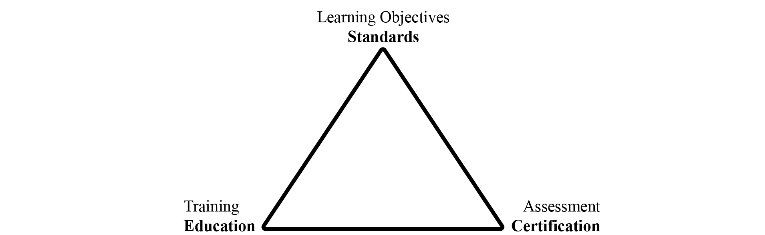

The Committee has until now focused attention on the standards and the certification pieces in the triangle as illustrated in the following flowcharts.

Standard Subsystem
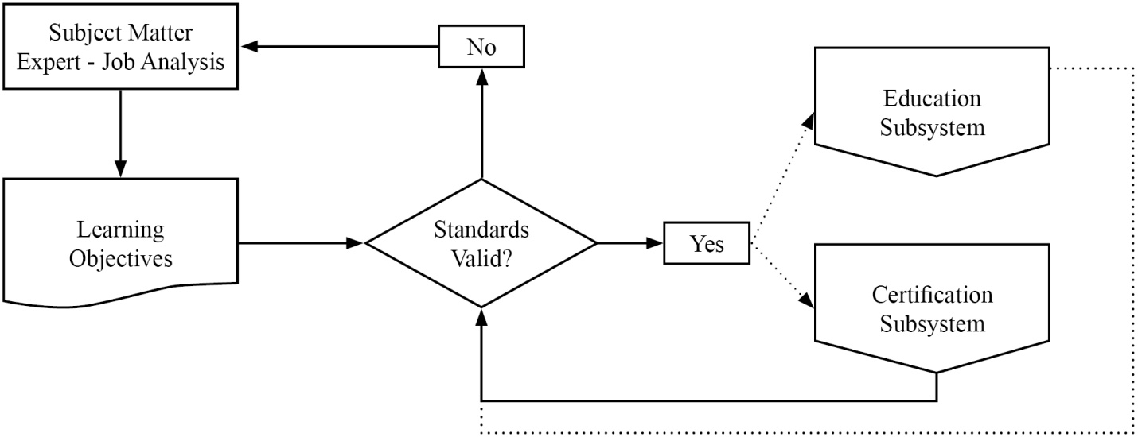

Certification Subsystem

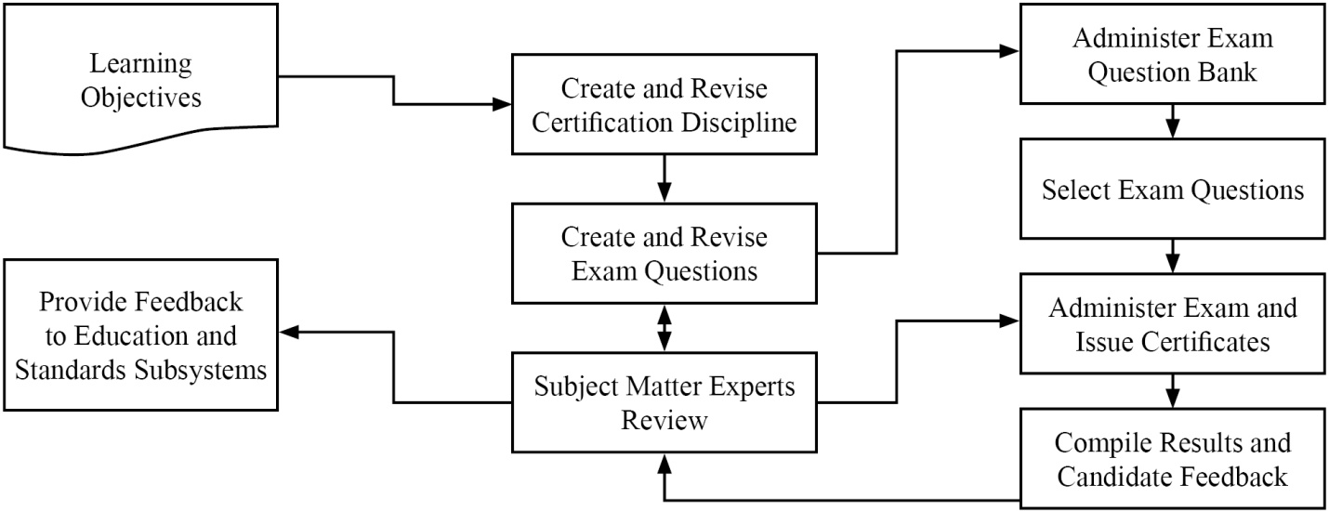
The Committee has described this work in a number of documents. In those documents the Committee is using terminology consistent with current usage in the education and certification field. The following important terms will be used throughout the Committee’s work on the subject.
Body of Knowledge (BOK) – refers broadly to the knowledge and skills required to function as a weights and measures professional. The term may refer broadly to the entire scope of knowledge and skills required within the profession or in a more directed manner to any selected subset for which the particular person is responsible. The BOK describes what you expect the weights and measures professional to achieve as opposed to how he/she will achieve it. To make the BOK more manageable in administration of the Professional Certification Program, it will be subdivided into modules in a tree-like structure moving from general knowledge and skills to more specific.
Module – refers to a group of related subject materials within the BOK. The module contains the articulated learning objectives for the subject area. Each module is considered a single, self-contained course of study. However, a broader course may span multiple modules and specific training may include only part of a module or parts of multiple modules. The PDC has created a standard format to create modules for the Professional Certification Program. The Committee has also created the Curriculum Outline and work plans to help manage the work activities within the program to create the many modules necessary to cover the entire profession.
Learning Objective – refers to the articulation of expectations of performance in measureable terms. Learning objectives are stated using active terms to be precise and measureable. There are two types of learning objectives, a terminal objective and an enabling objective. Terminal objectives state broadly the expectation of performance. The enabling objectives state the specific parts or steps required to demonstrate competence. The PDC has developed a guide to writing the learning objectives for both terminal and enabling which include the active verbs associated with the cognitive levels in Bloom’s Taxonomy. In training, the instructor will typically choose learning activities to explore each of the enabling objectives in an attempt to reach the terminal objective. In assessment, the questions will typically test for competence in each of the enabling objectives to demonstrate that the terminal objectives have been met.
Professional Certification – refers to verification of proficiency relative to all or part of the BOK for the profession as designated by the PDC for inclusion in a certification exam. The selected BOK includes all or part of specific modules and is documented in an exam description. Each of the modules, or combinations, is given a specific weighting in the design of the exam. After obtaining a passing score on the exam, the candidate is issued a certificate stating he/she has met the competency standard.
Curriculum – refers to the list of modules that are used to document the BOK (see Appendix A).
Bloom’s Taxonomy – refers to a classification of levels of cognitive leaning widely used in the field of education. The levels are knowledge, understanding, application, analysis, integration, and evaluation. The active verbs used in the articulation of learning objectives define the cognitive level. In training, the learning activities are matched to the cognitive level. In assessment, the form of the question is also matched to the cognitive level. The use of Bloom’s Taxonomy is described in detail in the Body of Knowledge Model document.
The PDC has prepared program documents that are available on NCWM website.
- The Curriculum Outline, which breaks the profession of weights and measures into component parts called modules.
- The Body of Knowledge Model, which explains how to create modules to document the learning objectives.
- The Modules developed thus far.
- The Certifications developed thus far.
Results of the Retail Motor Fuel Dispensing Systems exam indicate it will be very important as the program moves forward that trainers integrate the learning objectives into their materials and design courses in such a way that candidates will achieve the desired levels of learning. See Item 401-2 Instructor Improvement.
2011 NCWM Interim Meeting: The Committee addressed the need to build partnerships between the states, National Institute of Standards and Technology (NIST), Office of Weights and Measures (OWM), and NCWM. Each group has roles in relation to the Certification Triangle as shown in the diagram below.

Professional Certification Program
Applying Certification Triangle (Triumvirate Partnership)
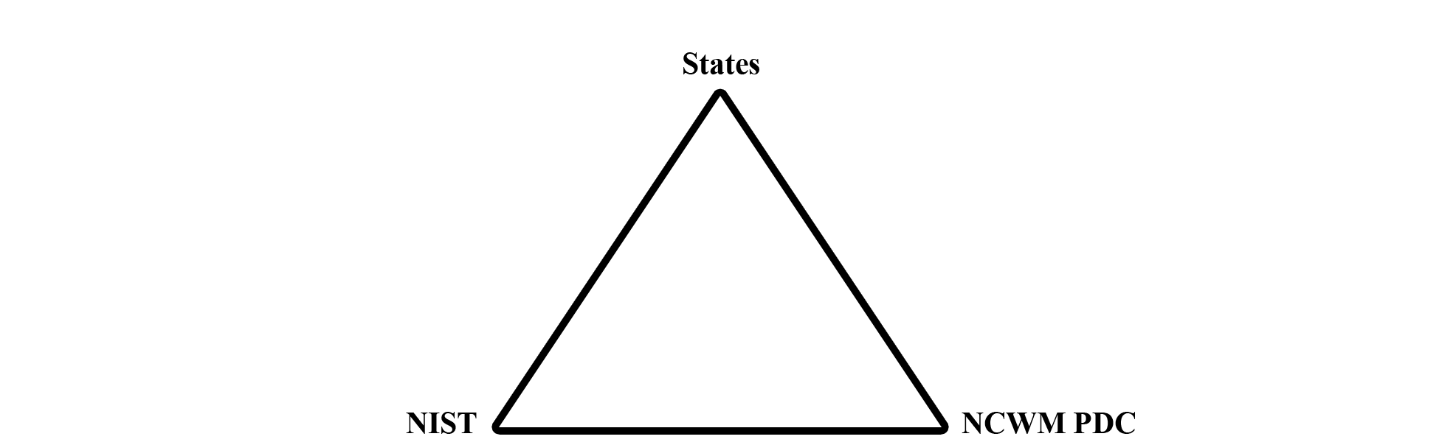
States | NCWM PDC | NIST
- National Certified Workforce  - Assessment Tools and Certification Triangle Applied  - Student Meets Training Milestones  - Feedback to Trainer and Employee  - Value Exam Results = Recognition + Adult Learning  - Develop New Training Standards  - NCWM/NIST Regional Education and Training | - Website and Administer Professional Certification Program  - Enlist SMEs  - Learning Objectives and Standards  - Curriculum Work Plans, Discipline, Segments  - Write/Verify Exam Questions  - Exam Evaluation/Statistical Analysis | - Training and Education  - Instructor Improvement “ADDIE”  - State Instruction Support  - Technical Materials  - Train the Trainer Material  - Classroom and Field Training

2012 NCWM Interim Meeting: The Committee received a comment from NIST, OWM that there is a need to provide an assessment tool to measure basic competence in fundamental subject areas such as NIST Handbook 44. They hope to partner with NCWM to administer those assessments using NCWM testing service. This would assure that participants at NIST, OWM sponsored training possess basic levels of proficiency in prerequisite materials so that instructors can deliver the primary material rather than spend time bringing all students up to the prerequisite level.
The Committee agrees and believes this fits with ongoing efforts to create a BOK and an exam to assess competence in mathematics for the entry level inspector. This could also be a useful tool to any jurisdiction offering training in these basic areas. The Committee will call these baseline competency examinations defined as:
Baseline Competency Examination - refers to verification of proficiency relative to one of the basic modules in the BOK for the profession. After obtaining a passing score on the exam, the candidate is issued a certificate stating he/she has met the competency standard.
The initial modules under consideration for the basic competency examinations are:
- Module XX. Weights and Measures Core Mathematics
- Module 4.2. NIST Handbook 44 – Introduction to Device Control
- Module 4.3. Weighing Systems – General
- Module 4.4. Dynamic Volume Measuring Systems – General
The BOK document for the Core Mathematics module has been drafted and will be posted on the website and appears in Appendix B.
The professional certifications currently developed (or in development) are:
- Retail Motor Fuel Dispensing Systems (Available)
- Package Checking Basic (Available)
- Small Capacity Weighing Systems Class III (Available) and
- Vehicle Tank Meters (In Development)
The Committee reported that 18 Subject Matter Expert (SME) volunteers are working on the basic package checking exam and 20 SME volunteers are working on the small capacity scale exam. Those exams are nearing completion. Invitations will be sent shortly to NCWM members to solicit SME volunteers to work on the vehicle tank meter exam. The Committee noted that SME’s are the backbone of the program but also that they have competing priorities. One consideration is the idea of doing this work using web meetings, one to brief and train SMEs at the start of a project and one at the end to resolve any remaining issues with complex questions on the exam. The idea is to minimize the time commitment of our SME volunteers while maintaining high quality in our exams.
The PDC conducted a survey in November 2011 to evaluate priorities for future exam development, appropriate range of device capacities to include in the medium or large capacity scale modules, request feedback from people who had taken the Retail Motor Fuel Dispensing Systems Exam, appropriateness of our examinations for Registered Service Agents (RSAs), and potential problems in standardizing exams on the current NCWM standards.
The Committee received 134 responses covering 25 states, approximately 80 % weights and measures and 20 % industry. Based on the responses the Committee has selected the following subjects for priority development and will be requesting that the Board of Directors extend the Certification Coordinator’s contract for these new projects:
- Medium Capacity Scales
- Large Capacity Scales III and IIIL
- Liquefied Petroleum Gas (LPG) and Anhydrous Ammonia Liquid
- Price Verification
Survey questions on the Retail Motor Fuel Dispensing Systems Exam indicated that the majority were somewhat or very satisfied with the test taking experience, that the exam questions were appropriate to the basic level inspector, that the questions were straight forward and clearly written, and that they were able to finish in the allotted time. The only problems identified seemed to be related to computer connections and loading of graphics. NCWM staff worked with the testing service to mitigate these issues.
On the issue of using NCWM professional certifications for RSAs, the majority responded with interest in this area. The Committee worked with NCWM staff to solicit RSA volunteers to take the exam for free in order to obtain feedback. Volunteers who passed the exam would receive the formal certificate if they were members or if they pay the $75 testing fee as non-members. Four RSAs took the exam thus far and others are scheduled to take it. The Committee will gather additional data, evaluate the results and report at the Annual Meeting.
2012 NCWM Interim Meeting: Several state officials questioned the appropriateness of charging these volunteers for the certificate if they are non-members. They noted that the service agents invested considerable time in taking the exam so that those who passed could have been rewarded with a waiver of the fee. Mr. Onwiler, NCWM Executive Director, reported that the exam fee structure is controlled by the Board of Directors. The exam fee is waived for members as a way to improve membership value. The exam has always been available to service agents, but this was a means of acquiring volunteers for data collection without making them pay fees as non-members. The Committee verified that participants were advised of the conditions when the volunteers were contacted. The Western Weights and Measures Association (WWMA) made a proposal in 2011 that NCWM consider a tiered membership that would allow for a group rate category or reduced fees for non-members presently employed in a weights and measures related field wishing only to take the examinations. The Committee will ask the Board of Directors to consider these comments.
On the subject of the use of the current NCWM standard as the basis of all exams, the feedback from the survey clearly indicated that this should not be a problem for most jurisdictions. Therefore, the Committee will develop all exams based on the current editions of NCWM standards.
Officials had concerns about preparing their workforce for taking the Retail Motor Fuel Dispensing Systems Exam. As the PDC proceeds in offering other certifications, the Committee wants jurisdictions and industry to feel supported and confident that the training they provide for their workforce will be comprehensive and will prepare their people to take the certification exams without providing them with the exam questions. The Committee therefore recommends better communication so they understand what tools are available to help them create their own comprehensive training programs. The critical viewpoint is that a professional has to be prepared to perform the job and not just prepared to take the exam. This is the age old question of training to the learning objectives (the BOK) or training to the exam. The Committee strongly believes that training has to focus on the BOK and not on the exam questions.
2012 NCWM Annual Meeting: The Committee met with the Board of Directors to provide an update on progress and agree on priorities. The Certification Coordinator reported that two additional question banks for small capacity scales and package checking had passed the technical review and were submitted to NCWM Headquarters. He also reported that SME volunteers are now working on the vehicle tank meter exam, and that he is expecting to start the search for SME volunteers for the medium and large capacity scale exams shortly after the Annual Meeting. NCWM Executive Director Don Onwiler reported that there has been a slight glitch in the system that must be corrected before two new the exams can be opened for use. This involves making sure that Headquarters controls the individual’s access to exams. Each candidate gets access to initially take the exam and then can get a retest if they fail. The original process had given the candidate access to all exams using the same credentials. As soon as this is corrected they will broadcast the availability of the two new exams.
The idea of accrediting the certification program was discussed. The Executive Director reported that he had been discussing the idea with the Institute for Credentialing Excellence (ICE) to see what parts of our program might be potential stumbling blocks. One area involves the SME’s who develop and vet the test questions. Our problem is that our SMEs are virtually all trainers within their jurisdictions and the vetting and training functions need to be separated. One possible avenue that we are pursuing is to restrict the access each SME has to the exam bank by only allowing them to review a part (~¼) of the test bank. The advice also suggested that SMEs be asked to sign over rights to the test questions and that NCWM seek to copyright its exams. The Committee and the Coordinator will continue to work with the Executive Director toward the goal of meeting the accreditation standards and both the Coordinator and Headquarters will work on documenting procedures as a necessary step in that process. The Executive Director will continue to seek advice towards this long term project from ICE.
The Executive Director provided the Committee and the Board of Directors with following statistics on the Retail Motor Fuel Exam.
 | FY 2011 | FY 2012
Number of Individuals taking the exam | 76 | 128
Number of Organizations taking the exam | 32 | 68
Number of Exams taken | 189 Note(1) | Note (2)
Number of Certificates issued | 45 | 79
Further Breakout State Gov’t  Local Gov’t  Industry |  | 86  37  5
Note 1: In the Beta testing phase several took the exam multiple times.
Note 2: Results unavailable yet for FY 12
The Committee and the Board of Directors agreed that priorities will remain on the Professional Certifications. The Committee will not be pursuing the competency exams. This will help focus efforts to get the exams out based on priorities established by the survey the Committee conducted.
The Committee understands that the SMEs are the critical part of our certification program. The Committee wants to recognize those that are contributing and also encourage others to volunteer on future projects (i.e., the medium and large capacity scale exams that will start soon). To this end, the Committee wants to express gratitude by giving recognition to the following who contributed to the package checking and small capacity scale exams.
Package Checking Basic | Small Capacity Scales Class III
D'Arcy, Carlos, FL | Smith, Dan, AK
Wilson, Peter, VA | D'Arcy, Carlos, FL
Gurney, Brett, UT | Wilson, Peter, VA
Chesser, Tim, AR | Gurney, Brett, UT
Merritt, Kevin, ID | Chesser, Tim, AR
Shultz, Steve, NV | Merritt, Kevin, ID
McGee, Robert, SC | Shultz, Steve, NV
Hicks, Tyler, OK | Stokes, John, SC
Johnson, Ray, NM | McGee, Robert, SC
Paquette, Marc, VT | Hicks, Tyler, OK
Tubacki, Jeff, IL | Johnson, Ray, NM
Dillibaugh, John, PA | Paquette, Marc, VT
Miller, Rachelle, WI | Tubacki, Jeff, IL
Feagan, Bruce, WA | Dillibaugh, John, PA
Butcher, Ken, NIST OWM | Miller, Rachelle, WI
 | Feagan, Bruce, WA

The Committee heard testimony from a number of individuals during the open hearings and appreciates the comments. In particular, the Committee is very pleased that states are starting to find ways to integrate our standards and the certifications in their programs. One state reported their efforts to mandate in regulation that RSAs get NCWM certification to demonstrate competence. Another is giving CEUs to county officials who obtain NCWM Certification. Others are using the exam results to evaluate their training efforts. One jurisdiction is using NCWM certifications in labor relations to demonstrate that retention and promotion decisions are being based on an unbiased third party assessment. The CWMA is considering whether it might be possible to use the NCWM exam in their reciprocal testing program for RSAs.
One state director reported that he had his entire staff take the RMFD exam. He provided some valuable feedback that the Committee and the Coordinator will consider. One involved making clear which version of the handbooks is being used in the exams. He also reported that candidates taking the exam wanted to learn about which questions they got wrong. He also wanted the Committee to look at extending the Certification Program to accredit the overall weights and measures program.
The Committee understands the concern about the wrong answers, but maintaining integrity of the test precludes us from giving that kind of specific feedback on the exam. At the end of the exam, the candidate is provided with the pass/fail on each segment of the exam and the final score. The candidate is also provided with the option of designating the e-mail address where the results will be sent. Thus, the results could go to a Supervisor or the Director. The Committee is considering avenues to provide feedback that will help states identify potential weaknesses in their training programs. Again, the Committee wants to divert the focus from the test back to ensuring mastery of the learning objectives in the BOK. To that end, the Committee is considering providing general statistics on each part of the exam so that a jurisdiction/company could compare their staff’s results with the composite of all those who took the exam. There is a further fear that providing detailed feedback on specific learning objectives where exam results showed low scoring would then divert the focus from the broad objectives of the BOK.
2012 CWMA Interim Meeting: There was general support for removing much of the content in this item and making it reference material on the NCWM website. There was a question regarding how NCWM assesses exam difficulty and a suggestion to look at professional certification programs for other industries to see what the passing rates are and what they use to know if the exams are at the appropriate difficulty level. There were several suggestions to improve the exam process, including a flag button on each test question that test takers could select to notify that a specific question was problematic. Another was to provide a direct link at the end of the test to a survey site or other site for immediate feedback on the test. Another suggestion was to disclose to test takers which areas of NIST Handbook 44 they should study based on their results, without being told the actual questions that were incorrect. This would maintain the integrity of the test while providing guidance to the test taker.
2012 WWMA Annual Meeting: The WWMA PDC chair presented a PowerPoint presentation reviewing the Professional Certification Program (PCP) entitled “Using the NCWM Program” during the open hearings. One comment/question was received during the open hearings regarding the time limit to take an exam after an individual has registered and received their passcode. The Committee, in conversation with the NCWM Executive Director by telephone, confirmed that there is no time limit for initial log in or between taking the first and second exam. Furthermore, if a NCWM member fails the second exam, he or she can reapply and retest until they pass the exam, free of charge. The Committee discussed the draft FAQ sheet developed by Ross Andersen and recognized that it is a good start and is in need of further development. The Committee is willing to assist with enhancing and clarifying this document. The Committee discussed the exam result data compiled on the three exams to date. The RMFD exam has been available since 2010. The Package Checking Basic and Small Capacity Scales Class III have been available since August 2012. The Committee recognized the likelihood that the pass/fail rate on the exams to date may not reflect the difficulty of the exam since many may be taking the exams to familiarize themselves with the exam process, not necessarily for obtaining the certificate. The Committee discussed accreditation of the PCP, the benefits to both industry and regulatory individuals, and the issue created by crossover between persons serving as both Subject Matter Experts (SMEs) and trainers. The Committee discussed the difference between certification to demonstrate basic competency, accreditation, and licensing with continuing education requirements. The Committee believes that for the PCP to be accredited more information is needed about the specific accreditation requirements so the NCWM Professional Development Committee (NCWM PDC) can efficiently and correctly design the Program. The Committee encouraged the WWMA audience to take one or more of the three exams that are available. The Committee discussed the need for volunteer SMEs, exam results data and feedback on the exam taking experience, to assist the NCWM PDC in the continuous improvement of existing exams, and further development of future exams. Feedback can be submitted to the NCWM PDC through NCWM via e-mail to info@ncwm.net or call (402) 434-4880. The concept of free exams or a “rollback” in pricing for a period of time was discussed. There may be jurisdictions, business organizations, or other entities that desire to take the exams, but find the cost of membership is prohibitive. The Committee believed there might need to be an initial incentive to encourage participation. The Committee recommends the following:
- NCWM survey jurisdictions to find out the number of Registered Service Agents (RSAs) within the jurisdiction, whether these jurisdictions require the RSA to pass an examination, and what fees and timelines are associated with these requirements. Determining the number of jurisdictions that require licensing and the content of their examinations (e.g., regulatory vs. technical requirements) would allow the NCWM PDC to evaluate the appropriateness of administering the same exams for RSAs or development of separate exams particular to RSAs. The jurisdictions using these written exams in their training programs could do so in conjunction with a field component to certify inspectors and RSAs.
- NCWM Executive Director continue research into the accreditation requirements and recommend the appropriate accreditation body for the PCP; weights and measures jurisdictions and industry organizations that may require certification recognize the value and credibility provided through formal accreditation.
- NCWM PDC continues its work refining the PCP FAQ Sheet. The WWMA PDC Committee is willing to assist with enhancing and clarifying this document. The PCP FAQ Sheet is a valuable tool for new exam takers.
- NCWM PDC consider implementing a policy of offering newly introduced exams at a reduced price for a fixed period of time (e.g., $30 per exam for six months, providing the exam taker agree to provide feedback on the exam contents and exam taking experience before receiving their certificate). NCWM needs to encourage the widest possible participation in the early stages of PCP development. To bring the PCP to full program fruition, offering incentives to exam takers may assist the NCWM in reaching its goals.
One jurisdiction indicated that they would begin using the examinations as part of their annual performance plans and performance evaluations for their staff. The Committee realized that the PCP was originally designed for weights and measures officials, but discussed whether the exams should be modified for RSA to put more emphasis on proper calibrations, sealing, etc.

This page intentionally left blank

Appendix C
History of Instructor Improvement
Source:
Carryover Item 401-3 (This item originated from the Committee and first appeared on its agenda in 2003.)
Background/Discussion:
Prior to the 2010 Annual Meeting, Ms. Georgia Harris, NIST, OWM provided the Committee with reference material on teaching methods and assessment of training success. Distilling the essence of these materials, the Committee believes that instructors need training in more than just the technical material; they need training in setting the learning objectives, developing the training materials with those objectives in mind, selecting training methods that incorporate adult learning styles, and evaluating the effectiveness of their training.
Education Subsystem
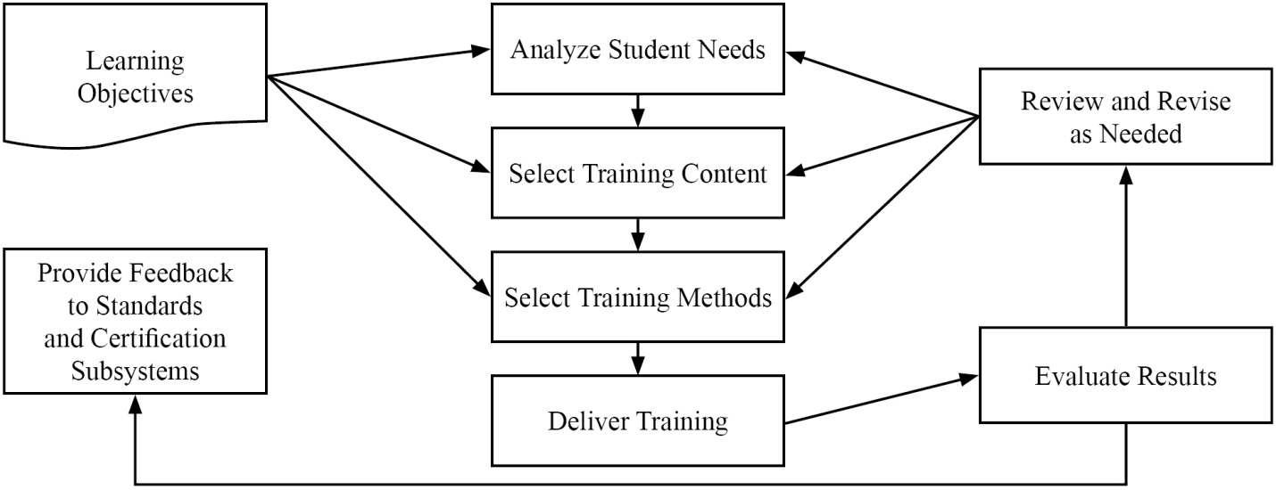

The chart below covers three levels of learning objectives and relates them to (1) the training activities most likely to be successful and (2) the best methods for assessing the success of the training. The curriculum segments state the learning objectives using verbs similar to those in the bottom row of the table. These drive both the training activities required to promote adult learning and the assessment tools appropriate to measure success at that level.
Assessments | Multiple Choice | Multiple Choice | Practical Examples Short Answer
Training Activities | Lecture  Videos  Examples | Discussion  Review  Learner  Presentation | Exercises  Simulations  Demonstrations
Cognitive Levels | Knowledge | Comprehensive | Application
 | Define  Relate  List | Restate  Discuss  Describe  Identify | Employ  Apply  Use  Illustrate

NIST, OWM has expressed strong interest in collaborating with NCWM in efforts to educate instructors in adult learning techniques and relating them to the learning objectives in NCWM curriculum. The Committee will be posting NIST, OWM material on converting technical content to training material on the PDC training resources webpages. The importance of pre-training analysis and post-training evaluation cannot be overestimated. Failure to include these steps often leads to failure of training efforts.
Professional Certification Program
Systems Approach to Training Evaluation
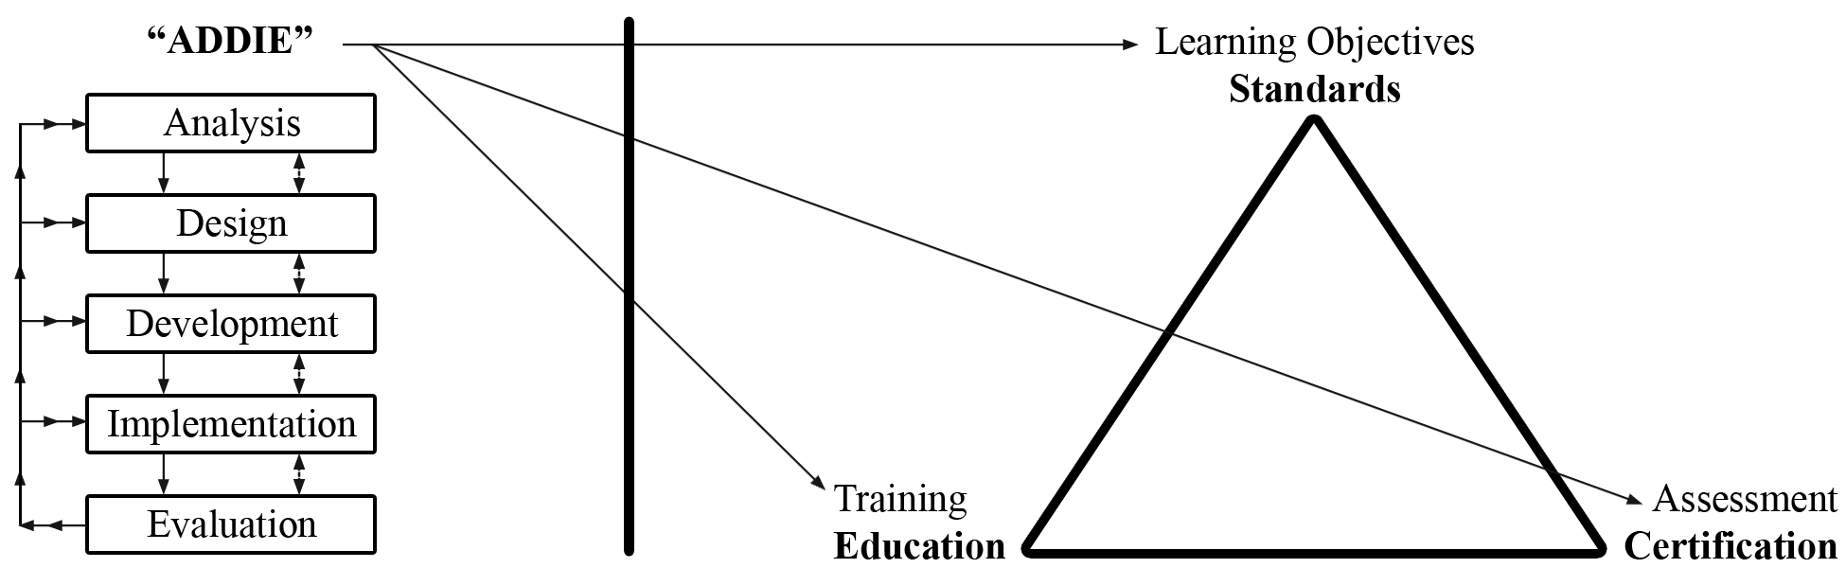
The Committee is calling on the states and other training developers to implement the Analysis, Design, Development, Implementation, and Evaluation (ADDIE) model in their training preparations and post training evaluation. Everyone needs to participate in the development of new BOK modules and then encourage their trainers to use existing BOK modules in their training plans.
The Committee encourages members to also look at the presentation on A Complete Training Program prepared by Ms. Carol, Hockert, NIST, OWM. The presentation outlines ways to develop training programs and improve instruction of weights and measures material. Contact Ms. Hockert for a copy.
2012 NCWM Interim Meeting: Advisors from NIST, OWM, reported that they are using NCWM BOK in preparing new training initiatives. They are stressing adult learning techniques, particularly focusing on the use of hands-on training as the most popular and effective training tool. This ties in closely with the new baseline competency exams discussed in Item 410-1. NIST, OWM is using these exams to ensure students in NIST sponsored training courses are competent in prerequisite course materials prior to taking training. They reported that they are already drafting questions for the baseline competency exams. They see significant efficiencies in using NCWM testing services for this purpose since they are already in place.
Ms. Hockert, NIST, OWM, recommended a basic math prerequisite for persons taking Metrology or other related weights and measures courses sponsored by NIST. The math exam would allow trainees to demonstrate entry level math skills and make the training process more efficient and effective. One official discussed the California licensing requirement of a college degree which requires a certain number of math courses and asked if this would satisfy the need for the math prerequisite. Several California officials expressed concern about the Professional Certification Program replacing existing state licensing programs, and if adopted, it might require amendment of existing state statutes. Because math competency is an essential skill for weights and measures work, the Committee recommends that the PDC include in its scope the development of an exam to demonstrate basic math competency before taking the Fundamentals of Metrology or other training courses at NIST.
2011 SWMA Annual Meeting: It was stated that we should consider training state trainers on adult learning techniques as well as subject matter. No further recommendations were made.
2012 NCWM Annual Meeting: The Committee stressed instructor improvement. The Committee reviewed the importance of using the NCWM learning objectives and the ADDIE model in training. This stresses the importance of training to the goals in the BOK and not training to pass the test. If the training is appropriate and has been delivered effectively, the employee should have no problem passing a fair exam. The end is not a certificate on the wall, but rather a competent inspector. In other words,
JOB SUCCESS = EXAM SUCCESS
Ms. Hockert stressed that good training requires a partnership between the trainee, trainer, and the supervisor. The Committee agrees that buy-in from all levels is critical to training success.
2012 CWMA Interim Meeting: The Committee recommended archiving most of the content in this item to the NCWM website as reference material.
2012 WWMA Annual Meeting: The Committee noted that it is in the best interest of NIST and NCWM that regional training efforts are of the highest quality and uniform throughout the United States. The Committee recommends the following:
- Regional trainers be selected as per the process agreed upon between NIST and NCWM;
- Regional trainers receive courses on adult learning techniques and converting technical information into training materials;
- Regional trainers be afforded the opportunity to shadow NIST trainers as they perform training in individual jurisdictions; and
- The use of funds from the Associate Membership Committee or the NIST Training Initiative Grant be made available for this purpose.
2012 NEWMA Interim Meeting: Members expressed interest in NIST Train-the-Trainer classes. A demonstration was provided on how to access materials for taking the Professional Certification Exams and then for taking the exams. The Committee encouraged those in attendance to seek certification of their inspectors.

This page intentionally left blank

