Grasp Strength

Metric
Grasp strength is a kinetic measure of the maximum force a robotic hand can impose on an object. This measure will yield information regarding a particular hand’s payload capabilities for various object sizes as well as its limits in resisting pulling or pushing forces during a grasp operation.

Dependencies
Grasp strength is a function of the hand’s actuator capabilities, motion controllers, mechanical design, grasp configuration, and object size.

Test Method
Artifact:
- Single axis load cells for one-dimensional force measurement ($F_{i}$ where $i=1, 2, …, n$ and $n$ is the total number of load cells)
- Split cylinder artifacts example (Figure 1)
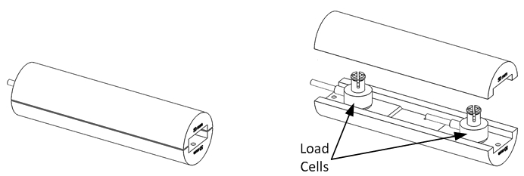
Figure 1: Split cylinder artifact fully assembled (left), and partially assembled to reveal load cells (right)

Description:
Of the previously listed dependencies, only the grasp configuration and object size are assumed controllable. For this particular test, two common grasp types are chosen for investigation – pinch and wrap. The pinch grasp allows for measuring performance associated with precision grasping while the wrap grasp allows for measuring performance associated with power grasping. Split cylinder artifacts of different diameters are used to measure the internal force transmission of a grasp. Multiple cylinder diameters should be used to create a spread of performance results. Two different split cylinder artifact orientations are used:

- In the 0 degree orientation, the load cell axis is parallel with the palm surface.
- In the 90 degree orientation, the load cell axis is perpendicular to the palm surface.

These orientations are shown in Figure 2. Taking force measurements in two orthogonal directions provides the necessary measurements to approximate a resultant internal force measurement since this artifact design only measures force in one direction.

For each cylinder diameter, fully close and open a wrap grasp around each artifact for both artifact orientations under maximum allowable power. Record force sensor data throughout the test.

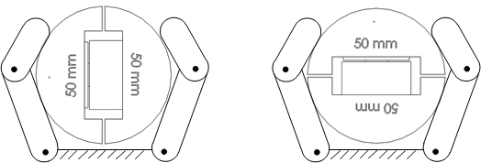

Figure 2: A shows the split cylinder artifact in the 0 and 90 degree orientations.

Performance Measures:
For each set of instantaneous force readings, add the forces across all load cells since they are in-line to yield a total grasp force$F_{total}$,
$$F_{total }= \sum_{i=1}^{n}{F_{i}}$$
Next, extract the quasi-static force for each grasp cycle (see Figure 3) for a particular artifact orientation and size. . Quasi-static grasp forces are chosen for evaluation as they remove impact effects and give a more accurate estimate of the true strength of the hand. Given these quasi-static grasp forces, compute the force mean and 95% confidence intervals for each artifact orientation (0 degrees and 90 degrees).

The final grasp force measure, $F_{grasp}$, is determined by computing the $L_{2}$ norm of the two means (one per orientation), the two lower bounds and two upper bounds of the confidence intervals. These values approximate the mean resultant internal force magnitude ($F_{grasp}$), and its uncertainty.

Note: the confidence interval is calculated separately on the 0 degrees and 90 degrees grasp forces, before computing the L₂ norm since the two data sets are independent test measures requiring repositioning of the split cylinder test artifact.

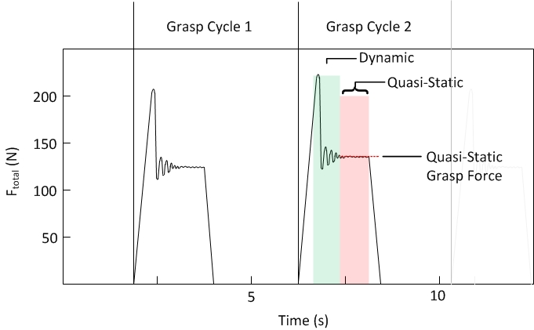
Figure 3: Depiction of dynamic and quasi-static force regions during grasp cycles.

Example Implementation
Test Setup:
Two different sized cylinders are chosen as a starting point to create a spread of performance results. Specifically, these cylinders were designed with 50 mm and 80 mm diameters that housed two single-axis load cells to capture internal force transmission by the grasp. Force data was captured from two load cells while fully opening and closing each robotic hand around each artifact 32 times for the 0 degree and 90 degree orientations. The test setup is shown in Figure 4.

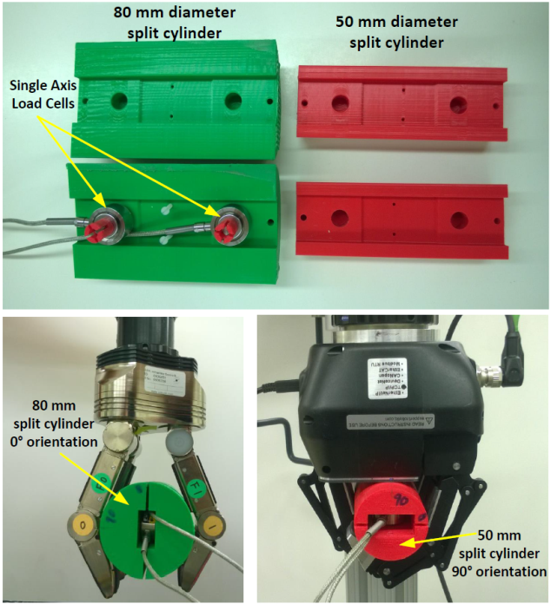
Figure 4: 80 mm and 50 mm diameter split cylinder configurations for determining grasp forces (top). Robotic hand performing wrap grasp on 80 mm split cylinder oriented at 0 degrees (bottom left). Robotic hand performing wrap grasp on 50 mm split cylinder oriented at 90 degrees (bottom right).

Results:
A data plot of $F_{total}$, the sum of the two load cells throughout the 32 grasp cycles, is shown in Figure 4. The mean quasi-static grasp forces were extracted for each data set. Next, the mean and 95% confidence intervals for the force data collected in both orientations (0 degrees and 90 degrees) and the $L_{2}$ norms are computed for both hands. The results are shown for Hand 1 and Hand 2 in Table 1.

Data:
Data File Archive: | Grasp Strength.zip
Data Files: | Hand 1/C[cylinder diameter]_[Orientation]
 | Hand 2/C[cylinder diameter]_[Orientation]
File Format: | ASCII, comma delimited
Data Values: | F₁ and F₂ (one set per line)
Units: | Newtons, Millimeter
Data Sample Rate: | 3 kHz
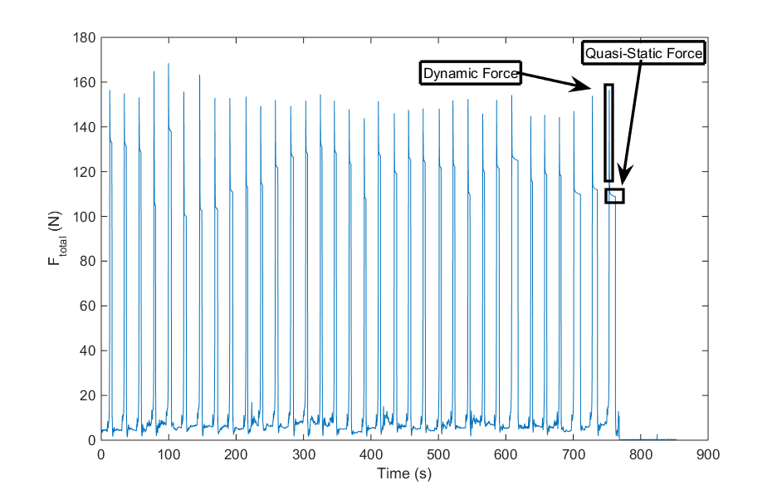
Figure 4. Shows the load cell force for Hand 2 wrap grasping the 50 mm cylinder in the 90 degree orientation.

Table 1. The mean and 95% confidence intervals of the internal grasp force for Hand 1 and Hand 2.
