Slip Resistance

Metric
Slip resistance is a kinetic measure of a robotic hand’s ability to resist slip. The focus of this metric is to investigate the inherent surface friction properties of the hand. With higher friction coefficients, robotic fingers will possess wider friction cones at the areas of contact with an object. This behavior would ultimately allow friction forces to contribute more greatly to the overall grasping effort yielding greater resistances to slipping, and generally enhanced energy efficiency during the grasping operation.

Dependencies
This characteristic is a function of the hand’s actuator capabilities, motion controllers, mechanical design, grasp configuration, object size, and object surface properties.

Test Method
Artifact:
- Standard ASTM D2665 PVC pipe segments
- Single axis load cell

Description:
Of the previously listed dependencies, only the grasp configuration, object size, and object surface properties are assumed controllable. Given this large performance search space, some variables are fixed to make testing more tractable while still providing useful results. Specifically, the wrap grasp on a cylindrical artifact was chosen to investigate slip resistance capabilities under maximum power and highest number of hand-object points of contact. Furthermore, use of a cylindrical shape under a wrap grasp eliminates the undesirable behavior of object-finger locking. ASTM D2665 PVC pipe is selected for the artifact for the following reasons: 1.) the cylindrical pipe comes in a variety of standard diameters with dimensions that are compatible with robotic hand volumetric capabilities, and 2.) the surface properties of these pipes are relatively consistent. The general setup for this test is shown in Figure 1.

Test Steps:
- Place a cylindrical artifact in the robotic hand using a wrap grasp at maximum power with the highest number of hand-object points of contact possible.
- Pull on the pipe at a controlled rate of increasing force, recording force until gross slipping is visually confirmed between the hand and PVC pipe.
- Repeat this process over a range of standard pipe diameters that the robotic hand is capable of grasping.

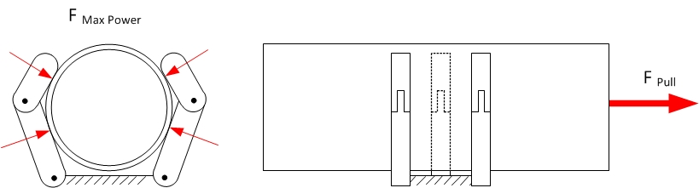

Figure 1: Test setup for slip resistance where a standard diameter of D2665 PVC pipe is placed in a wrap grasp at maximum hand power. The pipe is then pulled at an increasing force until slip is observed.

Performance Measures:
For each test cycle, record the pull force, $F_{pull}$, over time. The measure of interest in this test is the maximum obtainable pull force before gross slip of a given hand and pipe size under a full-force wrap grasp. Extract the maximum pull force, $F_{pull, max}$, from the force/time plot as shown in Figure 2. Calculate the mean and 95% confidence intervals for each pipe diameter size. Note that periodically during the pull force ascent, there are several instances of temporary “necking” or plateauing of pull force where micro-slipping is occurring in the grasp. We hypothesize that the object is leaving and entering new states of high grasp friction as the object “settles” within the grasp.

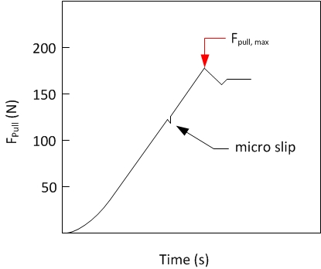
Figure 2: Depiction of $F_{pull, max}$ and micro-slip events

Example Implementation
Test Setup:
A test was conducted by commanding a fixed robotic hand to wrap around standard PVC waste pipe as shown in Figure 3. A linear drive provides a controllable pull force on the pipe when coupled with a cable and spring. The linear actuator is commanded to move at a constant velocity until gross slipping is visually confirmed between the hand and PVC pipe, and a peak force is shown by the load cell during data collection. This process is repeated 10 times for each robotic hand and four different cylinder diameters ranging from 2.54 cm to 10.16 cm.

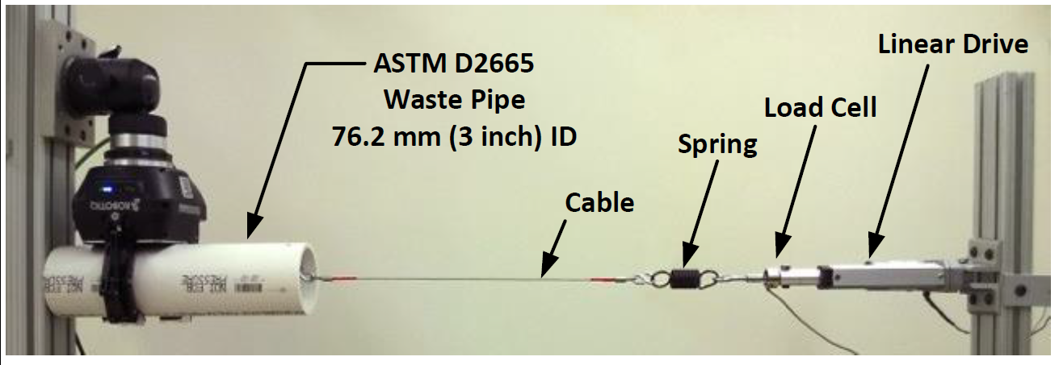
Figure 3. Slip resistance testing using a length of ASTM D2665 waste pipe. A linear drive attached to a cable provides incremental loading on the pipe. The load rate is decreased using an in-line spring and force is recorded using a single-axis load cell.

Results:
The measure of interest in this test is the maximum obtainable pull force for a given hand and pipe size under a full-force wrap grasp. The common trend in this test was that the pull force increased mostly linearly before reaching a peak force, and then subsequently yielded a drop in pull force (see Figure 4). This drop after the peak force indicates a shift from static Coulomb friction to dynamic Coulomb friction. After 10 test runs were conducted across both hands, and 4 different pipe diameters, the relevant data was extracted and calculated. The results for both hands across all pipe diameters tested are shown in Figure 5.

Data:
Data File Archive: | Slip Resistance.zip
Data Files: | Hand 1/C[cylinder ID]_[test run number]
 | Hand 2/C[cylinder ID]_[test run number]
Cylinder ID:  (Inside Diameter) | C1 = 25.4 mm (1.0 inches)  C2 = 50.8 mm (2.0 inches)  C3 = 76.2 mm (3.0 inches)  C4 = 101.6 mm (4.0 inches)
File Format: | ASCII, comma delimited
Data Values: | $F_{pull}$ (one per line)
Units: | Newtons, Millimeters
Data Sample Rate: | 3 kHz

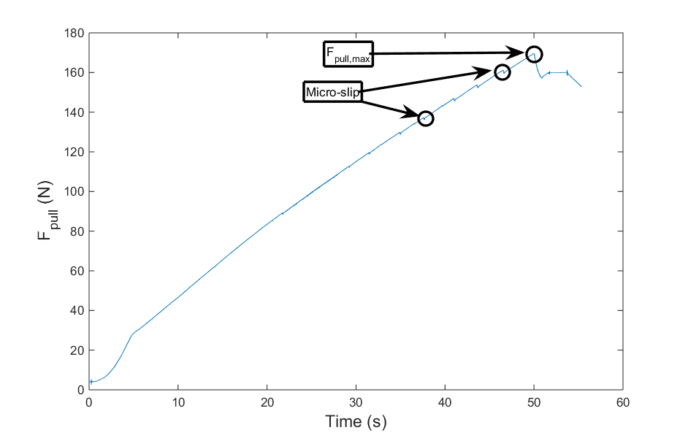
Figure 4. Shows the typical pull force profile as a function of time for Hand 2 and PVC pipe diameter of 7.62 cm.

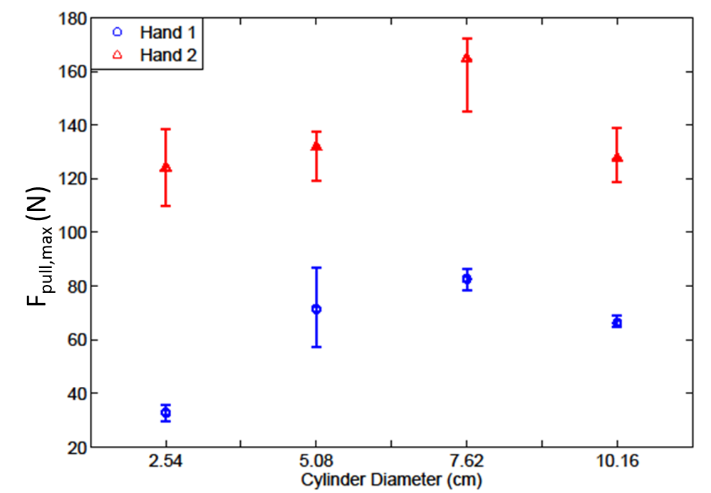
Figure 5. The maximum pull force achieved by each hand across several PVC pipes of diameters ranging from 2.54 cm to 10.16 cm (1 inches to 4 inches).

