Finger Force Tracking

Metric
Finger force tracking is a kinetic measure regarding the finger’s ability to impose desired contact forces on its environment. This capability is particularly important for many state-of-the-art robotic grasping and manipulation control algorithms that use force-based control approaches. Moreover, this capability can be used for touch-based grasp planning, controlled interaction for texture discrimination and object localization.

Dependencies
This characteristic is a function of the hand’s actuator capabilities, tactile sensor calibration, motion and force controllers, control and sensing bandwidth, mechanical design, finger-artifact configuration, and the parameters of the selected contact force trajectory.

Test Method
Apparatus:
Three axis load cell ($F_{x}$, $F_{y}$, $F_{z}$) or single axis load cell.
Object of desired geometry attached to load cell.

Description:
This test method seeks to capture the force tracking performance of an individual finger of a robotic hand. Of the previously listed dependencies, only the finger-artifact configuration and the parameters of the desired contact force profile are assumed controllable. The test begins by commanding the finger under test to track a desired force profile by making contact with an artifact attached to a reference load cell. The parameters of this desired force profile can vary in contact force directionality as well as magnitude. In addition, the finger-artifact configuration can also be varied to test performance for different contact scenarios. During the test, the desired force profile ($F_{d}∈R^{3x1}$), the contact forces measured by the finger sensor ($F_{S}∈R^{3x1}$), and the contact forces measured by the load cell ($F_{L}∈R^{3x1}$) are all recorded for extracting performance measures. This test assesses the total force tracking performance, and the controller force tracking performance. In the former, the desired profile data is compared to the reference force sensor data to establish real-world force tracking performance. In the latter, the desired profile data is compared to the hand sensor data to establish only the controller force tracking performance. For both of these considerations, the following performance measures are extracted.

Performance Measures:
- Force Magnitude: Calculate the Root Mean Squared Error (RMSE) between the desired force magnitudes ($\left\|F_{d}\right\|∈R$) and those measured by either the reference force sensor ($\left\|F_{L}\right\|∈R$) or hand sensor ($\left\|F_{S}\right\|∈R$) for all data collected. In the case of a single axis load cell, the sensor force should be applied along the load cell axis.
- Force Direction: Compute the RMSE between the desired force direction (${\hat{F}}_{d}∈R^{3x1}$) and the direction as measured by the external load cell (${\hat{F}}_{L}∈R^{3x1}$) or hand sensor (${\hat{F}}_{S}∈R^{3x1}$). This measure has three dimensions (one for each axis) and therefore requires the use of a three axis load cell. Note: Only performed on robotic hands with sufficient degrees of freedom.
- Force Peak Overshoot: Calculate the peak overshoot ($F_{peak}∈R$) between the desired contact force magnitude and the contact force magnitude as measured by the reference sensor or hand sensor. This measure will give an upper bound to the finger’s control response.

Example Implementation

Test Setup:
In order to extract force tracking performance, each finger for each robotic hand is commanded to exert a specified force profile onto an artifact mounted to an external force sensor (in this case, 6-axis load cell) as shown in Figure 1 below. In the case of this experimentation, four distinct forces profile magnitudes were prescribed for testing. Three were fixed-force profiles of 1N, $\frac{\left\|F_{finger, max}\right\|}{2}$ N, and $\left\|F_{finger, max}\right\|$ N where $F_{finger,max}$ is the maximum finger force capability as determined in the previous test for finger strength. The final force profile was time-varying in nature with two frequencies and varying amplitudes defined by

$$\left\|F_{d}\right\|=5log\left(sin\left(\frac{π\left(t+3\right)}{2}\right)+cos\left(\frac{t}{4}+π\right)+3\right)+1$$

This equation is purposefully scaled in magnitude to remain within the maximum force strength capabilities of the robotic hand under test. The direction of all force profile magnitudes were vertically downward into the artifact mounted to the force sensor (see Figure 1). Different force profiles will be added and tested in the future.

The test is performed on two hand configuration; Hand 1, a robotic hand platform retrofitted with resistance based fingertip sensors, and Hand 1, the same robotic hand platform retrofitted with impedance based fingertip sensors, and Hand 2 which uses current sensing. The test begins by positioning either Hand 1 or Hand 2 such that the palm is parallel to the vertical axis of the artifact. Next, the finger under test was placed in a configuration of maximum manipulability with the fingertip parallel to and offset by approximately 1 cm from the artifact surface. For Hand 1, the maximum manipulability finger pose resulted in joint angles of -45 degrees for the first joint, and 45 degrees for the second joint. Since Hand 2 is underactuated and possesses only one degree of freedom per finger, the specification of joint angles for maximum manipulability is not relevant. Different finger-artifact configurations will be added and tested in the future.
Each finger was then commanded to track the desired force profile, and the contact forces were measured using the external force sensor. Since Hand 1 exhibited continuous force tracking control capability, it was tasked with tracking the desired for profile for 60 seconds. Since Hand 2 used a simpler stop-and-hold strategy upon achieving the desired force, it was tasked to cyclically achieve the desired force by lifting off and making contact again, a process that was repeated 10 times for each finger. For both hands, the force profile was used to generate a mean performance and its uncertainty measures.

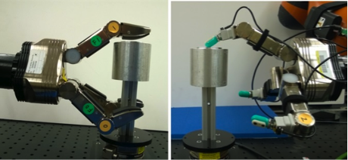
Figure 1. Test setup for finger force tracking: Hand 1 with resistance based fingertip sensors (left), Hand 2 with impedance based fingertip sensors (right).

Results:
The three performance measures were extracted from the collected data that concern the total force tracking performance (controller performance will be added in the future). First, the Root Mean Squared Error (RMSE) was calculated between the desired force magnitudes and those measured by the reference force sensor for all data collected (see Figure 2 for example visualization of force controller results). This measure gives an indication of how well the fingers impart desired contact force magnitudes. Second, the RMSE between the desired force direction and measured contact force direction is calculated. This measure has three dimensions (one for each axis). Lastly, peak overshoot, a measure often used to indicate controller performance, is calculated between the desired contact force magnitude and the measured contact force magnitude. Results for Hand 1 and Hand 2 are shown in Table 1. The lower the RMSE reported values, the closer the hand was to imparting the pre-defined force profile. The lower the peak overshoot, the lower the maximum error between the desired and imparted forces. Hand 2 is under-actuated and therefore does have any reportable measures for RMSE for the force control directions.

Data:
Data File Archive: | Finger Force Tracking.zip
Data Files: | Hand 1 Impedance/Set Point/Finger[No.]_[File Type.]_ [Magnitude]N  Hand 1 Impedance/Time Varying/Finger[No.]_[File Type.]
Hand 1 Resistance/Set Point/Finger[No.]_[File Type]_ [Magnitude]N
Hand 1 Resistance/Time Varying/Finger[No.]_[File Type]
Hand 2/Set Point/Finger[No.]_[File Type]_[Magnitude]N
File Type: | LoadCell - reference load cell  Impedance - impedance contact sensing  Resistance - resistance contact sensing
File Format: | ASCII, comma delimited
Data Values: | $F_{x}$, $F_{y}$, $F_{z}$ (one set per line)
Units: | Newtons
Data Sample Rate: | 3 kHz
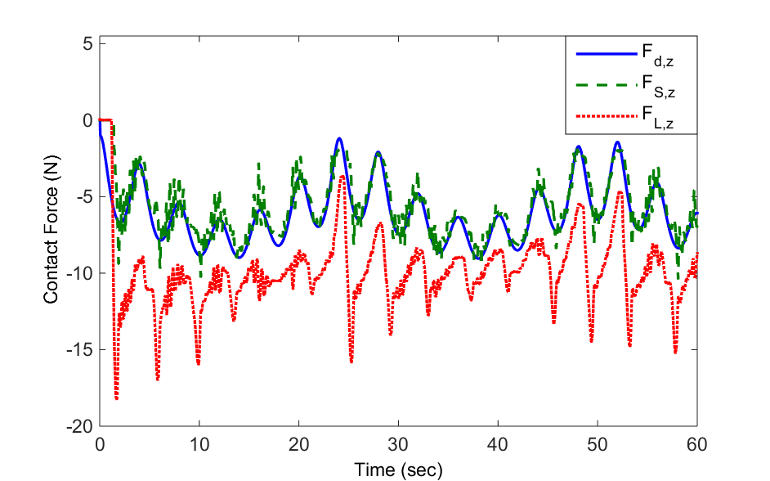
Figure 2. The desired force profile ($F_{d,Z}$), the contact force as sensed by the onboard sensor ($F_{S,Z}$), and the contact force as sensed by an external load cell ($F_{L,Z}$) for Hand 1, finger 2 with resistance sensing.

Table 1. Shows the various force tracking performance errors for the three force-controlled hand layouts.
