Appendix A
NTEP Statistics Report
General NTEP Statistics | Last Year | This Year | Grand Total
 | 10/01/11 –  6/30/12 | 10/01/12 – 6/30/13 | 10/1/00 – 6/30/13
Total Applications Processed | (21) 204 | (8) 185 | (152) 3216
Applications Completed | 210 | 194 | 3080
New Certificates Issued | 195 | 193 | 2788
Active NTEP Certificates on 3/31/2012 | 1896 | 1977
( ) = Reactivations
Assignments to Labs per Year | 10/1/11 –  9/30/12 | 10/1/12 –  6/30/13 | 10/1/00 – 6/30/13
California | 27 | 33 | (16) 441
Canada | 7 | 1 | (4) 44
GIPSA-DC | 1 | 1 | 17
GIPSA-KC | 10 | 6 | 93
Kansas | 2 | 0 | (9) 70
Maryland | (9) 61 | (6) 33 | (43) 401
New York | 2 | (1) 7 | (18) 170
NIST Force Group | 6 | 1 | (1) 89
North Carolina | 13 | 6 | (4) 118
Ohio | (13) 53 | 43 | (28) 820
NTEP Staff | (1) 92 | (2) 35 | (12) 875
Applications Not Yet Assigned to a Lab |  |  | 3
( ) = Reassignments from another lab
Process Statistics |  | 2012 - 2013 | 2000 - 2013
Average Time to Assign an Evaluation |  | 4 Days | 9 Days
Average Time to Complete an Evaluation |  |  | 137 Days

Report on Evaluations in Progress
Evaluations in Progress | 0-3 Months | 3-6 Months | 6-9 Months | 9-12 Months | Over 1 Year | Total
June 2009 | 48 | 27 | 17 | 12 | 29 | 133
October 2009 | 41 | 33 | 18 | 12 | 33 | 137
December 2009 | 45 | 30 | 22 | 12 | 28 | 137
March 31, 2010 | 24 | 20 | 18 | 19 | 23 | 104
June 30, 2010 | 37 | 12 | 11 | 13 | 24 | 97
October 30, 2010 | 40 | 30 | 8 | 8 | 20 | 106
December 31, 2010 | 39 | 25 | 22 | 5 | 20 | 111
March 31, 2011 | 37 | 27 | 13 | 19 | 17 | 107
June 30, 2011 | 47 | 20 | 7 | 7 | 21 | 102
September 30, 2011 | 42 | 28 | 11 | 5 | 19 | 105
December 31, 2011 | 37 | 19 | 23 | 5 | 17 | 101
March 31, 2012 | 40 | 17 | 7 | 21 | 14 | 99
June 30, 2012 | 41 | 21 | 10 | 6 | 20 | 98
September 30, 2012 | 50 | 30 | 15 | 7 | 19 | 121
December 31, 2012 | 32 | 24 | 17 | 7 | 18 | 98
March 31, 2012 | 36 | 12 | 14 | 12 | 18 | 92
June 30, 2013 | 53 | 18 | 6 | 6 | 19 | 102
In Progress by Lab | 0-3 Months | 3-6 Months | 6-9 Months | 9-12 Months | Over 1 Year | Total
California | 18 | 1 | 2 | 1 | 4 | 26
Canada | 0 | 0 | 0 | 0 | 0 | 0
GIPSA-DC | 0 | 0 | 0 | 0 | 1 | 1
GIPSA-KC | 6 | 0 | 0 | 0 | 1 | 7
Maryland | 8 | 3 | 0 | 2 | 3 | 16
New York | 2 | 1 | 0 | 0 | 0 | 3
NIST Force Group | 0 | 0 | 0 | 0 | 4 | 4
North Carolina | 2 | 2 | 0 | 0 | 2 | 6
Ohio | 10 | 10 | 4 | 3 | 4 | 31
NTEP Staff | 3 | 1 | 0 | 0 | 0 | 4
Unassigned | 4 | 0 | 0 | 0 | 0 | 4
 |  |  |  | Total Pending: |  | 102

Report on Applications Received by Quarter
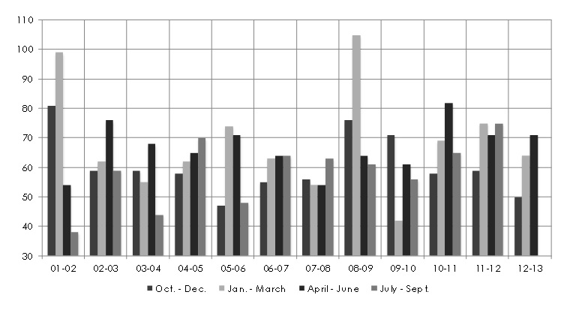
NTEP 2013 Final Report
Appendix A – NTEP Statistics Report

 | 01-02 | 02-03 |  |  | 03-04 | 04-05 |  | 05-06 | 06-07 | 07-08 |  |  | 08-09 |  | 09-10 | 10-11 |  | 11-12 |  | 12-13
Oct – Dec | 81 |  | 59 | 59 |  | 58 |  | 47 | 55 |  | 56 | 76 |  | 71 |  |  | 58 | 59 | 50
Jan – Mar | 99 |  | 62 | 55 |  | 62 |  | 74 | 63 |  | 54 | 105 |  | 42 |  |  | 69 | 75 | 64
Apr – Jun | 54 |  | 76 | 68 |  | 65 |  | 71 | 64 |  | 54 | 64 |  | 61 |  |  | 82 | 71 | 71
Jul - Sep | 38 |  | 59 | 44 |  | 70 |  | 48 | 64 |  | 63 | 61 |  | 56 |  |  | 65 | 75
Total | 272 |  | 256 | 226 |  | 255 |  | 240 | 246 |  | 227 | 306 |  | 230 |  |  | 274 | 280 | 185
Average Per Quarter Overall: 63.8
Average Per Quarter This FY: 61.7

NTEP 2013 Final Report
Appendix A – NTEP Statistics Report

THIS PAGE INTENTIONALLY LEFT BLANK

