Appendix K
National Pasta Association (NPA)
Proposal to Establish a Moisture Allowance for Pasta Products

THIS PAGE INTENTIONALLY LEFT BLANK
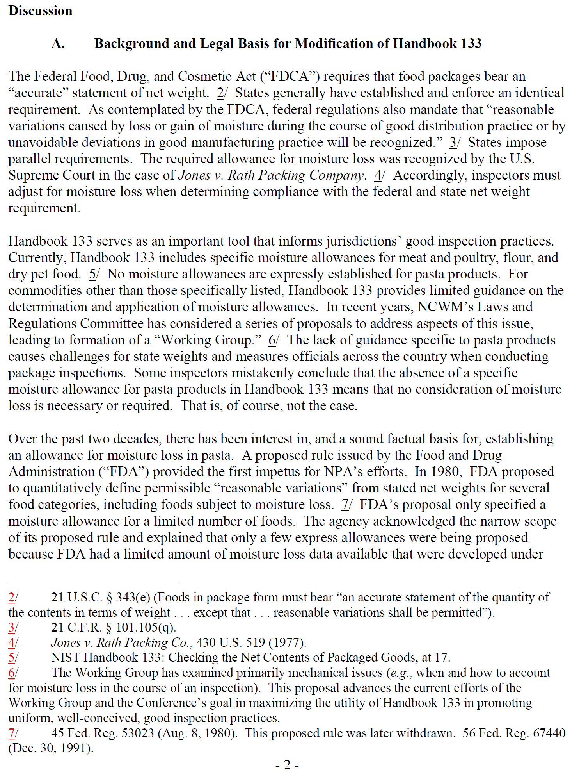

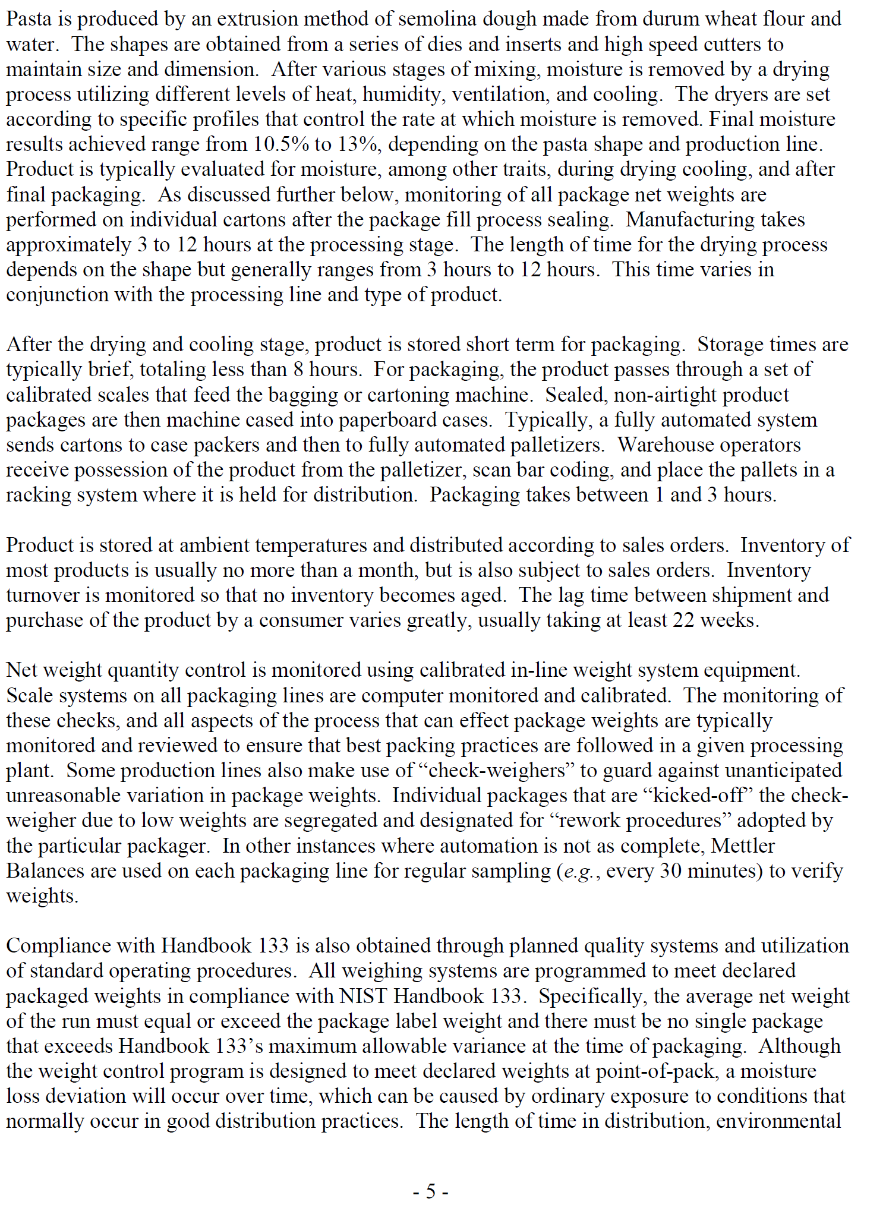
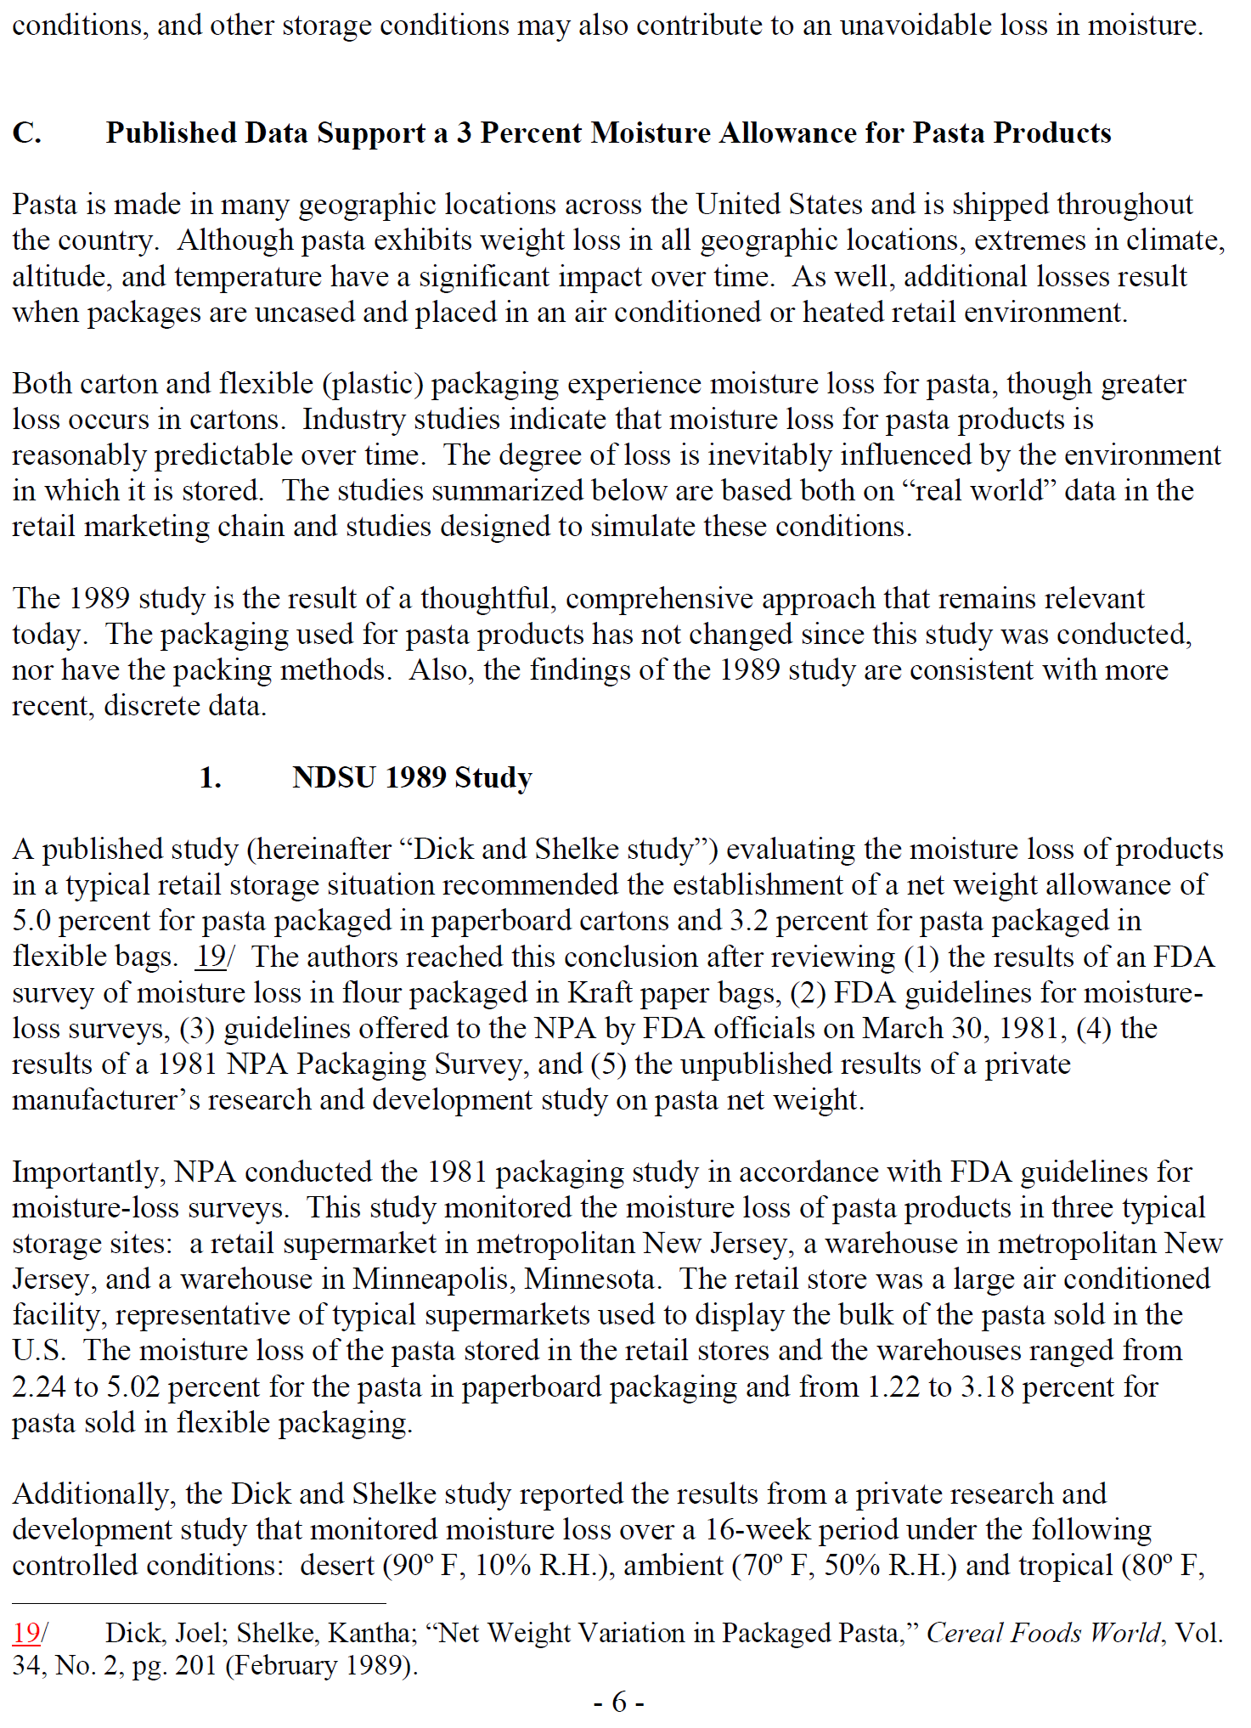
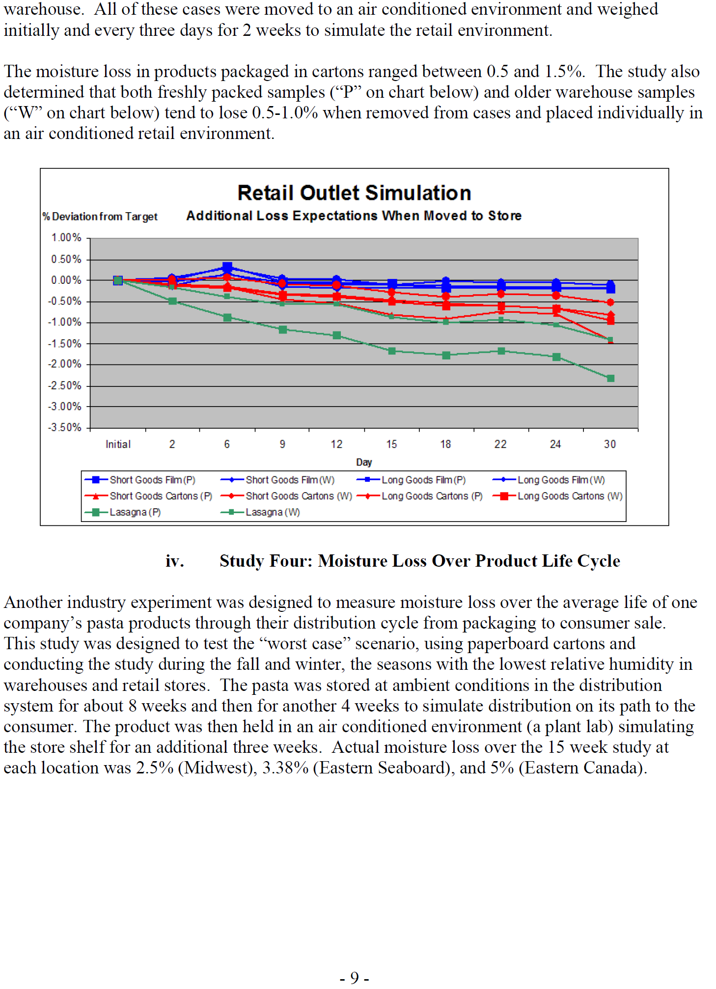
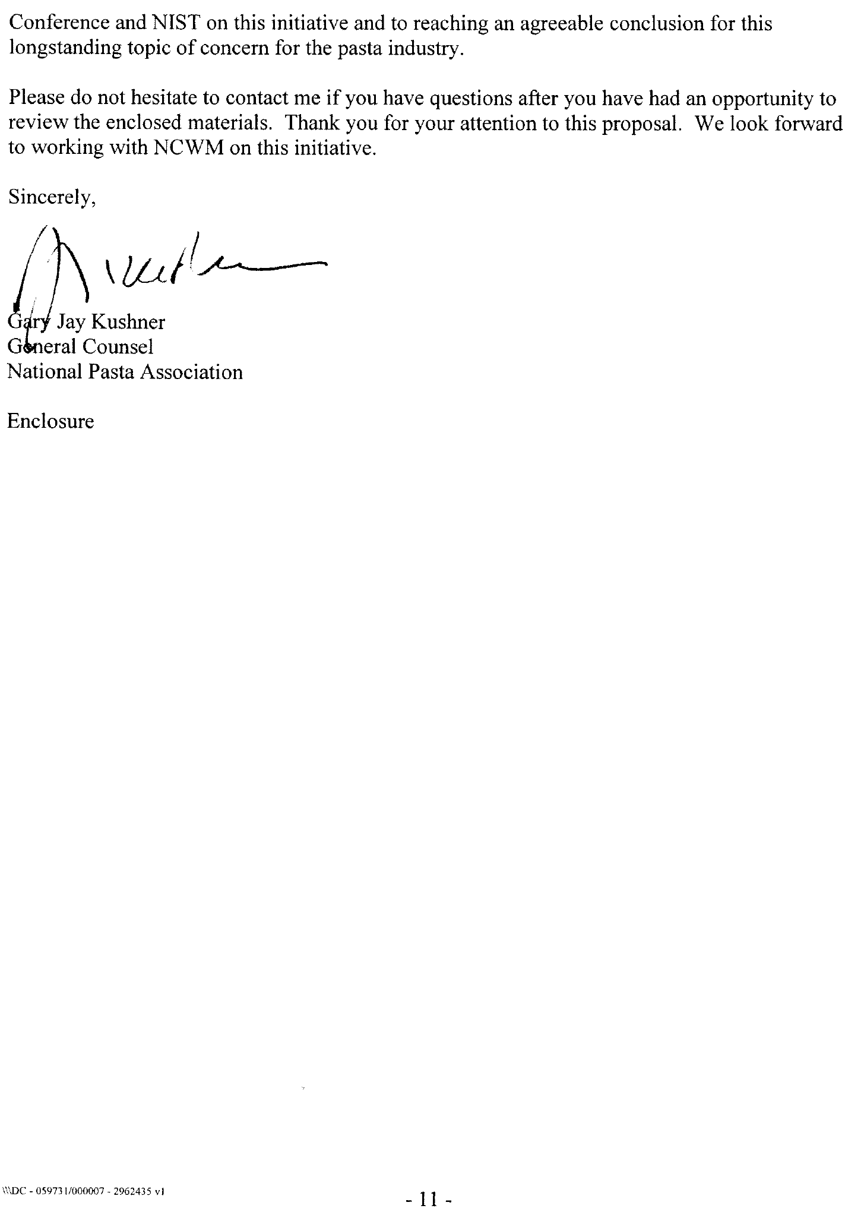

THIS PAGE INTENTIONALLY LEFT BLANK

THIS PAGE INTENTIONALLY LEFT BLANK

