Appendix I

Polyethylene Sheeting

Table of Contents
Page
Berry Plastics Corporation I3
Sigma Stretch Film I5

This page intentionally left blank
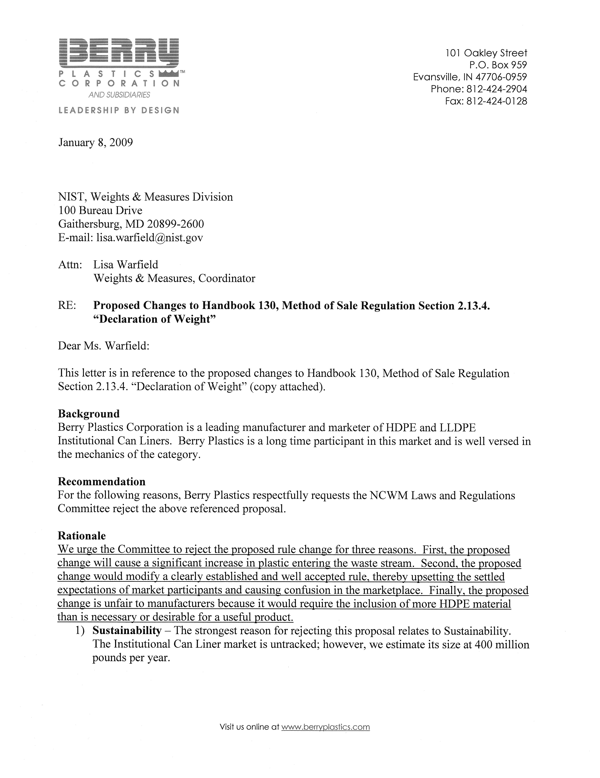
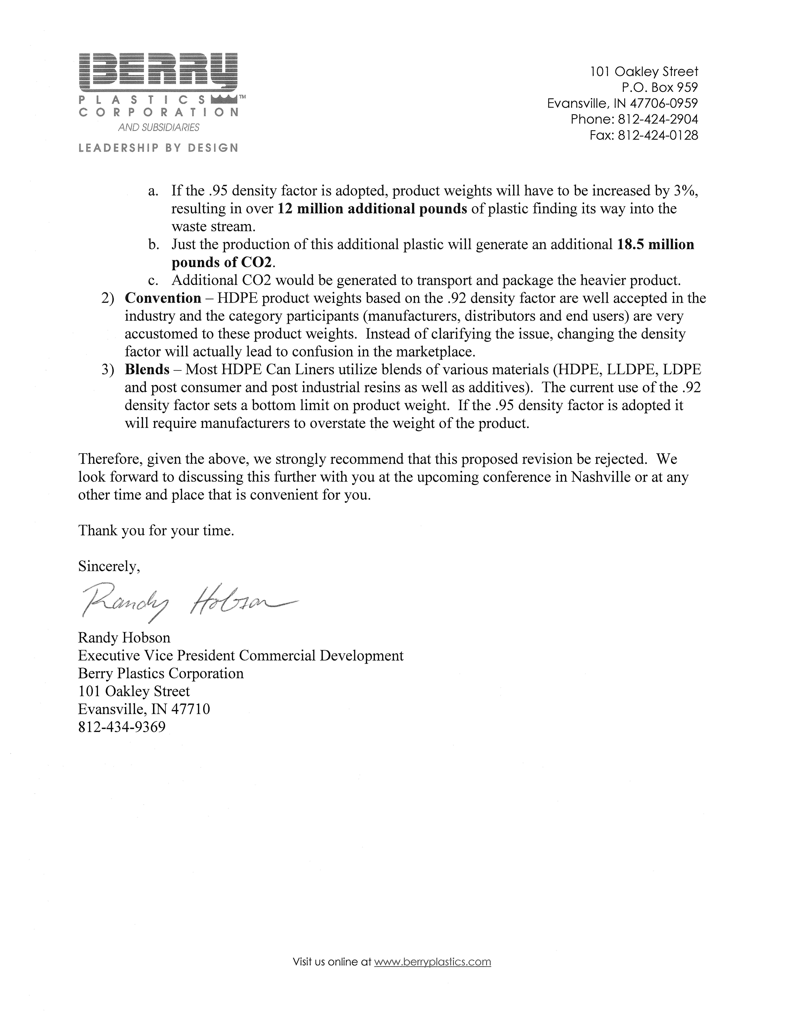
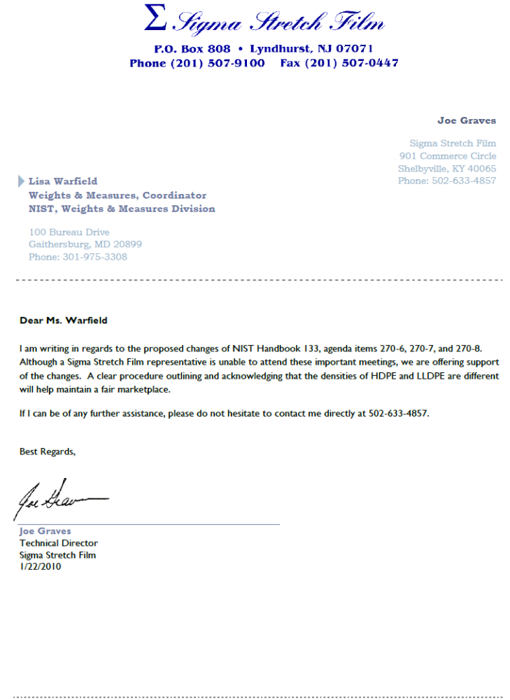

This page intentionally left blank

