Report of the

Professional Development Committee (PDC)

Ross Andersen, Chairman
New York Weights and Measures
Albany, New York

Reference
Key Number

INTRODUCTION

This is the report of the Professional Development Committee (hereinafter referred to as the “Committee” or PDC) for the 95th Annual Meeting of the National Conference on Weights and Measures (NCWM). This report is based on the Interim Report offered in the NCWM Publication 16, testimony heard at public hearings, comments received from the regional weights and measures associations and other parties, the addendum sheets issued at the Annual Meeting, and actions taken by the membership at the voting session of the Annual Meeting. The informational items presented below were adopted as presented when the Committee’s report was approved.

Table A identifies the agenda items in the Report by Reference Key Number, Item Title, and Page Number. Item numbers are those assigned in the Interim Meeting agenda. A Voting item is indicated with a “V” after the item number. An item marked with an “I” after the reference key number is an Information item. An item marked with a “D” after the reference key number is a Developing item. The developing designation indicates an item has merit; however, the item was returned to the submitter for further development before any action can be taken at the national level. Table B lists the appendices to the report.

Table A
Index to Reference Key Items
Reference
Key Number Title of Item Page
400 INTRODUCTION 1
401 EDUCATION 2
401-1 I National Certification Program (NCP) 2
401-2 D Instructor Improvement 6
401-3 I Recommended Topics for Conference Training 8
402 PROGRAM MANAGEMENT 9
402-1 I Safety Awareness 9
402-2 I PDC Publication 9

Table B
Appendices
Appendix Title Page

A NCWM National Certification Program, NCWM Curriculum Work Plan – January 2010 A1
B NCWM National Training Program, Certification Discipline for Retail Motor Fuel Devices (RMFD) Beta
Exam – February 2010 B1
C NCWM National Training Program, Instructions for On-Line Certification Examinations – Beta Exam C1

Table C
Voting Results
Reference Key Number |  | House of State Representatives |  |  | House of Delegates |  | Results
 |  | Yeas |  | Nays | Yeas | Nays
 | No Voting items

Details of All Items
(In Order by Reference Key Number)

401 EDUCATION

401-1 I National Certification Program (NCP)

Source: Carryover Item 401-1. (This item originated from the Committee and first appeared on its agenda in 2003.) The Committee has combined items previously numbered as 401-1 National Certification Program (NCP), 401-2 Create a Curriculum Plan, and 401-4 Certification into one item covering all aspects of the Certification Program.

Background/Discussion: For complete background information, see the PDC page or the PDC Meeting archives on the NCWM website (www.ncwm.net), or the previous Committee reports available from the National Institute of Standards and Technology (NIST) website (www.nist.gov/pml/wmd/index.cfm).

The Committee set a goal at the 2009 Annual Meeting to conduct an on-line beta test on the retail motor fuel curriculum. The beta test is completed and the results reviewed and analyzed.

Results:

- 63 took exam/43 completed exam/20 timed out and did not receive a score.
- 6 passed with passing set at 85 %.
- 20 would have passed if passing was set at 75 %.
- 27 would have passed if passing was set at 70 %.
What did the results show about the exam process itself?

- The settings of the service caused a large number of people to time out. Each section of the test was timed. Any remaining time from one section could not be added to the next sections, but the instructions did not make that clear to the candidates. In addition, if candidates timed out in the first section, they were not allowed to continue to the other sections. The NCWM staff has corrected this. In the future, if a candidate times out on a section, the candidate will progress to the next section or the test will end. The candidate will receive the score for all questions answered correctly.

- Some candidates had web navigation issues. It was difficult or impossible to use an electronic version of Handbook 44 as a reference while taking the test. Reviewing past answers was cumbersome because the candidates were required to page back question by question. There is no solution for this as this is the way the testing service operates. Candidates should consider using a hardcopy of Handbook 44 when taking the test.

- The illustration graphic quality needs improvement. Every effort will be made to provide quality graphics in the first case and to improve graphics where test results show that improvements are necessary.

- The grading of short answer questions was very intolerant of variations like capitalization and punctuation. The Committee believes that short answer questions are necessary to test for the ability to apply code requirements. To help in this regard, the Committee is working on improved instruction on how to take the test. A sample test, which will not be timed or graded, may be built into the test itself. The Committee is also looking at using a pull-down help feature on some questions to aid the candidate in properly formatting the answers.

- Some candidates could not see the entire question without scrolling down. Others experienced difficulty seeing the graphics. These problems are related to the candidates’ computer settings and can be corrected by changing the screen resolution, or by using the zoom function on the bottom of the Internet browser. The graphics can be seen by adjusting the candidates’ browser security settings. The Committee thinks that the sample test can be designed so that the candidate discovers these problems before getting to the real test. The candidate will then have the opportunity to leave the exam and make the needed setting changes or consult with the information technology (IT) department as needed. In addition, a guide to taking the NCWM certification tests could be written addressing frequently asked questions (FAQs) that arise out of taking the tests.

What did the results show about the exam content?

- The Committee analyzed the scoring versus the elapsed time on each section and found that 16 of the 20 people, who timed out on the test, did so on the first section relating to general Handbook 44 questions. Three people timed out in the general liquid measuring section, and only one person timed out on the retail motor fuel device (RMFD) section. The Committee will be adjusting the timing by taking five minutes off the RMFD section, and adding it to the Handbook 44 section. The Committee also expects that timeout problems will decrease as candidates become accustomed to taking tests with timed sections.

- Questions with high error rates and low average times were identified as problem questions. People thought they knew the answers as evidenced by the quickness of their responses, but the error rate indicates that something is potentially wrong with those questions. Questions with high error rates and long response times will also be subject to review to determine whether they exceed the learning objectives.

- Ms. Georgia Harris, NIST Weights and Measures Division (WMD), assisted the Committee with information on International Organization for Standardization (ISO) 17204, which is the ISO guide for certification bodies. One component of this guide is analysis of the cut score that defines the passing grade. A wealth of information exists on setting the cut score to define the minimally competent person. The competent group includes individuals at the basic, proficient, and advanced levels. The Committee wants to ensure that the candidate at the bottom of the basically competent group has a reasonable chance of passing the test. Based upon the results of the beta test, the Committee thinks that the cut score for the RMFD test should be set at either 70 % or 75 %.

- Future tests will require similar question evaluation and cut score analyses that will require staff resources to coordinate the review of questions and tests.

What did the result show about the Committee’s plan for certification?

The low passing rate may indicate that the parts of the system were not working together. It is important that users of the NCWM Certification Program understand how the pieces fit together and form a coherent system. To illustrate the relationships, we can describe the system as a triangle of interdependent parts (see diagram below). The standards come in the form of goals with measureable learning objectives. The education section involves training provided to help the candidate reach the desired level of proficiency for each of the learning objectives. The certification involves an assessment of proficiency that measures whether or not the objectives have been met.

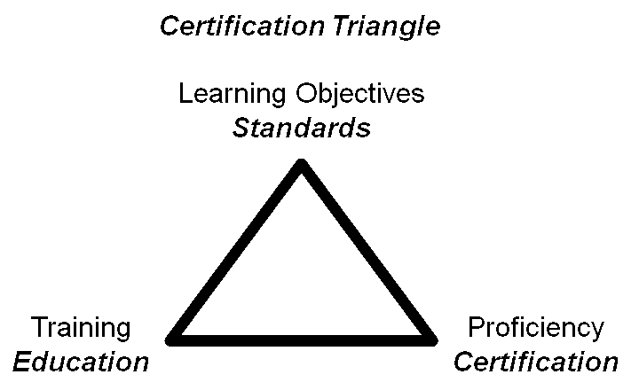

Until now, the Committee has focused attention on the standards and the certification pieces in the triangle, as illustrated in the flowcharts below.

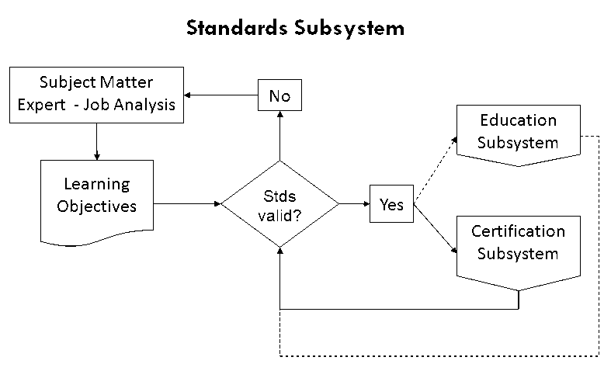

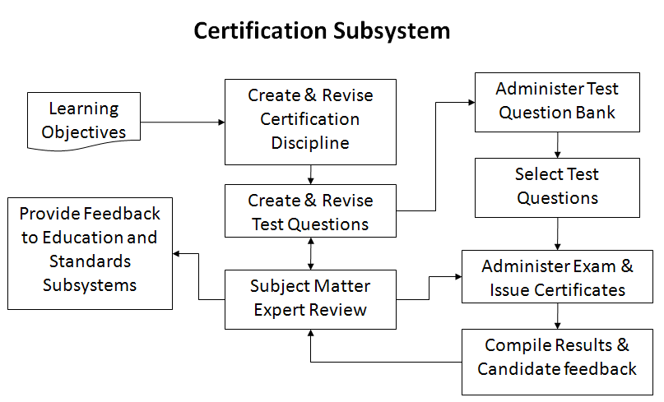

The Committee has described this work in a number of documents available on the PDC pages of the NCWM website:

- the Curriculum Outline, which breaks the profession of Weights and Measures into component parts called curriculum segments;

- the Core Competency Model, which explains how to create the curriculum segments as learning goals with measureable learning objectives or milestones;

- the Curriculum Segments that have been developed; and

- the Certification Disciplines, which identify the areas of certification offered and the Curriculum Segments on which the exam will be based.

Results of the beta test indicate that as the program moves forward, it will be very important that trainers integrate the learning objectives into their materials and design courses in such a way that students will achieve the desired levels of learning. See Item 401-2 Instructor Improvement.

What will happen next?

The PDC will adjust the timing allocation on the test, will review and fix the problem questions, develop the practice test, and set the cut score. The NCWM board will be continuing to develop the infrastructure to manage the Certification Program.

Discussion: Comments were heard from the regulatory sector noting that the average score was 72 %, but the test takers were most likely the cream of the crop of the regulatory agencies. Therefore, the test may not be a basic test even if the bar is lowered to 72 %. Concern was expressed that the cut score not be set so high that the test would not be useful for service agent certification. The necessity of short answer questions on a basic test was questioned. The speaker thought that making sure that the test is really a basic test was more important than rushing the test into production by an August 1, 2010, deadline.

A beta test taker found that the timing element was intimidating, and questioned whether the test itself might be more useful as a learning tool than as a certification tool. He suggested candidates be allowed to take the test together and discuss the questions. The Committee agrees that collaborative work would be an excellent training technique, but certification must be done individually.

An associate member indicated that there is a lot of interest in using the test at the associate level. The speaker echoed the regulatory member’s concerns that the quality of the people taking the test was in the upper 20 % and that if service people had taken this test the passing level would have been much lower.

The Committee plans to ask the people who took the beta test to be among the first people to take the official version, so that we can measure improvement in the test.

401-2 D Instructor Improvement

Source: Carryover Item 401-3 (This item originated from the Committee and first appeared on its agenda in 2003.)

Background/Discussion: The Committee is charged with the coordination of activities to improve the competence of instructors and the uniformity of delivery of the curriculum. For complete background information, see the PDC pages of the NCWM website (www.ncwm.net). After logging in under the members’ area, look under the PDC Legacy Documents for the PDC Formal Scope.

Industry has continued to support and sponsor training on their new technology for weighing and measuring devices. NIST has assured the Committee that work will continue towards providing technical training for the trainers. The Committee supports the recommendation from the WWMA to encourage jurisdictions to participate in the NIST, WMD Instructor Training program as those classes become available.

At the NCWM 2009 Interim Meeting, a work group from the NCWM Board of Directores (BOD) provided information to the Committee on initiatives it was considering to use the NCWM website to provide training materials and other trainer aids, such as presentations, videos, etc. The Committee applauds and supports the BOD’s efforts. However, the Committee will continue to maintain this item as low priority until other parts of the Certification Program are completed.

At the 2009 Annual Meeting and 2010 Interim Meeting, the Committee reported that no action is being taken on this item while the Committee concentrates on curriculum development and the establishment of the Certification Program.

Prior to the 2010 open hearing, Ms. Harris, NIST WMD, provided the Committee with reference material on teaching methods and assessment of training success. Distilling the essence of these materials, the Committee feels that instructors need training in more than just the technical material; they need training in setting the learning objectives, developing the training materials with those objectives in mind, selecting training methods that incorporate adult learning styles, and evaluating the effectiveness of their training.

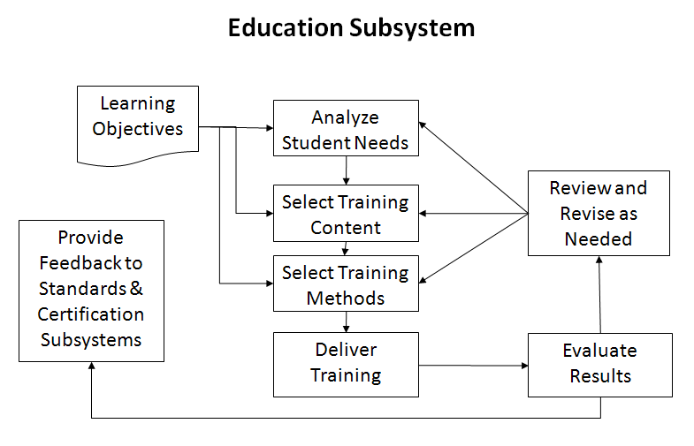

The chart below covers three levels of learning objectives and relates them to the training activities most likely to be successful and best methods for assessing the success of the training. The curriculum segments state the learning objectives using verbs similar to those in the bottom row of the table. These drive both the training activities required to promote adult learning and the assessment tools appropriate to measure success at that level.

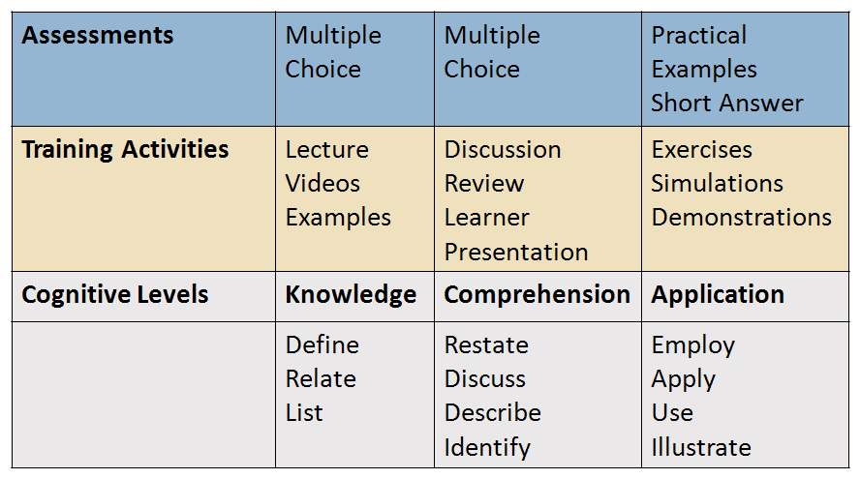

The NIST WMD has expressed strong interest in collaborating with the NCWM in efforts to educate instructors in adult learning techniques and relating them to the learning objectives in the NCWM curriculum. The Committee is considering developing another document describing how to translate a curriculum segment into a lesson plan.

The Committee would like to remind everybody designing training materials that the Core Competency Model document is available on the PDC section of the NCWM website. (www.ncwm.net)

Discussion: No comments were received from the floor.

401-3 I Recommended Topics for Conference Training

Source: Carryover Item 401-5 (This item originated from the Committee and first appeared on its agenda in 2003.)

Background/Discussion: The Board has charged the Committee with responsibility for selecting appropriate topics for the technical sessions at future Annual Meetings. The Board asked that the Committee review and prioritize possible presentations and submit those to the Chairman. The Chairman would then work with the NCWM staff to make the arrangements and schedule the sessions.

The Committee continues to carry the following list and recommends these topics for possible training seminars, roundtables, or symposia for presentation at the NCWM meetings:

- Marketplace Surveys;

- Auditing the Performance of Field Staff (Mr. Will Wotthlie, Maryland, volunteered to lead the session);

- Alternative Fuels (Fuel Volatility Issues and Ethanol Blending, and biodiesel blend issues);

- Device Inspections Using a Sampling Model;

- Emerging Issues;

- Ergonomics (including Proper Lifting Techniques, Back and Stress Techniques and Office Ergonomics);

- Public Relations, specifically dealing with aggressive/angry people (recommended by the Southern Weights and Measures Association [SWMA]);

- General Safety Issues (recommended by the WWMA);

- Defensive Driving (recommended by the WWMA);

- Administrative Civil Penalty Process (recommended by the WWMA);

- Price Verification (recommended by the WWMA);

- Customer Service (recommended by the WWMA);

- Ethics (recommended by the Central Weights and Measures Association [CWMA]);

- Automatic Temperature Compensation (ATC) testing for field inspectors;

- Hydrogen Measuring Systems;

- Handbook 44 Scale Code Tare Changes;

- Wet Tare/U.S. Department of Agriculture (USDA) Issues; and

- Moisture Loss.

The Committee asked for suggestions for future training or recommendation on how to prioritize suggestions already on the list. Based on the needs identified in the first two items (401-1 and 401-2), the Committee would like to recommend that the regional associations and the NCWM consider offering training or trainers on how to identify learning objectives, and design training materials that integrate interactive activities and adult learning styles. Ms. Harris mentioned that NIST has a 1.5 hour course on taking technical material and turning it into a course for adult learners.

Discussion: No comments were received from the floor.

The committee received written comments from Mr. Paul Hoar, AgriFuels LLC, suggesting that the Committee challenge the Associate Membership to provide training materials (videos, operations manuals, etc.) to the Conference for use in developing the skills of the NCWM members and state weights and measures officials.

402 PROGRAM MANAGEMENT

402-1 I Safety Awareness

Source: Carryover Item 402-1 (This item originated from the Committee and first appeared on its agenda in 2003.)

Background/Discussion: In the past, the Committee’s responsibility extended to the identification of safety issues in the weights and measures field and included efforts to increase safety awareness. Jurisdictions are encouraged to send their safety reports and issues to their regional safety liaison, who in turn will forward them to the PDC. Below is a list of the Regional Safety Liaisons.

SWMA Mr. Steve Hadder, Florida Department of Agriculture and Consumer Services
WWMA Mr. Douglas Deiman, Alaska Division of Measurement Standards/CVE
CWMA Ms. Julie Quinn, Minnesota Department of Commerce
NEWMA Mr. Michael Sikula, New York Bureau of Weights and Measures

The Committee will continue to ask the regions to prepare articles for the NCWM newsletter and revised the schedule as follows for future issues. The Committee plans to notify the Regional Safety Coordinators as their assignment date approaches.

Association | Issue | Publication Date | Article Deadline
NEWMA | 2010, Issue 3 | September | July 15, 2010
SWMA | 2011, Issue 1 | February | January 15, 2011
WWMA | 2011, Issue 2 | June | April 15, 2011
CWMA | 2011, Issue 3 | September | July 15, 2011
All articles should be e-mailed to the NCWM headquarters at info@ncwm.net.

The Committee has not received any reports of safety incidents in the last six months.

Mr. Craig Harris, Ohio, has prepared safety material on handling diesel emission fluid (DEF). Anyone interested in seeing or utilizing this material should contact the Director, Ohio Weights and Measures.

The Committee asks for suggestions on safety articles people would like to see in future newsletters and/or safety issues which must be addressed immediately. They would like to remind regional associations to check the submission deadlines for their upcoming article assignments. Completed articles should be sent to NCWM headquarters by the submission deadline.

Discussion: The Committee was informed that Mr. Douglas Deiman, Alaska, is now the safety liaison for the WWMA.

402-2 I PDC Publication

Background/Discussion: This item originally served to record the development of various documents prepared in pursuit of our training and Certification Programs. These are available on the Member’s section of the NCWM website at www.ncwm.net. At the 2008 Annual Meeting, the Committee indicated its desire to eliminate this item from the agenda. However, in the report from the CWMA PDC, the Committee received a proposal to create a standard like Handbook 130, Uniform Laws and Regulations in the Areas of Legal Metrology and Engine Fuel Quality, or Handbook 44, Specifications, Tolerances, and Other Technical Requirements for Weighing and Measuring Devices, to serve as the work product of the Committee. This standard could be reviewed, amended, and adopted by the NCWM to make it a living document. The Committee considered this proposal during discussions held at the 2009 Interim Meetings.

Based on feedback at the 2009 NCWM Interim Meeting, the PDC decided to move forward on the new publication to be titled NCWM Publication XX National Certification Program Guide. This Guide will serve to document the details of the Certification Program.

The Guide will remain under control of the PDC, but will not require a formal NCWM vote to add new sections or revise existing sections. The Committee will add and modify sections continuously to meet its priority objectives with a concerted effort to respond to feedback from program users and the NCWM membership. The three main sections of the Guide would include:

- Program Administration – combines historical documentation (curriculum outline and work plan, etc.) with administrative procedures on administering exams and records of certifications;

- Competency Standards – includes the curriculum segments that describe the objectives and measurable competencies that will be used in certification; and

- Certification Disciplines – includes one document per certification area delineating the standards from the curricula that will be covered in the exam and the weighting of the competencies.

All segments of the PDC Guide will be posted online as they are developed. New pages within the NCWM website will be created for the curriculum disciplines and segments so that interested parties can easily find and utilize this material.

Guidelines for operation of the Certification Program still need developing and will be posted online when they are completed.

As of July 2010, the PDC Guide will remain on the website at this point and not be printed as a separate handbook. The Committee anticipates organizing the material into three sub-pages (Curriculum Development, Training, and Certification) following the triangle model pictured in Item 401-1. We will work with the NCWM staff to establish those pages and keep them updated.

Discussion: No comments were received from the floor.

Mr. Ross Andersen, Chair, New York

Ms. Stacy Carlsen, Marin County, California
Ms. Julie Quinn, Minnesota
Mr. Dale Saunders, Virginia
Mr. Steven Grabski, Walmart

Professional Development Committee

Appendix A
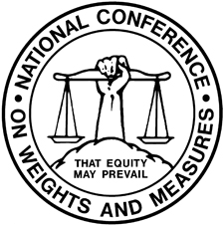

National Conference on Weight and Measures
National Certification Program

NCWM CURRICULUM WORK PLAN
Revised January 2010

Segment/Subject

Level 1/Level 2/Level 3

- Fundamentals of Weights and Measures
  - Introduction to Weights and Measures Programs
  - W&M Laws and Regulations
  - Field Standards and Test Equipment
  - State Program Scope and Overview
  - Enforcement Powers

- Weights and Measures Administration
  - Fundamentals of Weights and Measures Administration (Commercial System, Powers and Duties, etc.)
  - Administration Functions (Personnel, Management, Budget, Safety, etc.)
  - Legislation and Regulations (Legal Considerations, Interaction with Legislature, Stakeholders, Industry, etc.)
  - Regulatory Control (Device Inspection, Commodities, Complaints)
  - Laboratory Metrology Administration (Purpose of Laboratory, Responsibilities of Metrologist, NIST Expectations for Recognition of Laboratory, Quality System, Training Requirements, etc.)
  - Public Relations and Communications (Publicity, Public Relations, Communications)

- Laboratory Metrology
  - NIST Basic Metrology
  - NIST Intermediate Metrology
  - NIST Advanced Metrology

- Device Control Program
  - Safety Considerations
  - NIST Handbook 44 – Introduction to Device Control
  - Weighing Systems, General
    - Static Electronic Weighing Systems, General
    - Static Mechanical and Hybrid Weighing Systems, General
    - Dynamic Weighing Systems, General
    - Precision Weighing Systems Class I and II
    - Small Capacity Weighing Systems Class III
    - Medium Capacity Weighing Systems Class III
    - Large Capacity Class III and IIIL Weighing Systems (Vehicle and Livestock)
    - Large Capacity Class III and IIIL Weighing Systems - Advanced
    - Railroad Track Weighing Systems
    - In-Motion Railroad Track Weighing Systems
    - Hopper Weighing Systems
    - Automatic Bulk Weighing Systems
    - Automatic Weighing Systems
    - Belt Conveyor Weighing Systems
    - In-Motion Monorail Weighing Systems
    - Point-of-Sale Weighing Systems
    - Other Specialty Weighing Systems
  - Dynamic Measuring Systems – General
    - Retail Motor Fuel Dispensers
    - Loading Rack and Other Stationary Metering Systems
    - Loading Rack and Other Stationary Metering Systems – Advanced
    - Vehicle-Tank Meter Systems
    - Vehicle-Tank Meter Systems – Advanced
    - Milk Metering Systems
    - Water Meters
    - LPG/Anhydrous Ammonia Liquid Metering Systems
    - LPG/Anhydrous Ammonia Liquid Metering Systems – Advanced
    - LPG Vapor Meter Systems
    - Mass Flow Metering Systems
    - Other Metering Systems (Cryogenics, Carbon Dioxide, etc.)
  - Static Volume Measuring Systems – General
    - Liquid Measures
    - Farm Milk Tanks
    - Dry Measures
  - Other Measuring Systems
    - Taximeters and Odometers
    - Wire and Cordage Measuring Systems
    - Linear Measures
    - Timing Devices
    - Weights
    - Multiple Dimension Measuring Systems
  - Quality Measuring Systems
    - Grain Moisture Meters
    - NIR Grain Analyzers
    - Carcass Evaluation Systems

- Market Practices, Laws and Regulations (NIST Handbook 130) and Commodities (NIST Handbook 133)
  - Safety Considerations – Market Practices, NIST Handbook 130, NIST Handbook 133
  - NIST Handbook 130 – Laws and Regulations
    - NIST Handbook 130 – General Provisions
    - Packaging and Labeling Regulations
    - Method of Sale Regulations
    - Quality of Automotive Fuels and Lubricants
    - Price Verification
  - NIST Handbook 133 – Package Net Contents Control
    - Commodities – General
    - Packages Labeled by Weight, Standard, and Random
    - Packages Labeled by Weight, Special Commodities
    - Packages Labeled by Volume (Volumetric and Gravimetric Testing)
    - Packages Labeled by Volume, Special
    - Packages Labeled by Length/Area/Thickness
    - Packages Labeled by Count
    - Other Package Types
  - Test Purchases
  - E-Commerce
Note: Initial Verification has been intentionally left off this listing and will be addressed later.
Appendix B

National Conference on Weights and Measures
National Training Program

Certification Discipline
for
Retail Motor Fuel Devices (RMFD)
Beta Exam – February 2010

Prepared by the NCWM Professional Development Committee

The NCWM is offering a (beta) certification examination on the subject above. The examination will be taken on-line via the NCWM website. You must register with the NCWM and be granted a user authorization to access the test site. For registration information call the NCWM at (402) 434-4880 or email info@ncwm.net. Be sure to include the exam title in the subject line.

Format and Duration:

The examination will be in three sections with a total of 50 questions and a two hour time limit to complete all three parts. The test will be given in one session and you may not log off and then attempt to return to that exam. You must complete each section before moving to the next section.

The exam is OPEN BOOK, and you may make use of any reference materials, training documents, and procedural guides at your disposal. You are expected to take the examination alone and may not receive assistance from any other person. You will be asked to affirm that at the conclusion of the examination.

Test instructions will be provided on-line. Since the test is electronically graded, the answer must be marked or typed correctly. The test questions will be either multiple choice, fill-in-the-blank, or compliance/citation. For multiple choice questions, you will be asked to pick the best answer from four options. For fill-in-the-blank questions, you must enter the specific answer, typed correctly. For compliance/citation questions, you will be given information describing a situation and asked to assess compliance. Answer yes if the situation complies based on the information provided, otherwise provide the specific citation if the device does not comply. The form of the citation will typically be something like S.X.X. for a specification, T.X.X. for a tolerance, N.X.X. for a note, or UR.X.X. for a user requirement. Typically, you will be directed to the specific Handbook Code so reference to the code designations, such as 1.10. for the General Code, will usually not be necessary.

Subject of Examination:

- Segment 4.2. Introduction to Device Control – 15 questions
These questions test for knowledge, understanding, and ability to apply the basic requirements applicable to all weighing and measuring devices. This may include questions on the selection, care and use of standards, the legal basis of NIST Handbook 44, the organization of that handbook, understanding of Fundamental Considerations, knowledge of systems of measurement units, understanding and application of General Code requirements, and understanding of NTEP and Certificates of Conformance CC).

- Segment 4.4. Dynamic Measuring Systems – General – 15 questions
These questions test for knowledge and understanding of the basic technologies used in liquid measuring devices (LMD), understanding of classification of various LMD, ability to operate LMD and interpret indications, understanding and ability to apply code requirements from NIST Handbook 44 LMD Code, and understanding and ability to conduct basic tests of LMD and properly apply tolerances.

- Segment 4.4.1. Retail Motor Fuel Dispensers (RMFD) – 20 questions
These questions test for knowledge and understanding of the basic technologies used in RMFD, understanding and ability to apply code requirements from NIST Handbook 44 LMD Code for RMFDs, and understanding and ability to conduct basic tests of RMFDs and properly apply tolerances.

Additional Information:

For more details on the subject matter for this exam, refer to the individual curriculum segments as published on the Certification pages on the NCWM website at www.ncwm.net/certification.

Passing Score and Grading: (not applicable for Beta Exam)

Weights and Measures regulatory officials 85 % (43 or more correct answers)

Service agents 75 % (38 or more correct answers)

You will be given a score for each section and total score immediately after completing the exam (or upon reaching the two-hour time limit). To protect the integrity of the test questions, you will not be advised of the specific questions you answered incorrectly. The PDC Committee will be reviewing incorrect answers in periodic reviews and will adjust scores in select cases, if a question is judged invalid. If your score is affected, you will be notified.

If you wish to challenge any of the questions, there will be a section at the end of the examination where you can offer comments. You may also contact the NCWM PDC through the NCWM staff via the website.

Appendix C

National Conference on Weights and Measures
National Training Program

Instructions for On-Line Certification Examinations – Beta Exam

Prepared by the NCWM Professional Development Committee

Exam Title: 4.4.1 Retail Motor Fuel Devices

Scope of Exam: The exam will consist of three sections comprising 50 test questions as follows:

- Segment 4.2. Introduction to Device Control – 15 questions
These questions test for knowledge, understanding, and ability to apply the basic requirements applicable to all weighing and measuring devices. This may include questions on the selection, care and use of standards, the legal basis of NIST Handbook 44, the organization of that Handbook, understanding of Fundamental Considerations, knowledge of systems of measurement units, understanding and application of General Code requirements, and understanding of the National Type Evaluation Program (NTEP) and Certificates of Conformance (CC).

- Segment 4.4. Dynamic Measuring Systems – General – 15 questions
These questions test for knowledge and understanding of the basic technologies used in liquid measuring devices (LMDs), understanding of classification of various LMDs, ability to operate LMDs and interpret indications, understanding and ability to apply code requirements from NIST Handbook 44 Liquid Measuring Device Code, and understanding and ability to conduct basic tests of liquid measuring devices and properly apply tolerances.

- Segment 4.4.1. Retail Motor Fuel Dispensers – 20 questions
These questions test for knowledge and understanding of the basic technologies used in retail motor fuel devices, understanding and ability to apply code requirements from NIST Handbook 44 Liquid Measuring Device Code for RMFDs, and understanding and ability to conduct basic tests of RMFDs and properly apply tolerances.

Time Limit: You must complete the test in one session limited to two hours from the time the first question screen appears. Each Section also has a time limit and once you complete the last test question in a section, you will not be allowed to go back to any question in that section. Please be sure you have completed and checked each question in the section before answering the last questions. You should plan a dedicated two hour slot and may not log out and back in.

Test Conditions: The exam is OPEN BOOK, and you may make use of any reference materials, training documents, and procedural guides at your disposal. You are expected to take the examination alone and may not receive assistance from any other person. You will be asked to affirm that at the conclusion of the examination.

Navigation: You may move ahead and back within a test section using the F8 (ahead) key and F7 (back) key. This allows you to skip questions within a section and return to it later. Once you complete a section you will not be able to go back to any question in that section so be sure to answer all questions before leaving a section.

Types of Questions: Since the test is electronically graded, the answer must be marked or typed correctly. The test questions will be either multiple choice, fill-in-the-blank, or compliance/citation.

Multiple Choice - You will be asked to pick the best answer from four options. If there is more than one correct answer, you must select the best option.

Fill-in-the-Blank - You must enter the specific answer, typed correctly. When providing numerical answers, you will be informed of the number of decimal places to include in your answer.

Compliance/Citation - You will be given information describing a situation and asked to assess compliance. Answer yes if the situation complies based on the information provided, otherwise provide the specific citation if the device does not comply. DO NOT answer no as it will be scored incorrect. The form of the citation will typically be something like S.X.X. for a specification, T.X.X. for a tolerance, N.X.X. for a note, or UR.X.X. for a user requirement. You will typically be directed to the specific Handbook Code so reference to the code designations such as 1.10 for the General Code will usually not be necessary.

Scoring: You will receive a score for each section and for the total exam. The score for the section will show the number of questions and the number answered correctly. The final score will include the number of questions, the total answered correctly, and the percent correct.

Passing score for Weights and Measures Professionals is 85 % (43 or more correct answers).

Passing score for Service and Repair Technicians is 75 % (38 or more correct answers).

Comments and Challenges: The NCWM PDC encourages you to comment on the test to help us improve our product. If you wish to challenge any of the questions, contact the Committee via the NCWM e-mail at info@ncwm.net, and please include the exam title in the subject line.

