Appendix C
Handbook 130 – Uniform Regulation for Method of Sale of Commodities and
Uniform Engine Fuels and Automotive Lubricants Regulation

Items:
Item 232-2: Uniform Method of Sale of Commodities:
2.33. Oil,
2.33.1.4. Engine Service Category,
2.33.1.4.1. Vehicle or Engine Manufacturer Standards, and
2.33.1.4.2. Inactive or Obsolete Service Category

Item 237-4: Uniform Engine Fuels and Automotive Lubricants Regulation:
3.13. Oil,
3.13.1.4. Engine Service Category,
3.33.1.4.1. Vehicle or Engine Manufacturer Standard, and
3.13.1.4.2. Inactive or Obsolete Service Categories)

Table of Contents
Items | L&R Appendix – C Page
API Motor Oil Guide 3
API, Kevin Ferrick 5

THIS PAGE INTENTIONALLY LEFT BLANK

API Motor Oil Guide
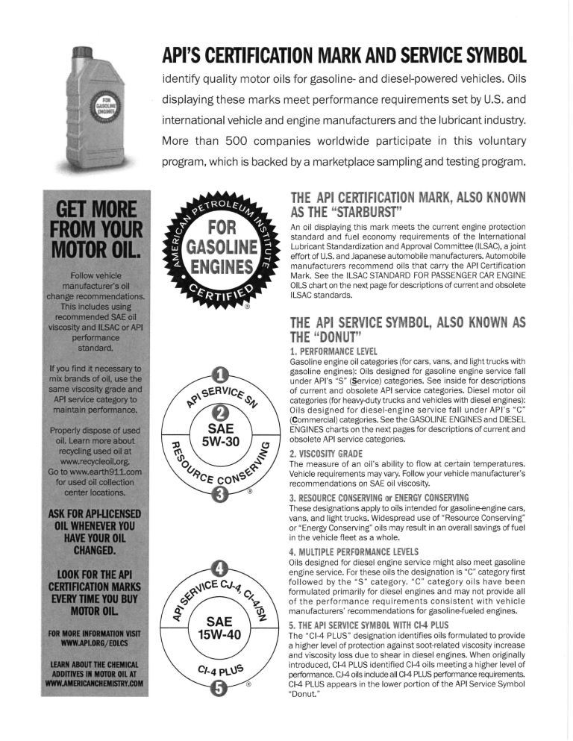
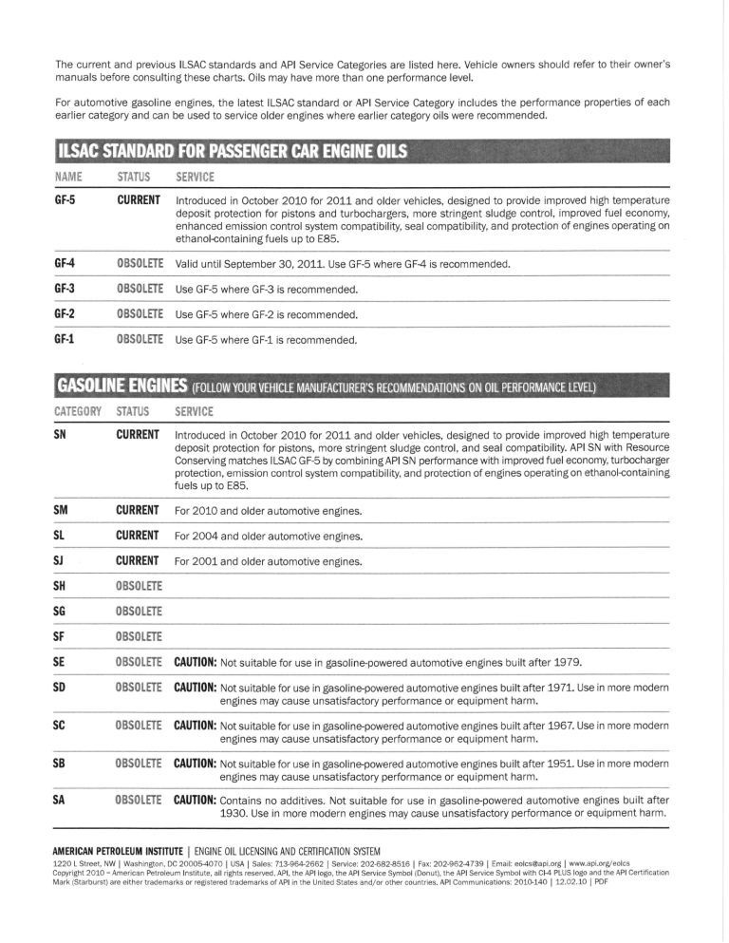

Response to 232-2 and 237-4
Kevin Ferrick
API
1220 L Street, NW
Washington, DC 20005
ferrick@api.org

API supports the current language in Handbook 130 paragraphs 2.33.1.4.1 and 3.13.1.4.1 approved at the July 2012 National Conference on Weights and Measures meeting. In response to the comments received in support of new items 232-2 and 237-4, we offer the following comments for consideration.

- “Older, specialty, and some non-American vehicles take engine oil not listed as active under API’s private regulatory scheme”
  - API’s Engine Oil Licensing and Certification System is a voluntary program based on consensus-based industry standards; it’s not a private regulatory scheme.
  - API and ILSAC standards are developed in cooperation with OEMs, oil marketers, additive companies, test labs, and other interested parties. This includes AOCA.
  - API declares categories obsolete when the tests used to verify those levels of performance no longer exist.
    - For example, API SG was in use through 1993, but the engine tests used to measure SG performance are no longer available. The engine manufacturers stopped making the engines and parts used by the tests.
    - Without SG engine tests, oil marketers might be able to refer to old SG data to confirm an SG oil’s ability to protect against wear and prevent sludge and varnish. Marketers seeking to develop new SG formulations don’t have SG engine tests to verify performance.
- “If OEMs recommend those engine oils for their vehicles, consumers have a right to use them regardless of API’s blessing, and installers and retailers should be able to sell them without obstruction”
  - API doesn’t recommend engine oils for vehicles—OEMs do.
  - Most US, Japanese and South Korean OEMs recommend oils licensed to use the API Starburst.
    - The Starburst identifies oils meeting the most recent ILSAC performance standard. Today, that’s GF-5. If the Starburst appears in an owner’s manual, the OEM is recommending the vehicle owner use GF-5.
    - The Starburst system is possible because oils meeting ILSAC standards are backward compatible: the latest ILSAC standard meets or exceeds the previous standard. If an owner’s manual for a 1998 model year vehicle includes the Starburst, the OEM is recommending the owner use the latest ILSAC standard (in this case GF-5).
  - If an installer stocks in bulk an oil meeting an older API performance standard (for example API SF), how would the installer ensure this older oil is not installed in a newer engine unless the installer follows the requirements in the approved National Conference language?
- “The average fast lube customer doesn’t recognize API or SAE to mean anything in particular”
  - We agree—that’s why API launched a new program to educate marketers, distributors, installers and consumers on the importance of oil quality.
  - This includes educating everyone on the meaning of the API Starburst and Donut.
- “When API publishes a new edition of 1509 and/or creates a new service category, a reasonable phase-in period for bulk oil stock is necessary to accommodate older vehicle owners’ needs”
  - API provides a phase-in for all new API Starburst and Donut performance standards.
    - We start with a six- to nine-month waiting period before API begins licensing oils against the standard.
    - This is followed by a one-year period when the previous and new standards co-exist.
    - Then, according to OEM recommendations, consumers with a Starburst in their owner’s manual are recommended to start using oil’s meeting the new standard.
  - API does maintain older standards where possible. Currently, three older “S” categories (SJ, SL, and SM) can still be licensed. This is possible because the engine tests for these categories are still available.
- “Although it is common for API to retain a couple of the most recent service categories as “active,” API could choose to make all but the most recent service category “obsolete’”
  - API declares service categories obsolete when the tests used to verify their performance are no longer available.
  - If API were to consider making a category obsolete while the engine tests were still available, API would need to ballot the change through our consensus-based standards-setting process.
- “And what about packaged engine oil products already on the shelf or in the distribution chain when API makes a unilateral decision to deactivate an engine oil category?”
  - API-licensed products packaged before category obsolescence are considered licensed after the obsolescence date. We can verify date of manufacture through the oil bottle’s traceability code. All packaged API-licensed oils are required to include traceability codes.
  - Unilateral decision? No tests available results in category obsolescence.

