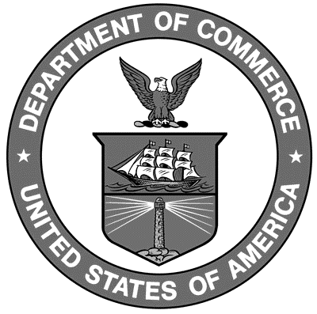

Uniform Laws and Regulations
in the Areas of
Legal Metrology and
Engine Fuel Quality

as adopted by the 98th National Conference on Weights and Measures 2013

Editors:
Linda Crown
David Sefcik
Lisa Warfield

Carol Hockert, Chief
Office of Weights and Measures
Physical Measurement Laboratory

U.S. Department of Commerce
Penny Pritzker, Secretary

National Institute of

Standards and Technology
Patrick D. Gallagher, Under Secretary of Commerce for
Standards and Technology and Director
NIST Handbook₁₃₀
2014 Edition
Supersedes NIST Handbook 130, 2013 Edition
Certain commercial entities, equipment, or materials may be identified in this document in order to describe an experimental procedure or concept adequately. Such identification is not intended to imply recommendation or endorsement by the National Institute of Standards and Technology, nor is it intended to imply that the entities, materials, or equipment are necessarily the best available for the purpose.

National Institute of Standards and Technology Handbook 130, 2014 Edition
Natl. Inst. Stand. Technol. Handb. 130, 2014 Ed., 300 pages (October 2013)
CODEN: NIHAE2

