SOP 17

Standard Operating Procedure for
Control Charts of Check Standards

- Introduction

  - Purpose

This procedure may be used to develop and maintain control charts to monitor the statistical control of laboratory check standards when replicate measurements are made as a part of the standard operating procedure. This procedure may be used for volume, length, time, or other calibrations when replicate measurements are made.

  - Prerequisites

    - The procedure to be monitored must match the calibration procedure that is used.

    - Either a check standard at each nominal value is used or a set of check standards are selected to monitor the range of items that are calibrated by the laboratory.

- Summary

A check standard is obtained and calibrated several times initially to establish a reliable mean value and to estimate the standard deviation of calibration. All such calibrations are made using the applicable procedure that is used for calibration. A reference value may be obtained from a suitable calibration laboratory or by using a more accurate and precise calibration than the one that will be monitored. Directions for preparing and using a control chart for monitoring the mean ($\overline{x}$) and the standard deviation chart are given. The $\overline{x}$ control chart monitors the process with respect to both the standard and the variability, while the standard deviation chart monitors its short-term precision. When the calibration process is determined to be in a state of statistical control, the calibrations made at that time may be considered to be valid and the standard deviation of the measurement process may be included in uncertainty calculations using SOP 29.

Note: If a full evaluation of potential bias is desired, it is best if the reference value of the check standard is provided by an outside laboratory accredited to perform the applicable calibrations taking care to ensure that the source calibration has a sufficiently small uncertainty.

- Equipment

  - A check standard is required, and should be constructed of similar materials and design as the standards or devices under calibration. Check standards are maintained in the laboratory as a surrogate for items submitted for routine calibration. Examples of check standards might include a quality assurance reference flask (QARF), a test measure, an extra length standard, or a stopwatch, taking care that all check standards are sufficiently similar to those submitted for calibration to obtain a suitable standard deviation of the measurement process and similar stability over time.

  - All equipment designated in the applicable SOP.

- Procedure

  - Initial Measurements

    - Calibrate the check standard a minimum of 12 times to establish the baseline chart. A calibration is defined as the result of replicate measurements as required by the SOP (i.e., a complete test consists of the number of runs specified in the SOP). Calibrations may be made on successive days, but no two complete tests should be made on any single day. Note: 25 to 30 points are recommended to determine uncertainties.

    - Tabulate the measurement data using the notation and a form such as the one contained in the Appendix of this SOP. The appendix provides an example for duplicate runs only; modifications would be needed when other replicates are used. The data may be maintained in a spreadsheet or other electronic program in lieu of a paper form.

    - A standard deviation may be calculated for each set of runs according to the appropriate SOP. A pooled standard deviation is then determined for the measurement process. When all of the runs have the same number of replicates, each test will have the same number of degrees of freedom and an average of the standard deviations may be used. Use of a standard deviation of replicate measurements is preferred to the use of Range charts (see SOP 20 for guidance on Range charts.)

  - Construction of Control Charts (See also SOP 9)

    - Construct the following control charts using the data of section 4.1.

    - Construct an $\overline{x}$ control chart for a check standard with the following control limits:

Reference value | (when available)
Central Line | $\overline{x}$ (mean of the average values)
Lower warning limit (LWL) | $$\overline{x}−2s_{p}$$
Lower control (or action) limit (LCL) | $$\overline{x}−3s_{p}$$
Upper warning limit (UWL) | $$\overline{x}+2s_{p}$$
Upper control (or action) limit (UCL) | $$\overline{x}+3s_{p}$$

    - Construct a Standard Deviation chart using the same approach. You should use 2 and 3 as the respective multipliers for the Upper Warning Limit and Upper Control Limits. Note that there will be no negative numbers when calculating standard deviations.

  - Use of Control Charts

    - An appropriate check standard is calibrated each time the laboratory performs calibrations using the SOP or on a set periodic basis if many calibrations are performed by the laboratory. If the calibrations extend over several days, the check standard is calibrated daily. The values of $\overline{x}$ and s_{p} for each calibration of the check standard are plotted on the respective charts, preferably in sequential order. The limits on the charts are such that 95 % of the values should fall within the warning limits and rarely should a value fall outside of the control limits, provided that the system is in a state of statistical control.

    - If the plotted value of $\overline{x}$ lies outside of the control limits and the corresponding value on the standard deviation chart is within the control limits, a source of systematic error is suspected.

    - If the values for the standard deviation chart fall outside of the warning limits but inside of the control limits, a decrease in precision is indicated. Other problems should be investigated.

    - No calibration data should be accepted when the system is out of control.

    - If the plotted values for either$\overline{x}$, or s_{p} are outside of the warning limits but inside of the control limits, a second set of duplicate calibrations should be made. If the new values are within the warning limits, the process may be considered to be in control. If they lie outside of the warning limits, lack of control is indicated. Investigation actions should be taken and attainment of control demonstrated before calibration measurements are considered to be acceptable.

    - Even while the system is in an apparent state of control, incipient troubles may be indicated when the control data show short- or long-term trends, shifts, or runs. The t-test and F-test may be used to assess the significance of such observations (see NIST IR 6969 Sections 8.9, 8.10, and 8.11).

  - Interpretation of Control Chart Data

    - Demonstration of "in control" status indicates that the calibration process is consistent with the past experience of the laboratory. That is to say, there is no reason to believe that excessive systematic error or changes in precision have occurred.

    - To the extent appropriate, the precision of measurement of the check standard may be extended to the calibration of other standards of similar nominal size made by the same measurement method.

    - Extension of the s_{p} for the check standard to other calibrations assumes that all aspects of its calibration correspond to those for the other calibration.

Figure 1. Example Control Chart
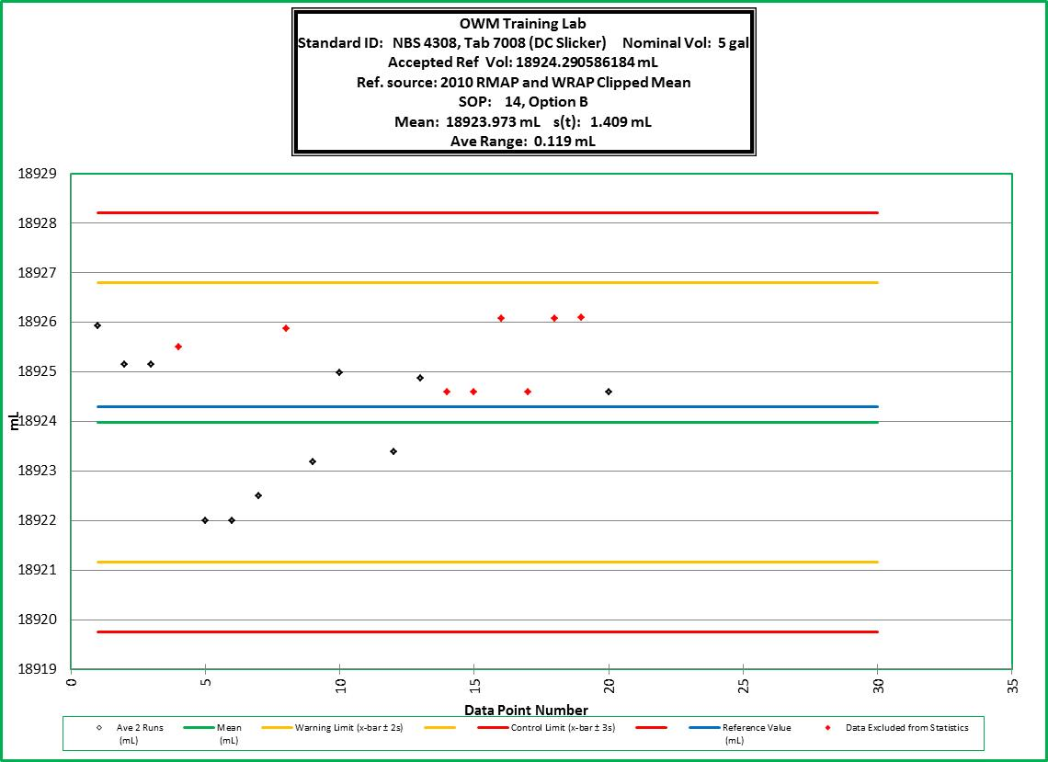

Figure 2. Example Standard Deviation Chart

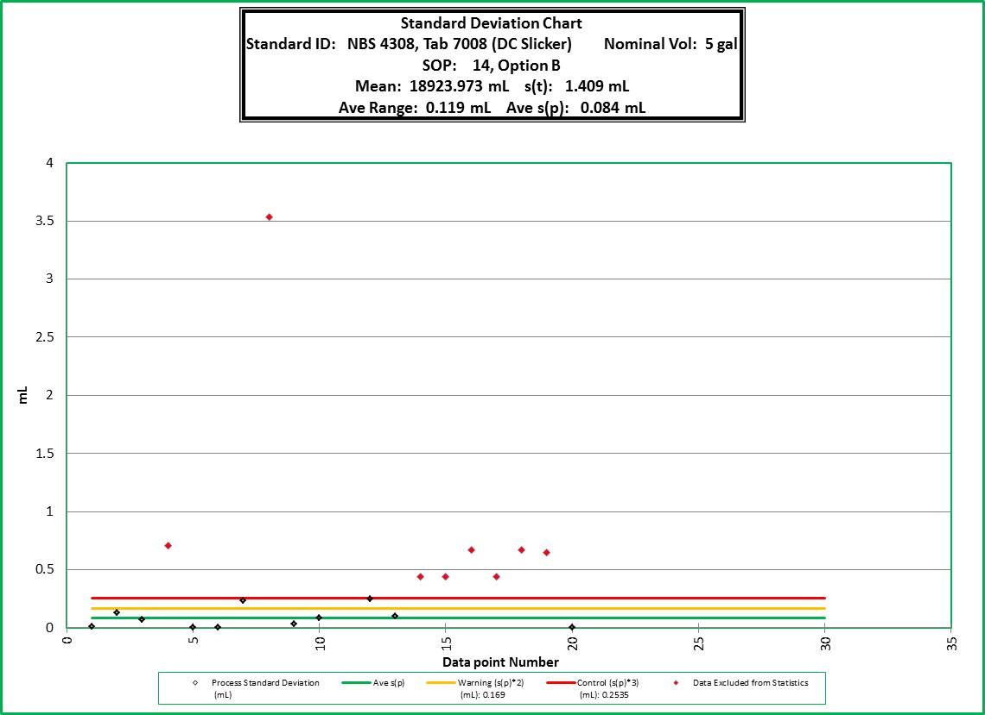
Note: see point 8 that is outside of control limits.
Appendix
Control Chart Check Standard Data

Check Standard Identification Nominal Value _____________

Test  Number | Date | Run 1 | Run 2* | Average of Runs | Standard deviation
1
2
3
4
5
6
7
8
9
10
11
12
13
14
15
16
17
18
19
20
21
22
23
24
25
26
27
28
29
30
* Additional columns will be needed when replicates runs beyond two are used.

