Books

Atmospheric Chemistry and Physics: From Air Pollutions to Climate Change
J.H Seinfeld, S N. Pandis
Wiley, 2006.
QC879.6.S45 2006

The Global Climate System: Patterns, Processes, and Teleconnections
H.A. Bridgeman, J.E. Oliver
Cambridge, 2006
QC981.B75 2006

Fairness in Adaptation to Climate Change
W. N. Adger, et.al., editors.
MIT Press, 2006
QC981.8.C5F345 2006

Solar Activity and the Earth’s Climate
R.E. Benestad
Springer, 2006
QB524.B46 2006

Avoiding Dangerous Climate Change: International Symposium on Stabilisation of Greenhouse Gas Concentrations
H. J. Schellnhuber, editor.
Cambridge University Press, 2006.

QC981.8 .C5 I58 2005

Greenhouse gas control technologies: Proceedings

of the 7th International Conference on Greenhouse

Gas Control Technologies
E. S. Rubin, editor.
Elsevier, 2005.
TD885.5 .G73 I55 2004

Satellite instrument calibration for measuring

global climate change

G. Ohring, et. al., editors.
NISTIR 7047, 2004.
QC100 .U56 NO.7047

Statistical Analysis in Climate Research
H. von Storch, F.W. Zwiers
Cambridge, 1999
QC981.S735 1999

Measurement Challenges in Atmospheric Chemistry
L. Newman, editor.
American Chemical Society, 1993
QC879.6.M41 1993

Physics of Climate
J.P. Peixoto, A.H. Oort
AIP, 1992
QC981.P434 1992

Electronic Journals
(see the E-Journals page on the NIST Virtual Library to access these journals http://nvl.nist.gov)

Archives of Environmental Contamination and Toxicology
Experimental or theoretical research work pertaining to the scientific aspects of contaminants in the environment. Published by Elsevier.

Atmospheric Chemistry and Physics
An interdisciplinary journal investigating the Earth's atmosphere and the underlying chemical and physical processes. Published by Copernicus Publications.

Atmospheric Environment
Covers air pollution research and its applications. Published by Elsevier.

Environmental Science & Technology
Reports on aspects of the environment and its protection by scientific, engineering, and political means. Published by the American Chemical Society.

Journal of Atmospheric Chemistry
Study of the chemistry of the Earth's atmosphere, the emphasis being laid on the region below about 100 km. Published by Springer.

Journal of Environmental Science and Health
All aspects of science and engineering as they apply to environmental problem solving. Published by Taylor and Francis.

Science of the Total Environment
Research on the environment with emphasis on changes caused by human activities. Published by Elsevier.

DVD and Video

Baked Alaska: changing climate, changing

landscapes

Bruce Molnia

NIST colloquium, March 31, 2006.

QC984 .A4 M65 2006 DVD

The discovery of global warming
Spencer R. Weart

NIST colloquium, January 7, 2005.
QC981.8 .G56 W43 2005 VHS

Stratospheric ozone depletion: a global problem
Mario J. Molina

NIST colloquium, September 6, 1996.
QC879.7 .M65 1996 VHS

Web Sites

Federal R&D Project Summaries
http://www.osti.gov/fedrnd/
Review other federal agencies environmental R&D projects through this Department of Energy sponsored site.

Grants.gov
http://www.grants.gov/
Database of Federal grant opportunities including scientific R&D opportunities.

U.S. Climate Change Science Program
http://www.climatescience.gov/
This Office of Science and Technology Policy site includes the Strategic Plan for the U.S. Climate Change Science Program report.

Selected Environmental Metrology Resources

in the

NIST Research Library

May, 2007

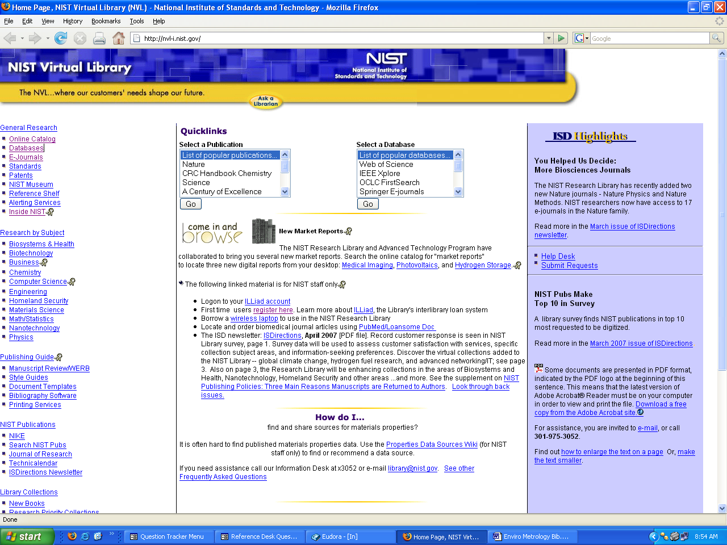

NIST Research Library

Bldg. 101 E-wing
x3051, library@nist.gov
http://nvl.nist.gov

