U.S. Election Assistance Commission
Technical Guidelines Development Committee
Resolution adopted by the TGDC at their plenary meeting, July 9, 2004

Resolution #01-04, Offered by: Dr. Harding

Three subcommittees shall be established to gather and analyze information. Subcommittees shall be comprised only of TGDC members. Subcommittees shall propose resolutions to the TGDC on best practices, specifications and standards. Subcommittees shall be named:
- Security and Transparency,
- Human Factors and Privacy, and
- Core Requirements and Testing.

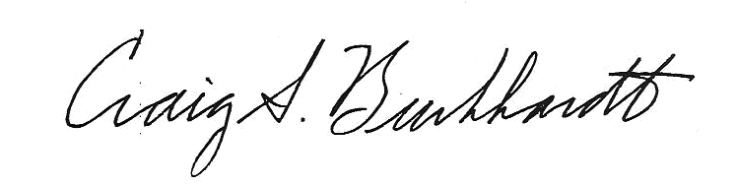
I hereby certify the accuracy of Resolution #01-04:

____________________________________________ Craig S. Burkhardt, Parlimentarian

U.S. Election Assistance Commission
Technical Guidelines Development Committee
Resolution adopted by the TGDC at their plenary meeting, July 9, 2004

Resolution #02-04, Offered by: Mr. Berger

The Chair shall survey the interest of TGDC members, and thereafter appoint the members and chairs of the subcommittees.

I hereby certify the accuracy of Resolution #02-04:

____________________________________________ Craig S. Burkhardt, Parlimentarian

U.S. Election Assistance Commission
Technical Guidelines Development Committee
Resolution adopted by the TGDC at their plenary meeting, July 9, 2004

Resolution #03-04, Offered by: Dr. Harding

Resolutions prepared by the subcommittees shall be considered by the TGDC. Resolutions adopted by the TGDC shall be referred to NIST for technical assistance and editing. Upon return from NIST, the TGDC shall review the resolutions to confirm they conform to its intent.

I hereby certify the accuracy of Resolution #03-04:

____________________________________________ Craig S. Burkhardt, Parlimentarian

U.S. Election Assistance Commission
Technical Guidelines Development Committee
Resolution adopted by the TGDC at their plenary meeting, July 9, 2004

Resolution #04-04, Offered by: Ms. Davidson

Adopted resolutions and appropriate explanatory materials comprise the “first set of recommendations” mandated by the Help America Vote Act.

I hereby certify the accuracy of Resolution #04-04:

____________________________________________ Craig S. Burkhardt, Parlimentarian

U.S. Election Assistance Commission
Technical Guidelines Development Committee
Resolution adopted by the TGDC at their plenary meeting, July 9, 2004

Resolution #05-04, Offered by: Mr. Craft

The TGDC shall recommend to the EAC that they expedite making currently certified voting software available to the National Software Reference Library as soon as possible.

I hereby certify the accuracy of Resolution #05-04:

____________________________________________ Craig S. Burkhardt, Parlimentarian

