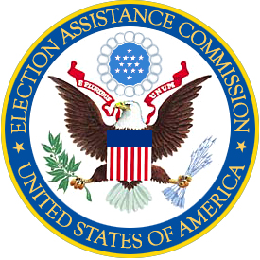

TECHNICAL GUIDELINES DEVELOPMENT COMMITTEE (TGDC)
MEMBER ROSTER

Designated Federal Official
The Honorable Donetta Davidson
Commissioner, U.S. Election Assistance Commission
Washington, DC

TGDC MEMBERS

Chair
Dr. Patrick Gallagher
Under Secretary of Commerce for Standards and Technology
Director, National Institute for Standards and Technology
Gaithersburg MD

Standards Board

Donald Palmer
Director, Division of Elections
Florida Department of State, Division of Elections
Tallahassee Florida

Donald R. Merriman*
County Clerk and Election Officer
Saline County
Salina, KS

Board of Advisors

Linda Lamone
Administrator of Elections
Maryland State Board of Elections
Annapolis, MD

Helen Purcell
County Recorder
Maricopa County
Phoenix, AZ

ACCESS Board

Ronald Gardner
Director of Field Services
National Federation of the Blind
Bountiful, UT

Phillip Jenkins
Senior Software Engineer
IBM Human Ability and Accessibility Center
Austin, TX

ANSI

Dr. David Wagner
Professor
EECS Department
University of California-Berkeley
Berkley, CA

IEEE

(Vacant)

NASED

Ann McGeehan
Director of the Elections Division
State of Texas
Office of the Secretary of State
Austin, TX

Matt Masterson*
Deputy Election Administrator
Ohio Secretary of State
Columbus, OH

Scientific Experts

Steven Bellovin
Professor of Computer Science
Columbia, University
New York, New York

Diane Cordry Golden
Program Coordinator
Association of Assistive Technology Act Programs
Grain Valley, Missouri

Douglas Jones
Associate Professor
Department of Computer Science
University of Iowa
Iowa City, Iowa

Edwin Smith, III
Vice President
Compliance and Certification
Dominion Voting Systems
Longmont, Colorado

