Appendix E

NIST Handbook 44 – Mass Flow Meters

Item 337-2:
Submitters Background and Justification for NIST Handbook 44 Definition of “Diesel Gallon Equivalent (DGE)” of Compressed Natural Gas (CNG) and Liquefied Natural Gas (LNG) as a Vehicular Fuel Clean Vehicle Education Foundation

Development of the “Gasoline Gallon Equivalent” by NCWM*

In 1993, under the auspices of the National Conference on Weights and Measures (NCWM), a Compressed Natural Gas (CNG) Working Group came together to determine the way in which CNG would be sold to the public at retail as a motor fuel.

The working group focused on three issues:
1. How to provide the Natural Gas Vehicle (NGV) industry a method of sale that would be familiar and acceptable to consumers
2. How to provide weights and measures officials a verifiable and quantifiable
means to determine the accuracy of natural gas dispensers; and
3. How to meet these requirements with a uniform, national standard.

NCWM considered three proposals for the method of sale of CNG:
1. Joules, the unit of energy measurement in SI units
2. Mass
3. The Gasoline Gallon Equivalent (GGE)

The Natural Gas Vehicle Coalition (now NGVAmerica) recommended that the Gasoline Gallon Equivalent be adopted as the method of sale for CNG, and that it be based on the energy equivalent of a gallon of gasoline. The use of the GGE was recommended primarily for the convenience of the retail customer comparing the cost and fuel economy of a natural gas vehicle to a comparable gasoline vehicle. During the discussion, a proposal was made to eliminate the reference to energy content of CNG and replace it with a fixed conversion factor based on mass, with the fixed mass of CNG being equal to a gallon of gasoline. Measurement of mass in the retail dispenser and verification by WEIGHTS AND MEASURES officials is easier and less costly than measurement of energy content.

Since the energy content of a unit measure of CNG (standard cubic foot - scf) and gasoline (gallon) vary widely depending on the sample of fuel measured, the reference gallon of gasoline was determined to be Indolene, the gasoline used by EPA to certify emissions and fuel economy, with an energy content (lower heating value) of
114,118 BTU/gal. Work conducted by the Institute of Gas Technology and the Gas Research Institute (now combined into the Gas Technology Institute) surveyed 6811 samples of natural gas nationwide and concluded that the “average” natural gas in the US had an

* Report of the 78th National Conference on Weights and measures, 1993, NIST Special Publication 854, pp 322-326.
Report of the 79th National Conference on Weights and Measures, 1994, NIST Special Publication 870,
pp 213-217.
Program and Committee Reports for the National Conference on Weights and Measures, 79th Annual
Meeting, July 17-21, 1994, NCWM Publication 16, pp 89-92.

CVEF Page 1 11/25/13

energy content (lower heating value) of 923.7 BTU/scf, and a density of 0.0458172 lbs/cubic foot. This translates 20,160.551 BTU/lb. Dividing gasoline’s 114.118 BTU/gal by natural gas’s 20,160.551
BTU/lb gives 5.660 lbs of natural gas = 1 GGE. Similar calculations determined that a gasoline liter equivalent of natural gas equals 0.678 kg of natural gas.
At its 79th Annual Meeting in July of 1994, NCWM adopted resolutions that: “All natural gas kept, offered or exposed for sale or sold at retail as a
vehicle fuel shall be in terms of the gasoline liter equivalent (GLE) or gasoline gallon equivalent (GGE), and

All retail natural gas dispensers shall be labeled with the conversion factor in terms of kilograms or pounds. The label shall be permanently and conspicuously displayed on the face of the dispenser and shall have either the statement “1 Gasoline Liter Equivalent (GLE) is equal to 0.678 kg of Natural Gas” or “1 Gasoline Gallon Equivalent (GGE) is equal to 5.660 lbs of Natural Gas” according to the method of sale used.”

These statements can be found in NIST Handbook130*, along with the definition of “natural gas” which seems to apply only to Compressed Natural Gas, not to Liquefied Natural Gas. Handbook 130, §§3.11 and 3.12. (Engine Fuels, Petroleum Products, and Automotive Lubricants Regulations) confirm that these requirements are for CNG, rather than LNG. Similar requirements and definitions are found in NIST Handbook 44.

During the discussions it was recognized that, although diesel and gasoline are both sold in gallon units, a gallon of diesel fuel has substantially more energy content than a gallon of gasoline. While it is convenient to use the Gasoline Gallon Equivalent unit when comparing the cost and fuel economy of gasoline-powered light-duty vehicles to equivalent natural gas vehicles, a Diesel Gallon Equivalent unit would be more useful for operators of medium and heavy-duty (usually diesel powered) vehicles. However, in 1994, the NCWM working group “agreed to defer development of a “Diesel Gallon Equivalent” until the issues related to the ‘Gasoline Gallon Equivalent’ were decided by the NCWM and agreed to meet again if additional work is necessary.”** The issue of the formal definition a Diesel Gallon Equivalent (DGE) unit has not come before NCWM from that time until today, although the DGE is often used in the industry, defined as 6.31 lbs of compressed natural gas.

Need for a Definition of a “Diesel Gallon Equivalent” Unit

Today there are an increasing number of commercial vehicles using natural gas as a fuel, to lower emissions and Greenhouse Gases, decrease America’s use of petroleum, and lower fuel costs (U.S. DOE Clean Cities Alternative Fuel Price Report for April 2012

* “Method of Sale Regulation,” §2.27
** Report of the 79th National Conference on Weights and Measures, 1994, NIST Special
Publication 870, p 214

CVEF Page 2 11/25/13

shows in Table 2 ‘Overall Average Fuel Price on Energy-Equivalent Basis’ that diesel is priced at
$4.12/gal and CNG at $2.32/gal

http://www.afdc.energy.gov/afdc/pdfs/afpr_apr_12.pdf ).

Since the NCWM’s working group deferred development of a DGE unit in 1994, there has been little call by the natural gas vehicle industry for the formalization of that unit in the sale of Compressed Natural Gas. However the use of Liquefied Natural Gas (LNG) as a motor fuel has been growing (more than
350 LNG stations are being built on the nations interstate Highways) and there is significant interest in using the DGE as a unit for the sale of that fuel.

LNG as a motor fuel is used almost exclusively by commercial vehicles, most of which view diesel as the conventional alternative. Using the same logic as was used for the development of the GGE unit, the convenience of the retail customer comparing the cost and fuel economy of a natural gas vehicle to a comparable conventional vehicle, it makes sense for NCWM to now “officially” define the DGE.

Other than §3.12. Liquefied Natural Gas, in the Engine Fuels and Automotive Lubricants

Regulation section of Handbook 130, we find no specific provisions in either Handbook

44 or Handbook 130 for the retail sale of LNG as a motor fuel. However LNG is sold in

California and other states on a mass basis (by the pound), which allows for easy confirmation by weights and measures authorities. An “official” definition of the DGE as a specific mass of LNG and CNG would allow states to easily move from retail sale by pound to retail sale by DGE, simplifying the sale process for the retail customer used to dealing with “gallons of diesel” as a fuel measure.

Therefore, at this time we are asking for a definition of the Diesel Gallon Equivalent (and Diesel Liter
Equivalent) units by NCWM.
Justification of the Definition of a DGE as 6.38 Pounds of Compressed Natural Gas Handbook 130 contains the following definitions of natural Gas as a vehicle fuel*: Gasoline liter equivalent (GLE). – Gasoline liter equivalent (GLE) means
0.678 kg of natural gas.

Gasoline gallon equivalent (GGE). – Gasoline gallon equivalent (GGE) means
2.567 kg (5.660 lb) of natural gas.

As the NCWM working group recognized during its deliberations in 1993 on the Gasoline Gallon Equivalent unit, both gasoline and natural gas can vary in their BTU content from sample to sample. The working group determined the gasoline gallon (energy) equivalent based on a gallon of Indolene (114,118 BTU/gal – lower heating value) and a survey of 6811 natural gas samples nationwide with an average of 923.7 BTU/scf (lower heating value) and a density of 0.0458172 lbs/cubic foot. This equates

* NIST handbook 130, 2006, Method of State Regulation, §§2.27.1.2 and 2.227.1.3; also Engine
Fuels, Petroleum Products, and Automotive Lubricants Regulation, §§1.25 and 1.26.

CVEF Page 3 11/25/13

to 20,160.551 BTU/lb. Dividing gasoline’s 114.118 BTU/gal by natural gas’s 20,160.551
BTU/lb gives 5.660 lbs of natural gas = 1 GGE. Similar calculations determined that a gasoline liter equivalent of natural gas equals 0.678 kg of natural gas.

Starting with 5.660 lbs of natural gas = 1 GGE and 0.678 kg of natural gas = 1 GLE, we can calculate the mass of natural gas necessary to make a DGE and a DLE by comparing the amount of energy in a gallon of diesel fuel to the amount of energy in a gallon of gasoline fuel and apply that ratio to scale up the masses of natural gas calculated for the GGE and GLE units.

Unfortunately it is no easier today than it was in 1993 to set one energy value as representative of a unit for all gasoline, (or diesel) fuel. EPA’s certification fuel has likely changed in energy content since
1993, as both gasoline and diesel fuels have been modified for improved emissions.

We recommend using the most recent Department of Energy Transportation Energy Data *
Book

, as an

authoritative reference for both gasoline and diesel fuel energy values. Taking further surveys or basing our calculations on today’s EPA certification fuel only delays our action, substantially increases costs, and, in the end, provides a limited potential increase in accuracy based on one point in time. Table B.4 of the Transportation Energy Data Book, on the heat content of fuels lists the net energy of diesel as 128,700 BTU/Gal. The 31st Edition may be downloaded at the following site.

http://cta.ornl.gov/data/download31.shtml

Therefore a Diesel Gallon Equivalent of compressed natural gas is: (128,700 BTU/Gal / 20,160.551

BTU/lb) = 6.38 lb/DGE (2.894 kg/DGE) and a Diesel Liter Equivalent of compressed natural gas is:

2.894 kg/DGE X 0.2642 Gal/Liter = 0.765 kg/DLE

Justification of the Definition of a DGE as 6.06 Pounds of Liquefied Natural Gas

Cooling pipeline natural gas to -259 0F makes liquefied Natural Gas (LNG). The pipeline natural gas has the same national average composition as was determined for CNG

with a LHV of 20,160.551 BTU/lb. In order to reduce the natural gas temperature for liquefaction carbon dioxide must be removed since it would solidify in the system and

nitrogen, which remains a gas at LNG temperatures, is reduced to less that 0.5% by volume in the final product. These changes to the composition of the pipeline gas increase the LHV of LNG to
21,240 BTU/lb.

* Stacy C. Davis and Susan W. Diegel, Oak Ridge National Laboratory, Transportation Energy
Data Book, Edition 31, 2012, ORNL-6987, or http://cta.ornl.gov/data/index.shtml

CVEF Page 4 11/25/13

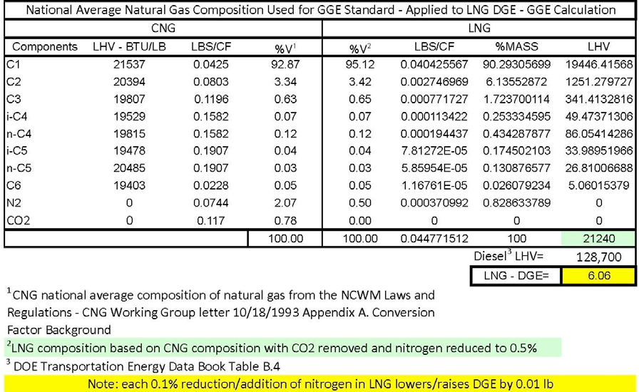

Therefore a Diesel Gallon Equivalent of LNG is:

128,700 BTU/lb / 21,240 BTU/lb = 6.06 lb/DGE (2.749 kg/DGE)

and a Diesel Liter Equivalent of LNG is:

2.749 kg/DGE X 0.2642 Gal/Liter = 0.7263 kg/DLE

The attached presentation file provides an overview of the CNG and LNG processes from pipeline to dispensing along with the calculation of the LNG LHV based on the change in LNG chemical composition through the liquefaction process.

Prepared by:
Clean Vehicle Education Foundation http://www.cleanvehicle.org

CVEF Page 5 11/25/13

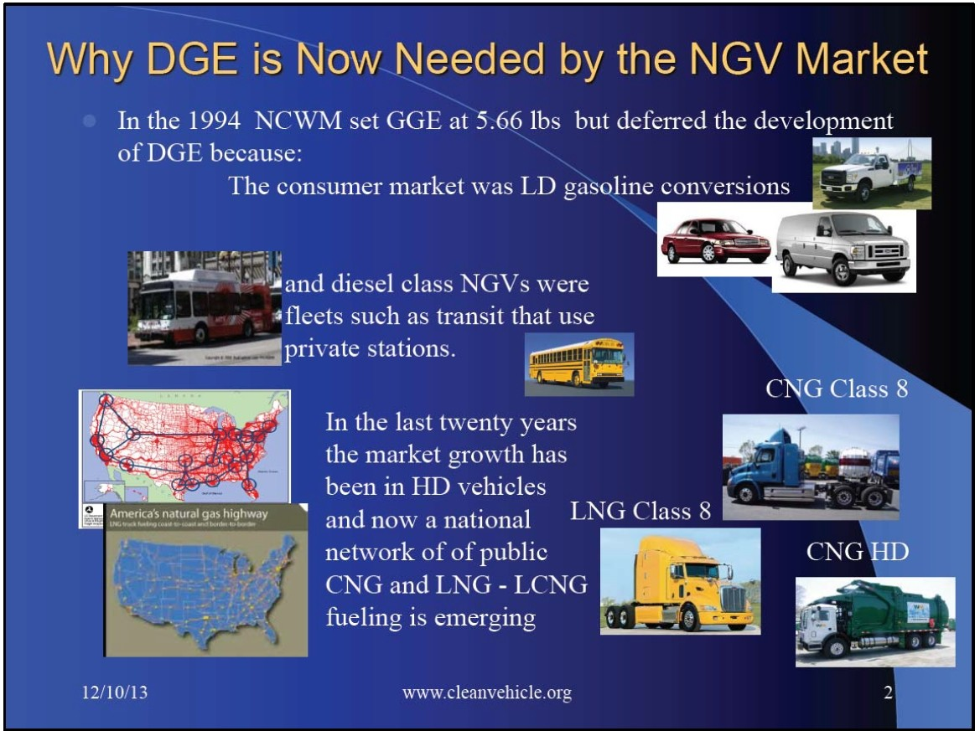

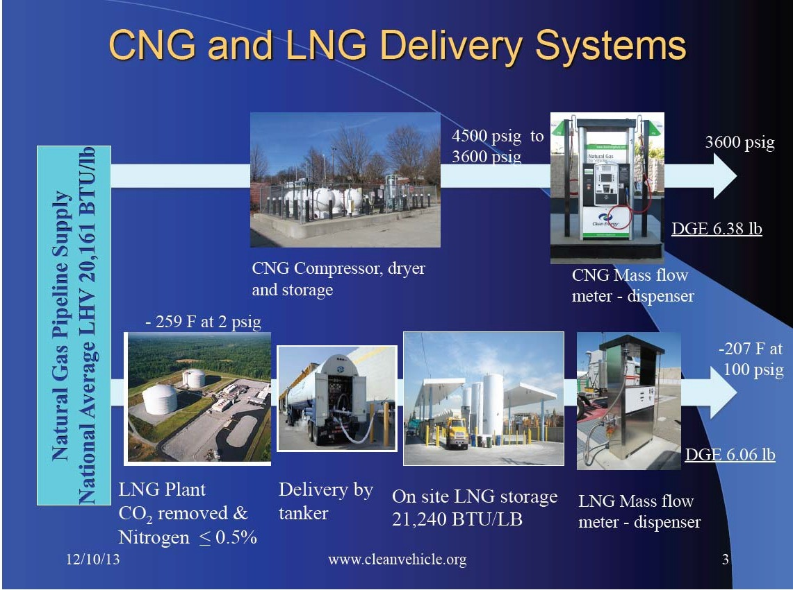

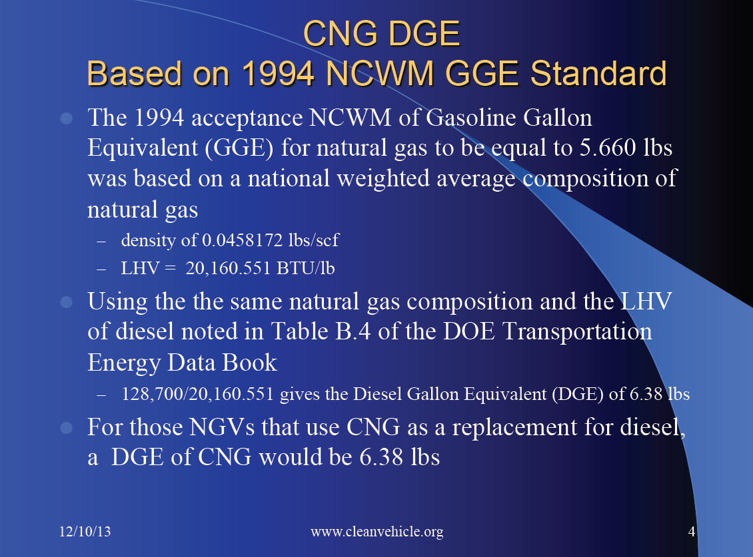

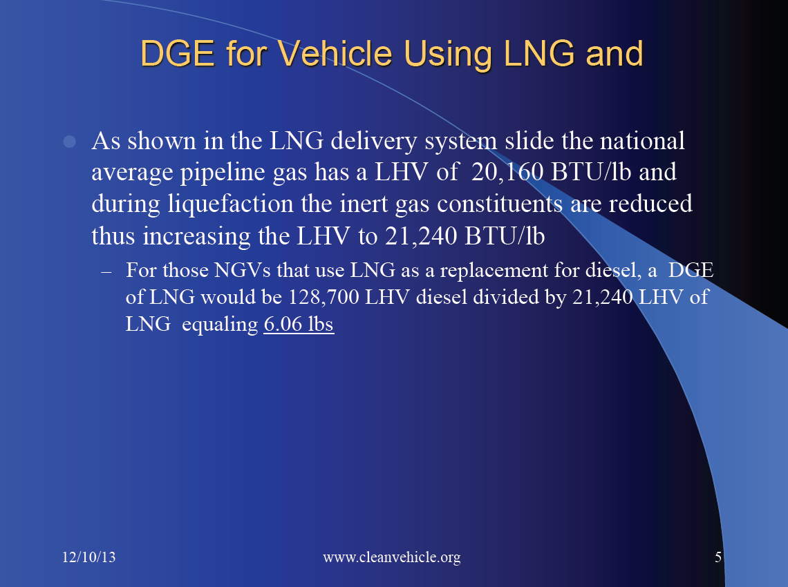

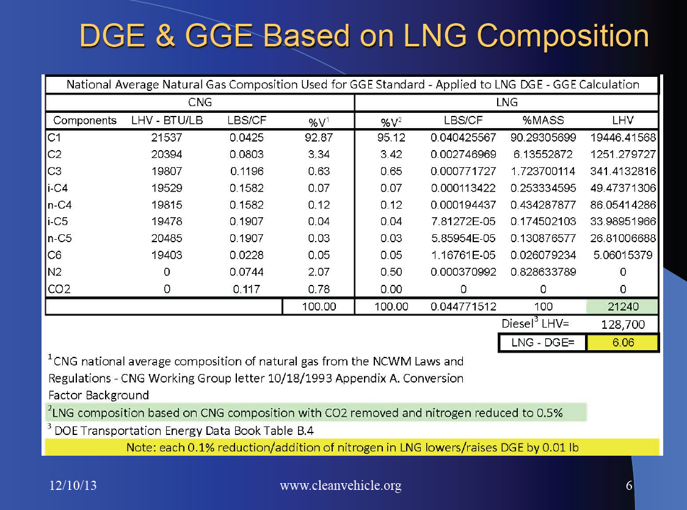

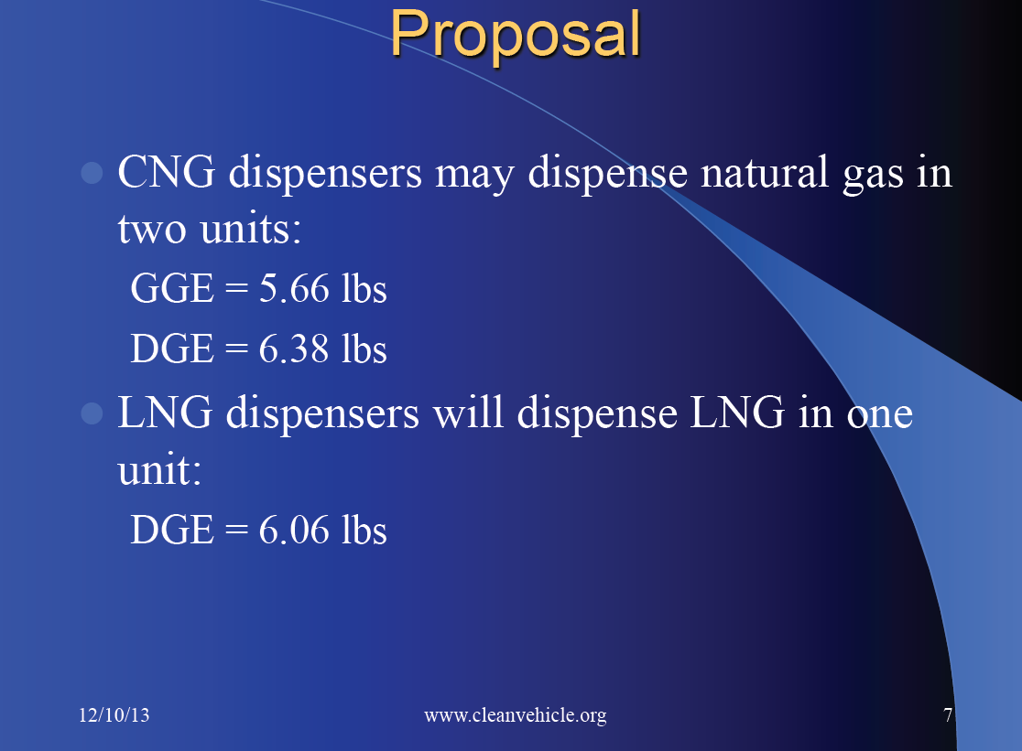

THIS PAGE INTENTIONALLY LEFT BLANK

