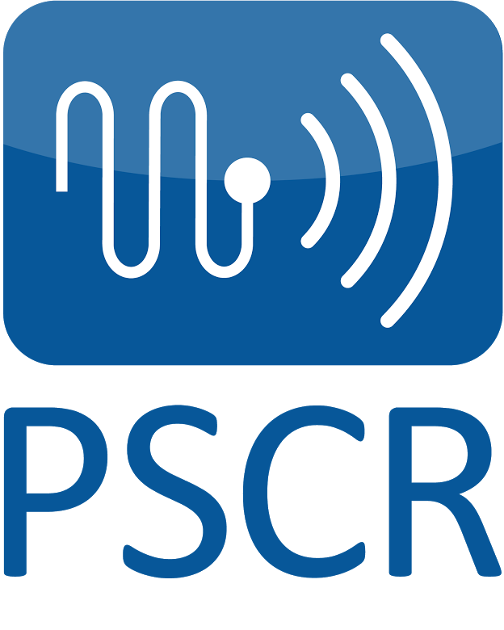

NIST Public Safety Innovation Accelerator Program –

First Responder 3D Indoor Tracking Prize (FR3D)

Notice of Funding Opportunity
Frequently Asked Questions

- How do I apply?
Applicants must submit their applications materials via grants.gov. The application package is available at www.grants.gov under Funding Opportunity Number 2020-NIST-PSIAP-FR3D Amendment 3.
For further information or questions regarding submitting electronic applications on Grants.gov, contact:
Leon Sampson
Phone: (301) 975-3086
Email: Leon.Sampson@nist.gov

- What are the application submission deadlines?

Pre-Applications must be received at grants.gov no later than 11:59 p.m. Eastern Time, Monday, December 9, 2019.
Full-Applications must be received at grants.gov no later than 11:59 p.m. Eastern Time, Thursday, August 20, 2020.

- How does the application process work?

The FR3D competition will be conducted in two phases: The pre-application phase and the full application phase.
- Pre-applications received by the deadline will be reviewed by NIST to determine which applicants will be invited to submit a full application. NIST will only review Full Applications submitted by applicants who were invited to submit Full Applications at the conclusion of the Pre-application stage.
- Full Applications received by the deadline will be reviewed by NIST in accordance with the review and selection processes set forth in the Notice of Funding Opportunity (NOFO).
Detailed information about the application review process can be found in Sections V.1 (Pre-application phase) and V.2 (Full Application phase) of the NOFO.

- Can I submit multiple applications?

No, NIST will only consider one application per applicant organization. However, an applicant entity may be proposed as a subrecipient, contractor, or unfunded collaborator within applications submitted by other entities.

- What type of work will be performed under the award?

PSCR is seeking to enter into a cooperative agreement with an organization possessing expertise in prize competitions to collaborate with technical experts from NIST, industry/academia, and public safety to serve as Prize Administrator (PA) and be responsible for developing and implementing the First Responder 3D Indoor Tracking (FR3D) Prize. Administration of the FR3D Prize will include all aspects prize development, project management, and execution.

- Who is eligible to apply for this award?

Applications are open to U.S. institutions of higher education, non-profit organizations, and for-profit organizations. NIST will not be accepting proposals from foreign entities or state, local, or tribal government entities. Please note that individuals and unincorporated sole proprietors are not considered “non-Federal entities” and are not eligible to apply.
Further, please note that foreign entities may not be funded as subrecipients or contractors under this award.

- This program is for a 2-year, $8,000,000 project, correct?

A 2-year, $8,000,000 project would represent the maximum anticipated amount of funding NIST could provide to the awardee.

- We are already working with NIST under a CRADA (Cooperative Research and Development Agreement). Are we eligible to apply for this grant?

Potentially: Being a CRADA partner does not, in itself, preclude you from applying to this competition, but conflicts are possible. For example, an entity cannot receive NIST funds for the same activities being performed under the CRADA. If you are a current CRADA partner and considering applying, please contact us directly to discuss your specific situation.

- Are non-US entities eligible to serve as prize administrator?

No, NIST will not be accepting proposals from foreign entities.

- When will NIST announce the award recipient?

Review of Applications, selection of successful applicants, and award processing is expected to be completed by June 2020. The earliest start date for awards under this NOFO is expected to be July 2020.

- What’s the “unique entity identifier number”?

Applicants will need a “D-U-N-S” number, which is a free, unique identifier provided by Dun and Bradstreet. Applicants will also need to obtain an Employer Identification Number (EIN) provided by the Internal Revenue Service.

Note, if your organization does not have these numbers, it may take some time to acquire them. Please see the Organization Applicant Registration page on the Applicants tab on Grants.gov.

- Do references and citations count towards the page limit?

Yes, the page limits include all tables, charts, graphs, figures, maps, photos, graphics, and citations. Resumes and CVs do not count toward page limits.

13. What if my institution will be collecting data about people, subjects, or participants during our proposed project?

Protection of human subjects is a priority of PSCR’s research and development programs. If you receive funding for a project that potentially includes research involving human subjects, or data or recordings involving human subjects (including software testing), the NIST Research Protection Office (RPO) must perform a review of your proposal as described in the Notice of Funding Opportunity. You may be asked to provide details about your proposed human subjects research; supporting documents such as consent forms; survey instruments; and IRB documentation. Before research involving human subjects may commence, it must be explicitly authorized by the NIST Grants Officer in the form of a Special Award Condition.
NIST uses the Common Rule for the Protection of Human Subjects, codified by the Department of Commerce at 15 C.F.R. Part 27, to define its criteria for research involving human subjects.

15. Are federally funded research and development centers (FFRDC) eligible to apply?

Because of the funding instruments used to manage FFRDCs, FFRDCs are generally not eligible to apply. Interested FFRDCs should discuss this further with their Contracting Officer. FFRDCs are, however, eligible to be subcontractors to other eligible applicants.

16. Where can I find information about past awards?

To learn more about research and development projects funded by PSCR, visit https://www.nist.gov/ctl/pscr/funding-opportunities/past-funding-opportunities.

17. Can you review our technical proposal and provide comments to ensure it meets the objectives in the NOFO?

No. Applicants should refer to Section I of the PSIAP-FR3D NOFO for details about the program goals and objectives.

18. Can I submit proposals for R&D related to indoor tracking?

No, this NOFO is specifically to fund a prize administrator to run the FR3D Prize challenge. However, once the challenge is launched there will be an opportunity for teams to submit proposals to participate in the actual FR3D Prize challenge. Be sure to sign up for the PSCR newsletter <insert link> to stay up to date with the challenge launch.

19. Is there a follow-on competition after this one? Or will there be a potential contracting opportunity for the award recipient after the award is over?

No.

20. How long will it take for PSCR to review applications and choose an award recipient?

We expect to announce the award recipient at the end of June 2020.

21. Can organizations partner together as a consortium to apply for this award?

Yes, partnering is encouraged, but there must be a primary applicant organization that, if awarded, will be legally responsible for the award. If an applicant has subcontractors and/or subrecipients who will be actively involved in the work, letters of commitment are required from them at the full application stage.

22. I want to compete in the prize challenge. Should I apply for this award?

No. This competition is to make an award for an organization to serve as the prize administrator. It is not for vendors who want to compete in a prize challenge.

23. Is the award recipient required to plan and facilitate the prize challenge events?

Yes, organizing the prize challenge events is one of the main activities of the prize administrator.

24. How many awards will be made?

NIST will make one award from this competition.

25 Should my team submit letters of commitment in the pre-application?

Letters of commitment are not required for the pre-application stage. Letters of commitment are required as part of the full application.

26. Does the prize administrator determine the prize amount?

Applicants will propose the prize amounts in their applications. NIST will work with the selected recipient to finalize the amounts once the award is made.

27. Can the competitors in the prize challenge be foreign entities?

Yes, competitors in the prize challenge can be foreign entities. However, applicants to this competition must be domestic entities.

