NIST Task Board #4
This document provides fabrication instructions to create NIST Assembly Task Board #4 (ATB4) to support the benchmarking and performance measurement of robotic systems . This task board supports assembly operations associated with creating a wire harness. Four, color coordinated, different length wires are routed per a wiring diagram. Wire routing is accomplished by pressing each wire into pin terminals. Wire bundles are then secured using ties. The last operation is to un-clip the harness from the board and remove it. This task board was designed to support the growing need for robotics in harness assembly operations.

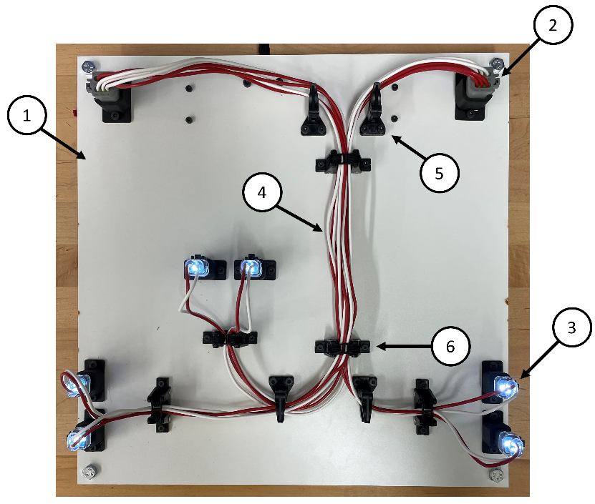
- Assembled (b) Disassembled
(c) Underside
Figure 1. Identification of assembly parts and locations
The parts purchased and tools used are meant to be common off-the-shelf items so that any user can fabricate the board at low cost. The wire colors used in the images are not necessarily the required colors for the harness, as long as there are 4 separate colors.

Purchasing:
- Majority of parts are specified based on availability through Allied electric (www.alliedelec.com). Part numbers are from the Allied website. Small fabrication parts such as fasteners were purchased from Misumi but can be found at a variety of possible vendors.
- The design files of the laser-cut board can be downloaded in various formats from the NIST ATB website. The design file can be uploaded to a laser cutting service, e.g. to Ponoko.com. To minimize variation in board properties, please select for cutting the design in black melamine MDF board of 0.25” thickness, 15” length, and 15” width.

Parts List
(Example)
ID | Item | Part Number | Unit Cost ($) | QTY
1 | Laser cut board | N/A | 41.65 | 1
2 | 6 pin connector female | AT06-6S | 1.22 | 2
3 | 2 pin connector w/ LED female | AT06-2S-LED1201 | 7.35 | 6
4 | 16 AWG stranded insolated wire 25ft. red and black | WH16-02-25  WH16-00-25 | 10.77 | 1 of each
5** | Corner post | CPL.75-S8-X | 7.79 | 4
6** | Elastic retainer | ER.5-E4-X | 20.24 | 5
7 | 6 pin wire connector male | AT04-6P | 1.03 | 2
8 | 2 pin wire connector male | AT04-2P | 0.41 | 6
9 | Power adaptor socket connector | 368 | 2.00 | 1
10** | Quick connect 2 in 6 out wire terminal | N/A | 13.99  www.gkeemars.com | 2
11** | M4 screw | CSH-STN-M4-16 | 3.41 | 26
12** | M3 screw | CSH-STN-M3-16 | 3.41 | 14
13** | M4 nut | LBNR4 | 0.45 | 26
14** | M3 nut | LBNR3 | 0.45 | 14
15 | Round wire pins | AT60-202-16141 | 0.50 | 12
16 | Round wire sockets | AT62-201-16141 | 0.63 | 24
17 | Wedge lock 2 pin | AW2P | 0.9 | 6
18 | Wedge lock 6 pin | AW6P | 0.25 | 2
19 | Power adapter | VEL12US120-US-JA | 14.57 | 1
A | 2-pin connector housing | N/A | N/A | 6
B | 6-pin connector housing | N/A | N/A | 2
C | Socket connector housing | N/A | N/A | 1
Table 1: Bill of Materials

*3D printed part.
** Choice of supplier as long as specifications are met.

Tools List

- Metric wrench for M3 nuts
- Metric wrench for M4 nuts
- Metric Hex-keys for M3 & M4 screws
- Pin crimping tool (16-20 awg) PA1462 from Allied
- Wire strippers 45-121from allied
- Scissors or snips
- Pin extraction tool or small flat head screw driver (optional)

Disclaimer

Certain commercial equipment, instruments, or materials are identified in this paper to foster understanding. Such identification does not imply recommendation or endorsement by the National Institute of Standards and Technology, nor does it imply that the materials or equipment identified are necessarily the best available for the purpose.

Assembly Instructions
Step 1 task: preparation
- Using the scissors/snips, cut each of the needed wire lengths shown below.
  - QTY: 2. Red and Black 60cm
  - QTY: 6. Red and Black 70cm
  - QTY: 4. Red and Black 78cm
  - QTY: 6. Red and Black 20cm
  - QTY: 4. Red and Black 40cm
- Strip both ends of each wire approximately 5mm from the end.
- Use the crimping tool to securely attach the round wire sockets to the end of each of the following wires.
  - Red and Black 60cm
  - Red and Black 70cm
  - Red and Black 78cm
- Use the crimping tool to securely attach the round wire pins to one end of the following wires.
  - Red and Black 20cm

Step 2 task: board assembly
- Place the female 6 pin and 2 pin wire connectors (7 and 8) within the printed brackets on the board in each of the locations shown in the figure to the right. Secure the brackets to the board using the M4 screw and nut. Make sure to check the orientation of the bracket before securing it.
- Place the corner posts and elastic retainers on the board in their associated locations according to figure 1. Secure each of them with their respective M4 and M3 screws and nuts. Make sure to check the orientation of the corner posts.

Step 3 task: Wiring assembly
- Place the quick connect wire terminals under the board and secure using M3 screws at the locations shown in figure 1.
- Insert the socket crimped red and black wires into the 6 pin male wire connectors. (An audible click can be heard when pin is fully seated). Insert the exposed wire ends into the wire terminal. Make sure to separate the colors as shown in the image to the right.
- Insert the exposed ends of the 40cm wires into the 2-pin end of the wire terminal. Join the like-colored wires together before inserting the other ends into the power adaptor socket connector.
- Insert the socket connector into the printed housing ( C ) and secure to the underside of the board using M4 screws as shown in figure 1.
- Use a screwdriver to tighten the screws on the socket connector to firmly grab the wires. See image to the right.

A wiring diagram is provided below. It displays the path of electricity when the task board has been complete and wire harness is installed correctly.
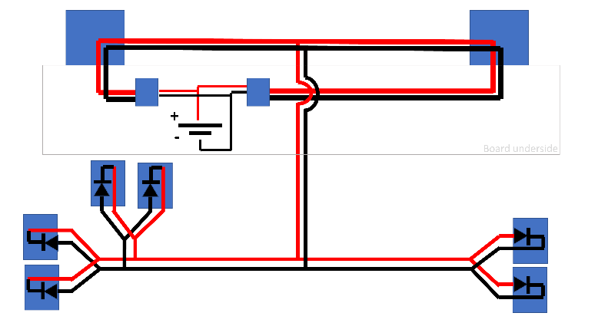
Standoffs:
- Standoffs are not necessarily needed but can be useful for leveling and balance of the board.
- Connect the threaded standoffs to the four corners of the board as shown in the figure below, holes will need to be drilled.
- There may be variation on how the standoff can connect to the board depending on the chosen standoff, itself. One method is shown below with a threaded standoff and two nuts that pin the plate.

Notes:
- The Board has open space for the placement of tags such as an AR tag to help localize the board for testing. This is useful for researchers interested in focusing on the grasping, manipulation, and control aspects for the task board.
- Additional supporting documents such as a wiring key diagram, assembly protocol, and downloadable CAD and STL files can be found at https://www.nist.gov/el/intelligent-systems-division-73500/robotic-grasping-and-manipulation-assembly/assembly

