Measurement and validation of cell-based assays with microfluidics at the
National Institute of Standards and Technology (NIST)

Gregory A. Cooksey*, Javier Atencia, and Samuel P. Forry
Biochemical Science Division, Material Measurement Laboratory
National Institute of Standards and Technology (NIST), Gaithersburg, MD, USA.
*correspondence: gregory.cooksey@nist.gov, 301-975-5529

Keywords: microfluidics, cell-based assays, validation, measurement

Introduction
The National Institute of Standards and Technology (NIST) is the National Metrology Institute (NMI) for the United States. Our mission is to advance measurement science, standards, and technology in ways that enhance economic security and improve quality of life in the United States. Because of the increased need for technologies that advance biological research and the many new and exciting innovations in microfluidics, our projects are aimed at engineering well-controlled microenvironments for quantitative measurements of cell behavior in microfluidic systems. Cell-based microfluidics at NIST is a highly multidisciplinary activity, and is greatly influenced by NIST programs in biochemical sciences, materials science, engineering, and information technology. Although there are many microfluidic-related activities ongoing at NIST, we will focus on projects related to cell-based measurements in this Spotlight.

Our goal for studying cells with microfluidic systems is to create efficient, multiplexed experimental systems in which new hypotheses can be tested and complex experimental designs can be used to generate useful biological insight. Cell culture, perturbation of conditions, and analysis can be integrated within microfluidic systems to generate information about how single cells or populations of cells behave through time. Together, these features of microfluidic systems can provide rich data sets.

From an engineering perspective, microfluidic technologies provide an exciting array of opportunities to isolate and contain cells, control parameters, and measure response to perturbation. Devices are constructed with an expanding gamut of materials that can be tailored to have specific physical properties and can be fabricated with nanometer precision. The integration of pneumatic and microelectronic functionality also provides real-time control of fluid flow, multiplexing, and measurement capabilities that enable on-chip analyses of cellular behavior and downstream products with minimal mixing or dilution.

Indeed, there are many reasons microfluidic devices hold much promise for advancing the capabilities of biomedical research. Ultimately, however, the utility of microfluidic devices depends on what can be measured, how well it is measured, and how easy it is to measure cell behaviors within them. Methods for validating both the microfluidic system and the resulting data are critical to the usability of this technology. Thus, it is important to have appropriate tools to measure both the environmental that cells are growing in and the specific cell responses to those conditions.

Advances in Fabrication and Ease of use
Microfluidics efforts at NIST have focused on ways to improve ease of use, reliability, and stability of microfluidic systems (Figure 1). Our work to improve benchtop-to-device connectivity includes the development of reliable and simple vacuum manifolds and magnetic connectors [1] that seal devices to platforms preconnected to large numbers of fluid reservoirs and pneumatic controllers [2]. In addition, we have developed a portable and robust fluid delivery system that delivers many fluids simultaneously into microdevices without need of sophisticated pumps [3]. One of our new focuses utilizes double-sided tapes to make microfluidic devices. So far we have demonstrated that experiments yielding rich biological information can be accomplished using devices fabricated with very simple methods [4]. By integrating folding lines into the tapes, we have also made novel 3-dimensional systems that contain valves and create opportunities to fluidically address specific locations within enclosed volumes [5]. We have begun utilizing this system to study chemotactic responses of C. elegans to complex configurations of signals in space and time.

Cell assays using chemical gradients
Compared to conventional cell culture technology, such as high-throughput studies in multiwell plates, microfluidics devices offer unique opportunities to control spatial and temporal signals within the cellular microenvironment. One particularly useful application involves the ability to generate quantitative and reproducible chemical gradients [4, 6-8]. These tools are useful to emulate biomolecular gradients that are important in biological processes such as development, wound healing, and cancer. In contrast with experiments in tissue culture vessels where concentrations of factors is difficult to control, microfluidic gradients enable designed and predictable spatial control of concentration, allowing the effects of chemical concentration on cell response to be studied over a wide concentration range.

At NIST, we have developed a number of new capabilities for generating robust, functional chemical gradients for the study of biological behavior. One design is called the microfluidic palette (Figure 2a) [6]. This microﬂuidic device can generate spatially overlapping chemical gradients in a microﬂuidic chamber. The gradients, generated by diffusion rather than convection, are created in such a way that they can be modified dynamically inside the chamber. With three inlets surrounding a circular chamber design, we demonstrated a triangular overlapping gradient that could furthermore be rotated by moving chemicals from inlet to inlet around the circle. Bacteria loaded into the device demonstrated chemotaxis in response to glucose gradients created within the device.

We also have created a convection-free gradient generator that is simple in design and easy to use [4]. Only a desktop razor cutter was needed to fabricate the inherently robust design from double-sided tape and plastic films. The unique design concept creates a diffusive chemical gradient by sampling from points of equal pressure from two side-by-side chemical streams. Importantly, because the culture chamber where the gradient forms is separated from the main flowing fluid, chemicals secreted by the cell are not carried away in the fluid flow. As a demonstration of the device operation, a population of cells expressing destabilized green fluorescent protein (GFP) was subjected to a gradient of cycloheximide (CHX), a ribosome inhibitor. The expression of GFP was monitored with timelapse microscopy over the course of 3 cycles of exposure and recovery from CHX gradients. These experiments illustrate the potential for temporal variation of chemical gradients to provide useful insight into complex biological processes that are difficult to attain with traditional methods.

Quality assurance of microfluidic assays
An important part of the NIST mission is to establish measurement benchmarks and to provide qualifications associated with the measurements we have taken. The microfluidics literature is filled with published reports demonstrating that a particular assay can be performed in a microchip. Though such publications present innovative ideas, they often take only small steps toward demonstrating accuracy and reliability, which are important if such methods are to be used to generate robust data sets and to provide quality assurance and validation.

Validation of cell assays can be challenging under any conditions, but can be even more challenging when dealing with a microdevice. Microfluidic systems should be tested to establish confidence in within-device consistency and to assure day-to-day reproducibility. Because small devices will contain small numbers of living cells, it is critical to establish a clear understanding of the distribution of cell heterogeneity to assure that sampling of the population response is adequate. These exercises are particularly relevant for new technologies like microfluidics, where it can be quite challenging to fabricate devices that are defect free, robust to mechanical failure, and stable over long time periods. Furthermore, surface chemistry variations, transport limitations, and shear forces may induce cellular responses that are different from those encountered in larger volume assays. Given the high cell-to-medium ratio within the small microfluidic volumes, one must also carefully consider how even a few cells or contaminants could change the concentrations of nutrients or metabolic products. The material from which the device is made can also contribute to unexpected behavior. Leachables present in the materials or the porosity and surface chemistry of the materials may entrap material or affect gas permeability. For example, poly(dimethylsiloxane) (PDMS) is a common substrate chosen for microfluidic devices, but it is unresolved why under some conditions it appears to cause deleterious effects to cells.

We recently completed a study in which we assessed repeatability in a 64-chamber microfluidic device (Figure 2b) [9]. We wanted to know how the measurements would vary within the device under slightly modified conditions. We examined measurement quality using different fluorescence excitation sources and tubing materials that might be a source of leachates. Additionally, we wanted to know if the density of cells within the chamber might change the assay outcomes. Finally, we compared the results from the microfluidic conditions with the results acquired from larger volume assays in both a standard culture dish and a dish coated with the material used to make the microfluidic devices (PDMS).

Under all condition that we tested, a similar half-life of GFP decay was measured following shut-down of the ribosomes (the mean decay time measured over all experiments performed was 241 min with a standard deviation of 13 min). Importantly, we observed that measurements from microfluidic devices had considerably higher signal-to-noise ratios than measurements from Petri dishes, primarily due to the smaller height of serum-containing medium within the microchambers. This demonstrates a distinct advantage for using microfluidic devices when making high sensitivity measurements. Also, we were able to determine the minimum number of cells required within a chamber that was necessary to fully capture the average behavior of the population (≈ 100).

Surprisingly, though protein degradation rates were identical, we observed much slower proliferation and significantly higher migration rates in the microfluidic devices compared to the larger volume dish cultures. Because cell-substratum interactions play a key role in determining both proliferative and migratory behavior, we are currently looking in closer detail at the nature of the differences between the surfaces in microfluidic and standard tissue culture plastic. We are also very interested in determining how we can use the GFP expressing cells to more generally characterize cell well-being under typical growth conditions.

Control of cellular environment
Cells in culture depend on, respond to and actively change chemical and physical cues in their surroundings. Though local environments can be defined within conventional Petri-dish cultures, spatial inhomogeneities and temporal changes are common, and rapid changes in conditions are difficult to achieve [10]. Since subtle changes in the cellular microenvironment can significantly modulate cell phenotype, well-engineered microsystems that can provide improved control are desirable to decrease the variability within cell-based assays. We have designed cell culture systems that allow dissolved gas partial pressures to be manipulated on chips that are made of gas permeable microfluidic device material (PDMS) (Figure 2c) [11-12]. Using these systems to maintain elevated CO₂ partial pressure, we demonstrated long-term (>1 week) culture of mouse fibroblasts without using a controlled-environment cell culture incubator. Since the on-chip dissolved gases were controlled externally, we were able to dynamically modulate the O₂ partial pressure in time and space. The small volumes (typically <1 µL) of microfluidic systems make evaporation and pervaporation constant concerns. However, the systems for maintaining gas partial pressure were also useful in maintaining high local relative humidity, and successfully mitigated pervaporation for stopped-flow culture experiments.

Isolating cells
When culturing cells within microfabricated devices, one may want to very specifically control the location of cellular attachment (e.g. near fluid inlets, or within an imaging window). We have explored several strategies to deterministically manipulate suspended cells in solution in order to localize their position. In dielectrophoretic (DEP) capture, electrical fields generated at microfabricated electrodes can immobilize cells at defined positions, where cell-substratum attachment can then keep the cells in the desired location [13]. Electrodes fabricated from indium tin oxide (ITO) are transparent, facilitating microscopic characterization of immobilized single cells within a microfluidic channel network [14].

Manipulation of suspended cells in microfluidic systems can also be accomplished by labeling cells of interest with specific handles. For example, we used antibody chemistry to attach magnetic particles to breast cancer cells in whole blood [15]. The magnetic labels allowed magnetophoretic dragging of labeled cells across laminar stream lines within a microfluidic channel, effectively enriching the target cell population out of whole human blood. This example illustrates the utility of microfluidic systems for working with and manipulating complex real-world samples, and could be useful for trapping and analyzing a variety of rare cell subpopulations found in biologically important samples.

Executive Summary and Future Perspective
The National Institute of Standards and Technology is actively developing technology for simple and robust connectivity and control of microfluidic devices and to improve the quality of measurements for cell-based microfluidic assays. The study of cell responses in microfluidics has great potential to revolutionize high-content screening, environmental and drug toxicology, and our understanding of complex biological processes, but microfluidics will only become a common and truly useful technology for biological research with simplified fabrication and connectivity of devices and with reliable and validated experimental methods and measurements.

Acknowledgements
We are grateful to Anne Plant for helpful discussions.

References
[1] Atencia J, Cooksey GA, Jahn A, Zook JM, Vreeland WN, Locascio LE. Magnetic connectors for microfluidic applications. Lab Chip 10, 246-249 (2010).
[2] Cooksey GA, Plant AL, Atencia J. A vacuum manifold for rapid world-to-chip connectivity of complex PDMS microdevices. Lab Chip. 9, 1298-300 (2009).
[3] Cooksey GA (NIST). Fluid Delivery System. US 20110180150A1.
[4] Atencia J, Cooksey GA, Locascio LE. Robust and tunable gradient generator for dynamic cell assays fabricated with double-sided tape, plastic films and a desktop razor cutter. Lab Chip. 12, 309-316 (2012).
[5] Cooksey GA, Atencia J. Microvalves integrated into foldable multilayered microfluidic devices made of double-sided tape. Lab Chip, (in preparation).
[6] Atencia J, Morrow J, Locascio LE. The microfluidic palette: A diffusive gradient generator with spatio-temporal control. Lab Chip. 9(18), 2707-2714 (2009).
[7] Cooksey GA, Sip CG, Folch A. A multi-purpose microfluidic perfusion system with combinatorial choice of inputs, mixtures, gradient patterns, and flow rates. Lab Chip. 9, 417-26 (2009).
[8] Keenan TM, Folch A. “Biomolecular gradients in cell culture systems,” Lab Chip. 8, 34–57 (2008).
[9] Cooksey GA, Elliott JT, Plant AL. Reproducibility and robustness of a real-time microfluidic cell toxicity assay. Anal. Chem. 83, 3890–3896 (2011).
[10] Thomas PC, Halter M, Tona A, Raghavan SR, Plant AL, Forry SP. A noninvasive thin film sensor for monitoring oxygen tension during in vitro cell culture. Anal. Chem. 81(22), 9239-46 (2009).
[11] Forry SP, Locascio, LE. On-chip CO₂ control for microfluidic cell culture. Lab Chip. 11 (23), 4041-4046 (2011).
[12] Thomas, PC, Raghavan, SR, Forry, SP. Regulating oxygen levels in a microfluidic device. Anal. Chem. 83 (22), 8821-8824 (2011).
[13] Forry, SP, Reyes, DR, Gaitan M, Locascio LE. Cellular Immobilization within Microfluidic Microenvironments: Dielectrophoresis with Polyelectrolyte Multilayers. J. Am. Chem. Soc. 128 (42), 13678-13679 (2006).
[14] Sankaran B, Racic M, Tona A, Rao MV, Gaitan M, Forry SP. Dielectrophoretic capture of mammalian cells using transparent indium tin oxide electrodes in microfluidic systems. Electrophoresis. 29 (24), 5047–5054 (2009).
[15] Forbes TP, Forry SP. Microfluidic magnetophoretic separations of immunomagnetically labeled rare mammalian cells. Lab Chip. 12, 1471-1479 (2012).

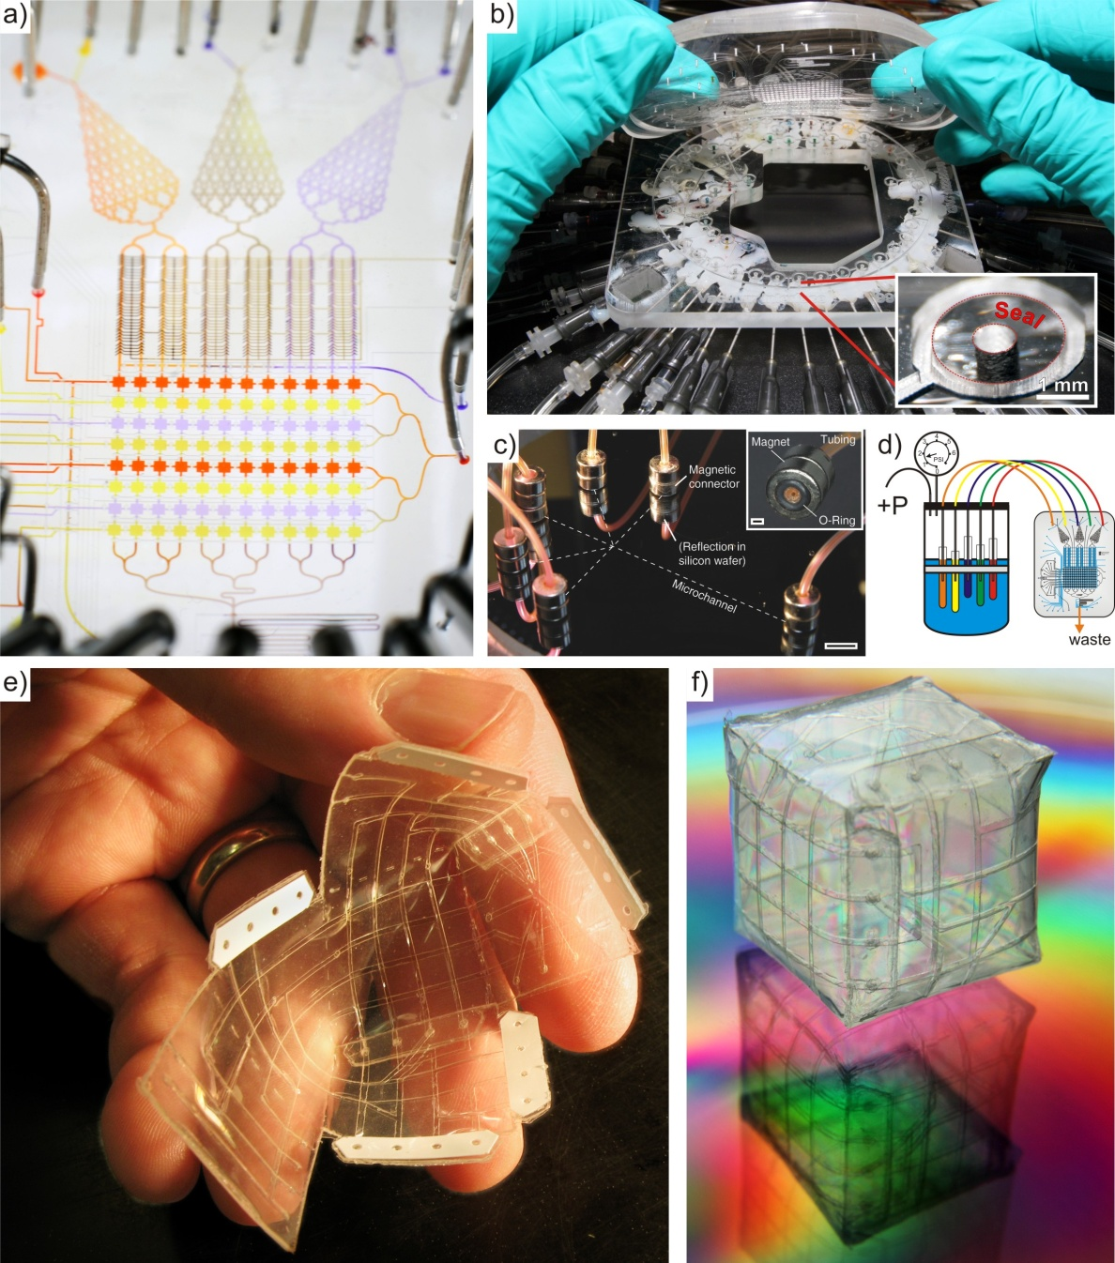
Figure 1. Much of the microfluidic work at NIST has focused on design of easy to use, reliable, and stable microfluidic systems. (a) Microfluidic devices made of PDMS offer many exciting opportunities to simultaneously deliver multiple chemicals to many cell-containing chambers in parallel and in series. However, traditionally, connecting many chemicals and valve control lines requires routing many needles from fluid reservoirs and controllers into the chip. (b) One solution we proposed is to utilize a vacuum manifold to seal devices directly to pre-connected manifolds. In this way, we simplified connectivity and testing of a 52-inlet device from several hours to several minutes. Reproduced with permission from [2]. (c) Magnetic connectors also make fast, reliable, and reversible connectors. Reproduced with permission from [1]. (d) As a way to deliver multiple fluids to devices, we created a pressurizeable container that uses floatation to stabilize fluid flow from draining reservoirs. Thus, many inputs have balanced flow into microdevices from a small, portable container [3]. As we began using simple devices made from double-sided tapes for cell assays, (e) we had the idea to incorporate folding into the flat laminates. (f) The result of folding coupled with the incorporation of pneumatic microvalves permits novel 3-dimensional microfluidic structures that can define closed fluidic volumes.
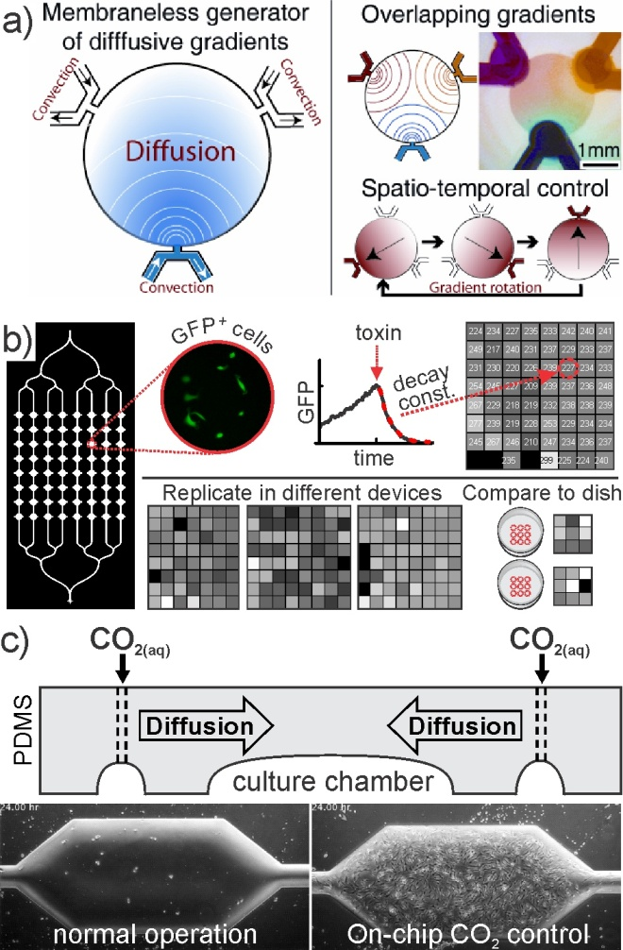
Figure 2. (a) The microfluidic palette creates overlapping chemical gradients by diffusion from multiple fluids. This technology allows us to modify in time, the orientation of the chemical gradients with exquisite control. Reproduced with permission from [4]. (b) Using a 64-chamber microfluidic device, we tested the repeatability, reproducibility and robustness of a cell-based assay. The decay in fluorescence intensity of GFP-expressing cells was monitored following the inhibition of ribosomes by a toxin (cycloheximide) and was quantified in each microfluidic compartment and replicated in three additional devices using slightly modified experimental protocols. Experiments were benchmarked to responses in larger volume conditions in Petri dishes. We determined how measurement quality varied with different experimental conditions and found that microfluidic devices demonstrated a significantly higher signal-to-noise ratio compared to petri dishes. Reproduced with permission from [9]. (c) A schematic side view of the device design depicts gas control lines routed near a stagnant cell culture chamber. Mouse fibroblast cultures deteriorated quickly (24 h shown) under typical operation, while on-chip control over CO₂ partial pressure yielded viable cultures for >1 week. In both cases, cells were seeded in stagnant chambers for 2 h before initiating intermittent perfusion (one volume change over 90 s at the beginning of each hour). Reproduced with permission from [11].

