The Network Simulator NS-2

NIST add-on

IEEE 802.16 model (MAC+PHY)

January 2009

Table of Content

1 Overview 4
2 Glossary 4
3 Packet CS 4
3.1 Classifier class structure 5
3.2 DestClassifier example 5
3.3 TCL commands 6
4 MAC sublayer 6
4.1 MAC module structure 7
4.2 Addressing and connection 8
4.3 MAC PDU format 9
4.3.1 Packet header structure 9
4.3.2 Defined Management messages 10
4.4 Construction and transmission of MAC PDUs 10
4.4.1 Fragmentation 10
4.4.2 Packing 10
4.5 ARQ 11
4.6 Scheduling services 11
4.6.1 Schedulers 11
4.6.2 TCL commands 12
4.7 Bandwidth allocation and request mechanisms 12
4.7.1 Contention resolution 12
4.7.2 TCL commands 13
4.8 MAC support of PHY 14
4.9 Network entry and initialization 14
4.10 Ranging 15
4.11 QoS 16
4.11.1 TCL commands 17
4.12 MAC layer handover procedures 17
4.12.1 Scanning 17
4.12.2 TCL commands 18
4.13 Frame structure 19
4.14 Packet processing 20
5 PHY 23
5.1 OFDM PHY 23
5.1.1 OFDM physical layer class diagram 23
5.1.2 OFDM Packet schedulers 24
5.1.3 TCL Configuration 24
5.2 OFDMA PHY 25
6 Configuration 25
6.1 Setup 25
6.1.1 Configure the node 25
6.1.2 Configure a packet classifier 25
6.1.3 Configure a scheduler 26
6.1.4 Configure the channel 26
6.2 Statistics 26
6.3 Tracing 27
7 Parameters and Constants 27
7.1 Parameters 27
8 Annexes 28
8.1 Current known issues 28
8.2 FAQ 29
9 References 29

Overview
The model currently implemented is based on the IEEE 802.16 standard (802.16-2004) and the mobility extension 80216e-2005. A snapshot of available and missing features is listed below:

Available features | Summary of features NOT implemented
- WirelessMAN-OFDM physical layer with configurable modulation  - Time Division duplexing (TDD)  - Management messages to execute network entry (without authentication)  - Default scheduler providing round robin uplink allocation to registered Mobile Stations (MSs) according to bandwidth requested  - IEEE 802.16e extensions to support scanning and handovers  - Fragmentation and reassembly of frames | - WirelessMAN-OFDMA  - Frequency Division duplexing (FDD)  - ARQ (Automatic Repeat Request)  - Service Flow and QoS scheduling  - Periodic ranging and power adjustments  - Packing  - Error Correction

It is important to note that many components are not defined in the standard. Therefore the model implements one solution, which may or may not fit the user’s need. This is the case for the bandwidth scheduler, and flow handler, or scanning scheduler. The model was designed to be relatively extensible.

Glossary
BS: Base Station
CID: Connection Identifier
CS: Convergence Sublayer
MAC: Media Access Control
MIB: Management Information Base
MS: Mobile Station
OFDM: Orthogonal Frequency Division Multiplexing
OFDMA: Orthogonal Frequency Division Multiple Access
PDU: Protocol Data Unit
PMP: Point to MultiPoint
PS: Physical Slot
RTG: Receive/transmit Transition Gap
SAP: Service Access Point
TTG: Transmit/Receive Transition Gap

Packet CS
The CS layer resides on top of the MAC layer and performs the following functions:
- Receives higher-layer PDUs
- Perform classification
- Deliver the CS PDUs to the MAC SAP
- Receives CS PDUs from the peer entity

In the current implementation, the Packet CS only performs classification. The method used to classify packets is implementation dependent. It may also be useful to implement multiple solutions in order to find the appropriate connection. The model supports user-defined classifiers.

Classifier class structure
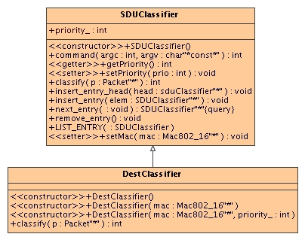
Figure 1: Packet classifier class diagram
To implement a new classifier, subclass the SDUClassifier class and implement the classify (Packet *) method. The SDUClassifier supports priority, which can be used to specify the order in which the classifiers are called. The smaller the priority value, the sooner it will be called (default value=0).
Note: The priority must be set prior to adding the classifier into the MAC since it is used to order the list of classifiers.

DestClassifier example

The DestClassifier class can be used as a reference to implements more complex packet classifiers. It uses the destination IP address to classify the packets.

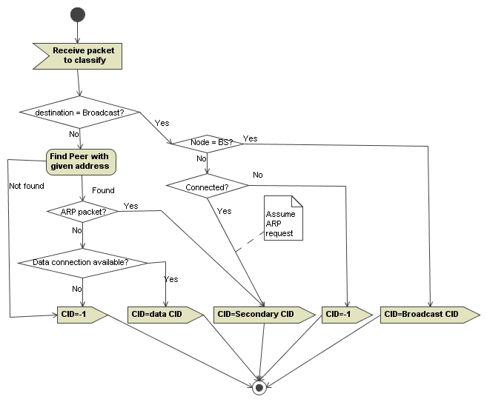
Figure 2: Flow diagram for DestClassifier
As show in Figure 2, the DestClassifier uses the destination MAC address located in the packet (and computed at the routing level) and the packet type to determine the proper CID. If there is no match, it will return -1.

TCL commands
$classifier set-priority $prio
Change the classifier’s priority. Default value is 0.

$mac reset-classifiers
Clear the list of classifier in the MAC. This must be called before adding custom packet classifier.

$mac add-classifier $classifier
Add classifier to the list of packet classifiers to use.

MAC sublayer
This section presents the MAC sublayer that currently supports PMP.

MAC module structure
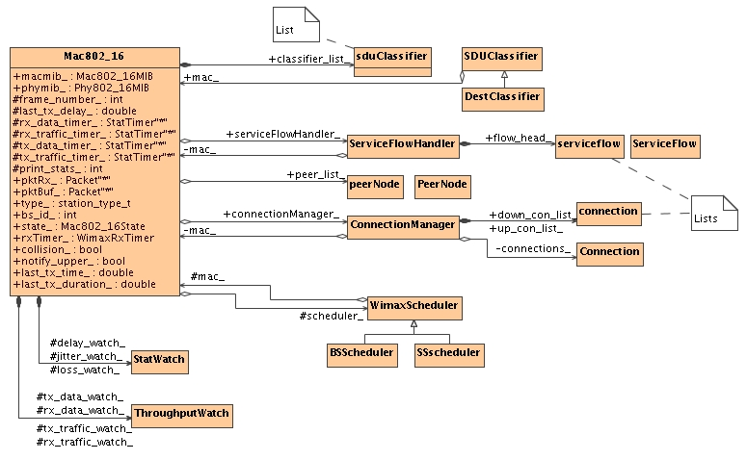
Figure 3: MAC 802.16 class diagram

The Mac802_16 is a subclass of the Mac class. It is an abstract class that contains the common elements of the BS and MS. For example it stores the MAC MIB and PHY MIB. It is the interface with other layers for sending and receiving packets. Figure 3 shows the class and the relations with other modules.
A MAC has a list of packet classifiers (SDUClassifier) that maps each outgoing packet with the proper connection identifier (CID). Using TCL, the user configures the list of classifiers to be used (see section 3). The current implementation uses the destination IP address as the classifying element.
The ServiceFlowHandler is responsible for handling flow requests/responses. It also stores the list of flows for the node.
A SS is registered to a BS, and a BS can be connected to multiple SSs. The class PeerNode contains information about the peer, such as its connections and status. The Connections are also accessed via the ConnectionManager, which contains the list of incoming and outgoing connections.
The WimaxScheduler abstract class is used to create an interface with the MAC. There are mainly two types of schedulers: one for the BS, and one for the SS. Since the scheduler is specified in TCL, it is easy to implement the abstract class and change it.
Finally, the MAC computes statistics via StatWatch and ThroughputWatch objects for packet and traffic information. The values are used to trigger events, but can also be printed during the simulation for post processing.

Since a BS and an SS have different state machines we defined 2 subclasses, namely Mac802_16BS and Mac802_16SS, as shown below.
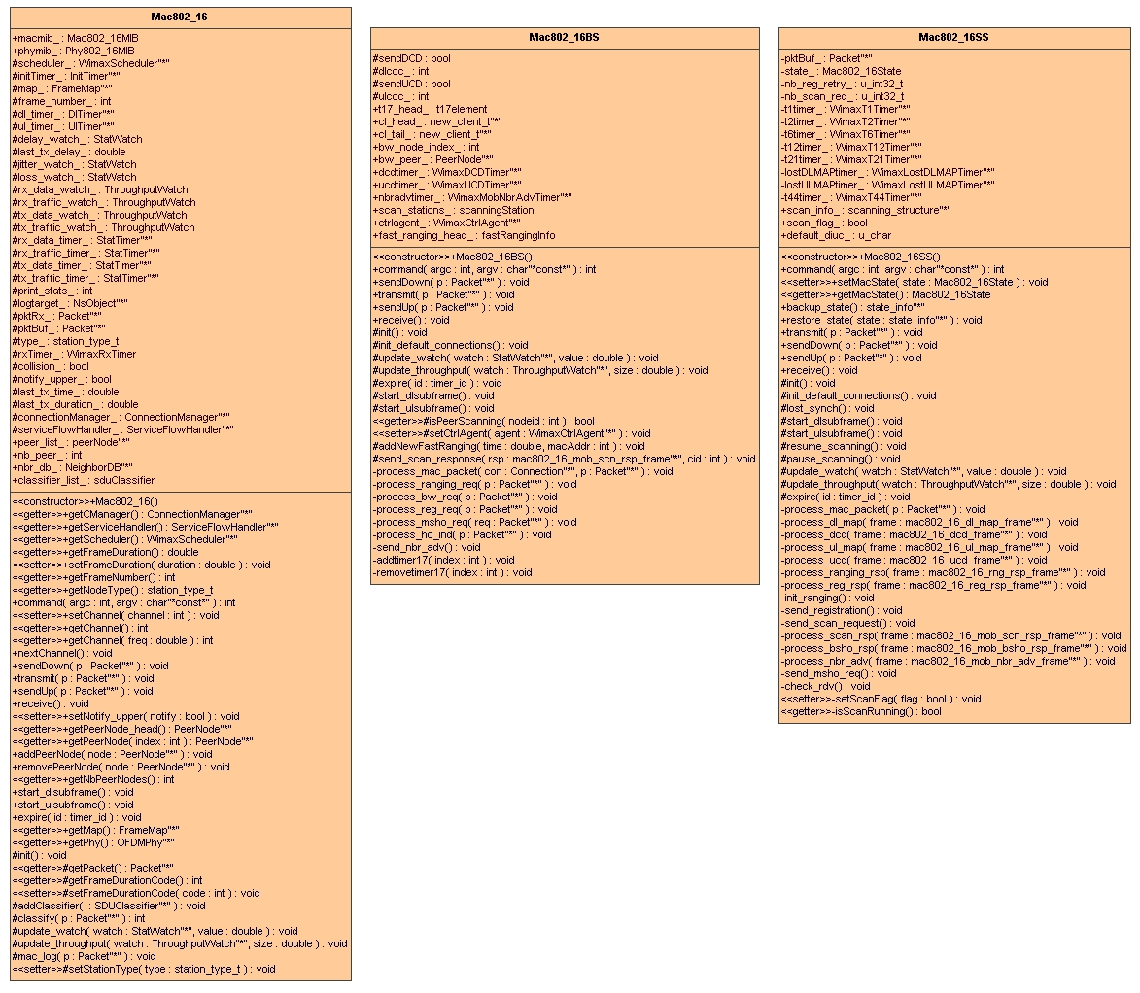
Figure 4: classes Mac802_16, Mac802_16BS and Mac802_16SS

Addressing and connection
Each MAC has a unique address coded as an int that is defined in the MAC class of NS-2.

The model also defines connection identifiers as int but they are carried as 16-bit in the messages.
The CIDs are assigned according to section 10.4 of [1] during initialization and dynamic setup of connections.
The following connections are created during initialization at the BS:
- Initial Ranging (incoming and outgoing)
- Padding (incoming and outgoing)
- Broadcast (outgoing)
- Adaptive Antenna System (AAS) (outgoing, not used)
The following connections are created during initialization at the SS:
- Initial Ranging (incoming and outgoing)
- Padding (incoming and outgoing)
- Broadcast (incoming)

Additionally, during network entry the following connections are setup and CIDs assigned:
- Basic CID (incoming and outgoing)
- Primary CID (incoming and outgoing)
- Secondary CID (incoming and outgoing)
- Data CIDs. Currently the model only supports one data connection.

MAC PDU format
The model defines a new header for carrying IEEE 802.16 packets.

Packet header structure
The class diagram of the hdr_mac802_16 class is show in Figure 5.

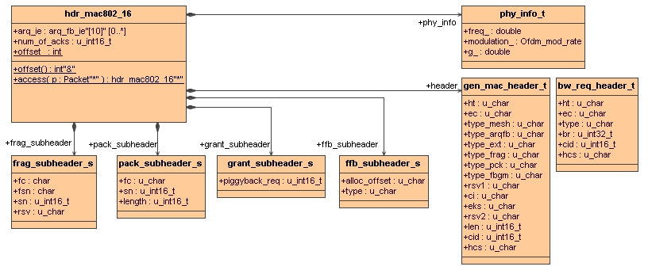
Figure 5: Class diagram of MAC header

The header contains 3 main elements:
- A virtual physical header of type phy_info_t. This structure is used to carry physical information such as frequency, modulation and cyclic prefix.
- A generic MAC header of type gen_mac_header_t containing the generic MAC information. The structure can be cast to bw_req_header_t when the packet is a bandwidth request.
- Structures to store the different sub headers. The structures are present in all the packets but the type attribute of the generic header indicates if the entry is valid or not.
When ARQ is enabled, the header also contains feedback information.

For MAC management messages, the payload contains the variable size information.

Note: Since it is not advised to use pointers in packets we implement list as arrays and include the number of elements in the list. The maximum number of elements can be updated if needed.

Defined Management messages
The following table indicates the packets currently defined in the model. All the packet definitions are located in the file mac802_16pkt.h. To compute the packet size, utility functions have been implemented in the file mac802_16pkt.cc.

Category | Messages defined
Synchronization | DL-MAP / DCD  UL-MAP / UCD  RNG-REQ/RSP  REG-REQ/RSP
Service flows | DSA-REQ/RSP/ACK
Mobility | MOB_NBR_ADV  MOB_SCN-REQ/RSP  MOB_BSHO-REQ/RSP  MON_SSHO-REQ  MOB_HO-IND  MOB_SCN-REP  MOB_ASC-REP

Construction and transmission of MAC PDUs
The construction and transmission of packets can be divided into three steps:
- Reception of outgoing packet from the upper layer: The MAC runs through the classifiers to find the proper CID. If a valid CID is found, it appends a default MAC header and puts the packet in the connection queue.
- Scheduling: Every frame the schedulers go through the list of connections to find the packets to transmit. At the BS, the scheduler performs burst allocation then transfer packets from the connection queue to the bursts. At the MS, it uses the received UL MAP to find the allocation and transfer the packets to the bursts.
- Transmission: two timers are going through the DL and UL MAP to transmit the packets stored in the burst queues.

Fragmentation
Fragmentation can be enabled/disabled on a connection based. Currently the default value is to enable the fragmentation.
When scheduling packets for transmission, the scheduler checks if fragmentation is enabled for the connection and splits the packet to fit into the burst. The fragmentation context is stored in the Connection. The method transfert_packets in the file scheduling/wimaxscheduler.cc takes care of transferring packet from their connection queue to the bursts.

Packing
Packing is currently not implemented

ARQ
ARQ is not currently implemented in the NIST model. The WiMAX forum is extending the model to support this feature (http://www.wimaxforum.org).

Scheduling services
The class structure allows for specifying different data services namely UGS, rtPS, nrTPS, and Best Effort. The services are specified in the ServiceFlow class. See section 4.11 for detailed information on QoS.
The scheduling of the packets is done by a Scheduler. This scheduler is interacting with the MAC via well defined API allowing custom implementations.

Schedulers
Different types of nodes require different packet schedulers. In IEEE 802.16, the BS controls the bandwidth allocation and there are an infinite number of implementations. The model includes an abstract class, WimaxScheduler, created to easily use different packet schedulers. As shown in Figure 6, this class already contains two implementations, an SSscheduler for SSs and a BSscheduler for BSs. These schedulers can be replaced by using the TCL as defined in section 6.1.3.
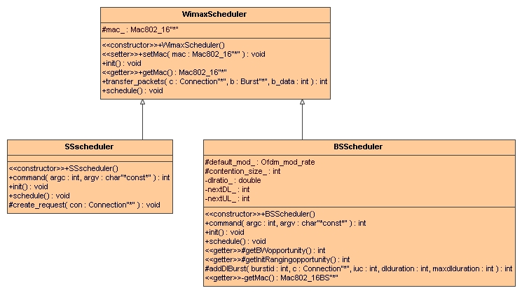
Figure 6: Packet scheduler class diagram
When implementing a new scheduler, the following methods must be implemented:
- init (): initialize the scheduler.
- process (Packet *): This method is used to process packets received by the scheduler (such as synchronization messages).
- start_ulsubframe (): code to be executed at the beginning of a new uplink subframe.
- start_dlsubframe (): code to be executed at the beginning of a new downlink subframe.

A detailed description of the default schedulers is available in the PHY sections.

TCL commands
$mac set-scheduler $scheduler
Set the MAC scheduler. It removes the previously assigned scheduler if present.

Bandwidth allocation and request mechanisms
This section describes the implementation of the different mechanisms by which a SS can request bandwidth.

Contention resolution
The BS allocates slots that are subject to collisions in the uplink direction. These slots are used in two cases:
- Initial Ranging request
- Bandwidth request

The model supports a truncated binary exponential backoff for contention resolution. The UCD messages broadcasted by the BS contain the window sizes (as a power-of-two value). The BS also decides on the number of slots allocated in each frame.

Figure 7 shows the class structure used for contention resolution. An uplink subframe contains a BwContentionslot and a RngContentionSlot. Both are subclasses of ContentionSlot which provides the basic mechanisms related to contention.
During Network Entry, the SS performs ranging to adjust its transmission power. During this step, the SS generates a RangingRequest. The SS picks a random backoff within the windows provided by the BS and stores it. Then the SS decrements the counter every time a new contention slot is found in the frame. When the counter reaches 0, the packet is being transmitted.

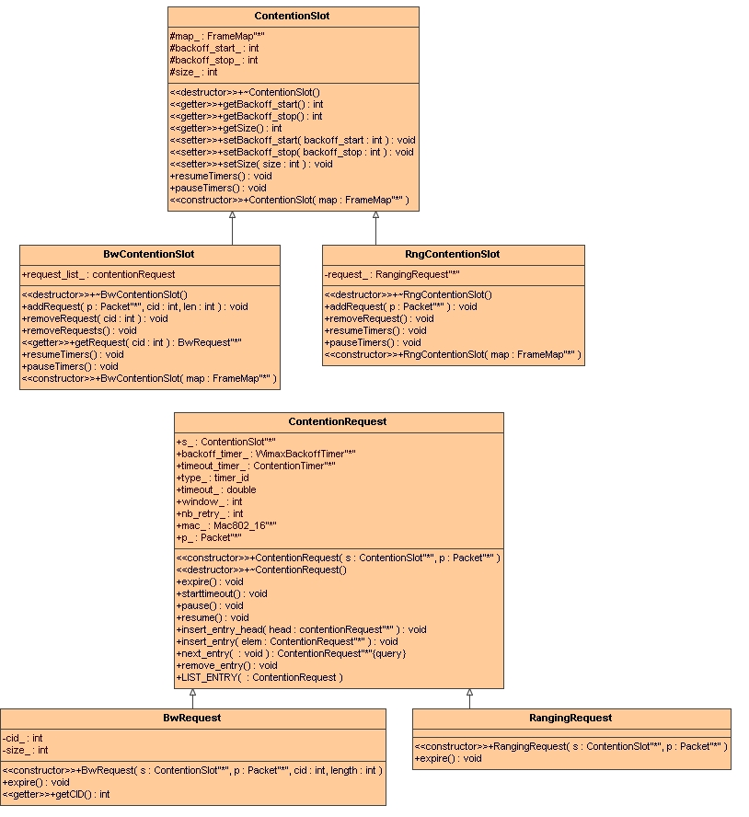
Figure 7: Contention slots and contention requests

TCL commands

Mac/802_16 set rng_backoff_start_ 2
Mac/802_16 set rng_backoff_stop_ 6
Set the backoff window size for initial ranging requests

Mac/802_16 set bw_backoff_start_ 2
Mac/802_16 set bw_backoff_stop_ 6
Set the backoff window size for bandwidth requests

Mac/802_16 set contention_rng_retry_ 16
Number of retransmission for sending ranging requests.

Mac/802_16 set request_retry_ 2
Number of retransmission for bandwidth requests

Note: the backoff windows are MAC parameters while the number of contention slots for ranging and bandwidth is a BS scheduler parameter.

MAC support of PHY
The model currently supports TDD. In this mode, uplink transmission occurs after downlink in each frame.
The DL_MAP and UL_MAP messages sent every frame defines the burst allocation and transmission opportunities for each station.
The information contained in the UL_MAP belongs to the same frame as shown in Figure 8.

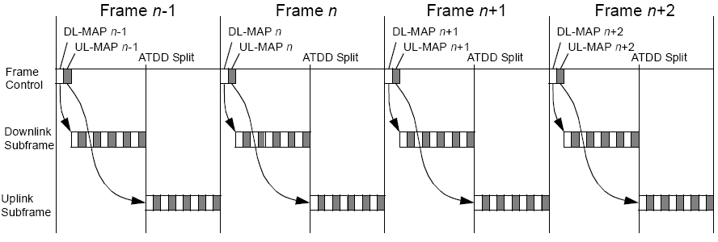
Figure 8: Time relevance of DL_MAP and UL_MAP

Network entry and initialization
When an SS wants to join a network it needs to perform network entry. As shown in Figure 9 the model implements the following components of the network entry:
- Scan downlink channel
- Obtain transmit parameters
- Initial ranging
- Registration

The following parameters can be configured:
Figure 9: Network entry
- Timers to perform channel scanning
- Frequency of the DCD/UCD messages
- Parameters for initial ranging (backoff window size and number of slots per frame)
- Channel allocation

Some aspects are IEEE 802.16e are implemented therefore network entry can be reduced if the SS has acquired the transmission parameters from the serving BS or during scanning (see section 4.12).

Ranging
Ranging is a mechanism to allow a SS to maintain a good link quality by adjusting its transmission power and modulation.

During the initial ranging, the SS includes the default DIUC profile to use for transmission. This allows the simulation of nodes transmitting at different rates.

Currently there is no algorithm implemented to make use of the ranging capabilities. It is used to add additional latency to the network entry. Periodic ranging and CDMA request are also not implemented.
TCL command:
$mac set-diuc ProfileID ;# 1<= ProfileID <= 11
Set the profile to use by the MAC. The command is only valid at an MS.

QoS
The framework defines structures to support the implementation of schedulers that make use of the different classes of service defined in [1].

Each Connection can be associated with a ServiceFlow and corresponding QoS parameters as show in Figure 10.

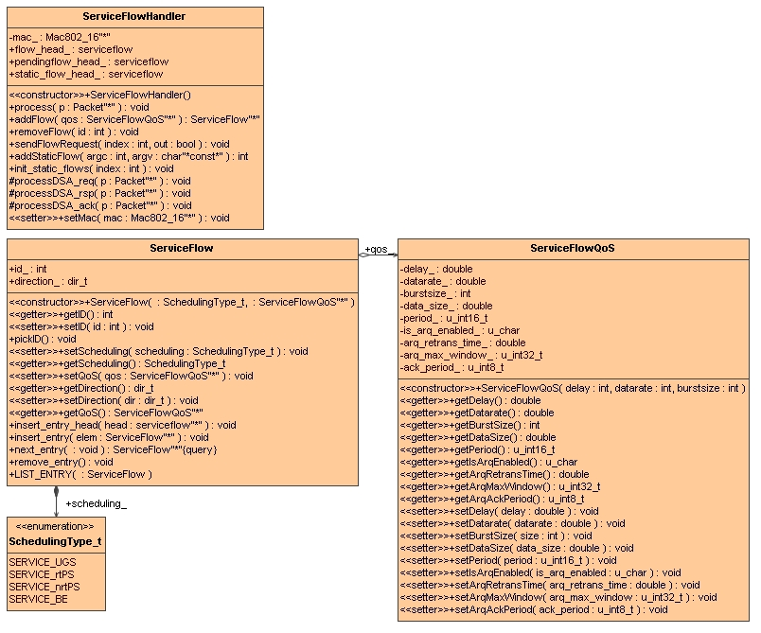
Figure 10: Service Flow

QoS flows are not currently implemented in the NIST model. By default, one data connection in each direction is setup during the network entry and the BE is used for allocation. The WiMAX forum is extending the model to support this feature (http://www.wimaxforum.org).

TCL commands
$mac set-servicehandler FlowHandler
Replace the default service flow handler.

MAC layer handover procedures
The model supports layer 2 mobility. Depending on the configuration, the MS may perform scanning and handover between BSs. This section presents the configuration parameters that affect the handover capability.

Scanning
When the link quality deteriorates, the MS can send a MOB-SCN_REQ to the serving BS to request scanning interval for the purpose of finding surrounding BSs. Figure 11 shows the messages sequence during scanning as implemented in the model.

Figure 11: Scanning procedure

To trigger the sending of a MOB-SCN_REQ, the MS monitors the signal level of the incoming packets. When the level crosses a threshold, the message is sent.
By default, the threshold is set to the RXThreshold therefore scanning is not used. To enable scanning, change the lgd_factor_ attribute of the MIB to a value greater than 1.0. The higher the value, the sooner the scanning will trigger.

During scanning, the MS collects RSSI values of incoming packets. These values are reported to the serving BS that uses the information to select the best target BS.
After the MS receives indication of the selected BS, it waits for a few frames before indicating its intention to perform handover. The introduction of the delay is to allow the traffic buffered during scanning to be exchanged before switching BSs.

Different scanning modes are implemented:
- In scan without association, the MS attempts to identify and synchronize with one or more BSs. It also estimates the signal quality.
- In association level 0, the target BS has no information about the scanning MS and only provides contention-based ranging allocations. After sending a ranging request, the MS waits for a response from the BS with a default timeout value of 50ms.
- In association level 1, the serving BS negotiates with the target BSs a time at which the MS will find a dedicated ranging region. After sending a ranging request, the MS waits for a response from the BS with a default timeout value of 50ms.
Association level 2 is not currently implemented.

To allow these different scanning modes and to perform fast handovers, the WiMAXCtrlAgent is required. The WiMAXCtrlAgent is an Agent performing 3 functions. The first one is to exchange DCD/UCD information between the neighbor BSs. The second is to trigger the sending of NBR-ADV messages to the MSs. The third one is to synchronize the serving BS and the target BSs when performing scanning level 1 or 2. The messages are exchanged over wired links using standard IP packets.

TCL commands
Mac/802_16 set lgd_factor_ factor ;# factor >= 1.0
Set the factor used to generate a link going down. When the received power is less that factor*RXThresh_, a trigger is generated to initiate scanning. The higher the factor, the sooner the trigger is generated.

Mac/802_16 set scan_duration_ 50
Set the number of frames to perform scanning.

Mac/802_16 set interleaving_interval_ 50
The number of frames interleaved between two scanning iterations.

Mac/802_16 set scan_iteration_ 2
Set the number of iterations to perform scanning.

Mac/802_16 set nbr_adv_interval_ 0.5 ;#in seconds
The interval time between two MOB_NBR-ADV messages

Mac/802_16 set scan_req_retry_ 3
Set the number of retransmission for MOB_SCAN-REQ

Agent/WimaxCtrl set debug_ 0 ;#set to 1 to print debug
Indicates if debug information must be printed regarding the scanning controller.

Agent/WimaxCtrl set adv_interval_ 1.0 ;# in seconds
Set the interval time between the exchanges of DCD/UCD information between neighboring BSs. This exchange is done using the backbone network.

Agent/WimaxCtrl set default_association_level_ 0
Set the scanning level to use. The information is embedded in the MOB_SCAN-RSP message sent by the BS to the MS.

Agent/WimaxCtrl set synch_frame_delay_ 50 ;# in second
Processing delay between the reception of a MOB_SCAN-REQ and the sending of the MOB_SCAN-RSP when synchronization with target BSs is needed.

Frame structure
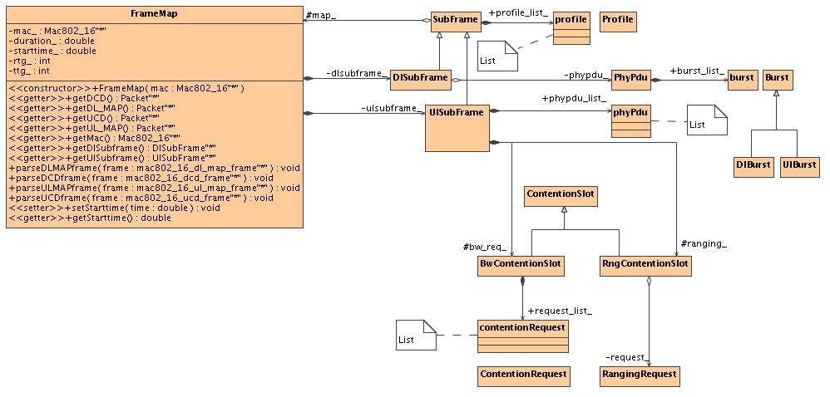
Figure 12: Frame class diagram
The design used to represent a frame is closely similar to the structure defined in IEEE 802.16 for TDD. A frame (class FrameMap) contains a downlink and an uplink subframe (abstract class SubFrame, class DlSubFrame and UlSubFrame). The subframes are themselves seperated into PHY PDU intervals. In each of these intervals, bandwidth is allocated in burst (abstract class Burst, class UlBurst and class DlBurst) for the different stations. Each of these bursts can have a different modulation and frequency called profile (class Profile).
Normally the BS allocates bandwidth for a station to transmit its data. In some cases, generally initial ranging and bandwidth requests, the SSs need to compete with each other to access the medium. These intervals (class ContentionSlot) are only present in the uplink since the BS has total control over the downlink traffic.
The FrameMap class also contains methods to extract and parse the control messages. At the BS, the scheduler creates the map structure according to an allocation algorithm, and then calls the functions getDL_MAP, getUL_MAP, getDCD, and getUCD, to retrieve the packets containing the necessary information to be sent to the SSs. At the SS, the scheduler calls the reverse functions parseDL_MAP, parseUL_MAP, parseDCD, and parseUCD to recreate the datastructure necessary to handle proper reception and transmission of packets.

Packet processing
Figure 4 shows the packet flows for incoming and outgoing packets.

The activity diagrams (Figure 14 to Figure 16) provide more detailed information on how the packets cross the MAC layer.
Figure 13: Packet processing overview

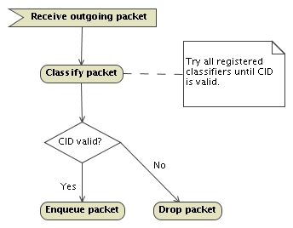
Figure 14: Outgoing packet processing
A packet received from an upper layer is classified using the registered classifiers. Since there may be multiple classifiers, the MAC accesses them one by one trying until a valid CID is found, or all classifiers have been tested. If the CID is valid, the packet is added to the matching queue otherwise it is dropped.

When a new packet is received, i.e. its first bit, steps shown in Figure 15 are executed. At the end of the reception, the packet is processed as shown in Figure 16.

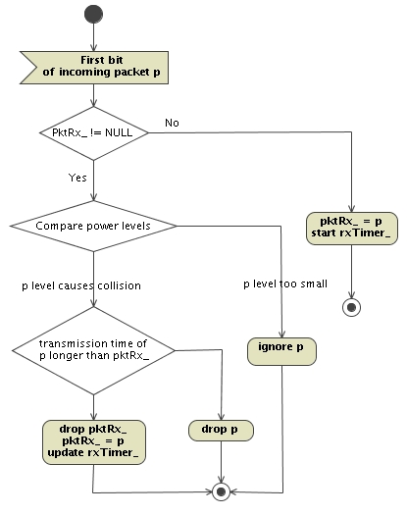
Figure 15: New incoming packet processing

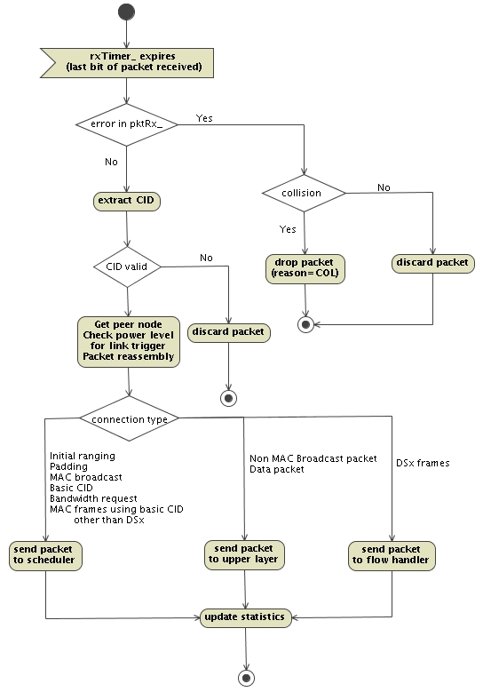
Figure 16: received packet processing

PHY

OFDM PHY

OFDM physical layer class diagram
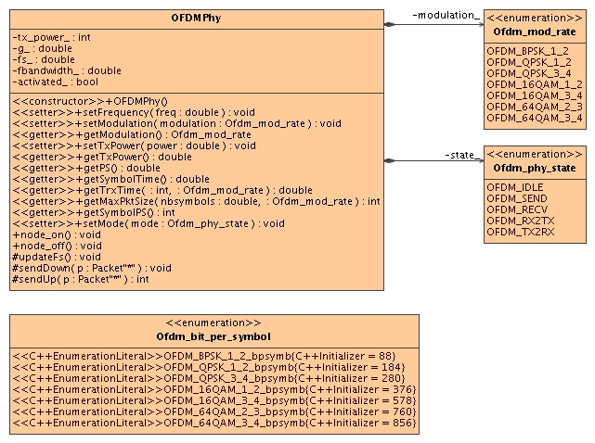
Figure 17: OFDM Physical layer class diagram
The OFDM physical layer is used to transmit packets in the implemented model. The configuration is done using TCL bindings for the frequency bandwidth and cyclic prefix. Since it inherits from the WirelessPhy class, attributes such as frequency or transmission power can also be configured by TCL.
As Shown in Figure 17, the physical layer can be in different states. When in sending mode, all incoming packets are discarded. In receiving mode, packets cannot be sent. Furthermore, the packet header contains virtual information, such as frequency, modulation, and cyclic prefix, which are used to filter incoming packets.
The model supports different modulations. The MAC layer allocates bursts that can use different modulations according to distance or interference. This affects the data rate and transmission time. The physical layer includes helper functions called by the MAC layers when transmitting data:
- getTrxTime returns the time required to send a packet given its size and modulation.
- getMaxPktSize is the reverse function and returns the maximum packet size given the number of OFDM symbols available and the modulation used.
The node_on and node_off functions enable or disable blocking all transmissions and receptions of packets, but is not currently linked to any power consumption mechanisms.

OFDM Packet schedulers

BSscheduler
The current implementation of the packet scheduler for BS can be configured using the following commands:

set scheduler [new WimaxScheduler/BS]
Creates a packet scheduler for BS.

$scheduler set-contention-size $size
Set the number of contention slots to be allocated for initial ranging and bandwidth requests in each frame.

The scheduler implements a Best-Effort scheduler coupled with a Round Robin algorithm to distribute the bandwidth allocations among the users.
To support BE, bandwidth requests are generated at the SS indicating the amount of data to transfer.
The ratio between the downlink and uplink subframes is fixed and is configured via TCL

WimaxScheduler/BS set dlratio_ 0.3
Indicates 30% of the frame is for downlink and 70% is for uplink.

The scheduler also allows users to have different modulations.
$scheduler set-default-modulation $modulation
sets the modulation to use for the initial ranging and bandwidth requests slots.

Profile bursts are created by default as follows:
Profile name | Modulation
DIUC_PROFILE_1, UIUC_PROFILE_1 | OFDM_BPSK_1_2
DIUC_PROFILE_2, UIUC_PROFILE_2 | OFDM_QPSK_1_2
DIUC_PROFILE_3, UIUC_PROFILE_3 | OFDM_QPSK_3_4
DIUC_PROFILE_4, UIUC_PROFILE_4 | OFDM_16QAM_1_2
DIUC_PROFILE_5, UIUC_PROFILE_5 | OFDM_16QAM_3_4
DIUC_PROFILE_6, UIUC_PROFILE_6 | OFDM_64QAM_2_3
DIUC_PROFILE_7, UIUC_PROFILE_7 | OFDM_64QAM_3_4

The user can select the burst profile to use [1-7] by TCL using the following:
[$SSWithWiMax set mac_(0)] set-diuc 7
Note: By default, the profile (modulation) is the same for BOTH downlink and uplink for communication between a SS and a BS.

SSscheduler
set scheduler [new WimaxScheduler/SS]
Creates a packet scheduler for SS.

TCL Configuration
Phy/WirelessPhy/OFDM set g_ 0 ;# cyclic prefix
Set the cyclic prefix to use. Valid values are 0.25 (1/4), 0.125 (1/8), 0.0625 (1/16), 0.03125 (1/32)
By increasing the cyclic prefix, the overhead is increasing thus reducing the maximum throughput.

Mac/802_16 set fbandwidth_ 5e+6 ;# frequency bandwidth (MHz)
Configure the frequency bandwidth. Setting a higher bandwidth increases the throughput.

Mac/802_16 set rtg_ 10 ;# number of PS to switch from receiving to transmitting state
The duration required to switch from receiving to transmitting. Increasing the value decreases the maximum achievable throughput.

Mac/802_16 set ttg_ 10 ;# number of PS to switch from transmitting to receiving state
The duration required to switch from transmitting to receiving. Increasing the value decreases the maximum achievable throughput.

Mac/802_16 set channel_ 0 ;# channel number
Se the channel to use. This is configured at the MAC and passed to the physical layer. It is required to set it at the BS. The MS will scan the channels to detect surrounding BSs.

OFDMA PHY
OFDMA physical layer is not currently implemented in the NIST model. The WiMAX forum is extending the model to support this feature (http://www.wimaxforum.org).

Configuration

Setup
There are multiple steps required to start using the IEEE 802.16 model in the simulations.

Configure the node
The MAC and Physical layers are specified using the node-config method in TCL:

$BSWithWiMax node-config
-macType Mac/802_16/BS
-phyType Phy/WirelessPhy/OFDM

$SSWithWiMax node-config
-macType Mac/802_16/SS
-phyType Phy/WirelessPhy/OFDM

Configure a packet classifier
In IEEE 802.16, packets received by the MAC layer from upper layers are classified in order to direct them to the proper connection. The model proposes a classifier based on the destination MAC address and packet type.

# Create classifier
set classifier [new SDUClassifier/Dest]
# Set the classifier priority
$classifer set-priority 1
# Retrieve the MAC layer and delete all registered classifiers
[$nodeWithWiMax set mac_(0)] reset-classifiers
# Retrieve the MAC layer and set classifier
[$nodeWithWiMax set mac_(0)] add-classifier $classifier

Note: A default classifier (DestClassifier) is added to the MAC. To add change the classier, reset the list and add a new classifier.

Configure a scheduler
To allow flexibility the MAC layer can use different types of schedulers. Mainly there is one for Base Stations (BSs) and one for Subscriber Stations (SSs). Section 4.6.1 shows how to extend the default schedulers.
For BS, the following TCL code sets the scheduler

# Create scheduler
set scheduler [new WimaxScheduler/BS]
# Add scheduler
[$nodeWithWiMax set mac_(0)] set-scheduler $scheduler

Note: This scheduler is automatically created when the MAC 802.16 BS is created.

For SS, the following needs to be used

# Create scheduler
set scheduler [new WimaxScheduler/SS]
# Add scheduler
[$nodeWithWiMax set mac_(0)] set-scheduler $scheduler

Note: This scheduler is now automatically created when the MAC 802.16 SS is created.

Configure the channel
To allow multi cell topologies, the MAC layers can operate at different frequencies. To set the frequencies, the user can set the channel number for the MAC.

# Retrieve the MAC layer and set classifier
[$nodeWithWiMax set mac_(0)] set-channel 1 #valid 0-4

The current frequency table contains 5 channels on the 3.5GHz band and 7MHz frequency bandwidth.

Statistics
Some statistics are collected at the MAC layer. The following command is used to display their values during the simulation.

Mac/802_16 set print_stats_ true

Tracing
The IEEE 802.16 model introduces new values in the trace file. Two new reasons for dropping a packet appear:
- CID: this reason code is used when a packet received at the MAC layer cannot be matched to any connection.
- QWI: each connection has a queue to store pending frames. When the queue is full, the packet is dropped using this reason code.
- FRG: indicates an error during the transmission of a fragment.
A new packet type is introduced. Sometimes, BSs need to communicate for synchronization purposes. A new agent called Agent/WimaxCtrl handles this communication, and sends packets marked as WimaxCtrl.

Note on traces when fragmentation is used:
If MAC traces are enabled and fragmentation is used, the fragments will be shown as sent but not received. At the last fragment, the complete packet can be decoded and passed to upper layer which would then create a trace entry on the receiver side. For example, let’s consider a packet with 1520 bytes which will be fragmented in four fragments of 396, 396, 396, and 364 bytes. The trace file will contain four “send” entries for each of the fragments but only one “received” entry of 1520 bytes for the complete packet.

Parameters and Constants

Parameters
Many parameters exist to configure the MAC and Physical layers. Below is the list of parameters, default values, and descriptions as presented in the file ns-wimax.tcl.

# This class contains default value for tcl

#Physical layer configuration
Phy/WirelessPhy/OFDM set g_ 0 ;# cyclic prefix
Mac/802_16 set channel_ 0 ;# channel number
Mac/802_16 set fbandwidth_ 5e+6 ;# frequency bandwidth (MHz)
Mac/802_16 set rtg_ 10 ;# number of PS to switch from receiving to transmitting state
Mac/802_16 set ttg_ 10 ;# number of PS to switch from transmitting to receiving state

#MAC layer configuration
Mac/802_16 set queue_length_ 50 ;#maximum number of packets

Mac/802_16 set frame_duration_ 0.004 ;# frame duration (s)
Mac/802_16 set dcd_interval_ 5 ;# interval between the broadcast of DCD messages (max 10s)
Mac/802_16 set ucd_interval_ 5 ;# interval between the broadcast of UCD messages (max 10s)
Mac/802_16 set init_rng_interval_ 1 ;# time between initial ranging regions assigned by the BS (max 2s). Note used
Mac/802_16 set lost_dlmap_interval_ 0.6 ;# timeout value for receiving DL_MAP message (s)
Mac/802_16 set lost_ulmap_interval_ 0.6 ;# timeout value for receiving UL_MAP message (s)

#Timers (all values in seconds)
Mac/802_16 set t1_timeout_ [expr 5* [Mac/802_16 set dcd_interval_]] ;# wait for DCD timeout
Mac/802_16 set t2_timeout_ [expr 5* [Mac/802_16 set init_rng_interval_]] ;# wait for broadcast ranging timeout
Mac/802_16 set t3_timeout_ 0.2 ;# ranging response timeout
Mac/802_16 set t6_timeout_ 3 ;# registration response timeout
Mac/802_16 set t12_timeout_ [expr 5* [Mac/802_16 set ucd_interval_]] ;# UCD descriptor timeout
Mac/802_16 set t16_timeout_ 0.1 ;# bandwidth request timeout
Mac/802_16 set t17_timeout_ 5 ;# authentication. Not used
Mac/802_16 set t21_timeout_ 0.02 ;# wait for DL_MAP timeout. Replace with 20ms to emulate preamble scanning on channel.

Mac/802_16 set contention_rng_retry_ 16 ;# number of retries on ranging requests (contention mode)
Mac/802_16 set invited_rng_retry_ 16 ;# number of retries on ranging requests (invited mode)
Mac/802_16 set request_retry_ 16 ;# number of retries on bandwidth allocation requests
Mac/802_16 set reg_req_retry_ 3 ;# number of retries on registration requests
Mac/802_16 set tproc_ 0.001 ;# time between arrival of last bit of a UL_MAP and effectiveness. Note used
Mac/802_16 set dsx_req_retry_ 3 ;# number of retries on DSx requests
Mac/802_16 set dsx_rsp_retry_ 3 ;# number of retries on DSx responses

Mac/802_16 set rng_backoff_start_ 2 ;# initial backoff window size for ranging requests
Mac/802_16 set rng_backoff_stop_ 6 ;# maximal backoff window size for ranging requests
Mac/802_16 set bw_backoff_start_ 2 ;# initial backoff window size for bandwidth requests
Mac/802_16 set bw_backoff_stop_ 6 ;# maximal backoff window size for bandwitdh requests

Mac/802_16 set scan_duration_ 50 ;# duration (in frames) of scan interval
Mac/802_16 set interleaving_interval_ 50 ;# duration (in frames) of interleaving interval
Mac/802_16 set scan_iteration_ 2 ;# number of scan iterations
Mac/802_16 set t44_timeout_ 0.1 ;# timeout value for scan requests (s)
Mac/802_16 set scan_req_retry_ 5 ;# number of retries on scan requests
Mac/802_16 set max_dir_scan_time_ 0.2 ;# max scan for each neighbor BSs (s)
Mac/802_16 set nbr_adv_interval_ 0.5 ;# interval between 2 MOB-NBR_ADV messages (s)
Mac/802_16 set client_timeout_ 0.5 ;# timeout value for detecting out of range client

Mac/802_16 set lgd_factor_ 1 ;# coefficient used to trigger Link Going Down (1 for no trigger)
Mac/802_16 set print_stats_ false ;# true to activate print of statistics
Mac/802_16 set rxp_avg_alpha_ 1 ;# coefficient for statistic on receiving power
Mac/802_16 set delay_avg_alpha_ 1 ;# coefficient for statistic on frame delay
Mac/802_16 set jitter_avg_alpha_ 1 ;# coefficient for statistic on frame jitter
Mac/802_16 set loss_avg_alpha_ 1 ;# coefficient for statistic on frame loss
Mac/802_16 set throughput_avg_alpha_ 1 ;# coefficient for statistic on throughput
Mac/802_16 set throughput_delay_ 0.02 ;# interval time to update throughput when there is no traffic

WimaxScheduler/BS set dlratio_ 0.3 ;#default DL/UL subframe ratio

Annexes

Current known issues
Pb when changing channel bandwidth

FAQ
Q: What does "bash: ns: command not found" mean?
A: The NS-2 simulator is not properly installed/compiled. Execute "./configure; make clean; make" from the ns-2.29 directory.

Q: What does invalid command name "Phy/WirelessPhy/OFDM" while executing "Phy/WirelessPhy/OFDM set g_0" mean?
A: The OFDM class is unknown to NS. This means the code has not been recompiled. Execute "./configure; make clean; make" from the ns-2.29 directory.

Q: What does invalid command name "Mac/802_16" while executing "Mac/802_16 set debug_ 0" mean?
A: The Mac/802_16 class is unknown to NS. This means the code has not been recompiled. Execute "./configure; make clean; make" from the ns-2.29 directory.

Q: Does the current model support class of service (UGS, RTPS, NRTPS and BE)?
A: No. Though the architecture defines the structures to use it, the current scheduler does not make use of it.

Q: What scheduler is implemented?
A: The default scheduler for OFDM uses a Best Effort algorithm coupled with the Round Robin.

Q: How to set the -DDEBUG_WIMAX switch?
A: Look for the line starting with "DEFINE = -DTCP_DELAY_BIND_ALL" and add the -DDEBUG_WIMAX.

Q: How to set the datarate?
A: Unlike the 802.11 implementation, the datarate is not something set in TCL. Since each burst can use a different modulation and therefore have different datarates, we opted for a dynamic calculation of the datarate. By setting the frequency bandwidth, cyclic prefix and the modulation, the datarate will change. Other parameters such as number of contention slots for initial ranging and bandwidth requests or the downlink/uplink ratio affect the maximum amount of data that can be transferred during a frame.

References

IEEE Std 802.16-2004: IEEE Standard for Local and metropolitan area networks. Part 16: Air Interface for Fixed Broadband Wireless Access Systems

Ieee Std 802.16e-2005: IEEE Standard for Local and metropolitan area networks. Part 16: Air Interface for Fixed and Mobile Broadband Wireless Access Systems. Amendment 2: Physical and Medium Access Control Layers for Combined Fixed and Mobile Operation in Licensed Bands and Corrigendum 1

