Dear <examiner name> :
The Baldrige Online Scorebook Solution (BOSS), is available for you to use in completing your pre-work assignments for on-site training.
Getting Started
First, please check your browser settings. Open up a browser session (e.g., Internet Explorer). Click on Tools, then Internet Options. Click on the Advanced tab. Scroll down through the settings to find "Use TLS 1.0," and be sure it is checked. Click on Apply and OK to save the setting.
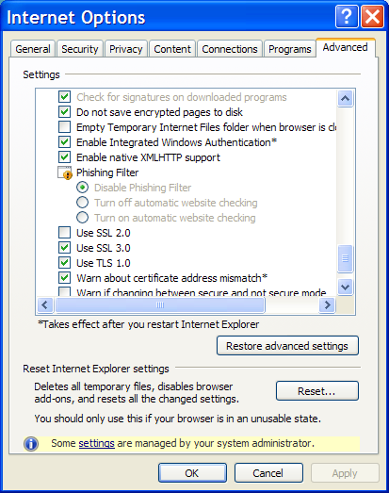
The URL for the site is: https://www-s.nist.gov/boss
Your username is: < username>
Once we activate your account, you will receive a temporary password in a second e-mail at this address, which is the primary e-mail address we have for you in our database.
1. Open a browser and navigate to https://www-s.nist.gov/boss. Enter your user name and temporary password. Please remember that both are case sensitive.
2. Answer the three security questions on the screen. If you forget your password later, providing the same answers to these questions will enable you to verify your identity and reset your password.
3. Follow the directions on the "Change Password" screen to set a new password that meets the requirements shown on the screen.
4. If you see an Adobe request to save some data on your local machine, click "yes." This allows BOSS to store data (such as the Criteria and glossary text) locally and run more efficiently. This one-time request will appear on every machine you use to access BOSS.
5. Read, agree to, and acknowledge the Code of Ethical Conduct.
6. Complete the Conflict of Interest questionnaire. When you determine that you have no conflicts and save your responses, you will gain access to BOSS. (Even though the case study is fictitious, you must still complete the questionnaire.)
BOSS Feature Highlights:
- Security: Meets federal requirements
- Availability: Access BOSS from any Internet-connected computer at any time
- Self-service password: Change your password by answering security questions
- Built-in formatting: Enter text in database-driven fields, eliminating table-formatting issues
- Spelling checker: Check spelling within fields (rather than the full document)
- Criteria: Available within BOSS; toggle the Criteria pane on and off by clicking an icon
- Glossary: Available within BOSS; click on a term to see the definition in a pop-up
- File upload and viewing area: for team agendas, timelines, etc.
- Customizable view: Adjust the size of columns, panes, and fonts, and sort many columns
- Flexible format: See and save Item Worksheets and scorebooks in Microsoft Word format
New to BOSS:
- New drop down box to select the appropriate item reference for the comment
- Score must be consistent with the selected scoring range for each item
- No requirement to mark items or individual sections complete
- Scorebook Progress tab now shows the number of Strengths and OFIs for each item as well as the scoring range and score
- A “BOSS Suggestion” icon (top right of screen) where you can record any suggestions or ideas related to BOSS as you navigate through the interface.
If you have any questions or need assistance, please send an e-mail to examtrng@nist.gov
Refer to the Examiner Resource Center for more information: http://www.nist.gov/baldrige/examiners/resource_center/

