BOSS Worksheet Samples
(thanks to Amy Katschman)
The following pages are samples of the Item and SVI Worksheets for Process Item 5.1 and Results Item 7.3 as they would look online in BOSS at the end of the planning phase, before the export to PDFs.
Please note that the samples may contain less content or editing than the actual worksheets developed for a site visit but are provided to show how information flows through BOSS.
Additional tools and information are available at Examiner Resource Center / Site Visit Review .

BOSS Online Process Item Worksheet 5.1 Planning Phase (screenshot 1 of 1)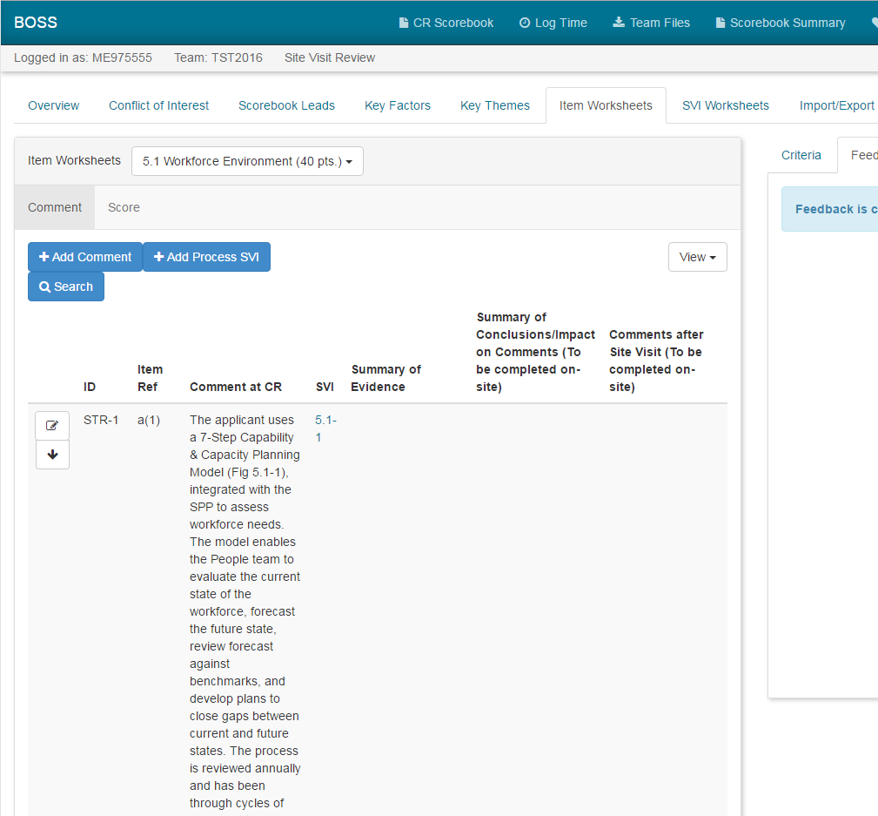
The ID, Item Ref, and Comment at CR are filled in by BOSS automatically after the team is switched to site visit stage by BPEP
Start a Process SVI Worksheet by clicking on the “Add Process SVI” button or go to the SVI Worksheets tab
BOSS Online Process Site Visit Issue Worksheet 5.1-1 Planning Phase (screenshot 1 of 3)
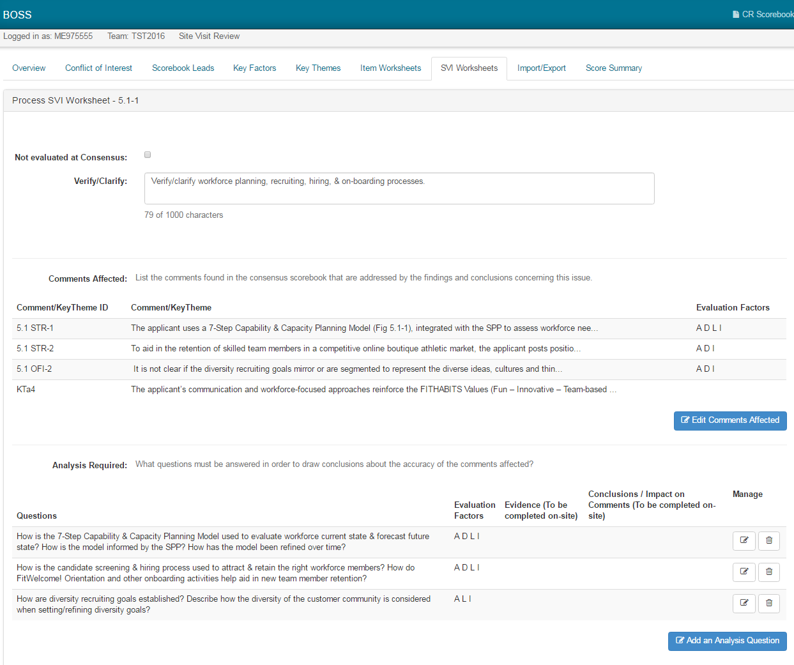
Once clicked, a popup window will appear where Comments, Key Themes, and Evaluation Factors can be selected
Once clicked, a popup will appear where Questions and Evaluation Factors can be selected
This is where to write the site visit issue
BOSS Online Process Site Visit Issue Worksheet 5.1-1 Planning Phase (screenshot 2 of 3)
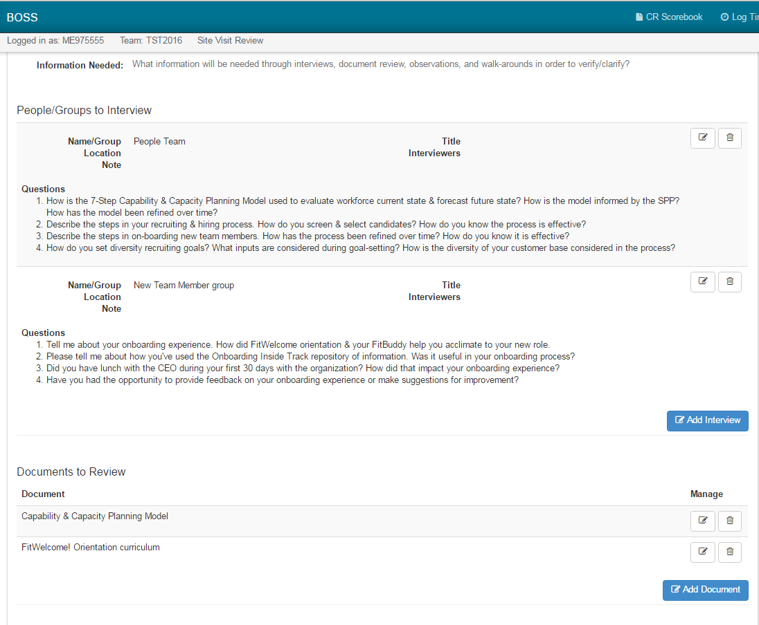
Add each Document to Review that is being requested from the applicant. This information from the entire team will be added to the Consolidated Document List PDF; one of the Export files
A popup window will appear to fill in relevant interview information. This will be compiled from the entire team in to the Consolidated Interview List PDF; one of the Export files
BOSS Online Process Site Visit Issue Worksheet 5.1-1 Planning Phase (screenshot 3 of 3)

Observations to Make could include online demos or processes that need to be seen in person
These Walk-Around Questions will be compiled from the entire team to the Consolidated Question List PDF; one of the Export files
BOSS Online Results Item Worksheet 7.3 Planning Phase (screenshot 1 of 1)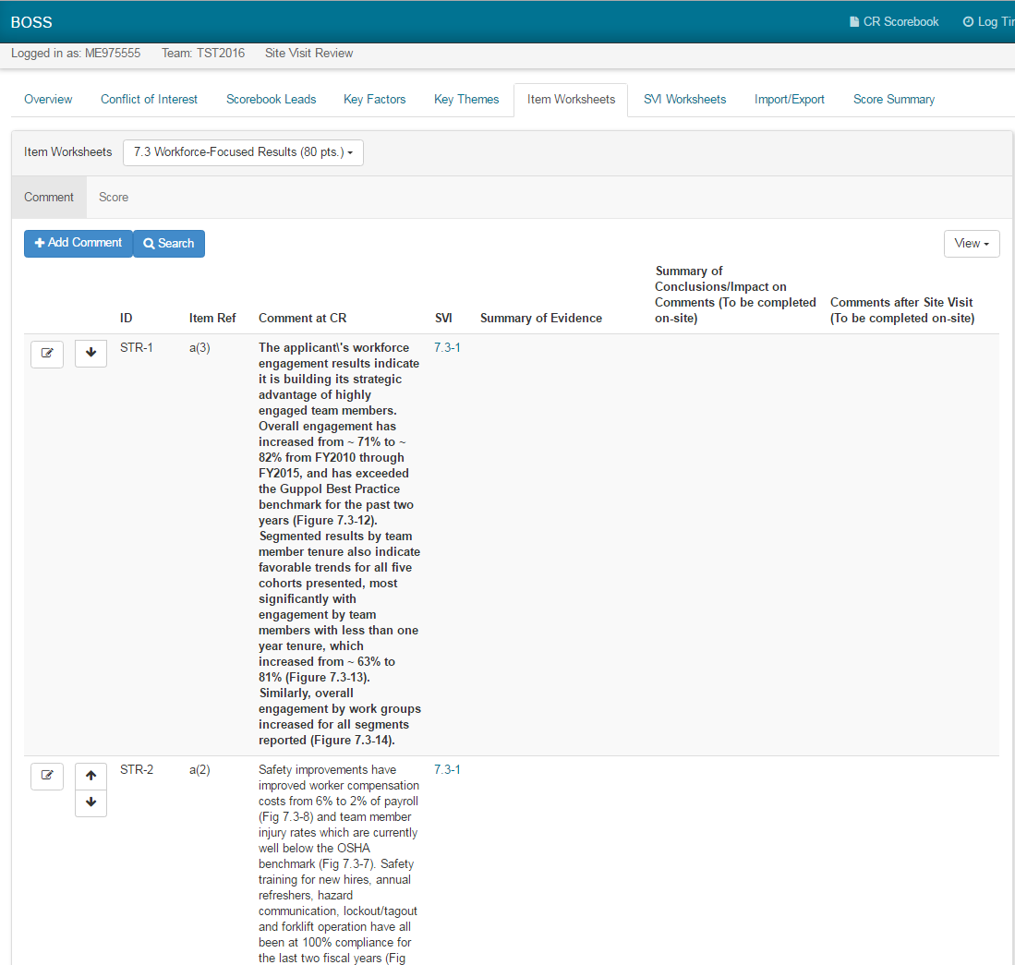
The ID, Item Ref, and Comment at CR are filled in by BOSS automatically after the team is switched to site visit stage by BPEP

There is only one SVI Worksheet per Results Item
BOSS Online Results Site Visit Issue Worksheet 7-3-1 Planning Phase (screenshot 1 of 2)
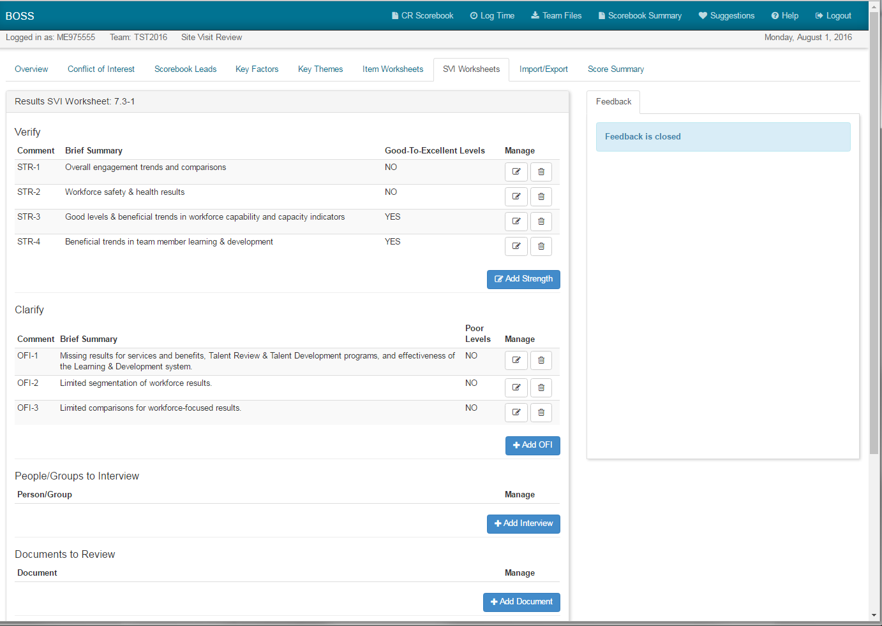
A popup appears to Add Document that is being requested from the applicant. This will be added to the Consolidated Document List PDF; one of the Export files

After clicking Add Strength or Add OFI, a popup window appears to select Comments, provide a Brief Summary; describe Levels, Trends, Comparisons, Segmentation; and list applicable Figures

A popup appears to fill in relevant interview information. This will be added to the team’s Consolidated Interview List PDF; one of the Export files

BOSS Online Results Site Visit Issue Worksheet 7-3-1 Planning Phase (screenshot 2 of 2)

