Instructions for Completing
training Prework
NEW Examiners

This pre work assignment must be completed prior to your classroom session. Your progress will be checked.
The following six-part process and Web page links will guide you in creating a partial Independent Review (IR) Scorebook for your fictitious Baldrige award application.
PART 1: Review the 8 On-Line Modules
Click this link: http://www.nist.gov/baldrige/examiners/resource_center/onboarding.cfm
This link takes you to the page where you will see links to 8 short online modules. These modules will provide you a better understanding of the application evaluation process, which will help your understanding this assignment. Please review these modules in the order presented.

PART 2: Locate and become familiar with these resources:

Click this link: On the Board. Scroll down and find these resources in the Pre Work section. It will help you to print these and have them handy as you do this exercise. (Printing 2-sided is recommended if possible).

- FitHabits Case Study (This is your sample Award Application)
- Process Sample Item 5.1 Independent Review (IR) Worksheet
- Results Sample Item 7.3 IR Worksheet
(In Part 4 below, please follow these examples, paying particular attention to format, brevity, and clarity.)
- Comment Guidelines
- 2016 Key Factors Worksheet Sample

PART 3: Access BOSS
1. After receiving your email with account information from
BOSSAdm@nist.gov, sign into BOSS and follow the instructions. Note that you will be asked to answer a conflict of interest questionnaire, as if you were evaluating a real applicant. Just respond that you do not have a conflict of interest with this applicant.
2. Become familiar with BOSS navigation and functionality.

PART 4: Evaluate case study items 4.1, 4.2, 5.2, 7.1, and 7.2 (using BOSS).
a. Become familiar with the Baldrige Excellence Framework booklet you were instructed to download from BOSS. Jot down any questions you have about the meaning of the Criteria. You will have a chance to ask questions in the classroom session.
b. Read the application (case study), highlighting and/or making notes on anything you feel may be important to the evaluation of this (fictitious) award applicant.
c. Draft an initial list of Key Factors. A key factor is an attribute of an organization or its environment that has a significant influence on the way the organization operates and the key challenges it faces. Examples may include its mission, vision, and values; strategic challenges; and workforce groups and segments. However, key factors do not include descriptions of processes.

Examiners use their best judgment to determine key factors. Examiners then use key factors to focus their assessment on what is really important to the applicant. Key factors are found primarily by reading the applicant’s responses to the questions in the Organizational Profile portion of the award application, but may be found elsewhere in the application.
Your draft list of key factors should look similar to the 2016 Key Factors Worksheet Sample (partial key factors list), which can be found in the online prework materials.

Now, click on the Key Factors tab in BOSS and enter your key factors.
- For each key factor you enter, click Add Key Factor.
- Indicate the section of the Organizational Profile that applies to the key
factor (e.g., P.1a, P.1b, etc.)
- Record a label and the text for the key factor.

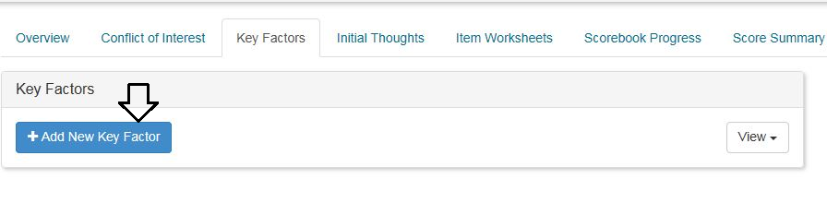

d. For each Criteria Item (4.1, 4.2, 5.2, 7.1 and 7.2), complete the following six-step
“Independent Review” award application evaluation process: (You may want to start with item 5.2 as it tends to be easier)
(Step 1) Read the Criteria Item requirements (e.g., Item 5.2 in the Baldrige Excellence Framework booklet) to gain a good understanding of Criteria Item you are going to work on.
(Step 2) Determine and select the most relevant key factors for the item.
In BOSS, review the list of key factors you created. Select the four to six key factors you believe are the most relevant for the Criteria item you are working on (e.g., item 5.2). These will be a subset of those on your key factors list --
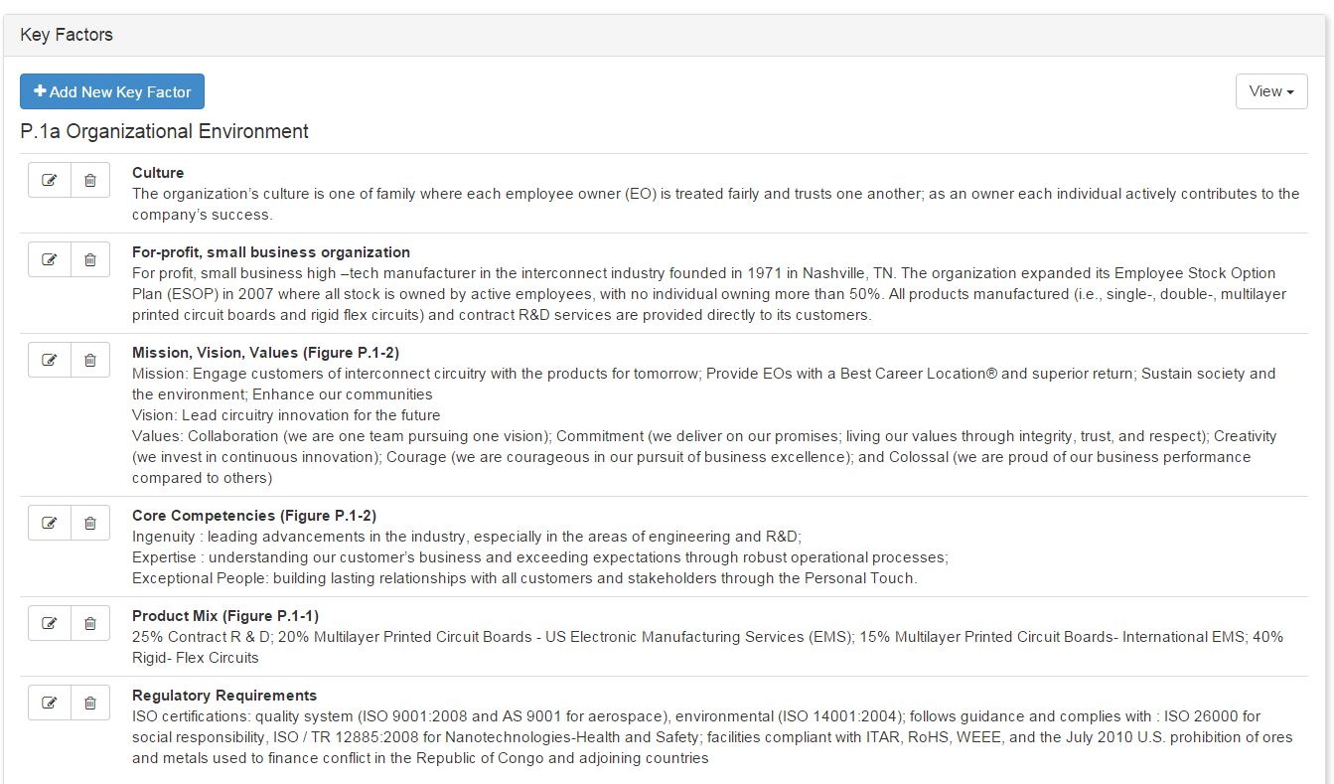

and may even be a subset of one key factor (e.g., only the Mission instead of the Mission, Vision and Values) that is most relevant to the Item.
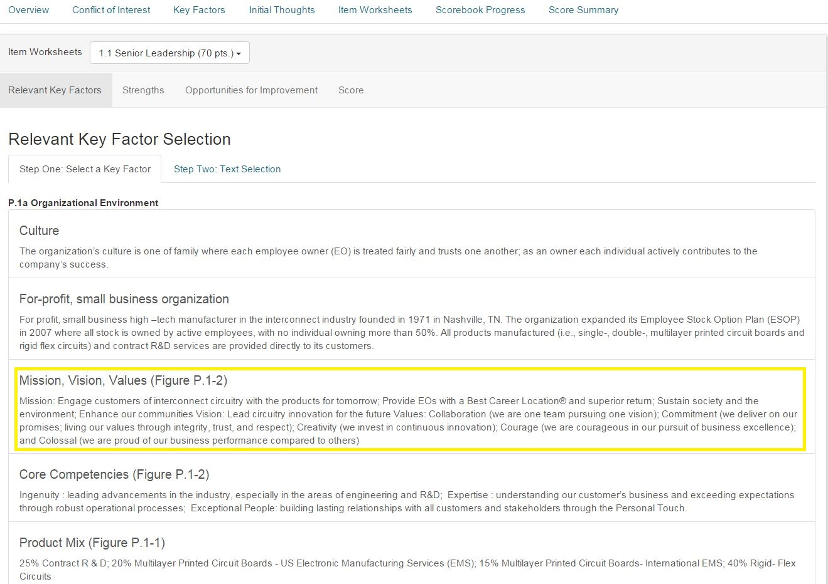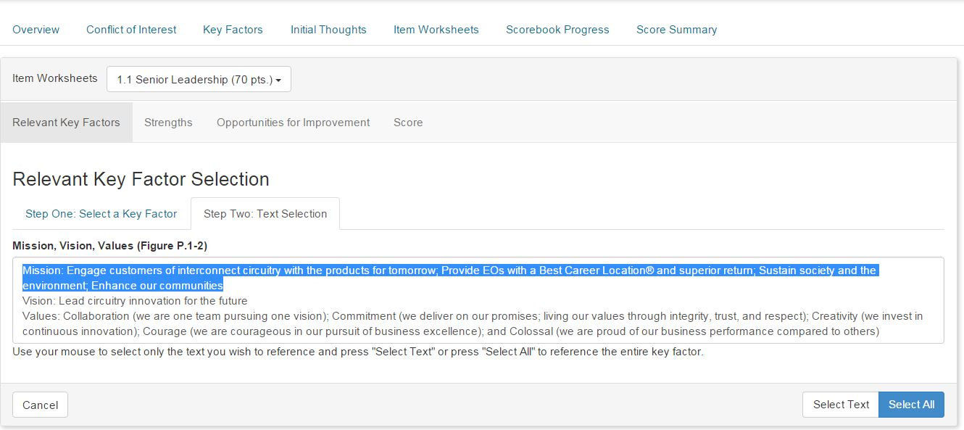
The saved part of the relevant Key Factor is shown next.
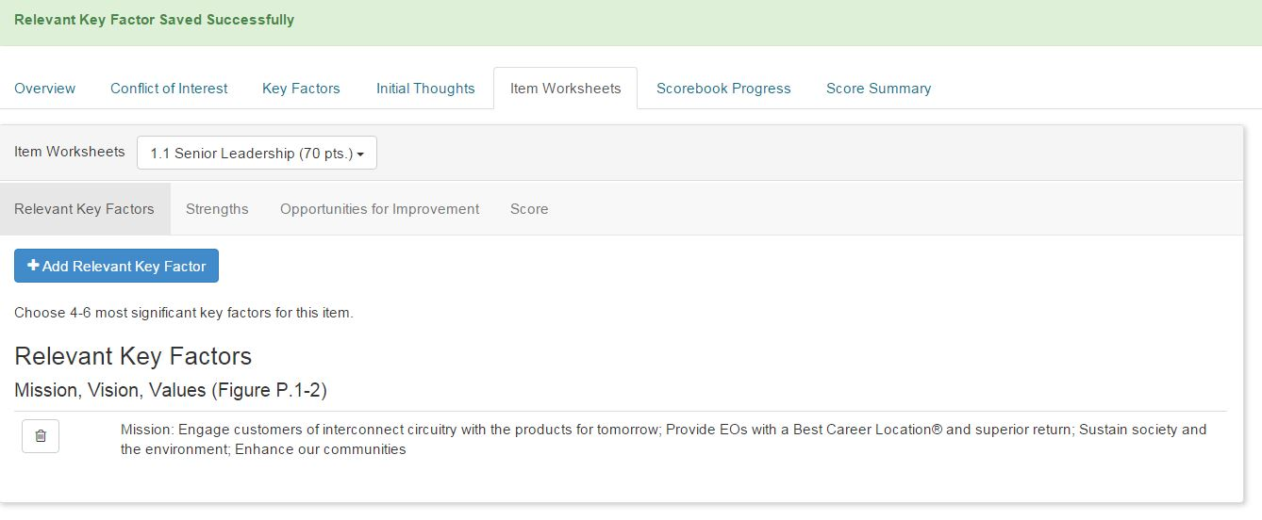 (Step 3) Read the applicant’s response to the Criteria Item in the case study
Identify the processes / approach the applicant uses to satisfy the Criteria Item requirements.
(Step 4) Analyze the applicant’s response to each item.
Read the response against the relevant Criteria requirements, and identify around six combined “strengths,” and “opportunities for improvement” (we call them OFIs). Record strengths and OFIs in BOSS on the Independent Review Worksheet. For each strength or OFI, follow these rules:
    - Enter the strength (or OFI) as a brief statement of an approach. It should represent the responsiveness of the applicant to one or more Criteria requirements in the Item. What makes it a strength or OFI is most often its importance. This is where the key factors you chose come in handy. Strengths and OFIs should reference one or more key factors.
    - Provide the evidence that supports the statement as a strength (for example: “the strategic planning process has seven steps, was expanded in 2015, and includes a final step for evaluation and feedback”).
    - Select the appropriate evaluation factors—Approach, Deployment, Learning, and Integration (ADLI)—that apply to this strength (or OFI). (See page 30, Scoring Dimensions for Process in your Baldrige Excellence Framework booklet).
      - Determine the significance of the strength (or OFI) to your evaluation of the applicant and whether it should be “bolded” (indicating high importance).
      - Provide the Criteria requirement reference to which the processes or methods relate for example, a(1), (b1,3), or c(1–3).
      - Use the arrows in BOSS to arrange the priority order of the strengths / OFIs, starting with the most important feedback to give the applicant.
      - Check your work, eliminating any conflicts between strengths and OFIs (i.e., when a strength contradicts an OFI for the same Criteria requirement).

At this point, your Independent Review (IR) Worksheet in BOSS should look something like this: (Strengths)
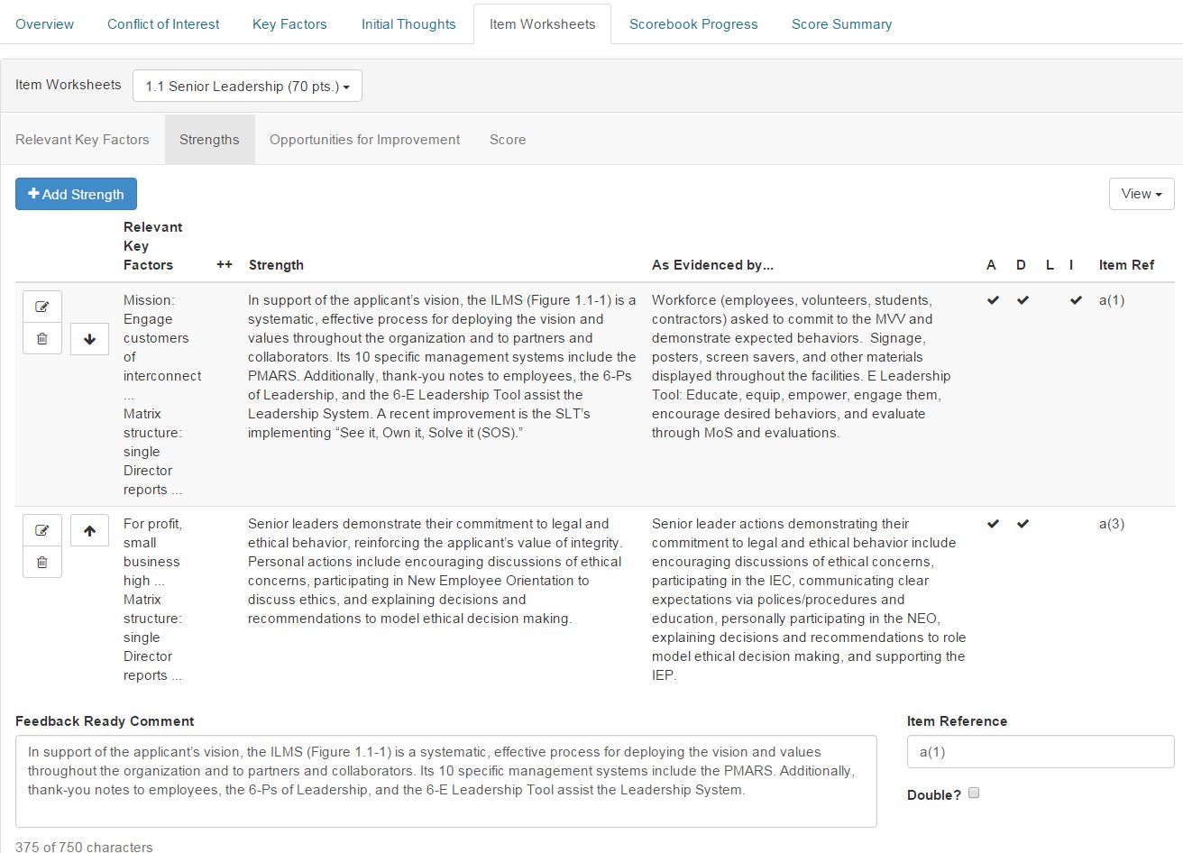
(Opportunities for Improvement)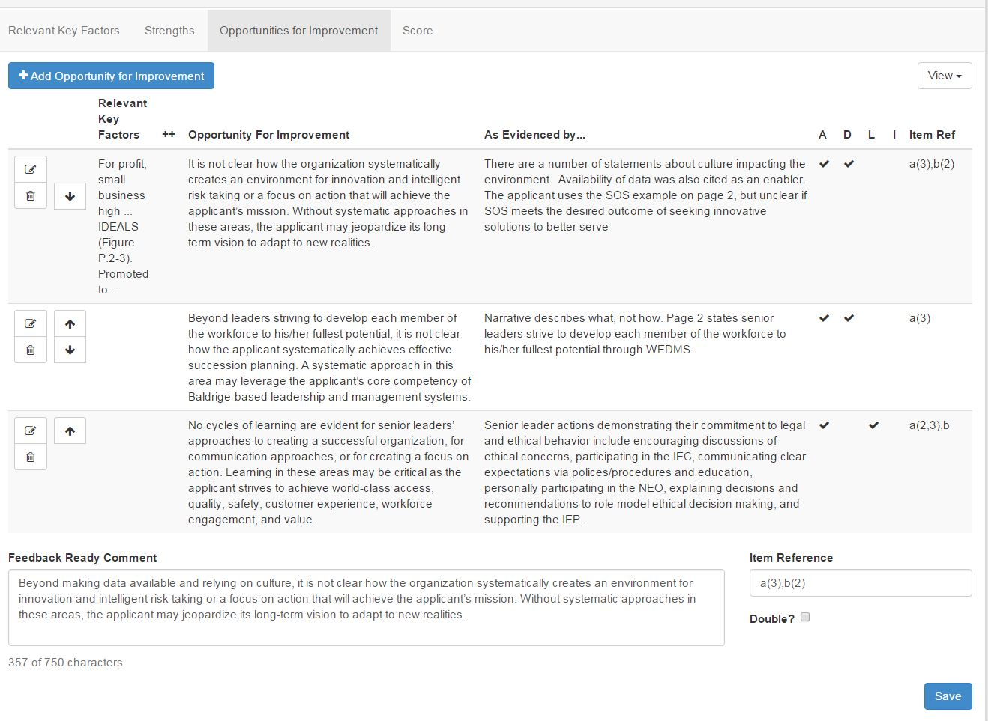
(Score)
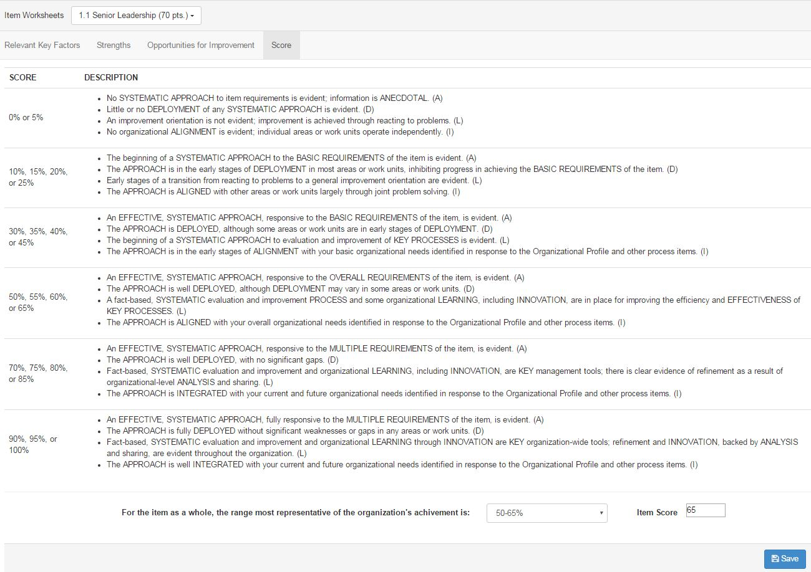
Note: Sample IR Worksheets for items 5.1and 7.3 can be found in the Prework section to compare your work with.

(5) Draft one “feedback-ready” strength comment and one “feedback-ready” OFI (opportunity for improvement) comment.
From your strengths and OFIs, select one of each (your choice) to develop into feedback- ready comments. The purpose of this step is to allow a team leader to check and see if you are on the right track, and allow the team leader to provide you feedback on your comment writing. For the purpose of this training, you will receive feedback in your classroom training session. In writing your comments, please follow the following rules.
Use the Comment Guidelines (found in the Prework section) to craft (in BOSS) two feedback-ready comments that capture the findings of your analysis, using the strengths and OFIs that you have listed.
Each strength or OFI comment should include:
- a concise opening sentence that expresses a single thought—the “nugget” (or essence, or main point) of the comment
- one or two examples (including figure numbers, if applicable)—referring to the approach or results given in the applicant’s response to Criteria questions
- language that shows the relevance (why the comment is important) to the applicant by tying the main point to one or more of the applicant’s key factors. You can also ask yourself, “What evaluation factor is relevant to this strength or OFI?” Thinking this way may help you focus the comment on the importance to the applicant (e.g., if the important element of the comment is deployment, there may be no need to add text on approach, learning, and integration).

(6) Determine the scoring range and the score for the item.
Determine the applicant’s overall scoring range for the item. Start by reviewing the Criteria requirements and the strengths and OFIs for the item.
Review the Scoring Guidelines descriptions (pages 34 and 35 in the Framework booklet) and determine the range that is, overall, most descriptive of the organization’s achievement level. Place this range on the Scoring page for the Criteria Item.
The applicant does not need to demonstrate all the characteristics in the selected range; rather, the score is based on a holistic view of the Criteria Item.
TIP: As a check, read the description of the ranges above and below the selected range to ensure you are in the range that is most descriptive of this applicant’s responses.
Finally, determine a percentage score that is a multiple of 5 for the item (e.g. 50%, 55%, 60%, and 65% are all multiples of 5 within the 50 – 65 Scoring Range. This percentage score is your best judgement of where the Item falls in the range – near the bottom or near the top. Record the percentage score in the space provided at the lower right side of the Scoring page.

You made it through your first Item! Congratulations! Now repeat this process (steps 1 through 6) for the rest of your assigned items. Once you have finished all assigned Items, mark your scorebook “Complete” in BOSS.

PART 5: Review and be prepared to discuss the meaning and importance of all remaining Criteria items.

PART 6: Bring these documents to class.
Your printed copy of:

- the case study (application)
- the Baldrige Excellence Framework booklet and any questions you have about the Criteria
- Your pre work assignment – the IR Scorebook from BOSS.
Note: We will check your pre work in class for completion. Your pre work also may be monitored for completion prior to class, as it is so important to this learning experience. You can print just the Items you completed, or you can print the whole scorebook as a place to take notes – your choice.

Remember, the goal is simply to be familiar with the process, tools, and outputs. We expect that your work won’t be perfect. Have fun with this.

Contact the Baldrige Examiner Help Center at examtrng@nist.gov for fastest service, or call 1-877-237-9064, option 2, and leave a voice mail if you have any problems or questions. A member of the examiner training team will respond as soon as possible.

