Video Analytics ­ Quality Metrics (VAQM)

Purpose
No­reference video quality metrics (NRVQM) are needed which can objectively demonstrate the relationship between video quality and its use in video analysis and forensic applications to:
- objectively ground forensic video data and equipment standards
- improve optimization of compression for public safety video analysis applications
- improve the performance of both human and automated video analysis systems
This toolset is created to facilitate video quality metric research and foster future R&D. It enables the user to compare quality scores to human judgments and to an existing video processing analytic (e.g. a video event detection algorithm).

Example Usage
Type the code following %%bash into your command line after installation.

%%bash python2 tools/import/import.py ‐f tests/sampledata/E021_blurs.csv ‐s \
blurnaive ‐‐flush

%%bash python2 tools/score/score_VQM_vs_Analytic.py ‐m E0XX‐Events ‐s blurnaive ‐fs \ PROGRESS ‐‐plot

The scores, along with their systems and model set ID's, are output to a text file called
video_quality_vs_analytic_scores.txt. In addition to the scores, the following plot should be displayed during runtime:

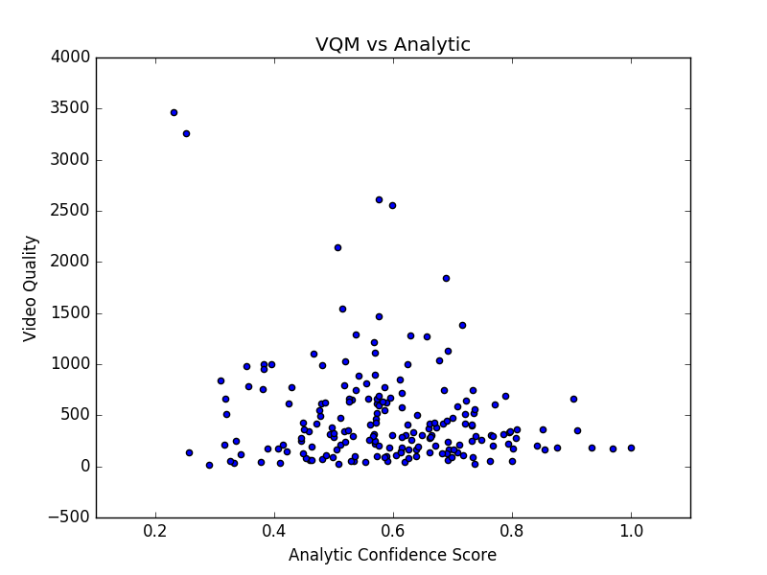

A similar syntax works for the Quality Score Judgments:

%%bash python2 tools/score/score_VQM_vs_HumanJudgments.py ‐m VQM ‐s \
'Video_BLIINDS' -fs LiveVQA

Detailed explanation on scoring options are available in the Modules section below.

Description
This software package is designed to evaluate the performance of candidate quality metrics in predicting video analytics performance and forensic human quality assessment.

Requirements
The script for Video Analytics and Quality Metrics comparison accesses a MySQL database. The MySQL version used is 14.14; the distribution is 5.7.17. The code was built using Python version 2.7.12.
This code requires the following packages, which may be installed via pip:
pandas pymysql
matplotlib

Installation
- Run init.sh. This will import the reference analytic and dataset information into MySQL. Other parameters for setting up the database including server, username, password, etc. can be changed in the lib/config.py file.
%%bash ./init.sh

- Run your quality metric system using an index file as reference for videos to be processed under the VAQM_Package/indexes directory.
- Import quality metric output with import.py under the VAQM_Package/import directory. Instructions on usage are discussed below under the Modules section, point 1.
- Depending on whether you scored the analytic reference videos (under
VAQM_Package/indexes/index_analytic.csv) or the quality judgments videos (under
VAQM_Package/indexes/index_human.csv), compute the scores with score_VQM_vs_HumanJudgments.py or score_VQM_vs_Analytic.py, under the VAQM/score directory. Instructions on usage are discussed under the Modules section, point 2.

Modules

1. VQM Import Module
This module imports the system­computed into the database for scoring and prediction of analytics. Baseline analytic data of the corresponding videos is also imported as reference for evaluation.
Command­Line Options
­f ­­filename
Specify the CSV file containing the system­computed video quality data. The csv to be uploaded should contain the headers 'fileID' and 'score' in that order.
­s ­­sysID
Specify the name of the system used to compute the quality data.
­tn ­­teamname
Specify the name of the team running the algorithm. This field is not required.
­­flush
Flush data if it exists from the database before inserting into the database. This can be used to clean up old data.
1.1 VQM Flush Submodule
The submodule in the import module deletes the uploaded records and scores based on the sysID passed.
Command­Line Option
­s ­­sysID
Specify the name of the system to flush out. Select 'all' to delete all system scores and computed metrics uploaded to the database. Example command:

%%bash python2 tools/import/flush.py ‐s blurnaive

2. VQM Scoring
This module scores the user's video quality scores against analytic scores or human­generated scores using Pearson's R2, Kendall's Tau, and Spearman's Rho.
To correlate the user's video quality scores with the analytic scores, specify the modelSetID as matches with the analytic task being run against: in this case, 'E0XX­Events'. To correlate the user's video quality scores with the human­generated quality scores, specify the modelSetID as 'VQM'. For both events, the ­­plot option may be included to show graphs of the points over which computation took place.
2.1 Analytic Submodule
Command Line Options
­s ­­sysID
Specify the name of the system used to compute the video quality scores.
­f ­­fileSetID
Specify the name of the file set over which the scores are computed. The analytic file set included is named 'PROGRESS'.
­m ­­modelSetID
Specify the name of the set of models according to which scores are computed. The analytic modelset included is named 'E0XX­Events'.
Plotting Option
­­plot
Plot the points over which computation took place.
Scoring Options
­fy ­­filterYes
Filter scoring according to ground­truth positives of the analytic data.
­fms ­­factorModelSet
Score for each model under the modelSet chosen.
­ffs ­­factorFileSet
Score for all filesets under the same corpus as the fileset picked, where relevant.
Following are sample plots from two different quality metrics tested on the analytic dataset.
Artificially­produced "good results": Variance is added to the ground truth analytic scores. | Naïve Blur Metric: A blur metric is applied to individual frames of the video.  The scores are then averaged to produce the final score.
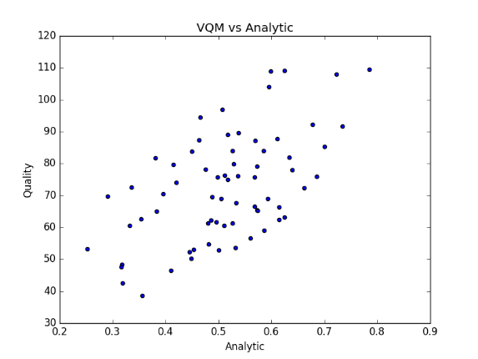

2.2 Quality Submodule
All the command line options available for the Analytic submodule are also available for the quality submodule, with the exception of ­­filterYes, since it is irrelevant to this module.
2.3 Factor­Based Scoring
Examples of models that may be obtained by factor­based output are displayed below:
%%bash python2 tools/score/score_VQM_vs_HumanJudgments.py ‐m VQM \ ‐s 'Video_BLIINDS' -fs LiveVQA ‐fms

Two samples of factor­based output are included to demonstrate the plots that would result. The second plot would result from running the above code with the ­­plot option:

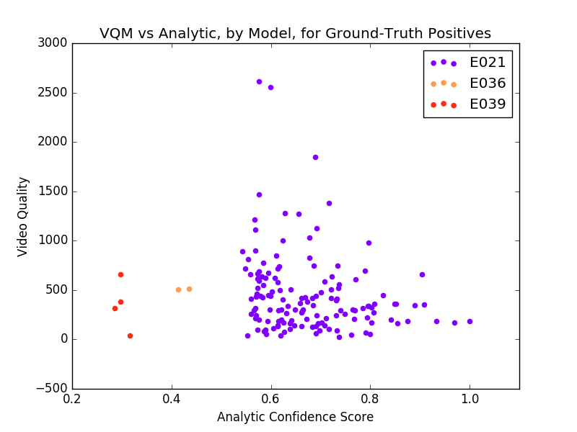 | 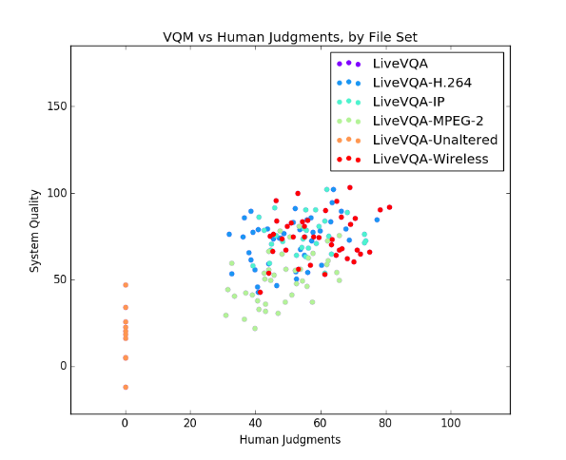

Appendix: Database
The database contains analytic confidence scores from an event detection analytic on a set of videos known to be true targets and the average of many human judgment scores on another set of videos of varying quality. The fileID's and names of the videos to compute quality scores over are pipe­separated files (a CSV with column entries separated by pipes '|') under the index directory, called index_analytic.csv and index_human.csv.

Analytic Database Stats
Event | No. Target Videos | Description
E021 | 198 | Attempting a bike trick
E022 | 172 | Cleaning an appliance
E023 | 194 | Dog show
E024 | 103 | Giving directions to a location
E025 | 134 | Marriage proposal
E026 | 248 | Renovating a home
E027 | 334 | Rock climbing
E028 | 172 | Town hall meeting
E029 | 237 | Winning a race without a vehicle
E030 | 168 | Working on a metal crafts project
E031 | 158 | Beekeeping
E032 | 220 | Wedding shower
E033 | 126 | Non­motorized vehicle repair
E034 | 118 | Fixing musical instrument
E035 | 116 | Horse riding competition
E036 | 197 | Felling a tree
E037 | 161 | Parking a vehicle
E038 | 195 | Playing fetch
E039 | 145 | Tailgating
E040 | 120 | Tuning musical instrument

Quality Database Stats
No.  Videos | Distinct video subjects | Videos per  Subject | Partitioned Groups
160 | 10 | 16 | Undistorted videos, H.264 transmission, IP packet loss, MPEG­2 distortion, and Wireless packet loss

Support
If you are having issues, please email us at: videoquality@nist.gov.

Disclaimer
This software was developed at the National Institute of Standards and Technology (NIST) by employees of the Federal Government in the course of their official duties. Pursuant to Title 17 Section 105 of the United States Code, this software is not subject to copyright protection and is in the public domain. NIST assumes no responsibility whatsoever for use by other parties of its source code or open source server, and makes no guarantees, expressed or implied, about its quality, reliability, or any other characteristic.

